# 墨宝DAPP开发教程

## 墨宝介绍

墨宝钱包是首款支持通证、收藏品、子链以及DAPP的MOAC移动端钱包。

墨宝钱包目前开放了第三方DAPP接口，让开发者可以开发自己的DAPP，为用户提供更多的选择和功能。

## 墨宝接口介绍

接口对象

window.moac

### 接口属性

window.moac.networkVersion，当前墨客网络ID

window.moac.isMobao，是否是墨宝的DAPP接口，返回true或false

window.moac.version，DAPP的接口版本

window.moac.selectedAddress，当前用户的钱包地址

### 接口方法

**moac.enable(callback)**

返回用户在墨宝的墨客钱包地址列表，当前只返回用户的当前地址。

moac.enable(function(accounts) {

console.log(accounts[0]);

});

**moac.sendAsync(options, callback)**

发送消息给墨宝，消息格式按[Moac Chain3 JSON-RPC](https://github.com/MOACChain/moac-core/wiki/JSON-RPC)。

var params: [{

"from": "0xb60e8dd61c5d32be8058bb8eb970870f07233155",

"to": "0xd46e8dd67c5d32be8058bb8eb970870f07244567",

"gas": "0x76c0", // 30400

"gasPrice": "0x9184e72a000", // 10000000000000

"value": "0x9184e72a", // 2441406250

"data": "0xd46e8dd67c5d32be8d46e8dd67c5d32be8058bb8eb970870f072445675058bb8eb970870f072445675"

}];

moac.sendAsync({

method: 'mc\_sendTransaction',

params: params

}, function(err, result) {

// TODO

});

**目前支持的JSONRPC API包括如下**

1. [chain3\_clientVersion](https://github.com/MOACChain/moac-core/wiki/JSON-RPC" \l "chain3_clientversion)
2. [chain3\_sha3](https://github.com/MOACChain/moac-core/wiki/JSON-RPC" \l "chain3_sha3)
3. [net\_listening](https://github.com/MOACChain/moac-core/wiki/JSON-RPC" \l "net_listening)
4. [net\_peerCount](https://github.com/MOACChain/moac-core/wiki/JSON-RPC" \l "net_peerCount)
5. [net\_version](https://github.com/MOACChain/moac-core/wiki/JSON-RPC" \l "net_version)
6. [mc\_getBalance](https://github.com/MOACChain/moac-core/wiki/JSON-RPC" \l "mc_getBalance)
7. [mc\_accounts](https://github.com/MOACChain/moac-core/wiki/JSON-RPC" \l "mc_accounts)
8. [mc\_blockNumber](https://github.com/MOACChain/moac-core/wiki/JSON-RPC" \l "mc_blockNumber)
9. [mc\_call](https://github.com/MOACChain/moac-core/wiki/JSON-RPC" \l "mc_call)
10. [mc\_coinbase](https://github.com/MOACChain/moac-core/wiki/JSON-RPC" \l "mc_coinbase)
11. [mc\_estimateGas](https://github.com/MOACChain/moac-core/wiki/JSON-RPC" \l "mc_estimateGas)
12. [mc\_gasPrice](https://github.com/MOACChain/moac-core/wiki/JSON-RPC" \l "mc_gasPrice)
13. [mc\_getBlockByHash](https://github.com/MOACChain/moac-core/wiki/JSON-RPC" \l "mc_getBlockByHash)
14. [mc\_getBlockByNumber](https://github.com/MOACChain/moac-core/wiki/JSON-RPC" \l "mc_getBlockByNumber)
15. [mc\_getBlockTransactionCountByHash](https://github.com/MOACChain/moac-core/wiki/JSON-RPC" \l "mc_getBlockTransactionCountByHash)
16. [mc\_getBlockTransactionCountByNumber](https://github.com/MOACChain/moac-core/wiki/JSON-RPC" \l "mc_getBlockTransactionCountByNumber)
17. [mc\_getCode](https://github.com/MOACChain/moac-core/wiki/JSON-RPC" \l "mc_getCode)
18. [mc\_getStorageAt](https://github.com/MOACChain/moac-core/wiki/JSON-RPC" \l "mc_getStorageAt)
19. [mc\_getTransactionByBlockHashAndIndex](https://github.com/MOACChain/moac-core/wiki/JSON-RPC" \l "mc_getTransactionByBlockHashAndIndex)
20. [mc\_getTransactionByBlockNumberAndIndex](https://github.com/MOACChain/moac-core/wiki/JSON-RPC" \l "mc_getTransactionByBlockNumberAndIndex)
21. [mc\_getTransactionByHash](https://github.com/MOACChain/moac-core/wiki/JSON-RPC" \l "mc_getTransactionByHash)
22. [mc\_getTransactionCount](https://github.com/MOACChain/moac-core/wiki/JSON-RPC" \l "mc_getTransactionCount)
23. [mc\_getTransactionReceipt](https://github.com/MOACChain/moac-core/wiki/JSON-RPC" \l "mc_getTransactionReceipt)
24. [mc\_getUncleByBlockHashAndIndex](https://github.com/MOACChain/moac-core/wiki/JSON-RPC" \l "mc_getUncleByBlockHashAndIndex)
25. [mc\_getUncleByBlockNumberAndIndex](https://github.com/MOACChain/moac-core/wiki/JSON-RPC" \l "mc_getUncleByBlockNumberAndIndex)
26. [mc\_getUncleCountByBlockHash](https://github.com/MOACChain/moac-core/wiki/JSON-RPC" \l "mc_getUncleCountByBlockHash)
27. [mc\_getUncleCountByBlockNumber](https://github.com/MOACChain/moac-core/wiki/JSON-RPC" \l "mc_getUncleCountByBlockNumber)
28. [mc\_hashrate](https://github.com/MOACChain/moac-core/wiki/JSON-RPC" \l "mc_hashrate)
29. [mc\_mining](https://github.com/MOACChain/moac-core/wiki/JSON-RPC" \l "mc_mining)
30. [mc\_protocolVersion](https://github.com/MOACChain/moac-core/wiki/JSON-RPC" \l "mc_protocolVersion)
31. [mc\_sendRawTransaction](https://github.com/MOACChain/moac-core/wiki/JSON-RPC" \l "mc_sendRawTransaction)
32. [mc\_sendTransaction](https://github.com/MOACChain/moac-core/wiki/JSON-RPC" \l "mc_sendTransaction)
33. [mc\_syncing](https://github.com/MOACChain/moac-core/wiki/JSON-RPC" \l "mc_syncing)

## 墨宝开发测试版本dapp使用介绍

开发测试DAPP，请下载“墨宝开发测试版”（以下简称“墨宝”），下载地址：<https://fir.im/mobaotest>

墨宝DAPP列表里已经提供官方版的DAPP示例可供参考。

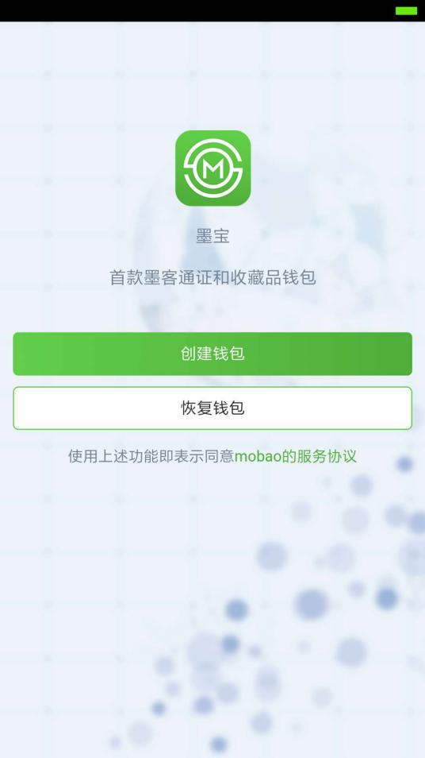 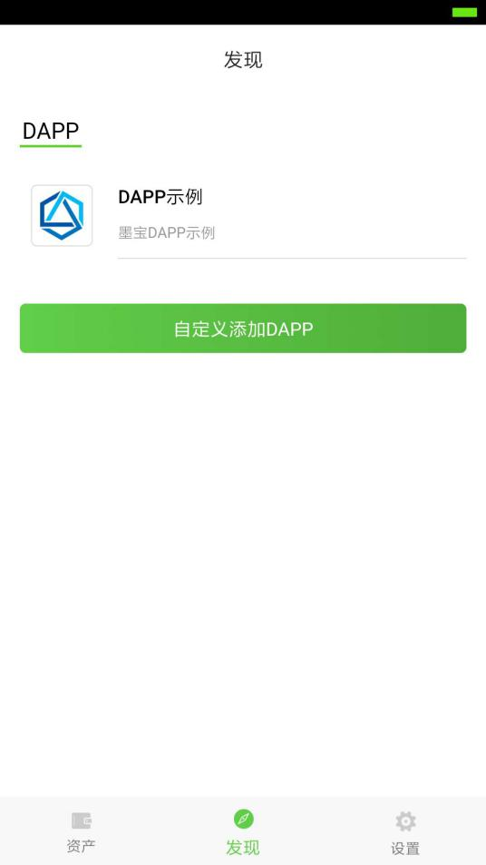

墨宝安装完成后，创建或恢复钱包至少一个地址，选择墨宝中的“发现”，点击“自定义添加DAPP”，输入名称、URL、ABI点击确定即可，DAPP列表中就会出现刚刚添加的DAPP。

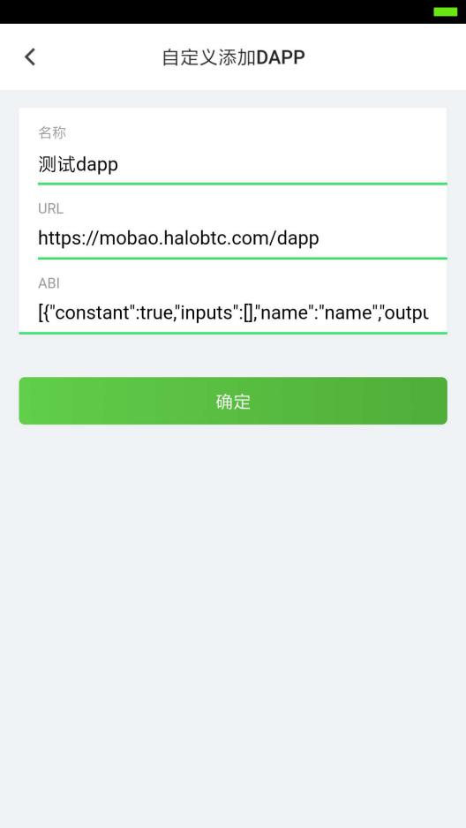 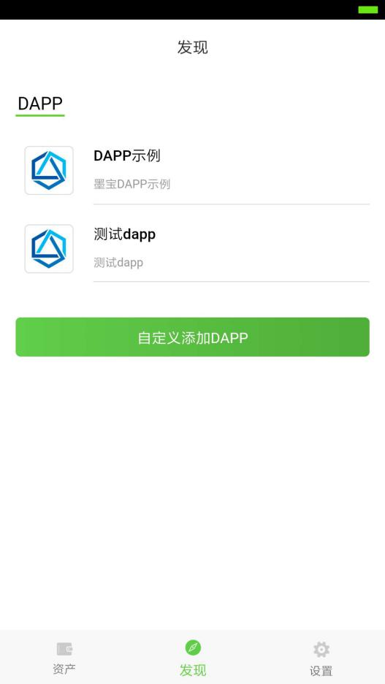

页面在墨宝打开之后，墨宝钱包会注入moac对象，可以使用window.moac访问，据此判断DAPP是否是在墨宝中打开。

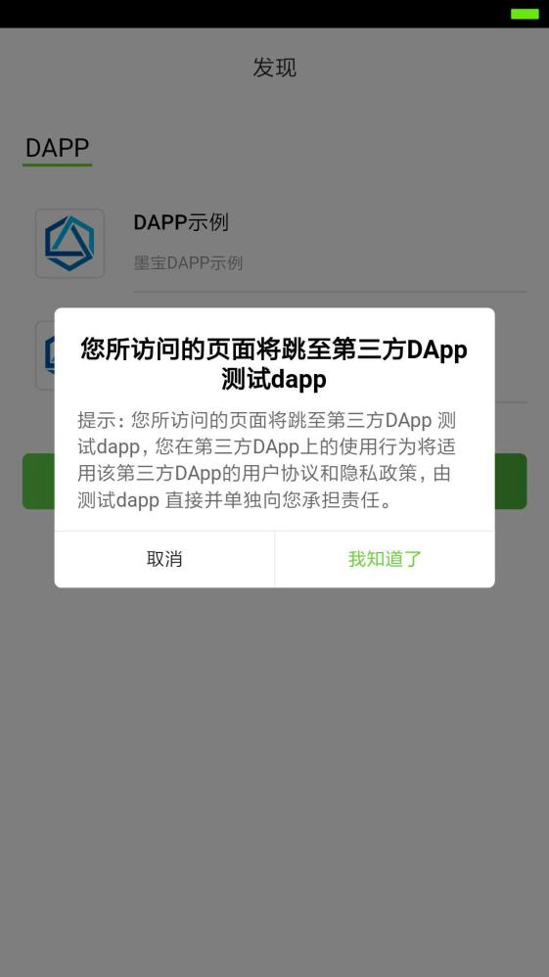 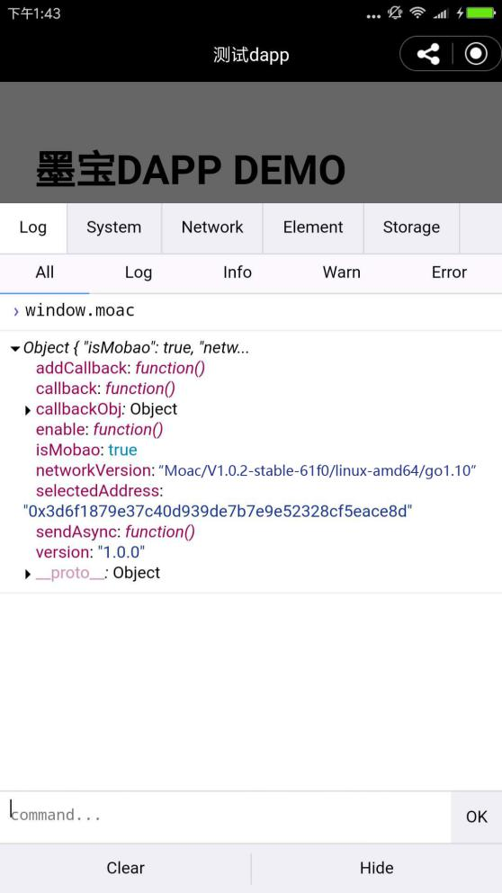

if (typeof window.moac === 'undefined') {

console.log(“你需要在墨宝app中访问”)

} else {

// TODO

moac.enable(function(accounts) {

console.log(accounts[0]);

});

moac.networkVersion，当前墨客网络ID

moac.isMobao，是否是墨宝的DAPP接口，返回true或false

moac.version，DAPP的接口版本

moac.selectedAddress，当前用户的钱包地址

moac.enable(callback)，返回用户在墨宝的墨客钱包地址列表

moac.sendAsync(options, callback)，发送消息给墨宝

}