Student Management System

By
Name of the student

CSC2100 Introduction to Problem Solving and Computer Programming
Fall 2011
Date Submitted: November 2, 2011

Scope of Work:
The Python based Student Management System can be used to update, access, encrypt and decrypt the data of the record of the students maintained by the university. This program provides various functions to:
- Append the current list.
- Display the information of all the students registered in the university.
- Display the information of all the students registered for a particular class.
- Display the youngest student in the university
- Display the oldest student in the university.
- Encrypt the data of the record.
- Decode the encrypted file.

Using this program, the administrative tasks can be handled efficiently and will consume less time. This will prove to be a great productivity tool for the staff.

Assumptions:
Although proper care has been taken to make this program capable to run in every situation, but still for smooth functioning, the following assumptions are made:
- It is assumed that the email Ids do not contain numeric.
- It is assumed that except the first and last name, all other fields are entered in lowercase letters.
- It is assumed that the fodsel number and the email id entered by the user are valid.

Design:
The program consists of three files :
- StudentRecordClass.py
- EncodeDecodeClass.py
- StudentManagement.py

StudentRecordClass.py
This class contains the methods for updating and accessing the student list.

The method WriteInfo() ensures that the information in entered in a valid format i.e. fodsel number and age are entered as integers and all the information fields, except last name are not null. After that, using try and except error handling technique, the information is written to the text file.

The methods DisplayStudents(), DisplaySubjectClassList(), DisplayOldest() And DisplayYoungest() read the file StudentRecord.txt and retrieve the required information.

In all the methods provided in this class, special care has been taken to close the file after the operation is completed.

EncodeDecodeClass.py

This class contains the methods to encrypt and decrypt the student record data.

The method EncodeStudentList(file1, file2) takes two files as parameter. It reads the StudentRecord.txt text file and then encodes the data of this file using encodeText(text) method and writes the encrypted data to file EncodedStudentRecord.txt . For encoding the string, shiftCipher is used with implementation of ROT(5).

The method DecodeStudentList(file1,file2) also takes two files as parameters.It reads the EncodedStudentRecord.txt text file and then decodes the data of this file using decodeText(text) method and writes the decoded data to file DecodedStudentRecord.txt .

In both the methods, the “@” and “.” symbols in the email are not changed.

StudentManagement.py

This class contains the main function.

The user prompted to choose the task he/she wishes to perform. Then based on the task that the user wishes to perform, the methods from other classes are called.

Test Plan and TestCases:
All the methods in the assignment were first tested individually and then the complete testing of the program was done.

Some of the results during individual testing of the methods are shown below ( screenshots attested at the end ) :

Test Case Number | Input Values | Output
1 | encodeText(“1234”) | “4231”
2 | encodeText(“abcd”) | “fghi”
3 | decodeText(“4231”) | “1234”
4 | decodeText(“fghi”) | “abcd”
5 | Student’s age =”erd” | “please enter a valid value”

For the testing of the full program, first the student information was written into the file named “StudentRecord.txt”. Once successful, the information based on different parameters such as subject class, age etc was retrieved by selecting the options in the main program which called the functions of class StudentRecordClass. This was also successful.

In the second phased of the testing of the full program, the program was asked to produce the encrypted version of the “StudentRecord.txt”.
The resulted encrypted file was then manually checked to ensure that the encryption algorithm is working properly. After that, the encrypted file was decoded and the decoded file was matched with the original file “StudentRecord.txt” to ensure that the decoded file is similar to the original file.

Feedback:
Although the assignment was mostly fun, it did provide some challenges. The challenges faced and the ways through which the were tackled are described in the following points:
- During the encryption of the data of the file StudentRecord.txt, encoding the numbers was a challenging task because only first and the last digits were to be swapped and the rest were not to be touched. It was done by converting the number into a list and then swapping the first and the last term using the list indices.
- Another challenge was faced while writing the encoded data to the EncodedStudentRecord.txt. During the write operation, the code would clear the previous entries and just write the encoded data of the last line of the original StudentRecord.txt. This was dealt with opening the file with append permission, instead of opening it with mere write permission.

Appendix A: Test Log (required)
Test Case Number | Input Values | Actual Output | Result
1 | encodeText(“1234”) | “4231” | Pass
2 | encodeText(“abcd”) | “fghi” | Pass
3 | encodeText(“john@gmail.com”) | “otms@lrfnq.htr” | Pass
4 | encodeText(“Bella”) | “Gjqqf” | Pass
5 | decodeText(“4231”) | “1234” | Pass
6 | decodeText(“fghi”) | “abcd” | Pass
7 | decodeText(“otms@lrfnq.htr”) | “john@gmail.com” | Pass
8 | decodeText(“Gjqqf”) | “Bella” | Pass
9 | Student.age=”red” | “please enter a valid value” | Pass
10 | Student.first_name=” “ | “please enter a valid value” | Pass
11 | shift_Cipher(“a”) | “f” | Pass
12 | deCipher(“f”) | “a” | Pass
13 | swap_first_last(“4567”) | “7564” | Pass

Appendix B: Screen Shots of the working program
- WriteInfo()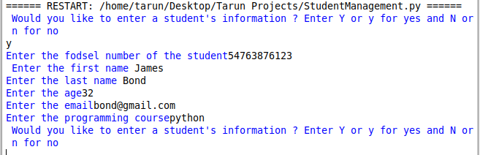
- StudentRecord.txt ( after the entry )
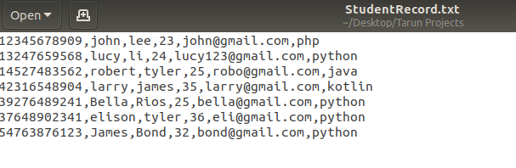
- DisplayStudents()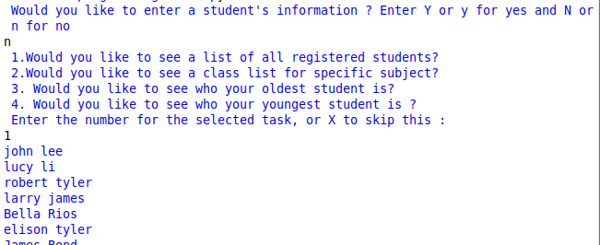
- DisplaySubjectList()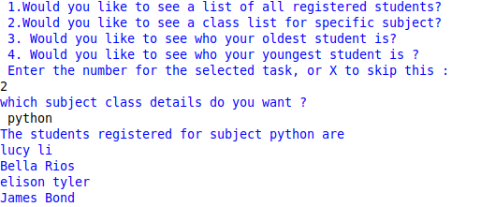
- DisplayOldest()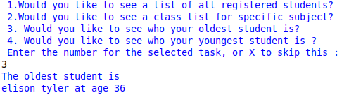
- DisplayYoungest()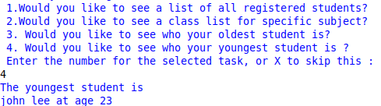
- EncodeStudentList()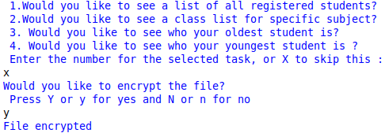
- EncodedStudentRecord.txt ( after the file is encrypted )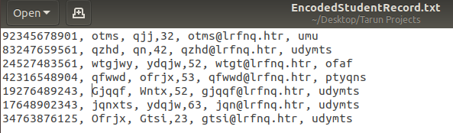
- DecodeStudentList()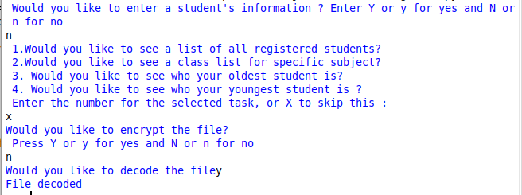
- DecodedStudentRecord.txt ( after the file is decoded )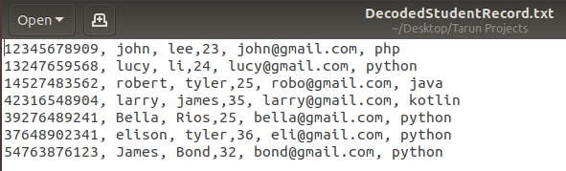
- shiftCipher( )
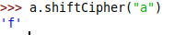

- encodeText()
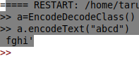
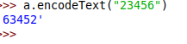
- decodeText()
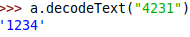
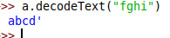
- deCipher()
