Design:

# 3) what is design?

The design phase can be referred to as the transformation phase, because this phase is brought into action when an idea is actually transformed into a real working system. Phase two comes to an end once a customer has agreed and signed off on the system. Once this happens, the building begins. Data is formed into chats, and the design team uses those charts to decide the best way for the data to move and be stored.

# 3.1 structural modelling.

## 3.1.1 class diagram:

Definition:

A class diagram is an illustration of the relationships and source code dependencies among classes in the unified modeling language or UML. Here, a class can be defined as the methods and variables in an object, which is specific entity in a program. Class diagrams are very crucial in all forms of Object-Oriented Programming.

Justification.

I have used class diagram in my project because:

* My project is an object-oriented programming and class diagram can be directly mapped with object-oriented languages.
* It helps to describe responsibilities of a system.
* It is analysis and design of the static view of an application.

Notation used (in table):

|  |  |  |
| --- | --- | --- |
| Symbols | name | Definition |
| Inheritance |  |  |
| Dependency |  |  |
| Aggregation |  |  |
| Containment |  |  |
| Association |  |  |
| Direct association |  |  |
| Realization/ implementation |  |  |

## Diagram: (NOT NOW)

Diagram explanation:

## 3.1.2 Data-Flow diagram:

Data flow diagram is a graphical representation of the flow of data through a system. it shows how information is input to and output from the system, the sources and destination of that information and where that information is stored.

Justification:

I have used Data flow diagram in my project because:

* It aids in describing the boundaries of the system.
* It can provide a detailed representation of system components.
* It supports the logic behind the data flow within the system.

Notation used in Data-Flow diagram:

|  |  |  |  |
| --- | --- | --- | --- |
| NO. | Name of natation | Notation | Description |
| 1 | Data flow |  |  |
| 2 | Process |  |  |
| 3 | External entity |  |  |
| 4 | Data store |  |  |

## Diagram:

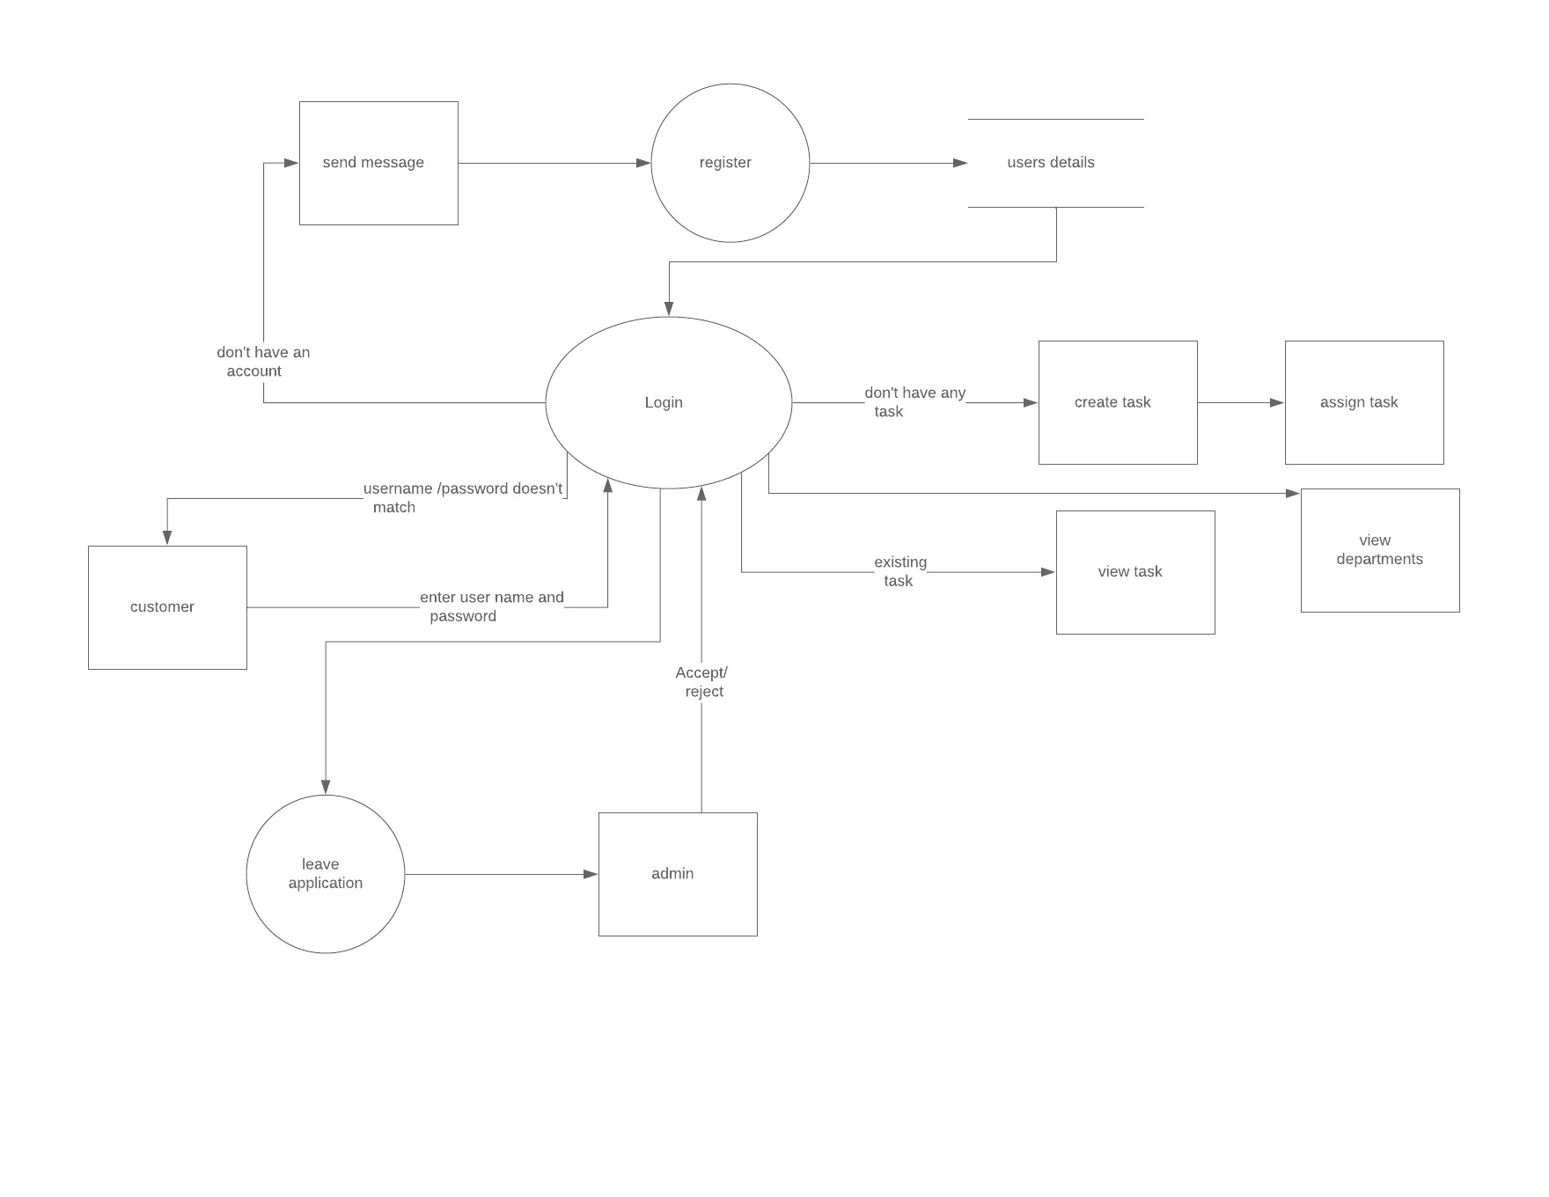

Description of the diagram:

# 3.2 behavioral modelling.

## 3.2.1 activity diagram:

Definition:

An activity diagram is a graphical representation of an executed set of procedural system activities and considered a state chat diagram variation. Activity diagram describe parallel and conditional activities, use cases and system function at a detailed level.

Justification:

I have used activity diagram for my project because:

* It draws the activity flow of a system.
* Describes the sequence from one activity to another.
* Describes the branched, parallel and concurrent flow of the system.

Notation used (in table):

|  |  |  |
| --- | --- | --- |
| Symbols | name | Definition |
| Swim lane |  |  |
| Initial state |  |  |
| Final state |  |  |
| Action/ activity |  |  |
| Decision |  |  |
| Control flow |  |  |
| Send signal |  |  |
| Fork |  |  |

## Diagram:

Diagram explanation:

# 3.2.2 sequence diagram:

Definition:

A sequence diagram or also known as timing diagram/ event diagram represents object collaboration and is used to define event sequence between objects for a certain outcome. A sequence diagram is an essential component used in processes related to analysis, design and documentation.

Justification:

I have used sequence diagram for my project because:

* It helps to show the interaction between the active objects in a system.
* It helps to document on how a system should behave.
* It helps to show the requirements for a future system implementation if needed.

Notation used (in table):

|  |  |  |
| --- | --- | --- |
| Symbols | name | Definition |
| Lifeline |  |  |
| Message |  |  |
| Recursive message |  |  |

## Diagram:

Diagram explanation:

# 3.3 database modelling.

## 3.3.1 data dictionary: NOT NEEDED

## 3.3.2 ER diagram:

ER diagram also known as Entity Relationship model, is a graphical representation of an information system that depicts the relationship among objects, places, or events in a system.ER diagram is a data modelling technique that can help define business processes and be used as the foundation for a relational database.

# 3.4 UI modelling.

User Interface (UI) modelling is the process of making interface in software or computerized devices with a focus on looks or styles. Similarly, UI modelling is important to my project as it helps to make the design easier to develop and use.

## 3.4.1 prototype:

Prototype is an example that servers as a basis for future models. Prototyping will give me an opportunity to research new alternative and test the existing design to confirm a product’s functionality prior to products.