**U01E01 -- FIRST PHP PROGRAMS**

Make the following programs using html and php.

For these programs that are simple, you paste the code directly after the statement.

1. **Create a php script that creates 2 variables, one with a number and the other with a text string and displays them without any formatting.**

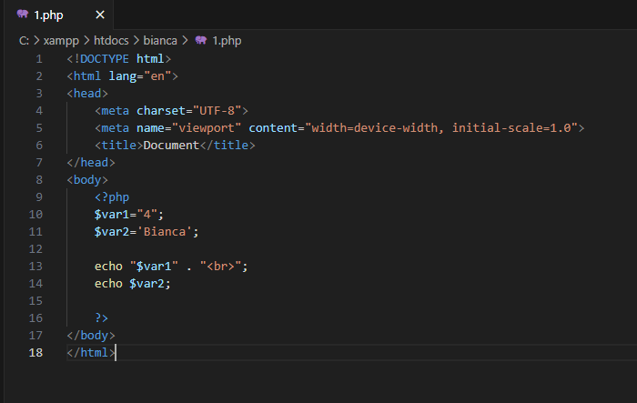

1. **Create a php script that creates 2 variables, one with a number and the other with a text string and displays its value in a table, each in a row.**

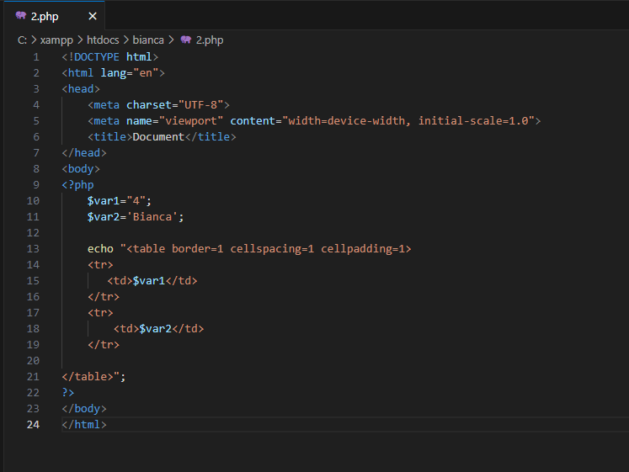

1. **Create a php script that creates 3 variables, one with an integer value, another with a decimal value and another with a string and displays them within a table with 3 rows and two cells per row: in one cell we will show the value and in other than what type of variable it is. (Find a function that returns the type of a variable)**

