**U01E02 – LOOPS**

Make the following scripts using html and php.

For these scripts that are simple, you paste the code directly after the statement.

1. Define a variable with a number (for example 5) and using a **for loop** create a page in which there is a table with as many rows as indicated in the variable and that the * of have been drawn in the following mode.

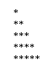

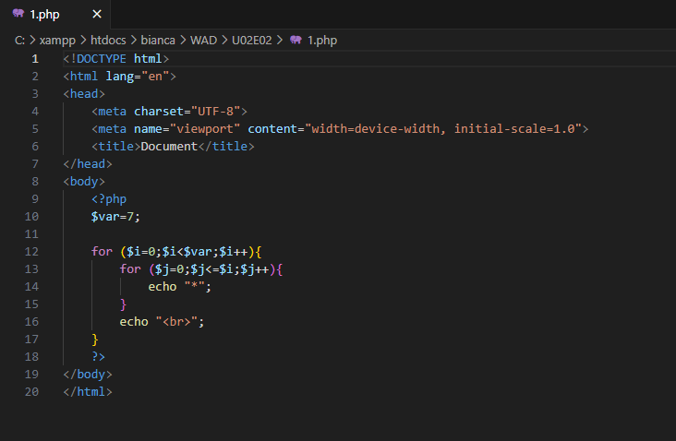

1. Loop through an array of meals (an associative array) of the type from the previous practice with a foreach loop in the drawing row with days of the week, row with meals for each day (one per cell) using a foreach loop and the structure:

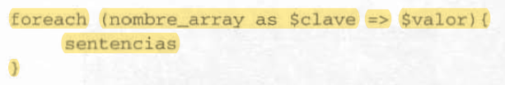

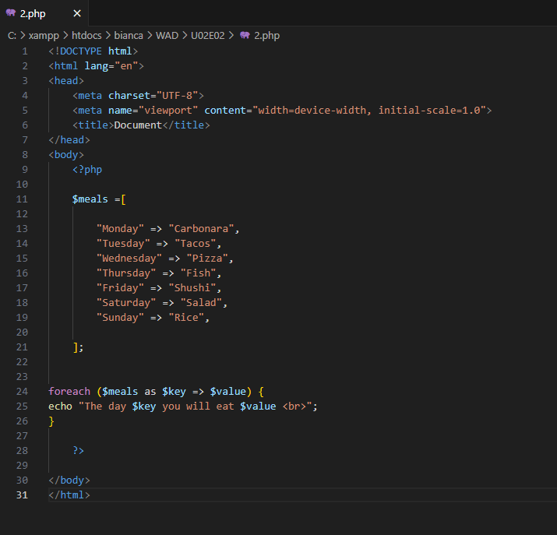

1. Defining a variable with a number (for example 5) and using while loops draws a ladder of numbers of the type:



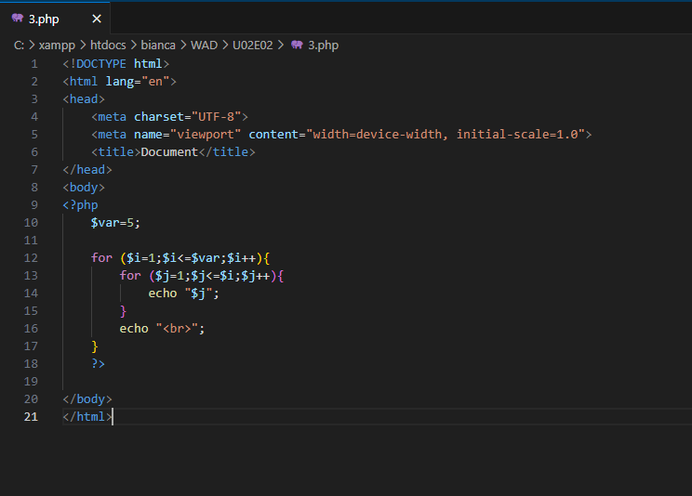

1. You are going to define a variable called secret_num that is a number from 1 to 100. And you are going to make a loop to guess it using the break statement at the appropriate time and showing on the screen what the number is.