Deploy an application (Apache) in a single Availability Zone (AZ) and use an EC2 instance as the database (MySQL)

Development VPC.  
  
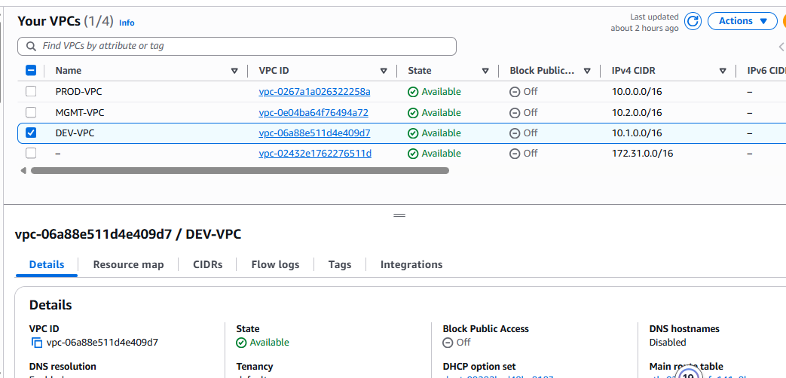

Installing an EC2 instance in a public and private subnet using Ubuntu .

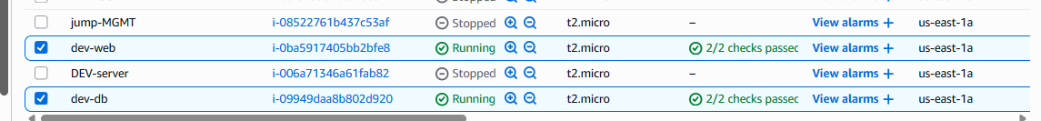

The dev-web was deployed in public subnet so it has public internet for user access.

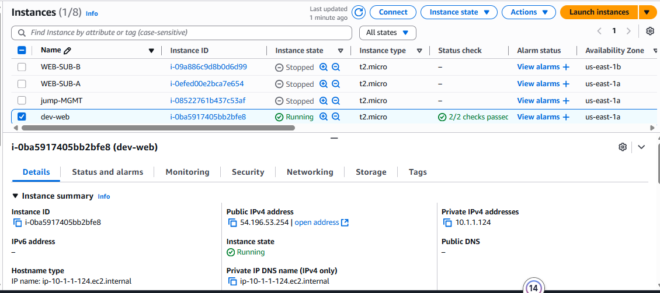

The security group for the dev-web EC2 instance allows incoming HTTP/HTTPS traffic (ports 80/443) from the internet.

Dev-db is placed in the private subnet with no public IP.

The security group for the dev-db only allows incoming connections from the dev-web security group, not from the public internet.

**Configure Database EC2 Instance**

* SSH into the **dev-db EC2 instance**: from the dev-web EC2

Installing mysql

sudo apt-get install mysql-server -y

sudo service mysql start

sudo mysql_secure_installation

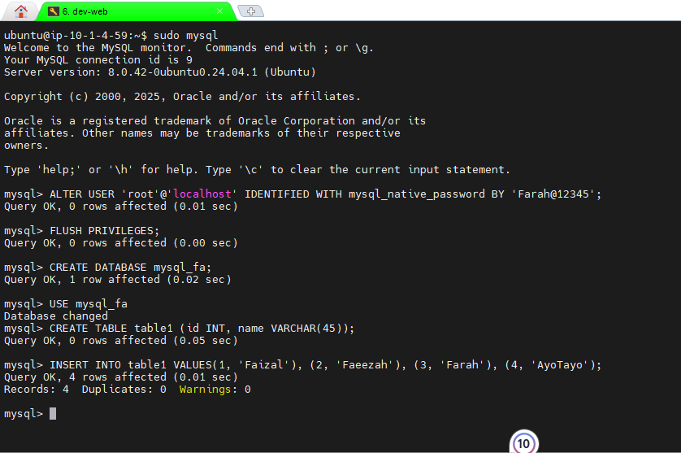

Login to MySql as a root

Sudo mysql

Update the password for the MySql Server

ALTER USER’root@’localhost’ IDENTIFIED WITH mysql native password BY ‘Farah@123’;

FLUSH PRIVILEGES;

Test the MySql server if it is working by running sample sql queries

CREATE DATABASE mysql_fa;

USE mysql_fa;

CREATE TABLE table1 (id INT, name VARCHAR(45));

INSERT INTO table1 VALUES91, ‘Faizal’), (2, ‘Faeezah’), (3, ‘Farah’), (4, ‘AyoTayo’);

SELECT * FROM table1;

Installing Apache into the dev- web public subnet.

sudo apt-get install apache2 -y

sudo systemctl start apache2

sudo systemctl enable apache2

sudo systemctl status apache2

Using the public IP.

Using domain: web.bbtlab.org

