Exploratory Data Analysis for Customer Churn Prediction

Bipin Ghimire
IBM Exploratory Data Analysis for Machine Learning
Date: March 24, 2026
Abstract
The present project focuses on exploratory data analysis of the Telco Customer Churn dataset to determine the essential variables that have an impact on customer churn. One of the analysis stages involves data cleaning, visualization, feature engineering, and hypothesis testing. To test the parameters between tenure and churn a statistical test was carried out and the outcomes indicated that there was a significant difference between churned and non-churned customers. As well, the dataset was formatted to be used with machine learning and a logistic regression model was found to be able to predict with accuracy of 80 which is a good result.
Keywords: Exploratory Data Analysis, Customer Churn, Data Cleaning, Feature Engineering, Hypothesis Testing, Data Visualization, Machine Learning

Customer Churn Prediction Exploratory Data Analysis.
Introduction
Customer retention is one of the crucial areas of success in the contemporary competitive business setup. The companies should know the cause of churn among the customers so that the better strategies could be formulated to retain the customers. This project aims at discussing customer data of one of the telecommunications companies to define trends and variables which affect churn. In a bid to generate insights that can enable companies in making their business decisions to enhance customer retention, this study steps into the exploratory data analysis.
Dataset Summary
The data set employed in this project is the Telco Customer Churn dataset, which includes the data on the customers and their demographics, types of services consumed, and billing information. The sample has 7043 observations and 21 variables. These variables are both categorical and numerical.
The numerical variables are tenure, MonthlyCharges and TotalCharges, whereas the categorical variables are gender, type of contract, internet service and the method of payment. Churn is the target variable in order to show whether a customer has left the service or not.
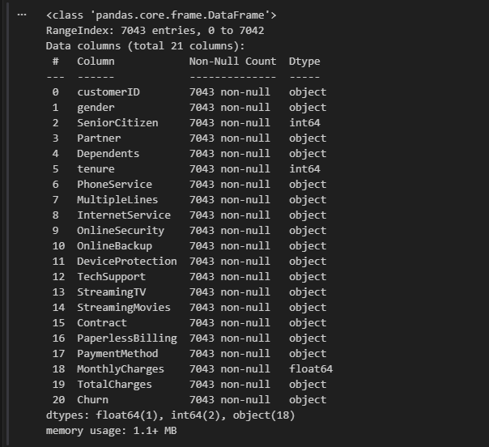
Figure 1: Sample of the Telco Customer Churn Dataset
Data Exploration Plan
The exploration of the dataset was done in a systematic way. The data types and dataset structure were tested first. Thereafter, missing data and duplications were verified to provide good quality data. The numerical variables were studied with the help of descriptive statistics and distribution plots, whereas the categorical variables were studied with the help of frequency counts and visualization. The analysis of relationships between variables and churn was done, followed by the correlation analysis and outlier detection. Lastly, decision-making was made based on feature engineering.
Preparation and Cleaning of Data.
The TotalCharges variable has been stored in an object data form at first and changed to a numeric form so that it could be analyzed. Once converted, 11 empty values were found on the column TotalCharges. These gaps were eliminated to ensure active data consistency.
The gender variable was further brought to a standard where all the values were done in lower case. The data was subsequently separated into numerical and categorical variables with which it could be further analyzed.
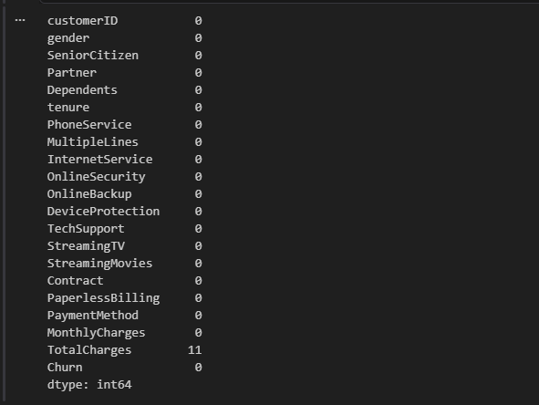
Figure 2: Missing Values after Data Type Conversion
Exploratory Data Analysis
Numerical Analysis
Descriptive statistics reveal that an average length of customer tenure is about 32 months and an average monthly fee is about 64.8. The overall charges are quite different meaning that there are different levels of customer spending. TotalCharges distribution is skewed to the right and tenure is a combination of new and long-term customers.
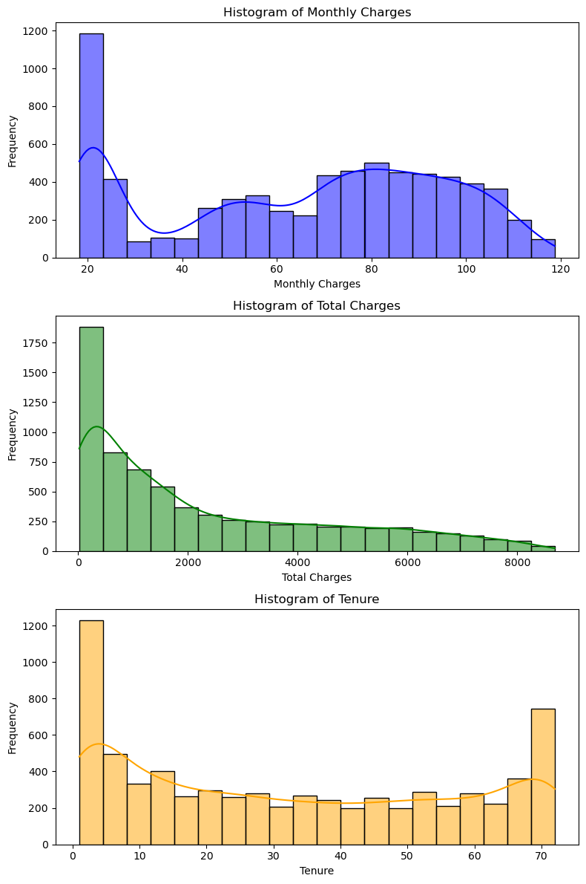
Figure 3: Distribution of Numerical Variables
Categorical Analysis
There is an equal distribution of dark and light blue with regard to customers, both male and female. The majority of customers are under month-by-month contracts, which is flexible and also increases the risk of churn. The most common internet service is that of fiber optic and the most common mode of payment is electronic check.
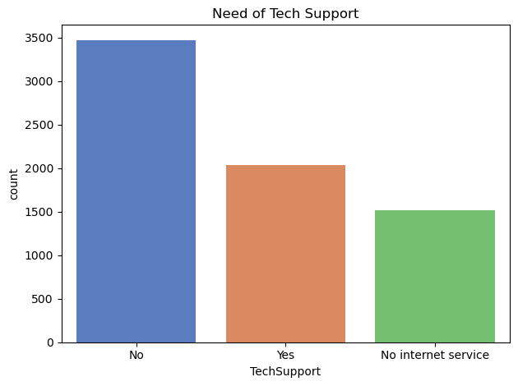

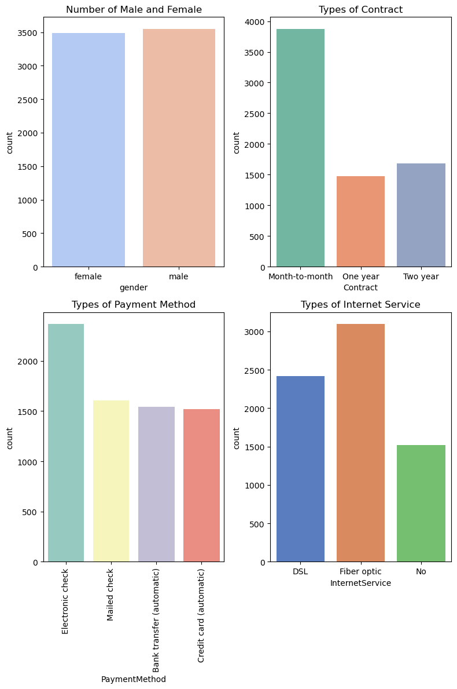
Figure 4: Distribution of Categorical Variables
Relationship with Churn
customers whose monthly charges are higher have a greater risk of churning. Low tenure customers are likely churners whereas long term customers become loyal. The type of contract also contributes to high churn rates since customers with month-to-month contracts have much higher churn rates, in comparison to long term contracts. Also, the churn rates are higher among customers reporting to be using fiber optic internet services than customers who use DSL or no internet service.
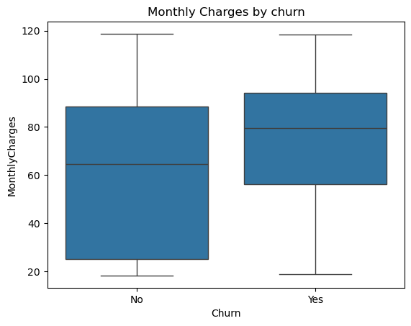
Figure 5: Monthly Charges by Churn Status

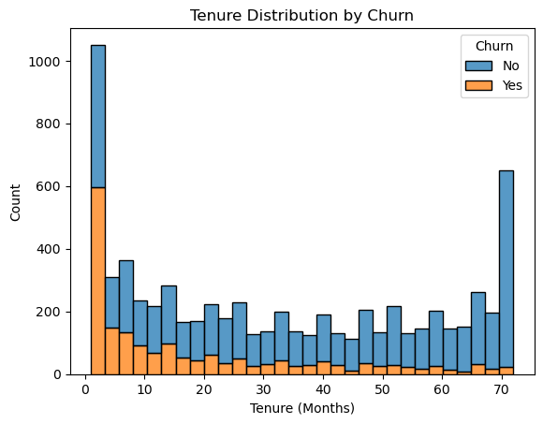
Figure 6: Tenure Distribution by Churn

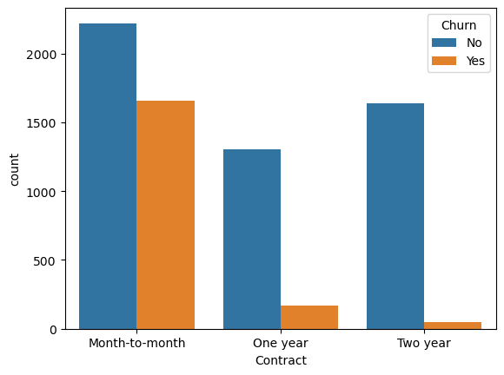
Figure 7: Contract Type vs Churn
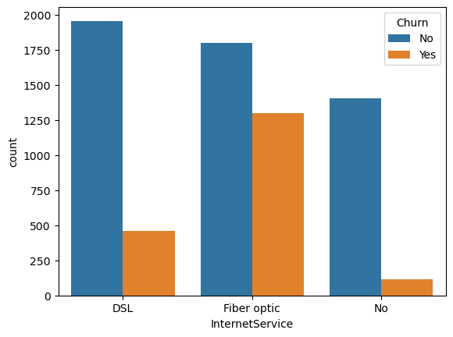
Figure 8: Internet Service vs Churn

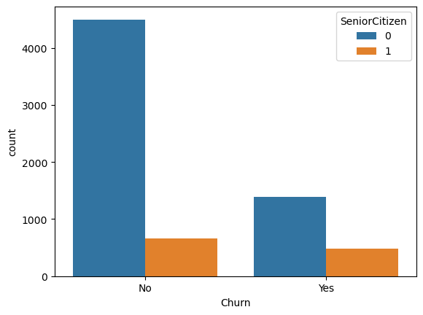
Figure 9: Senior Citizen vs Churn
Correlation Analysis
The correlation analysis demonstrates that the relationship between the tenure and TotalCharges is highly positive with the correlation coefficient of around 0.83. This means that those customers with longer stay periods will have a more accumulated total charge. MonthlyCharges and TotalCharges have a moderate relation showing that higher payment at the end of the month leads to increment in total spending with time.
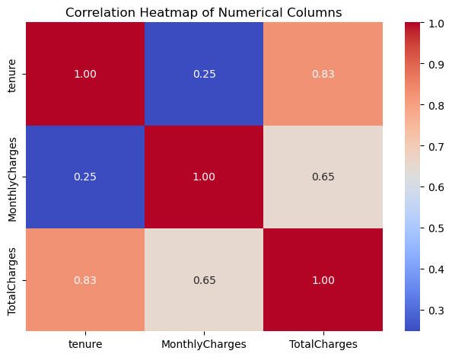
Figure 10: Correlation Heatmap of Numerical Variables
Outlier Detection
In case of any outliers, box plot was utilized in detecting outliers in case of a numerical variable like tenure, MonthlyCharges and TotalCharges. The findings tell that there are no radical outliers that will significantly influence the analysis. The variations that have been observed in the information are normal variations in customer behaviors and not anomalies of the data.
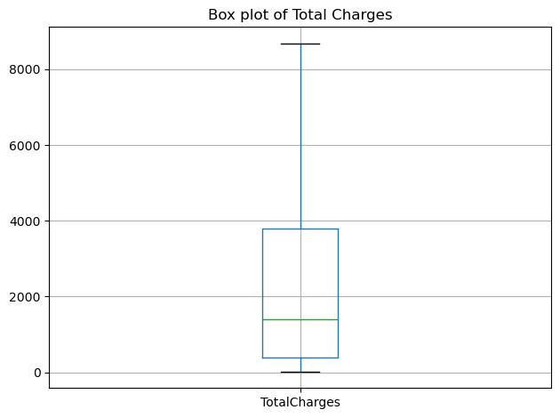
Figure 11: Boxplots of Total Charges for Outlier Detection

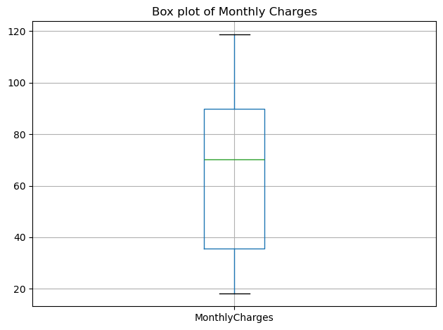
Figure 12: Boxplots of Monthly Charges for Outlier Detection

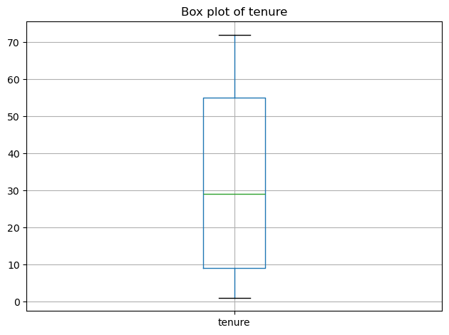
Figure 13: Boxplots of tenure for Outlier Detection

Feature Engineering
As a new addition, a tenure group was developed to place the customers in three categories, i.e., new, medium and long-term. Customers whose tenure was lower or at most 12 months old were indicated as new, those who fell within the range of 13 to 48 months as medium and customers who exceeded 48 months of tenure as long-term. This change will facilitate the analysis and give a better understanding of the customer behavior.
The resultant analysis revealed that churn rates among long-term customers are considerably low as compared to new customers, implying the need to keep customers through the effective customer retention process.
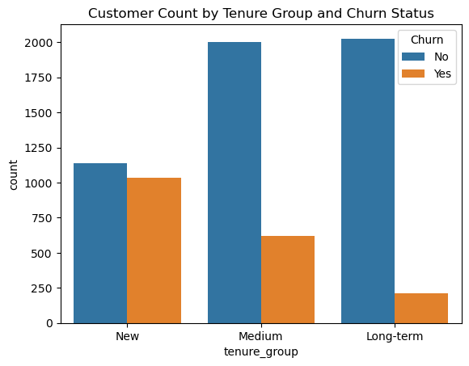
Figure 14: Customer Distribution by Tenure Group and Churn
Hypotheses
Three hypotheses were developed based on the exploratory analysis.
- The higher the monthly prices charged to the customers, the higher the chances to churn.
- Monthly contract customers have higher churn rates than long-term customers.
- Long term customers have less chances of churning.
Hypothesis Testing
The third hypothesis was tested using two-sample T-test to determine whether there was any difference between the mean tenure of completed customers who churned and those who did not. The null hypothesis was that tenure difference does not significantly differ in churned and non-churned customers, and the alternative was tenure difference is lower in the churned customers.
The test outcomes revealed T -statistic -34.97 and a p-value of 2.34 x 10-234. The p-value is much below the value of 0.05; therefore, the null hypothesis is rejected. This means that the difference in tenure in the churned and the non- churned customers is statistically significant. The T-statistic value of negative further proves that churned customers possess shorter high tenure on average.
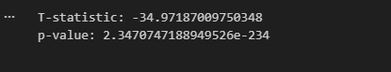
Figure 15: T-test Result for Tenure and Churn
This observation portrays that the service will lose customers at the beginning stages of customers subscription, and long-term customers would remain loyal.
Key Findings
The analysis reflected a number of key points. Higher monthly charges will increase the likelihood of customers churning and this measure implies that pricing can impact customer behavior. The churn in month-to-month contract is greatest whereas long-term contract greatly mitigates churn. Customer loyalty is important since customers who have longer tenure would find it difficult to exit the service. Also, fiber optic users and electronic check users demonstrate worse churn behavior, which implies that the type of service and the method of payment can be a determinant in the retention of customers.
Conclusion
To sum up, the exploratory data analysis helped to give useful information on the customer churn behavior. The tenure, type of contract, and monthly payment were reported to play a critical role in determining whether a customer would quit or not. The findings indicate the need to pay attention to customer retention strategies, especially at the initial stages of customer interaction. These factors can be dealt with to enhance customer satisfaction and lower the rate of churn.
Next Steps
The development of advanced machine learning models to predict customer churn in a more accurate manner can be carried out in future. Predictive performance can be enhanced with the use of techniques like feature selection, hyperparameter tuning and model evaluation. Also, these insights can guide organizations in developing specific retention strategies, including providing incentives to new customers and encouraging long-term contracts.

