**Revision:**

|  |  |  |  |  |
| --- | --- | --- | --- | --- |
| **Version** | **Status** | **Author** | **Date** | **Remarks** |
| **1.0** | **Release** | **Kendrick** | **20200702** | **First Edition** |
| **1.1** | **Function Upgrade** | **Kendrick** | **20200715** | **ROIC RW Function** |
| **1.2** | **Function Upgrade** | **Kendrick** | **20200805** | **ROIC Wrapper Function** |

**Contents**

**Chapter 0 Environment Setting**

* + Connecting to Computer
  + Connecting to Device

**Chapter 1 UI Overview**

* Software UI Overview

**Chapter 2 Basic Function**

* Image Streaming
* Backlight Control
* Pixel Information
* Save Current Image
* ROIC Performance Function

**Chapter 3 Additional Function**

* Zoom In/Out
* Image Rotate

**Chapter 4 Development Function**

* ROIC Control Function

**Chapter 0 Environment Setting:**

* Connecting to Computer:

Use USB Type-C cable connect between FP device and computer at first, verify cable was connected stably that computer can enumerate*1 the device.

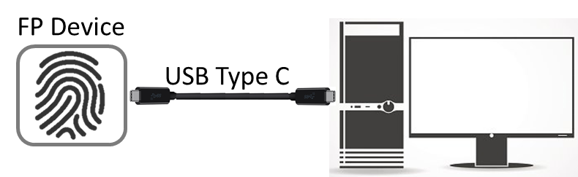

* Connecting to Device :

After Cable connected, open this program and hit the connect button.

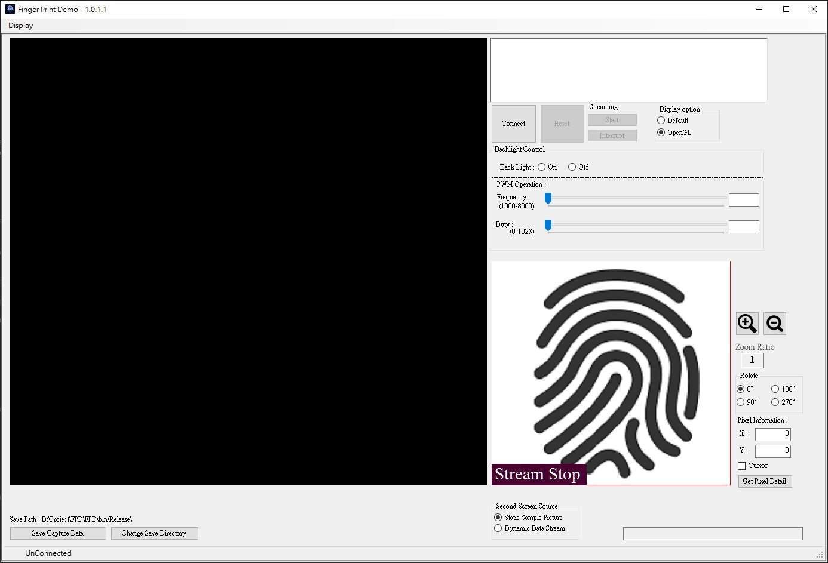

After successful connecting, the log area will display device description like: FW version…etc. , till this step, the device connecting and initializing is done.

FAQ:

1. **How to know the device has been enumerated?**

A: Open the Device Manager, and check the device.

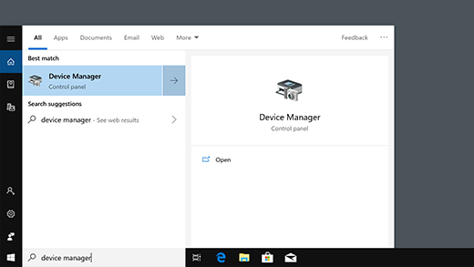

1. **How to do when the program connect to device failed?**

A:

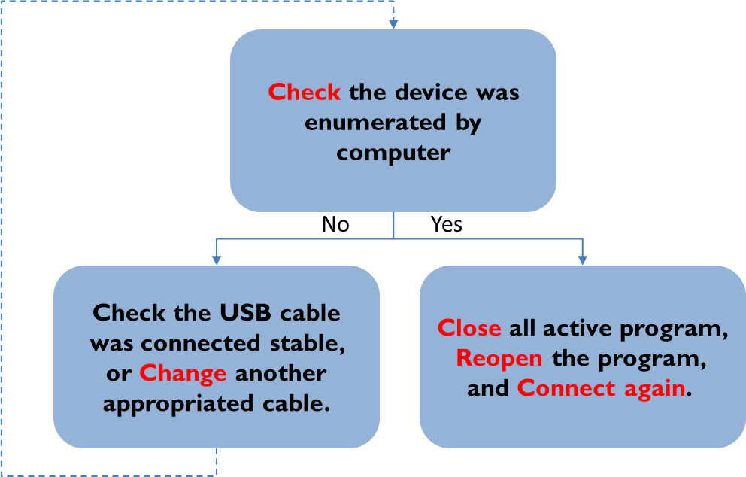

**Chapter 1 UI** **Overview:**

* Software UI Overview

12

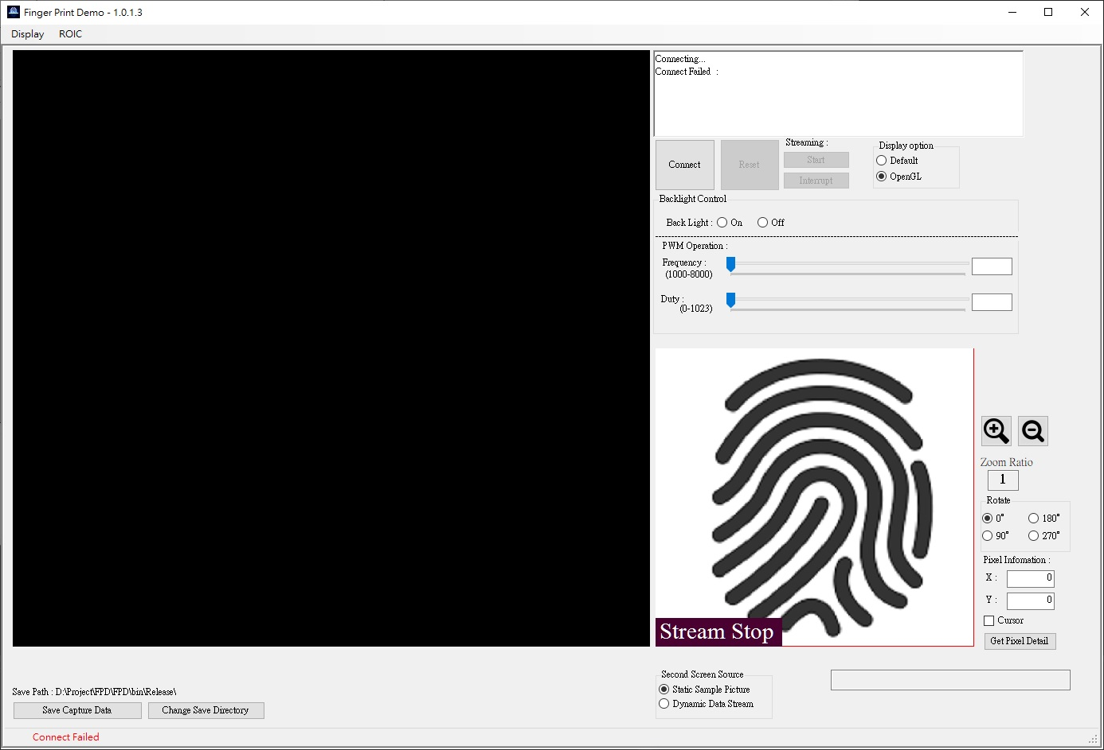

11

10

9

8

7

6

5

4

3

2

1

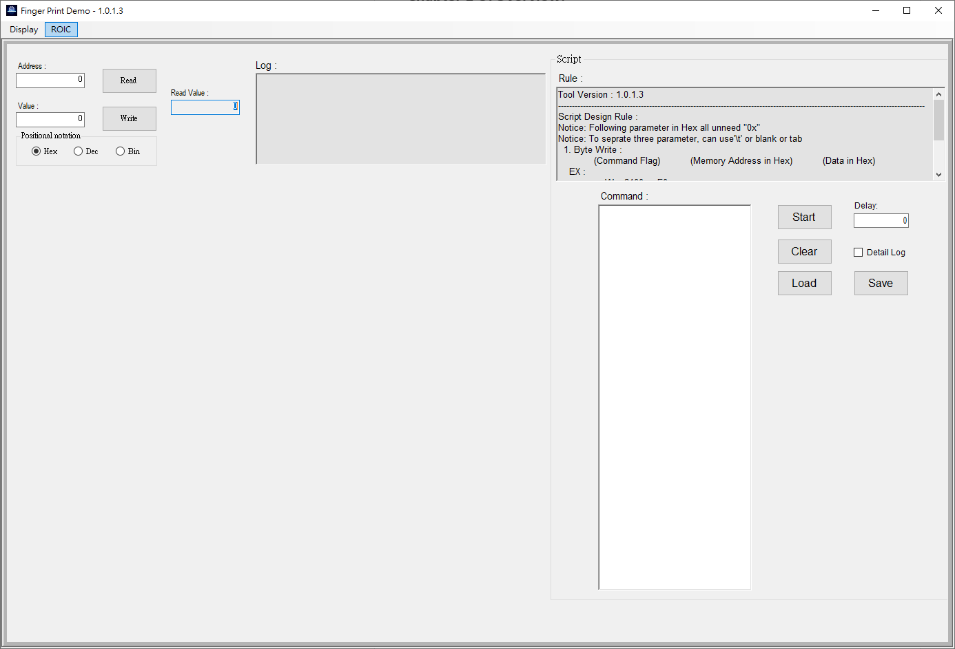

14

13

1. **Main Display Area : 800 x 750 (pixel2)**

Display compressed image at this area. *Raw image (1600 x 1500)

1. **Sub Display Area : 400 x 375 (pixel2)**

Choosing and moving zoom in area.

Display compressed image at this area (option).

1. **Log :**

Display device feedback message.

1. **Device Connect & Reset :**

Connect to device or reset the device.

1. **Stream Control :**

Control the stream start or interrupt.

1. **Display Option :**

Offer two way to generating image.

1. **Backlight Control**

Control backlight by PWM duty.

1. **Additional Feature**

Offer zoom In/Out function and image rotate function.

1. **Pixel Information**

Offer user check the pixel detail.

1. **Sub Display Source**

Change sub display source between static image and streaming.

1. **Save Image**

Saving the current frame of image.

1. **ROIC Control Form**

Open the ROIC control form

1. **Byte Read/Write Function**

Do the specific byte read/write to ROIC

1. **Script Read/Write Function**

Load/Write the operated script, do several bytes read/write to ROIC

**Chapter 2 Basic Function**

* **Image Streaming:**

When device was connected, streaming function will be enabled.

Click start will trigger device start the data transfer, and generate the image at main display area, according to the chosen method.

When you want to stop the streaming, press the interrupt.

This program offer two way to generating image:

1. Default is use window default drawing function, mainly use CPU source.
2. OpenGL is calling the GL library, mainly use GPU source.

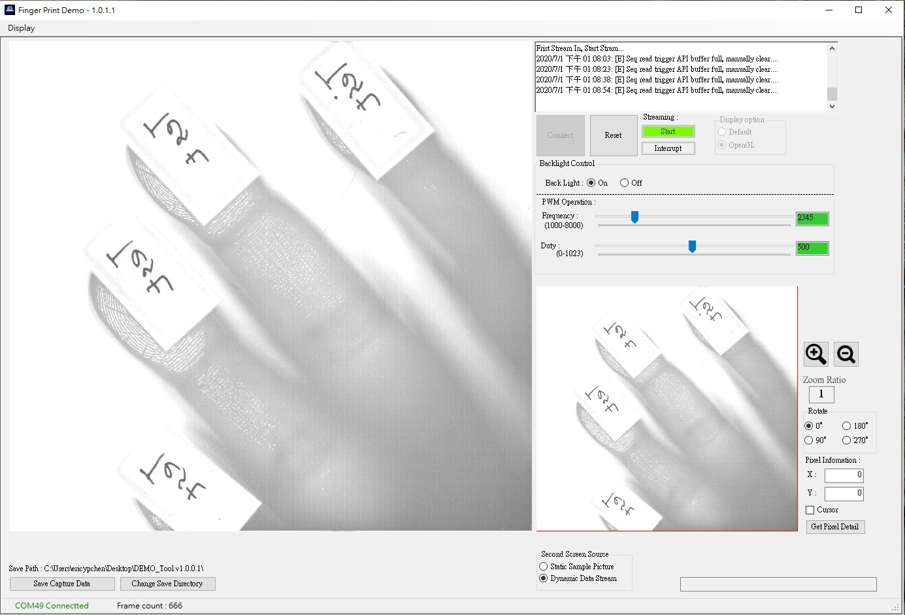

* **Backlight Control:**

This program support device’s backlight control with simple control and advance control. Simple control offer on/off switch, duty memory (re-open backlight). Advance control offer duty and frequency precisely control.

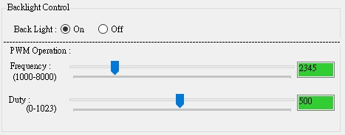

* **Pixel Information:**

This program support user monitor the specific pixel’s RGB value by two way.

1. Use mouse click to check this position’s pixel RGB
2. Key in specific pixel coordinate, to get pixel RGB.

This program offer an additional feature, draw a cursor on image, help user know where the pixel at.

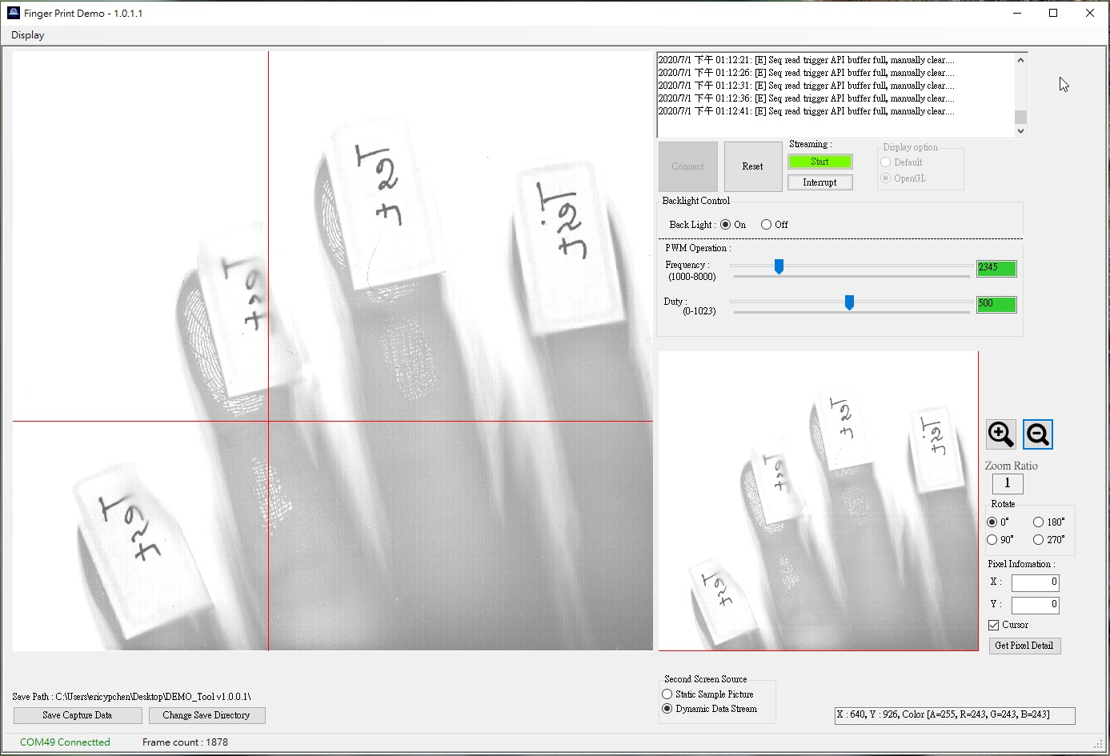

Cursor:

Information:

* **Save Current Image:**

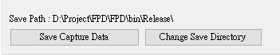

When click the “Save Capture Data” to Save the current Image to the save path.

Click the “Change Save Directory” to change the save path.

* **ROIC Performance Function :**

This program support ROIC operating Function, with performance tuning.

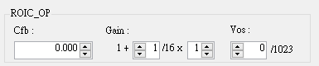

This area has three tuning item: Cfb, Gain and ADC V offset;

Cfb : Range is between 0 ~ 3.875 (0.125 per step)

Gain : Is combine with two parameter, Ratio and Times, the actually gain value as UI display

Vos : Range is between 0 ~ 1023 (1 per step)

**Chapter 3 Additional Function**

* **Zoom In/Out:**

APP support zoom in/out function, to display non-compress image, support zoom ratio about 1-8, click the zoom in/out button or scroll the wheel on the display area.

When zoom in function active, sub display will marked out the display area of main display.

Can move the display area thru sub display area by mouse dragging.

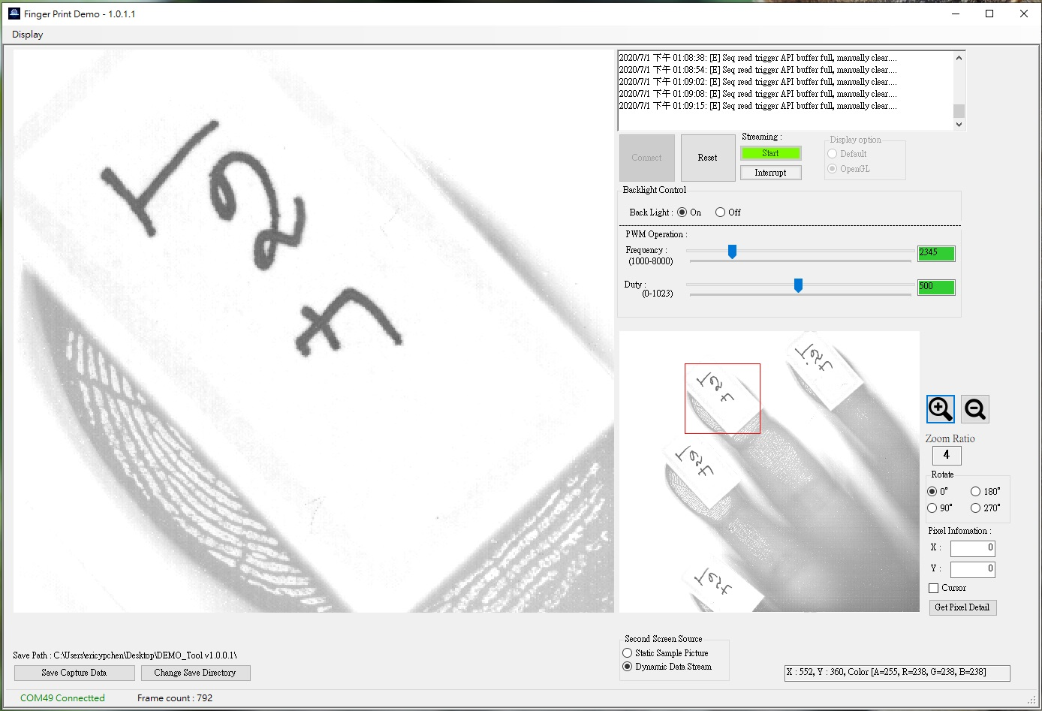

* **Image Rotate:**

APP support image rotate with four designed angle.

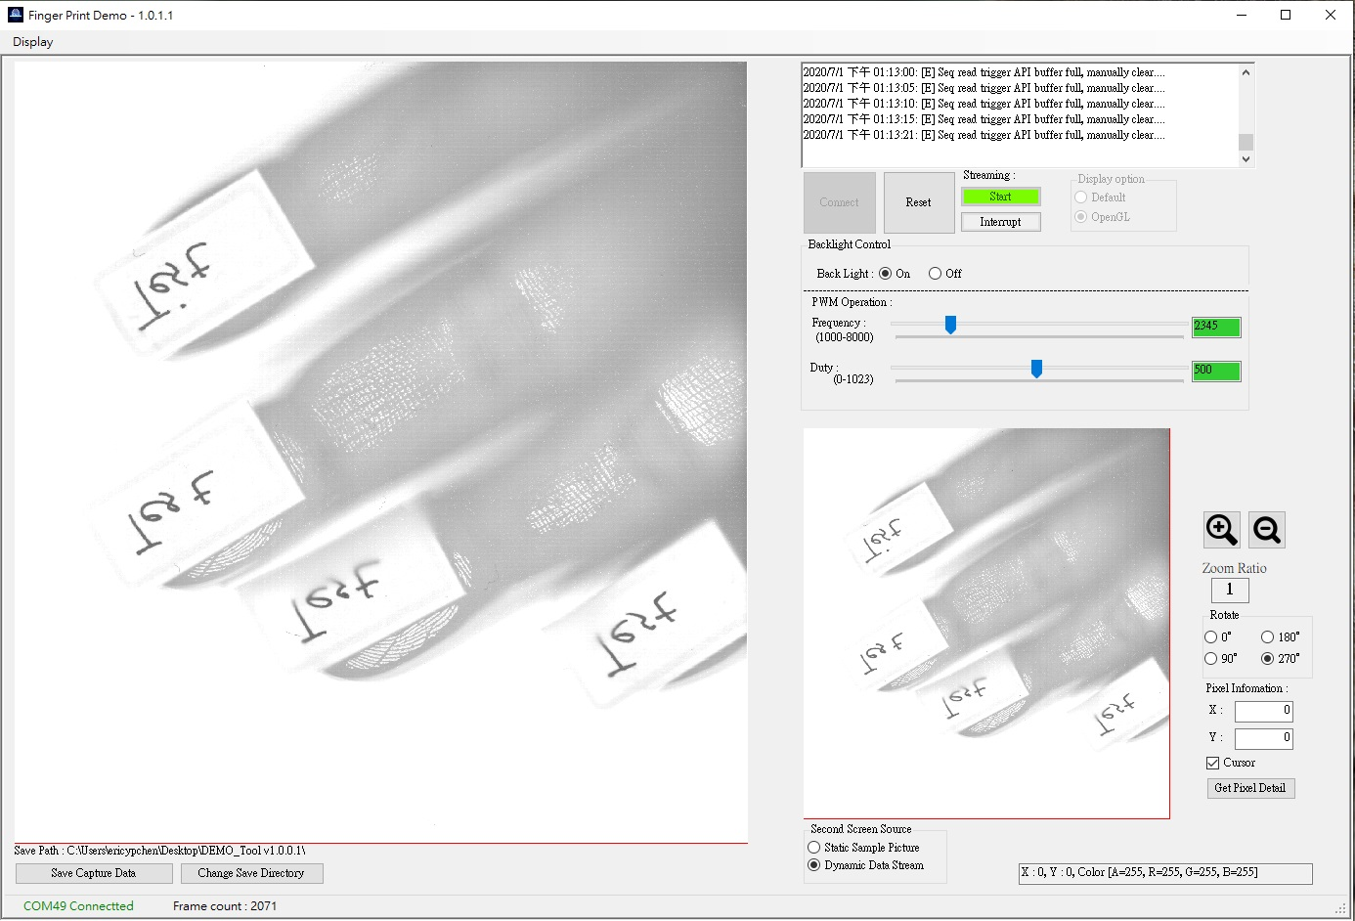

**Chapter 4 Development Function**

* **ROIC Control Function :**

This program support Byte/Script type ROIC Read/Write Function.

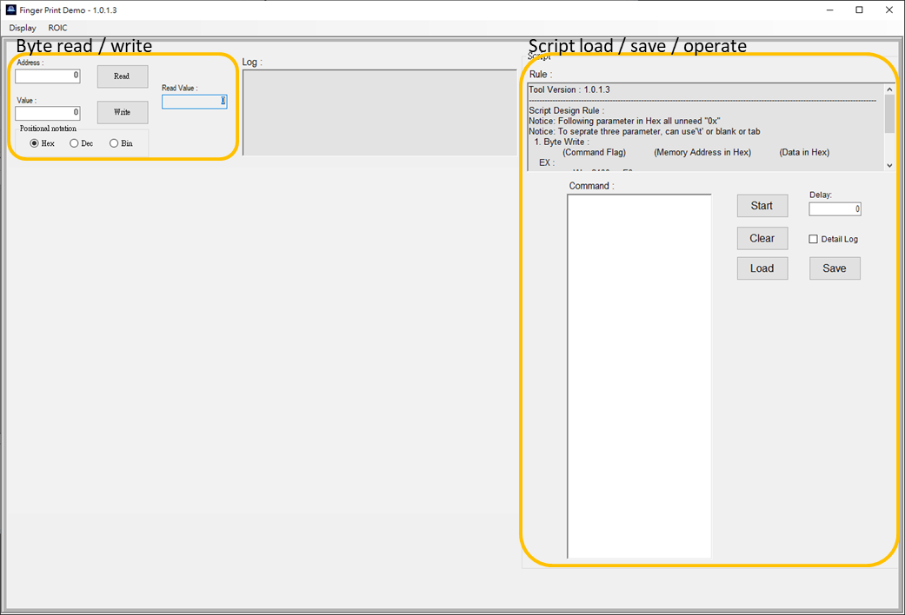

* Byte Read/Write Function:

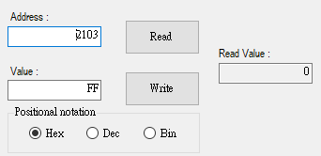

Key in address to read byte, Key in address and value to write byte.

Address and value default use Hex, but this program support Dec and Bin input by change the selection of “Positional notation”.

* Script Read/Write Function:

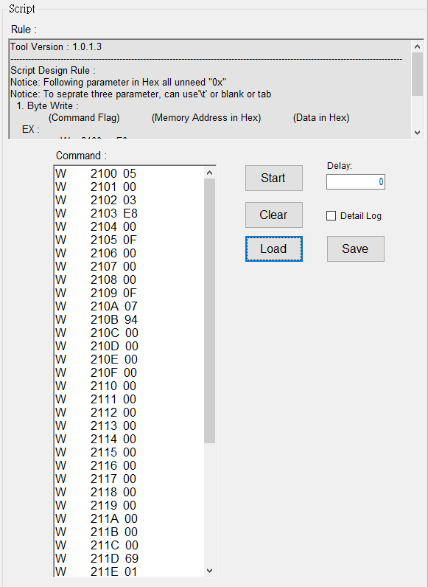

Script function support “Load or Write” the “Script”, and do the byte read/write following the script.

* Script Design Rule:
* Following parameter in Hex all unneeded "0x"
* To separate three parameter, can use'\t' or blank or tab

1. Byte Write :

(Command Flag) (Memory Address in Hex) (Data in Hex)

EX :

W 2100 F0

2. Byte Read :

(Command Flag) (Memory Address in Hex)

EX :

R 2100