Implementation of Thyroid disease prediction system using LDA and PCA algorithm

**Requirements Analysis Document (RAD)**

# 1 Introduction

## 1.1 Purpose of the system

There are no systems yet for the prediction of the thyroid disease. We aim to create a portal to help predict thyroid disease for doctors and people who feel they have similar symptoms to thyroid.

## 1.2 Scope of the System

Doctors will be able to use the portal for prediction of the thyroid disease and support their diagnosis of the patients. People will be able to use the portal to diagnose themselves on the basis of reports generated by their previous blood tests or required tests.

## 1.3 Core System Functionalities

Your application must be able to:

* The application should be so user-friendly.
* According to the symptoms entered by the user, it will use LDA algorithm and predict that the user has thyroid or not.
* Based on the prediction, the system will suggest the user a temporary medication.

## 1.4 Objectives and success criteria of the project

The success of the application depends upon meeting the following core set of objectives:

* To be able to fetch the dataset and train the system.
* Able to store the data of the user and update the existing data sets.
* To be able to predict whether a patient will be having thyroid in future.
* Suggest necessary medications based on the results.
* The use of automatic test cases to validate that 80% of the written code executes according to specification.

## 1.5 Definitions, acronyms, and abbreviations

Important terms and concepts are listed here. More will be added by the project teams.

|  |  |
| --- | --- |
| *Model* | A schematic description of a system that accounts for its known or inferred properties |
| *View* | A visual representation of a model which might also enable a user to manipulate properties of the model |
| *Disease* | A disorder of structure or function in a human, animal, or plant, especially one that produces specific symptoms or that affects a specific location and is not simply a direct result of physical injury |
| *Thyroid* | A large ductless gland in the neck which secretes hormones regulating growth and development through the rate of metabolism |
| *LDA* | Latent Dirichlet allocation (LDA) is a generative statistical model that allows sets of observations to be explained by unobserved groups that explain why some parts of the data are similar |
| *PCA* | Principal component analysis (PCA) is a statistical procedure that uses an orthogonal transformation to convert a set of observations of possibly correlated variables into a set of values of linearly uncorrelated variables called principal components |

**1.6 References**

[www.indjst.org/index.php/indjst/article/download/93705/71830](http://www.indjst.org/index.php/indjst/article/download/93705/71830)  
 <https://www.caeaccess.org/research/volume4/number1/banu-2016-cae-651990.pdf>

<https://pdfs.semanticscholar.org/5254/a6bc467b49f27c00f4654d03dc5d69d9d38d.pdf>

<https://www.researchgate.net/publication/308983859>

<http://ijesc.org/upload/ef06f1ef6b0feb76822f3b72b2515809.Applying%20Classification%20Algorithms%20to%20Predict%20Thyroid%20Disease.pdf>

<https://en.wikipedia.org/wiki/Principal_component_analysis>

# 2 Current System

No system is in place yet, people have to follow the traditional method of going to the clinic and get themselves checked by the doctor.

# 3 Proposed System

## 3.1 Overview

The proposed system consists of a web portal wherein a patient can input their reports and our machine learning based prediction system will predict whether the patient will be having thyroid or not.

**3.2 Functional Requirements**

* System should fetch the dataset and train itself accordingly
* System should store the data of the users
* System should predict whether a patient will be having thyroid in future
* System should suggest necessary medications based on the results
* System should provide a UI to interact with user

## 3.3 Nonfunctional Requirements

* System should be user friendly
* Response Time should be less
* System should be designed in such a way that it can be modified easily
* System should be secure
* System should be cost efficient

## 3.4 System Models

### 3.4.1 Scenarios

<<These are specific scenarios that must be contextualized within the application domains you are working on>>

### 3.4.2 Use case model

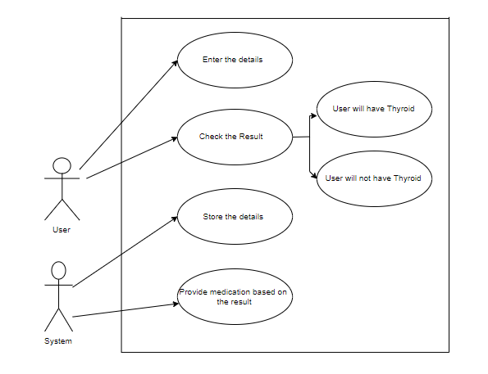

***3.4.3 Object model***

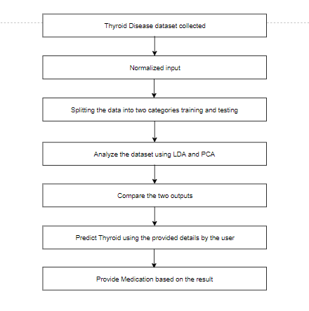

**3.4.4 User interface – navigational paths and screen mock-ups**

You will devise the appropriate GUI mock-ups.

**4 References**

[www.indjst.org/index.php/indjst/article/download/93705/71830](http://www.indjst.org/index.php/indjst/article/download/93705/71830)  
 <https://www.caeaccess.org/research/volume4/number1/banu-2016-cae-651990.pdf>

<https://pdfs.semanticscholar.org/5254/a6bc467b49f27c00f4654d03dc5d69d9d38d.pdf>

<https://www.researchgate.net/publication/308983859>

<http://ijesc.org/upload/ef06f1ef6b0feb76822f3b72b2515809.Applying%20Classification%20Algorithms%20to%20Predict%20Thyroid%20Disease.pdf>