**SYSTEM ANALYSIS DOCUMENT**

**PROJECT TITLE: Prediction of Thyroid Disease using Machine Learning Algorithms**

**TEAM MEMBERS (CMPN A):**

1. Viral Haria (30)
2. Suraksha More (57)
3. Bijal Patel (65)
4. Mrs. Harshali Patil (Guide)

**DATA FLOW DIAGRAM:**

**Level 0**

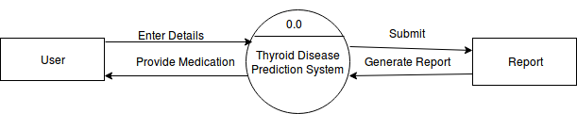

**Level 1**

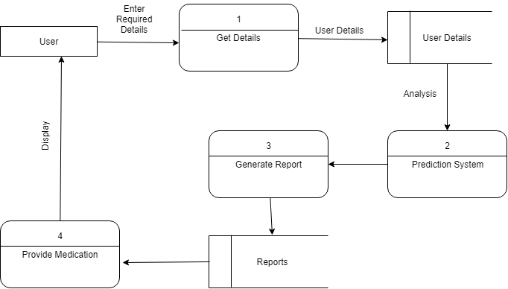

**CLASS DIAGRAM:**

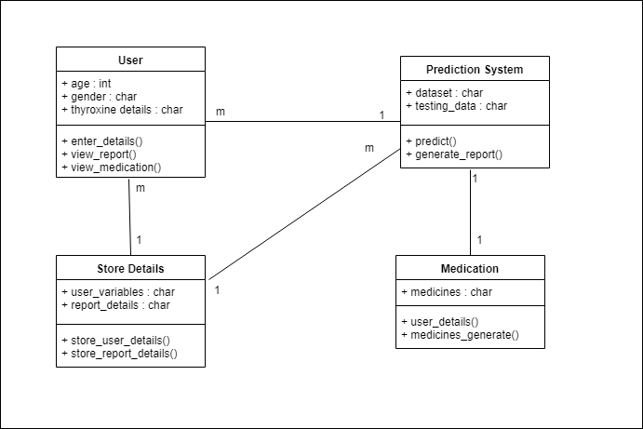

**USE CASE:**

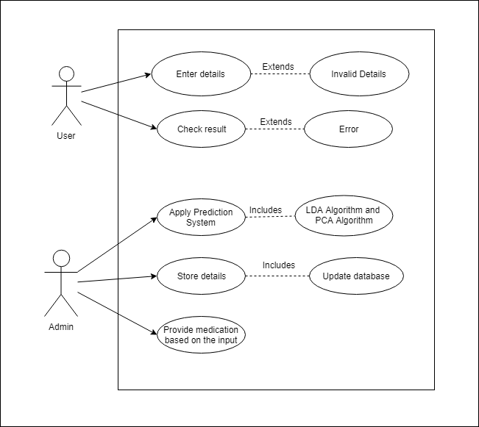

**ACTIVITY DIAGRAM:**

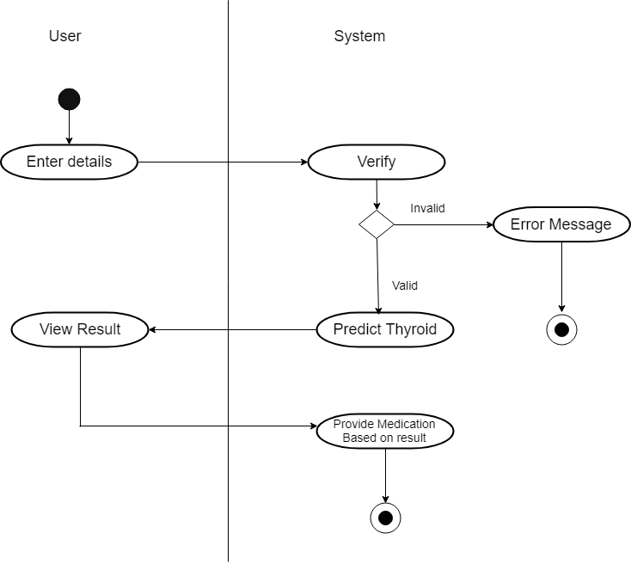

**DEPLOYMENT DIAGRAM:**

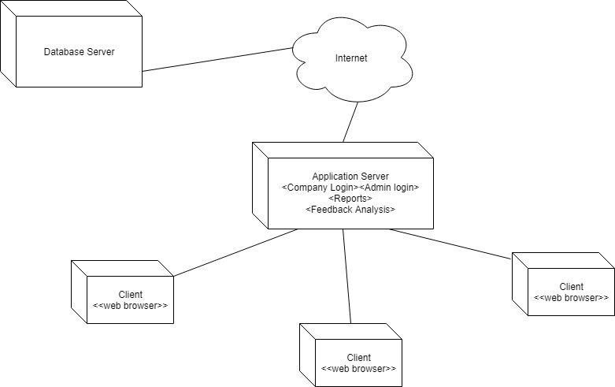

**ACTIVITY DIAGRAM:**

