**SOFTWARE DESIGN DOCUMENT**

**PROJECT TITLE**: Thyroid Prediction System using Machine Learning Techniques

**TEAM MEMBER:**

* Viral Haria (BE CMPN A 30)
* Suraksha More (BE CMPN A 57)
* Bijal Patel (BE CMPN A 65)
* Mrs. Harshali Patil (Guide)

**FLOWCHART:**

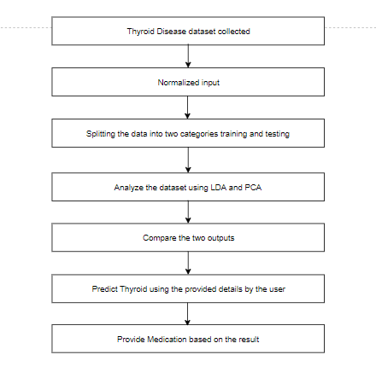

**FRONT-END:**

