Projet ThreeME

##   
## Attachement du package : 'dplyr'

## Les objets suivants sont masqués depuis 'package:stats':  
##   
## filter, lag

## Les objets suivants sont masqués depuis 'package:base':  
##   
## intersect, setdiff, setequal, union

# I. Générale

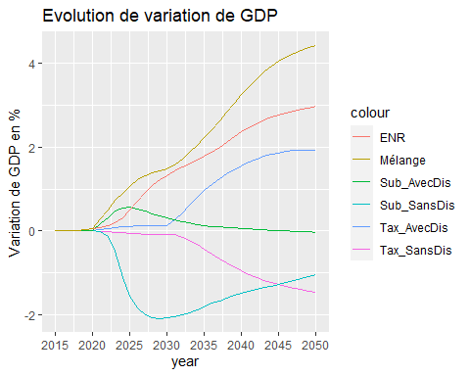

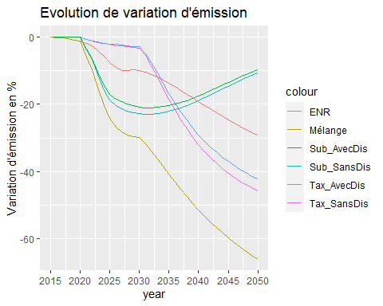

# II. Energie

## A. Consommation énergétique par secteurs

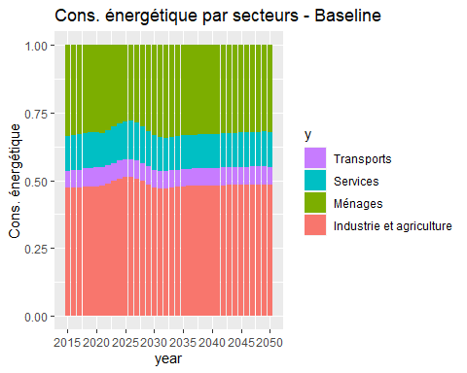

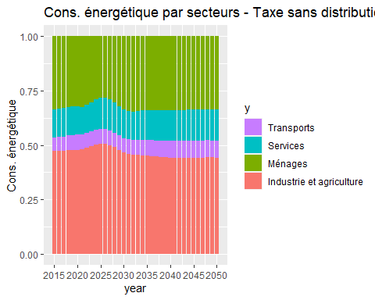

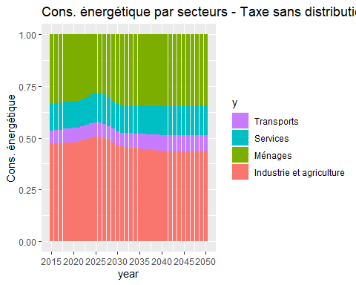

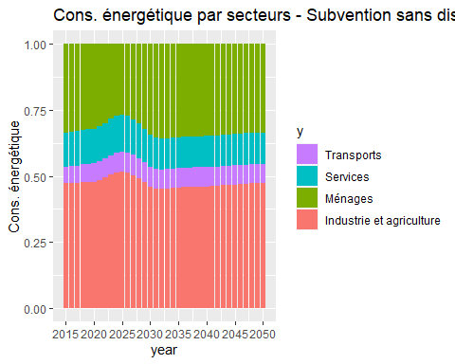

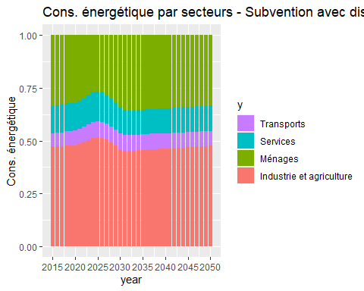

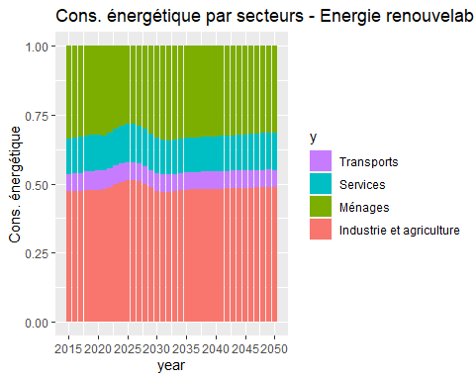

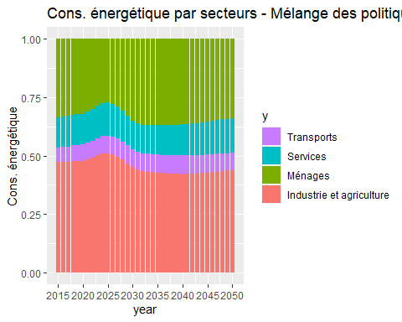

## B. Production énergétique par énergies

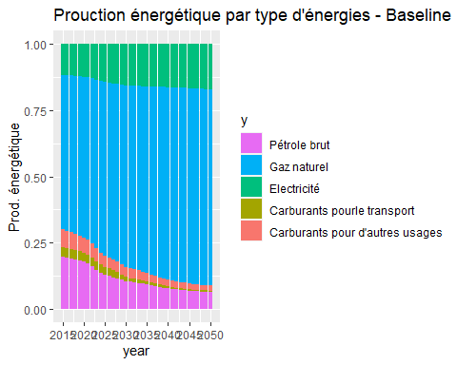

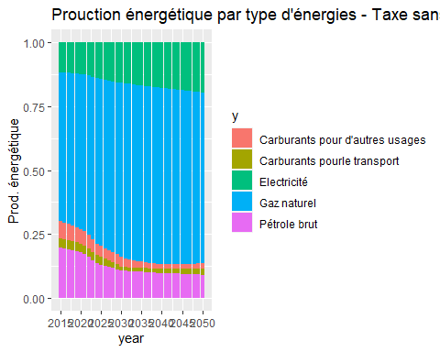

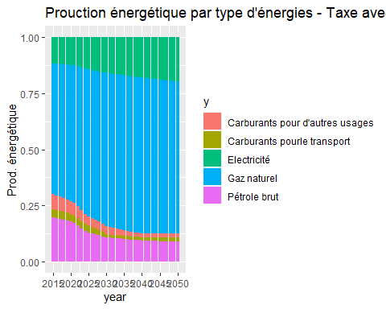

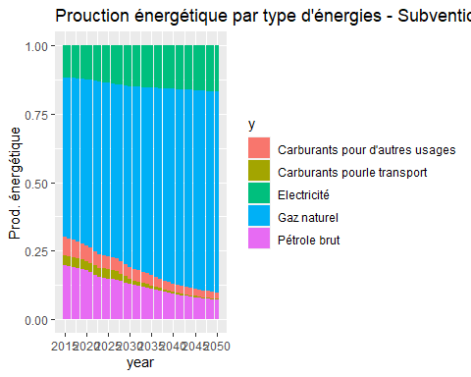

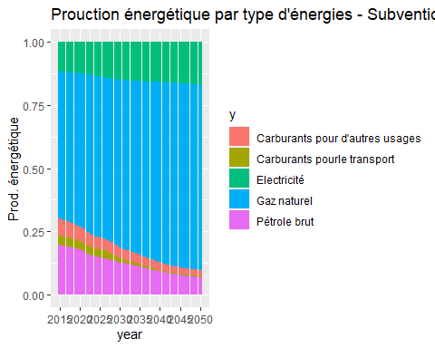

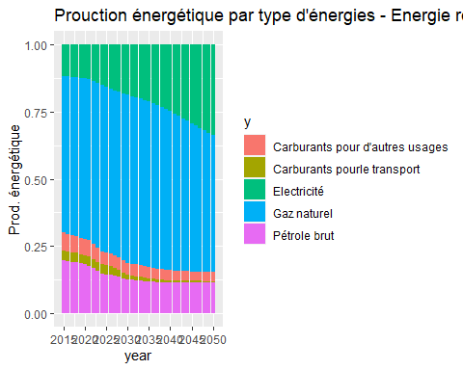

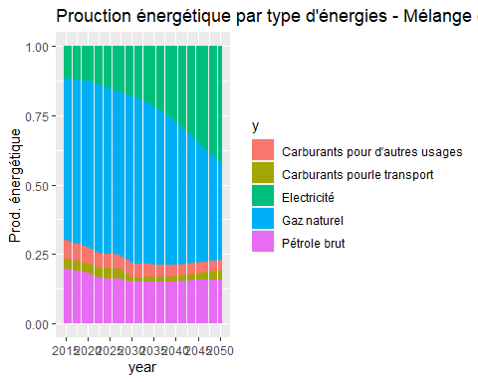

## C. Consommation finale énergétique par énergies

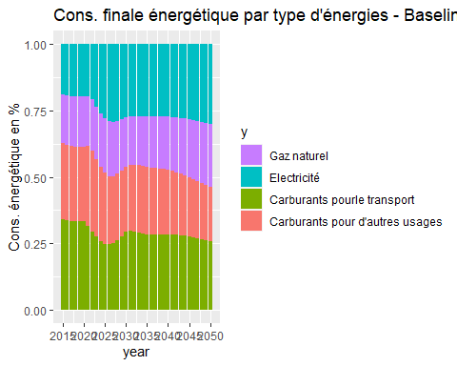

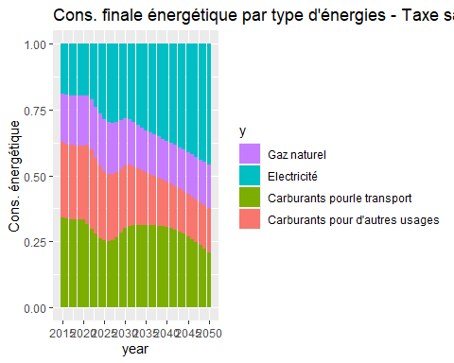

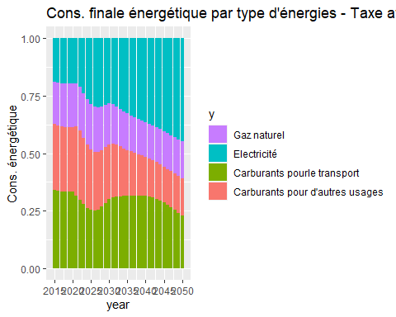

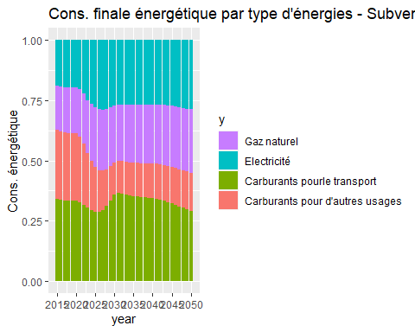

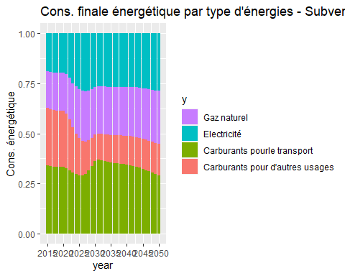

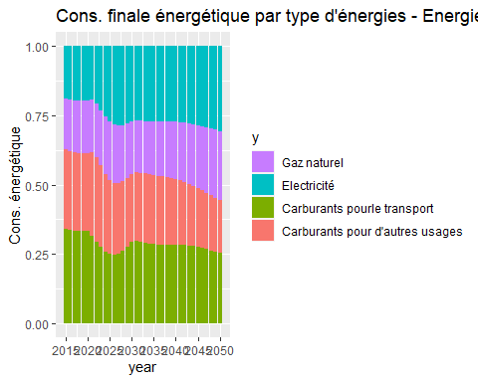

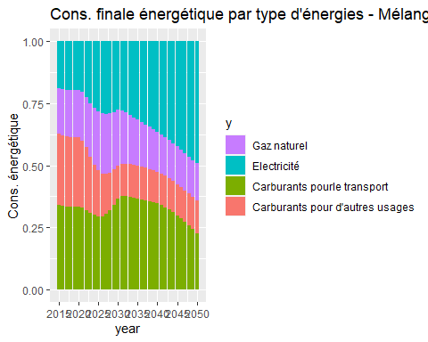

# III. Analyse d’identité Kaya

On a modifié l’identité de Kaya pour qu’elle soit plus cohérente avec notre étude:

$$Émission_{CO_{2}}=VA×Σ(\frac{VA_{i}}{VA}×\frac{CE_{i}}{VA_{i}}×\frac{EM_{i}}{CE_{i}})=VA×Σ(S_{i}I_{i}U_{i})$$

où, VA est la valeur ajoutée totale dans l’économie, $VA_{i}$ est la valeur ajoutée dans secteur $i$, $CE_{i}$ est la consommation énergétique dans secteur $i$, $EM_{i}$ est l’émission de $CO_{2}$ dans secteur $i$. On a alors 4 indicateurs qui servent à expliquer la variation d’émission de $CO_{2}$: $S=Σ\frac{VA_{i}}{VA}$, $I=Σ\frac{CE_{i}}{VA_{i}}$, $U=Σ\frac{EM_{i}}{CE_{i}}$ sont, respectivement, la structure écnomique, l’intensité énergétique et l’intensité carbone.

# Decomposition multiplicative  
  
name <- c("D1","D2","D3","D4","D5","D6")  
secteur <- c("ems_ci_co2_ind_2","ems_ci_co2_trsp_2","ems_ci_co2_ser_2","ems_ci_co2_trsf_2","ems_ci_co2_ele_2")  
secteur0 <- c("ems_ci_co2_ind_0","ems_ci_co2_trsp_0","ems_ci_co2_ser_0","ems_ci_co2_trsf_0","ems_ci_co2_ele_0")  
kayaname <- c("S_ind","S_trsp","S_ser","S_trsf","S_ele","I_ind","I_trsp","I_ser","I_trsf","I_ele","U_ind","U_trsp","U_ser","U_trsf","U_ele","VA","ind","trsp","ser","trsf","ele","S","I","U")  
  
for (i in 1:6) {  
   
 w <- as.data.frame(array(,dim=c(36,16)))  
 for (j in 1:5) {  
 w[,c(j,j+5,j+10)] <- ((DataBase[[i]][,secteur[j]]-Baseline[,secteur0[j]])/  
 log(DataBase[[i]][,secteur[j]]/Baseline[,secteur0[j]]))/  
 ((DataBase[[i]][,"ems_ci_co2_2"] - Baseline[,"ems_ci_co2_0"])/  
 log(DataBase[[i]][,"ems_ci_co2_2"]/Baseline[,"ems_ci_co2_0"]))  
 }  
 w[,16] <- w[,1]+ w[,2]+ w[,3]+ w[,4]+ w[,5]  
 data <- exp(w*log(Kaya_Base[[i]]/KAYA_Baseline))  
 data <- rapply( data, f=function(x) ifelse(is.nan(x),1,x), how="replace" )  
   
 for (k in 1:8) {  
 if (k < 6) {  
 data <- data %>% add_column(newColname = data[,k] * data[,k+5] * data[,k+10])   
 }  
 else if (k == 6) {  
 data <- data %>% add_column(newColname = data[,k-5]*data[,k-4]*data[,k-3]*data[,k-2]*data[,k-1])   
 }  
 else if (k == 7) {  
 data <- data %>% add_column(newColname = data[,k-1]*data[,k]*data[,k+1]*data[,k+2]*data[,k+3])   
 }  
 else if (k == 8) {  
 data <- data %>% add_column(newColname = data[,k+3]*data[,k+4]*data[,k+5]*data[,k+6]*data[,k+7])   
 }  
 }  
   
 colnames(data) <- kayaname  
 data$year <- c(2015:2050)  
 data <- (data - 1) * 100  
 jin <- name[i]  
 assign(jin,data)  
}  
  
Det <- list(D1,D2,D3,D4,D5,D6)  
  
rm(i,j,jin,name,kayaname,secteur,secteur0,w,data,D1,D2,D3,D4,D5,D6)

# Decomposition additive  
name <- c("D1","D2","D3","D4","D5","D6")  
secteur <- c("ems_ci_co2_ind_2","ems_ci_co2_trsp_2","ems_ci_co2_ser_2","ems_ci_co2_trsf_2","ems_ci_co2_ele_2")  
secteur0 <- c("ems_ci_co2_ind_0","ems_ci_co2_trsp_0","ems_ci_co2_ser_0","ems_ci_co2_trsf_0","ems_ci_co2_ele_0")  
kayaname <- c("S_ind","S_trsp","S_ser","S_trsf","S_ele","I_ind","I_trsp","I_ser","I_trsf","I_ele","U_ind","U_trsp","U_ser","U_trsf","U_ele","VA","ind","trsp","ser","trsf","ele","S","I","U")  
  
for (i in 1:6) {  
   
 w <- as.data.frame(array(,dim=c(36,16)))  
   
 for (j in 1:5) {  
 w[,c(j,j+5,j+10)] <- (DataBase[[i]][,secteur[j]]-Baseline[,secteur0[j]])/  
 log(DataBase[[i]][,secteur[j]]/Baseline[,secteur0[j]])  
 }  
   
 w[,16] <- w[,1]+ w[,2]+ w[,3]+ w[,4]+ w[,5]  
 data <- w*log(Kaya_Base[[i]]/KAYA_Baseline)  
 data <- rapply( data, f=function(x) ifelse(is.nan(x),0,x), how="replace" )  
   
 for (k in 1:8) {  
 if (k < 6) {  
 data <- data %>% add_column(newColname = data[,k] + data[,k+5] + data[,k+10])   
 }  
 else if (k == 6) {  
 data <- data %>% add_column(newColname = data[,k-5]+data[,k-4]+data[,k-3]+data[,k-2]+data[,k-1])   
 }  
 else if (k == 7) {  
 data <- data %>% add_column(newColname = data[,k-1]+data[,k]+data[,k+1]+data[,k+2]+data[,k+3])   
 }  
 else if (k == 8) {  
 data <- data %>% add_column(newColname = data[,k+3]+data[,k+4]+data[,k+5]+data[,k+6]+data[,k+7])   
 }  
 }  
   
 colnames(data) <- kayaname  
 data$year <- c(2015:2050)  
 jin <- name[i]  
 assign(jin,data)  
}  
  
Dif <- list(D1,D2,D3,D4,D5,D6)  
  
rm(i,j,jin,name,secteur,secteur0,w,data,D1,D2,D3,D4,D5,D6)

ggplot() +   
 geom_line( aes(x = Det[[1]][,"year"],y = S1[,"ems_ci_co2_2"]/Baseline[,"ems_ci_co2_0"]*100 - 100, group = 1, color = "Baisse totale")) +   
 geom_line( aes(x = Det[[1]][,"year"],y = Det[[6]][,"VA"], group = 1, color = "Activité économique")) +   
 geom_line( aes(x = Det[[1]][,"year"],y = Det[[6]][,"U"], group = 1, color = "Intensité carbone")) +   
 geom_line( aes(x = Det[[1]][,"year"],y = Det[[6]][,"S"], group = 1, color = "Structure économique")) +   
 geom_line( aes(x = Det[[1]][,"year"],y = Det[[6]][,"I"], group = 1, color = "Intensité énergétique")) +   
 labs(x = "year", y = "Variation d'émission CO2", title = "Contribution multiplicative sur l'émission - Melange politique") +  
 scale_x_continuous(breaks=seq(2015,2050,5))

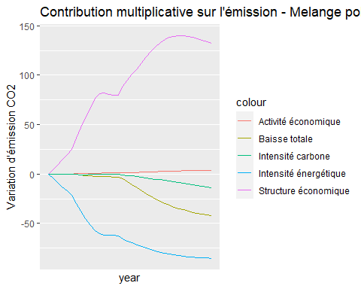

ggplot() +   
 geom_line( aes(x = Det[[5]][,"year"],y = Det[[6]][,"S"], group = 1, color = "Effect Total")) +   
 geom_line( aes(x = Det[[5]][,"year"],y = Det[[6]][,"S_ind"], group = 1, color = "Industrie & Agriculture")) +   
 geom_line( aes(x = Det[[5]][,"year"],y = Det[[6]][,"S_trsp"], group = 1, color = "Transport")) +   
 geom_line( aes(x = Det[[5]][,"year"],y = Det[[6]][,"S_ser"], group = 1, color = "Service")) +   
 geom_line( aes(x = Det[[5]][,"year"],y = Det[[6]][,"S_trsf"], group = 1, color = "Transformation énergétique")) +   
 geom_line( aes(x = Det[[5]][,"year"],y = Det[[6]][,"S_ele"], group = 1, color = "Electricité")) +  
 labs(x = "year", y = "Variation d'émission CO2", title = "Contribution multiplicative sur la structure economique Melange politique") +   
 scale_x_continuous(breaks=seq(2015,2050,5))

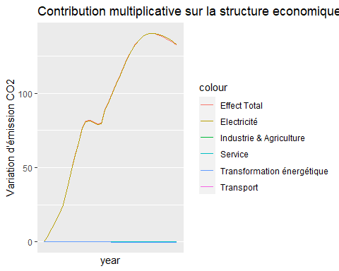

ggplot() +   
 geom_line( aes(x = Det[[5]][,"year"],y = Det[[6]][,"I"], group = 1, color = "Effect Total")) +   
 geom_line( aes(x = Det[[5]][,"year"],y = Det[[6]][,"I_ind"], group = 1, color = "Industrie & Agriculture")) +   
 geom_line( aes(x = Det[[5]][,"year"],y = Det[[6]][,"I_trsp"], group = 1, color = "Transport")) +   
 geom_line( aes(x = Det[[5]][,"year"],y = Det[[6]][,"I_ser"], group = 1, color = "Service")) +   
 geom_line( aes(x = Det[[5]][,"year"],y = Det[[6]][,"I_trsf"], group = 1, color = "Transformation énergétique")) +   
 geom_line( aes(x = Det[[5]][,"year"],y = Det[[6]][,"I_ele"], group = 1, color = "Electricité")) +  
 labs(x = "year", y = "Variation d'émission CO2", title = "Contribution multiplicative sur l'Intensité énergétique - Melange politique") +   
 scale_x_continuous(breaks=seq(2015,2050,5))

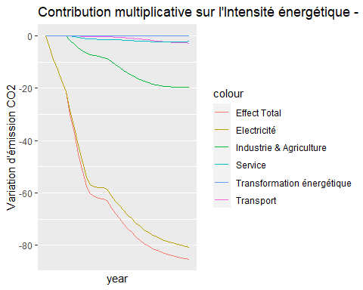

ggplot() +   
 geom_line( aes(x = Det[[5]][,"year"],y = Det[[6]][,"U"], group = 1, color = "Effect Total")) +   
 geom_line( aes(x = Det[[5]][,"year"],y = Det[[6]][,"U_ind"], group = 1, color = "Industrie & Agriculture")) +   
 geom_line( aes(x = Det[[5]][,"year"],y = Det[[6]][,"U_trsp"], group = 1, color = "Transport")) +   
 geom_line( aes(x = Det[[5]][,"year"],y = Det[[6]][,"U_ser"], group = 1, color = "Service")) +   
 geom_line( aes(x = Det[[5]][,"year"],y = Det[[6]][,"U_trsf"], group = 1, color = "Transformation énergétique")) +   
 geom_line( aes(x = Det[[5]][,"year"],y = Det[[6]][,"U_ele"], group = 1, color = "Electricité")) +  
 labs(x = "year", y = "Variation d'émission CO2", title = "Contribution multiplicative sur l'Intensité carbone - Melange politique") +   
 scale_x_continuous(breaks=seq(2015,2050,5))

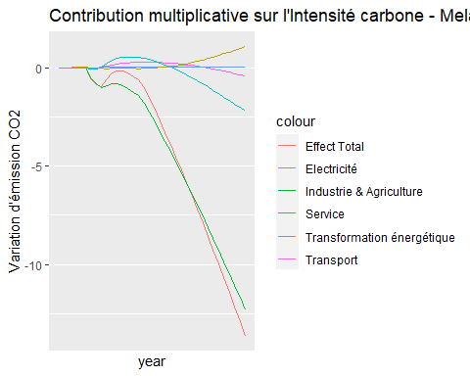

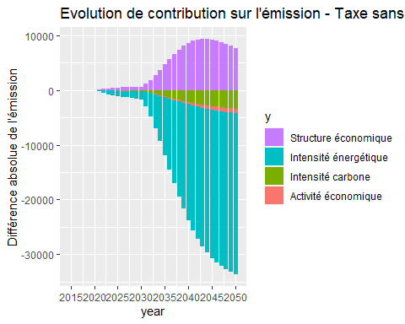

# IV. Economie

sheet_names <- excel_sheets("Page Macro.xlsx")  
nb_sheets <- length(sheet_names)  
for (i in 1:nb_sheets){   
 name <- sheet_names[i]   
 name2 <- paste0(name,"_Macro")   
 data <- read_excel("Page Macro.xlsx", sheet = i)   
 data <- column_to_rownames(data, var = '_date_')  
 colnames(data) <- c(2015:2050)  
 data <- data.frame(t(data))  
 data$year <- c(2015:2050)  
 assign(name2,data)  
 rm(name,name2,data)  
}

