🍽️ WAREHOUSE CANTEEN

Scan & Get Your
Meal Tokens

Daily Breakfast & Lunch · No paper · No queue
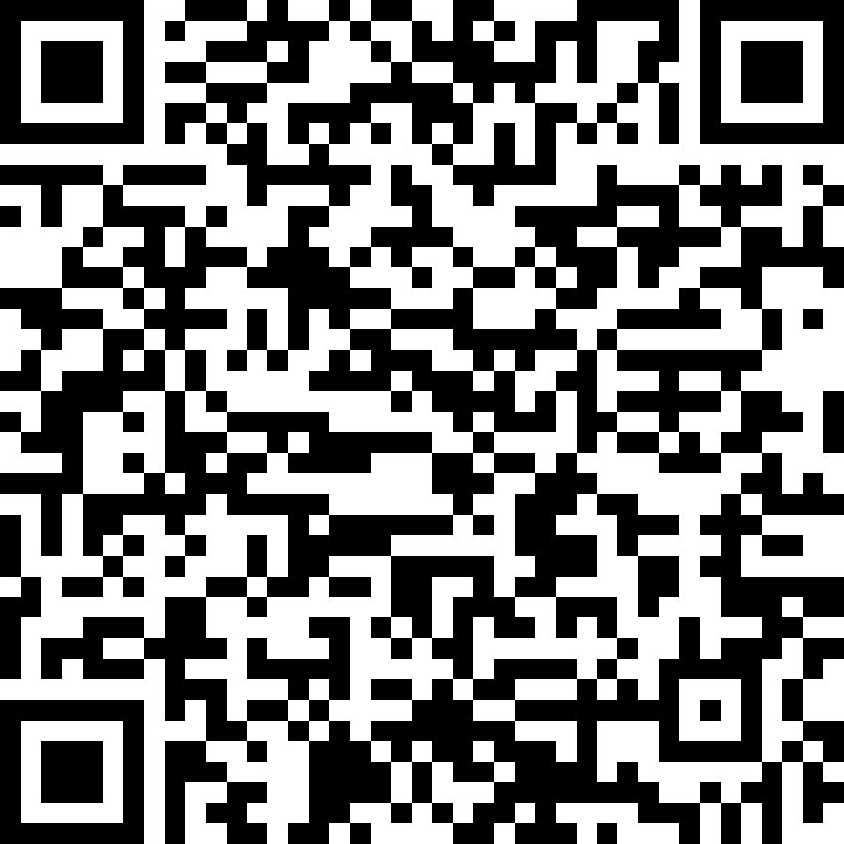
📱 SCAN THIS QR WITH YOUR PHONE CAMERA
1  Scan the QR  Opens the app in your browser | 2  Login & Setup  Phone + password + photo | 3  Collect Meal  Show token at the counter

🌅 BREAKFAST  6 AM – 11 AM | ☀️ LUNCH  12 PM – 4 PM

🔑 First-time password: rentomojo123 (you'll set your own after first login)

💬 NEED HELP?
Contact your location HRBP
They will guide you through registration and any login issues

