📱 USER MANUAL
Warehouse Canteen
Meal Token System

A step-by-step guide with real screenshots
For Employees & Canteen Staff
Designed and developed by
CHARAN A BIJAPUR
IT Engineer · Rentomojo
Warehouse Operations · 2026

👋 Welcome!
This is your new digital meal token system. Instead of paper tokens, you'll use your phone to claim breakfast and lunch every day at the warehouse canteen — fast, hygienic, and trackable.

✨ What You Can Do
✓ Get a digital Breakfast token between 6 AM – 11 AM
✓ Get a digital Lunch token between 12 PM – 4 PM
✓ Pre-book tomorrow's meals between 10 AM – 6 PM today
✓ View your monthly served-meal history
✓ Show the token at the canteen counter to collect your meal

📋 What You Need
✓ A smartphone (Android or iPhone)
✓ Internet connection (Wi-Fi or mobile data)
✓ Your 10-digit phone number registered by HR
✓ The app URL (shared by your supervisor or via warehouse QR code)
📌 NOTE: If you can't log in, double-check your phone number with HR. It must be exactly the one they registered.

PART 1
Employee Guide
How to claim your daily meal tokens

📲 Step 1 — Open the App
Open your phone's web browser (Safari on iPhone, Chrome on Android) and:
→ Scan the QR code displayed at the warehouse entrance, OR
→ Type the URL your supervisor shared with you
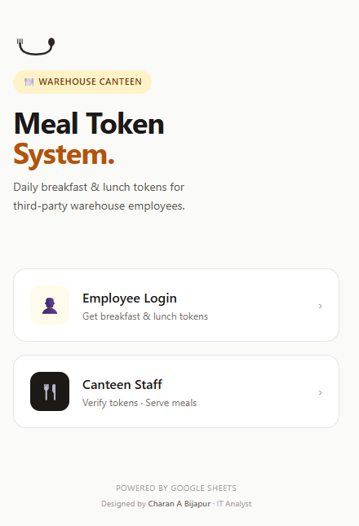
The home screen of the Meal Token System app.
⬇
1 | Tap the "Employee Login" button  It's the lighter top option with the person icon. The dark "Canteen Staff" button below is for the kitchen team only.
💡 TIP: Add the app to your phone's home screen so it works like a regular app. Tap the share icon (iPhone) or 3-dot menu (Android), then "Add to Home Screen."

🔐 Step 2 — Sign In (First Time)
Enter your details to log in:
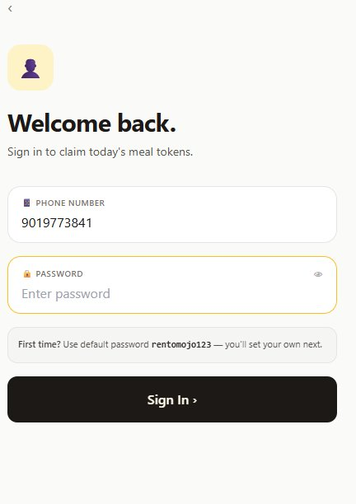
The Employee Login screen. Type your phone number and password here.
⬇
1 | Enter Phone Number  Type your 10-digit phone number — no spaces, no country code, no +91. Example: 9019773841

2 | Enter Password  First time? Use the default password: rentomojo123 (exactly as shown — lowercase, no spaces)

3 | Tap the dark "Sign In ›" button  Wait a moment while the system verifies your details.
⚠️ ERROR: Phone not whitelisted? Your number isn't in the employee list. Contact your supervisor immediately.

🛡️ Step 3 — Set Your Own Password (First Time Only)
After your first login with the default password, the app asks you to create your own password. This protects your account.
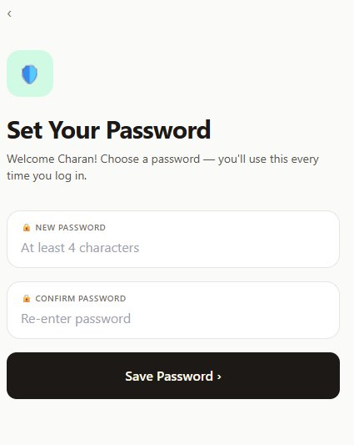
Choose and confirm your new password on this screen.
⬇
1 | Type a New Password  At least 4 characters. Use something memorable but hard to guess.

2 | Confirm the Same Password  Re-type it exactly in the second field to make sure you got it right.

3 | Tap "Save Password ›"  From now on, use this new password instead of the default.
💡 TIP: Write your new password somewhere safe. If you forget it, your supervisor will need to reset it for you in the system.

📸 Step 4 — Add Your Photo (First Time Only)
The canteen team will use this photo to verify your identity when serving your meal. It's a one-time setup — you won't be asked again.
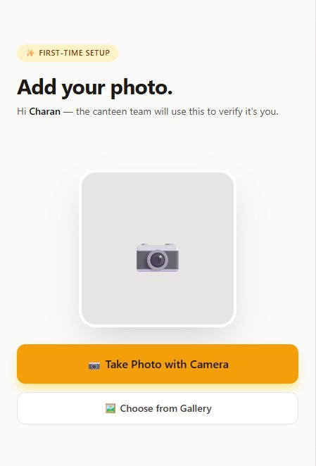
Tap the orange button to use your camera, or the gray button to pick from gallery.
⬇
1 | Tap the orange "Take Photo with Camera" button  Your phone's camera opens. Allow camera access if your browser asks.

2 | Take a clear front-facing selfie  Good lighting · your face clearly visible · looking at the camera. No sunglasses or masks.

3 | Tap "Use Photo" or "Done"  You'll see a preview. If you don't like it, tap "Retake" to try again.

4 | Tap "✓ Save Photo"  The photo uploads. Wait 5-10 seconds for it to finish.
💡 TIP: Take the photo at the warehouse with good lighting. Canteen staff will compare this with your face — clear photos mean faster service.

🏠 Step 5 — Your Main Dashboard
Once logged in, this is your home screen. Each card represents one meal of the day.
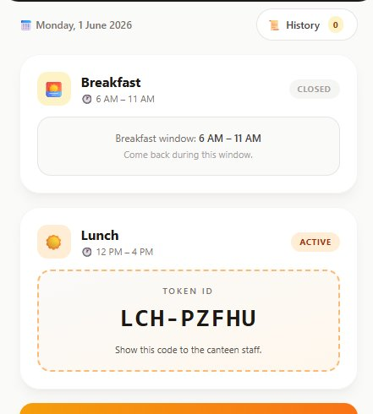
Your dashboard showing today's meal tokens (Lunch token LCH-PZFHU is active in this example).

What you see
📅 Date · History button — at the top, with a count pill showing your monthly served meals.
🌅 Breakfast Card — shows the meal window (6 AM – 11 AM) and either CLOSED (outside window) or READY/ACTIVE.
☀️ Lunch Card — same as breakfast but for 12 PM – 4 PM.
📆 Pre-book Tomorrow — big orange banner near the bottom for booking tomorrow's meals.

🍴 Step 6 — Get Your Meal Token
During the meal window, tap the "Use Token" button to generate your token code. Then show it at the counter.

Before tapping the button:
The card shows READY status with a button: ☕ Use Lunch Token.

After tapping the button:

After tapping "Use Lunch Token," your token code appears (LCH-PZFHU in this example).
⬇
1 | Tap the orange/amber "Use Token" button  Available only during the meal window. Outside that time the card shows CLOSED.

2 | Show the token code to canteen staff  Walk to the counter and show your phone screen with the BRK-XXXXX or LCH-XXXXX code.

3 | Collect your meal  Staff verify your photo, match the token, and serve. Your dashboard will update to SERVED within 15 seconds.
💡 TIP: One breakfast and one lunch per employee per day. No more. Don't share your token — it's tied to your photo and only works for you.

📆 Step 7 — Pre-Book Tomorrow's Meals
Help the canteen plan tomorrow's cooking by telling them in advance which meals you'll need. Available between 10 AM – 6 PM today.
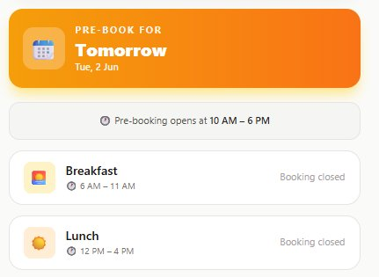
The Pre-Book section. The orange banner is for tomorrow's meals.
⬇
1 | Wait until 10 AM – 6 PM window opens  Outside this window, both buttons show "Booking closed."

2 | Tap "Request" next to Breakfast and/or Lunch  The button changes to "✓ Requested" with a small ✕ to cancel if needed.

3 | Tomorrow during the meal window  Tap "Use Token" as usual — a real token code will appear. No need to re-request.
💡 TIP: Pre-booking helps the canteen cook the right quantity. Even if you forget to pre-book, you can still claim your meal tomorrow.

📜 Step 8 — View Your Meal History
Want to see how many meals you've eaten this month? Tap the "History" pill at the top of the dashboard.
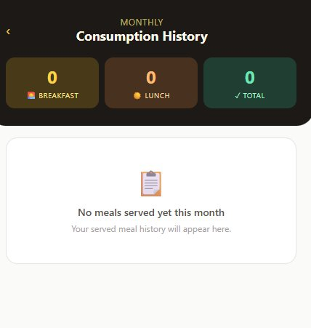
Your Monthly Consumption History showing only meals that were actually served.

What the history shows
🌅 Breakfast count: How many breakfasts you ate this month.
☀️ Lunch count: How many lunches you ate this month.
✓ Total: Total served meals.

💡 TIP: History only shows meals that the canteen actually served — not pending tokens, not pre-bookings. This is your true "meals eaten" record.

Tap the back arrow (‹) at the top to return to your main dashboard.

❓ Common Issues — Employee

"Phone not whitelisted"
Your phone number isn't registered. Contact your supervisor or HR to add you to the employee list.

"Incorrect password"
You typed the wrong password. If it's your first time, use rentomojo123. If you set your own and forgot it, ask your supervisor to reset it (they'll clear it in the Google Sheet so you can set a new one).

"Breakfast is only available from 6:00 to 11:00"
You're trying to claim outside the meal window. Breakfast: 6 AM – 11 AM. Lunch: 12 PM – 4 PM. Come back during the right window.

Camera doesn't open
Your browser may have blocked camera access. Go to phone Settings → Safari (or Chrome) → Camera → Allow. Then reload the app.

App says I'm logged out after restart
Sessions expire after 12 hours for security. Just sign in again with your phone number and password.

Can't see Refresh or Sign Out buttons
Make sure the page is fully loaded. If they're still missing, refresh the browser page (pull down to refresh on mobile).

PART 2
Canteen Staff Guide
How to verify tokens and serve meals

📲 Step 1 — Open the App
On your dedicated tablet or phone at the canteen counter, open the app URL.

The home screen. Tap the dark "Canteen Staff" button at the bottom.
⬇
1 | Tap the dark "Canteen Staff" button  The bottom option with the fork/knife icon. This is for canteen counter staff only — employees use the top option.

🔐 Step 2 — Sign In
Enter your canteen counter User ID and password.
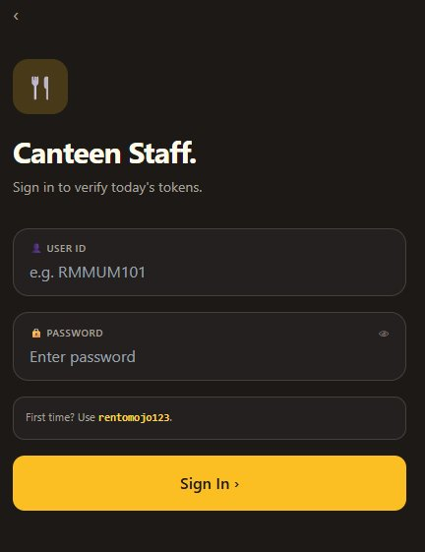
The Canteen Staff Sign In screen. Dark background to distinguish it from the employee app.
⬇
1 | Enter your User ID  Example: RMMUM101 (Mumbai) or RMBAN101 (Bangalore). Use CAPITAL LETTERS — provided by IT.

2 | Enter your password  First time: rentomojo123. The system will ask you to set your own after.

3 | Tap the yellow "Sign In ›" button  Wait for your warehouse dashboard to load.
💡 TIP: Your User ID is linked to a specific City + Warehouse. You'll only see tokens for employees of YOUR warehouse — not all warehouses.

📊 Step 3 — Understanding Your Dashboard
This is your main work screen. Today's tokens for your warehouse appear here in real time.
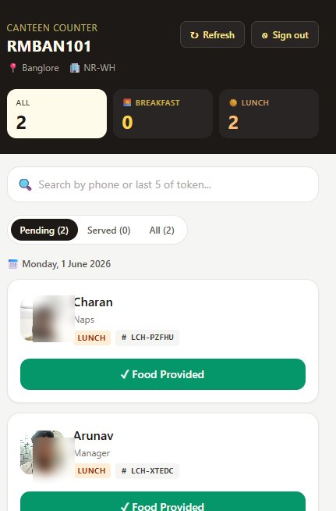
Canteen dashboard showing all today's tokens for your warehouse.

Top Counter Cards
ALL: Total tokens today (both meals combined).
BREAKFAST: Number of breakfast tokens today.
LUNCH: Number of lunch tokens today.

Status Filter Pills
Pending: Employees who came but haven't been served (your work queue).
Served: Already served meals (your completed work).
All: Everyone, served or pending.
💡 TIP: By default, you see PENDING tokens — these are the people waiting. Just work through this list top-to-bottom.

🍽️ Step 4 — Serve a Meal
When an employee comes to the counter and shows their phone with a token code, follow these steps:
⬇
1 | Look at the employee's photo on your screen  Compare it carefully to the person standing in front of you. If unsure, tap the photo to enlarge (Step 6).

2 | Check the token code  The # BRK-XXXXX or # LCH-XXXXX on their phone should exactly match what's on your screen.

3 | Serve the meal  Hand them their food.

4 | Tap the green "✓ Food Provided" button  The card turns green and shows "Served · by [your User ID]."
⚠️ IMPORTANT: Once you tap "Food Provided," the meal is logged PERMANENTLY in the system. There is no Undo button — be sure of identity before tapping.

🔍 Step 5 — Search For a Specific Employee
If the counter is busy or you need to find a specific person, use the search bar at the top.
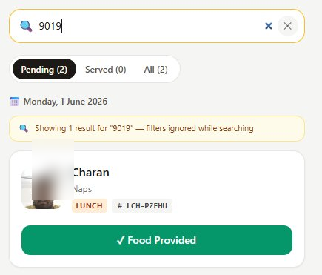
Searching by "9019" — the system finds the matching token immediately.

You can search by:
📱 Phone number: Full or partial — typing "9019" finds 9019773841.
🎫 Token last 5 characters: Just the part after the dash — typing "PZFHU" finds LCH-PZFHU.
🎫 Full token code: The complete code works too — e.g., BRK-FM2GC or LCH-PZFHU.
💡 TIP: While searching, the Pending/Served filter is automatically ignored — so all matching tokens show up regardless of status. You can find anyone instantly.

🖼️ Step 6 — Enlarge a Photo for Verification
If the small photo on the card isn't clear enough, tap on it to see a full-screen view.
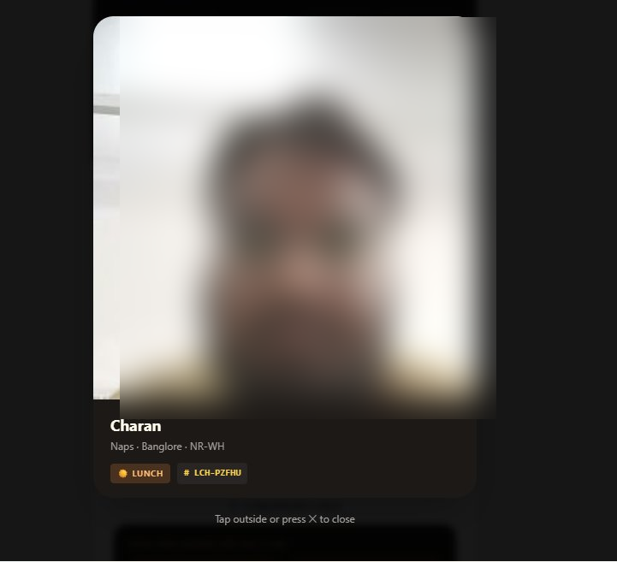
The enlarged photo view with name, location, meal type, and token code shown.
⬇
1 | Tap the small photo on the token card  A full-screen view opens with the photo and all employee details.

2 | Compare carefully — face, glasses, beard, hair  Look for any obvious differences. If something feels wrong, ask the person to verify their identity.

3 | Tap ✕ or anywhere outside the photo to close  Or press the back button on your tablet.
⚠️ CRITICAL: If the photo doesn't match the person at the counter, DO NOT serve the meal. Politely ask them to contact HR for identity verification.

📆 Step 7 — Tomorrow's Prep View
Scroll to the bottom of your dashboard. You'll see a special section called "Tomorrow's Prep" with counts and names of employees who have pre-booked tomorrow's meals.
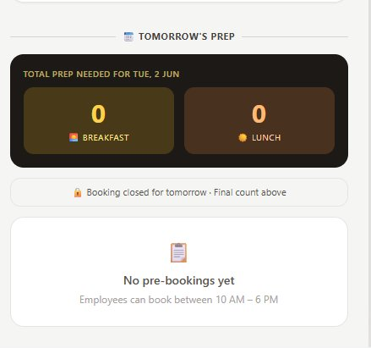
The Tomorrow's Prep section showing how many meals to prepare.

How to use this
Big count cards: Tells you exactly how many breakfasts and lunches to prepare for tomorrow.
Status indicator: Tells you whether more bookings can still come in (Booking is open until 6 PM, or Booking closed).
List of names: Shows everyone who pre-booked — with photos. You'll know who to expect.
💡 TIP: Check this section at 6 PM each day to get the final headcount for tomorrow's preparation. Bookings auto-close at 6 PM.

🔄 Step 8 — Refresh & Sign Out
At the top-right of your dashboard, you have two important buttons:

↻ Refresh Button
Reloads the list to show new tokens that employees just claimed. The list also refreshes automatically every 15 seconds — you usually don't need to tap this.

⎋ Sign Out Button
Tap this at the end of your shift to log out. Your session also expires automatically after 12 hours for security.
💡 TIP: Don't share your User ID and password with anyone. If you suspect someone else has used your account, tell your supervisor immediately.

❓ Common Issues — Canteen Staff

"No tokens to show"
Either no employees have claimed tokens yet, or your filter is hiding them. Try switching the status pill to "All" to see everyone.

Employee says they got a token but I don't see it
Tap the Refresh button (↻) — the list updates from the server. Also check that the employee belongs to YOUR warehouse (city + warehouse must match).

Employee's photo doesn't match
Do NOT serve the meal. Send them to HR for identity verification. Their photo may need to be re-taken.

I accidentally tapped "Food Provided"
There is no undo — the row is locked once marked as served. If a correction is genuinely needed, contact Charan (IT) — they can manually edit the Google Sheet.

Two employees with same name at the counter
Use the search bar to filter by phone number. Match the phone with their ID card.

Forgot my password
Ask Charan (IT) or your supervisor to reset it. They'll clear the password in the system and you can set a new one on next login.

⚡ Quick Reference Card
Print this page and post it at the warehouse / canteen for quick reference.

Meal Timings
Meal | Window | Token Prefix
🌅 Breakfast | 6 AM – 11 AM | BRK-XXXXX
☀️ Lunch | 12 PM – 4 PM | LCH-XXXXX
📆 Pre-book tomorrow | 10 AM – 6 PM | (no token until tomorrow)

Default Password
First-time login password: rentomojo123
You'll be required to set your own password after your first login.

Token Format Examples
Breakfast tokens: BRK-FM2GC · BRK-A7K2P · BRK-X9VN3
Lunch tokens: LCH-PZFHU · LCH-K7P3M · LCH-NLYBW

Rules to Remember
1. One breakfast + one lunch per employee per day. No exceptions.
2. Token only works during the meal window — outside, the button is disabled.
3. Photo verification is MANDATORY at the canteen counter.
4. Pre-bookings (Requests) do NOT generate a token immediately — they're just a headcount.
5. Real tokens are generated only when the employee taps "Use Token" within the meal window.
6. Once a meal is marked "Served," it can't be undone — be sure before tapping.

📞 Need Help?

For any technical issues, password resets, new employee additions, or feature requests, contact:
CHARAN A BIJAPUR
IT Engineer · Rentomojo
System designer & developer

Common Requests
→ Forgot password? Need it reset.
→ Need to add a new employee to the system.
→ Need to deactivate an employee who has left.
→ App is not loading or showing errors.
→ Need to change meal timings or add dinner.
→ Need to correct a wrongly-marked Food Provided.

Thank you for using the Warehouse Canteen Meal Token System!
Bon appétit 🍽️

