Howard University
College of Engineering and Architecture
Department of Electrical Engineering & Computer Science

Large Scale Programming
Fall 2024

Midterm Exam – Part I
October 17, 2024

Part I: 50 pts. (essay questions)

Instructions:
- Submit completed exam to your github repository under package org.howard.edu.lsp.midterm

Verify that the commit(s) completed successfully

- OPEN BOOK, OPEN NOTES. THERE IS NO COLLABORATION ON THIS EXAM
- Site any and ALL references for anything obtained off the internet.

Question 1. (10 pts.)

You are reviewing the following class in a Fitness Tracking System. The class is intended to manage various aspects of a user’s fitness activities.

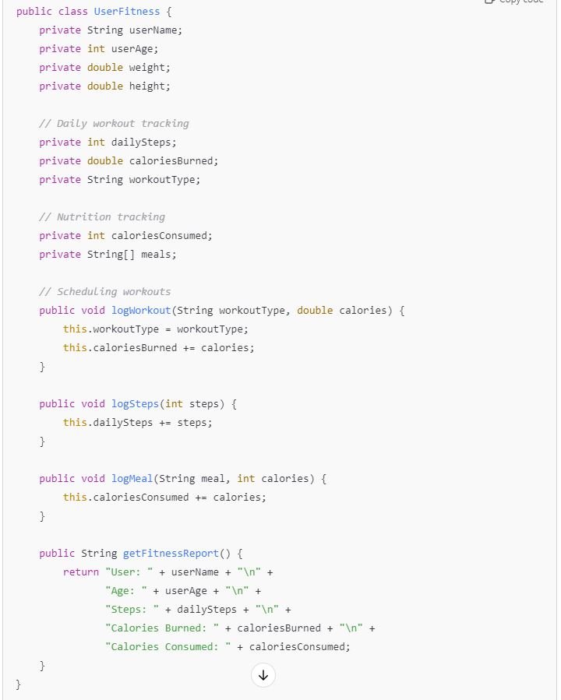

Tasks:
- Analyze the UserFitness class. Explain why this class has low cohesion. (5 pts.)

Cohesion refers to how well the responsibilities of a class align. A class with high cohesion focuses on a single task or a set of closely related tasks. However, the UserFitness class demonstrates low cohesion because it tries to manage several unrelated responsibilities:
- User Information Management: Stores personal information like user name, age, weight, and height.
- Workout Tracking: Tracks workout activities, steps, and calories burned.
- Nutrition Tracking: Manages meals and calorie intake.
- Reporting: Generates fitness reports summarizing all activities.
These activities belong to different areas (user data, workout tracking, and nutrition management). Since the class is handling multiple concerns, it makes the code harder to maintain, extend, or test effectively.

- Describe, in general, how you would split the UserFitness class into more cohesive classes. Your answer should not be a complete design. (5 pts.)

To improve cohesion, we can split the UserFitness class into smaller, specialized classes. Each new class will focus on a specific concern, making the code more organized and easier to manage. Below are the new classes:
- User Class:
  - Stores personal details like userName, age, weight, and height.
  - Example fields: String userName, int age, double weight, double height.
- WorkoutTracker Class:
  - Manages workouts, including daily steps, calories burned, and workout types.
  - Example fields: int dailySteps, double caloriesBurned, String workoutType.
  - Example methods: logWorkout(), logSteps().
- NutritionTracker Class:
  - Tracks meals and calories consumed.
  - Example fields: String[] meals, int caloriesConsumed.
  - Example methods: logMeal().
- FitnessReport Class:
  - Responsible for generating reports by gathering data from WorkoutTracker and NutritionTracker.
  - Example method: generateReport().
By separating these tasks, each class will now have high cohesion, focusing on a single responsibility. This design will make the code easier to test, extend, and maintain, while also ensuring that adding new features only impacts the relevant class.

Question 2. (5 pts.)
Given the following, answer the below questions.

A university manages its students using a program that has a class Student with subclasses FirstYear, SecondYear, and ThirdYear for year-specific state and behaviors. The program has a List that contains all Students.

Should Student be a class, an abstract class or an interface? Explain your answer

The Student class should be an abstract class because it will contain both common state (like name, ID, and year) and behavior (like enrolling or getting academic progress) shared by all students, while also requiring some behaviors to be implemented differently in the subclasses (FirstYear, SecondYear, and ThirdYear).
An interface would not be a good choice because it only defines behaviors and doesn’t store common data fields. A concrete class isn’t ideal either because we shouldn’t be able to directly create a general Student object — students should only exist as FirstYear, SecondYear, or ThirdYear students.

- At the end of each year, the third-year students graduate and must be removed. This is done by passing the list to the following method:

void removeThirdYears(List<Students> students) {
for (Student student : students) {
try {
ThirdYear = (ThirdYear) student;
students.remove(thirdyear);
}
}
}

Why is the above method flawed? Hint: Another Arthur Riel heuristic (5 pts.)

The above method is flawed for the following reasons.

- ConcurrentModificationException:
Modifying a list (students.remove(thirdYear)) while iterating over it using an enhanced for loop will throw a ConcurrentModificationException. This breaks the rule of avoiding side effects when iterating over collections.
- ClassCastException:
The method tries to cast all students to ThirdYear, which will throw a ClassCastException if the student isn’t a ThirdYear. This is unnecessary and error-prone.
- Logic Issue:
Even if the cast succeeds, the way students are removed is incorrect. The list is being modified in an unsafe way during iteration, making it unreliable and likely to break.

Question 3. (5 pts.)
Given the following, answer the below questions.

public class BankAccount {
public String accountHolderName;
public String accountNumber;
public double balance;
public double interestRate;

public BankAccount(
String accountHolderName,
String accountNumber,
double initialDeposit,
double interestRate) {
this.accountHolderName = accountHolderName;
this.accountNumber = accountNumber;
this.balance = initialDeposit;
this.interestRate = interestRate;
}

// Exposed implementation for adding interest
public void addInterest() {
double interest = balance * (interestRate / 100);
balance += interest;
}

// Exposed implementation for deposits
public void deposit(double amount) {
balance += amount;
}

// Exposed implementation for withdrawals
public void withdraw(double amount) {
balance -= amount;
}
}

- Is BankAccount well-encapsulated? Why or why not? If so, describe what changes you would make to the class. Otherwise, state nothing. (5 pts.)

The BankAccount class is not well-encapsulated.

Reason:
All fields (accountHolderName, accountNumber, balance, and interestRate) are declared as public. This allows external code to access and modify the fields directly, which violates the principle of encapsulation. Encapsulation ensures that the internal state of an object is hidden, and only controlled access is provided through methods.
Changes to improve encapsulation:
- Make all fields private so they are not directly accessible from outside the class.
- Provide getter and setter methods for controlled access to field values.
- Add validation checks for deposits and withdrawals to ensure proper behavior.

Improved Code:

public class BankAccount {
private String accountHolderName;
private String accountNumber;
private double balance;
private double interestRate;

public BankAccount(String accountHolderName, String accountNumber,
double initialDeposit, double interestRate) {
this.accountHolderName = accountHolderName;
this.accountNumber = accountNumber;
this.balance = initialDeposit;
this.interestRate = interestRate;
}

public String getAccountHolderName() {
return accountHolderName;
}

public String getAccountNumber() {
return accountNumber;
}

public double getBalance() {
return balance;
}

public double getInterestRate() {
return interestRate;
}

public void setInterestRate(double interestRate) {
this.interestRate = interestRate;
}

public void addInterest() {
double interest = balance * (interestRate / 100);
balance += interest;
}

public void deposit(double amount) {
if (amount > 0) {
balance += amount;
}
}

public void withdraw(double amount) {
if (amount > 0 && amount <= balance) {
balance -= amount;
}
}
}

Summary:
By making the fields private and providing getter and setter methods, we improve encapsulation. This ensures the internal state of the class is protected and only accessible through well-defined methods.

Question 4. (10 pts.)
Given the following, answer the below questions.

Given:
A car manufacturer uses Java software to track current vehicles being built. The UML diagram below shows an excerpt of the current software structure. You should assume the presence of other appropriate fields and methods

Car
getTrimLevel()
Engine
accelerate()
getFuelLevel()
Base
Sports
Luxury
Electric
Petrol

Each car can be built to one of three trim levels: Base, Luxury or Sport. They can also be configured with an electric or petrol engine. At various points in the manufacturing process the customer can choose to change the trim level.

Task:
- Explain in detail why the current structure does not support this. (5 pts.)

The current structure seems to represent trim levels (Base, Sports, and Luxury) as subclasses of the Car class. This creates a rigid hierarchy where once a car is assigned a specific trim, it cannot be changed easily during runtime. If a customer wants to change the trim level, the software would need to create a new object from the appropriate subclass (like switching from Base to Luxury), which is inefficient and not practical. This structure assumes the trim level is fixed when the car object is created, making it impossible to update the trim dynamically during the manufacturing process.

- Describe how to refactor the structure to allow trim-level change for a car to dynamically change. Hint: How would you modify Car to use composition to solve the problem? (5 pts.)

To solve this, the design should be refactored using composition instead of inheritance. Instead of making each trim level a subclass, we can create a TrimLevel interface or class (e.g., BaseTrim, LuxuryTrim, SportsTrim). The Car class will hold a reference to a TrimLevel object as a field. A method like setTrimLevel(TrimLevel newTrim) can be added to the Car class, allowing the car’s trim to be changed at any point during manufacturing.
This way, the Car object stays the same, and only the TrimLevel object it holds gets replaced. This makes the system more flexible and supports runtime updates to the trim level without needing to recreate the car object.

Question 5. (5 pts.)
Suppose you are about to code a particular class and find that you have written another class with nearly the functionality that you now are developing. This means that the two classes in large parts contain the same code, but in smaller parts have different code. Explain in detail why this may be a problem and how to solve it. Give your answer in terms of Arthur Riel’s design heuristics.

If two classes contain similar code with slight differences, it creates issues. According to Arthur Riel’s Design Heuristics, the problems and solutions are:

Problems
- Code Duplication: Violates the DRY (Don’t Repeat Yourself) principle, making the code harder to update and debug.
- Maintenance Overhead: Any change requires updates in multiple places, increasing the risk of errors.
- Poor Encapsulation: Spreading logic across classes makes the code less organized and harder to manage.

Solutions
- Use Inheritance: Move shared code to a base class if the classes have an "is-a" relationship.
- Favor Composition Over Inheritance: If inheritance doesn’t fit, extract the shared logic into a helper class and use it within the original classes.
- Use Abstract Classes or Interfaces: Create a shared structure to ensure consistent behavior across related classes.
- Apply Design Patterns: Use patterns like Template Method to separate common and varying logic.

Redundant code complicates maintenance and increases errors. Following Riel’s heuristics ensures clean, reusable, and maintainable code by using inheritance, composition, or design patterns.

Question 6. (5 pts.)
Suppose we need to store instances of the classes Car and BankAccount in a database. To obtain low coupling it may seem as if the functionality to save an instance should be in precisely those classes, since they have the information that shall be saved. Why is it unwise to place the database calls there?

Placing database calls within the Car and BankAccount classes is problematic because:
- Separation of Concerns: These classes should focus on business logic, not persistence.
- Single Responsibility Principle (SRP): Mixing logic requires changes for both domain and database updates, making maintenance harder.
- Tight Coupling: Direct database integration limits flexibility to switch storage solutions.
- Testability Issues: Database logic complicates unit testing, requiring unnecessary mocks.
- Maintainability: Mixing responsibilities makes the code harder to extend, debug, and refactor.
Solution: Use a repository or DAO pattern to handle database operations separately. This ensures the Car and BankAccount classes remain focused on their core responsibilities while the repository manages data persistence, promoting better modularity, flexibility, and testability.

Question 7. (5 pts.)
Given a set of requirements, what conditions must be met to make it appropriate to create a new class hierarchy using inheritance? Neither superclass nor subclass exist before, the question is about designing a new class hierarchy.

To justify creating a new class hierarchy using inheritance, the following conditions must be met:

- Shared Features: The classes should have common attributes or behaviors that can be placed in the parent class to avoid repeating code.
- "Is-a" Relationship: The subclass should logically fit under the parent class (like a Car being a type of Vehicle).
- Polymorphism: You need to treat different subclasses the same way using the parent class (like calling a method that behaves differently depending on the subclass).
- Future Growth: If more similar subclasses might be added later, inheritance makes it easier to extend the code.
- Code Reuse: Shared functionality can be put in the parent class, so you don’t have to rewrite it in every subclass.
- Specialized Behavior: Subclasses should need to change or extend the parent class’s behavior to add their own specific features.
- Meaningful Structure: The hierarchy should be clear and logical, making it easier to understand the relationship between classes.

Question 8. (2.5 pts.)
Describe the difference between inheritance and composition why would you choose one over the other.

Inheritance and composition are two fundamental principles in object-oriented programming. Inheritance establishes an "is-a" relationship, where a subclass inherits properties and behavior from a superclass. For example, a Car is a type of Vehicle. Inheritance is useful when multiple classes share common functionality, and there’s a need for a hierarchy that allows behavior to be extended or modified through subclassing. It also supports polymorphism, enabling the same method to behave differently depending on the subclass.
Composition, by contrast, creates a "has-a" relationship, where one class contains objects of other classes to use their functionality. For example, a Car has an Engine. Composition offers more flexibility since components can be swapped or reused independently. It also promotes loose coupling, making the code easier to maintain and modify over time.
Choosing between inheritance and composition depends on the situation. Inheritance is ideal when a class needs to extend shared behavior within a clear hierarchy. However, composition is better when flexibility, modularity, and maintainability are priorities, as it avoids the risks associated with tightly coupling classes through inheritance.

Question 9. (2.5 pts.)
Explain the meaning of cohesion and describe whether low or high cohesion is better.
Cohesion refers to how closely related and focused the responsibilities of a class or module are. A highly cohesive class has a single, well-defined purpose, with all its methods and attributes working toward that purpose. On the other hand, low cohesion occurs when a class or module handles unrelated tasks, making it harder to understand, maintain, and test.
High cohesion is generally better because it makes the code more organized, easier to maintain, and reduces the risk of unexpected bugs. With highly cohesive classes, changes or extensions to one part of the system are less likely to affect other parts. This also promotes reusability, since classes with a focused purpose are easier to adapt to different contexts.
In contrast, low cohesion often leads to complex and confusing code since it combines unrelated responsibilities. This makes the class difficult to manage and prone to errors, especially when updates are needed. Therefore, high cohesion is preferred, as it results in cleaner, more maintainable, and robust code.

