SQL interface on Python

Package – PySimpleGUI

Name – Bijay .G

**HomePage/Dashboard**

3 parts:

* Connecting to Database
* Manual Entry of Queries
* Pre-Defined Queries

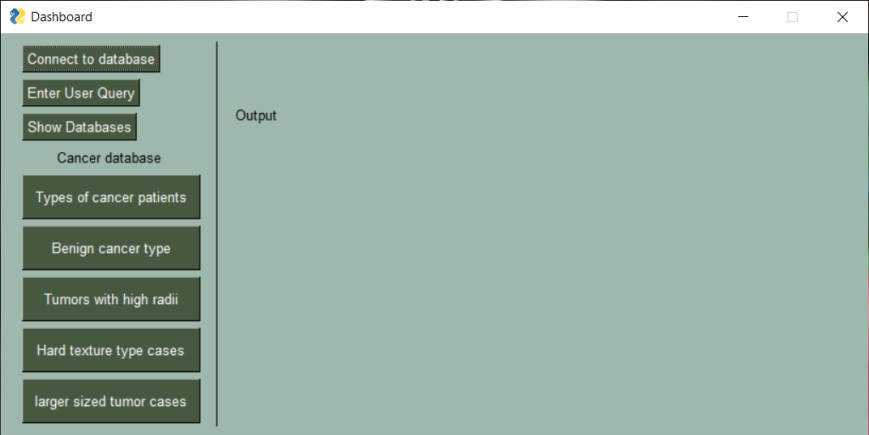

**Username Entry:**

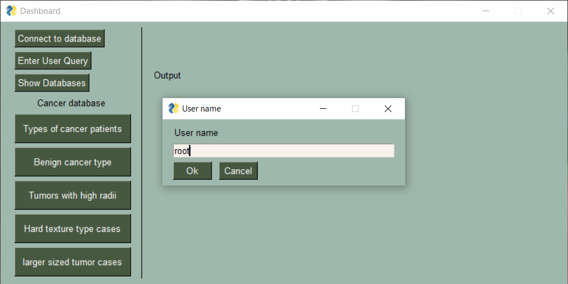

**Password Entry:**

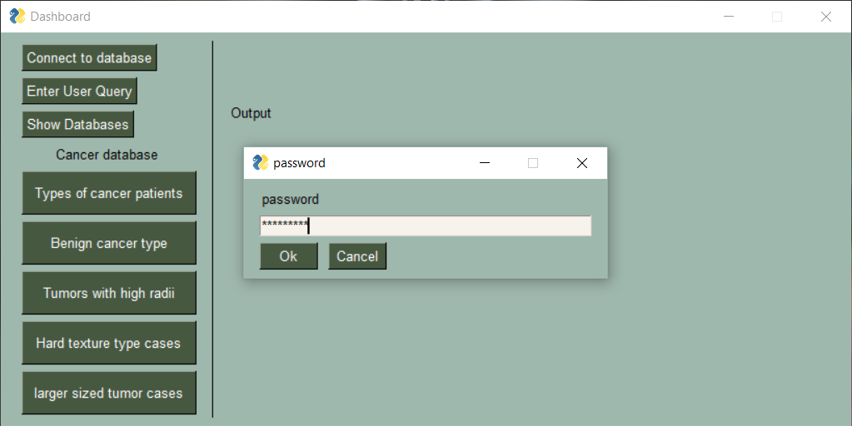

**Notification after successful connection:**

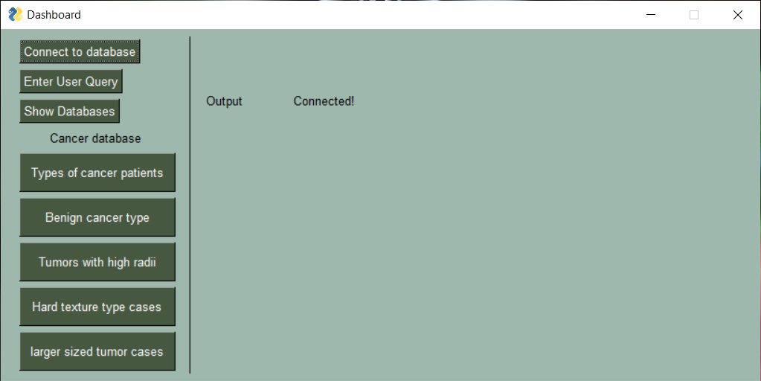

**Manual Entry Query Input Example:**

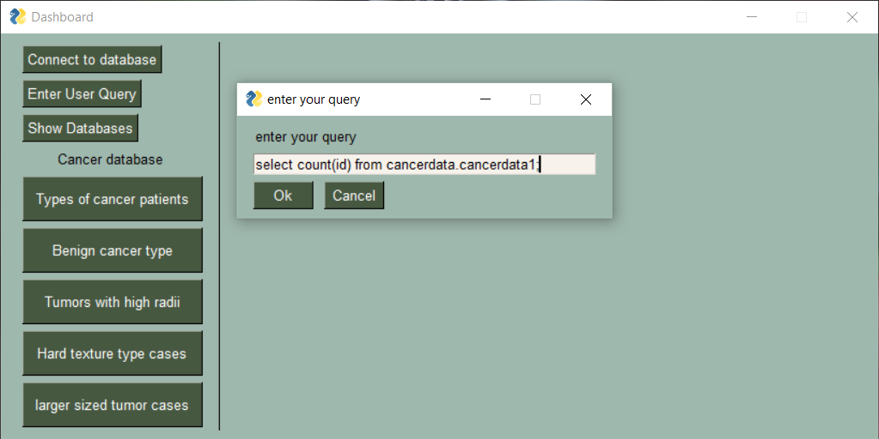

**Manual Entry Query Output Example:**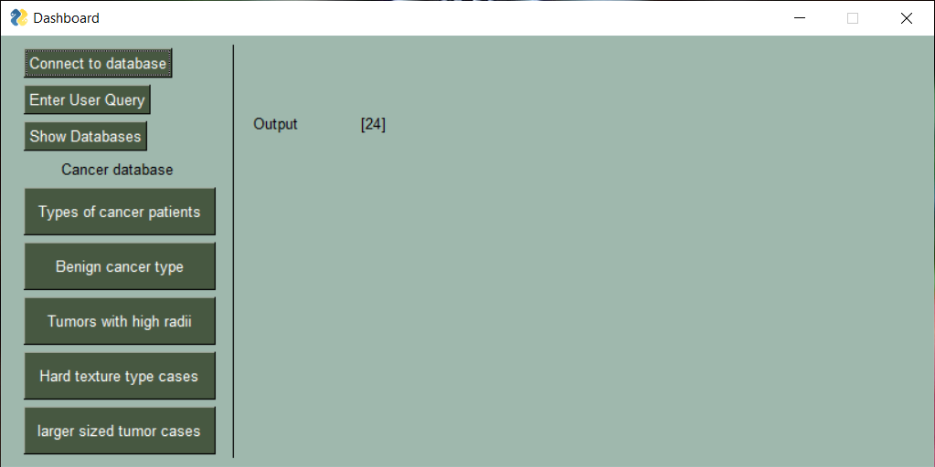

**Inbuilt GUI Query Examples:**

**Showing Number of patients with Malignant and Benign type of cancer.**

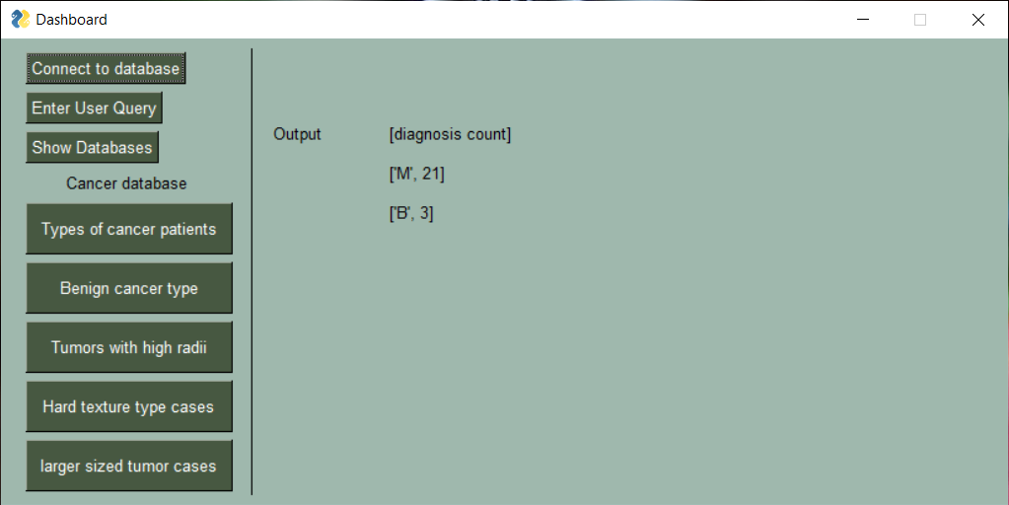

**Showing Data from both tables using INNER JOIN to show patients suffering from Benign Cancer:**

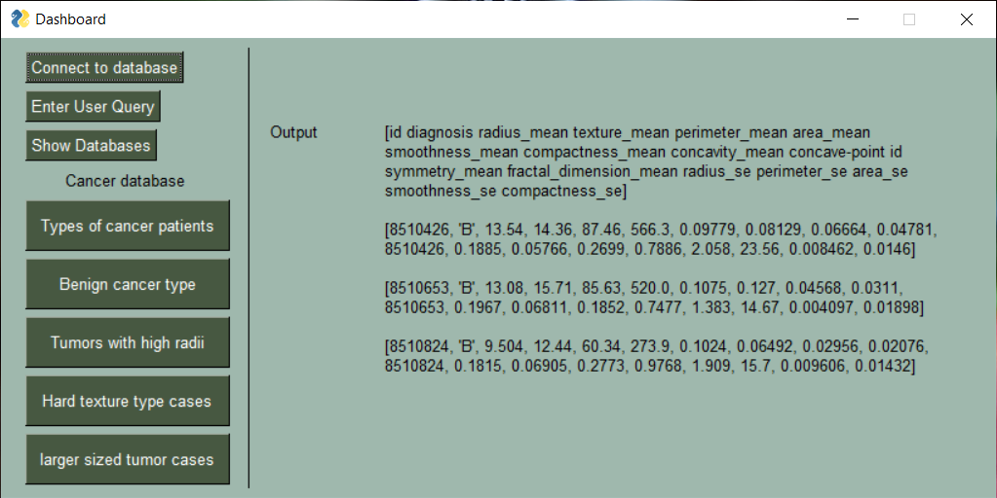

**Showing data from both tables using Inner Join of patients with Radius mean > 15 cms:**

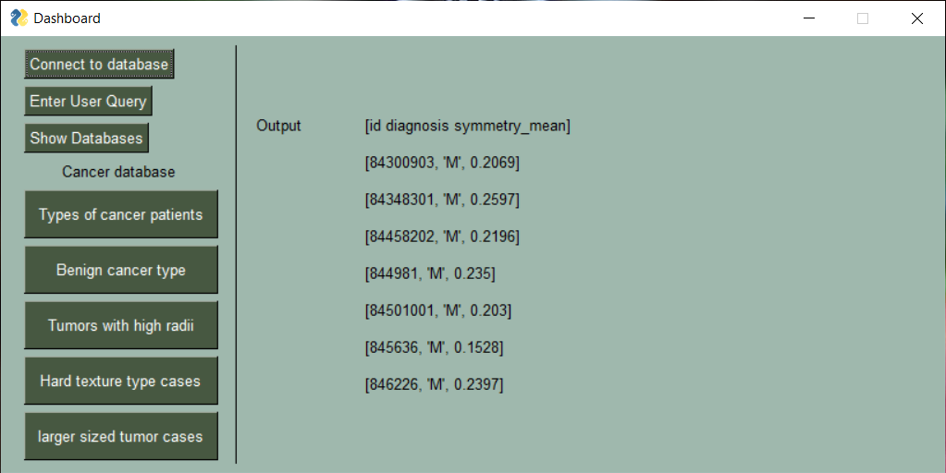

**Showing Data from both tables using Inner Join of patients having hard texture tumours (>20):**

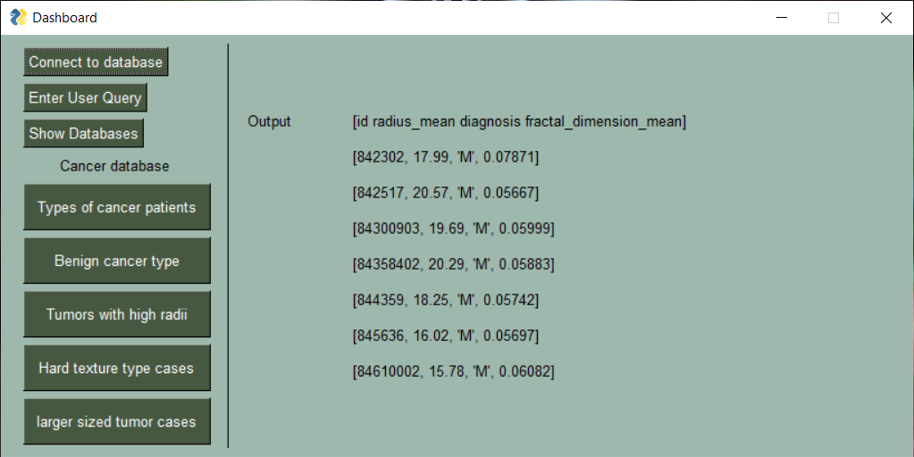

**Showing specific details from both tables using Inner Join of patients having area mean of tumours more than 1000 cm square:**