

Concepts and Technologies of AI

Human Development Index Analysis:
A Data-Driven Exploration
Name: Bijay Acharya
Group: L5CG12
University ID: 2550709
Tutor: Robin Tulhadhar
Module Leader: Siman Giri

1. Introduction

Human Development Index (HDI) is a composite measure of human development set by the United Nations Development Programme (UNDP), which is there to measure the development levels of countries. HDI provides a wider scope compared to other measures which purely put emphasis on the economic performance of countries because it incorporates the most important dimensions of human well being like health, education and standard of living. It is computed as the combination of the indices of life expectancy at birth, education level and gross national income per capita in a geometric manner. The HDI is measured between 0 and 1 and the higher the value is, the better the development results. According to these values, the countries are categorized as Low, Medium, High, and Very High human development.

2. Objectives of the Analysis
This analysis aims to conduct a comprehensive statistical interpretation and exploratory data analysis of the Human Development Index dataset spanning from 1990 to 2022. The specific objectives include:
- To explore and analyze HDI patterns for the most recent year (2022)
- To investigate temporal trends in HDI values across the 2020–2022 period
- To perform advanced HDI exploration focusing on South Asian countries
- To conduct a comparative regional analysis between South Asia and the Middle East
- To apply data cleaning, preprocessing, and visualization techniques to extract meaningful insights

3. Scope of the Report
This report encompasses a systematic analysis of the Human Development Index dataset, focusing on:
- Temporal Coverage: Recent years (2020–2022) with emphasis on 2022
- Geographical Coverage: Global analysis with focus on South Asia and the Middle East
- Analytical Methods: Descriptive statistics, data cleaning, trend visualization, correlation analysis, outlier detection, and comparative assessments
- Metrics Examined: HDI, Gender Development Index, Life Expectancy Index, GNI per Capita Index, and custom composite scores

4. Problem 1A – Single Year HDI Exploration (2022)

4.1 Methods and Approach
The analysis followed a systematic exploratory data analysis (EDA) workflow:
- Data Extraction: Filtered dataset for year 2022
- Initial Exploration: Examined dataset structure, dimensions, and data types
- Data Quality Assessment: Checked for missing values, data type issues, duplicates, and special characters
- Cleaning Steps: Type conversion, duplicate removal, and handling missing HDI values
- Descriptive Statistics: Calculated mean, median, and standard deviation
- Filtering and Ranking: Identified countries with HDI > 0.800 and ranked by GNI per capita
- HDI Categorization: Created HDI_Category column using UNDP thresholds

4.2 Key Results

Dataset Characteristics:
- Total observations: 206 entries (30 columns)
- After cleaning: 204 valid country observations
- No duplicate records detected
- HDI missing rate: 0.97% (2 missing values)

Descriptive Statistics for HDI 2022:
Statistic | Value | Country
Mean HDI | 0.723 | -
Median HDI | 0.740 | -
Standard Deviation | 0.153 | -
Highest HDI | 0.967 | Switzerland
Lowest HDI | 0.380 | Somalia

HDI Category Distribution:
HDI Category | Count | Percentage | HDI Range
Very High | 63 | 30.9% | ≥ 0.800
High | 54 | 26.5% | 0.700–0.799
Medium | 45 | 22.1% | 0.550–0.699
Low | 42 | 20.6% | < 0.550

4.3 Visualizations and Tables
Figure 1: Top 10 Very High HDI Countries by GNI per Capita
This bar chart displays the top 10 countries with very high HDI (≥0.800) ranked by their Gross National Income per capita.
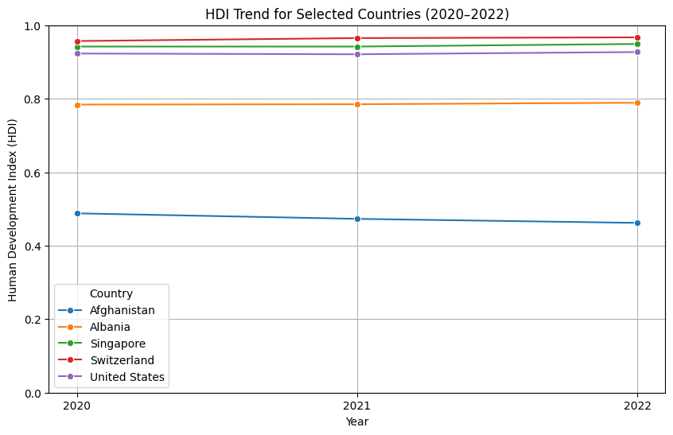

Figure 2: HDI Category Distribution
This bar chart shows the distribution of countries across the four HDI categories in 2022.
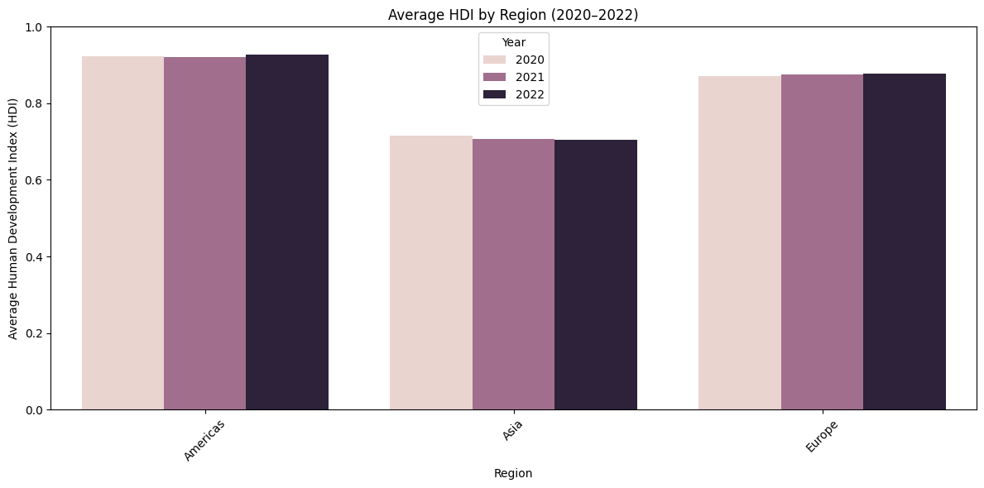

4.4 Interpretation and Discussion
- Global HDI Distribution: The 2022 statistics indicate that there is a world average of 0.723 HDI, and this category of development is High. This average however hides a lot of variations, with Switzerland on the forefront of 0.967 and Somalia at the rear with 0.380 which makes a difference of 0.587 points.
- Category Analysis: Only 30.9% of countries are at the level of either Very High development and 20.6% of countries are at the level of Low. This shows that though the world has made a lot of progress, there are still unresolved inequalities that are plaguing a considerable number of countries in the world.
- Income vs Development: This might be due to the interesting pattern of the analysis of the Very High HDI countries by GNI per capita. Although Liechtenstein has the biggest GNI per capita (146,673), Switzerland has the highest HDI (0.967) but with a lower income (69,433). This indicates that quality human development can be achieved by efficient investment in health and education despite the moderate level of income.

5. Problem 1B – HDI Trend Analysis (2020-2022)

5.1 Methods and Approach
The temporal analysis followed these steps:
- Data Extraction: Filtered dataset for years 2020, 2021, and 2022
- Data Cleaning: Addressed missing values, inconsistent country names, and data type issues
- Trend Visualization: Created line charts for country-level HDI trends
- Regional Analysis: Computed average HDI by region across the three years
- Distribution Analysis: Generated box plots to examine HDI spread
- Correlation Analysis: Explored relationships between HDI and GNI per capita

5.2 Key Results
- Temporal Stability: Most high-HDI countries maintained stable or slightly improving trends from 2020 to 2022, demonstrating resilience even during the COVID-19 pandemic period.
- Regional Variations: Developed regions (Europe, North America, East Asia) showed consistent high HDI values with minimal year-to-year variation. In contrast, conflict-affected regions displayed more volatility and declining trends.
- Notable Improvements: Some countries showed significant improvements, particularly those recovering from economic or health crises and implementing effective development policies.
- Concerning Declines: Afghanistan experienced the most significant decline, dropping from 0.488 in 2020 to 0.462 in 2022, primarily due to political instability and humanitarian crises.

5.3 Visualizations and Tables
Figure 3: HDI Trends for Selected Countries (2020-2022)
Line chart showing HDI trajectory for five selected countries across the three-year period.
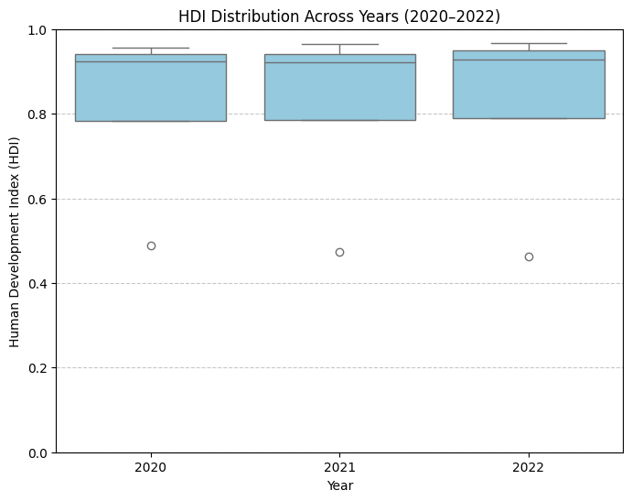

Figure 4: Average HDI by Region (2020-2022)
Bar chart comparing regional average HDI across the three years.
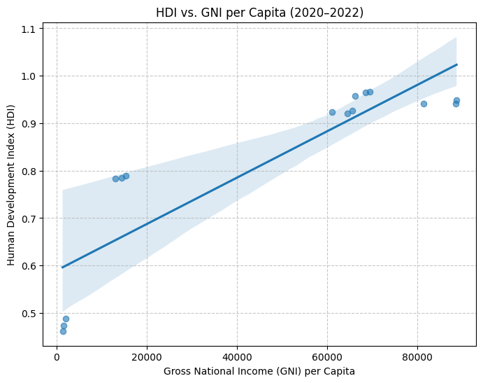

Figure 5: HDI Distribution Box Plot (2020-2022)
Box plot showing the spread and central tendency of HDI for each year.
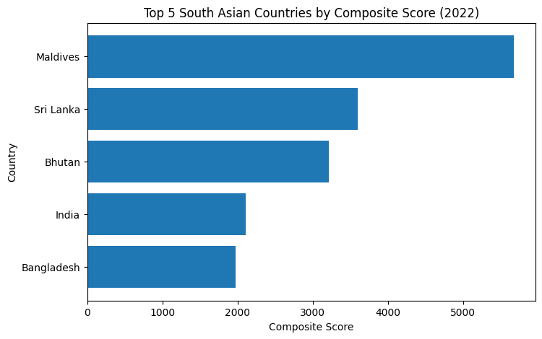

Figure 6: HDI vs GNI per Capita Scatter Plot
Scatter plot with regression line showing the relationship between HDI and economic wealth.
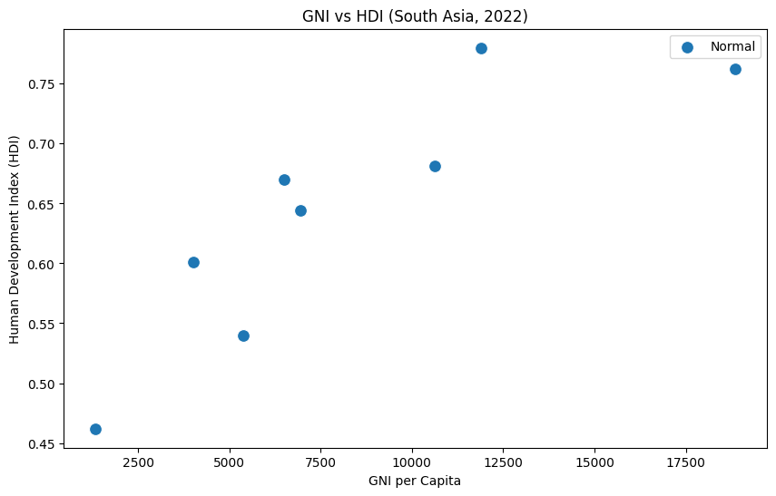

5.4 Interpretation and Discussion
The period 20202022 refers to the effects of the COVID-19 pandemic on human development. The countries with the robust economies and high health systems had the least decrease in HDI, and the weaker countries suffered loss of more in terms of health and education. The association between income and HDI is logarithmic in nature with initial increase in income resulting in a large increase in the HDIs but the gains diminish after higher income levels indicating that even income will not support human development past a certain threshold. Regional disparity has been perpetuated with Sub-Saharan Africa and South Asia having significantly lower averages in HDI scores, which highlights the significance of policy-specific interventions and global assistance.

6. Problem 2 – Advanced HDI Exploration (South Asia)

6.1 Methods and Approach
The advanced analysis focused on South Asian countries with the following methodology:
- Regional Subset Creation: Filtered data for eight South Asian countries
- Composite Score Development: Created weighted index combining life expectancy and GNI per capita
- Outlier Detection: Applied 1.5×IQR rule to identify statistical anomalies
- Correlation Analysis: Computed Pearson correlations between HDI and component metrics
- Gap Analysis: Developed GNI-HDI gap metric to identify development efficiency

6.2 Key Results
- South Asian HDI Range: The region shows moderate HDI diversity, ranging from Afghanistan (0.474) to Sri Lanka (0.780). This 0.306-point spread indicates significant intra-regional development disparities.
- Composite Score Rankings: Sri Lanka and Maldives consistently rank highest on both the composite score and official HDI, confirming strong performance across health, education, and income dimensions.
- Notable Outliers: Afghanistan and Pakistan emerge as outliers in different metrics—Afghanistan due to extremely low HDI, and certain data points showing unusual GNI-HDI relationships suggesting institutional or measurement factors.

6.3 Visualizations and Tables
Figure 7: Top 5 South Asian Countries by Composite Score
Horizontal bar chart ranking countries by the weighted composite development score.
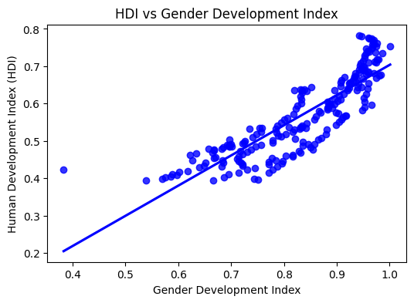

Figure 8: Outlier Detection - GNI per Capita vs HDI
Scatter plot highlighting statistical outliers in the South Asian dataset.
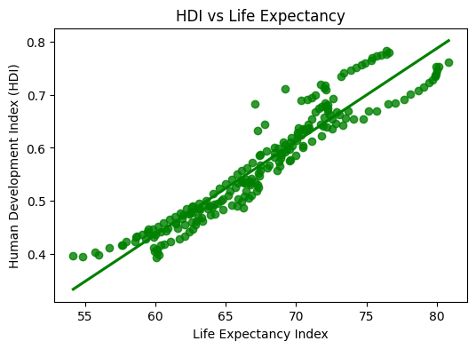

Figure 9: Correlation Analysis - HDI Components
Scatter plots with trendlines showing relationships between HDI and gender development index, and HDI and life expectancy.
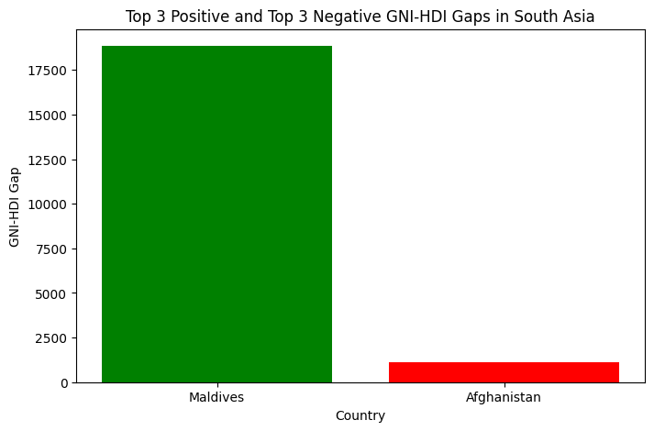

Figure 10: GNI-HDI Gap Analysis
Bar chart showing positive and negative gaps between economic wealth and human development.
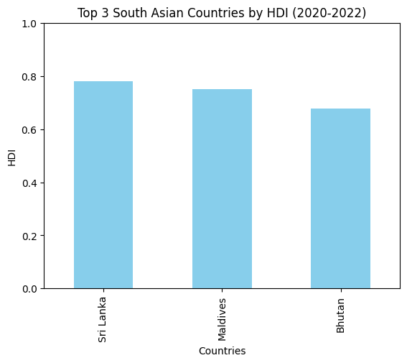

6.4 Interpretation and Discussion
- Development Efficiency: The composite score analysis reveals that Sri Lanka achieves high human development (0.780 HDI) with relatively moderate income levels, suggesting efficient resource allocation toward health and education. This contrasts with countries that have higher GNI but lower HDI scores.
- Correlation Insights: Strong positive correlations between HDI and both gender development (r > 0.85) and life expectancy (r > 0.90) confirm these as critical development drivers. This suggests that investments in gender equality and healthcare infrastructure yield substantial human development returns.
- Gap Analysis Implications: Countries with large positive GNI-HDI gaps (high income, lower HDI) may face governance challenges or resource misallocation. Conversely, those with negative gaps demonstrate exemplary development efficiency, achieving high HDI with limited economic resources.
- Policy Recommendations: South Asian countries should prioritize investments in education (particularly female education), healthcare infrastructure, and governance reforms to improve development efficiency and close intra-regional gaps.

7. Problem 3 – Comparative Regional Analysis: South Asia vs Middle East

7.1 Methods and Approach
The comparative analysis employed the following methodology:
- Regional Subset Creation: Filtered data for South Asia (8 countries) and Middle East (14 countries)
- Descriptive Statistics: Computed mean, standard deviation, and coefficient of variation
- Top/Bottom Performers: Identified best and worst performing countries in each region
- Metric Comparisons: Analyzed gender development, life expectancy, and GNI per capita
- Disparity Analysis: Calculated HDI range and coefficient of variation
- Correlation Analysis: Examined HDI relationships with component metrics by region
- Outlier Detection: Identified statistical anomalies in both regions

7.2 Key Results
Table: Regional HDI Comparison (2020-2022)
Metric | South Asia | Middle East
Mean HDI | 0.640 | 0.789
Standard Deviation | 0.098 | 0.141
Coefficient of Variation | 0.154 | 0.179

Regional Performance Gap: The Middle East demonstrates a significantly higher average HDI (0.789) compared to South Asia (0.640), a difference of 0.149 points. This gap reflects Middle Eastern resource wealth and earlier developmental investments.
Internal Inequality: While the Middle East has higher average HDI, it also shows greater internal inequality (CV = 0.179 vs 0.154), indicating more pronounced disparities within the region—primarily due to conflict-affected nations like Yemen.

7.3 Visualizations and Tables
Figure 11: Top and Bottom Performers Comparison
Bar chart comparing the top 3 and bottom 3 countries from each region.
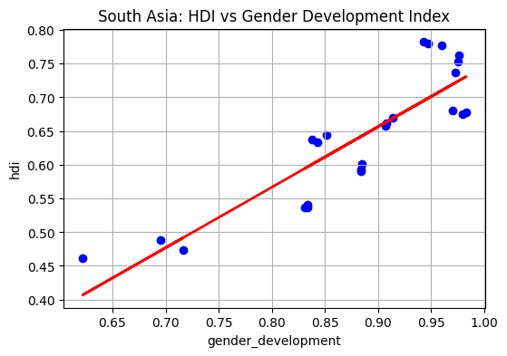

Figure 12: Metric Comparisons by Region
Grouped bar chart showing Gender Development Index, Life Expectancy, and GNI per Capita across regions.
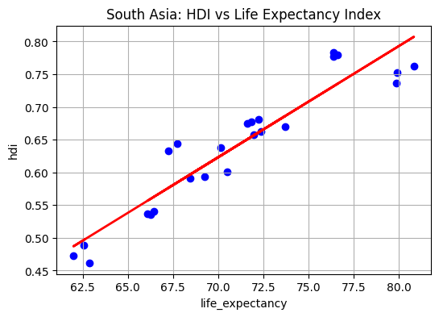

Figure 13: HDI Distribution Box Plot by Region
Box plot comparing HDI spread and central tendency between the two regions.
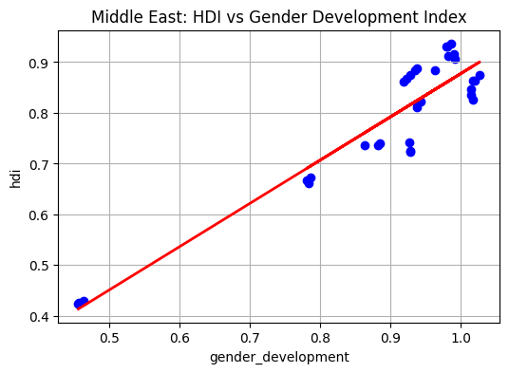

Figure 14: Correlation Scatter Plots by Region
Scatter plots with trendlines showing HDI relationships with gender development and life expectancy for both regions.
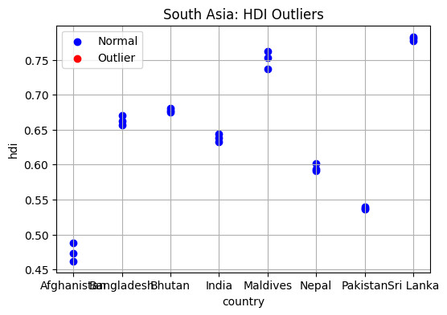

Figure 15: Outlier Detection by Region
Scatter plot highlighting statistical outliers in both South Asia and Middle East.
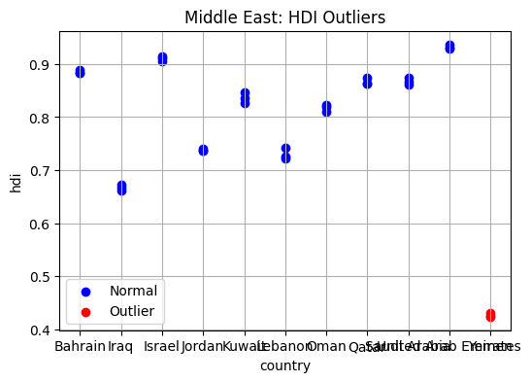

7.4 Interpretation and Discussion
- Regional Performance: The Middle East's superior average HDI (0.789 vs 0.640) across all dimensions reflects its resource wealth, particularly in oil-rich nations. However, this advantage comes with greater inequality (SD = 0.141 vs 0.098).
- Largest Disparity: GNI per capita shows the greatest difference (+0.203), reflecting the Middle East's oil wealth. However, this economic advantage doesn't translate proportionally to HDI, suggesting that resource wealth alone doesn't guarantee optimal human development.
- Top Performers Analysis: In the Middle East, UAE, Israel, and Bahrain all exceed 0.88 HDI, demonstrating successful conversion of economic resources into human development. In South Asia, Sri Lanka and Maldives lead but remain below 0.80, indicating room for improvement despite progress.
- Bottom Performers Analysis: Yemen (0.426) in the Middle East and Afghanistan (0.474) in South Asia are extreme outliers due to prolonged conflict and instability. Their positions demonstrate how violence and governance failures can severely disrupt development.
- Correlation Patterns: Both regions show very strong correlations between HDI and both gender development (r > 0.85) and life expectancy (r > 0.90), confirming these as universal development drivers regardless of regional context.
- Outlier Significance: Yemen's outlier status highlights how conflict can create extreme disparities within otherwise prosperous regions. Its HDI (0.426) is closer to sub-Saharan African levels than to its regional neighbors.
Policy Implications:
- South Asia: Needs broad-based improvements across all development dimensions, with particular focus on education and healthcare infrastructure
- Middle East: Should focus on reducing intra-regional inequalities and ensuring resource wealth benefits all segments of society
- Conflict-Affected Nations: Require special attention, including humanitarian assistance, peacekeeping, and post-conflict reconstruction
- Gender Equality: Strong correlation with HDI suggests this should be a priority area for both regions, particularly in South Asia

8. Conclusion

8.1 Summary of Findings

The global average HDI is 0.723 in 2022, which means that development overall is in the High category, but hides sharp inequalities. In Somalia, the lowest HDI is 0.380 and in Switzerland, the highest is 0.967 with approximately 30.9% of the nations having a development that is very high and 20.6% of countries are not developed. The COVID-19 pandemic influenced countries unequally between 2020 and 2022, with countries most affected being those with strong health systems, with the most notable examples being Afghanistan, which fell to 0.488 in 2020, and 0.462 in 2022; and Syria, which saw an increase by 0.255 and 0.391 respectively. At the regional level, Middle East is doing better in average HDI, beating South Asia (0.789 vs 0.640) but with higher internal inequality with Yemen and Afghanistan as the most striking laggards. By and large, this is substantiated by findings in that income as a factor alone cannot be considered to lead to high human development because countries such as Switzerland and Norway rank higher than wealthier countries due to their better investments in health and education.

8.2 Insights About HDI Trends and Disparities
Persistent Global Inequality: Despite overall progress in human development over recent decades, large gaps persist between high- and low-ranked countries. These disparities are driven by unequal access to healthcare, education, and economic opportunities, as well as differences in governance quality and institutional capacity.
Regional Development Patterns:

Middle East has more yet unequal human development, which is largely conditioned by reliance on resources and geopolitical state of affairs. Although oil wealth has an economic benefit, it does not always translate to a corresponding improvement in the HDI. South Asia on the other hand has uniform but lower development levels which implies that broad-based investments are necessary to allow convergence of the region. The 20202022 is indicative of the fact that global crises may derail the development process, especially in nations with less developed institutions, and the need to have the strong health system and social protection. Also, the existing gaps in gender and environmental information indicates the necessity to have better data gathering and enhanced statistical power, particularly in the developing nations.

8.3 Limitations
Methodological Limitations:
- Snapshot Analysis: Single-year and short-term analyses may not reflect long-term trends or capture the full trajectory of development
- Aggregate Metrics: HDI may mask within-country inequalities, urban-rural divides, and sector-specific issues
- Regional Filtering: Careful attention was required to filter out regional aggregates to avoid double-counting
- Missing Disaggregated Data: Limited gender and environmental data restricts deeper intersectional analysis
Dataset Limitations:
- Timeliness: 2022 data may not reflect most recent developments (2023-2026)
- Consistency: Some metrics have higher missing rates in certain regions, potentially biasing regional comparisons
- Contextual Factors: HDI doesn't capture political stability, environmental sustainability, happiness, or cultural factors that influence well-being

8.4 Recommendations and Implications
For Policymakers:
- Targeted Interventions: Low-HDI countries need focused investments in healthcare infrastructure, education systems, and economic diversification
- Inclusive Growth: Regions with large internal disparities should promote policies that reduce inequality and ensure resource benefits reach all population segments
- Gender Equality: Strong HDI-GDI correlation suggests gender equality should be prioritized as a development accelerator
- Conflict Resolution: Special attention needed for conflict-affected nations like Yemen and Afghanistan, including humanitarian assistance and post-conflict reconstruction
For Data Systems:

Enhancing the human development analysis must be done through the way of better gender-disaggregated and environmental data collection and matching methodologies that would facilitate comparability among countries and regions. Responsive and effective policy-making requires timely reporting of data. In development terms, the multidimensional strategies need to be given priority in such a way that economic development is then converted into physical improvement of health and education helped by increased regional co-operation and sharing of knowledge. Targeted international assistance, technical cooperation, and collective best practices, which are consistent with sustainable development goals, at the global level play a major role in ensuring that inclusive and sustainable development is encouraged, especially in the lagging regions.

8.5 Final Reflection
The Human Development Index is a useful tool in comparing the situation with development in the countries and shedding light on the achievements and the problems that still exist. Although the situation has improved in most countries, there are still high levels of inequalities both within and across territories. The results verify that economic growth is not sufficient in the achievement of development, effective governance, investment in human capabilities, and gender equality are equally significant. To attain inclusive and sustainable development, the balanced growth will be achieved through the effective health, education, and social protection systems as well as enhanced data transparency and collaborative efforts on an international level.

9. References
United Nations Development Programme. (2023). Human Development Report 2021-2022. UNDP.
United Nations. (2015). Transforming our world: the 2030 Agenda for Sustainable Development. UN General Assembly.
Sen, A. (1999). Development as Freedom. Oxford University Press.
Hickel, J. (2020). The Sustainable Development Index: Measuring the ecological efficiency of human development in the anthropocene. Ecological Economics, 167.
World Bank. (2023). World Development Indicators. World Bank Group.
Data source: "Human_Development_Index_Dataset.csv" by Lucas Yukiolmafuko (provided for assignment)

