Assignment: Using ImageNet-pretrained ResNet for cat vs dog classification → just replace and train the last classification layer so that it can detect objects such as car, truck, bicycle and a pedestrian.
Resnet18 model downloaded to path: C:\Users\bijay/.cache\torch\hub\checkpoints\resnet18-f37072fd.pth

Size before test:


Size After test:
After testing, I did not see any size increase for the model (may be due to the dataset is small : 20 images each set)
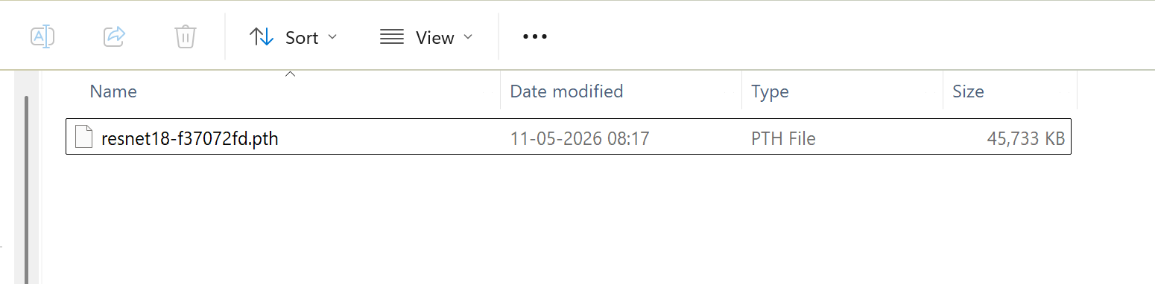

(tlresnet18) PS C:\BIJAY\GenAI\TL_ResNet18> python .\TL_main.py
Epoch [1/5]
Loss: 4.8854
Training Accuracy: 22.50%
Epoch [2/5]
Loss: 3.7632
Training Accuracy: 45.00%
Epoch [3/5]
Loss: 3.3471
Training Accuracy: 52.50%
Epoch [4/5]
Loss: 2.7653
Training Accuracy: 80.00%
Epoch [5/5]
Loss: 2.2627
Training Accuracy: 83.75%
Model saved successfully!
(tlresnet18) PS C:\BIJAY\GenAI\TL_ResNet18>

Model Testing:
Test-1: For car image
# Load image
image = Image.open("dataset/validation/car/test1.jpg").convert("RGB")

(tlresnet18) PS C:\BIJAY\GenAI\TL_ResNet18> python .\TL_test_image.py
Predicted Class: car

Test-2: For truck image
image = Image.open("dataset/validation/truck/test1.jpg").convert("RGB")

(tlresnet18) PS C:\BIJAY\GenAI\TL_ResNet18> python .\TL_test_image.py
Predicted Class: truck

Test-3: For bicycle image
image = Image.open("dataset/validation/bicycle/test1.jpg").convert("RGB")

(tlresnet18) PS C:\BIJAY\GenAI\TL_ResNet18> python .\TL_test_image.py
Predicted Class: bicycle

Test-4: For pedestrian image
image = Image.open("dataset/validation/pedestrian/test1.jpg").convert("RGB")

(tlresnet18) PS C:\BIJAY\GenAI\TL_ResNet18> python .\TL_test_image.py
Predicted Class: pedestrian

