For Level-4 Silver_assignment:

Assignment -1: Install autogpt in your desktop and run a agent on the desktop by giving a simple goal. send me a screenshot of the output

Already done the demo of AutoGPT to Guru in one session. Attaching the output screenshot here.
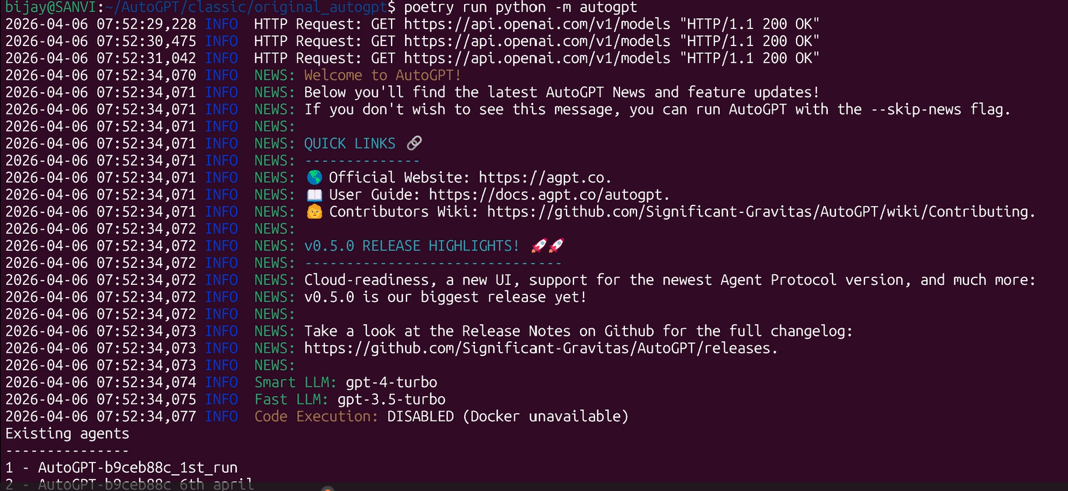
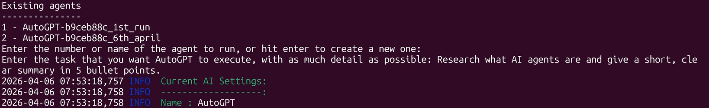
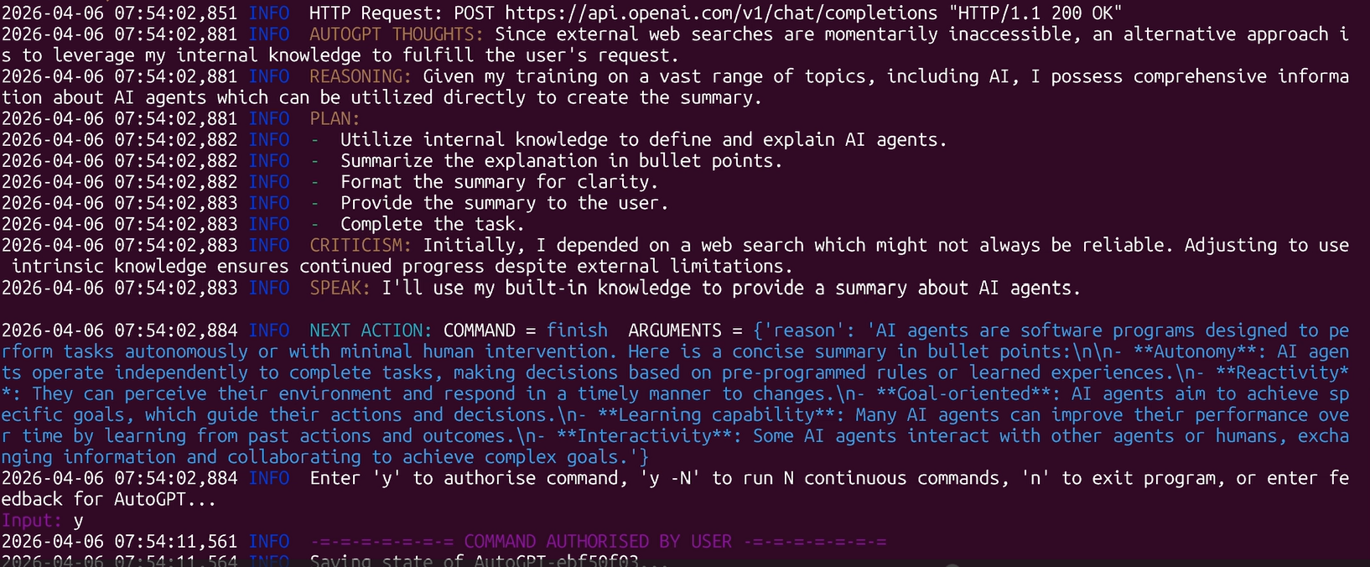

Final Output:
