ShieldSense - Week 3 Progress
Model & Evaluation
Student: Kapil Thapa Magar
Role: Model & Evaluation Lead

1. Introduction
ShieldSense is a proof-of-concept application designed to screen short SMS or chat messages for possible scam indicators and classify them as Low, Medium or High risk.
In Week 3, my work focused on the Model & Evaluation component. I reviewed scam indicators relevant to ShieldSense, designed and implemented an initial transparent rules-based baseline in Python, and tested it using sample messages. The baseline can later be compared with the TF-IDF and Logistic Regression classifier.
At this stage, the scoring rules and thresholds are proposed only and may be changed after discussion with the team and supervisor.

2. Proposed Scam Indicators for the Baseline
Scam Indicator | Example | Proposed Baseline Treatment
Urgency | “Act now”, “urgent”, “immediately” | Detect urgency-related words
Financial request | “Make payment”, “bank transfer” | Flag financial/payment language
Sensitive information | “Enter your PIN/password” | Flag requests for sensitive information
Suspicious link | Unknown URL in message | Detect presence of URL
Reward/prize | “You have won a prize” | Detect reward-related language
Account threat | “Your account will be suspended” | Detect account-warning language
Impersonation | Claiming to be a bank/company | Consider trusted-organisation claims
These indicators can occur individually or together. Therefore, the baseline should consider multiple indicators rather than classifying a message based only on one suspicious word.

3. Proposed Rules-Based Baseline
For the first baseline, I am considering a simple scoring approach:
Indicator | Proposed Score
Urgency language | +1
Financial/payment request | +2
Sensitive information request | +3
Suspicious URL | +2
Prize/reward language | +2
Account threat/warning | +2
Proposed initial classification: 0-1 points = Low Risk; 2-4 points = Medium Risk; 5 or more points = High Risk.
These scores and thresholds are not final or approved. They are an initial design that can be tested and adjusted after reviewing the agreed risk taxonomy, dataset and supervisor feedback.

4. Example Baseline Tests
Example Message | Indicators | Score | Proposed Result
Hi, are we still meeting at 4pm? | None | 0 | Low
Your payment is overdue. Please check your account. | Financial/payment | 2 | Medium
Congratulations! You have won a prize. | Reward/prize | 2 | Medium
Urgent! Your account has been suspended. Verify your password using http://example.com. | Urgency + sensitive information + URL + account threat | 6 | High

5. Evaluation Approach
As Model & Evaluation Lead, I also need to establish how the baseline will be evaluated.
- Accuracy - how many messages are classified correctly overall.
- Precision - how reliable the predictions are for a particular risk category.
- Recall - how many relevant messages the model successfully identifies.
- F1-score - provides a balance between precision and recall.
- Confusion matrix - shows where Low, Medium and High messages are classified correctly or incorrectly.
- Error analysis - review misclassified messages to understand why errors occur.

6. Week 3 Python Work - What I Need to Do
I implemented a small working rules-based baseline in Python and tested it using four sample messages representing Low, Medium and High risk. The baseline produced risk scores, classifications and explanations for detected indicators. The code and terminal output are retained as Week 3 evidence.
- Create a project folder called model_evaluation and a Week 3 evidence folder.
- Create a Python file named rules_baseline.py.
- Add lists of proposed keywords for urgency, financial requests, sensitive information, prizes/rewards and account warnings.
- Add a URL detector using a regular expression.
- Create a classify_message() function that calculates the proposed score and returns Low, Medium or High risk.
- Test the function with several Low, Medium and High example messages.
- Check whether the output makes sense. Record any obvious incorrect classifications as limitations rather than hiding them.
- Take a screenshot of the Python code and a screenshot of the terminal/output for Week 3 evidence.
- Commit the code and documentation to GitHub using clear commit messages.
- Discuss the proposed rules and thresholds with the team/supervisor before treating them as final.

Python file: rules_baseline.py
import re
URGENCY_WORDS = [
"urgent", "immediately", "act now", "limited time"
]
FINANCIAL_WORDS = [
"payment", "bank account", "transfer", "pay now"
]
SENSITIVE_INFO_WORDS = [
"password", "pin", "card details", "bank details"
]
PRIZE_WORDS = [
"winner", "prize", "claim reward", "congratulations"
]
THREAT_WORDS = [
"account suspended", "account blocked",
"account locked", "final warning"
]
def contains_keyword(message, keywords):
message = message.lower()
return any(keyword in message for keyword in keywords)
def contains_url(message):
url_pattern = r"https?://\S+|www\.\S+"
return bool(re.search(url_pattern, message.lower()))
def classify_message(message):
score = 0
reasons = []
if contains_keyword(message, URGENCY_WORDS):
score += 1
reasons.append("Urgency language detected")
if contains_keyword(message, FINANCIAL_WORDS):
score += 2
reasons.append("Financial/payment language detected")
if contains_keyword(message, SENSITIVE_INFO_WORDS):
score += 3
reasons.append("Request for sensitive information detected")
if contains_url(message):
score += 2
reasons.append("URL detected")
if contains_keyword(message, PRIZE_WORDS):
score += 2
reasons.append("Prize/reward language detected")
if contains_keyword(message, THREAT_WORDS):
score += 2
reasons.append("Threat or account-warning language detected")
# Proposed thresholds - subject to team/supervisor review
if score >= 5:
risk = "HIGH"
elif score >= 2:
risk = "MEDIUM"
else:
risk = "LOW"
return {
"message": message,
"score": score,
"risk": risk,
"reasons": reasons
}
if __name__ == "__main__":
test_messages = [
"Hi, are we still meeting at 4pm today?",
"Your payment is overdue. Please check your account.",
"Congratulations! You have won a prize.",
"URGENT! Your account has been suspended. "
"Verify your password immediately at http://example.com"
]
for message in test_messages:
result = classify_message(message)
print("\nMessage:", result["message"])
print("Score:", result["score"])
print("Risk:", result["risk"])
print("Reasons:", result["reasons"])

How to run it
1. Open VS Code and open your ShieldSense project folder.
2. Create the model_evaluation folder and create rules_baseline.py inside it.
3. Paste the Python code above and save the file.
4. Open Terminal in VS Code.
5. Run: python rules_baseline.py
6. Check the printed score, risk and reasons for each test message.
7. Take screenshots of the code and terminal output as evidence.

Initial Limitation Identified
During testing, the phrase “account has been suspended” was not detected by the current account-warning rule because the keyword list contains the exact phrase “account suspended”. This demonstrates a limitation of exact keyword matching. The rule will be refined and tested further after reviewing the agreed taxonomy and team feedback.

Figure 1. Week 3 Python baseline test output
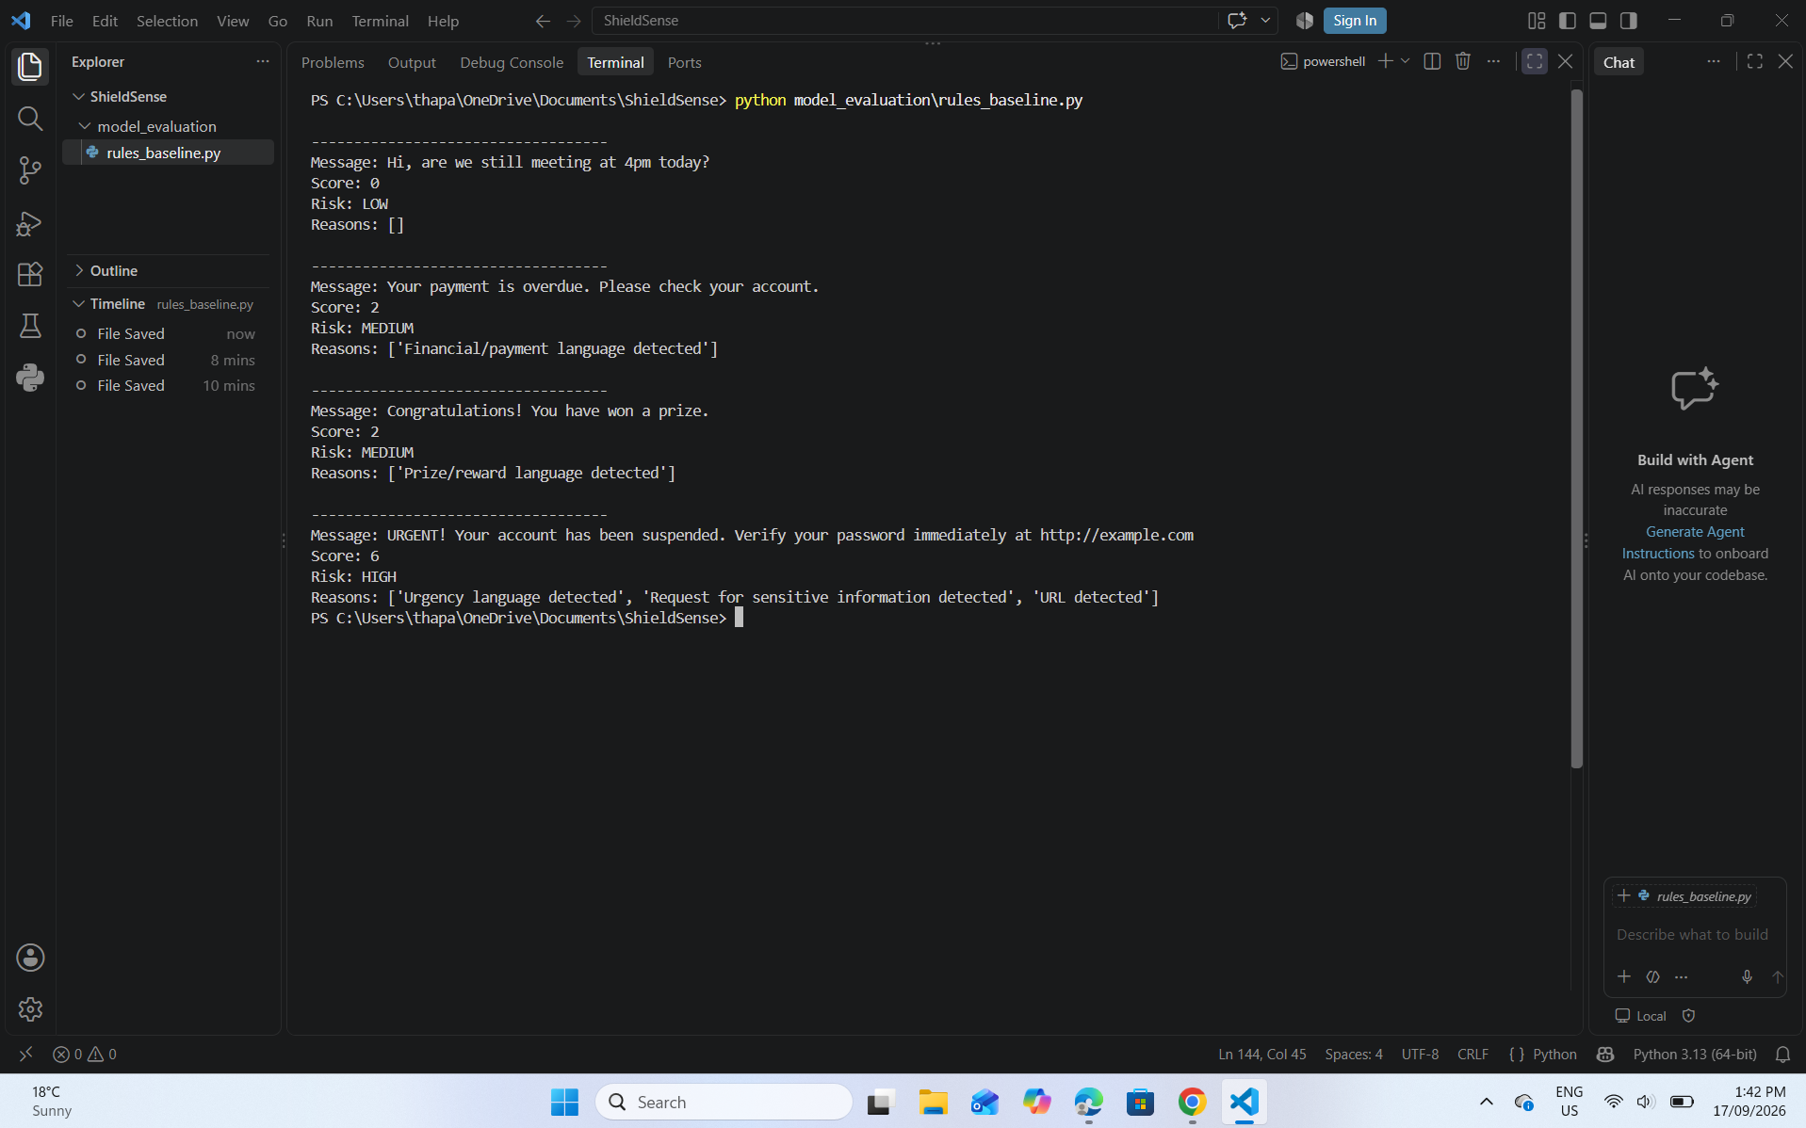
The test output shows a normal message classified as LOW (score 0), two suspicious examples classified as MEDIUM (score 2), and the urgent account/password/link example classified as HIGH (score 6).

7. Dependencies on Other Team Roles
Jaskaran Singh - Data & Labelling Lead: the final risk taxonomy, labelled dataset and held-out test data will support model development and evaluation.
Alisha - Interface & Accessibility Lead: the model's Low/Medium/High result and explanation need to be presented clearly through the interface.
Bijay Bahadur Chhetri - Integration, Documentation & QA Lead: the classification output will later need to be integrated consistently with the interface and tested as part of the complete application.

8. Next Steps
- Discuss the proposed baseline indicators with the team.
- Align the rules with the final risk taxonomy.
- Refine and test the rules-based baseline in Python.
- Record test results and identify weaknesses in the initial rules.
- Save development evidence in GitHub.
- Prepare for the TF-IDF and Logistic Regression classifier in the next stage.

9. What to Say in Today's Online Meeting
“For Week 3, I focused on my Model & Evaluation role. I translated the proposed scam indicators into an initial rules-based baseline in Python and tested it with sample messages. The baseline produced Low, Medium and High classifications with explanations. The scores are not final yet because I still need to align them with Jaskaran’s taxonomy and team/supervisor feedback. Testing also identified a limitation with exact keyword matching, which I will refine. I have also planned the later evaluation using accuracy, precision, recall, F1-score, a confusion matrix and error analysis.”

10. Week 3 Evidence Checklist
☑ Week 3 progress document
☑ rules_baseline.py
☑ Screenshot of Python code
☑ Screenshot of terminal test output
☐ GitHub commit(s)
☑ Short note about limitations or changes needed after testing
☐ Any feedback received from the team/supervisor

11. Conclusion
My Week 3 work converted the proposed scam indicators into an initial transparent and testable rules-based baseline for ShieldSense. The baseline was implemented in Python and tested using sample messages. The current scoring system remains an initial proposal rather than an approved final model. Testing identified an exact-keyword-matching limitation that will be refined using the agreed taxonomy and team feedback before the baseline is compared with the trained TF-IDF and Logistic Regression classifier.

