DEPARTMENT OF COMPUTER SCIENCE AND ENGINEERING

CSE -5162 Program Lab (ADSAL)

**Mini Project Report On:  
  
DISJOINT SET**

*Submitted by:*

Bijay Regmi

210913032

M-Tech(CSE)

*Under the guidance of:*

Mr. Gururaj

Assistant Professor -Selection Grade

Department of Computer Science & Engineering

**DESCRIPTION**

A disjoint-set data structure maintains a collection *S = {S1, S2, …, Sk}* of disjoint dynamic sets. We identify each set by a representative, which is some member of the set. As in implementation of dynamic-set we always represent each element of a set by an object. Letting *x* denote an object, it supports the following operations:

*MAKE-SET(x)* creates a new set whose only member (and thus representative) is *x*. Since the sets are disjoint, we require that *x* not already be in some other set.

*UNION(x , y)* unites the dynamic sets that contain *x* and *y*, say *Sx* and *Sy*, into a new set that is the union of these two sets. We assume that the two sets are disjoint prior to the operation. The representative of the resulting set is any member of *Sx*∪*Sy*, although many implementations of *UNION* specifically choose the representative of either *Sx* or *Sy* as the new representative. Since we require the sets in the collection to be disjoint, conceptually we destroy sets *Sx* and *Sy* , removing them from the collection S. In practice, we often absorb the elements of one of the sets into the other set.

*FINDSET(x*) returns a pointer to the representative of the (unique) set containing *x*.

Let *n* be the number of *MAKE-SET* operations, and *m*, the total number of *MAKE-SET*, *UNION*, and *FIND-SET* operations. Since the sets are disjoint, each *UNION* operation reduces the number of sets by one. After *n - 1 UNION* operations, therefore, only one set remains. The number of UNION operations is thus at most *n - 1*. Note also that since the *MAKE-SET* operations are included in the total number of operations m, we have *m ≥ n*. We assume that the *n* *MAKE-SET* operations are the first *n* operations performed.

**LINKED LIST REPRESENTATION OF DISJOINT SET**

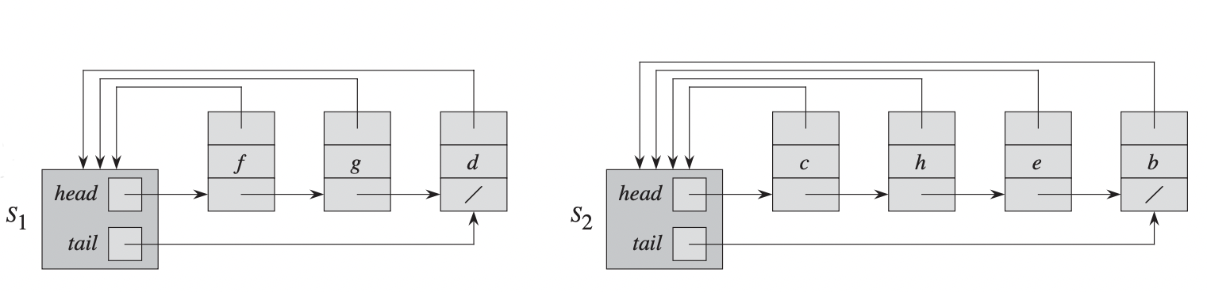

**Fig 1.** Linked-list representations of two sets *S1*and *S2*.

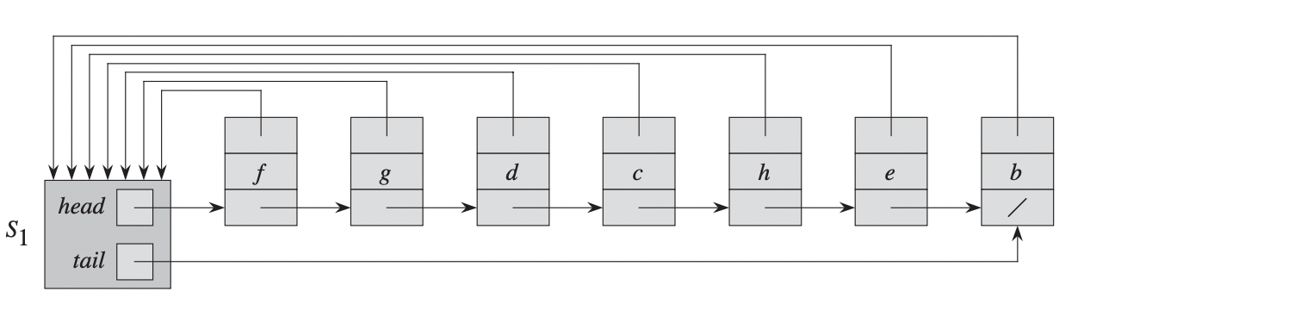

**Fig. 2** *UNION* of set *S1* and *S2*

Figure 1 represents set *S1* contains members *d , f* , and *g*, with representative f , and set *S2* contains members *b, c, e*, and *h*, with representative c. Each object in the list contains a set member, a pointer to the next object in the list, and a pointer back to the set object. Each set object has pointers head and tail to the first and last objects, respectively.

Figure 2 The result of *UNION(g , e)*, which appends the linked list containing e to the linked list containing g. The representative of the resulting set is *f* . The set object for *e*’s list, *S2*, is destroyed.

**ALGORITHM**

CONNECTED-COMPONENTS*(G)*

1. **for** each vertex *v ∈ G.V*
2. MAKE-SET*(V)*
3. **for** each vertex *(u* , *v) ∈ G.E*
4. **if** FIND-SET*(u)* ≠ FIND-SET*(v)*
5. UNION*(u , v)*

SAME-COMPONENT*(u , v)*

1. **if** FIND-SET*(u)* == FIND-SET*(v)*
2. **return** TRUE
3. **else return** FALSE

MAKE-SET*(x)*

1. Create empty set *S*
2. Insert *x* to *S*
3. **return** *S*

UNION*(Sx , Sy)*

1. **for** each y *∈ Sy*
2. **if** *y* ∉ *Sx*
3. Insert *y* to *Sx*
4. Make *Sy* empty set
5. **return** *Sx*

FIND*(x)*

1. **for** each *S* in *G.S*
2. **if** *x ∈ S*
3. **return** *S*

**ANALYSIS**

The simplest implementation of the *UNION* operation using the linked-list set representation takes significantly more time than *MAKE-SET* or *FIND-SET*. We can easily construct a sequence of m operations on *n* objects that requires Θ*(n2)* time. Suppose that we have objects *x1, x2, … ,xn*. We execute the sequence of *n MAKE-SET* operations followed by *n - 1 UNION* operations shown in Figure 3, so that *m=2n-1*. We spend Θ*(n)* time performing the *n MAKE-SET* operations. Because the *ith UNION* operation updates *i* objects, the total number of objects updated by all *n -1 UNION* operations is

**Fig 3**. A sequence of *2n - 1* operations on *n* objects that takes Θ*(n2*) time, or Θ*(n*) time per operation on average, using the linked-list set representation and the simple implementation of *UNION*.

The total number of operations is *2n - 1*, and so each operation on average requires Θ*(n*) time. That is, the amortized time of an operation is Θ*(n*).

**A WEIGHTED-UNION HEURISTIC**

In the worst case, the above implementation of the *UNION* procedure requires an average of Θ*(n*) time per call because we may be appending a longer list onto a shorter list; we must update the pointer to the set object for each member of the longer list. Suppose instead that each list also includes the length of the list (which we can easily maintain) and that we always append the shorter list onto the longer, breaking ties arbitrarily. With this simple ***weighted-union heuristic***, a single *UNION* operation can still take Ω*(n)* time if both sets have Ω*(n)* members. A sequence of *m* *MAKE-SET*, *UNION*, and *FIND-SET* operations, *n* of which are *MAKE-SET* operations, takes **Ο*(m + n* lg *n)*** time.

Each *UNION* operation unites two disjoint sets, we perform at most *n - 1 UNION* operations over all. We now bound the total time taken by these *UNION* operations. Consider a particular object *x*. We know that each time *x’*s pointer was updated, *x* must have started in the smaller set. The first time *x’*s pointer was updated, therefore, the resulting set must have had at least 2 members. Similarly, the next time *x’*s pointer was updated, the resulting set must have had at least 4 members. Continuing on, we observe that for any *k* ≤ *n*, after x’s pointer has been updated ⎡lg *k*⎤ times, the resulting set must have at least *k* members. Since the largest set has at most *n* members, each object’s pointer is updated at most ⎡lg *n*⎤ times over all the *UNION* operations. Thus the total time spent updating object pointers over all *UNION* operations is Ο*(n* lg *n)* .We must Θ(1) also account for updating the tail pointers and the list lengths, which take only time per *UNION* operation. The total time spent in all *UNION* operations is thus Ο*(n* lg *n).*

The time for the entire sequence of *m* operations follows easily. Each MAKE- SET and FIND-SET operation takes Ο(1) time, and there are Ο(*m*) of them. The total time for the entire sequence is thus **Ο*(m + n* lg *n).***

**EXAMPLE**

Undirected graph given in the Figure 4 has vertices *V = {a, b, c, d, e, f, g, h, i, j, k}* and edges *E = {(d, i), (f, k), (g, i), (b, g), (a, h), (i, j), (d, k), (b, j), (d, f), (g, j), (a, e)*}.

**Fig. 4** Undirected graph with four connected components *{a, b, c, d}, {e, f, g}, {h,i}, {j}*

**Fig. 5** The collection of disjoint sets after processing each edge.

**SOURCE CODE**

#include<stdio.h>

#include<stdlib.h>

#define MAX 20

*// Structure of Edge*

typedef struct Edge{

char source, destination;

}edge;

*// Structure of Node*

typedef struct Node{

char data;

struct Node *next;

}node;

*// Structure of Set*

typedef struct Set{

node *head;

int cardinal;

}set;

*// Finds whether key(int) is present in s(set) or not*

node* findData(set *s, char key){

if(s->cardinal == 0)

return NULL;

node *temp = s->head;

while(temp){

if(temp->data == key)

return temp;

temp=temp->next;

}

return NULL;

}

*// Adds Item n to the Set s*

void addItem(set *s, int data){

node *n = (node *)malloc(sizeof(node));

n->next = NULL;

n->data = data;

if(s->head == NULL){

s->head = n;

s->cardinal += 1;

return;

}

node *temp = s->head;

while(temp->next){

temp = temp->next;

}

temp->next = n;

s->cardinal += 1;

}

*// Union of Set s1 and s2*

set * unionOperation(set *s1, set *s2){

if(s2->cardinal == 0)

return s1;

node *temp2 = s2->head;

// Traversing through Set 1

while(temp2){

if(findData(s1,temp2->data) == NULL)

addItem(s1,temp2->data);

temp2 = temp2->next;

}

return s1;

}

*// Make a new set for given Vertex*

set * makeSet(char data){

set *s = (set*)malloc(sizeof(set));

node *newNode = (node*)malloc(sizeof(node));

newNode->data = data;

newNode->next = NULL;

s->head = newNode;

s->cardinal = 1;

return s;

}

*// Returns sets from allSets[MAX]*

int findSet(set *allSets[MAX], int noOfVertices, char key){

for (int i=0; i<noOfVertices; i++){

if(findData(allSets[i],key))

return i;

}

return -1;

}

*// Prints set*

void printSet(set *s){

if(s->cardinal == 0){

printf(" {} ");

return;

}

node *temp = s->head->next;

printf(" { %c",s->head->data);

while(temp){

printf(", %c", temp->data);

temp=temp->next;

}

printf(" } ");

}

*// Makes s(set) Empty*

void makeEmpty(set *s){

node *temp = s->head, *temp1;

while(temp){

temp1=temp;

temp = temp->next;

free(temp1);

}

s->cardinal = 0;

s->head = NULL;

}

*// Finds index of the vertes form all vertices*

int findIndex(char *vertices, int n, char key){

for(int i=0; i<n; i++){

if(key == vertices[i]){

return i;

}

}

return -1;

}

//Main Function

int main(){

*// Taking input for vertices and edges*

int noOfVertices = 10, noOfEdges = 6, i, j;

printf("\nEnter total number of Vertex : ");

scanf("%d",&noOfVertices);

char *vertices = (char*)malloc(noOfVertices * sizeof(char));

set *allSets[MAX];

printf("\nEnter all Vertices : ");

for(i=0; i<noOfVertices; i++){

scanf("%s",&vertices[i]);

allSets[i] = makeSet(vertices[i]);

}

printf("\nEnter total number of Edge : ");

scanf("%d",&noOfEdges);

edge *edges = (edge*)malloc(noOfEdges * sizeof(edge));

printf("\nEnter all Edges (Source and Destination):\n");

for(i=0; i<noOfEdges; i++){

scanf("%s",&edges[i].source);

scanf("%s",&edges[i].destination);

}

*// Printing vertices and edges*

printf("\n\nVertices(V) : %c",vertices[0]);

for(i=1; i<noOfVertices; i++)

printf(", %c",vertices[i]);

printf("\nEdges(E) : (%c,%c)", edges[0].source,

edges[0].destination);

for(i=1; i<noOfEdges; i++){

printf(", (%c, %c)", edges[i].source, edges[i].destination);

}

int sIndex, dIndex;

*// Looping through all the edges*

for(i=0; i<noOfEdges; i++){

sIndex = findIndex(vertices, noOfVertices, edges[i].source);

dIndex = findIndex(vertices, noOfVertices,

edges[i].destination);

if(allSets[sIndex]->cardinal == 0){

sIndex = findSet(allSets, noOfVertices, edges[i].source);

}

if(allSets[dIndex]->cardinal ==0){

dIndex = findSet(allSets, noOfVertices,

edges[i].destination);

}

unionOperation(allSets[sIndex], allSets[dIndex]);

if(sIndex != dIndex)

makeEmpty(allSets[dIndex]);

}

*// Printing all non empty sets*

printf("\n\n\nDISJOINT SETS : ");

for(i=0; i<noOfVertices; i++){

if(allSets[i]->cardinal != 0){

printSet(allSets[i]);

printf(",");

}

}

printf("\n\n");

return 0;

}

**INPUT/OUTPUT**

