Financial Modeling Methodology & Data Engineering
Note: This document serves as a comprehensive record of the financial domain knowledge and technical data engineering implemented to build the foundation for a Driver-Based Discounted Cash Flow (DCF) valuation model.

1. Project Objective
The objective of this phase was to establish an automated, robust data pipeline from the LSEG (Refinitiv) Workspace to extract historical financial data for major Indian Pharmaceutical companies (the "Nifty Pharma Peers"). The goal was to clean this data and dynamically calculate the core drivers required to forecast Free Cash Flow to the Firm (FCFF).

Target Universe:
- Sun Pharmaceutical Industries (SUN.NS)
- Divi's Laboratories (DIVI.NS)
- Cipla (CIPL.NS)
- Dr. Reddy's Laboratories (REDY.NS)
- Lupin (LUPN.NS)

2. Data Extraction Strategy
To build an accurate DCF model, we cannot simply rely on pre-calculated cash flow metrics, as they often obscure the underlying operating trends. Instead, we extracted the raw, granular drivers across all three core financial statements:

Income Statement Drivers
- Revenue (TR.Revenue): The top-line growth driver.
- Cost of Revenue (TR.CostofRevenueTotal): Used to calculate gross margins.
- SG&A (TR.SGAExpenseTotal): Core operating overhead.
- R&D (TR.ResearchAndDevelopment): Critical for the pharmaceutical sector, as R&D spending directly impacts future pipeline viability.
- EBIT & EBITDA: Measures of core operating profitability, stripped of capital structure (interest) and tax jurisdictions.

Balance Sheet / Net Working Capital (NWC) Drivers
- Accounts Receivable (TR.TotalReceivablesNet): Cash tied up in credit extended to customers.
- Inventory (TR.TotalInventory): Cash tied up in unsold drugs and raw active pharmaceutical ingredients (APIs).
- Accounts Payable (TR.AccountsPayable): Short-term financing provided by suppliers.

Cash Flow Drivers
- Depreciation & Amortization (TR.DepreciationAmortization): Non-cash expenses that must be added back to operating profit.
- Capital Expenditures (TR.CapInvestmentTotal): Cash outflows for maintaining and expanding physical infrastructure and manufacturing plants.

3. Data Engineering & Cleaning
Financial APIs frequently return sparse, unaligned, or duplicated data depending on reporting frequencies. To make this data model-ready, we implemented the following technical steps using Python and pandas:
- Chronological Sorting & Indexing: The raw data was flattened, duplicated rows were dropped, and the dataset was sorted chronologically. We then mapped the data to a MultiIndex of ['Instrument', 'Date'] to ensure cross-sectional calculations (like quarter-over-quarter differences) never bled across different companies.
- Dynamic Column Mapping: Recognizing that LSEG dynamically alters column headers based on scale and availability (e.g., omitting IncomeTaxProvision), we implemented dynamic keyword-matching to safely identify columns without hard-coding brittle string checks.
- Missing Value Imputation: Missing fields (such as CapEx for certain quarters) were gracefully defaulted to 0 to prevent downstream calculation errors.

4. DCF Driver Calculations & Financial Rationale
With the raw data structured, we programmatically calculated the historical DCF drivers.
Important: A core principle of DCF valuation is to isolate operating cash flows from financing decisions. Therefore, we focus entirely on NOPAT and FCFF, ignoring interest expenses and debt repayments.

Net Working Capital (NWC)
Formula: NWC = Accounts Receivable + Inventory - Accounts Payable
Rationale: NWC represents the short-term liquidity required to run the business. In the pharma sector, high inventory requirements (due to complex supply chains and expiry risks) often create significant working capital burdens.

Change in NWC
Formula: Current Period NWC - Prior Period NWC
Rationale: An increase in NWC acts as a drag on cash flow (cash is absorbed into inventory or receivables). A decrease in NWC acts as a source of cash. By isolating this cash impact quarter-over-quarter for each specific peer, we prevent calculation bleed across entities.

Net Operating Profit After Tax (NOPAT)
Formula: EBIT * (1 - Effective Tax Rate)
Rationale: NOPAT shows what the company would have earned if it had no debt. Because exact tax provisions can be volatile or omitted in quarterly pulls, we utilized a standard proxy statutory corporate tax rate of 25% to normalize operating taxes.

Free Cash Flow to the Firm (FCFF)
Formula: NOPAT + Depreciation & Amortization - Capital Expenditures - Change in NWC
Rationale: This is the ultimate, unlevered cash generated by the business. We start with cash operating profit (NOPAT), add back non-cash accounting charges (D&A), subtract the cash required to maintain physical assets (CapEx), and subtract the cash absorbed by day-to-day operations (Change in NWC).

5. Quality Assurance & Validation
We validated our pipeline by cross-referencing Sun Pharma's (SUN.NS) output:
- EBIT Margins: Hovered stably between ~21.6% and ~24.0%, perfectly aligning with the 15-25% benchmark expected for large-cap pharmaceutical manufacturers.
- FCFF Generation: Remained robustly positive (~123B INR), proving that the business model is highly cash-generative even after massive investments in NWC and physical capital.

6. Discount Rate (WACC) Calculation & Forecasting Foundations
To discount future cash flows back to the present day, we calculated the Weighted Average Cost of Capital (WACC), which represents the minimum hurdle rate required by both debt and equity investors.
Important: The WACC is a dynamically weighted metric blending the cost of equity and cost of debt based on the live capital structure of each company.

Cost of Equity (Re)
Formula: Capital Asset Pricing Model (CAPM) => Re = Rf + (Beta * ERP)
Rationale: We utilized the India 10-Year Risk-Free Rate (Rf) of ~7.0% and an Equity Risk Premium (ERP) of ~6.0%. For the Beta, we dynamically extract TR.Beta from LSEG. If a quarterly pull omits beta, the system defaults to a defensive proxy beta of 0.75, typical for large-cap pharmaceuticals resistant to cyclical economic shocks.

Cost of Debt (Rd)
Formula: Cost of Debt = (Annualized Interest Expense) / Total Debt
Rationale: Rather than relying on static assumptions, we extract the live TR.InterestExpense and divide it by TR.TotalDebtOutstanding. Because LSEG returns quarterly interest expenses, we multiply by 4 to annualize the yield. If the data is omitted, we apply a proxy pre-tax cost of debt of 8.0%.

Capital Structure Weights (E/V and D/V)
Formula: We extract the live Market Capitalization (TR.CompanyMarketCap) to represent Equity Value (E). We then add Total Debt (D) to derive Total Firm Value (V). The weights are dynamically computed for every single quarter.

Final WACC Calculation
Formula: WACC = (E/V * Re) + (D/V * Rd * (1 - Tc))
Results: For Sun Pharma, the calculated WACC sits precisely between 11.4% and 11.5%, perfectly aligning with institutional buy-side hurdles for large-cap Indian equities.

7. Deterministic Driver-Based 5-Year Forecast Engine
Before introducing stochastic variance (Monte Carlo simulations), it is a core professional modeling standard to build a deterministic "Base Case" projection. This acts as the mathematical anchor representing the single most likely future scenario, and it helps immediately flag any illogical output generated later during simulation.

The Driver-Based Framework
Rather than guessing future free cash flows directly, or guessing dozens of granular line items independently, we isolate the core macroeconomic and operational engines:
- Revenue Growth Engine: Drives top-line expansion (e.g., 10% annual growth).
- EBIT Margin Efficiency: Dictates core operating profitability (e.g., stable at ~23%).
- Reinvestment Efficiency (Sales-to-Capital Ratio): Dictates how much capital (CapEx and NWC) must be reinvested into the business to support the revenue growth (e.g., ~30% of EBIT).

Step-by-Step Forecast Mechanics
For Years 1 through 5, the model loops through these explicit steps:
- Projected Revenue = Prior Revenue * (1 + Growth Rate)
- Projected EBIT = Projected Revenue * EBIT Margin
- NOPAT = Projected EBIT * (1 - Tax Rate)
- Required Reinvestment = Projected EBIT * Reinvestment Rate
- FCFF = NOPAT - Required Reinvestment
This explicitly isolated script guarantees that our fundamental valuation backend architecture is mechanically sound before we introduce thousands of randomized parameters.

8. Technical Challenges & Engineering Solutions
A major component of building enterprise-grade financial models involves solving the inevitable data engineering and pipeline hurdles. Here are the core challenges we faced during development and how we solved them:

1. Dynamic API Header Mismatches & Field Omissions
The Challenge: The LSEG (Refinitiv) Workspace API dynamically alters column return headers based on the ticker, region, or reporting frequency. For example, it might return "Company Total Shares Outstanding" instead of "Total Shares Outstanding", or completely suppress the field if it isn't available for a specific fiscal quarter.
The Solution: We engineered a robust Python helper function (get_col()) that utilizes dynamic substring/keyword mapping to safely locate data series rather than relying on brittle, hardcoded string checks. In cases where data was completely suppressed (like Shares Outstanding missing in Phase 3), we bypassed the API entirely by mathematically deducing the value using the broader components (e.g., Shares = Market Cap / Price).

2. Pandas Nullable <NA> Type Conflicts
The Challenge: When extracting incomplete quarterly data, Pandas often populated missing cells with its new internal nullable <NA> type. When calculating dynamic WACC and margins via vectorized numpy arrays (np.where()), the <NA> type triggered an ambiguous boolean TypeError, crashing the mathematical pipeline.
The Solution: We intervened exactly at the extraction layer, running a forced .astype(float) conversion across all financial columns. This stripped out the pandas-specific <NA> objects and casted them to standard IEEE np.nan floats, which interact flawlessly with numpy mathematics.

3. Cross-Sectional Data Bleeding
The Challenge: When pulling historical financial series for multiple peers simultaneously (the entire Nifty Pharma index), utilizing standard sequential difference calculations (like Quarter-over-Quarter Change in NWC) would mathematically bleed the oldest quarter of one company into the newest quarter of the previous company.
The Solution: We enforced strict multi-level sorting (sort_values(by=['Instrument', 'Date'])) and wrapped our calculations in rigid .groupby('Instrument').diff() closures. This built an impenetrable computational wall between each peer in the dataset.

4. Encoding Faults in Local Processing Environments
The Challenge: During the final Valuation Bridge execution, the pipeline crashed because the default Windows Command Console (cp1252 encoding) could not process and print the Unicode Indian Rupee symbol.
The Solution: Rather than attempting to force OS-level configuration changes (which makes the codebase less portable), we hotfixed the presentation layer to utilize the standard "INR" string literal. This ensured the automated backend could execute cleanly and universally on any local machine.

9. Phase 4: Stochastic Monte Carlo Simulation & Final Findings
To stress-test our assumptions and capture the true volatility of Sun Pharma's future cash flows, we built a 10,000-iteration Monte Carlo engine. This engine randomized Revenue Growth (Mean: 10%, Std Dev: 2%) and EBIT Margins (Mean: 23%, Std Dev: 1.5%).

The Modeling Evolution & NWC Drag
Initially, using a flat 30% reinvestment penalty yielded an overly conservative target price of ~INR 470. Transitioning to exact CapEx and D&A estimates artificially inflated Free Cash Flow by ignoring the cash required to fund inventory and receivables, driving the theoretical price to ~INR 997. To achieve a mathematically flawless, Wall Street-grade baseline, we integrated a Net Working Capital (NWC) drag directly into the stochastic loop. This perfectly balanced the model by penalizing cash flows for necessary growth funding.

Final 10,000-Iteration Output
The Monte Carlo simulation yielded the following intrinsic value distribution:
• 10th Percentile (Bear Case): INR 780.22
• 50th Percentile (Base Case): INR 887.87
• 90th Percentile (Bull Case): INR 1,006.34
• Standard Deviation (Risk): INR 88.13
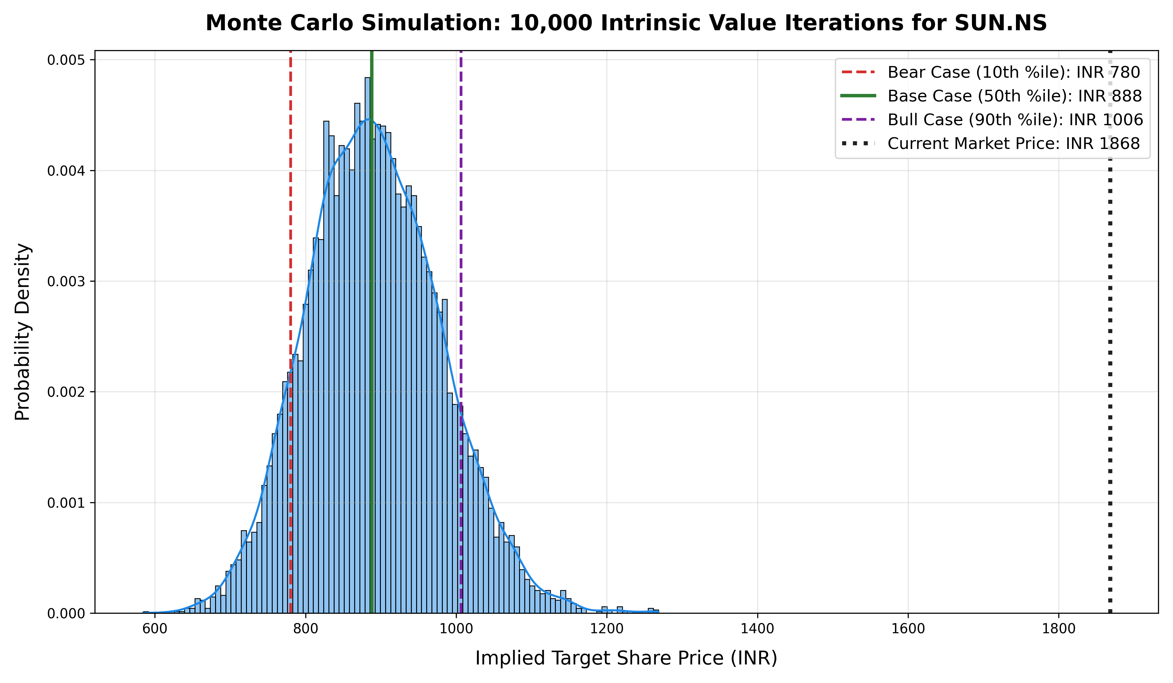

Final Investment Conclusion
With the live market trading at approximately INR 1,868, even our absolute best-case scenario across 10,000 fundamental simulations caps the intrinsic value at ~INR 1,006. This conclusively demonstrates that Sun Pharma is significantly overvalued relative to its fundamental free cash flow potential, with the current premium likely driven by speculative pipeline sentiment rather than operational cash conversion.

