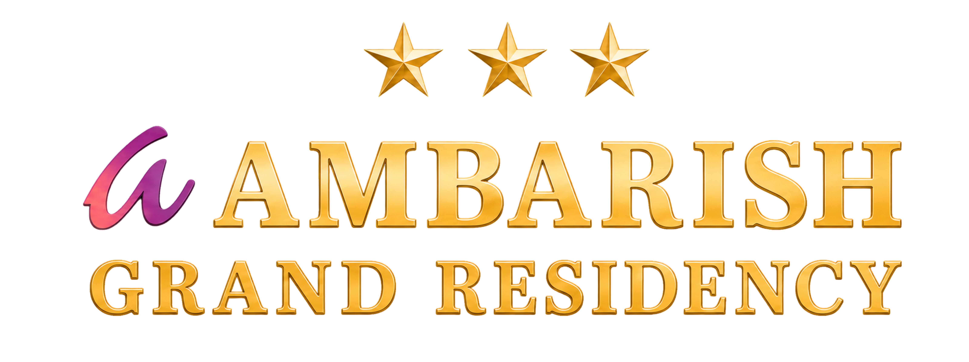
DIGITAL EXPERIENCE BLUEPRINT
UI & Interaction
Design Specification
Modern minimalism, image-led storytelling and motion that feels effortless.
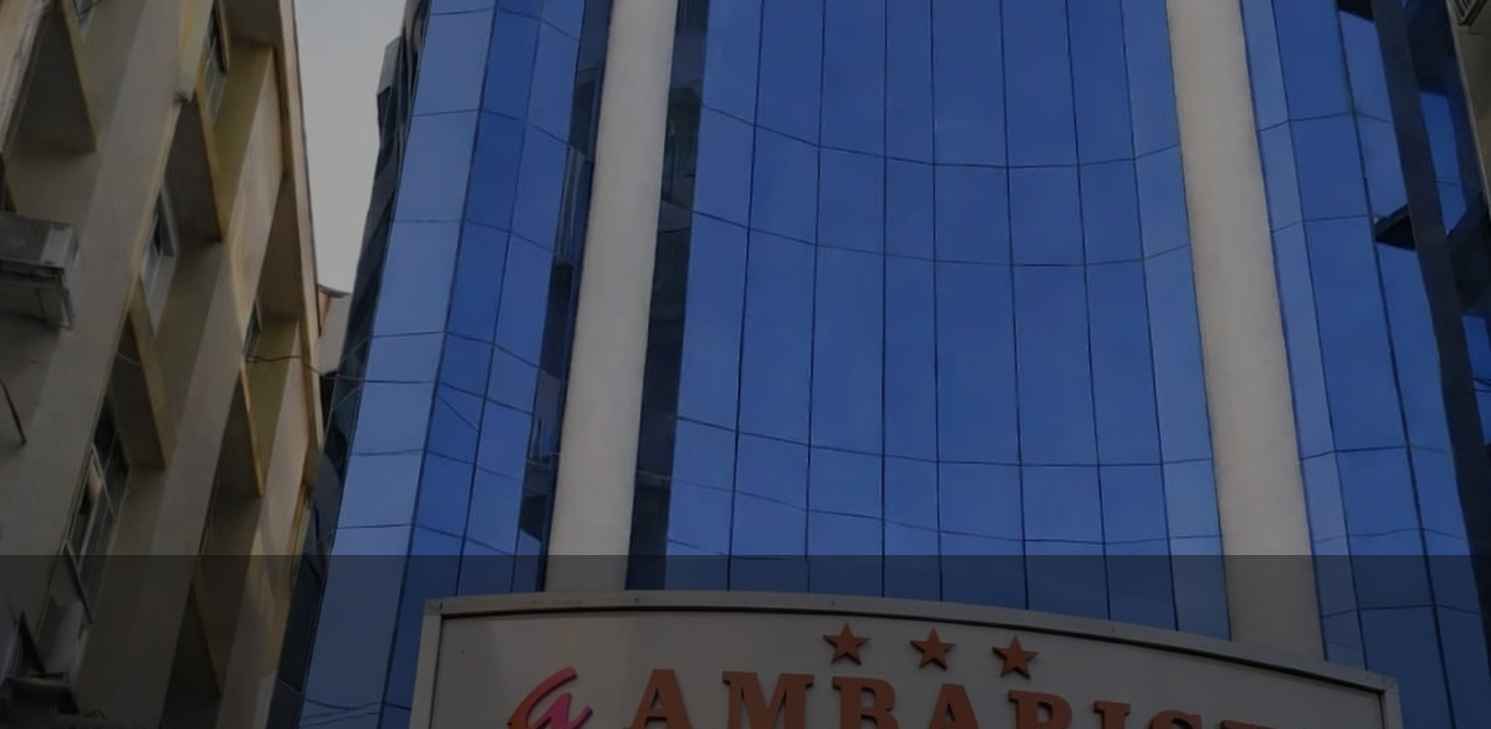
FLOATING NAVIGATION • RESPONSIVE LAYOUT • RESTRAINED PARALLAX
Version 1.0 | 21 August 2026 | Specification only - website build not started

1. Creative Direction
DESIGN INTENT The site should feel calm, premium and contemporary without pretending to be a luxury property. Real hotel photography leads; typography, spacing and motion quietly organise the experience.

1.1 Experience principles
Principle | Expression in the interface
Image first | Use large authentic photographs as the primary emotional and factual proof.
Minimal but useful | Remove decorative clutter while keeping booking, phone, location and policies immediately available.
Elegant restraint | Cream space, near-black surfaces, slim gold rules and a small magenta action accent.
Motion with purpose | Animation confirms hierarchy and continuity; it never delays reading or booking.
Mobile as a first-class layout | Every component is designed for touch, narrow screens and uncertain network conditions.

1.2 Visual moodboard
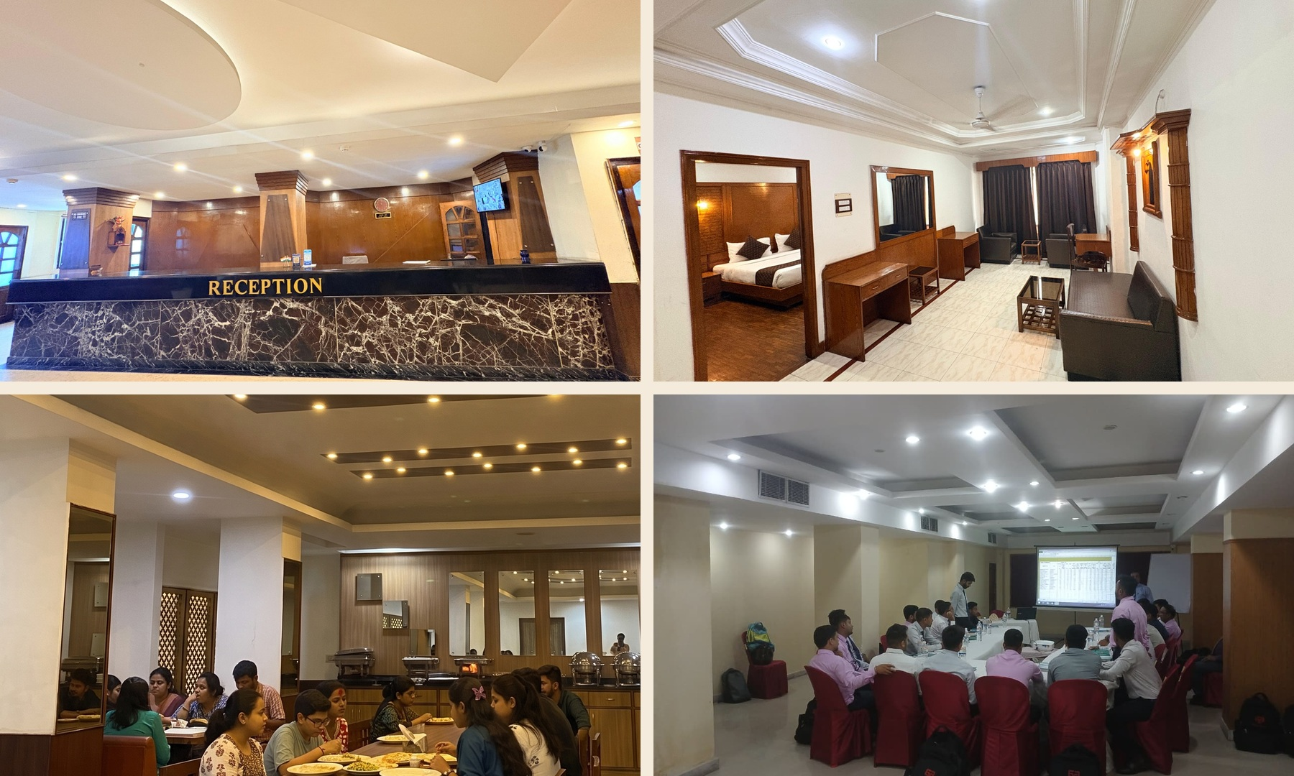
Authentic material cues: warm wood, cream surfaces, burgundy textiles, soft lighting and business-ready spaces.

2. Minimal Visual System

2.1 Colour roles
Token | Value | Use
Ink | #0C0B0B | Floating nav, footer, high-contrast text and image overlays
Warm cream | #F5EBDD | Page background, calm section bands and card surfaces
Hotel gold | #B4872F | Rules, focus details, icons and quiet emphasis
Brand magenta | #B62576 | Primary booking action and active-state accent only
Charcoal | #171414 | Secondary dark panels and modal surfaces

2.2 Typography
- Display serif. Cormorant Garamond, DM Serif Display or a comparable editorial serif for hero and major section headings.
- Interface sans. Inter, Manrope or a comparable highly legible sans serif for navigation, booking controls, forms and body copy.
- Desktop scale. Hero 56-72 px; H1 44-56; H2 30-40; body 16-18; labels 12-14 with modest tracking.
- Mobile scale. Hero 38-46 px; H1 34-40; H2 26-32; body 16-17; never reduce essential controls below 14 px.
- Line length. Keep narrative copy around 55-70 characters per line and use short, direct paragraphs.

2.3 Spacing and shape
- Use an 8 px spacing grid with generous 80-120 px desktop section padding and 48-72 px mobile padding.
- Content max-width: 1200-1320 px; text columns usually 560-680 px.
- Card radius: 16-20 px. Floating nav radius: 18-24 px. Buttons: 12-16 px or pill only for compact actions.
- Use shadows sparingly: soft, low-opacity elevation for the floating nav and active overlays only.

2.4 Image treatment
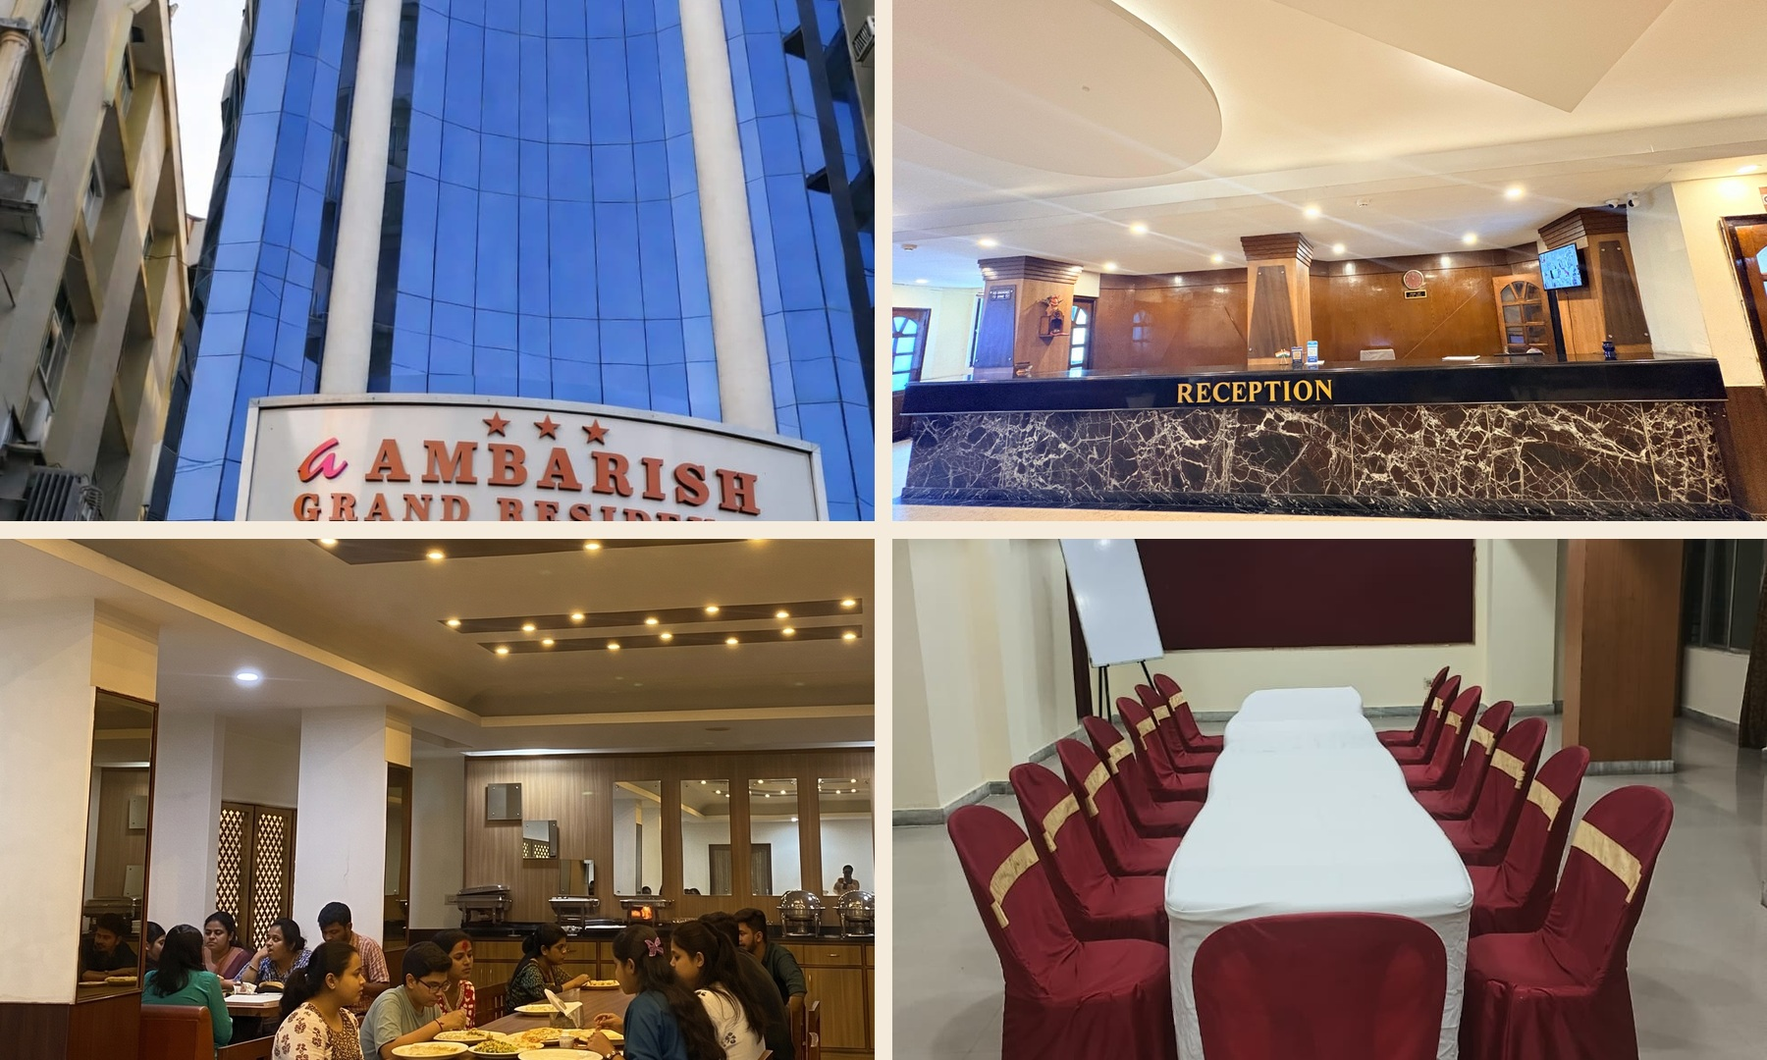
The visual system should frame the real property, not overpower it.

3. Floating Navigation System
PRIMARY BEHAVIOUR The navigation begins as a clean overlay or top bar, then becomes a compact floating capsule as the visitor scrolls. It stays visible without feeling heavy, and its booking action remains immediately reachable.

3.1 Desktop anatomy
Zone | Content | Behaviour
Left | Compact hotel logo | Links to home; reduces slightly after scroll
Centre | Rooms, Dining, Meetings, Gallery, Location | Active section indicator; six or fewer visible destinations
Right | Call icon + Check availability | Magenta primary action; clear keyboard focus

3.2 Scroll states
- At page top. Transparent or near-transparent over the hero when contrast is safe; 24-32 px horizontal page inset.
- After 48-80 px scroll. Compress height to 64-72 px, detach from the viewport edge and become a floating near-black/blurred surface.
- Scrolling down quickly. Remain visible but reduce visual weight; do not repeatedly hide and reveal on small scroll reversals.
- Scrolling upward. Restore full clarity within 180-220 ms and keep the current section highlighted.
- At footer. Stay above content and mobile safe-area insets; never cover legal links or form actions.

3.3 Motion specification
Property | Specification
Transition | 180-240 ms for size, position and surface changes
Easing | cubic-bezier(0.22, 1, 0.36, 1) for entrances; ease-out for short state changes
Movement | Translate no more than 12-20 px; avoid spring bounce
Surface | Backdrop blur 14-20 px where supported, plus a stable opaque fallback
Performance | Animate transform and opacity; avoid layout-triggering top/height animation when possible

4. Image-Led Homepage Composition

Hero direction: one decisive image, not an autoplay carousel.

4.1 Hero
- Use the strongest exterior or room image edge-to-edge with a restrained left-to-right or bottom gradient for text contrast.
- Headline: one or two lines. Supporting copy: one sentence. Actions: Check availability and Call hotel.
- Booking search may sit immediately below the hero on desktop and become a full-width compact panel on mobile.
- Use responsive focal points so signage, beds and important furniture are never accidentally cropped.

4.2 Recommended section rhythm
Sequence | Layout treatment | Motion
Hero | Full-bleed image + compact copy | Subtle image scale 1.02→1.00; content fade/raise
Trust strip | Check-in/out, location, 3-star positioning | Fast stagger under 120 ms total
Rooms | One large feature + two supporting cards | Reveal on entry; no card tilt
Suite story | Alternating image/text with generous cream space | Optional slow background offset
Dining | Wide restaurant image with short copy | Masked reveal or opacity only
Business | Conference image and event CTA | Static image; concise text movement
Location/CTA | Map preview, phone and booking | No parallax near forms or map controls

5. Photography and Content Framing
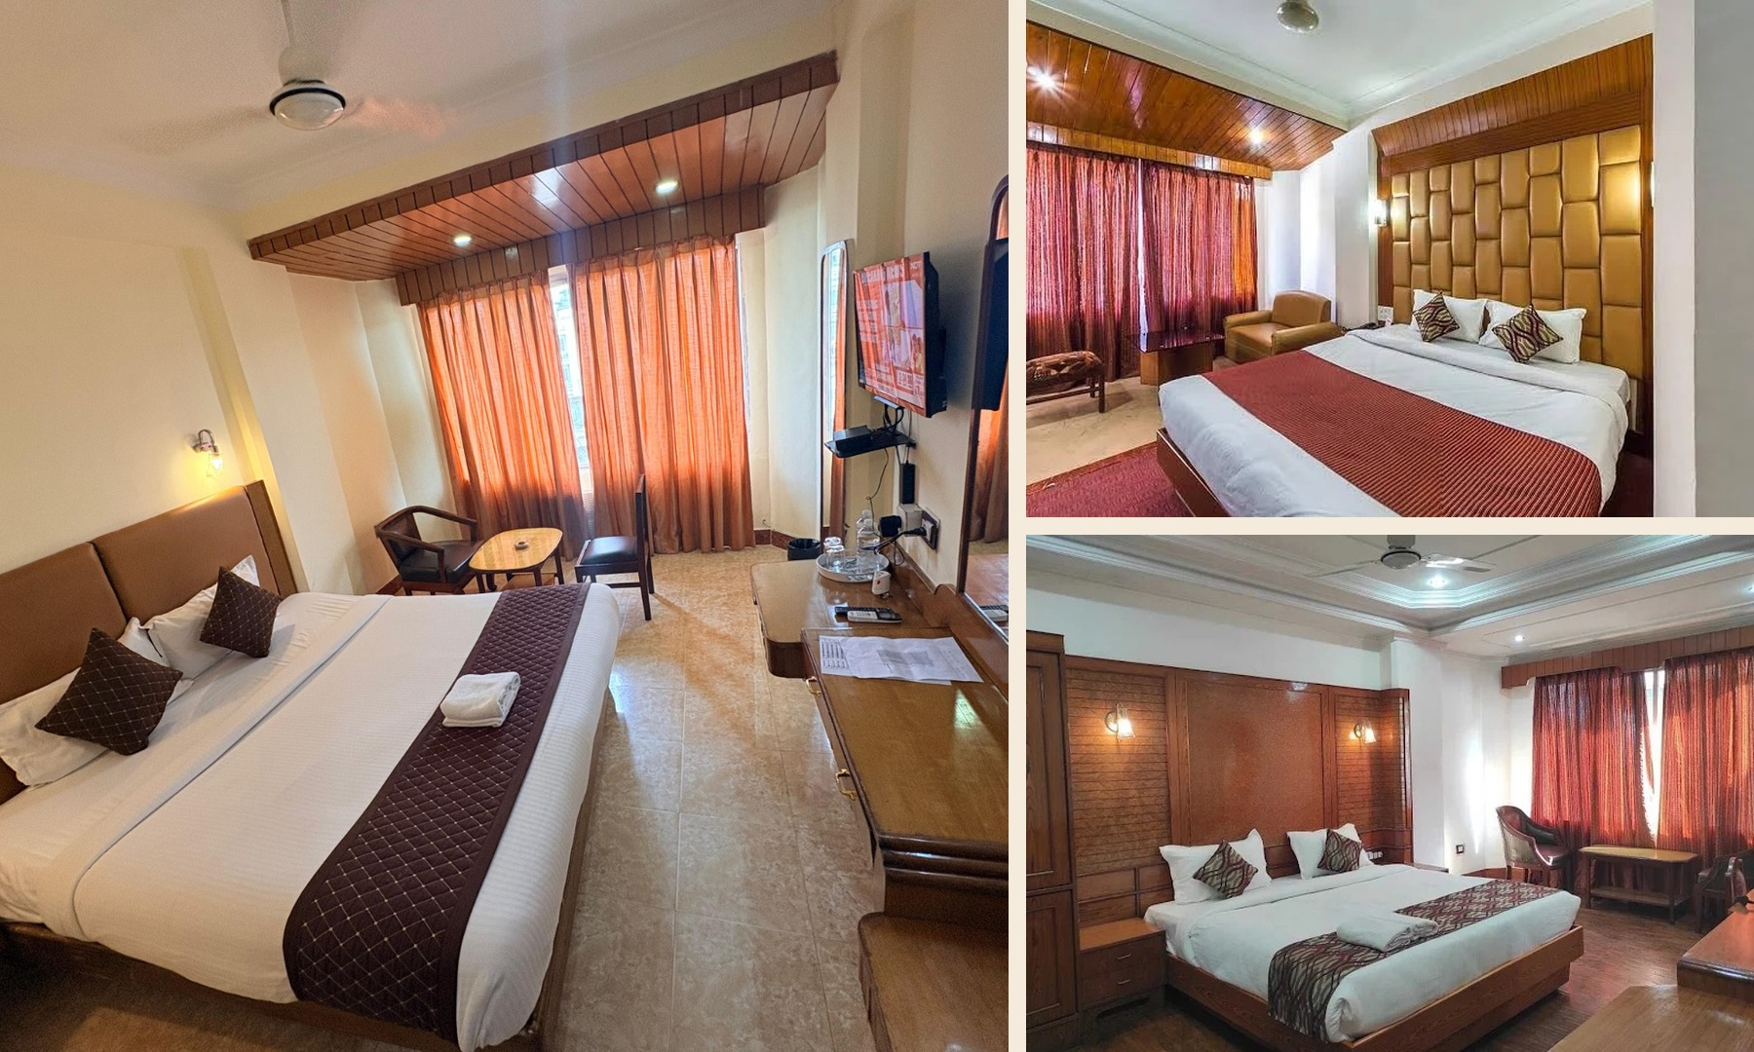
Room imagery should preserve spatial context and accurately match each bookable category.

5.1 Image hierarchy
- Homepage: 8-12 selected images maximum before lazy-loaded gallery content.
- Room cards: landscape 4:3 or 3:2. Hero: responsive 16:9/4:3/portrait crops from the same approved master.
- Use real reception, dining and conference photography as proof; do not fabricate facilities or add synthetic architectural details.
- Correct exposure, white balance and perspective modestly. Preserve the recognisable room and furniture arrangement.
- Every meaningful image requires specific alternative text; decorative texture uses empty alt text.

5.2 Image loading
- Serve AVIF/WebP with JPEG fallback, responsive srcset and explicit dimensions.
- Preload only the selected hero image. Lazy-load below-the-fold images near the viewport.
- Use low-quality placeholders or dominant-colour surfaces without causing layout shift.
- Target source masters at 2400 px or wider; generate crops automatically but review them manually before launch.

6. Fully Responsive Behaviour
Viewport | Layout rules
320-479 px | Single column; 20 px side padding; 44 px minimum targets; sticky bottom booking/call bar; compact logo.
480-767 px | Single column with wider media; selective two-up chips; booking search in stacked fields.
768-1023 px | Two-column cards where useful; floating tablet nav; balanced image/text sections.
1024-1439 px | Full floating navigation; 2-3 column grids; split editorial sections.
1440 px+ | Max-width container; stronger whitespace; images scale without stretching text columns.

6.1 Mobile navigation
- Top bar: compact logo, menu button and visible booking action. Keep the phone action available in the menu and sticky bottom bar.
- Menu opens as a fast full-height sheet or large rounded panel; lock background scroll and move focus into it.
- Use 52-56 px navigation rows, clear active state, close button and Escape/back-button behaviour.
- Respect iOS/Android safe-area insets and avoid covering browser controls.

6.2 Mobile content rules
- Reorder split sections so the image establishes context before supporting copy, except where the action must lead.
- Replace horizontal carousels with snap scrolling only when comparison remains obvious; otherwise use a vertical list.
- Booking fields use native date input where reliable or an accessible custom calendar with large touch targets.
- Never require hover. All image captions, amenities and actions remain available by tap and keyboard.
MOBILE PERFORMANCE Parallax is reduced or disabled on small screens. The visual effect must never compete with scrolling, battery life or booking responsiveness.

7. Motion and Parallax System

7.1 Motion tokens
Token | Duration | Use
Instant | 80-120 ms | Pressed, selected and small colour changes
Fast | 160-220 ms | Nav compression, menu controls, buttons and accordions
Standard | 240-360 ms | Section reveals, modal entrance and image masks
Ambient | 600-1200 ms | Very subtle hero or background settling only

7.2 Allowed parallax
- Hero depth. Move the background image 4-8% slower than page scroll with a maximum visual offset around 40-60 px.
- Editorial image offset. On selected desktop sections, translate a background crop by no more than 24-40 px across the full viewport pass.
- Decorative texture. Gold line or subtle texture may drift 8-16 px; it must never reduce text contrast.
- Pinned storytelling. Avoid by default. If used, limit to one short desktop section and provide normal document flow on mobile.

7.3 Prohibited motion
- No scroll hijacking, smooth-scroll libraries that override user input, excessive depth layers or long entrance delays.
- No parallax on booking forms, payment controls, calendars, maps, accessibility notices or legal content.
- No autoplay audio/video, infinite marquee text, cursor-following effects or decorative mouse trails.
- No essential information revealed only after animation completes.

7.4 Reduced-motion mode
ACCESSIBILITY RULE When prefers-reduced-motion is enabled, remove parallax and transform-based reveals, shorten fades to near-instant state changes and preserve the same content order and usability.

8. Booking Interface


8.1 Booking panel
- Fields: check-in, check-out, adults, children and optional room count. Primary action: Check availability.
- Desktop: horizontal floating panel or calm card under the hero. Mobile: stacked fields with a sticky summary/action.
- Results use real room images, room/rate names from Hotel OS, itemised totals, inclusions and cancellation terms.
- Loading uses stable skeletons. Sold-out, repriced, expired-hold and service-unavailable states provide a clear recovery action.

8.2 Checkout progression
- Stay. Dates and occupancy, with editable summary.
- Room. Available rooms and rate plans from Hotel OS.
- Guest. Minimal guest details and policy consent.
- Payment. Razorpay-hosted checkout with final total visible before launch.
- Confirmation. Hotel OS booking reference, stay summary and contact support.

8.3 Trust and failure states
- Never describe payment as final confirmation until Hotel OS returns confirmed reservation status.
- If payment succeeds but confirmation is pending, show a calm progress state, transaction reference and support number; prevent duplicate payment.
- Display privacy, cancellation/refund terms and secure-payment reassurance without cluttering the main task.

9. Component and State Inventory
Component | Required states
Floating nav | Top, scrolled, active section, menu open, keyboard focus, reduced motion
Buttons | Default, hover, focus-visible, pressed, loading, disabled, success
Room card | Available, selected, limited inventory, sold out, repriced
Booking fields | Empty, filled, focused, invalid, loading, unavailable
Gallery | Thumbnail, loading, expanded, caption, keyboard navigation, close
Notification | Informational, success, warning, error, payment pending
Accordion | Closed, open, focus, disabled; used for policies/FAQs only
Footer | Contact, location, legal, social and final booking action

9.1 Iconography
- Use one consistent rounded line-icon family at 1.5-2 px stroke.
- Pair amenity and action icons with text; icons alone require accessible names.
- Avoid ornate gold 3D icons, mixed illustration styles and generic luxury symbols.

9.2 Microcopy
- Use short action labels: Check availability, View room, Book direct, Call hotel, Get directions.
- Errors explain what happened and what the guest can do next; never use technical codes as the only message.
- Use sentence case throughout. Reserve uppercase tracking for small eyebrow labels only.

10. Performance and Accessibility Guardrails

10.1 Performance targets
- Target Largest Contentful Paint under 2.5 seconds, Interaction to Next Paint under 200 ms and Cumulative Layout Shift under 0.1 at the 75th percentile.
- Initial homepage transfer target: under 1.5 MB where practical; the hero and floating nav must become usable quickly.
- Animate transform and opacity only where possible; use IntersectionObserver instead of continuous scroll listeners for reveals.
- Throttle parallax with requestAnimationFrame, cap work to visible sections and stop updates when the tab is hidden.
- Avoid heavy animation libraries unless their value justifies the cost; prefer CSS and small focused utilities.

10.2 Accessibility
- Meet WCAG 2.2 AA for contrast, focus, keyboard access, semantics, forms, errors and target size.
- Provide skip-to-content, logical heading order, visible focus rings and predictable navigation behaviour.
- Floating navigation must not obscure focused elements or anchored headings; apply suitable scroll margin.
- Support 200% zoom and text resizing without horizontal scrolling in normal page content.
- Respect reduced motion, high contrast and screen-reader announcements for booking updates.

10.3 Device and browser QA
Area | Minimum test
Mobile | Current iOS Safari and Android Chrome at 320, 375, 390 and 430 px widths
Tablet | Portrait and landscape at 768-1024 px
Desktop | Current Chrome, Safari, Firefox and Edge from 1024-1920 px
Input | Touch, mouse, keyboard-only and screen-reader smoke tests
Network | Slow 4G, API delay, image failure and Hotel OS unavailable states

11. Design Deliverables and Acceptance

11.1 Required design outputs before development
- Responsive high-fidelity screens for home, rooms, room detail, dining, meetings, gallery, location/contact and the complete booking flow.
- Floating navigation specifications for top, scrolled, menu-open, active and reduced-motion states.
- Desktop, tablet and mobile component library with variables/tokens and all interaction states.
- Motion prototype showing nav compression, menu transition, section reveal and approved parallax behaviour at real speed.
- Responsive image crop guide using only approved hotel photography.
- Annotated booking prototype covering loading, sold out, repricing, payment pending, confirmation and failure recovery.

11.2 Acceptance checklist
Area | Pass condition
Minimalism | Every element has a clear content, navigation or conversion purpose.
Photography | Real hotel imagery leads and no room/facility is fabricated or mislabelled.
Floating nav | Smooth, fast, accessible and stable across desktop and mobile scroll conditions.
Motion | Parallax is restrained, performant and removed under reduced-motion preferences.
Responsive | All flows work from 320 px upward with no clipped content or hidden actions.
Booking | Hotel OS and Razorpay states are represented clearly without false confirmation.
Performance | The design can meet the stated Core Web Vitals and image budgets.
Accessibility | WCAG 2.2 AA design requirements and keyboard/focus paths are approved.
APPROVAL GATE Do not begin website development until the hotel has approved the responsive UI, real-image usage, floating navigation, motion prototype, parallax limits, booking states and mobile behaviour.

This document complements the separate Website Design Specification and focuses only on visual interface, responsive behaviour and interaction quality.

