
CSIT284-G5
PLATFORM-BASED
DEVELOPMENT (MOBILE)

FUNCTIONAL REQUIREMENTS
SPECIFICATION (FRS)

Project Title: SplitEase – Bill Splitting Mobile Application
Prepared By: Dacumos, Brixel Jay / Bill Splitting App / Developer
Date of Submission: 03/03/2026
Version: 1.0

Table of Contents
Contents
1. Introduction....................................................... 3
2. System Users (Actors)........................................ 3
3. Application Modules........................................... 3
4. Functional Requirements..................................... 4
5. UI Screen Designs.............................................. 5
6. Assumptions and Constraints.............................. 6

1. Introduction
1.1 Purpose of this document
This document defines the Functional Requirements of the SplitEase – Bill Splitting Mobile Application.
The purpose of this document is to formally describe the system behaviors, user interactions, and mobile application features that will be implemented using Android Studio with Kotlin and XML-based user interfaces.
This document will serve as the development blueprint for the Android mobile application.
1.2 Application Overview
SplitEase is an Android-based mobile application designed to help groups of friends easily split shared bills and track who owes what.
The application enables users to register, log in, create bills, add participants, split amounts equally or by custom amounts, and track payment statuses in real time.
The mobile application connects to a backend REST API for authentication and data storage.
The system aims to eliminate the confusion and awkwardness of manually calculating shared expenses among friends.
2. System Users (Actors)

Actor | Description
Registered User | A registered user who uses the Android application to create bills, split expenses, and track payments with friends.
3. Application Modules
3.1 Authentication Module
Handles user registration, login, logout, and session management.
3.2 Bill Management Module
Allows users to create, view, edit, and delete shared bills with friends.
3.3 Bill Splitting Module
Handles the calculation and distribution of bill amounts among participants using equal or custom split methods.
3.4 Payment Tracking Module
Allows users to track and update the payment status of each participant for every shared bill.
3.5 Profile Management Module
Allows users to view and update their personal information and account settings.
4. Functional Requirements
4.1 Authentication Module
FR-01: The system shall allow users to register using their full name, email address, phone number, and password.
FR-02: The system shall validate that all required registration fields are completed before submission.
FR-03: The system shall prevent registration if the email address is already registered in the system.
FR-04: The system shall allow users to log in using a registered email address and password.
FR-05: The system shall display an error message when login credentials are invalid.
FR-06: The system shall store authentication tokens securely after a successful login.
FR-07: The system shall allow users to log out and clear all stored session data.
4.2 Bill Management Module
FR-08: The system shall allow users to create a new bill with a title, total amount, category, date, and list of participants.
FR-09: The system shall display a list of all recent bills on the home dashboard.
FR-10: The system shall allow users to edit the details of an existing bill.
FR-11: The system shall allow users to delete a bill they created.
4.3 Bill Splitting Module
FR-12: The system shall allow users to split a bill equally among all selected participants.
FR-13: The system shall allow users to split a bill using custom amounts per participant.
FR-14: The system shall automatically calculate and display each participant’s share after a split method is selected.
FR-15: The system shall display a real-time preview of each person’s share before saving the bill.
4.4 Payment Tracking Module
FR-16: The system shall display the payment status (Paid or Unpaid) of each participant for every bill.
FR-17: The system shall allow users to mark a participant’s payment status as Paid.
FR-18: The system shall display a summary of total owed, total to collect, and net balance on the dashboard.
FR-19: The system shall send a notification reminder to participants who have not yet paid.
4.5 Profile Management Module
FR-20: The system shall display the logged-in user’s profile information including name, email, and phone number.
FR-21: The system shall allow users to update their personal information and profile photo.
FR-22: The system shall display a confirmation message after a successful profile update.
5. UI Screen Designs
5.1 Design Overview
The SplitEase application follows a clean and modern Material Design style suitable for Android devices.
The interface uses a teal-green primary color palette, prioritizing clarity and ease of use for users managing shared expenses with friends.
5.2 Screen Designs
Minimum: 5 Screens
Required Screens:
- Login Screen
- Registration Screen
- Dashboard/Home Screen
- Add Bill Screen (Core Feature Screen)
- Split Summary Screen (Profile/Settings Screen)
Optional: Additional screens if applicable.
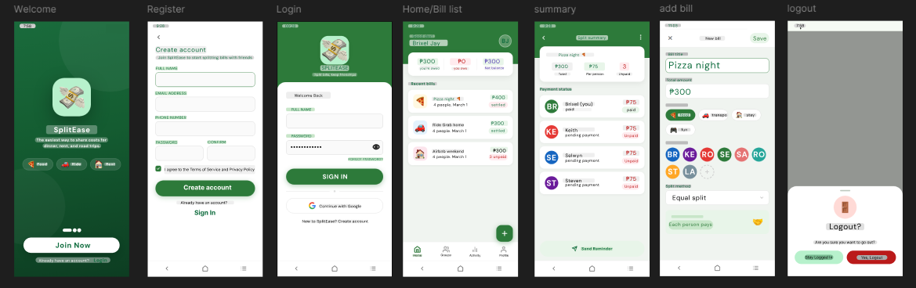
5.3 Screen Flow Diagram
Splash Screen → Login Screen ↔ Registration Screen → Dashboard/Home Screen → Add Bill / Bill List / Split Summary / Profile → Log Out → Login Screen

6. Assumptions and Constraints
The application assumes that users have stable internet connectivity for accessing backend services.
The application will be developed using Android Studio, Kotlin programming language, and XML-based layouts.
The backend system is assumed to provide RESTful API endpoints for authentication and bill data management.
Push notifications will depend on backend support and Firebase Cloud Messaging integration.
The application is intended for use among groups of friends who share expenses on a regular basis.

