STUDENT
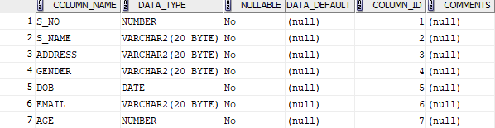

INSTRUCTOR
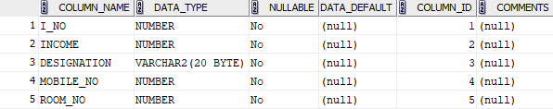

COURSE
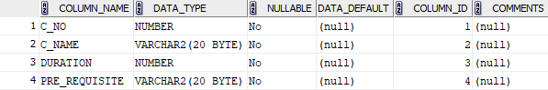

DEPARTMENT
