**ECE 6323 LAB Report**

**Submitted BY BIJON SAHU (#1647781)**

**\*\*\*\*\*\*\*\*\*\*\*\*\*\*\*\*\*\*\*\*\*\*\*\*\*\*\*\*\*\*\*\*\*\*\*\*\*\*\*\*\*\*\*\*\*\*\*\*\*\*\*\*\*\*\*\*\*\*\*\*\*\*\*\*\*\*\*\*\*\*\*\*\*\*\*\*\*\*\*\*\*\*\*\*\*\*\*\*\*\*\*\*\*\*\*\*\*\*\*\*\*\*\*\*\*\*\*\*\*\*\*\*\*\*\*\*\*\*\*\*\*\*\*\*\*\*\*\*\*\*\*\*\*\*\*\***

**Q1. (20 pts) Detector noise**

We discussed in class that dark current is undesirable. Use the APP to illustrate why with an example (compare a case of high and low dark current).

**Answer:**

Dark current carries a current noise inoise, that, from the lecture, we can see:

i^2 = 2 e *idark* B

Where e is the electron charge, **idark** is the dark current, and B is the bandwidth. To illustrate with an example, let’s consider the condition below. We have a detector with 10 nA dark current. The simulation indicates that dark current noise is very small compared with the signal noise; hence it is not a problem.

**Figure 1: Low dark current better BER**

Dark Current = 10 nA produces a **BER=approx.(10 ^-5.7)**

Optical Power signal :-26 db , RIN = -155 db , Wavelength = 1501.21 nm ,AMP Temperature= 300K

Detector Responsivity : 0.5 A/W , **Low Dark current** = 10 nA , Electronic Resistance = 10 K ohm, NF=3db

Sampling Rate = 10 GS/s , Samples = 5000

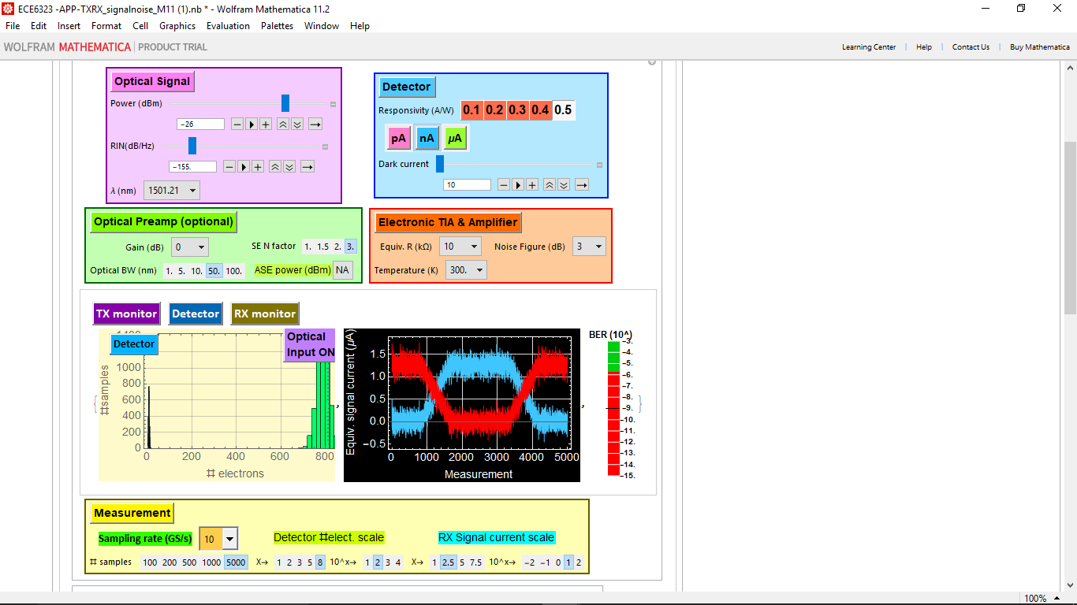

**Figure 2: Higher dark current low BER**

**Higher Dark Current** = 10 uA produces a **BER=approx.(10^-4)**

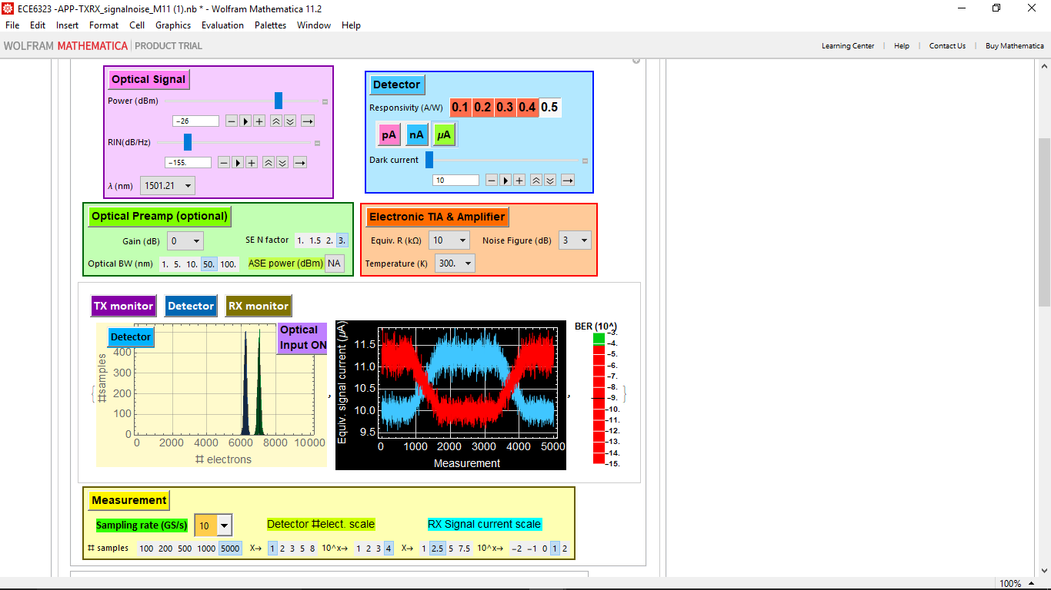

**Q2. (40 pts) Thermal (Johnson) noise**

We discussed in class that even if we have a good - low-dark current detector, noisy electronics which include low equivalent-impedance TIA (trans impedance amplifier) and voltage amplifier with high NF can also degrade the BER. Use the APP to illustrate these points with examples .

**Answer:**

**Even without dark current, any signal also has statistical fluctuation that obeys Poisson statistics:**

nave = isignal Δt/e

P[n] = Subscript[n, ave]n/n! 

The corresponding distribution of the current measurement is:

P[i] ≈ 1/( σi) 

where σi = e/Δt. Notice that:

Subscript[σ, i]2 =(nave e2)/Δt2= isignal e/Δt =isignal e 2B

**Or: =2 e isignal B**

**Here in the below use cases from 1a to 1c we are trying to capture BER by varying temperature and equivalent resistance .**

**Case 1a:** **Low Temperature** = 200 K , **high equivalent-impedance** = 10 ohm and NF= 3 produces a **BER = (10^-8).**

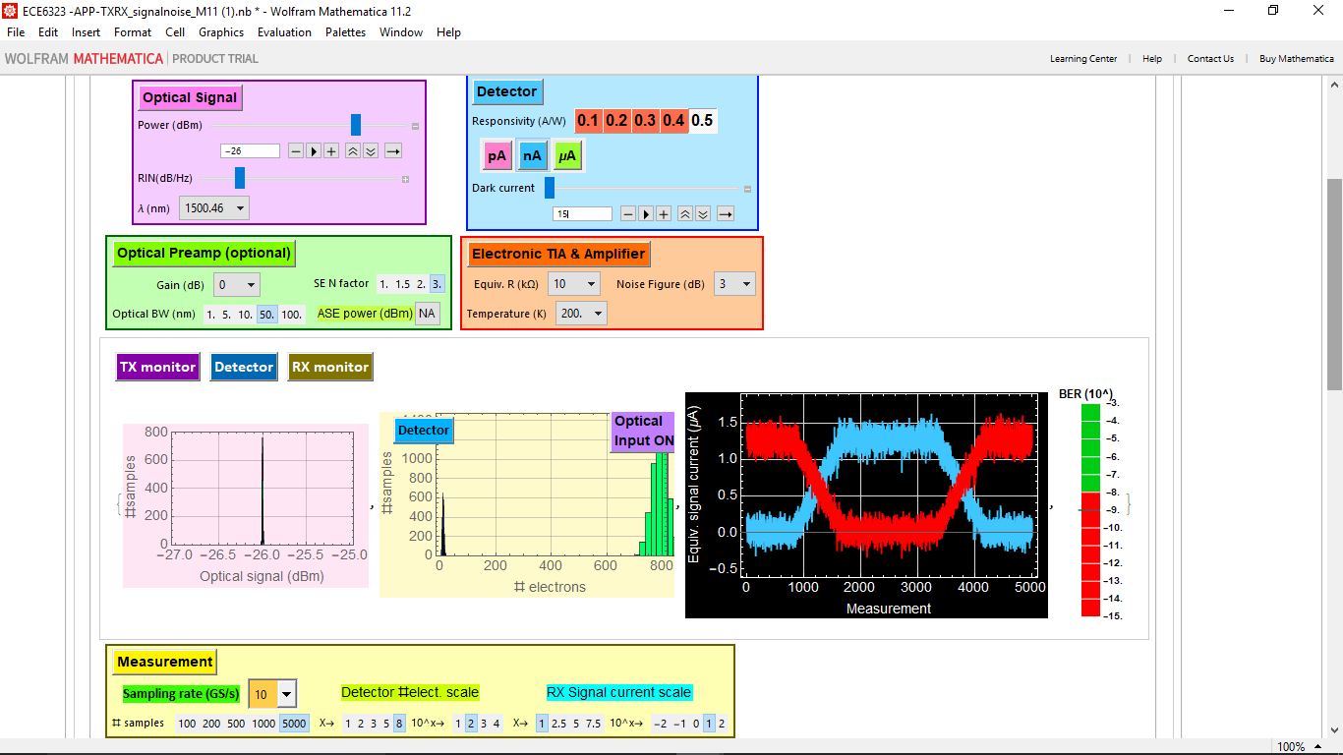

**Case 1b:** **Low Temperature** = 400 K , **high equivalent-impedance** = 10 ohm and NF= 3 produces a **BER = (10^-4.5).**

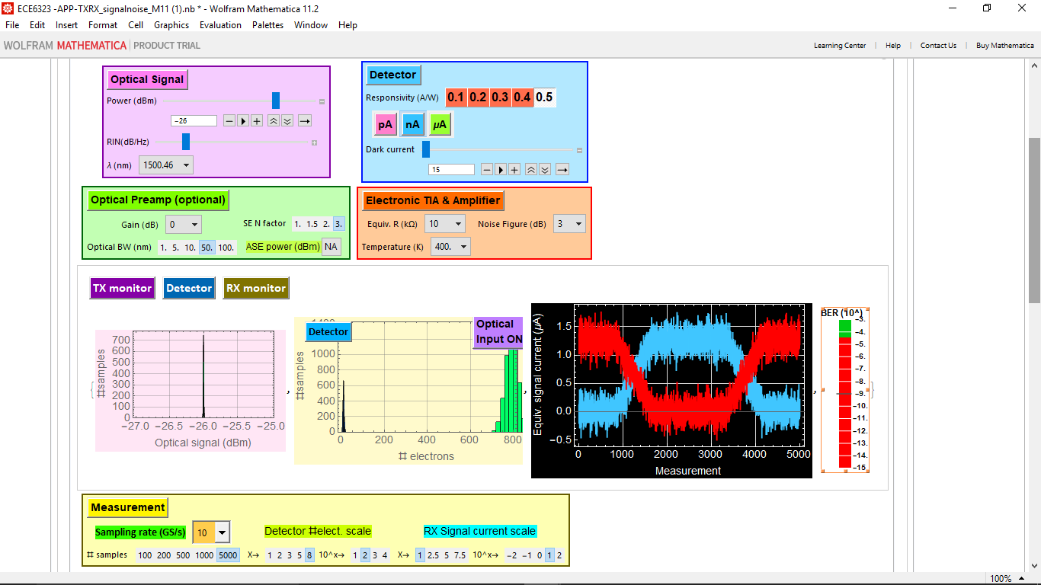

**Case 1c: (Still low impedance) .Low Temperature** = 400 K , **high equivalent-impedance** = 3.3 ohm and NF= 3 produces a **BER = (10^-3).**

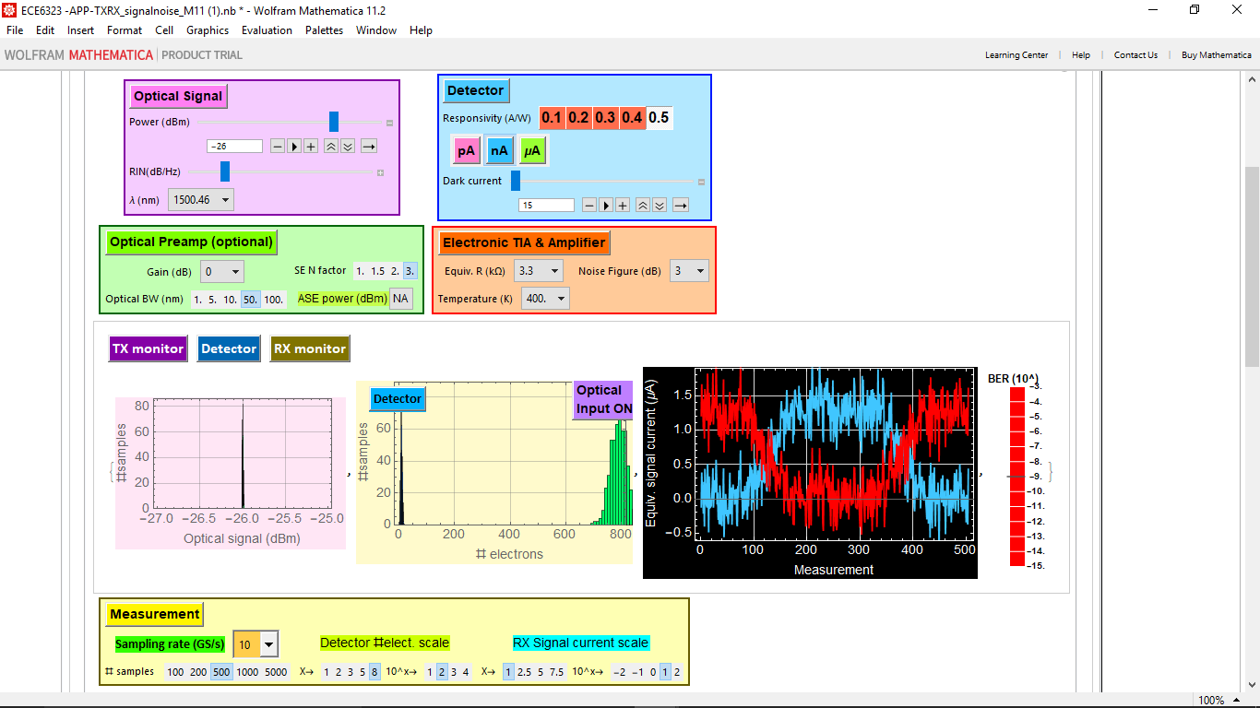

**Here in the below use cases from Case 2a to 2b we are trying to capture BER by varying NOISE FIGURE value.**

**Case 2a** **:** Temp= 300k , Eqi Res = 33 ohm **, NF= 7 DB** produces **BER = (10^-8.2)**

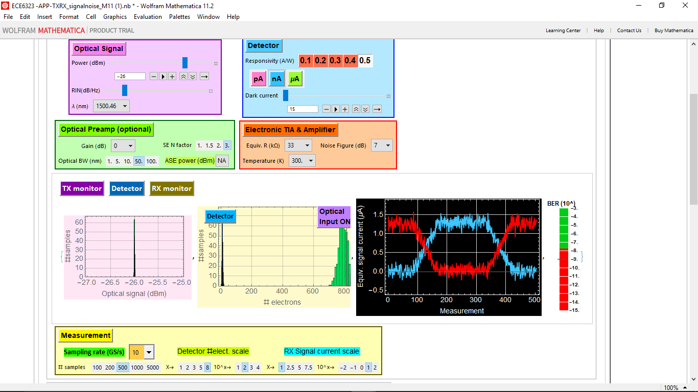

**Case 2b:** Temp= 300K , Eqi Res = 33 ohm , **NF= 3 DB** produces **BER = (10^-15)**

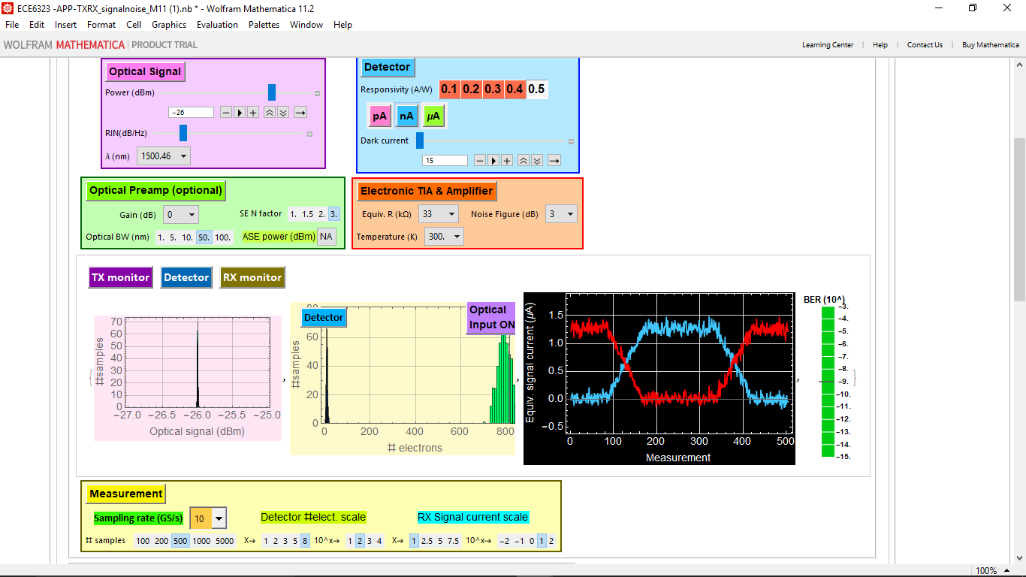

**3. (90 pts) Laser power and RIN noise**

It is obvious that the higher transmitter power, the better is the BER.

**Answer:**

**Here in the below cases from 1a to 1e we are trying to capture BER by varying temperature and equivalent resistance and getting BER below 10^-9 which implies less error in transmission.**

**Case1a :** Temp= 200 , Eqi Res = 10 , NF= 3 DB , Power=-26dbm, RIM=-150db/hz produces **BER = (10^-9).**

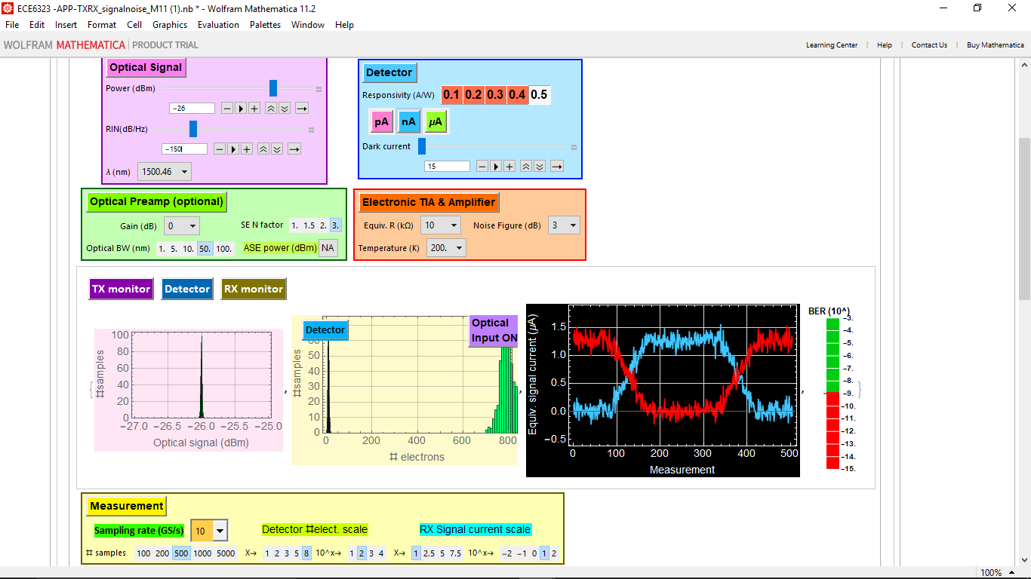

**Case1b:** Temp= 275 , Eqi Res = 10 , NF= 1 DB , Power=-26dbm, RIM=-150db/hz produces **BER = (10^-9.4).**

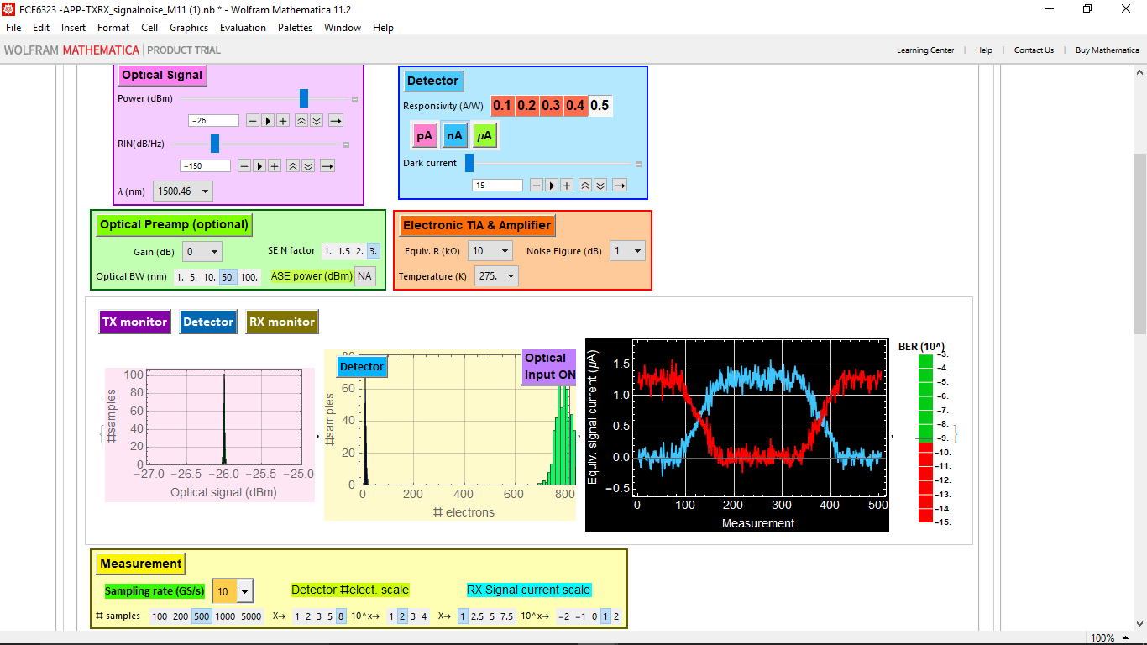

**Case1c :** Temp= 250 , Eqi Res = 33ohm , NF= 5 DB , Power=-26dbm, RIM=-150db/hz produces a **BER = (10^-11)**

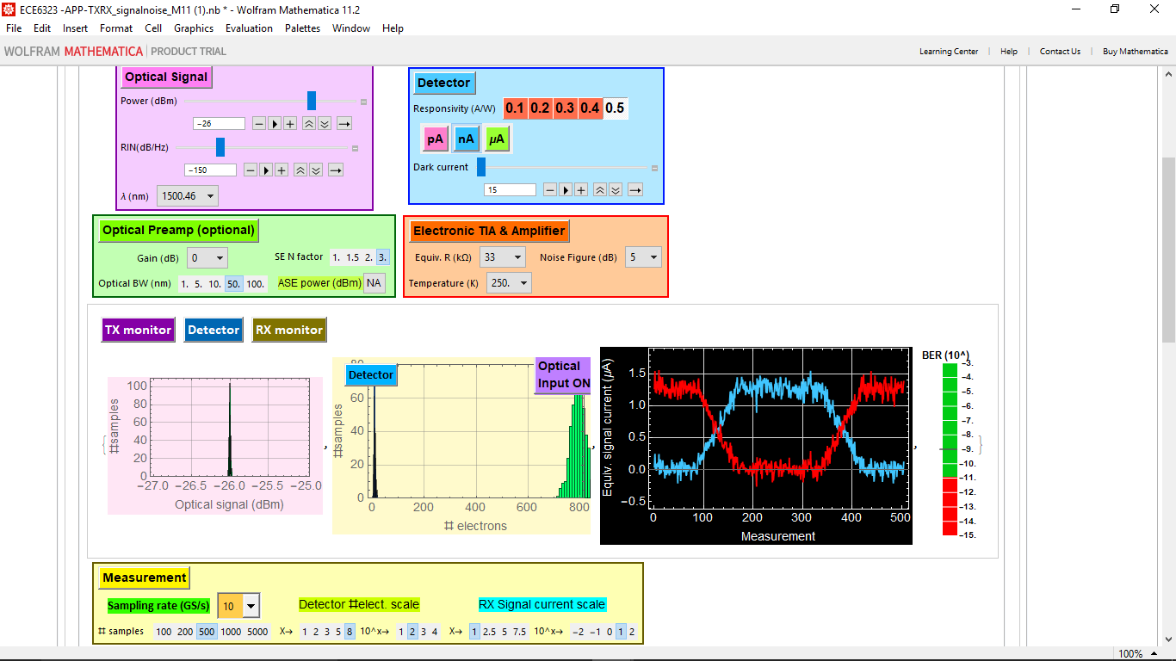

**Case1d:**Temp= 275 , Eqi Res = 33 , NF= 4 DB , Power=-26dbm, RIM=-150db/hz produces **a BER = (10^-14)**

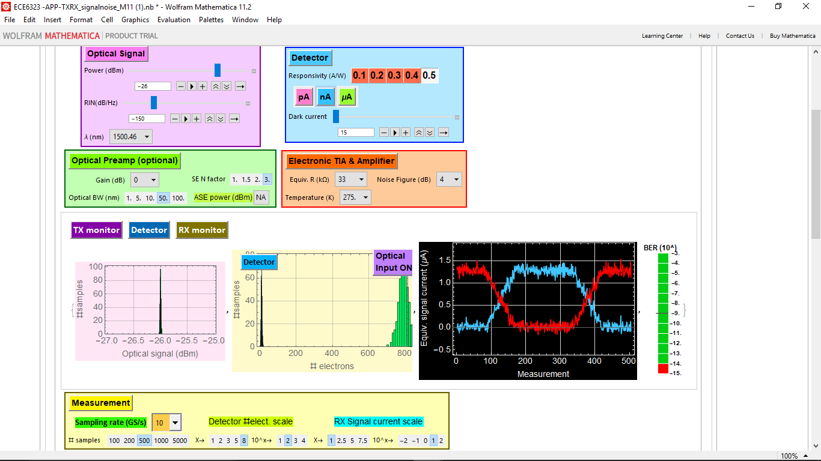

**Case1e:**Temp= 275 , Eqi Res = 33 , NF= 3 DB , Power=-26dbm, RIM=-150db/hz produces a **BER = (10^-15)**

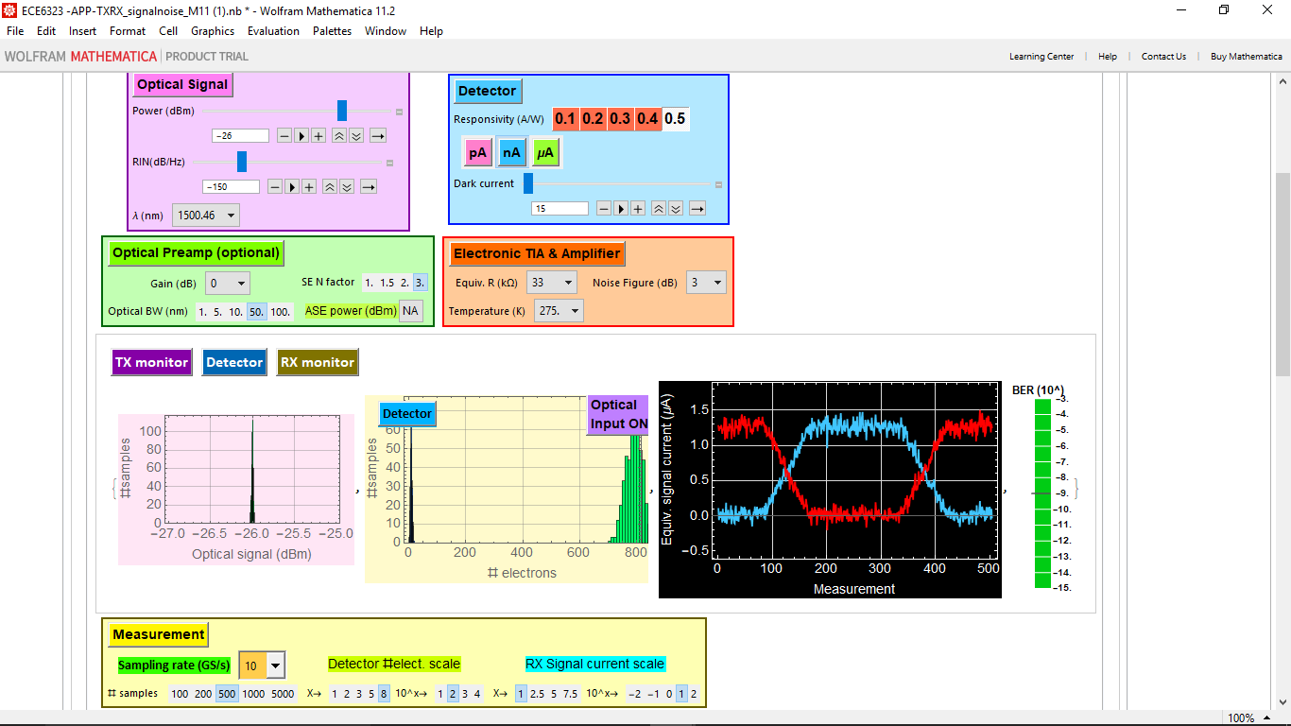

**Here in the below cases from 2a to 2e we are trying to capture BER by varying signal power and getting BER increasing that 10^-5 which implies less error in transmission.**

**We can always find BER as a function of power by using this formula mentioned below,**

**Case2a:**Temp= 300 , Eqi Res = 100 , NF= 3 DB , **Power=-31dbm**, RIM=-150db/hz producing a **BER = (10^-5)**

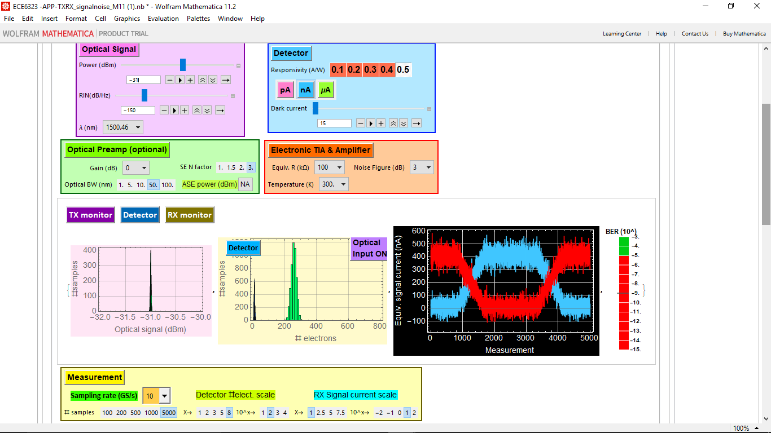

**Case2b:**Temp= 300 , Eqi Res = 100 , NF= 3 DB , **Power=-32dbm**, RIM=-150db/hz producing a **BER = (10^-3.5)**

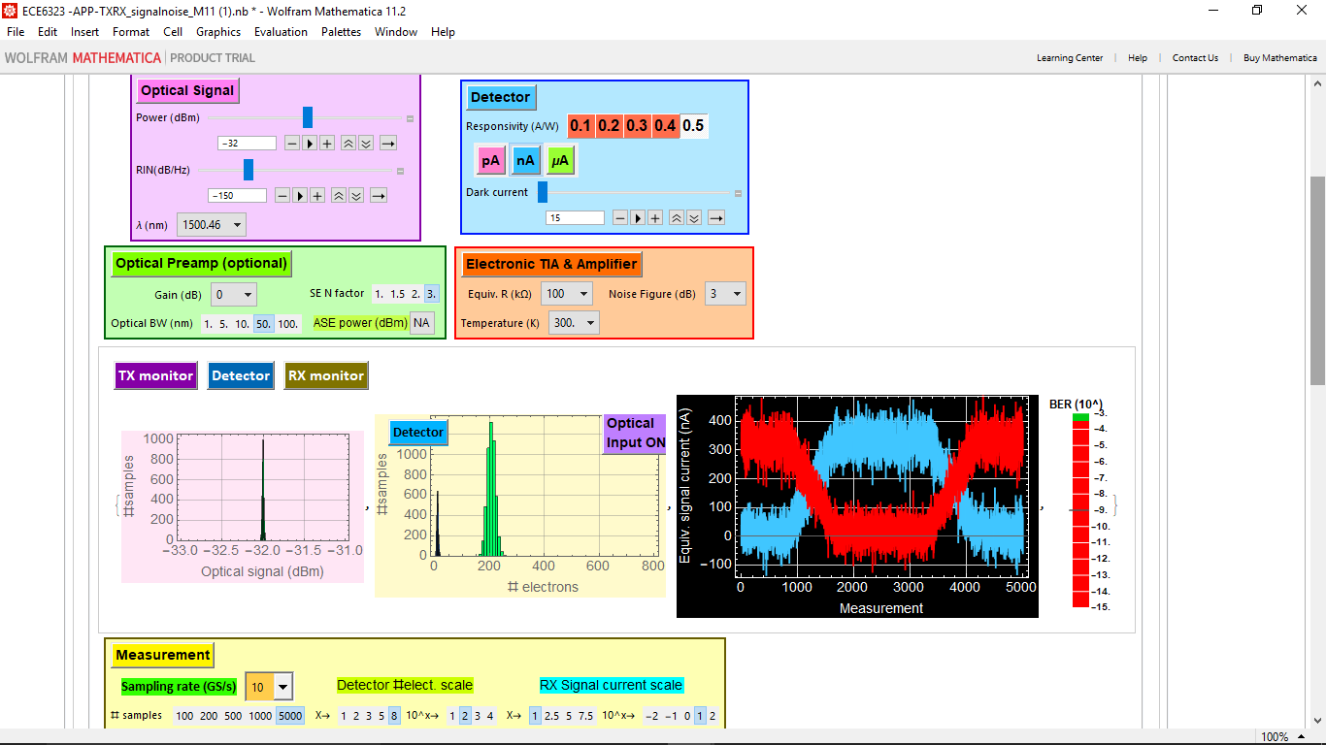

**Case2c:Power= -28db**, RIN=-150db/hz ,Temp= 300 , Eqi Res = 33 , NF= 5 DB , RIM=-150db/hz producing a **BER = (10^-15)**

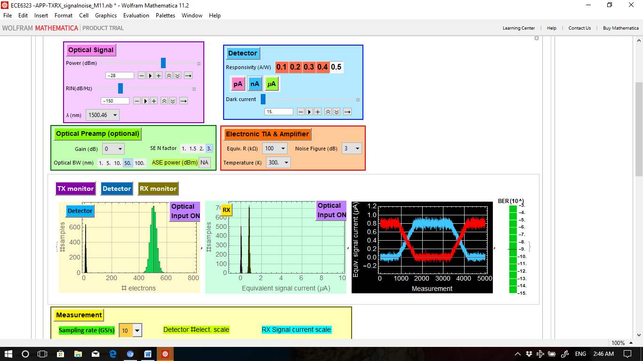

**Case2d:**Temp= 300 , Eqi Res = 100 , NF= 3 DB , **Power=-30dbm**, RIM=-150db/hz producing a **BER = (10^-8.5)**

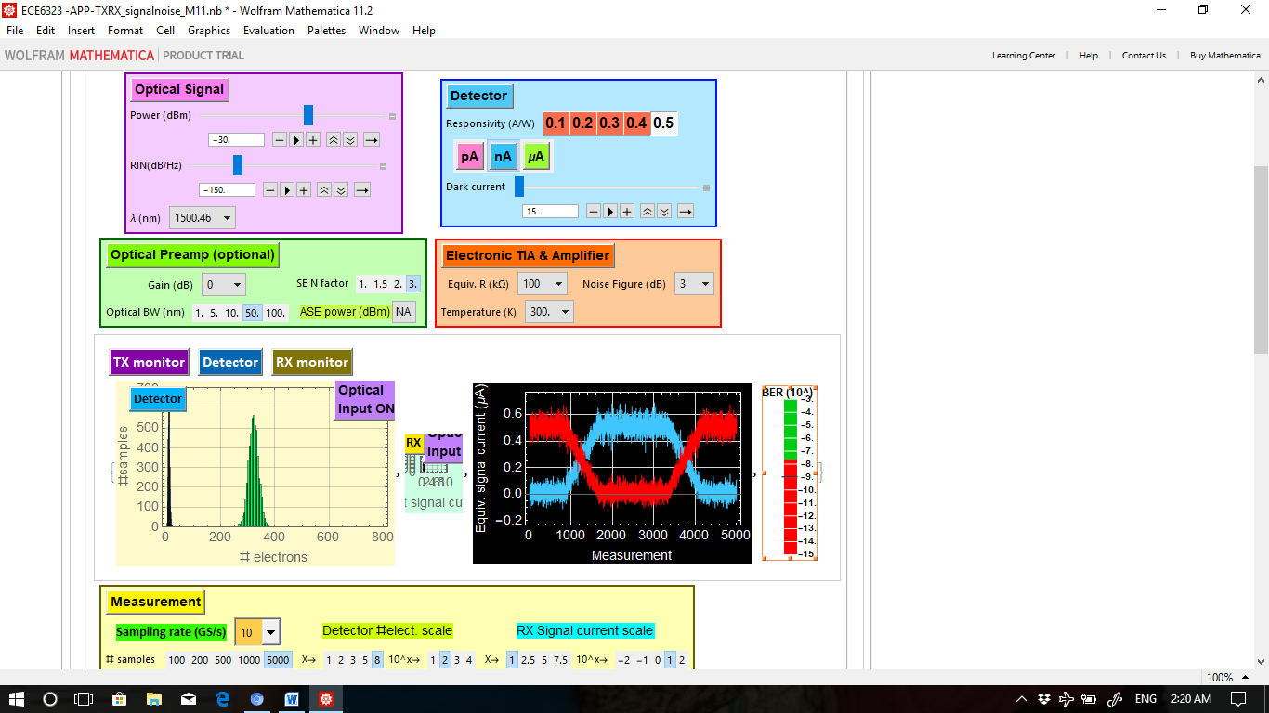

**Case2e:**Temp= 300 , Eqi Res = 100 , NF= 3 DB , **Power=-29dbm**, RIM=-150db/hz producing a **BER = (10^-11)**

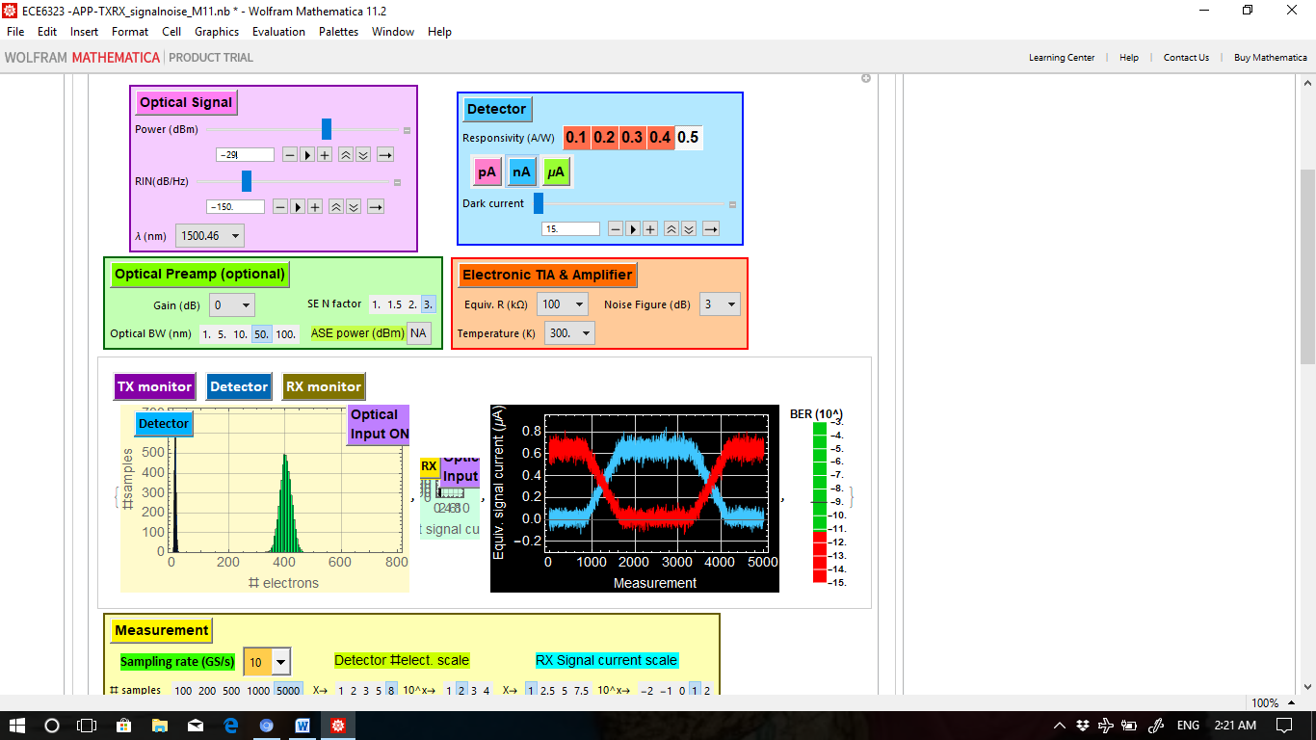

**4. (50 pts.) The use of optical pre-amp**

Assume that you have a laser power as in 3.1 such that the BER is just worse than 10-5. For example, in the example of 3.1, that power is -31.5 dBm. Show two examples how you can use optical preamp to improve the BER better than 10-9 with different gain and optical bandwidth. Below is both example:

**Answer:**

**Here in the below experiment we are trying to check the BER based on varying the Optical Amplifier and bandwidth. Seems like BER decreases when we use higher amplification .**

**Case1a:** Power= -28db, RIN=-150db/hz ,Temp= 300 , Eqi Res = 33 , NF= 5 DB , RIM=-150db/hz, **OPAMP=3,OP BW= 10**,producing a **BER = (10^-5.2)**

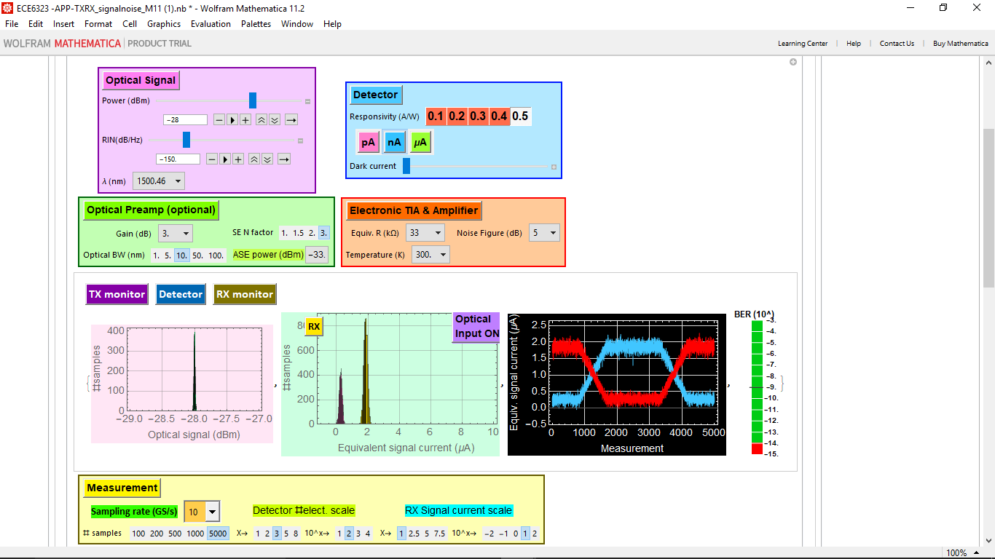

**Case1b:**Power= -28db, RIN=-150db/hz ,Temp= 300 , Eqi Res = 33 , NF= 5 DB , RIM=-150db/hz, **OPAMP=7,OP BW= 50** producing a **BER = (10^-15)**

