Severity Analysis of Plant Diseases Using Deep Learning and Understanding Patterns Using GradCAM

## ABSTRACT

The Irish Famine 1845/46 was primarily caused due to a potato plant disease named Potato Late Blight. Our understanding and knowledge of nature was questioned when single plant disease caused millions of damage and killed approximately one in every eight Irish people alive at that time. Despite all the existing modern agricultural technologies present, the world is still facing huge amounts of losses due to plant diseases and insect infestation. It might be thought that a lot of Plant Protection Products (PPPs) can be used to tackle this problem, where PPPs include herbicides, fungicides and insecticides. Depending upon the amount of PPPs used for agriculture, it can cause serious health effects for the individual consuming those vegetables. Since the time of spreading PPPs doesn't remain fixed, farmers have to continuously monitor his farm and each plant individually as well which is a very tiresome task. So farmers of today's world needs a smart monitoring system which should also include computer vision based plant health monitoring system which can be additionally integrated to mobile phones or drones for efficiently monitoring crops and plants.

A lot of remote sensing based solutions exist where we have to put a grid of sensors in our farm land to monitor soil contents, data collected from which reflects partial plants health based on soil analysis. Coming to plant leaves pathologies, there are several ways to do so. Many of the plant diseases show early characteristics in the visible spectrum, So farmers either examine them manually with naked eyes or capture images in mobile devices and send them to plant disease pathologists for advanced examination, which is a costly, time taking and cumbersome process. Mostly existing plant diseased leaf classification softwares uses traditional image processing methods. Very few deep learning based systems exist in the market which are using traditional outdated models like AlexNET and VGGNets and they perform better as compared to image processing based models.

Image Processing based methods are very slow and are highly susceptible to environmental conditions, and existing solutions are using outdated deep learning models thus there is a great scope of improvement lies in their performance and accuracy. Additionally, to train new plant pathologists deep learning can be very useful. Using GradCAM or Lime activation maps pattern of any new images can be viewed which will not just help in classification but can also explain the reason for classification using activation maps, thus bringing in the much needed explain ability of CNN model. I have planned to develop and test my models on the PlantVILLAGE dataset consisting of approx. 54,000 images of different plant varieties, thus the model will be very well generalized as well.

## LITERATURE REVIEW

In today’s modern world diseases whether it’s of human or plant can be transmitted globally very easily. Also plant disease occurrence is very much related to agricultural practices and climate change all over the globe. Plant pathogens can develop very fast due to change in the climatic condition. Even in today’s modern world, specialized plant pathologists are scarcely distributed and cannot be reached out in tier 3 cities/ town/ villages especially. Due to human greed sometimes and adverse use of pesticide, insecticides sometimes bacteria and viruses develop resistance towards the existing solution thus even if something has worked in the past may not work in the future. Which suggests that plant disease detection, recognition and monitoring becomes a very important part for agricultural society and people of the country and thus can be extended to whole world. It has been also observed that in desperate times like world corona outbreak social distancing becomes very important thus farmers working in the farms or field cannot be allowed to work at full capacity, but due to this calamity it can be seen that agriculture yield starts to decrease. Automation in agriculture is thus very much required to be prepared in these difficult times, thus plant disease diagnosis and detection quickly becomes most important, because when the scarcity of say it farmers or experienced pathologists is high, then if plant disease outbreak happens then it can spread over the entire field over hectares, thus large amount of crops will get destroyed. These destruction will not just impact economy of any country, but bring in huge amount of demand supply crunch situation thus same quantity of goods will be sold at higher prices, which in turn would lead to inflation and thus large amount of financial wastage will be resulted. Not just riches, but a lot of poor people will get affected and thus they have to remain hungry.

Most of the plant diseases while infesting will give you some visual clues, if those clues are captured and analyzed properly then we can protects lots of plants from getting infected in the earlier stages. Since there is a huge variation in the types of plant diseases, the person looking at the leaves has to be very well experienced and versed with all kinds of possibilities to catch true positive cases and reject false negatives. In that case an automated system built to identify plant diseases using images captured from any mobile devices will be great help to the professional in a better and quick decision making with high accuracy. The automation will not just bring in speed in diagnosis and detection but money savings as well. Thanks to the advancements in artificial intelligence that researchers have developed a lot of high end hardware and system for different computer vision tasks like object detection, recognition, and segmentation. In their review paper Shankaran and Mishra have talked about how plant diseases affect economic losses and major production halts in industry of agriculture all over the globe. In their paper they have also talked spectroscopy and imaging based methods to find diseases in plants. They have also talked about plant diseases detection based on volatile profiling but their method faces major challenges like background data might affect the resulting profile and their technique has to be optimized for separate plant type and disease, thus their technique automation to detect plant disease easily. Chaudhary et. el. In their paper has talked about how color transform based method could be applied for spot detection in plant leaf which will have very minimal effect from intensity of flash or different light condition while capturing the image. He has used YCBCR, HIS and CEILB color models. In another very good paper Patil and Bodhe detected plant disease by extracting shape features, then they applied threshold segmentation for determining leaf area and triangle threshold in the lesion area. They were able to achieve an accuracy of 98.60%. In another approach related closely to Machine Learning, neural network were applied for automatic classification and detection of plant disease. Features were generated first by applying neural networks, then using those features k-means clustering method was applied to form clusters to detect the diseases and normal leaves. In that method neural network consisted of 10 layers and output vector was vector of length six, thus it could classify five different diseases and healthy leaves. In this work the accuracy was around 95%.

## PROPOSED WORK

In the section below we have described the process which we have proposed to use for training the deep learning based CNN for plants disease detection.

### 1. Dataset

Selection of dataset is one of the most important part of deep learning model development, so that appropriate goals of object detection can be achieved starting from training phase to testing phase. We will try to collect as many images of plant leaves with diseases from internet as possible. We will try to collect pertaining to different plant varieties which will further belong to different disease categories. For expanding our searching domain we will perform searches in different languages like English, Hindi, Serbian, Latin etc. We have proposed to collect leaves image belonging to 10 different classes, among which there will be 9 different classes of disease category and one class will belong to healthy normal leaf images. In leaf data which is available in the internet, a lot of times it happens that background is very plain. But in real life we might be using mobiles to collect leaf images. So it becomes very important to distinguish leaf images from background. So we have used Stanford Background Dataset for background detection. We will try to use method of image hashing to find duplicate images in the dataset and remove them when found. In the following *figure 1* you can see leaf images at different stages of diseases.

Figure 1 Images of leaves at different stages of disease

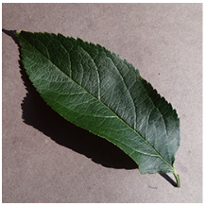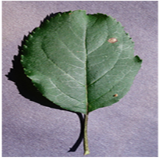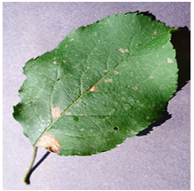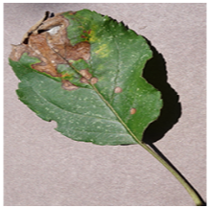

Images downloaded from internet varies in size, quality, and data format. For making the data consistent, we performed various image conversion methods to finally convert all images into *.jpg* format. Also to make the model training very seamless we converted all images into size 256*256. For this purpose we will use OpenCV framework in python.

### 2. Image Data Augmentation

It might happen that after collecting data from internet we might observe that number of images in each classes is not consistent, so our model might get biased towards the classes with more images. To solve this problem we have to use augmentation process of images. In augmentation process we make some altercations to produce new images. By augmentation process we can intuitively understand that, it’s helping us extract more information from the existing data. Augmentation can be of different type like geometric augmentation like cropping, zooming, translation of image, warping etc. These all transformation actually bring in different possible camera perspectives. Image augmentation techniques like GANs are very popular deep learning frameworks to generate additional data. Deep learning based augmentation is little complex, but if image processing based augmentation are found insufficient then deep learning based augmentation can be surely used.

### 3. Model Development using transfer learning and Fine tuning

In today’s modern deep learning science there are abundant of deep learning frameworks available which can be leveraged to train easy as well as very complex models. Some of the popular frameworks are theano, caffe, pytorch, tensorflow, all these are based on python as a programming language. We can also leverage matlab, which has a lot of trained model and its framework and UI is very simple to use. Out of python deep learning framework mentioned above, pytorch is one of the most useful framework. It has one very important feature called automatic backpropagation for which you do not have to write any function individually. We can consider pytorch or matlab as the starting point of our project and depending upon the requirements and complexity we can switch to other frameworks. For training using laptop for low to medium complex architectures, we will also leverage transfer learning for popular models like ResNET, VGGNet, Inception V2 etc.

### 3.1 Transfer Learning

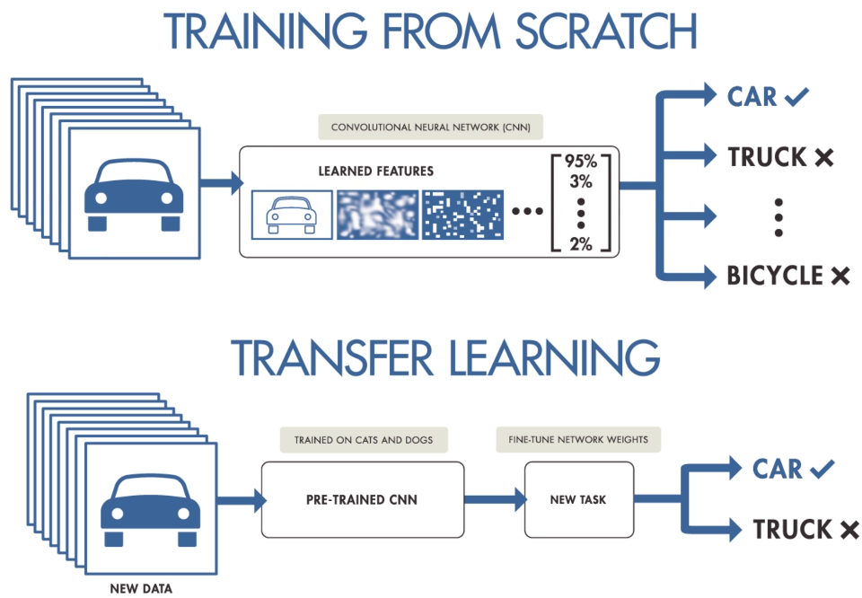In transfer learning a very big advantage is that your model has already learnt on how to find low level features like edges, lines, corners etc. Not just this if we take more complex transfer learnt model like ResNET, by the time you reach end of ResNET it has already learnt to find higher level features like contours, corners and similar shapes can be learnt. By removing final head, we will put our classifier which will categorize images into ten different classes. Following *figure 2* describes the difference in training from scratch and transfer learning.

Figure 2 describes the difference in training from scratch and transfer learning

### 3.2 Model Fine Tuning:

For fine tuning our model, we will first split the model in 80:20 ratio. Some of the data which will be reserved for validation set. Here we will be trying out with different activation function like ReLU, Leaky ReLU, Randomised Leaky ReLU. For learning rate selection we will experiment with exponential decay, step decay, cyclic learning rate etc. We will also add weight decay to prevent our model from overfitting so that our model generalizes well and predicts correctly in real world scenario.

### REFERENCES

1. R. Pydipati, T.F. Burks, W.S. Lee Statistical and neural network classifiers for citrus disease detection using machine vision Trans ASAE, 48 (5) (2005), pp. 2007-2014
2. P. Sanyal, S.C. Patel Pattern recognition method to detect two diseases in rice plants Imag Sci J, 56 (6) (2008), pp. 319-325
3. N.N. Kurniawati, S.N.H.S. Abdullah, S. Abdullah, S. Abdullah Investigation on image processing techniques for diagnosing paddy diseases 2009 International Conference of Soft Computing and Pattern Recognition (2009), pp. 272-277
4. A. Camargo, J. Smith An image-processing based algorithm to automatically identify plant disease visual symptoms Biosyst Eng, 102 (1) (2009), pp. 9-21
5. D. Story, M. Kacira, C. Kubota, A. Akoglu, L. An Lettuce calcium deficiency detection with machine vision computed plant features in controlled environments Comput Electron Agric, 74 (2) (2010), pp. 238-243
6. B. Liu, Y. Zhang, D. He, Y. Li Identification of apple leaf diseases based on deep convolutional networks Symmetry, 10 (2018), p. 11
7. S. Zhang, W. Huang, C. Zhang Three-channel convolutional neural networks for vegetable leaf disease recognition Cognit Syst Res, 53 (2019), pp. 31-41
8. E.C. Too, L. Yujian, S. Njuki, L. Yingchun A comparative study of fine-tuning deep learning models for plant disease identification Comput Electron Agric, 161 (2019), pp. 272-279