**MULTICLASS FUNDUS IMAGE CLASSIFICATION**

**FOR DIABETIC RETINOPATHY IDENTIFICATION**

## First Name Last Name, First Name Last Name, First Name Last Name

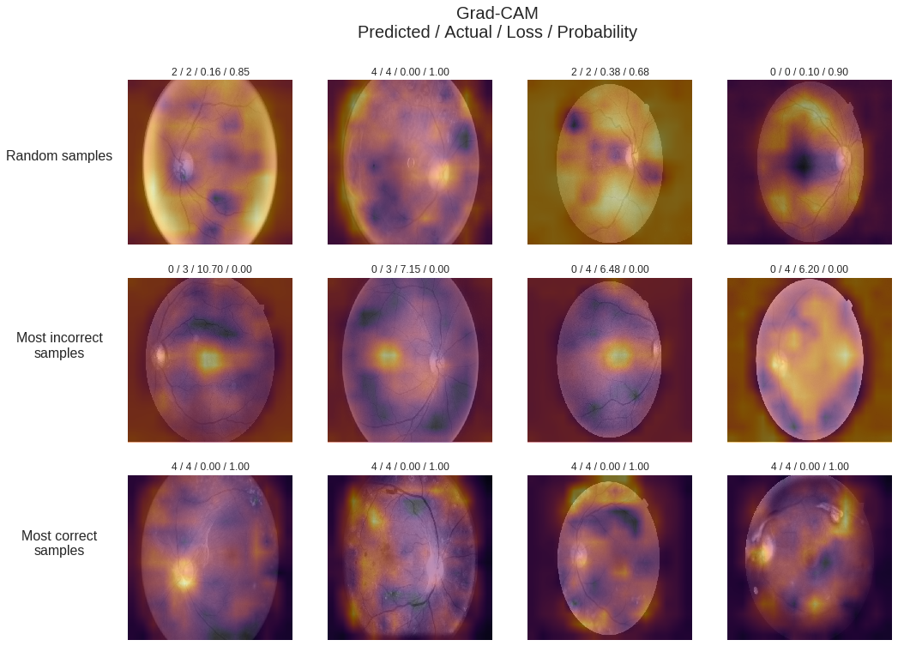

PRIMARY OBJECTIVE OF THIS RESEACH IS TO DEVELOP TECHNICALLY EFFICIENT AND ROBUST FUNDUS IMAGE CLASSIFIER TO MAKE EARLY DETECTION OF THIS DISEASE



Diabetic Retinopathy (DR) is a situation coined for malfunctioning of human eye which can make people blind. Usually properly trained ophthalmologists have to spend hours just to inspect each and every subtle features present and evaluate its significance and then arrive on conclusion. This whole process is very much time consuming and cumbersome from a human point of view. To reduce the human effort and window of error we are trying to build a deep learning based classifier which can take images from mobile and give results to the patients instantly, saving time and money.

Figure Showing Diabetes eyes at different Stages

**Quick facts about Diabetes**

* **422 Million people in world have diabetes thus they will inherently develop diabetic eye**
* **Diabetes is one of leading causes of death in world**
* **Diabetes is important reason for amputation, blindness and kidney failure**
* **4% 18-24 years old, 17 % 45-64 year olds, and 25 % of 65 year old have diabetes**
* **According to America Diabetes Association**  total cos of diagnosed diabetes in US was 327 Billion dollar

Stages of Diabetic Retinopathy

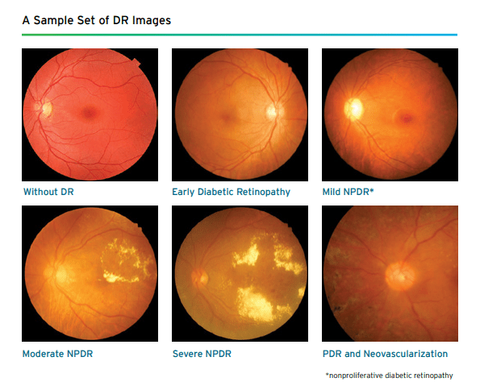

# DATA PREPROCESSING



Large Data imbalance is present as shown in *figure 2* below. There is a prevalence of large number of normal cases, but very less category 3 and 4 cases. Various Data Augmentation methods will be used :

* **Variance of Laplacian :** Laplacian of image gives edges present in an image. Blurry images have less edges so variance of edges will be lesser thus those images dropped
* **Sigmoid Correction :** A continuous non-linear sigmoid function will be used to adjust and correct the bad images
* **Log Enhancement :** To adjust the dynamic range present in the image, which makes poor visibility of some features log transformation is applied to solve the issue

Following the above approach, we tend to do oversampling based on above listed points from classes with less number of image representation and undersampling from normal cases to make a well balanced datset

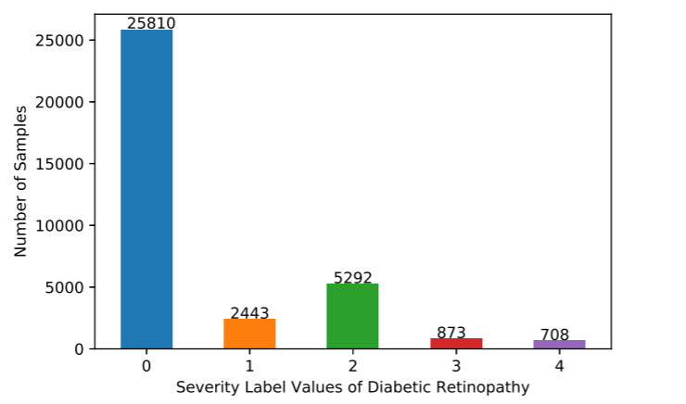

Figure 2

# TRANSFER LEARNING



For catering the problem of lack of compute power and architecture it is best idea to use transfer learning methodology

* Low Level Features : Very low level features like edges, lines, color fields etc would be learnt by initial layer of pre trained model
* High Level Features : like corners, contours or very simple initial shapes will be learnt by middle layers of pre trained model
* Object Parts : Few penultimate layers will be well equipped to spot very high level features like object parts, shapes of objects
* Complex Objects: Last layers get advanced to a level that they can now spot very complex objects in scene. We will now remove the head and train last layer with our custom eye dataset

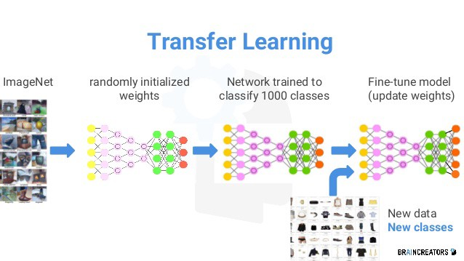

Figure 3 Grad CAM based final result Visualization

# TRAINING OUR MODEL



Original dataset was split into 80:20 ratio, out of which some data will be reserved for validation set as well ((0:10)

* **Activations functions :** To introduce non linearity in the models different activation function will be tried out which include ReLU, Leaky ReLU, Randomised Leaky ReLU
* **Learning Rate Identification :** Learning rate decides the rate at which the model will learn. Various learning rates will be tried out like Exponential, Step Decay and Cycling Learning rates
* Adding **Weight Decay :** To prevent overfitting and to ensure that our model will generalize well to all kind of images we will be trying out different weight decay, it’s a hyper parameter which we have to tune with respect to different learning rates.

## 

# REFERENCES



[1] Herbert Bay, Andreas Ess, Tinne Tuytelaars, and Luc Van Gool. 2008. Speeded-Up Robust Features (SURF). Comput. Vis. Image Underst. 110, 3 (June 2008), 346-359. DOI=http://dx.doi.org/10.1016/j.cviu.2007.09.014

[2] Shah AR, Gardner TW. Diabetic retinopathy: research to clinical practice. Clin Diabetes Endocrinol. 2017;3:9. Published 2017 Oct 19. doi:10.1186/s40842-017-0047-y

[3] Gardner TW, Chew EY. Future opportunities in diabetic retinopathy research. Curr Opin Endocrinol Diabetes Obes. 2016;23(2):91–96. doi:10.1097/MED.0000000000000238

[4] Lee R, Wong TY, Sabanayagam C. A two-stage filter for removing salt-and-pepper noise using noise detector based on characteristic difference parameter and adaptive directional mean filter. Eye Vis (Lond). 2015;2:17. Published 2015 Sep 30. doi:10.1186/s40662-015-0026-2

[5] Ankita Gupta, Rita Chhikara, Diabetic Retinopathy: Present and Past, Procedia Computer Science, Volume 132, 2018, Pages 1432-1440, ISSN 1877-0509

[6] S. izza Rufaida and M. I. Fanany, “Residual convolutional neural network for diabetic retinopathy,” in Proceedings of IEEE International Conference on Advanced Computer Science and Information Systems (ICACSIS). IEEE, 2017, pp. 367–374..