User guide

1. GUI Steps
2. Best Practices

GUI Steps

Step 1:

Open this link : <http://13.233.58.89:9444/#/dashboard>

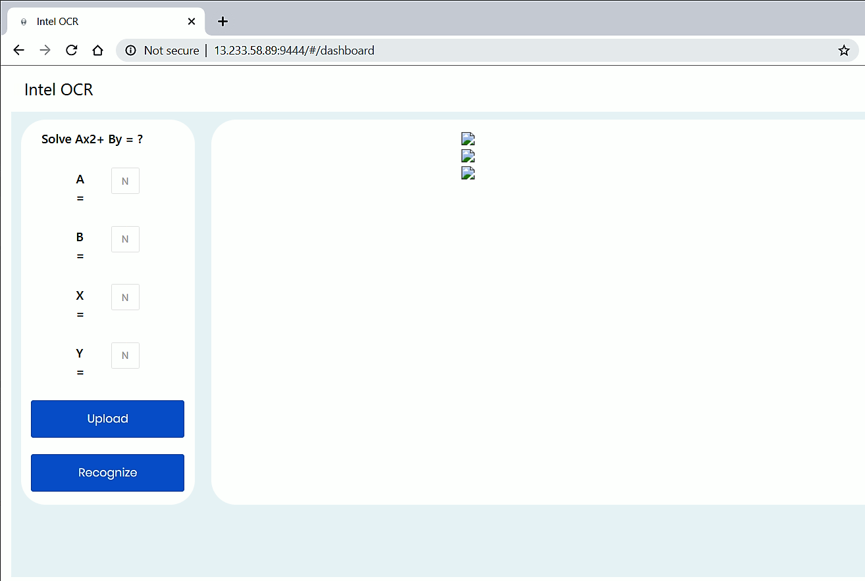

Step 2:

Click on Upload, Select Image to upload

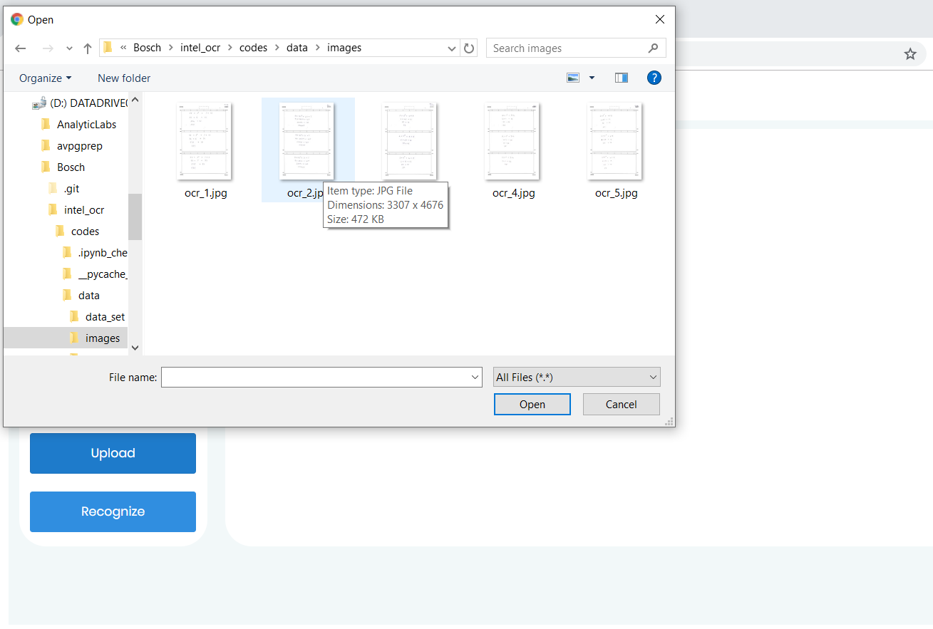

Step 3:

Fill Values of A, B, X, Y and then click Recognize

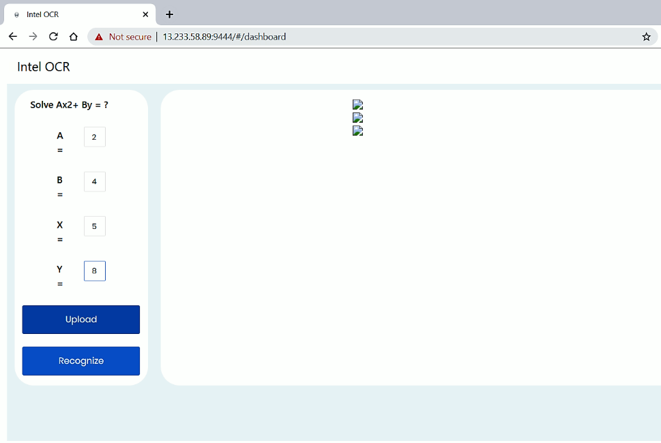

Step 4: Get answer

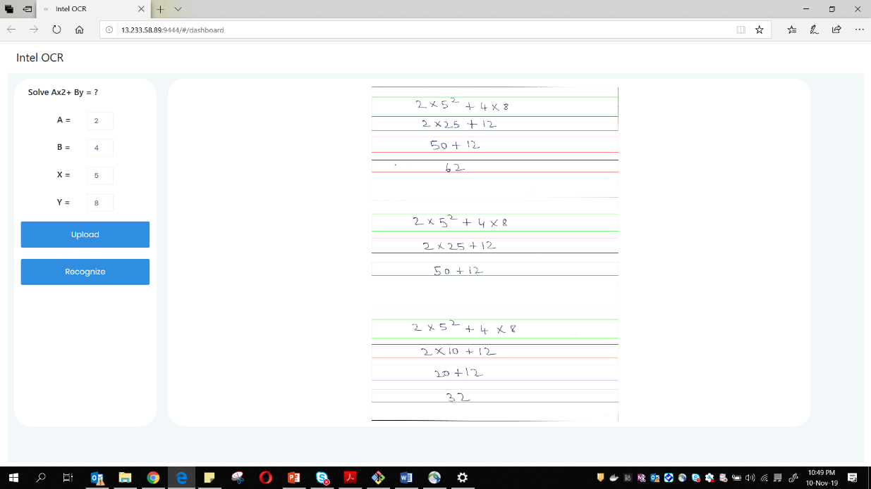

Color Coding:

**Red Box**: Wrong Step  
  
**Green Box**: Correct Step  
  
**Blue Box**: Undetermined Step

Best Practices

1. Template to be scanned should be first printed in A4 size of DPI = 400 for best results. Solution will work for other DPI setting as well but aspect ratio of A4 size is the minimum requirement
2. There should exist little space between each character and exponentials should be written properly, not farther away from the parent line
3. There should exist little space between consecutive lines in any workspace for better recognition
4. Rough work should not be done in a workspace which will lead to false detection as a character