**Employee Hierarchy through Command Line (Windows OS):**

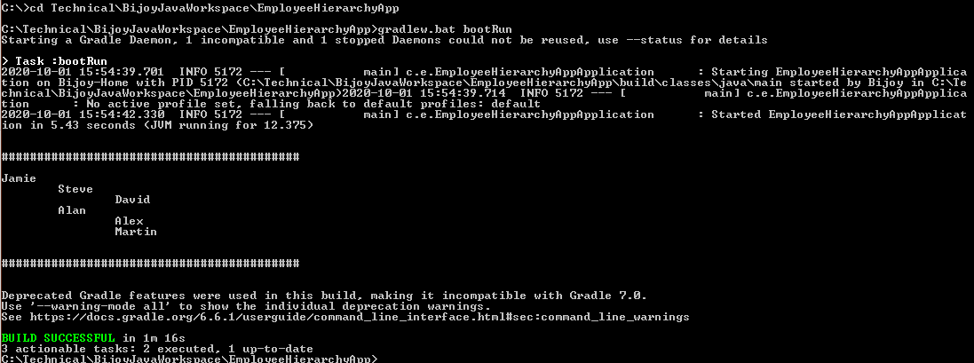

**Employee Hierarchy through** **Eclipse Main Application file**:

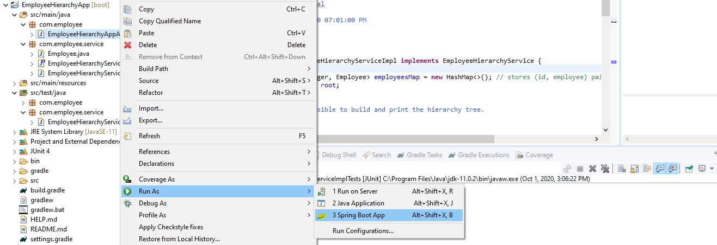

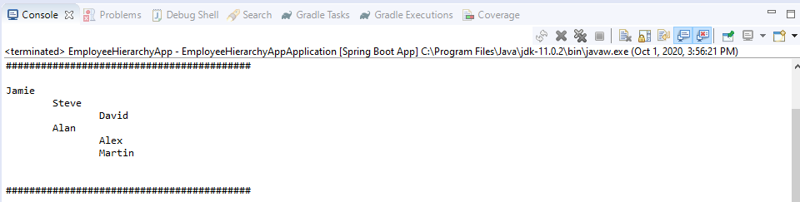

**Employee Hierarchy through** **Eclipse Test file**:

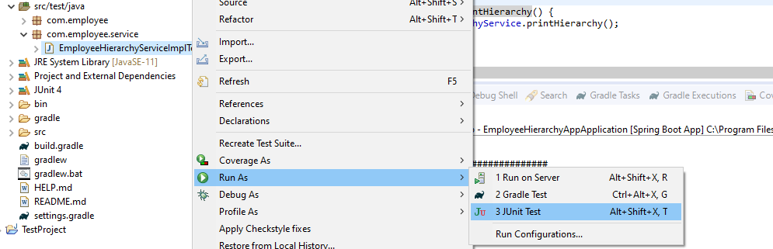

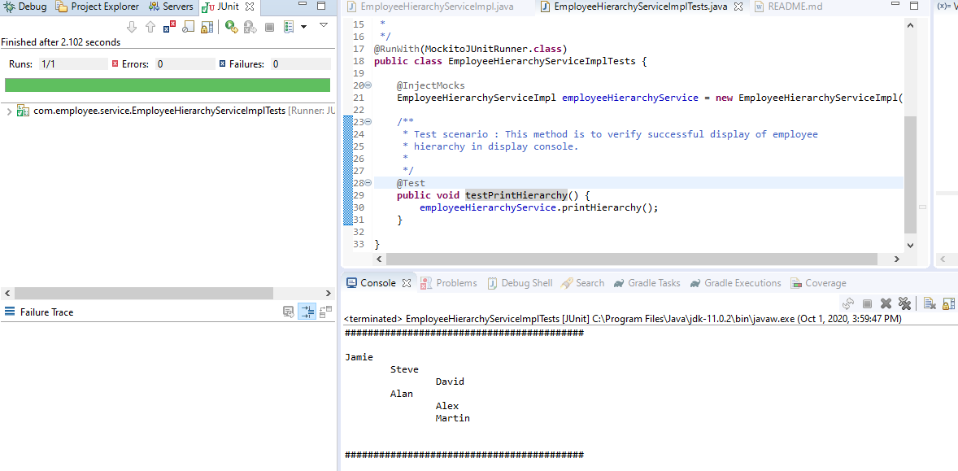

**Employee Hierarchy code coverage(approx 90%)**:

