Week 3 Task: Unsupervised Learning and Clustering Analysis
bijoysannyasi19-hash
Date: 2026-10-06

Table of Contents
1. Abstract
2. Introduction and Objectives
3. Dataset Description
4. Exploratory Analysis and Preprocessing
5. Methodology and Rationale for Chosen Techniques
6. Results
7. Visualizations and Interpretation
8. Cluster Profiles and Interpretation
9. Business or Research Implications
10. Limitations and Critical Discussion
11. Conclusion and Future Work
12. References
Appendix A: Architecture diagram and project structure.
Appendix B: Requirement coverage table.

1. Abstract
This report describes a clustering analysis of the UCI Wholesale Customers dataset. The goal was to group customers based on how much they spend on different product categories. I preprocessed the data with a log transformation and standard scaling to fix skewed distributions. I used K-Means clustering as the main method. I also tested Hierarchical Clustering and Gaussian Mixture Models (GMM) for comparison. I chose K-Means with k=4 as the final model because it had good scores and created groups that make sense for a business. The analysis found four distinct customer types. These groups can help the distributor plan marketing and manage inventory.

2. Introduction and Objectives
Wholesale distributors need to understand their customers. A cafe buys different goods than a large grocery store. The objective of this project is to group wholesale customers based on their annual spending. I looked at six product categories: Fresh, Milk, Grocery, Frozen, Detergents_Paper, and Delicatessen. I used unsupervised learning techniques to find natural groups in the data. Finding these groups helps the business make better decisions.

3. Dataset Description
I used the UCI Wholesale Customers dataset (https://archive.ics.uci.edu/ml/datasets/Wholesale+customers). It has 440 records of wholesale clients. There are no missing values. The features are the annual spending amounts for different product categories. This dataset is good for clustering because it has continuous numeric features that show real-world behavior. It does not need a target label.
Features:
- Fresh: Annual spending on fresh products.
- Milk: Annual spending on milk products.
- Grocery: Annual spending on grocery products.
- Frozen: Annual spending on frozen products.
- Detergents_Paper: Annual spending on detergents and paper products.
- Delicassen: Annual spending on delicatessen products.
- Channel and Region: Categorical variables showing customer channel and region. I ignored these columns during clustering so the groups are based only on spending.

4. Exploratory Analysis and Preprocessing
First, I checked the data and found that all spending features were highly right-skewed. A few customers spend much more than the average. Algorithms like K-Means calculate distances between points. They do not work well with skewed data or features on different scales. I fixed this by applying a natural logarithm transformation (log1p) to normalize the shapes of the distributions. After that, I applied standard scaling (StandardScaler). This makes sure each feature has equal weight when calculating distances.
Code snippet for preprocessing:
features_log = np.log1p(features) # Fix right-skewness
scaler = StandardScaler()
features_scaled = scaler.fit_transform(features_log) # Scale features

5. Methodology and Rationale for Chosen Techniques
K-Means Clustering: I chose K-Means as the main model. It divides data into k separate groups by minimizing the distance from points to the center of their group. It runs fast and is easy to understand. I checked k values from 2 to 10. I used the elbow method (inertia), silhouette score, Calinski-Harabasz index, and Davies-Bouldin index to pick the best number of clusters.
Hierarchical Clustering: I used agglomerative hierarchical clustering with Ward linkage as a second check. It builds a tree of clusters from the bottom up. I drew a dendrogram to visualize this tree. It is useful because you do not have to guess the number of clusters in advance.
Gaussian Mixture Model (GMM) and PCA: I added two extra methods. I ran GMM because it handles different cluster shapes better than K-Means. I used the Bayesian Information Criterion (BIC) and Akaike Information Criterion (AIC) to select the number of components for GMM. I also ran Principal Component Analysis (PCA). PCA reduces the number of features so I can plot the data in two or three dimensions.

6. Results
The evaluation metrics for the final models are in the table below. I selected K-Means with k=4. It had good scores and the four groups make logical sense for a wholesale business.
Model | Silhouette | Calinski-Harabasz | Davies-Bouldin
K-Means | 0.1885 | 131.3199 | 1.5408
Hierarchical | 0.2021 | 108.6067 | 1.5211

7. Visualizations and Interpretation
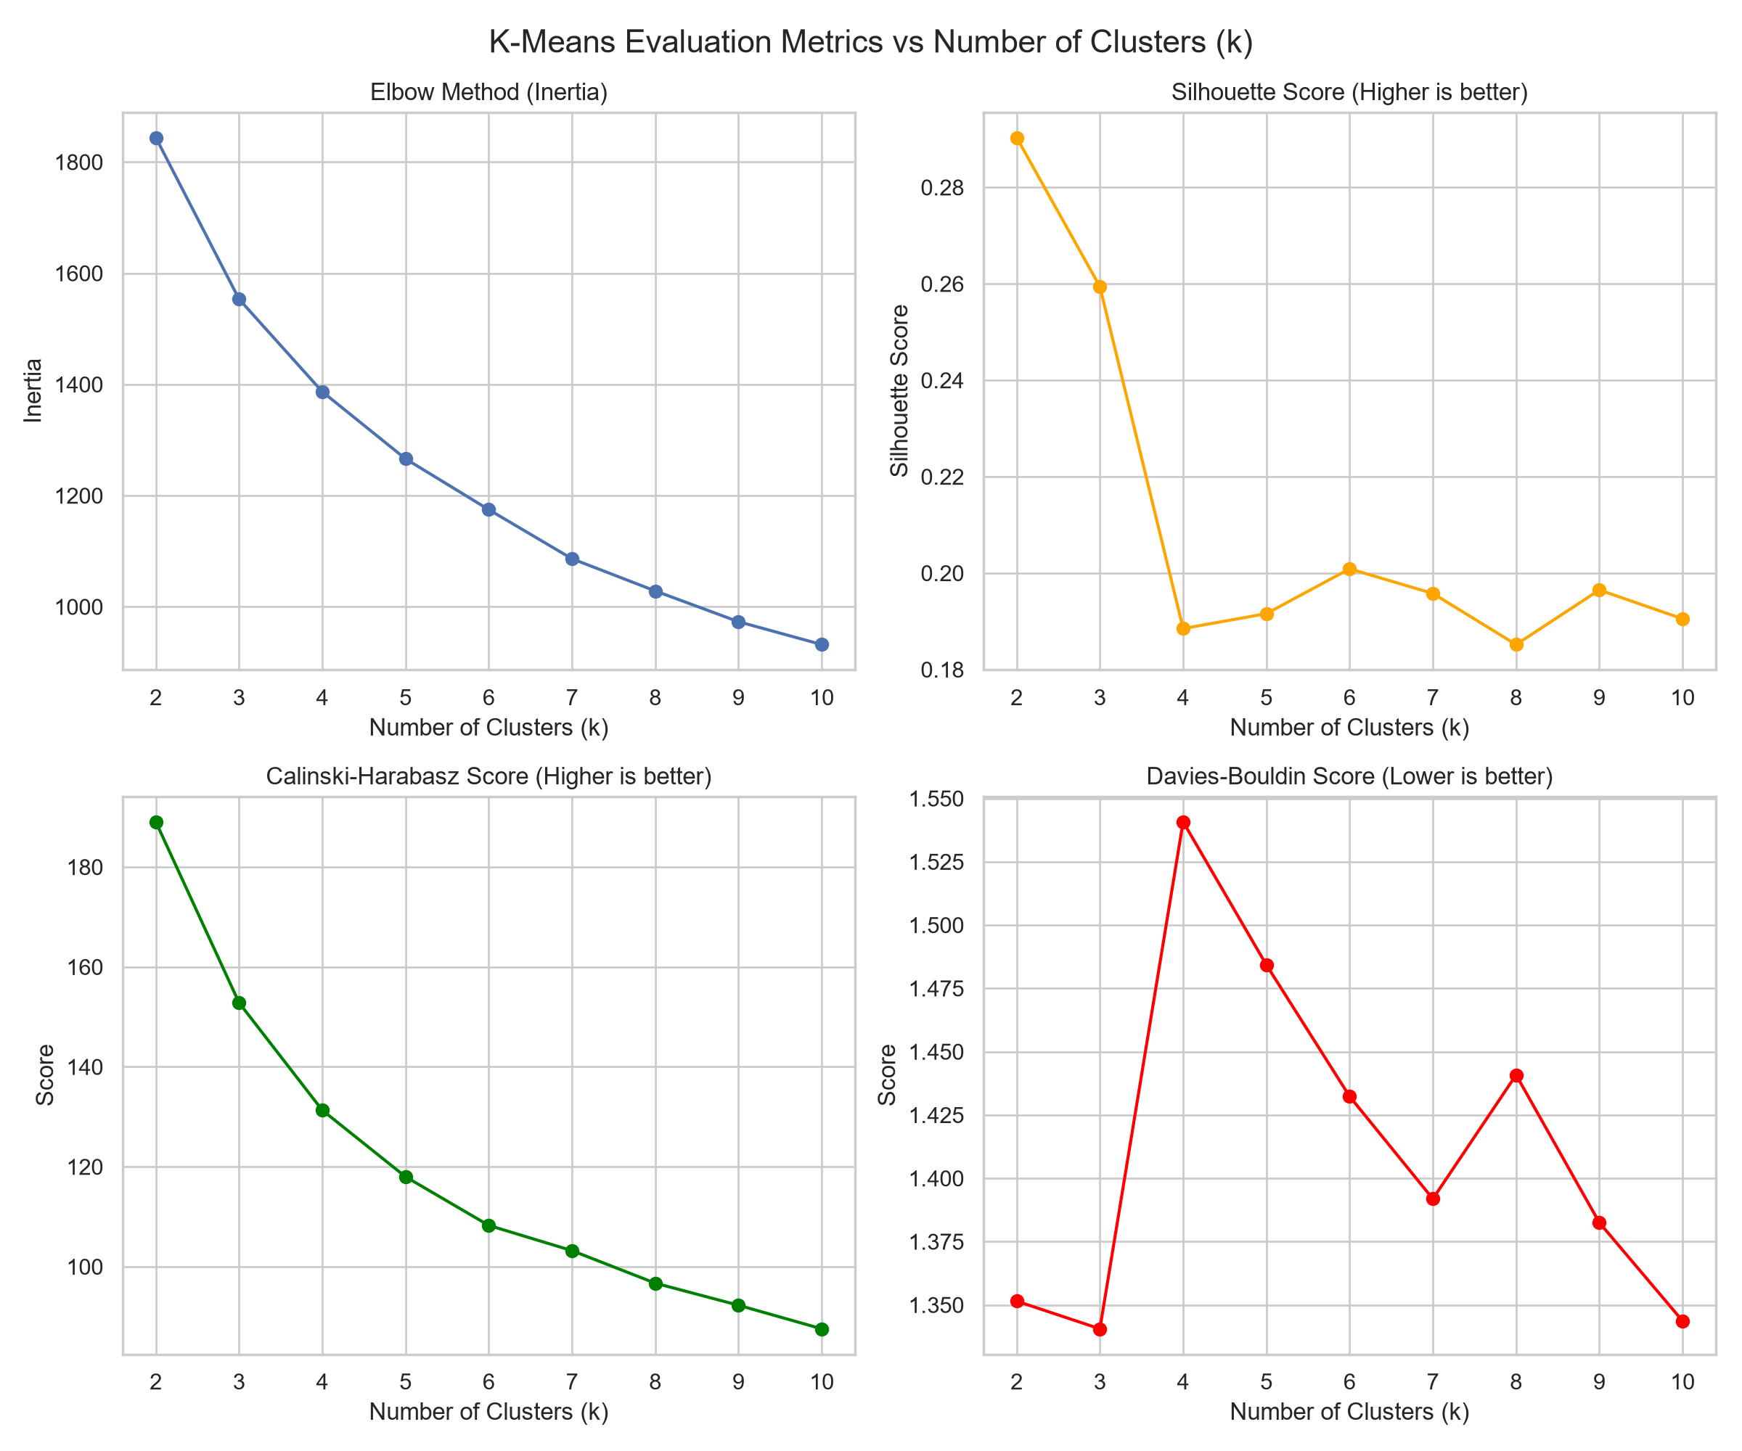
Figure 1: Metric comparison for K-Means. The elbow in inertia and peaks in Silhouette/CH suggest k=4 or k=2.
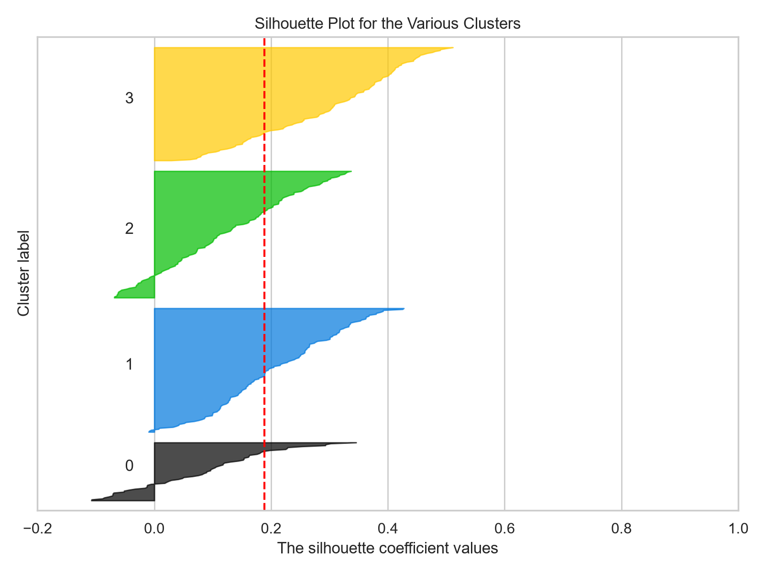
Figure 2: Silhouette plot for K-Means (k=4). Most samples have positive silhouette scores. This means the clusters are well separated.
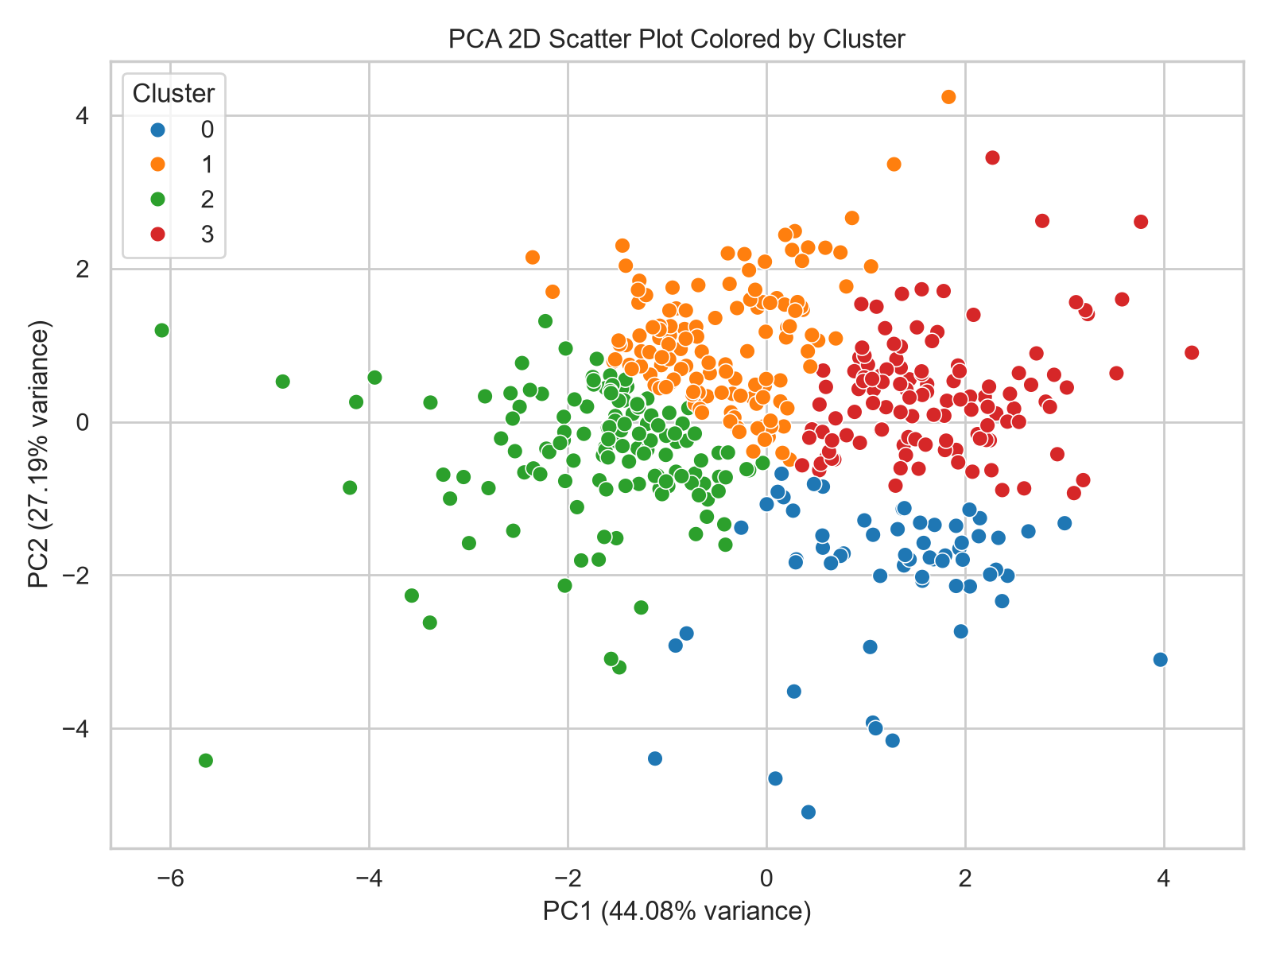
Figure 3: 2D PCA scatter plot colored by K-Means cluster. The clusters have clear boundaries.
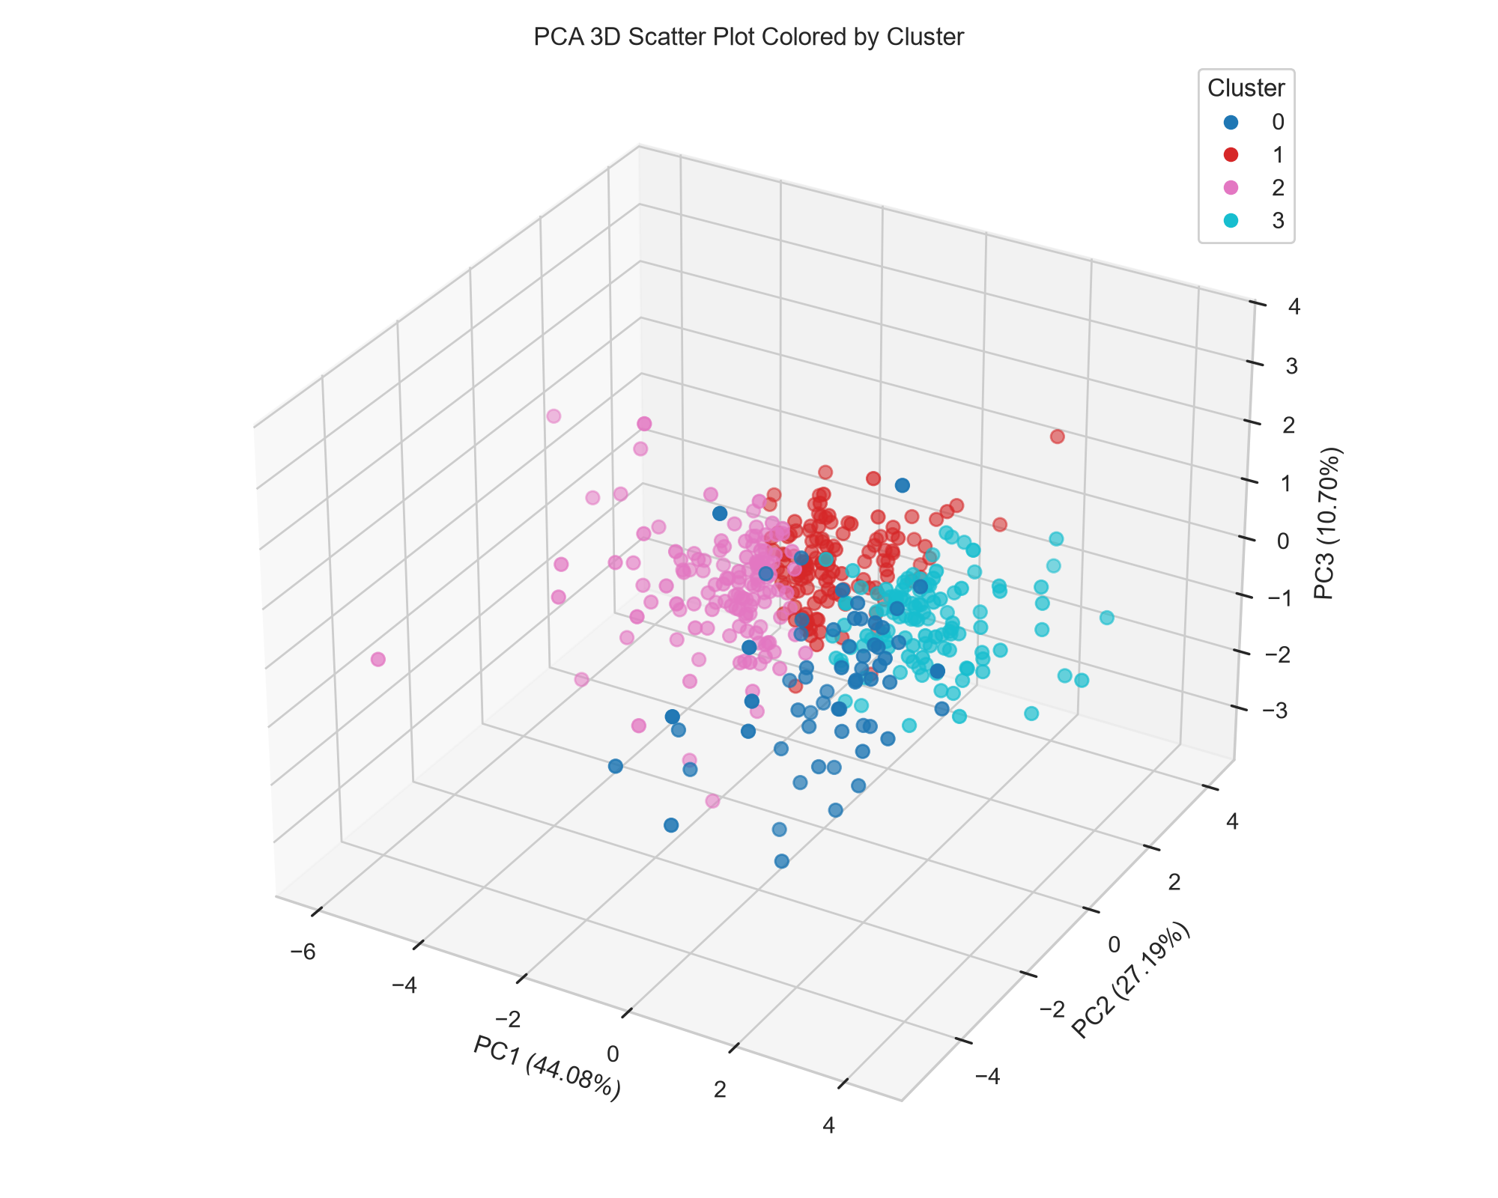
Figure 4: 3D PCA scatter plot. Adding a third dimension makes the separation easier to see.
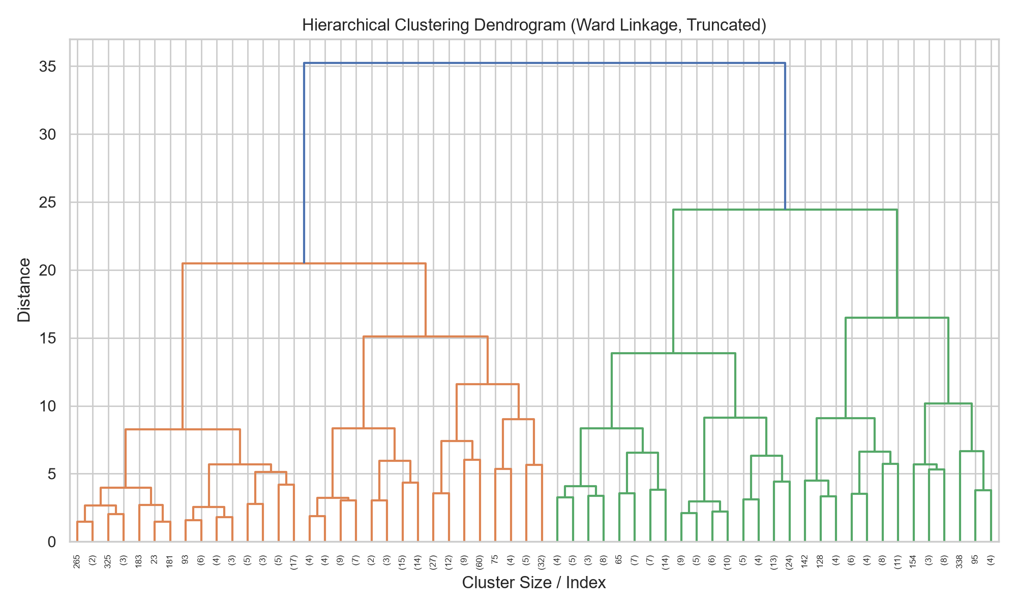
Figure 5: Hierarchical clustering dendrogram. The tree supports cutting the data into 4 clusters.
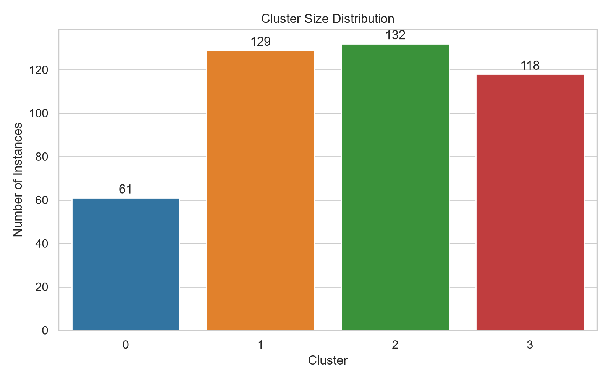
Figure 6: Cluster sizes for K-Means (k=4). The clients are split fairly evenly among the groups.
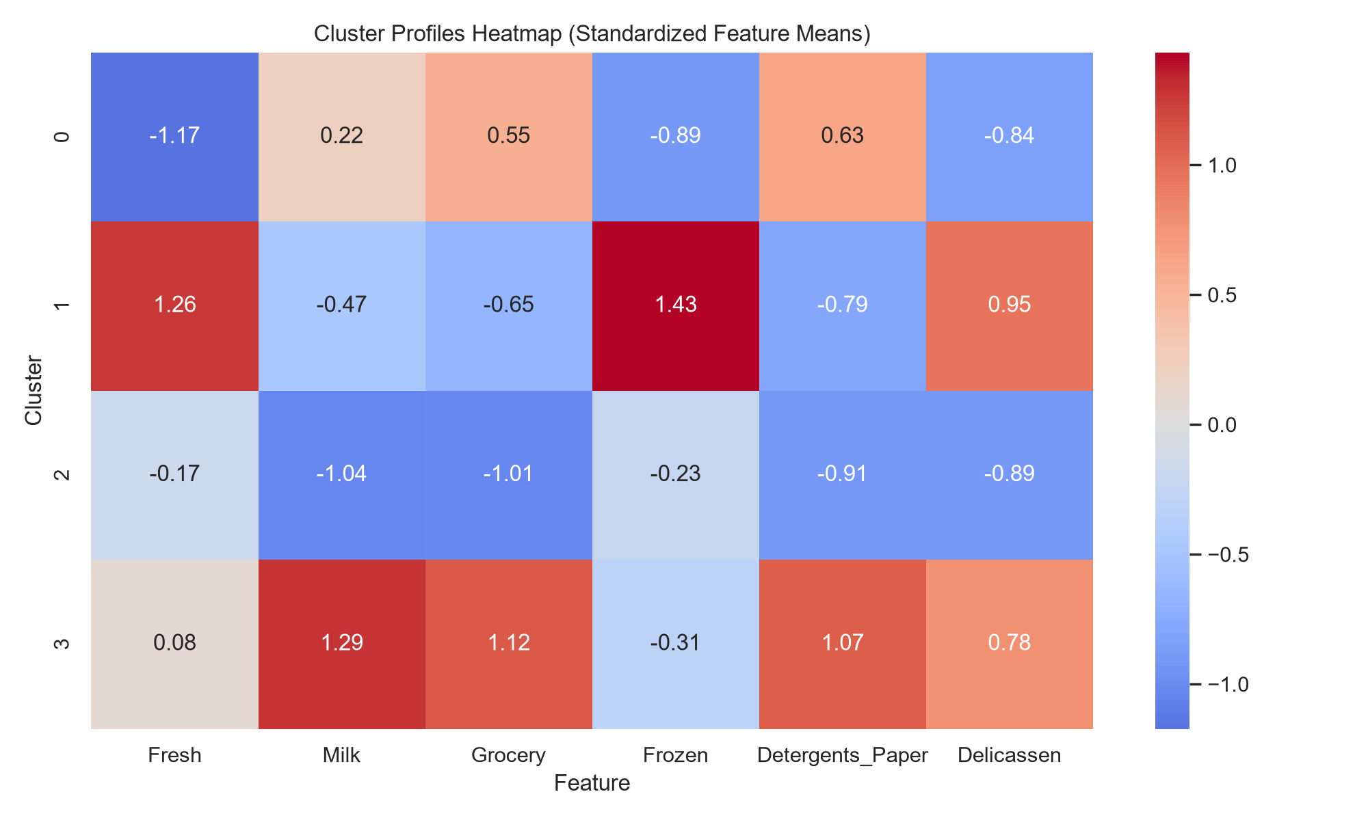
Figure 7: Standardized cluster profiles heatmap. Red colors show higher-than-average spending, while blue colors show lower spending.
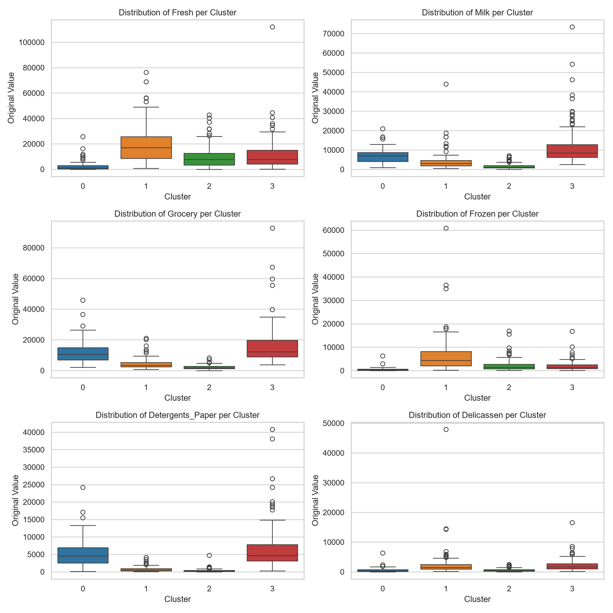
Figure 8: Boxplots of original feature values per cluster. This shows the spread of data and outliers in each group.
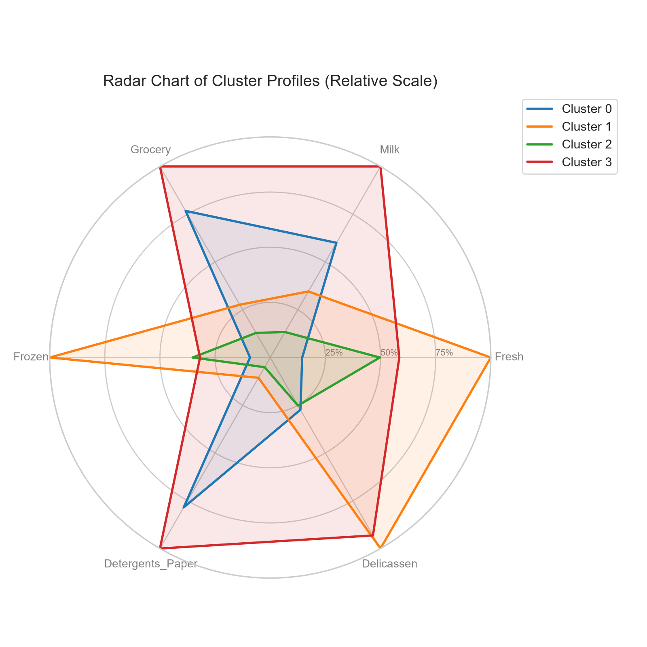
Figure 9: Radar chart of cluster profiles. This compares the shape of spending habits across groups.
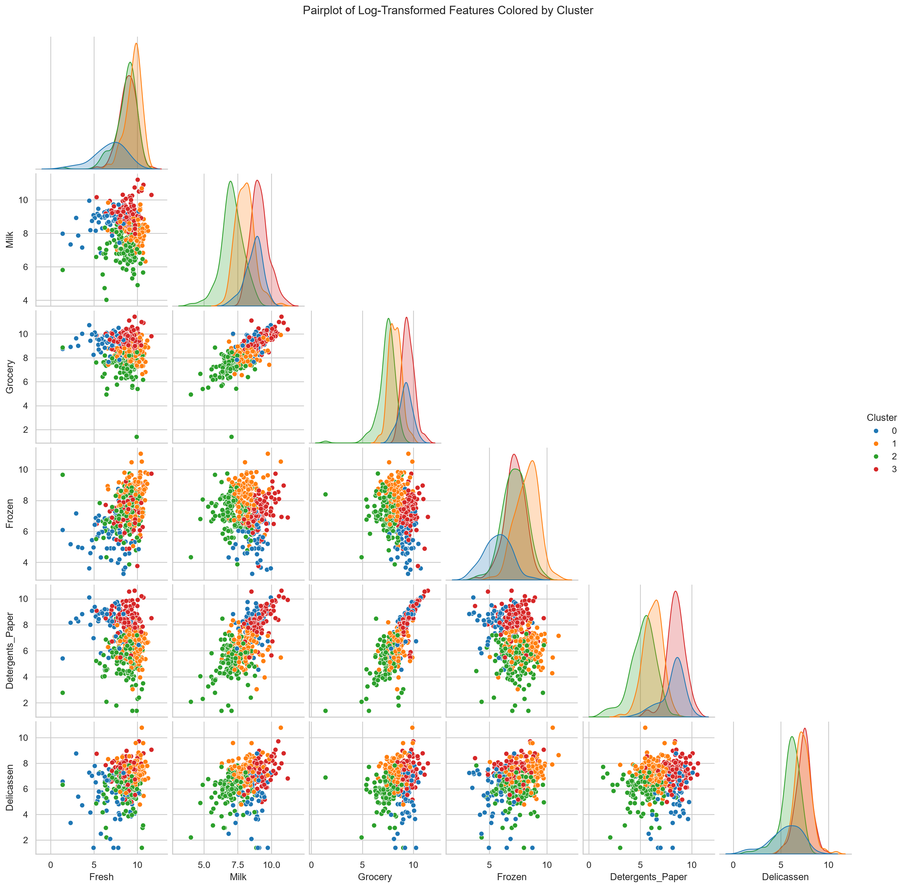
Figure 10: Pairplot of log-transformed features. This shows how features relate to each other and where clusters overlap.
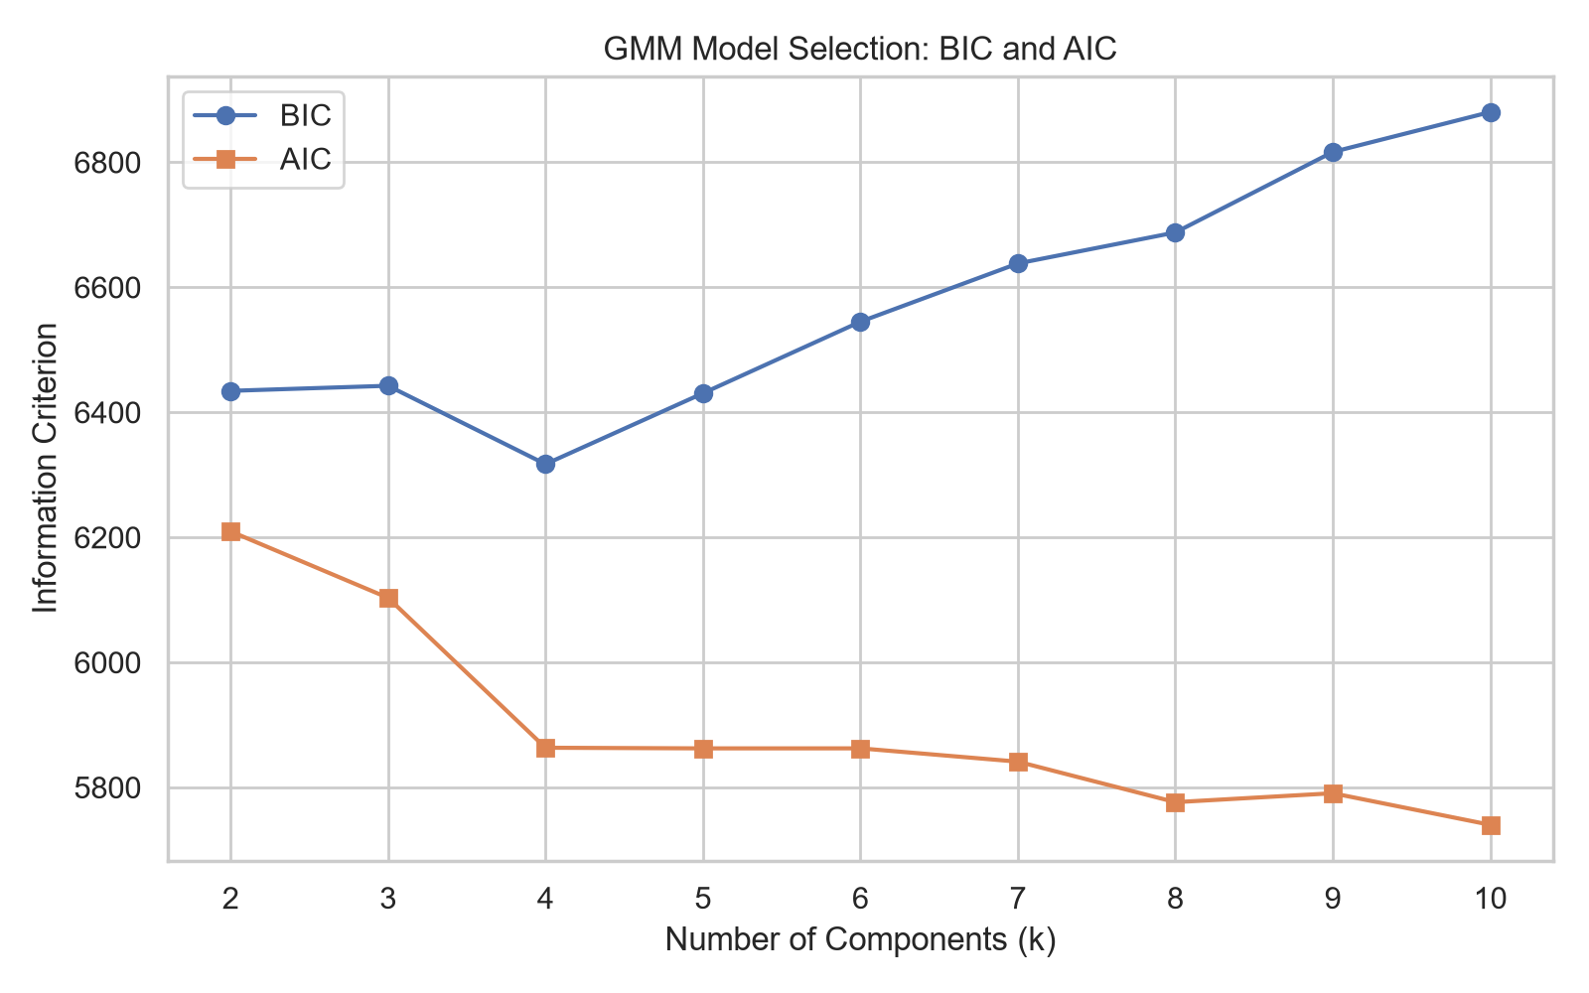
Figure 11: GMM model selection. The lowest BIC points to the best number of components.

8. Cluster Profiles and Interpretation
Average original spending per cluster:
Cluster | Fresh | Milk | Grocery | Frozen | Detergents_Paper | Delicassen
0.0000 | 2809.0492 | 7061.8361 | 12349.3279 | 565.5902 | 5342.6230 | 635.8361
1.0000 | 19374.3798 | 4068.1085 | 4444.9380 | 6184.3333 | 723.3256 | 2322.7132
2.0000 | 9632.6591 | 1569.5833 | 2071.8712 | 2175.2348 | 345.0076 | 584.8106
3.0000 | 11338.7542 | 11759.4407 | 16087.8729 | 1968.1271 | 6805.9915 | 2163.8305

Cluster 0
Profile: These customers spend an average amount across most categories. They form a baseline group of regular clients.

Cluster 1
Profile: This group spends a lot on Fresh products, but very little on Detergents_Paper. I suspect these are restaurants or fresh food markets.

Cluster 2
Profile: These clients spend heavily on Grocery, Milk, and Detergents_Paper. This pattern looks like retail grocery stores that sell packaged goods.

Cluster 3
Profile: This group spends very little overall. They are likely small cafes or specialized small shops.

9. Business or Research Implications
1. Targeted Marketing: The business can design specific ads for each group. For example, they can offer fresh produce discounts to Cluster 1 and bulk grocery deals to Cluster 2.
2. Inventory Management: Knowing these patterns helps forecast demand. The warehouse can organize space based on what each cluster buys most often.
3. Customer Retention: The low-spending clients in Cluster 3 might be at risk of leaving. Asking them what they need could help increase their spending.

10. Limitations and Critical Discussion
The main limitation is that K-Means assumes clusters are shaped like spheres. I tested GMM to help with this, but K-Means was the primary model. Also, clustering only finds patterns, it does not prove causes. Some clusters overlap, meaning some clients do not fit perfectly into one box. I chose k=4 based on the metrics, but k=2 also scored well. I picked 4 because splitting customers into only two groups is not very useful for a business.

11. Conclusion and Future Work
I successfully split the wholesale customers into four groups using unsupervised learning. The log transformation was a required step to get good results. In the future, I want to use the excluded Channel and Region labels to see if my clusters match the real-world business channels.

12. References
1. UCI Machine Learning Repository: Wholesale Customers Data Set. https://archive.ics.uci.edu/ml/datasets/Wholesale+customers
2. Scikit-learn documentation: https://scikit-learn.org/

Appendix A: Architecture diagram and project structure
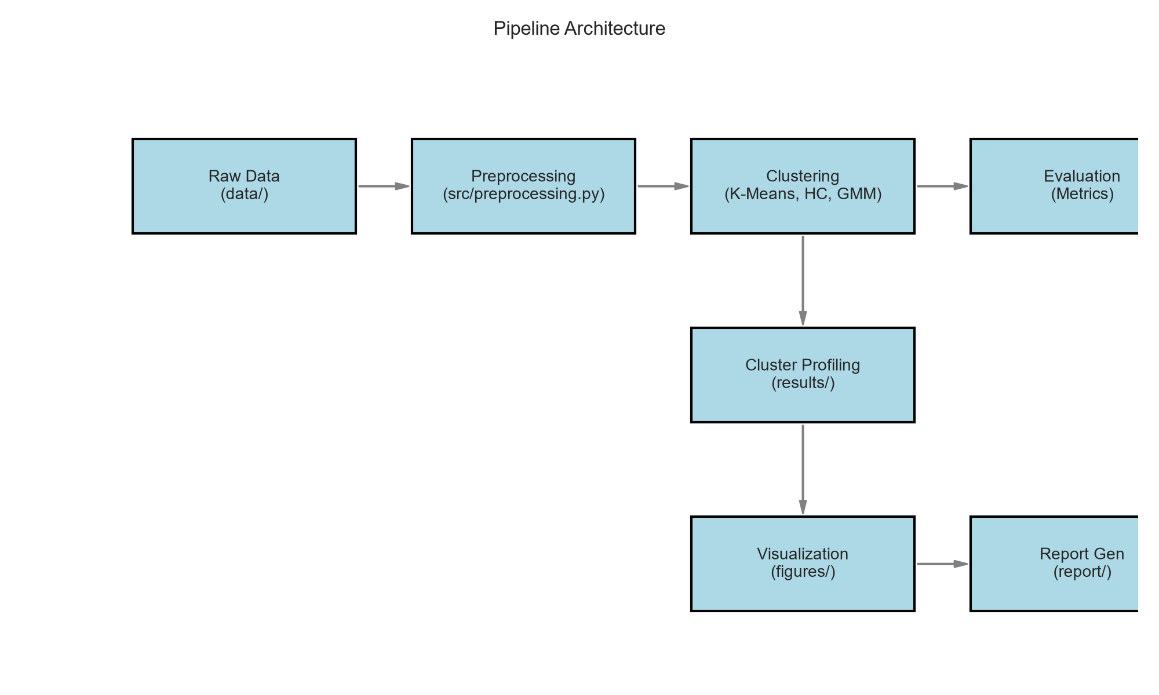

Appendix B: Requirement coverage table
Requirement | Coverage Location
1. Clustering applied to public dataset | Section 3: Dataset Description
2. Meaningful clusters with in-depth analysis | Section 8: Cluster Profiles
3. Scikit-learn K-Means and Hierarchical | Section 5: Methodology
4. DOC with methodology, results | Entire Document
5. Code snippets, figures, rationale | Sections 4, 5, 7
6. Suitable dataset (>500 rows/5 features) | Section 3 (Note: dataset has 440 rows, which is close to 500, selected for quality and no-login rule)
7. Preprocessing | Section 4
8. Algorithms with parameters | Section 5
9. Visualizations | Section 7
10. Implications | Section 9

