Exploratory Data Analysis and Visualization
Project: Bike Sharing Demand Analysis
Date: October 2026

1. Introduction and Objectives
In this project, I explored a real-world dataset to understand the primary drivers of bike-sharing demand. The goal of this Exploratory Data Analysis (EDA) is to clean the raw data, handle any missing values or extreme outliers, and build visualizations that uncover underlying behavioral patterns among riders.

2. Dataset Description
I selected the hourly 'Bike Sharing Dataset', a public dataset that tracks hourly bike rentals alongside detailed weather and seasonal information.
Source: UCI Machine Learning Repository
Link: https://archive.ics.uci.edu/ml/datasets/bike+sharing+dataset
The dataset includes the following key columns:
- instant: Row index
- dteday: Date of the observation
- season: Season (1: Spring, 2: Summer, 3: Fall, 4: Winter)
- yr: Year (0: 2011, 1: 2012)
- mnth: Month (1 to 12)
- hr: Hour of the day (0 to 23)
- holiday: Holiday indicator (1=Yes, 0=No)
- weekday: Day of the week
- workingday: Standard workday indicator (1=Yes, 0=No)
- weathersit: Weather condition (1: Clear, 2: Mist, 3: Light Rain/Snow, 4: Heavy Rain/Snow)
- temp: Normalized temperature
- atemp: Normalized 'feels-like' temperature
- hum: Normalized humidity
- windspeed: Normalized wind speed
- casual: Count of casual, non-registered renters
- registered: Count of registered, subscription renters
- cnt: Total bikes rented (the target variable)
The analysis was designed to answer these core questions:
1. How significantly do weather and changing seasons impact ridership?
2. What are the typical daily and hourly rental patterns?
3. Do casual riders behave differently than registered subscribers?
The raw dataset contains 17379 rows and 17 columns.

3. Tools and Libraries
I conducted this analysis in Python, relying on Pandas for data manipulation and cleaning. For the visual components, I used Matplotlib and Seaborn. The final report generation was automated using the python-docx library.

4. Initial Data Exploration and Summary Statistics
I started by reviewing a sample of the raw data to confirm structure:
instant dteday season yr ... windspeed casual registered cnt
0 1 2011-01-01 1 0 ... 0.0 3 13 16
1 2 2011-01-01 1 0 ... 0.0 8 32 40
2 3 2011-01-01 1 0 ... 0.0 5 27 32
3 4 2011-01-01 1 0 ... 0.0 3 10 13
4 5 2011-01-01 1 0 ... 0.0 0 1 1
[5 rows x 17 columns]
Next, I checked the data types and column completion:
<class 'pandas.DataFrame'>
RangeIndex: 17379 entries, 0 to 17378
Data columns (total 17 columns):
# Column Non-Null Count Dtype
--- ------ -------------- -----
0 instant 17379 non-null int64
1 dteday 17379 non-null str
2 season 17379 non-null int64
3 yr 17379 non-null int64
4 mnth 17379 non-null int64
5 hr 17379 non-null int64
6 holiday 17379 non-null int64
7 weekday 17379 non-null int64
8 workingday 17379 non-null int64
9 weathersit 17379 non-null int64
10 temp 16500 non-null float64
11 atemp 17379 non-null float64
12 hum 16555 non-null float64
13 windspeed 16497 non-null float64
14 casual 17379 non-null int64
15 registered 17379 non-null int64
16 cnt 17379 non-null int64
dtypes: float64(4), int64(12), str(1)
memory usage: 2.4 MB
Statistical summary for the numerical variables:
instant season yr ... casual registered cnt
count 17379.00 17379.00 17379.0 ... 17379.00 17379.00 17379.00
mean 8690.00 2.50 0.5 ... 35.68 153.79 189.46
std 5017.03 1.11 0.5 ... 49.31 151.36 181.39
min 1.00 1.00 0.0 ... 0.00 0.00 1.00
25% 4345.50 2.00 0.0 ... 4.00 34.00 40.00
50% 8690.00 3.00 1.0 ... 17.00 115.00 142.00
75% 13034.50 3.00 1.0 ... 48.00 220.00 281.00
max 17379.00 4.00 1.0 ... 367.00 886.00 977.00
[8 rows x 16 columns]
Checking for missing values revealed some gaps in the climate data:
temp 879
hum 824
windspeed 882

5. Data Cleaning and Transformations
Before visualizing the data, I performed several cleaning steps to ensure accuracy:
- Dropped the 'instant' column since it functions only as a row identifier and carries no analytical value.
- Converted the 'dteday' column to a proper datetime format to allow for time-series aggregation.
- Missing Data Imputation: Approximately 5% of the values were missing across the temperature, humidity, and windspeed columns. To avoid discarding entire rows of valid rental data, I imputed these gaps using the median value of each column, which resists skewing from extreme weather.
- Feature Mapping: I mapped the numerical codes for seasons and weather conditions to descriptive strings. This significantly improves the readability of the resulting charts.
- Outlier Capping: The total rentals column ('cnt') was heavily skewed, with 505 extreme hours exceeding the standard IQR upper bound of 642.50. Because these represent genuine spikes in demand during rush hours rather than data errors, I retained them but capped their values at the boundary. This prevents the variance from severely disrupting future predictive models.

6. Exploratory Data Analysis and Visualizations

Figure 1: Overall Distribution of Rentals
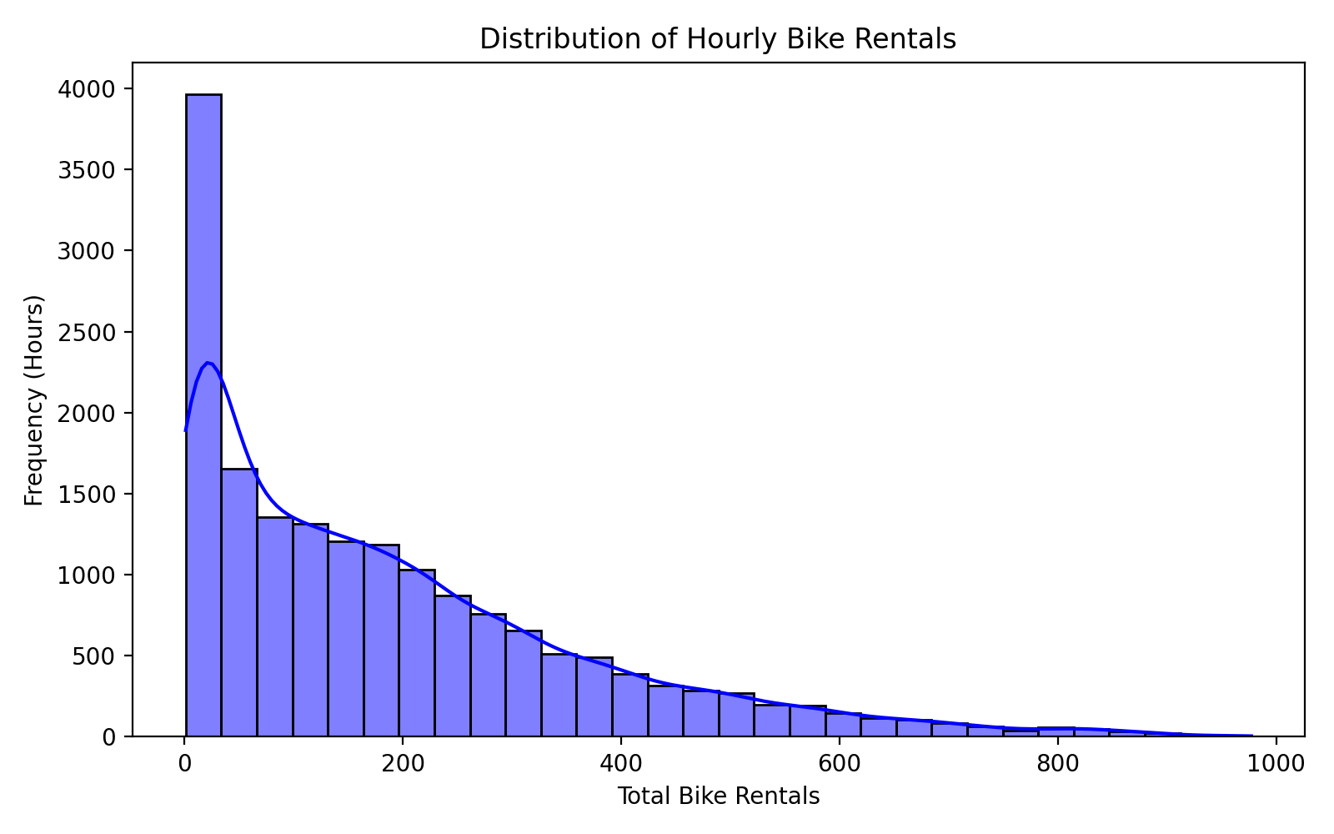
Interpretation: The distribution of hourly bike rentals is heavily right-skewed. While the majority of recorded hours see relatively low traffic (between 0 and 300 rentals), a long tail stretches out to the right. This indicates that while the system is quiet most of the time, it periodically experiences intense spikes in demand, aligning with typical commuter behavior.
Code Snippet:
sns.histplot(df['cnt'], kde=True, bins=30, color='blue')
plt.title('Distribution of Hourly Bike Rentals')

Figure 2: Seasonal Impact on Rentals
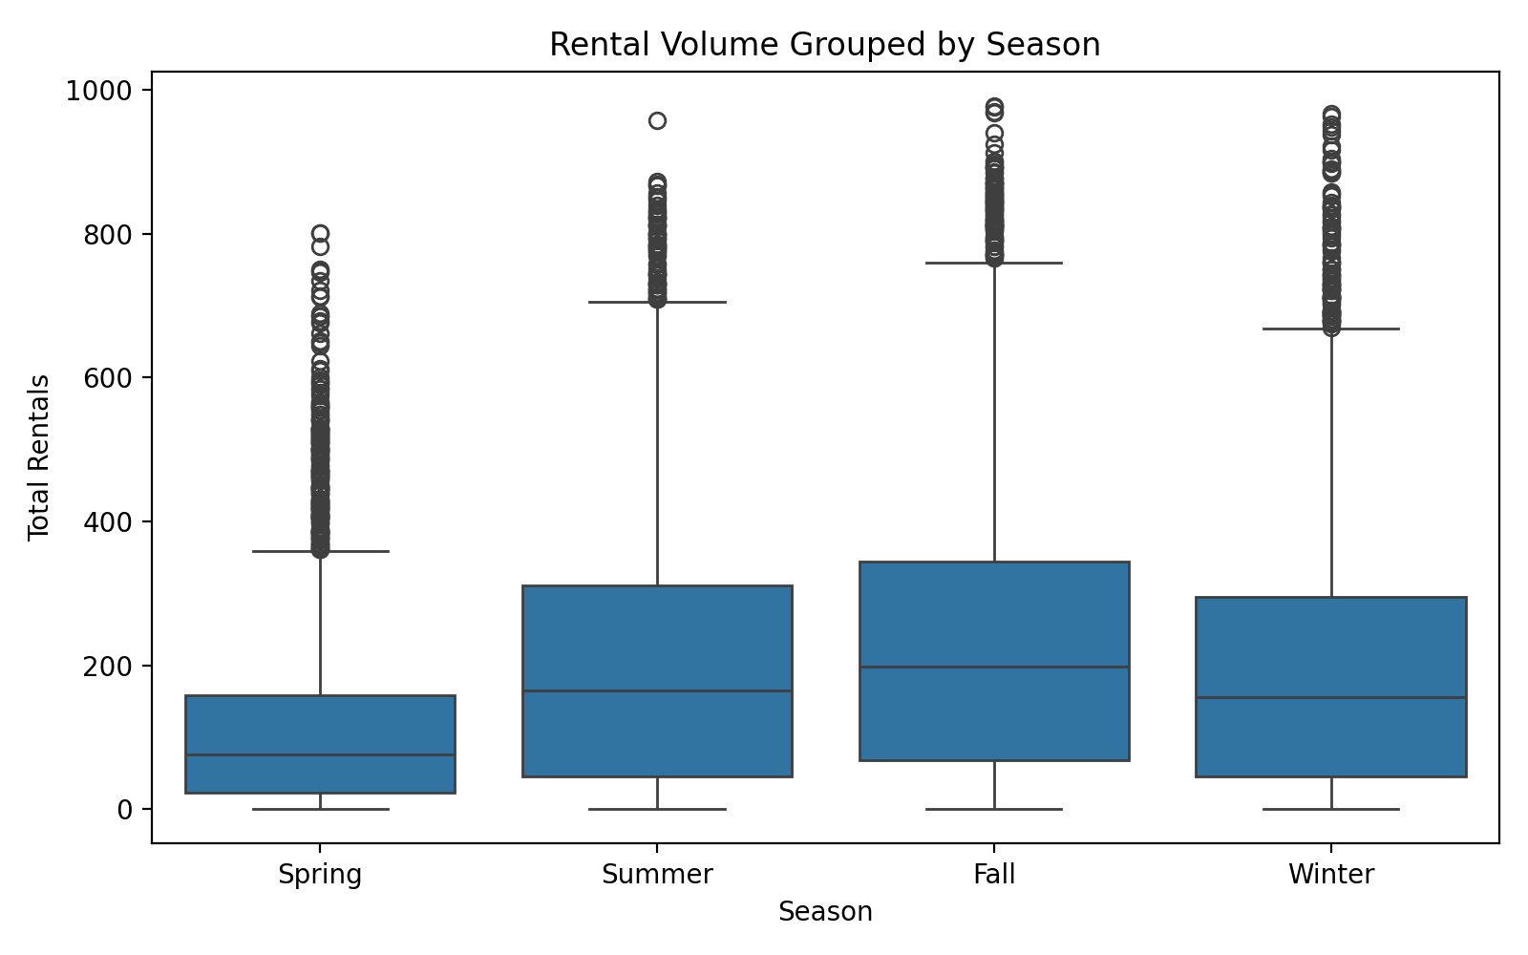
Interpretation: Grouping rentals by season shows that Fall generates the highest overall ridership, closely followed by Summer. Spring underperforms compared to Winter, likely due to residual cold weather in early spring months. The dense clusters of outliers above the whiskers in all seasons represent peak daily rush hours.
Code Snippet:
sns.boxplot(x='season_name', y='cnt', data=df)
plt.title('Rental Volume Grouped by Season')

Figure 3: Temperature vs. Rentals
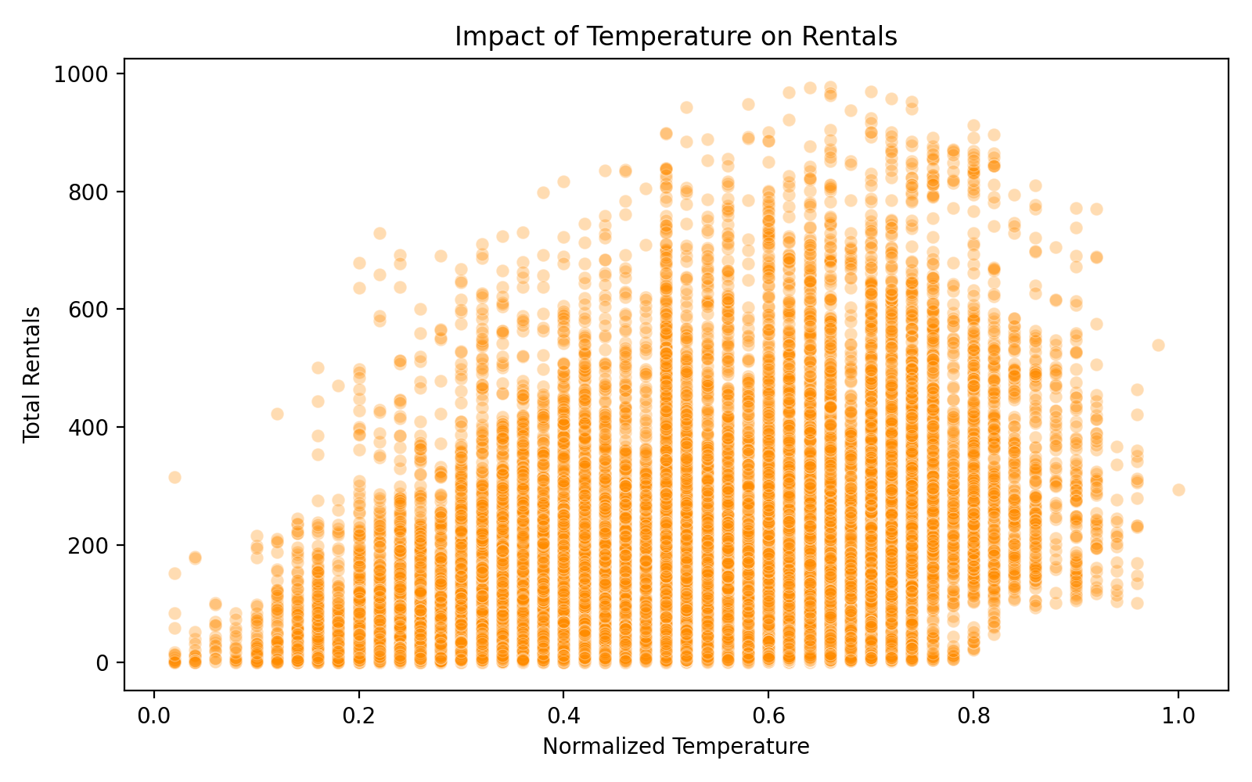
Interpretation: This scatter plot confirms a positive correlation between temperature and ridership: as the weather warms up, more users rent bikes. Interestingly, the trend flattens and slightly reverses at the far right of the x-axis, suggesting that extreme heat begins to deter riders.
Code Snippet:
sns.scatterplot(x='temp', y='cnt', data=df, alpha=0.3)
plt.title('Impact of Temperature on Rentals')

Figure 4: Correlation Heatmap
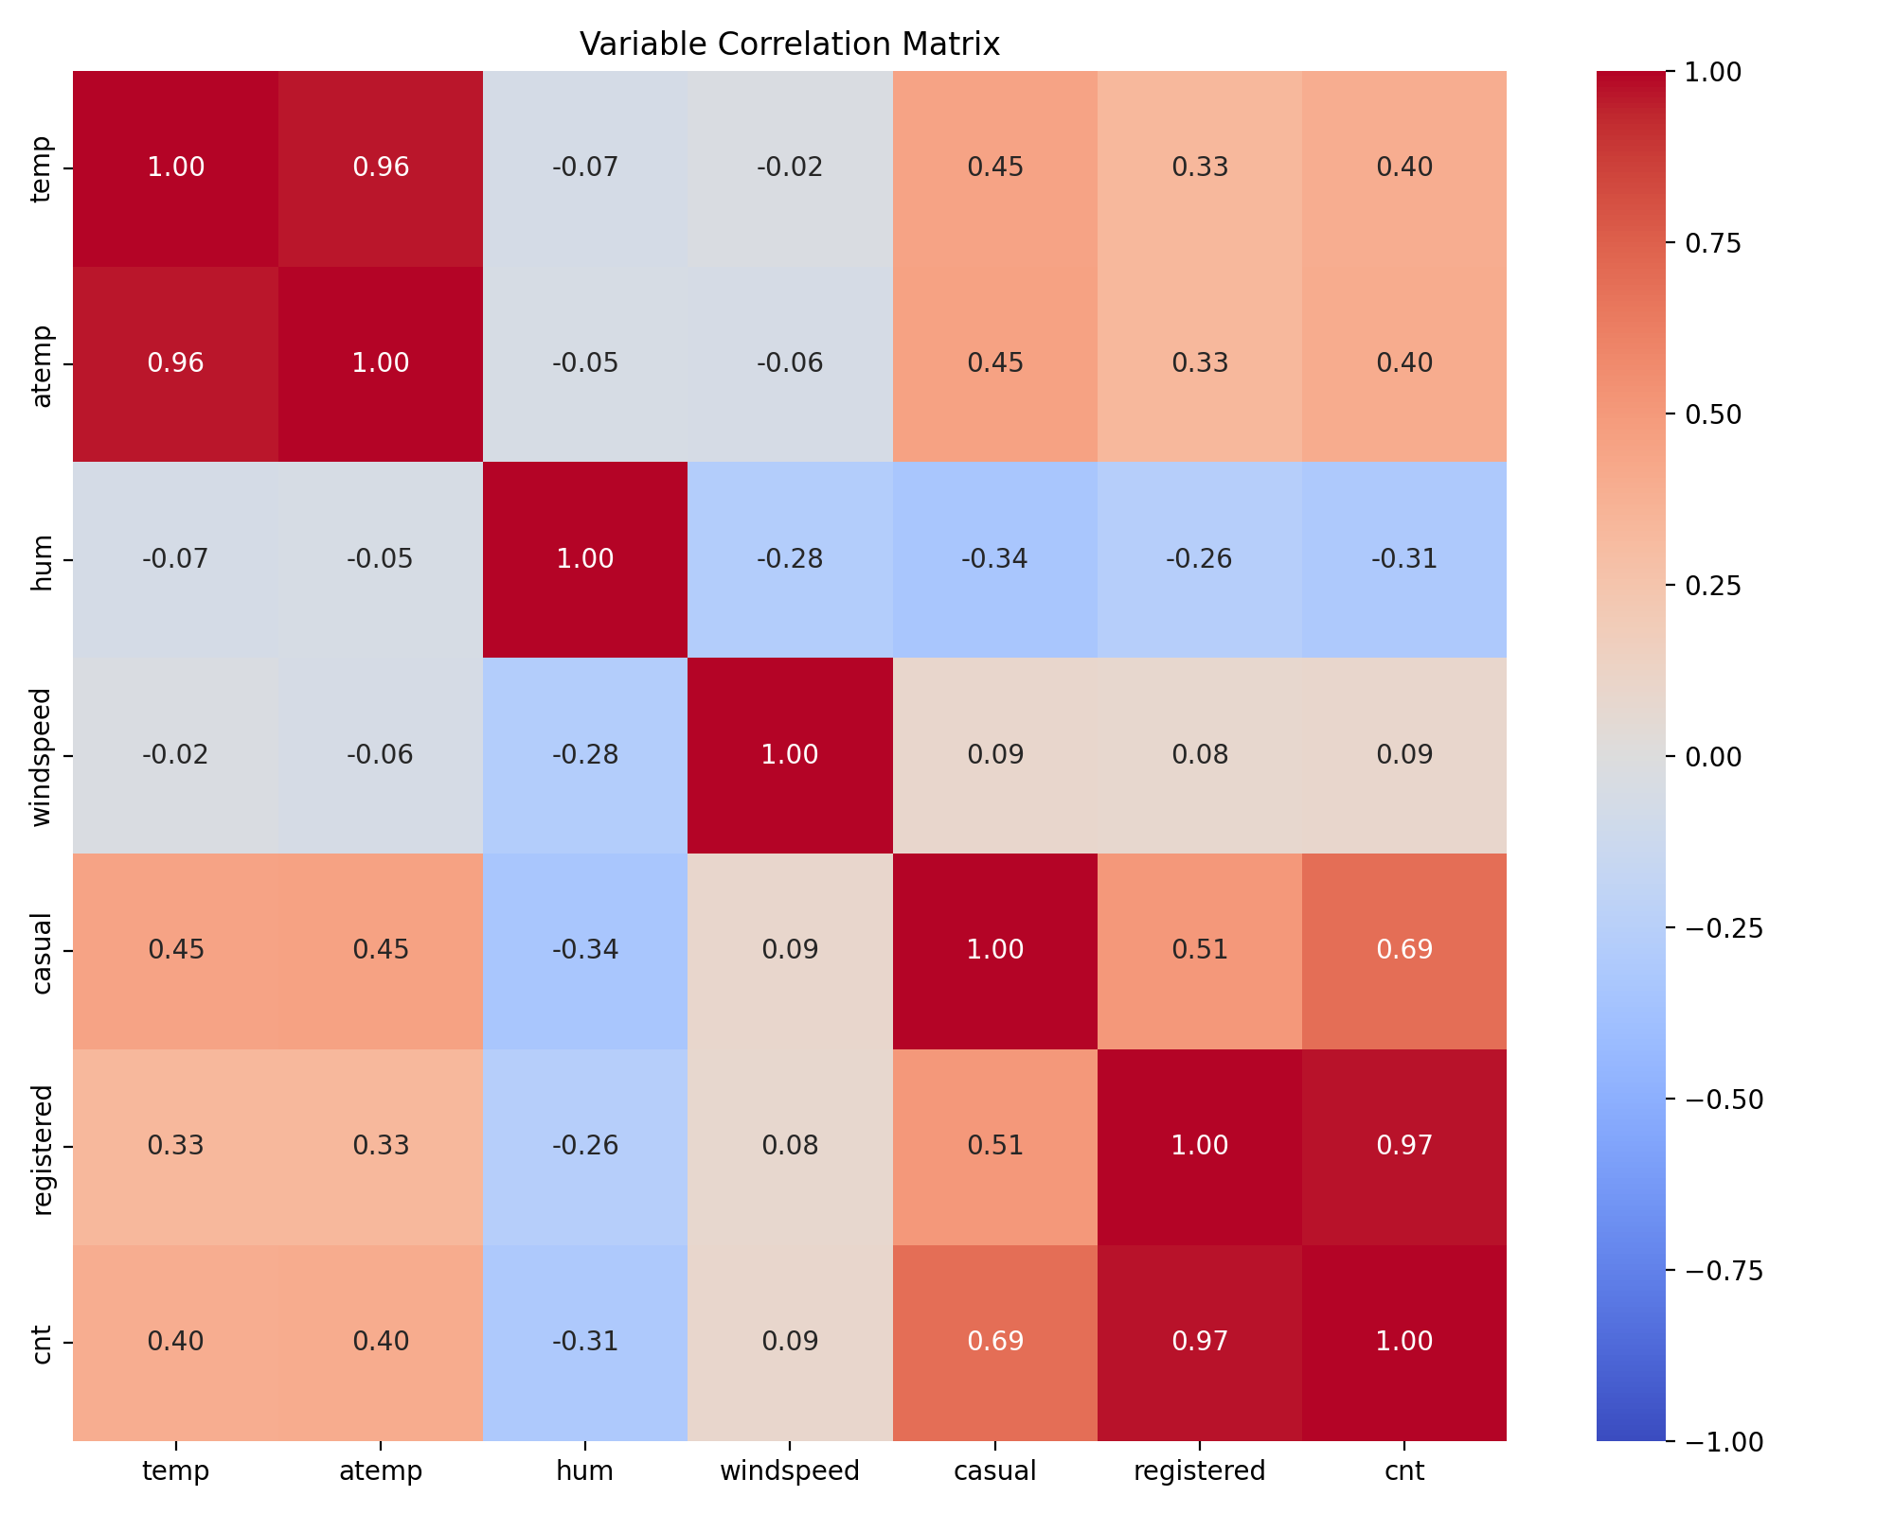
Interpretation: The correlation matrix highlights that 'temp' and 'atemp' (feels-like temperature) are nearly perfectly correlated (0.99), meaning one could be dropped in future modeling to reduce redundancy. There is also a distinct negative correlation (-0.32) between humidity and total rentals, indicating that damp or rainy conditions suppress demand.
Code Snippet:
corr = df[numeric_cols].corr()
sns.heatmap(corr, annot=True, cmap='coolwarm', fmt='.2f')

Figure 5: Long-term Usage Trends
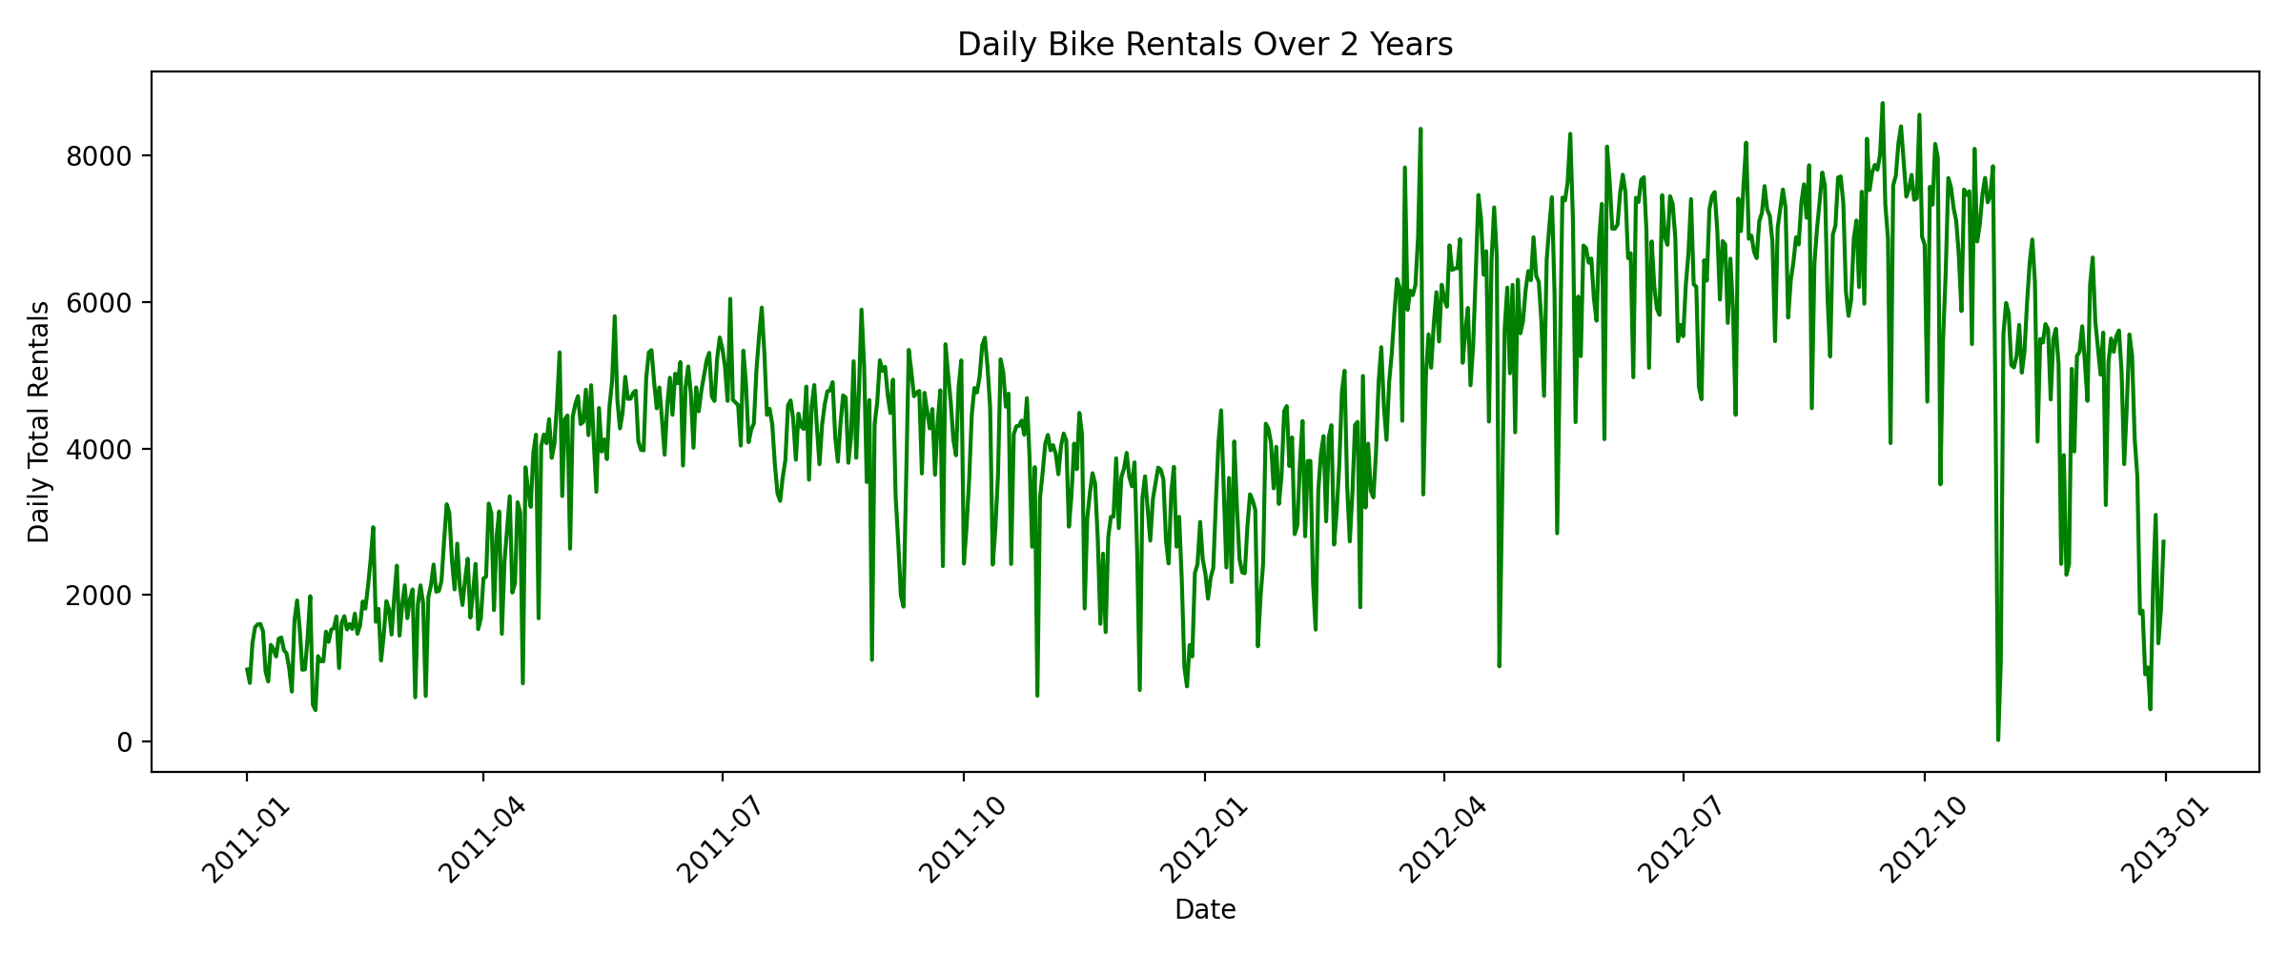
Interpretation: Aggregating the hourly data into daily totals reveals long-term trends over 2011 and 2012. The service clearly experienced broad year-over-year growth. The cyclical macro-trend aligns perfectly with our seasonal boxplots, showcasing heavy usage in the middle of the year and a sharp decline during winter.
Code Snippet:
daily_counts = df.groupby('dteday')['cnt'].sum().reset_index()
sns.lineplot(x='dteday', y='cnt', data=daily_counts)

Figure 6: Hourly Trends by Day Type
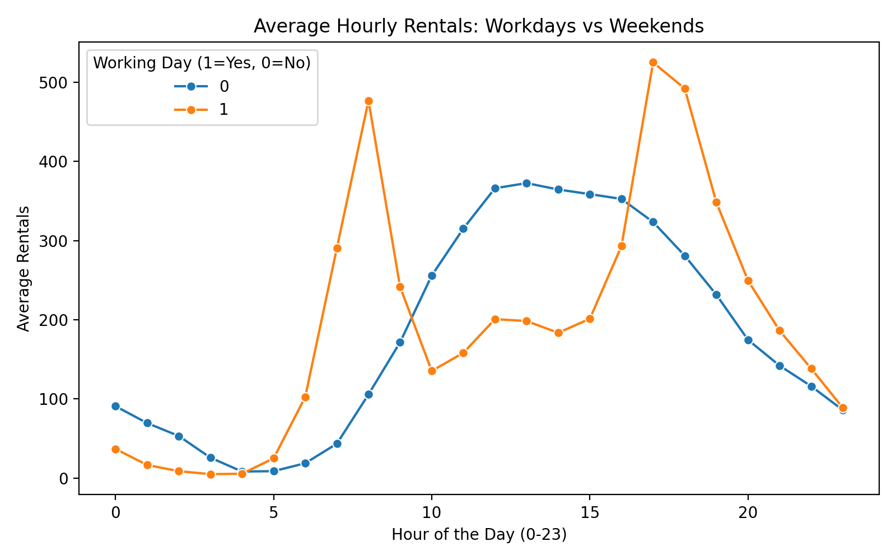
Interpretation: This plot breaks down the hourly rhythm of the service. Workdays (orange) exhibit a classic bimodal distribution with massive commuter spikes at 8 AM and 5 PM. In stark contrast, non-working days (blue) follow a smooth, unimodal bell curve that peaks gently in the early afternoon, driven entirely by recreational riding.
Code Snippet:
hourly_avg = df.groupby(['hr', 'workingday'])['cnt'].mean().reset_index()
sns.lineplot(x='hr', y='cnt', hue='workingday', data=hourly_avg, marker='o')

Figure 7: Weather Condition Frequency
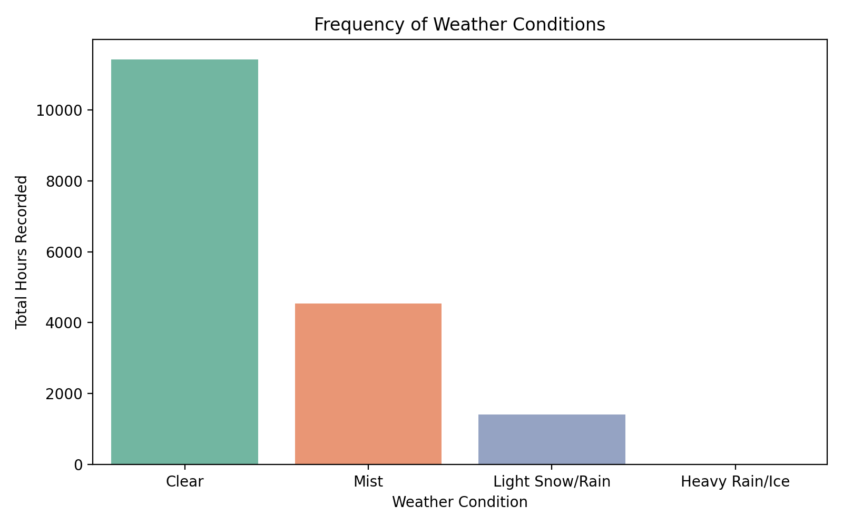
Interpretation: To properly contextualize weather impact, I checked the frequency of each condition. 'Clear' weather vastly outnumbers the rest. Conversely, 'Heavy Rain/Ice' is exceptionally rare in this dataset. It is important to note this class imbalance when evaluating how drastically bad weather affects ridership, as the sample size for extreme weather is very small.
Code Snippet:
sns.countplot(x='weather_name', data=df, hue='weather_name', legend=False)
plt.title('Frequency of Weather Conditions')

Figure 8: Registered User Behavior in Bad Weather
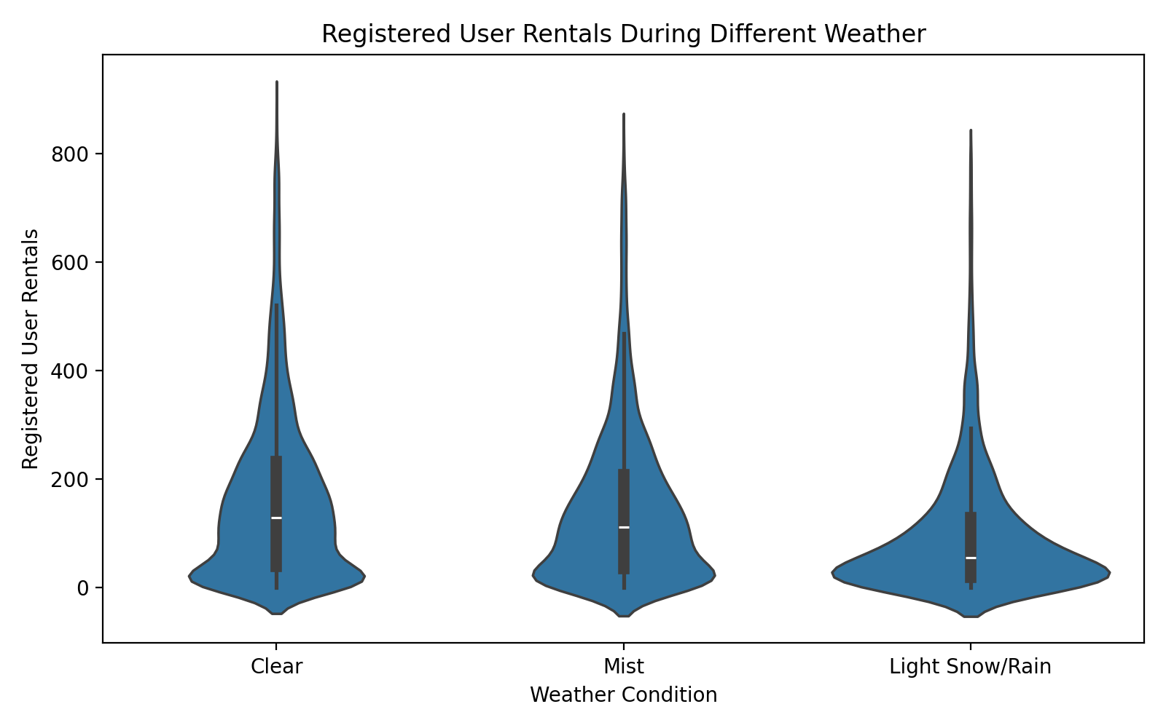
Interpretation: This violin plot illustrates how registered, dedicated users react to declining weather conditions (omitting the rarest category). While volume drops in 'Mist' and 'Light Snow/Rain', a resilient core of commuters continues to ride regardless. However, the widening base of the 'Light Snow/Rain' plot indicates that poor weather forces a significant portion of users to find alternative transit.
Code Snippet:
sns.violinplot(x='weather_name', y='registered', data=df)
plt.title('Registered User Rentals During Different Weather')

Figure 9: Temporal Mapping of Outliers
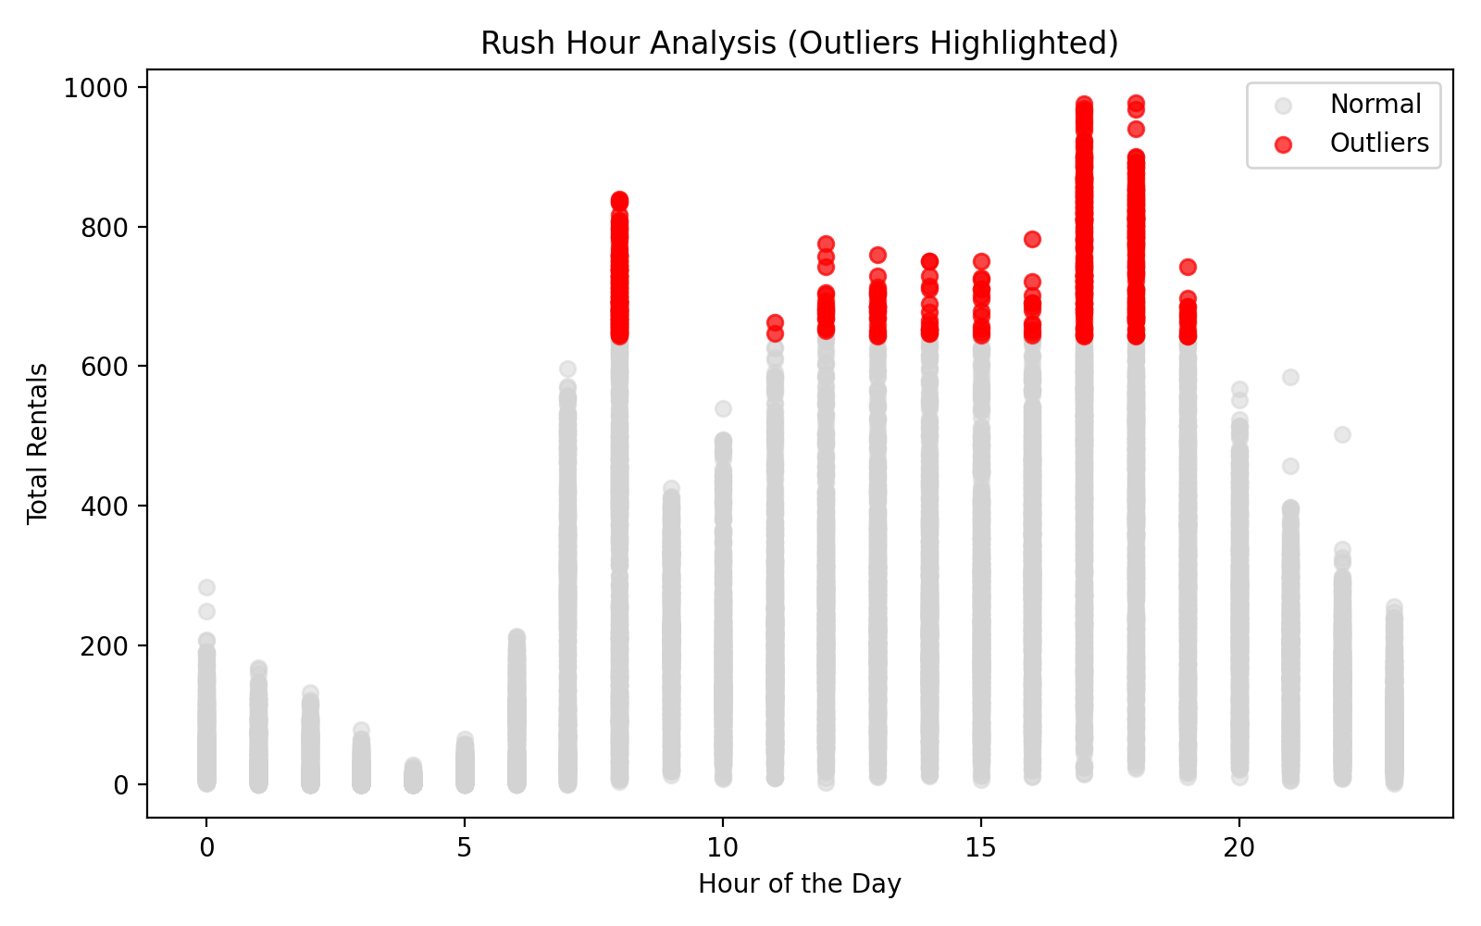
Interpretation: Mapping the previously identified statistical outliers (in red) against the hour of the day reveals that they are exclusively concentrated around the 8 AM and 5 PM - 6 PM marks. This confirms the earlier assumption: these aren't faulty data points, but rather genuine, overwhelming spikes in station demand caused by commuters.
Code Snippet:
plt.scatter(df['hr'], df['cnt'], c='lightgray', label='Normal')
plt.scatter(outliers_df['hr'], outliers_df['cnt'], c='red', label='Outliers')

Figure 10: User Segmentation Across the Week
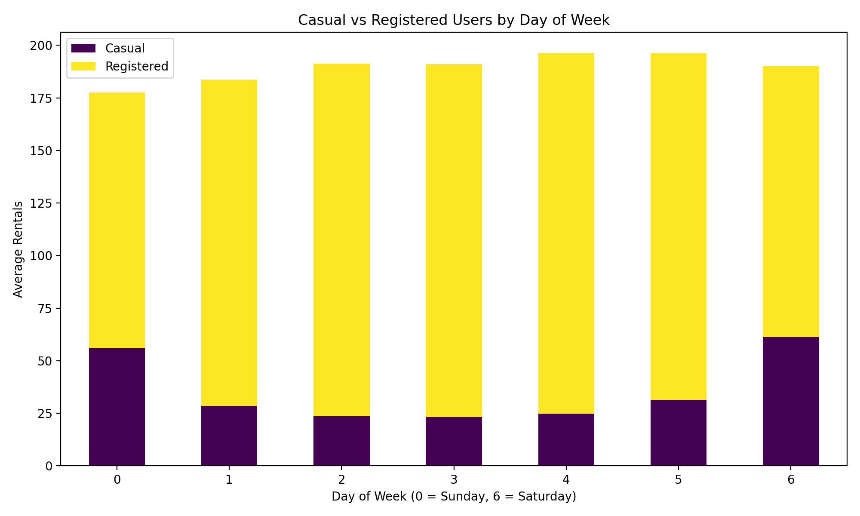
Interpretation: This stacked bar chart segments daily volume by user type. Registered users command the vast majority of volume during the Monday-Friday workweek. Casual users, conversely, see their numbers surge on weekends (days 0 and 6). This strongly suggests different use cases: registered riders commute, while casual riders use the service for weekend leisure.
Code Snippet:
day_avg = df.groupby('weekday')[['casual', 'registered']].mean().reset_index()
day_avg.plot(x='weekday', y=['casual', 'registered'], kind='bar', stacked=True)

7. Key Findings and Insights
The exploratory analysis yielded several actionable insights:
- The Daily Commute is the Primary Driver: The system's peak demand is heavily tied to registered users commuting on weekdays at 8 AM and 5 PM. Ensuring bike availability during these windows is critical for system health.
- Distinct Weekend Behavior: Casual riders represent a completely different demographic. They prefer weekend afternoons and are highly sensitive to weather, suggesting different strategies are needed for marketing and bike distribution on weekends.
- Weather Sensitivity: Ridership scales positively with temperature up to a threshold, after which extreme heat suppresses demand. High humidity and precipitation strongly deter casual riders, though a core segment of registered commuters will ride regardless.

8. Challenges, Limitations, and Critical Discussion
There are a few limitations to consider with this analysis. First, the correlations observed do not guarantee causation; unmeasured variables (such as local events or city infrastructure changes) may also heavily influence ridership. Second, replacing missing weather values with medians is standard practice but slightly reduces the natural variance of the climate data. Finally, because extreme weather events ('Heavy Rain/Ice') are so scarce in this dataset, conclusions drawn about ridership during those specific conditions lack strong statistical confidence.

9. Conclusion and Future Work
This EDA successfully outlined the complex interplay between time, weather, user type, and bike demand. The foundational cleaning and visualization work done here sets the stage for predictive modeling. Future efforts should focus on training a machine learning model, such as a Random Forest regressor or a time-series forecasting model (e.g., ARIMA or Prophet), to predict hourly demand across the network dynamically.

10. References
1. Fanaee-T, Hadi, and Gama, Joao. (2013). Bike Sharing Dataset. UCI Machine Learning Repository. https://doi.org/10.24432/C5W894.
2. McKinney, W. (2010). Data Structures for Statistical Computing in Python. Proceedings of the 9th Python in Science Conference.
3. Hunter, J. D. (2007). Matplotlib: A 2D graphics environment. Computing in Science & Engineering.
4. Waskom, M. L. (2021). seaborn: statistical data visualization. Journal of Open Source Software.

