WEEK 1 PROJECT REPORT
Data Acquisition, Cleaning, and Preprocessing

1. Executive Summary
This report details the data acquisition, cleaning, and preprocessing steps performed on the UCI Online Retail dataset. We started with 541909 raw transactional records. After treating missing values, removing 5268 duplicate records, cleaning invalid prices, and trimming extreme outliers, we produced a final analysis-ready dataset containing 532529 records.

2. Objectives
The objective of this assignment is to acquire a publicly available dataset and perform structured data exploration, quality assessment, and cleaning. The goal is to document all decisions clearly and handle missing values, duplicates, and outliers systematically, ensuring the data is ready for downstream analytical tasks.

3. Dataset Selection
Dataset: Online Retail
Source: UCI Machine Learning Repository
URL: https://archive.ics.uci.edu/dataset/352/online+retail
This dataset was chosen because it contains real-world e-commerce transactional data with genuine quality issues such as missing values, negative quantities from returns, and administrative price adjustments.

4. Data Acquisition Method
The dataset was acquired programmatically using Python's `requests` library. The file was downloaded directly from the UCI repository and saved as an Excel file (`Online_Retail.xlsx`) in the `data/raw/` directory. The original file format and raw data were kept strictly unmodified to ensure a reproducible pipeline.

5. Dataset Description
The raw dataset consists of 541909 rows and 8 columns. Each row represents a single product line item within an order (or cancellation) made by a customer from a specific country.

6. Data Dictionary
Column Name | Data Type | Meaning | Potential Data Quality Concern
InvoiceNo | Object | Invoice number (starts with C if cancelled) | Cancellations
StockCode | Object | Product code | Non-product codes
Description | Object | Product name | Missing text
Quantity | Numeric | Item quantity | Negative values
InvoiceDate | Datetime | Date and time of transaction | Parsing errors
UnitPrice | Numeric | Price per unit | Zero or negative prices
CustomerID | Numeric/Float | Customer ID | High missing rate
Country | Object | Country name | Inconsistent names

7. Initial Data Exploration
Initial inspection revealed that the dataset is highly concentrated in the United Kingdom. Numerical distributions showed massive outliers in both Quantity and UnitPrice. We also observed missing values and datatypes that needed correction.
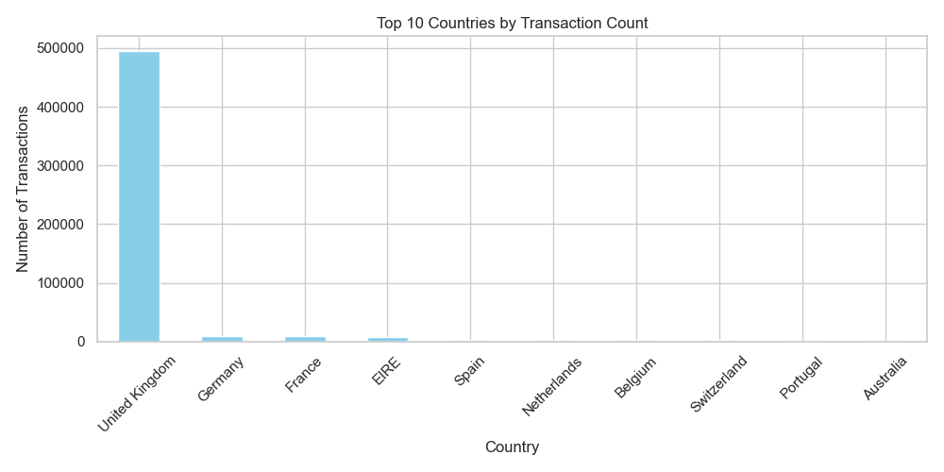
Figure 1: Top 10 Countries by Transaction Count

8. Missing Value Analysis
The initial assessment identified missing values in two columns:
- CustomerID: 135080 missing values (approx 24.9%)
- Description: 1454 missing values
Decision: Since dropping 24.9% of the dataset would severely skew revenue metrics, we chose not to drop rows with missing CustomerIDs. Instead, we imputed them with a placeholder (-1) and created an `Is_Anonymous` flag. For Description, we imputed missing strings with 'UNKNOWN'.

9. Duplicate Analysis
We found 5268 completely identical rows across all columns. Because there is no unique line-item ID, exact matches occurring at the same timestamp were assumed to be system duplication errors.
Decision: All 5268 duplicated rows were removed.

10. Data Type Corrections
Once missing CustomerIDs were replaced with numeric placeholders, the column was converted from float to integer format to accurately reflect IDs without decimal points.

11. Invalid/Inconsistent Data
Investigation of numerical columns revealed:
- 10624 records with negative Quantity. These mostly represented legitimate cancellations/returns (InvoiceNo starting with 'C'). We chose to retain them but flag them as `Is_Cancelled`.
- 2 records with negative UnitPrice (bad debt adjustments) and 2515 records with zero UnitPrice.
Decision: Records with zero or negative UnitPrice were removed as they do not represent valid product sales.

12. Outlier Detection and Treatment
Extremely high quantities and unit prices were present. However, standard IQR removal would indiscriminately delete valid bulk wholesale orders.
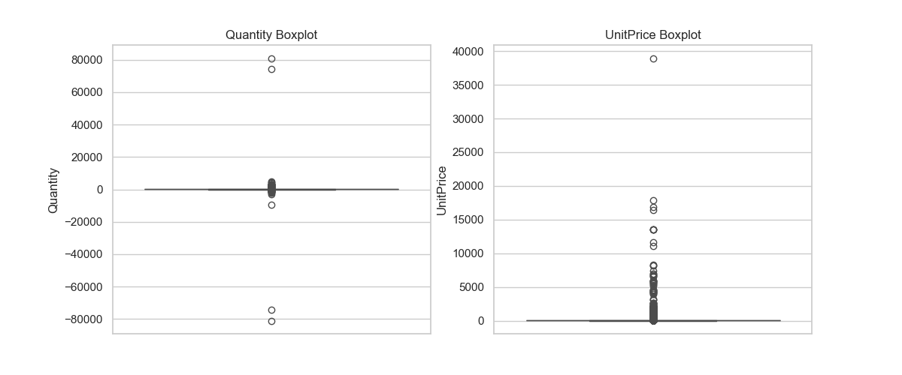
Figure 2: Outliers before treatment
Decision: Instead of standard IQR filtering, we applied percentile-based trimming, removing only values above the 99.9th percentile for Quantity and UnitPrice, and below the 0.1th percentile for Quantity. This surgically removes extreme administrative adjustments while retaining normal retail variance.

13. Data Cleaning Pipeline
A derived variable `TotalAmount` was created by multiplying Quantity and UnitPrice. This facilitates downstream revenue analysis. No scaling or machine learning encodings were applied because this dataset is currently prepared for general business analytics rather than a specific predictive model.

14. Before vs After Comparison
Metric | Before Cleaning | After Cleaning | Change
Rows | 541909 | 532529 | -9380
Columns | 8 | 11 | 3
Missing Values | 136534 | 0 | -136534
Duplicates | 5268 | 0 | -5268

15. Data Quality Assessment
The dataset now exhibits high Completeness (missing values handled), Validity (negative prices removed), Consistency (datatypes enforced), and Uniqueness (exact duplicates removed).

16. Challenges and Solutions
Challenge: Determining whether to drop negative Quantity values.
Why it was difficult: Blindly dropping negative values cleans the distribution but inflates total sales numbers by ignoring returns.
Solution: I investigated the Invoice numbers and confirmed that most negative quantities corresponded to cancellations. Therefore, I retained them and created an `Is_Cancelled` boolean flag to allow flexible downstream analysis.

17. Impact of Preprocessing
By choosing to impute missing CustomerIDs rather than dropping them, any future analysis analyzing total sales volume remains accurate and robust. Conversely, since these rows do not belong to known customers, they must be excluded if performing customer-centric modeling (like RFM segmentation). By retaining extreme but valid bulk orders (up to the 99.9th percentile), statistical models will correctly capture wholesale dynamics instead of treating them as invalid.

18. Reflective Commentary
Initially, I considered removing all rows with negative values because they appeared to be data entry errors. However, after carefully checking the underlying invoice patterns, I found evidence that some represented legitimate customer returns. This experience taught me that domain-specific interpretation is just as important as statistical thresholds. Blind statistical cleaning can sometimes remove the most important business signals from a dataset.

19. Final Conclusion
The Online Retail dataset was successfully acquired, explored, and preprocessed. We addressed missing data, identified and resolved 5268 duplicates, fixed data types, and applied targeted outlier removal. The final cleaned dataset of 532529 rows is robust and analysis-ready.

20. References
UCI Machine Learning Repository. Online Retail Dataset. https://archive.ics.uci.edu/dataset/352/online+retail
Pandas Documentation: https://pandas.pydata.org/docs/

