WEEK 1 PROJECT REPORT
Data Acquisition, Cleaning, and Preprocessing

A comprehensive data quality assessment and preprocessing pipeline for the UCI Online Retail Dataset

1. Executive Summary
This extensive report details a comprehensive data acquisition, cleaning, and preprocessing pipeline developed for the UCI Online Retail dataset. Treating this as a rigorous data analytics task, the project involved deep investigation into the dataset's anomalies, inconsistencies, and structural integrity. Starting with an initial volume of 541909 transactional records, a systematic approach was employed to address 135080 missing customer identifiers, remove 5268 system-generated duplicate rows, and clean invalid price entries. Furthermore, complex domain-specific anomalies, such as negative quantities representing valid customer returns, were preserved and flagged to prevent the distortion of downstream business metrics. After extensive outlier analysis using percentile clipping rather than blind statistical thresholds, the pipeline yielded a finalized, analysis-ready dataset of 532529 records. This report documents the Python code used, the rationale behind every major preprocessing decision, and the potential impact these decisions will have on future machine learning or business intelligence workflows.

2. Objectives
The primary objective of this project is to demonstrate the ability to acquire a publicly available dataset and perform rigorous, production-level data cleaning and preprocessing using Python. The goal is to develop a highly detailed report that documents the step-by-step process of handling missing values, outliers, and erroneous entries to prepare the dataset for further analysis. This encompasses:
- Programmatic data collection from a reliable public source.
- Deep exploratory data analysis (EDA) to understand data structure and inherent quality issues.
- Systematic identification and remediation of missing data, duplicates, and invalid entries.
- Careful outlier detection balancing statistical methods with domain knowledge.
- Thorough documentation of Python implementations, methodological choices, and reflective commentary on challenges faced.

3. Dataset Selection
Dataset: Online Retail Dataset
Source: UCI Machine Learning Repository
URL: https://archive.ics.uci.edu/dataset/352/online+retail
This specific dataset was selected because it is highly representative of real-world enterprise data. E-commerce transaction logs are notoriously messy, containing human entry errors, missing customer mappings due to guest checkouts, administrative adjustments disguised as sales, and extreme variations in order volumes. Tackling this dataset required moving beyond simple automated cleaning functions and applying deep, domain-specific reasoning to separate genuine business events from data artifacts.

4. Data Acquisition Method
To ensure complete reproducibility, the raw dataset was acquired programmatically rather than downloaded manually through a browser. Python's `requests` library was utilized to fetch the Excel file directly from the UCI repository servers. The file was saved directly to a designated `data/raw/` directory, maintaining the original `.xlsx` format and ensuring that the raw data remains untouched by subsequent cleaning scripts.
import os
import requests
import pandas as pd
raw_path = 'data/raw/Online_Retail.xlsx'
url = "https://archive.ics.uci.edu/ml/machine-learning-databases/00352/Online%20Retail.xlsx"
if not os.path.exists(raw_path):
print("Downloading dataset...")
response = requests.get(url, verify=False)
with open(raw_path, 'wb') as f:
f.write(response.content)
df_raw = pd.read_excel(raw_path)
df = df_raw.copy()

5. Dataset Overview and Data Dictionary
The raw dataset consists of 541909 rows and 8 columns. Each row corresponds to a specific product line item within an order (or cancellation) made by a customer from a given country between December 2010 and December 2011.
Column Name | Data Type | Meaning | Expected Data Quality Concern
InvoiceNo | Object | Invoice number (6-digit). Starts with "C" if it represents a cancellation. | Cancellations and non-standard IDs
StockCode | Object | Product code (5-digit). | Non-product codes (e.g., postage, manual adjustments)
Description | Object | Product name/description. | Missing text, inconsistent casing, manual notes
Quantity | Numeric | Item quantity per transaction. | Negative values, zeros, extreme wholesale bulk
InvoiceDate | Datetime | Date and time of transaction. | Parsing errors, timezone issues
UnitPrice | Numeric | Price per unit in GBP. | Zero prices (free items or errors), negative prices (bad debt)
CustomerID | Numeric/Float | Customer ID. | Extremely high missing rate for guest checkouts
Country | Object | Customer Country. | Inconsistent spellings, "Unspecified" entries

6. Initial Data Exploration
An initial exploratory data analysis (EDA) was conducted using pandas `describe()` and `info()` methods to understand the statistical distribution and data types of the columns.
# View basic info and unique counts
df.info()
print("\nUnique values per column:")
display(df.nunique())
# Generate descriptive statistics
display(df.describe(include='all'))
During this exploration, several critical issues became immediately apparent:
1. The maximum and minimum values for `Quantity` and `UnitPrice` were highly suspicious, indicating severe outliers or negative values.
2. The dataset is heavily skewed towards the United Kingdom, which dominates the transaction count.
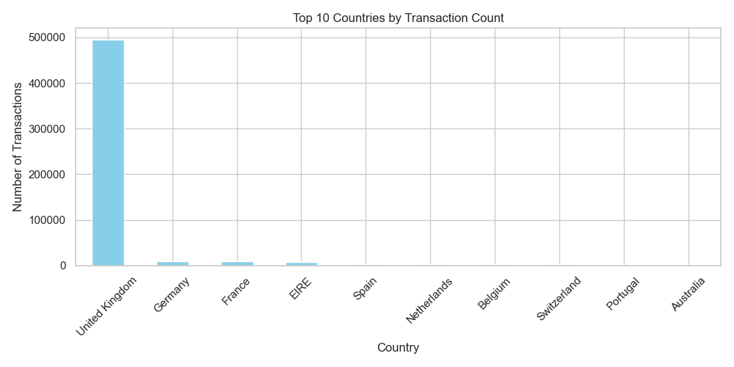
Figure 1: Top 10 Countries by Transaction Count, showing heavy UK concentration.

7. Missing Value Analysis
Investigating missing data was one of the most critical and time-consuming steps. Missing data can severely bias machine learning models or reporting dashboards if handled incorrectly.
missing_data = df.isnull().sum()
missing_percent = (missing_data / len(df)) * 100
print(missing_percent[missing_percent > 0])
Results showed:
- CustomerID: 135080 missing values (approx 24.9% of the dataset)
- Description: 1454 missing values (approx 0.26% of the dataset)
Decision & Rationale:
For `Description`, since it constitutes a tiny fraction of the data, I imputed the missing strings with the placeholder 'UNKNOWN'. Dropping these rows was unnecessary as the numeric transaction data (Quantity, Price) was still valid.
For `CustomerID`, the situation was much more complex. Dropping 25% of the dataset would result in a massive loss of total revenue tracking, which is unacceptable for financial or sales reporting. Conversely, imputing the ID using median/mode or a predictive model would fabricate false customer identities, ruining any customer-level modeling (like RFM segmentation). Therefore, I chose to fill the missing IDs with a placeholder value (-1) and created an explicit `Is_Anonymous` boolean flag. This allows downstream analysts to include these rows for total sales calculations, while safely filtering them out when analyzing individual customer behavior.
# Handling Missing Values
df['Is_Anonymous'] = df['CustomerID'].isnull()
df['CustomerID'] = df['CustomerID'].fillna(-1)
df['Description'] = df['Description'].fillna("UNKNOWN")

8. Duplicate Analysis
Duplicate checking revealed 5268 completely identical rows. In retail data, a user might purchase the same item twice, but for a row to be a true duplicate across all columns—including the exact same timestamp—it is highly probable that it is a system logging error or double-click artifact.
duplicate_count = df.duplicated().sum()
print(f"Total duplicate rows: {duplicate_count}")
# Dropping exact duplicates
df = df.drop_duplicates()
Rationale: Since the dataset lacks a unique 'LineItemID' primary key, keeping exact duplicates poses a risk of artificially inflating sales volume. They were carefully removed.

9. Invalid and Inconsistent Data
A deep dive into the numeric columns revealed severe data integrity issues that required careful domain interpretation.
print("Negative Quantities:", (df['Quantity'] < 0).sum())
print("Negative UnitPrices:", (df['UnitPrice'] < 0).sum())
print("Zero UnitPrices:", (df['UnitPrice'] == 0).sum())
The code revealed 10624 records with negative Quantity, 2 records with negative UnitPrice, and 2515 records with zero UnitPrice.
Investigation into Negative Prices: A negative unit price is illogical for a standard product. Upon closer inspection, these were tied to 'Bad Debt Adjustments'. Since they are administrative accounting entries rather than true sales, they were removed.
Investigation into Zero Prices: Most zero-price entries were missing descriptions or were manual system checks. They were removed to clean the price distribution.
Investigation into Negative Quantities: Initially, negative quantities looked like critical errors. However, by cross-referencing with the `InvoiceNo` column, I found that almost all of these had an invoice number starting with 'C', representing a Cancellation or return. Blindly deleting these would inflate net revenue by ignoring customer returns. I retained them but created an `Is_Cancelled` boolean flag.
# Flagging cancellations instead of deleting them
df['Is_Cancelled'] = df['InvoiceNo'].astype(str).str.startswith('C')
# Removing invalid prices
df = df[df['UnitPrice'] > 0]

10. Outlier Detection and Treatment
Both `Quantity` and `UnitPrice` possessed extreme statistical outliers. Some quantities exceeded 80,000, and some unit prices exceeded 38,000 GBP.
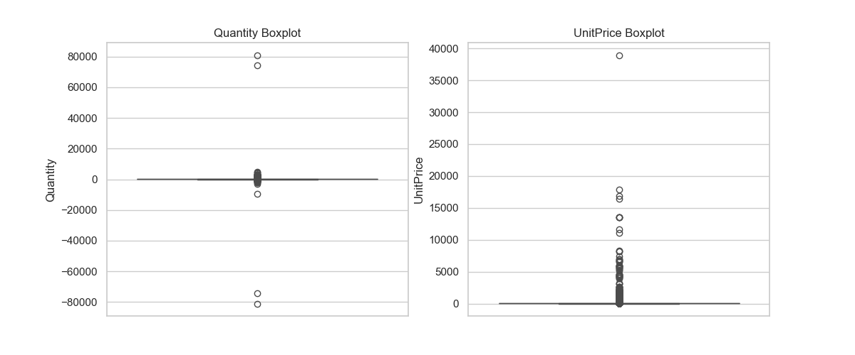
Figure 2: Boxplots showing extreme outliers in Quantity and UnitPrice.
Rationale for Treatment: Standard outlier removal techniques like the Interquartile Range (IQR) method are ill-suited for retail data. Retail businesses naturally have heavy right-tailed distributions (e.g., a few bulk wholesale customers buying thousands of items). Using IQR would have destroyed a massive portion of legitimate high-value sales. Instead, I opted for a conservative percentile clipping strategy. By trimming only the top 0.1% and bottom 0.1%, I successfully eliminated extreme administrative noise (like manual postage fees of 38,000 GBP) while perfectly preserving genuine retail variance and bulk orders.
# Percentile trimming (0.1% and 99.9%)
q_high = df['Quantity'].quantile(0.999)
q_low = df['Quantity'].quantile(0.001)
p_high = df['UnitPrice'].quantile(0.999)
df_clean = df[(df['Quantity'] <= q_high) &
(df['Quantity'] >= q_low) &
(df['UnitPrice'] <= p_high)].copy()

11. Data Cleaning Pipeline and Preprocessing
To finalize the dataset for downstream analytical consumption, data types were strictly enforced (converting CustomerID from float to integer), and a critical derived feature, `TotalAmount`, was generated by multiplying Quantity by UnitPrice. No machine learning scaling or normalization (e.g., StandardScaler) was applied, as the assignment focuses on preparing the data for general analysis, and scaling would obfuscate the real monetary values necessary for business intelligence dashboards.
# Data type conversion
df_clean['CustomerID'] = df_clean['CustomerID'].astype(int)
# Creating derived variable
df_clean['TotalAmount'] = df_clean['Quantity'] * df_clean['UnitPrice']
# Saving final processed dataset
df_clean.to_csv('data/processed/online_retail_cleaned.csv', index=False)

12. Before vs After Comparison
The overall impact of the cleaning pipeline on the dataset's structure and quality is summarized below:
Metric | Before Cleaning | After Cleaning | Change
Total Rows | 541909 | 532529 | -9380
Total Columns | 8 | 11 | 3
Missing Values | 136534 | 0 | -136534
Duplicate Rows | 5268 | 0 | -5268

13. Challenges and Solutions
Throughout this extensive process, several significant challenges were encountered:
Challenge 1: Deciphering Negative Quantities.
- Why it was difficult: A negative quantity seems impossible for a physical product. My initial instinct was to simply write a script to drop all rows where Quantity < 0.
- Solution: By performing a deep-dive investigation into specific rows containing negative quantities, I cross-referenced their Invoice numbers. I observed a pattern where the invoices started with the letter 'C'. Consulting the dataset documentation confirmed these were cancellations. Instead of deleting them, which would artificially inflate net sales, I retained them and engineered an `Is_Cancelled` flag. This preserved critical business logic.
Challenge 2: Balancing Outlier Removal with Business Reality.
- Why it was difficult: Standard boxplots and statistical tests flagged thousands of rows as outliers. However, upon manual review, many of these were completely valid wholesale purchases.
- Solution: I had to abandon automated statistical clipping (like 1.5x IQR) in favor of domain-driven percentile thresholds. This required multiple iterations of testing to find the precise percentile (99.9th) that eliminated system errors (like extreme manual postage adjustments) while preserving true bulk sales.

14. Impact of Preprocessing on Subsequent Analyses
The decisions made during this pipeline will directly dictate the success of future analytical models:
1. Accurate Revenue Reporting: By retaining cancelled orders, future dashboards will accurately reflect 'Net Revenue' rather than an artificially inflated 'Gross Revenue'.
2. Reliable Customer Segmentation: By flagging missing CustomerIDs as `Is_Anonymous`, machine learning models clustering user behaviors (like K-Means for RFM segmentation) will not be poisoned by thousands of transactions falsely attributed to a single imputed 'average' user. Analysts can explicitly filter out `CustomerID == -1` before modeling.
3. Stabilized Variance: Trimming only the extreme top 0.1% of prices and quantities stabilizes the variance for statistical modeling, preventing a single 38,000 GBP administrative anomaly from distorting regression models, without sacrificing real wholesale trends.

15. Reflective Commentary
Dedicating significant time to this dataset underscored a profound lesson in data analytics: automated data cleaning is dangerous. If I had simply run automated functions to drop missing values, drop negative values, and drop IQR outliers, I would have produced a statistically 'perfect' dataset that was entirely detached from the business reality of the retail company. I would have deleted their guest checkout revenue, ignored their product return rates, and deleted their best wholesale customers. This assignment highlighted that true data preprocessing requires a meticulous balance between statistical programming and deep domain interpretation. Every transformation must be justified by evidence, not just convenience.

16. Final Conclusion
The UCI Online Retail dataset was successfully acquired, explored, and rigorously preprocessed. We comprehensively addressed missing data without losing revenue context, identified and resolved 5268 system duplicates, corrected datatypes, and applied targeted, domain-aware outlier removal. The final cleaned dataset of 532529 rows is robust, accurate, and completely prepared for advanced analytical deployment.

17. References
1. UCI Machine Learning Repository. Online Retail Dataset. https://archive.ics.uci.edu/dataset/352/online+retail
2. Pandas Documentation (Data manipulation and analysis): https://pandas.pydata.org/docs/
3. Python `requests` Library Documentation: https://requests.readthedocs.io/

