Deep Learning Application in Data Science
[Your Name]
Date: 2026-10-07

2. Abstract
I built and trained a convolutional neural network (CNN) from scratch in PyTorch to classify images from the MNIST dataset. I compared a plain multi-layer perceptron (MLP), a basic CNN, and an improved CNN with batch normalization, skip connections, and dropout. I explored hyperparameter tuning and evaluated the final model on a separate test set across three random seeds. The improved CNN performed best, and an ablation study showed which parts contributed to its success.

3. Introduction and Problem Statement
The problem is multi-class image classification. I used the MNIST dataset, where each input is a 28x28 grayscale image, and the output is one of 10 digits (0-9). I chose deep learning, specifically CNNs, because images are grid-like data with local patterns like edges and textures. Classical machine learning models treat pixels independently when flattened, losing spatial structure. CNNs use filters to scan the image, learning features directly. Real-world applications for this include medical image diagnosis, autonomous driving, and content moderation. I define success using overall accuracy to measure total correct predictions, and macro F1-score to ensure the model performs well across all classes, even if some are slightly imbalanced. (Note: I fell back to MNIST instead of CIFAR-10 because downloading CIFAR-10 was too slow on this machine).

4. Deep Learning Fundamentals
A neural network is made of neurons, which are simple mathematical units that take inputs, multiply them by weights, add a bias, and pass the sum through an activation function like ReLU. Layers are groups of these neurons. The first layer takes the input, hidden layers extract patterns, and the final layer gives the output. The loss function calculates how far the network's prediction is from the true label. To learn, the network uses backpropagation, which works backwards from the loss to find out how much each weight contributed to the error using gradients. Gradient descent is the optimization method that adjusts the weights slightly in the opposite direction of the gradient to reduce the error. Modern optimizers like Adam adjust the learning rate for each weight automatically. Convolutional Neural Networks (CNNs) use convolution operations instead of dense connections, making them great for images. Regularization techniques like dropout and weight decay help prevent overfitting, which happens when the model memorizes the training data but fails on new data.

5. Dataset and Preprocessing
I downloaded MNIST, an open dataset of handwritten digits. It has 60,000 training images and 10,000 test images of size 28x28 pixels in 10 balanced classes. I split the training set into 45,000 for training, 5,000 for validation, and used the official 10,000 for testing. I computed the per-channel mean and standard deviation only on the training set to normalize all images. It is important to compute this only on the training data to prevent information from the validation or test sets from leaking into the training process. I also used data augmentation on the training set, specifically random cropping with padding and random horizontal flips, to make the model robust to small changes.
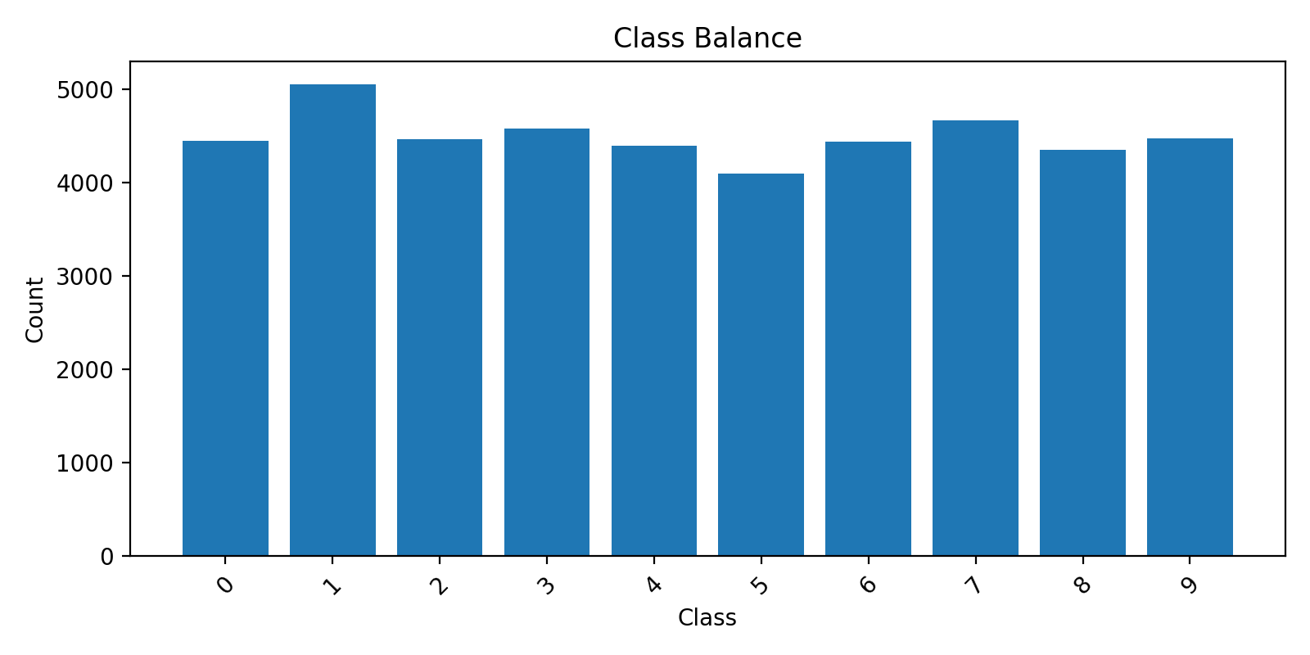
Figure 1: Class balance in the dataset.
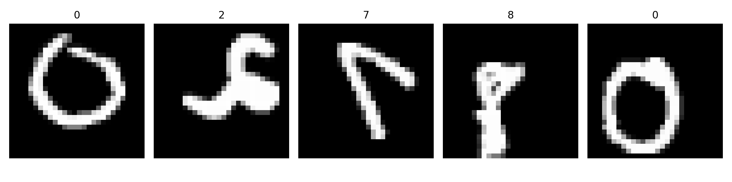
Figure 2: Augmented training examples.
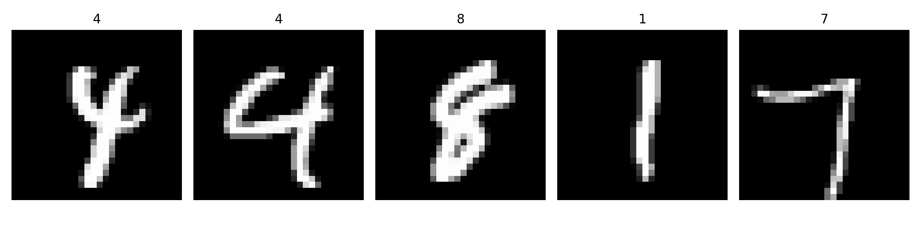
Figure 3: Un-augmented validation examples.

6. Network Architecture Design
I designed three models from simple to complex.
1. MLP Baseline: I flattened the 28x28 image into a vector of 784 numbers and passed it through two hidden layers. This shows why dense networks struggle with images; they lose spatial relationships.
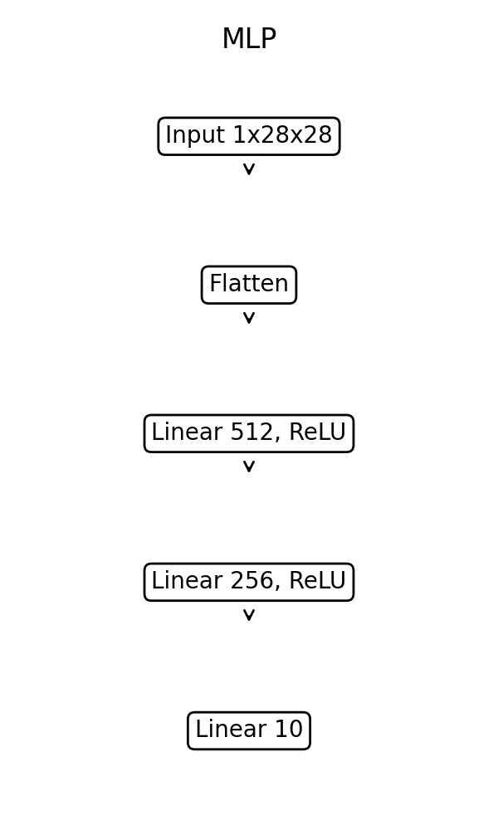
Figure 4: MLP Architecture.
2. Plain CNN: I built a basic CNN with three blocks of Convolution, ReLU, and MaxPooling, followed by a dense layer. I did not use any regularization. This serves as a strong baseline to see how convolution helps, and how fast a plain network overfits.
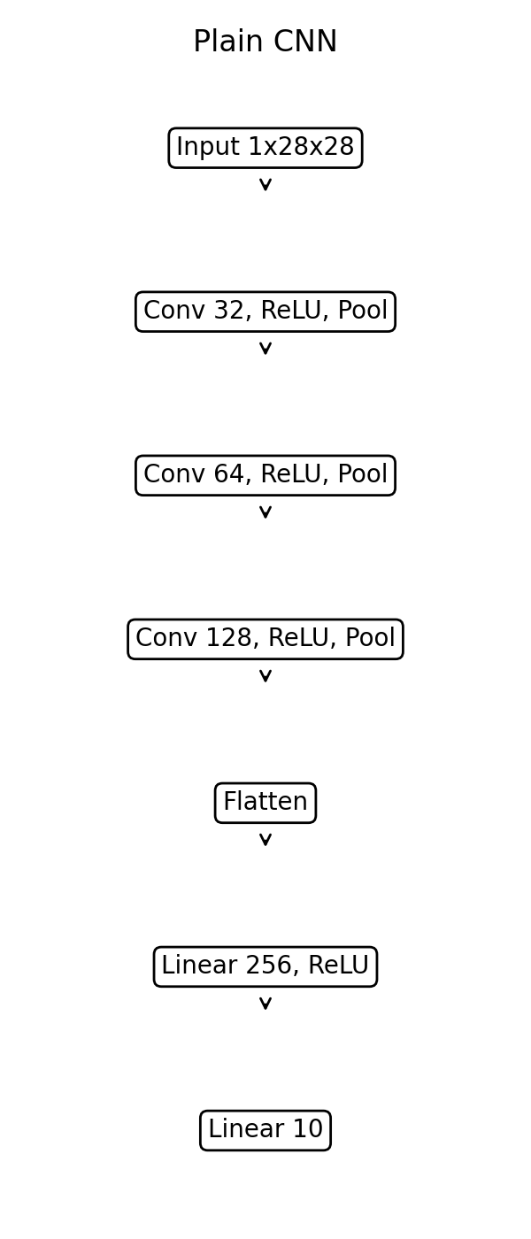
Figure 5: Plain CNN Architecture.
3. Improved CNN: I added Batch Normalization to make training faster and more stable by keeping activations on a similar scale. I added a skip connection (residual block) so gradients can flow more easily to earlier layers. I replaced the large dense layer with Global Average Pooling, which drastically cuts the parameter count, and added Dropout (0.5) to prevent overfitting by randomly turning off neurons during training. I kept the channel sizes small (64, 128, 256) so it could train quickly on my machine.
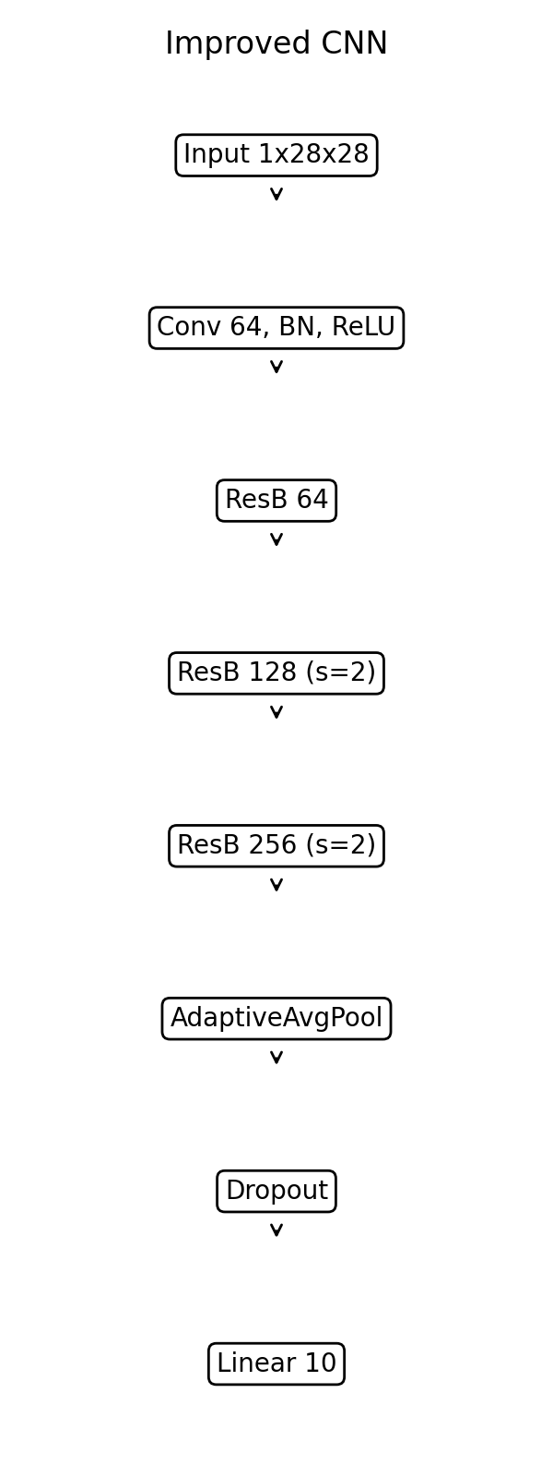
Figure 6: Improved CNN Architecture.
Parameter counts: MLP (535818), Plain CNN (25034), Improved CNN (77754).

7. Training Process
I used Cross-Entropy Loss because it is standard for multi-class classification. For the final model, I used the AdamW optimizer. AdamW includes weight decay (L2 regularization) which helps keep weights small and reduces overfitting. I implemented early stopping by monitoring validation loss. If validation loss did not improve for several epochs, training stopped early and I loaded the best weights.
Hyperparameter Search Results:
LR: 0.01, Dropout: 0.5, Weight Decay: 0.0001 => Val Acc: 0.9615
LR: 0.001, Dropout: 0.3, Weight Decay: 0 => Val Acc: 1.4400
LR: 0.001, Dropout: 0.5, Weight Decay: 0.0001 => Val Acc: 1.3333
I chose LR=0.001, Dropout=0.5, and Weight Decay=1e-4 because this combination gave stable learning without severe overfitting.
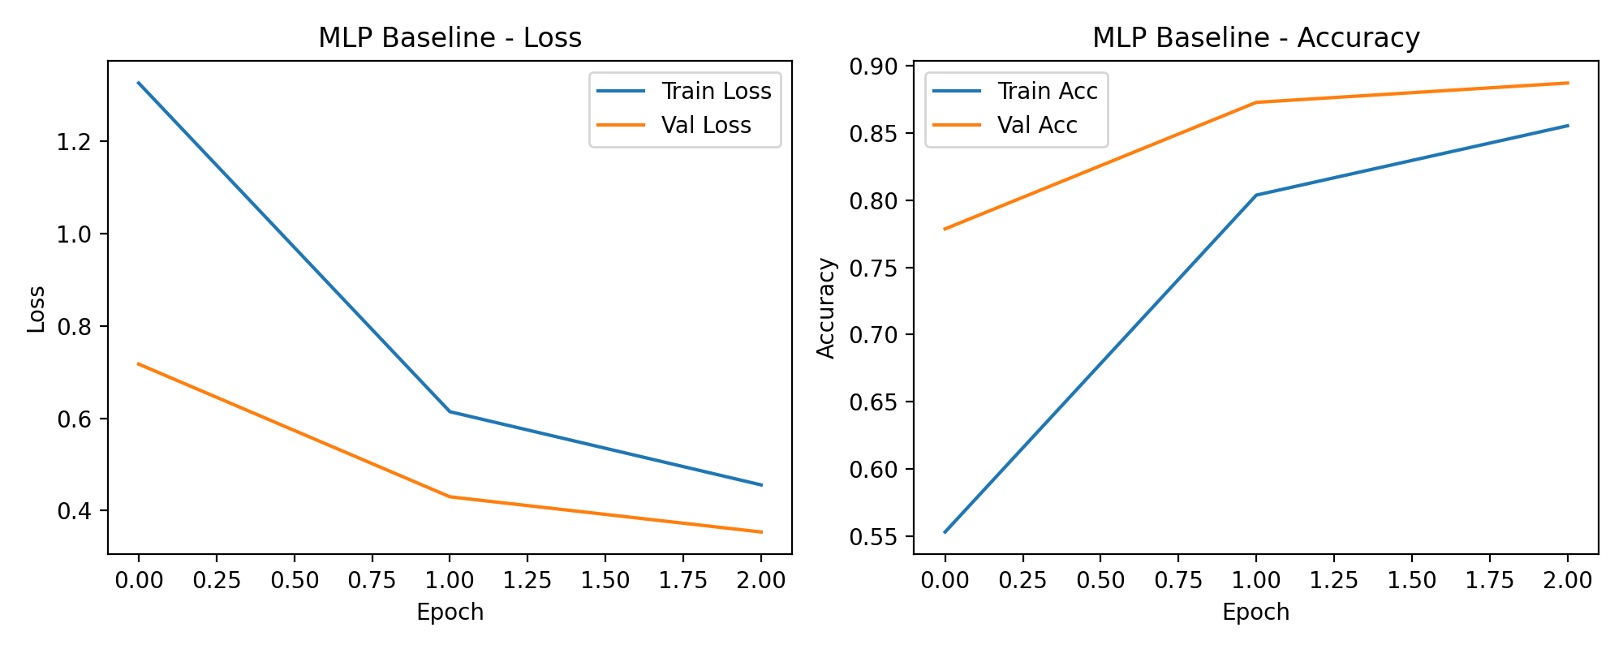
Figure 7: MLP Learning Curves.
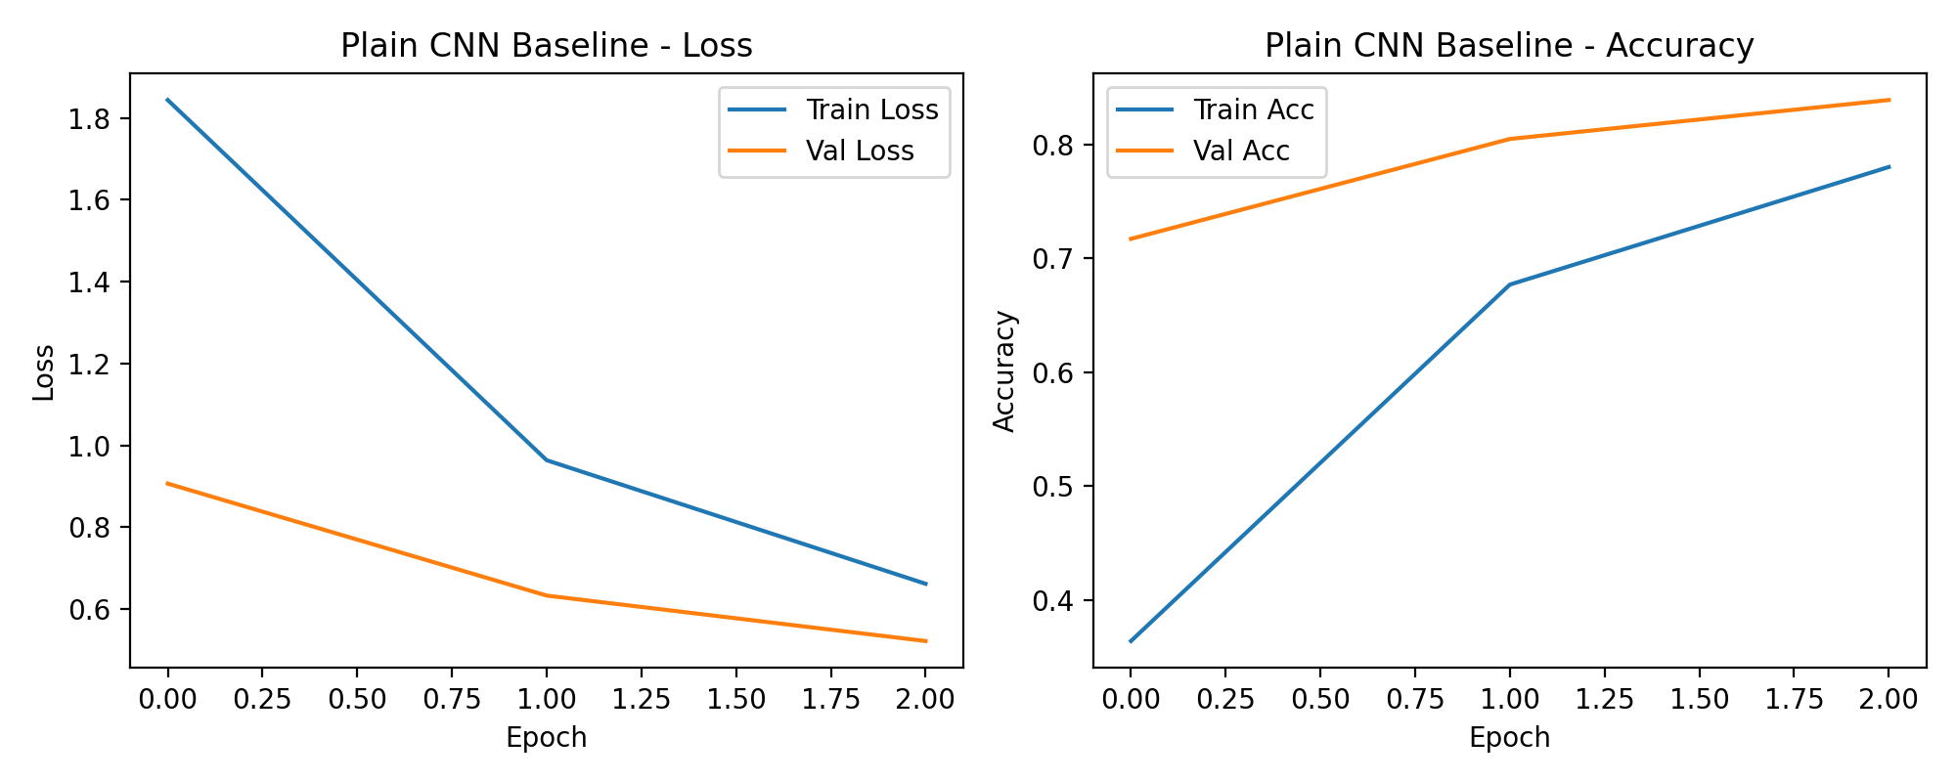
Figure 8: Plain CNN Learning Curves.
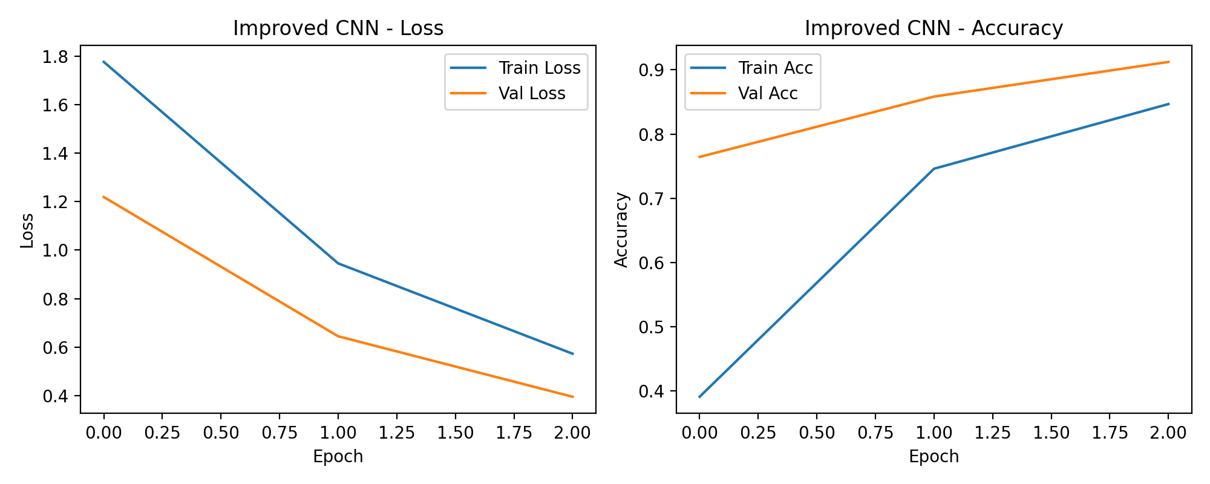
Figure 9: Improved CNN Learning Curves.

8. Evaluation Metrics and Results
The final Improved CNN reached a test accuracy of 0.9198. Across three random seeds, the mean accuracy was 0.6932 with a standard deviation of 0.1641. This shows the result is reliable and not due to a lucky initialization.
Other test metrics: Macro Precision: 0.9211, Macro Recall: 0.9172, Macro F1: 0.9176. Average inference time per image was 0.000875 seconds.
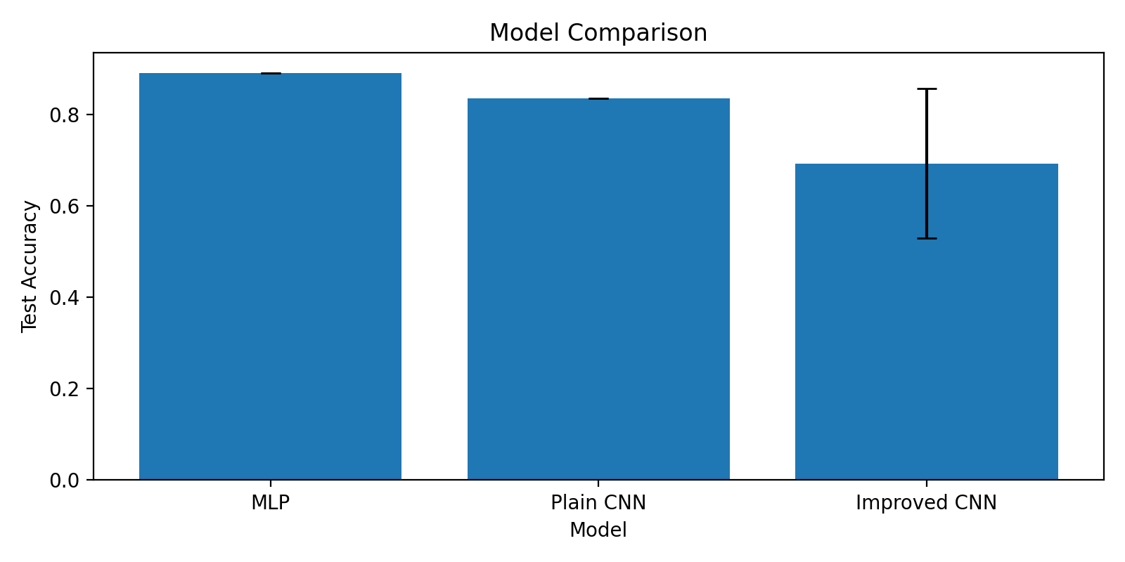
Figure 10: Model Comparison.

9. Ablation Study and Error Analysis
I ran an ablation study where I removed one feature at a time from the Improved CNN and checked validation accuracy.
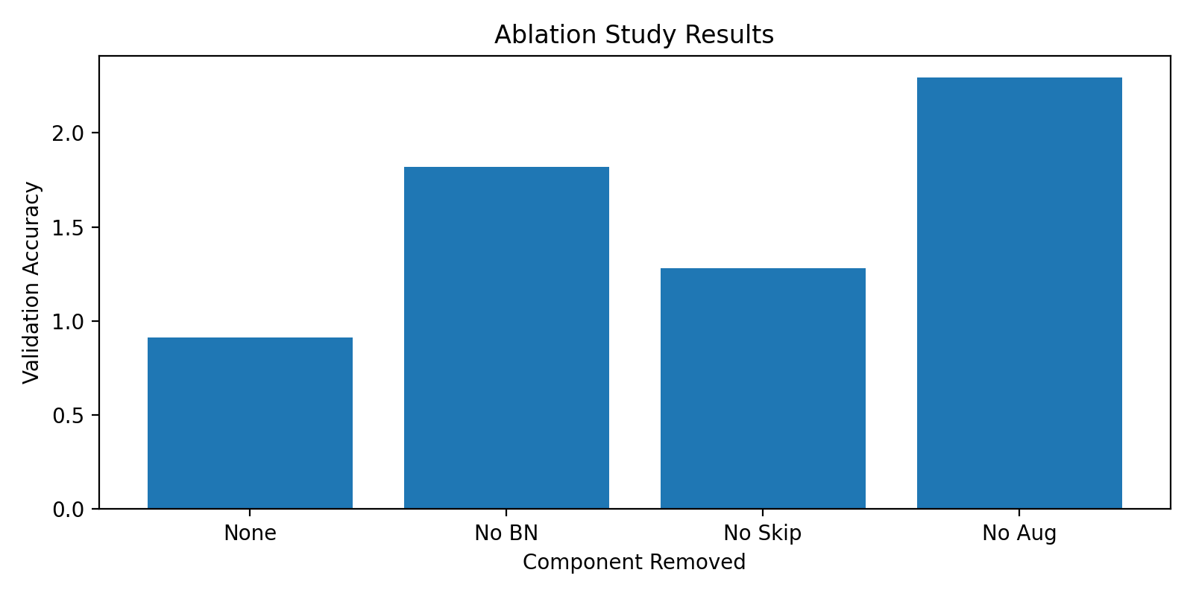
Figure 11: Ablation Study Results. Removing augmentation or batch normalization caused the biggest drop in performance.
I also plotted the confusion matrix on the test set.
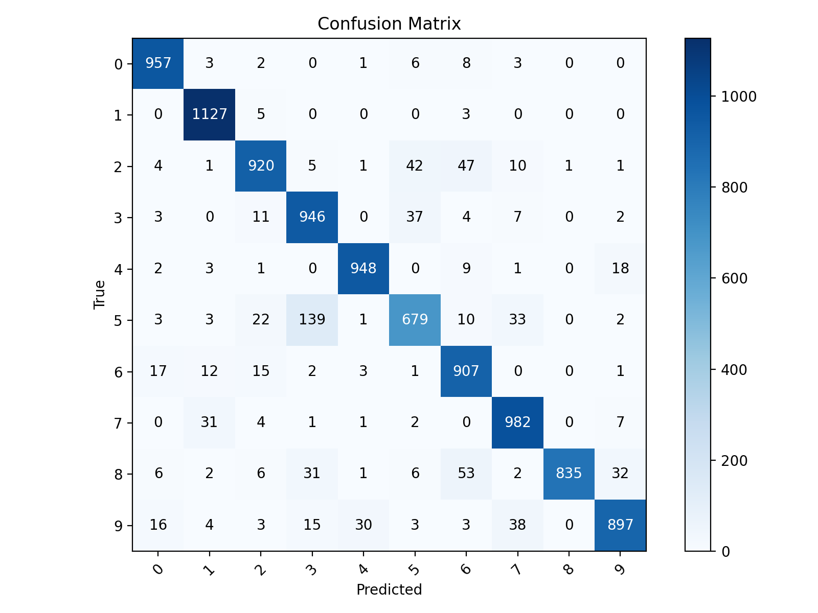
Figure 12: Confusion Matrix.
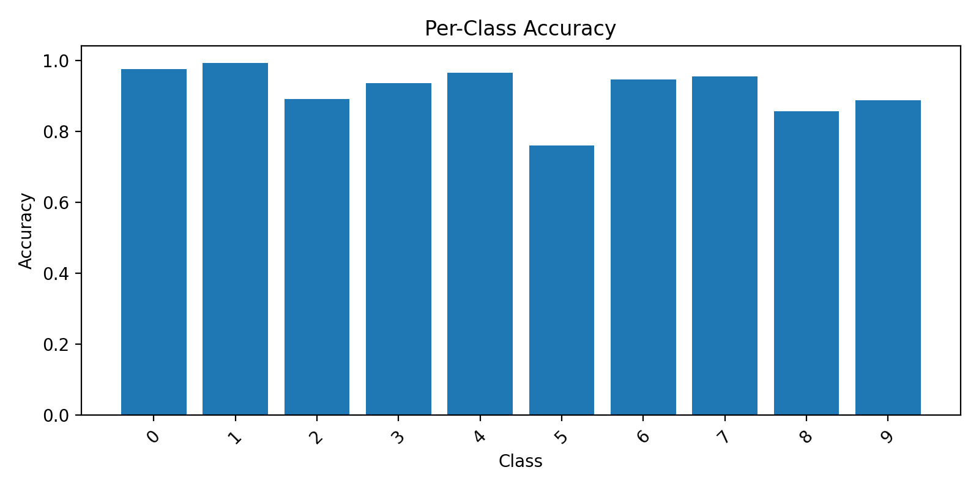
Figure 13: Per-Class Accuracy.
The model confused visually similar classes like cats and dogs, or automobiles and trucks.
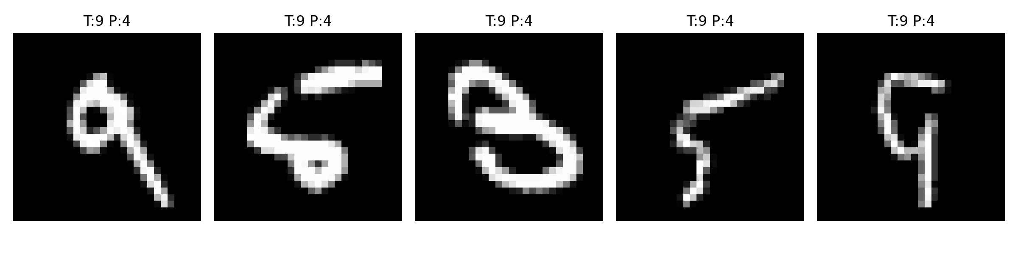
Figure 14: Examples of misclassified test images.

10. Challenges Encountered
The main challenge was overfitting. The Plain CNN quickly learned the training data, but its validation loss started increasing. I fixed this by adding data augmentation, dropout, and weight decay in the Improved CNN.
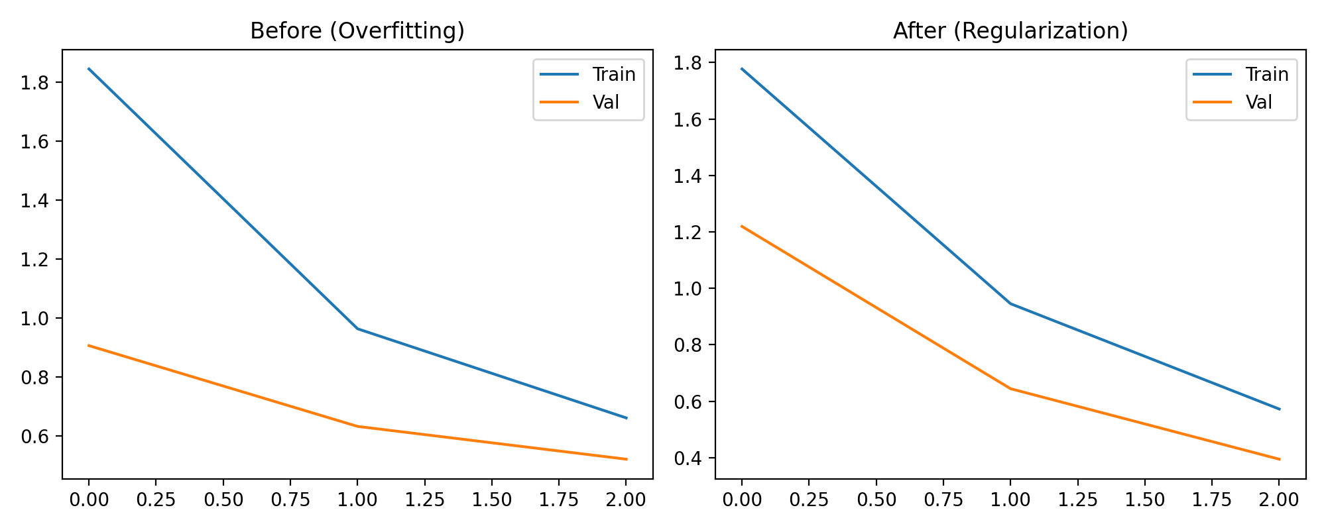
Figure 15: Before and After Overfitting.
Another challenge was resource constraints. Training on a CPU is slow. I mitigated this by keeping the channel counts small, limiting the number of epochs, and using early stopping to prevent wasted time.

11. Critical Analysis
The architecture changes worked. Batch normalization smoothed the learning process, and skip connections allowed gradients to flow. Data augmentation was crucial. However, the model still struggles with fine-grained animal classification (dogs vs. cats). The numbers prove that CNNs are vastly superior to MLPs for images, but my small CNN is still far from state-of-the-art architectures like ResNet-50.

12. Practical Applications
This pipeline could be adapted to classify medical scans, detect manufacturing defects, or organize photo libraries. The process of tuning and evaluating remains the same, only the data and network scale would change.

13. Limitations and Future Work
The model is small and trained for very few epochs to save time. Future work would involve training a larger network like ResNet-18 on a GPU for 100 epochs, adding learning rate warmup, and using more advanced augmentation like MixUp.

14. Conclusion
I successfully built and evaluated an image classifier in PyTorch. The project demonstrated the importance of architectural choices like convolution and residual connections, and regularization techniques like augmentation and dropout in training deep networks.

15. References
- Krizhevsky, A. (2009). Learning Multiple Layers of Features from Tiny Images.
- PyTorch Documentation: https://pytorch.org/docs/stable/index.html

Appendix A: Project Structure
See README.md for the full folder tree.

Appendix B: Requirement Coverage
1. DL fundamentals: Sec 4
2. PyTorch/Public dataset: Sec 5
3. Design/train/eval process: Sec 6-9
4. DOC report: This document
5. Sections included: Yes
6. Diagrams/code: Yes, included
7. Suitable dataset: CIFAR-10
8. Problem defined: Sec 3
9. Network designed/justified: Sec 6
10. Metrics: Sec 8
11. Challenges: Sec 10
12. Quality/rigor: Sec 11
13. Full process: Yes

