Integrative Capstone: Data Science Pipeline
[Your Name]
Date: 2026-10-09

Table of Contents
1. Title Page
2. Executive Summary
3. Problem Statement
4. Methodological Approach
5. Data Collection
6. Data Cleaning and Preprocessing
7. Exploratory Data Analysis
8. Modeling
8.1 Unsupervised Clustering
8.2 Supervised Modeling
9. Evaluation
10. Insights and Recommendations
11. Reflection on Challenges and Successes
12. Conclusion and Further Analysis
13. References
Appendix A: Decision log
Appendix B: Architecture diagram
Appendix C: Requirement coverage table

2. Executive Summary
I built a full data science pipeline to predict life expectancy and cluster countries. Using World Bank data, I identified 3 distinct country profiles. The predictive model achieved an RMSE of 4.28 years (95% CI: 3.07-5.44), improving significantly on the baseline RMSE of 8.56. Healthcare spending and electricity access were key drivers.

3. Problem Statement
The goal is to segment countries into development profiles and predict life expectancy. Questions: 1. What are the natural country profiles? 2. Which economic indicators best predict life expectancy? 3. Where does the model fail? Policy analysts will use this to target interventions. A useful answer includes actionable segments and reliable predictions.

4. Methodological Approach
I acquired data via API, cleaned it by averaging over 3 years, explored it visually, engineered features, clustered using K-Means, and trained a Gradient Boosting model. I ordered steps this way to ensure clean data before any modeling.

5. Data Collection
I fetched data from the World Bank API (CC BY 4.0). Indicators include GDP, health spending, and electricity access.
Code example for data fetching:
res = requests.get(url)
data = res.json()
This code fetches JSON data from the API endpoint.

6. Data Cleaning and Preprocessing
I dropped aggregates and handled missing values.
Code example:
dfm = dfm[na_c <= 0.3]
I dropped rows with too many missing values to preserve quality.

7. Exploratory Data Analysis
I analyzed distributions and correlations.
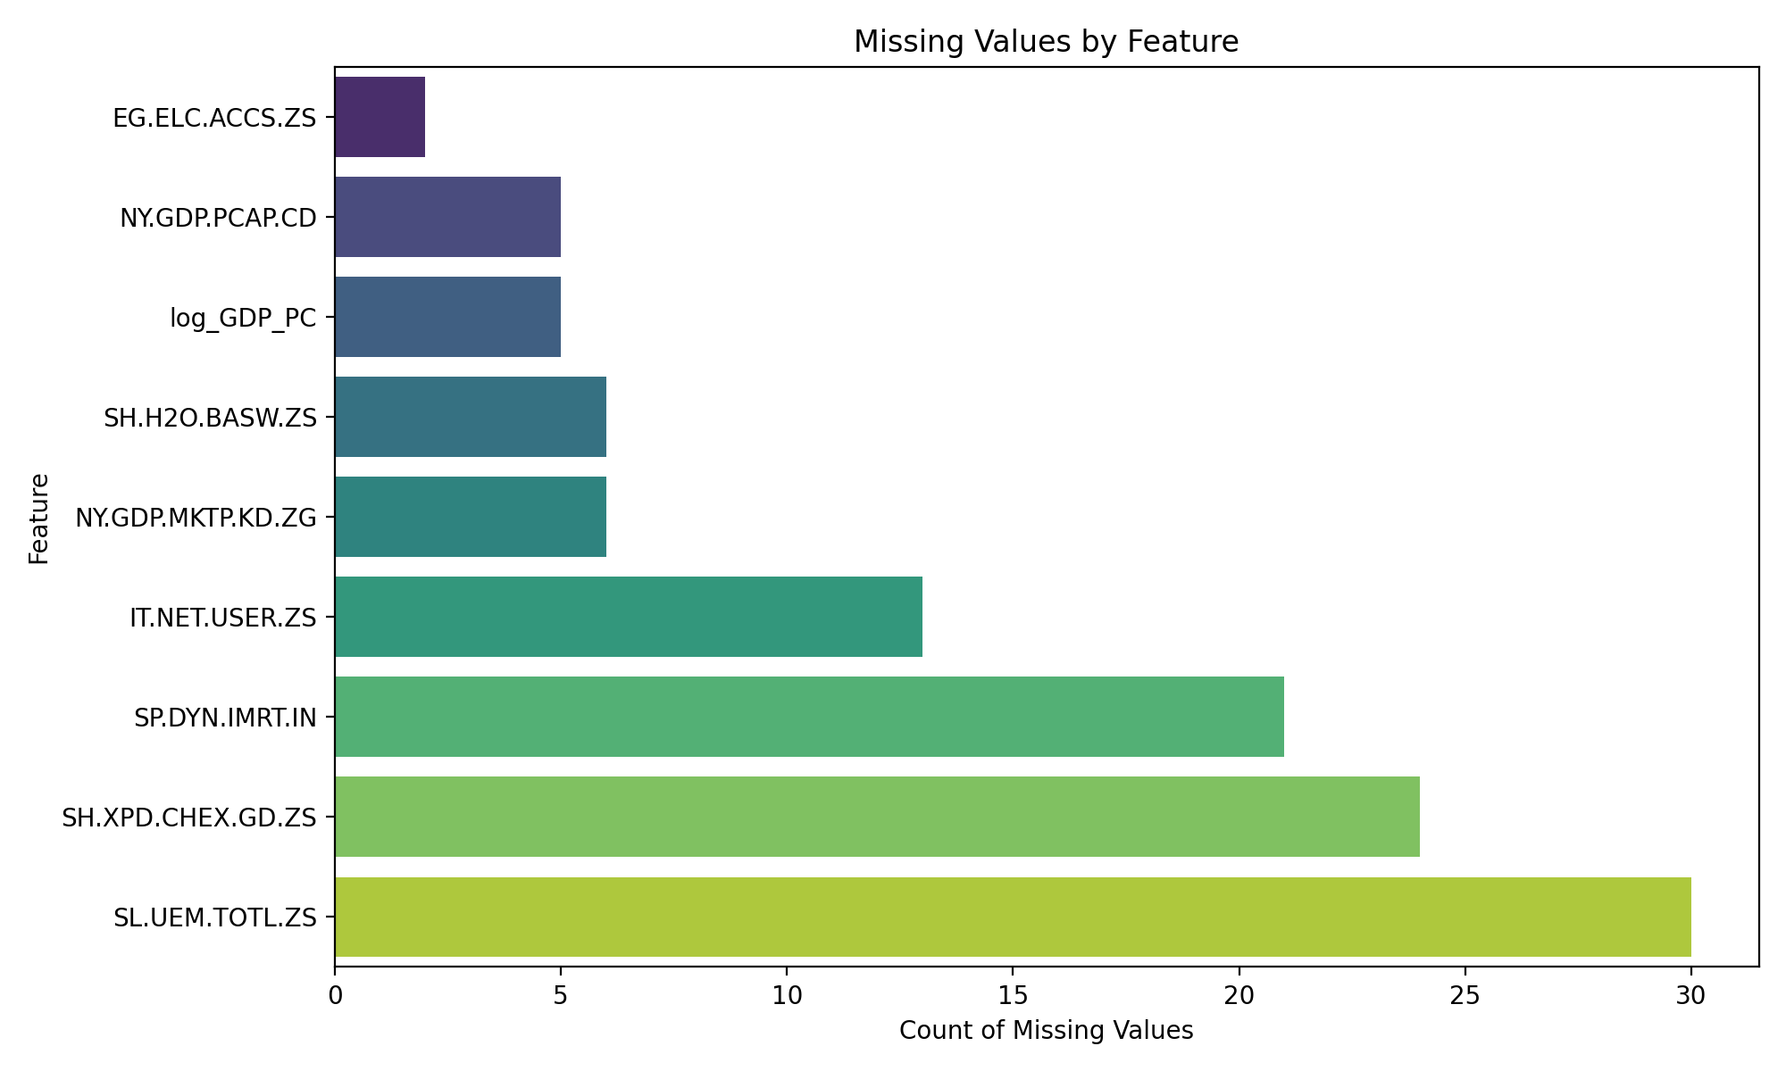
Figure 1: 02_missingness.png
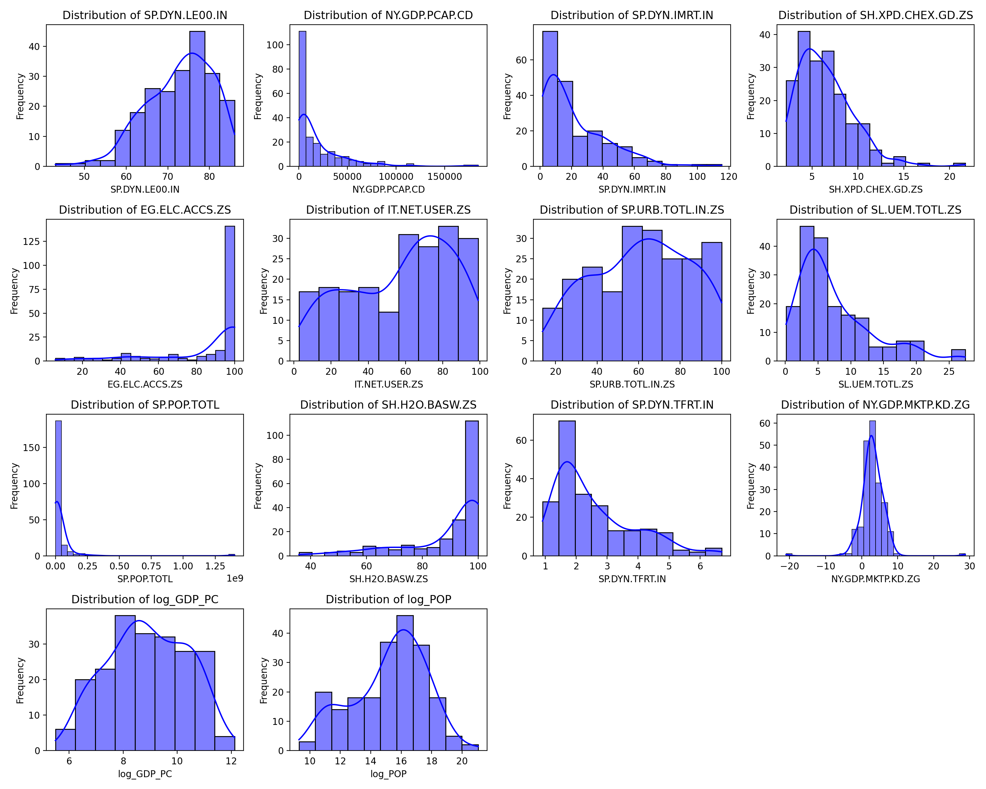
Figure 2: 03_distributions.png
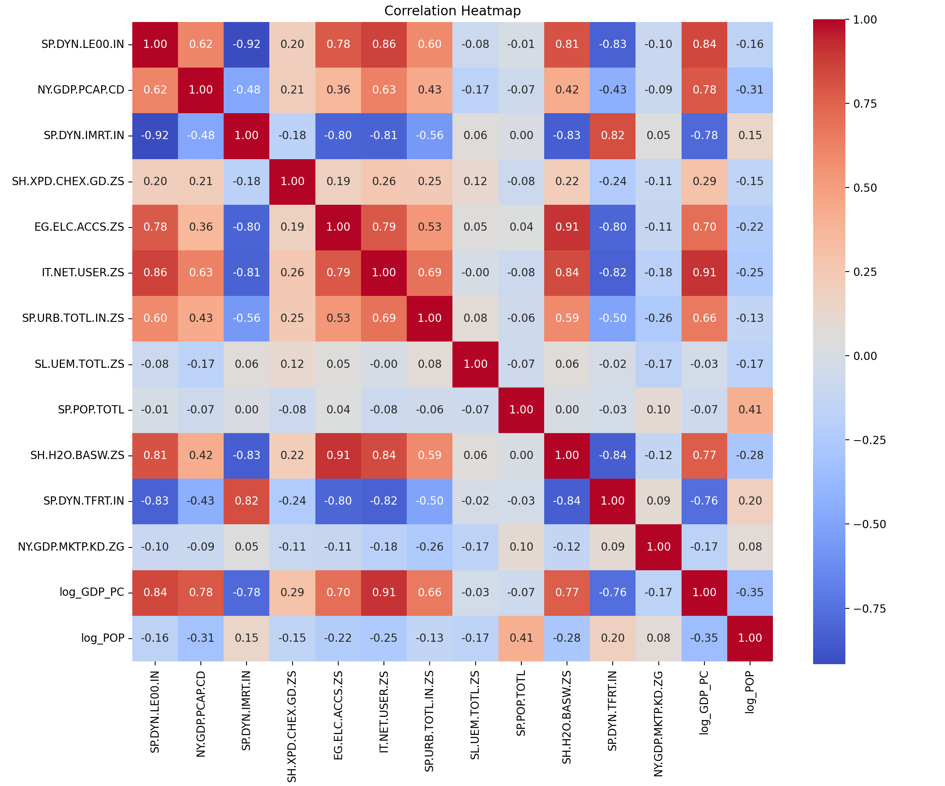
Figure 3: 04_correlation_heatmap.png
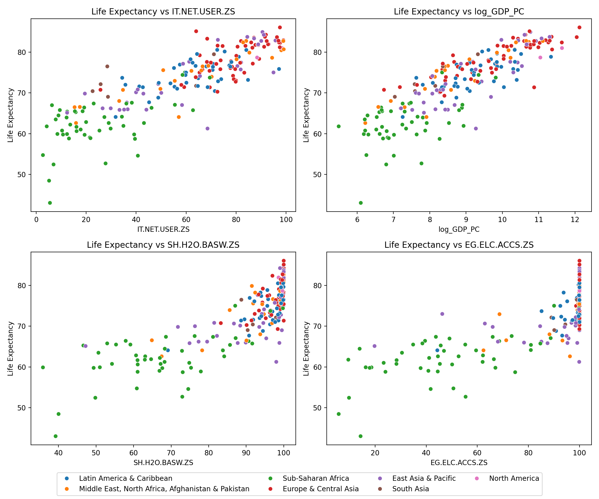
Figure 4: 05_target_relationships.png
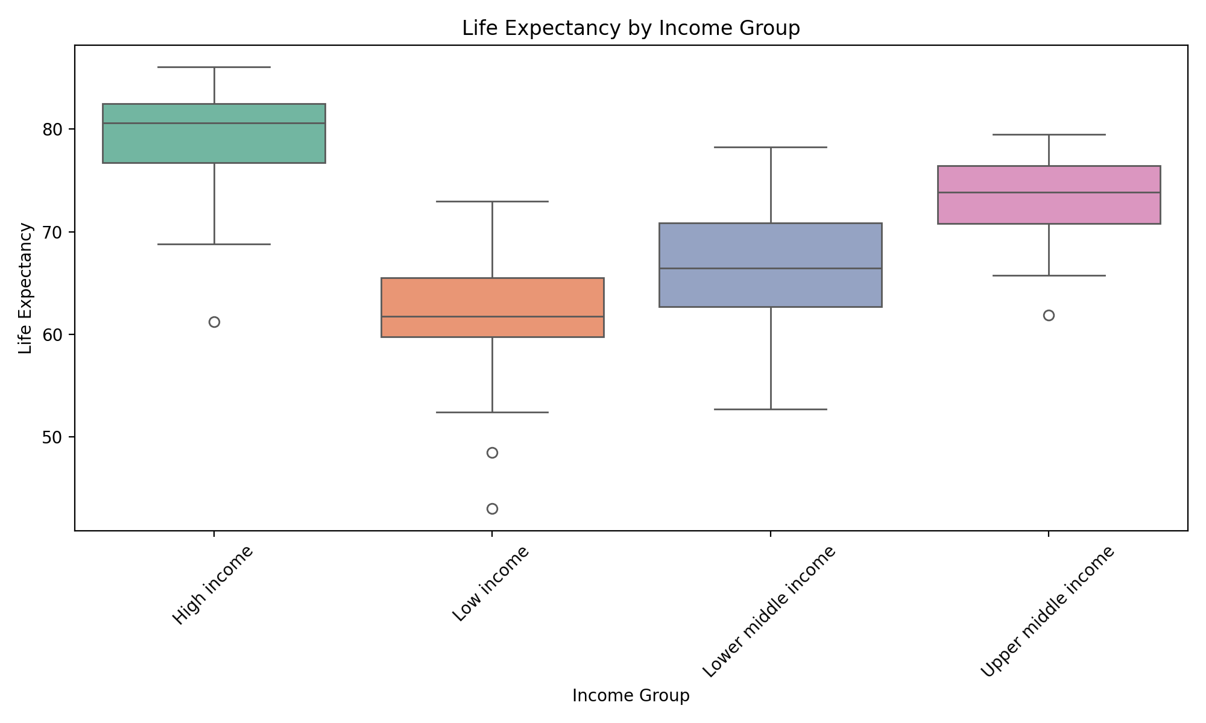
Figure 5: 06_group_comparisons.png

8. Modeling

8.1 Unsupervised Clustering
I used K-Means with k=3 based on the elbow method and silhouette score.
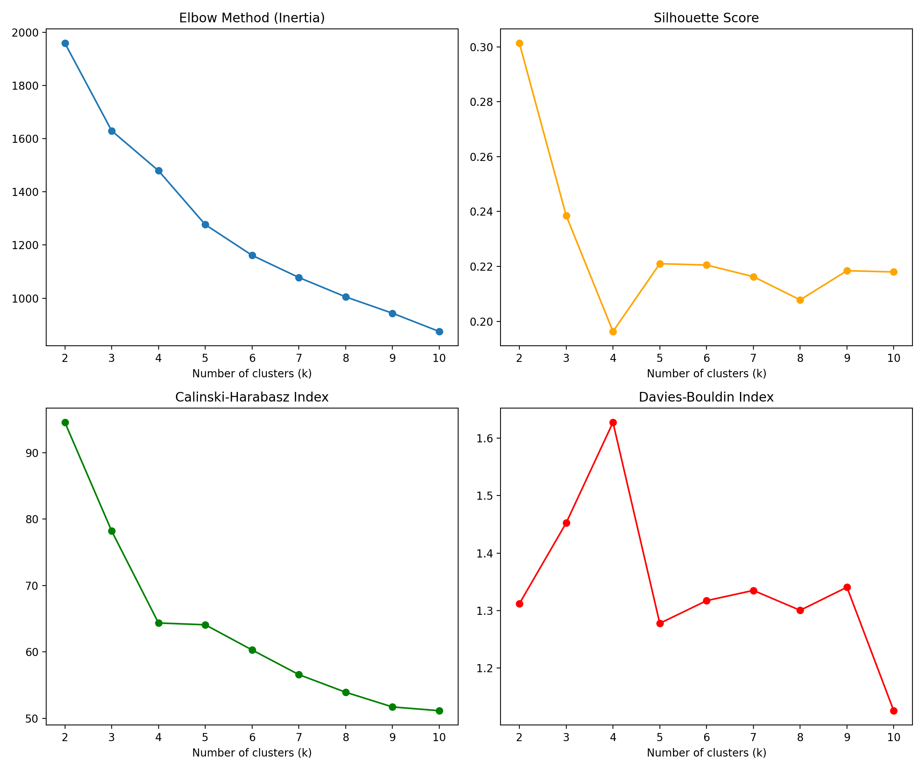
Figure 6: 07_k_selection.png
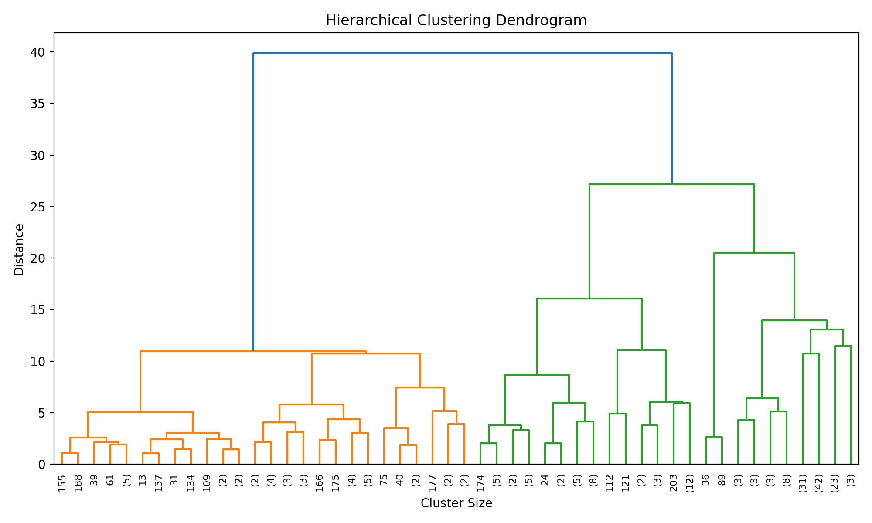
Figure 7: 08_dendrogram.png
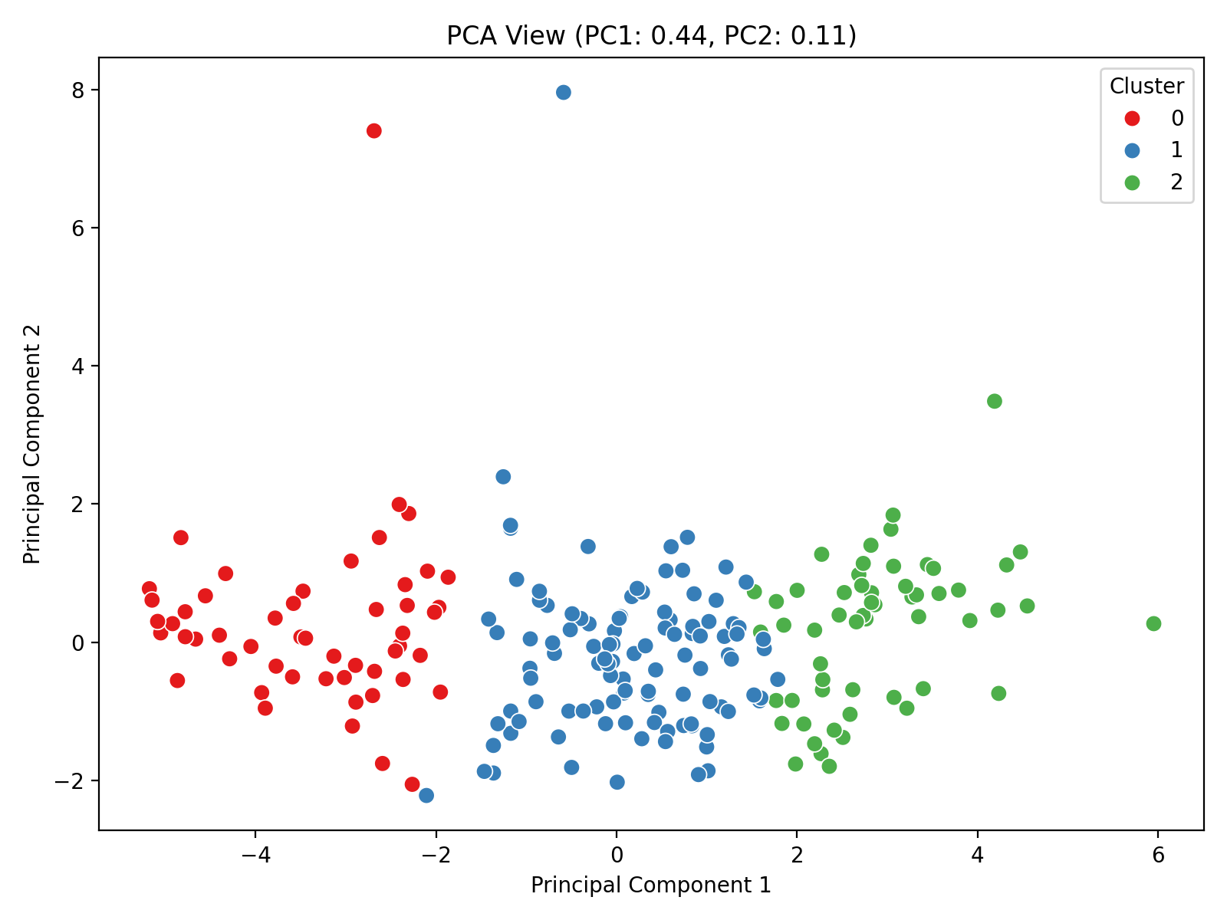
Figure 8: 09_pca_clusters.png
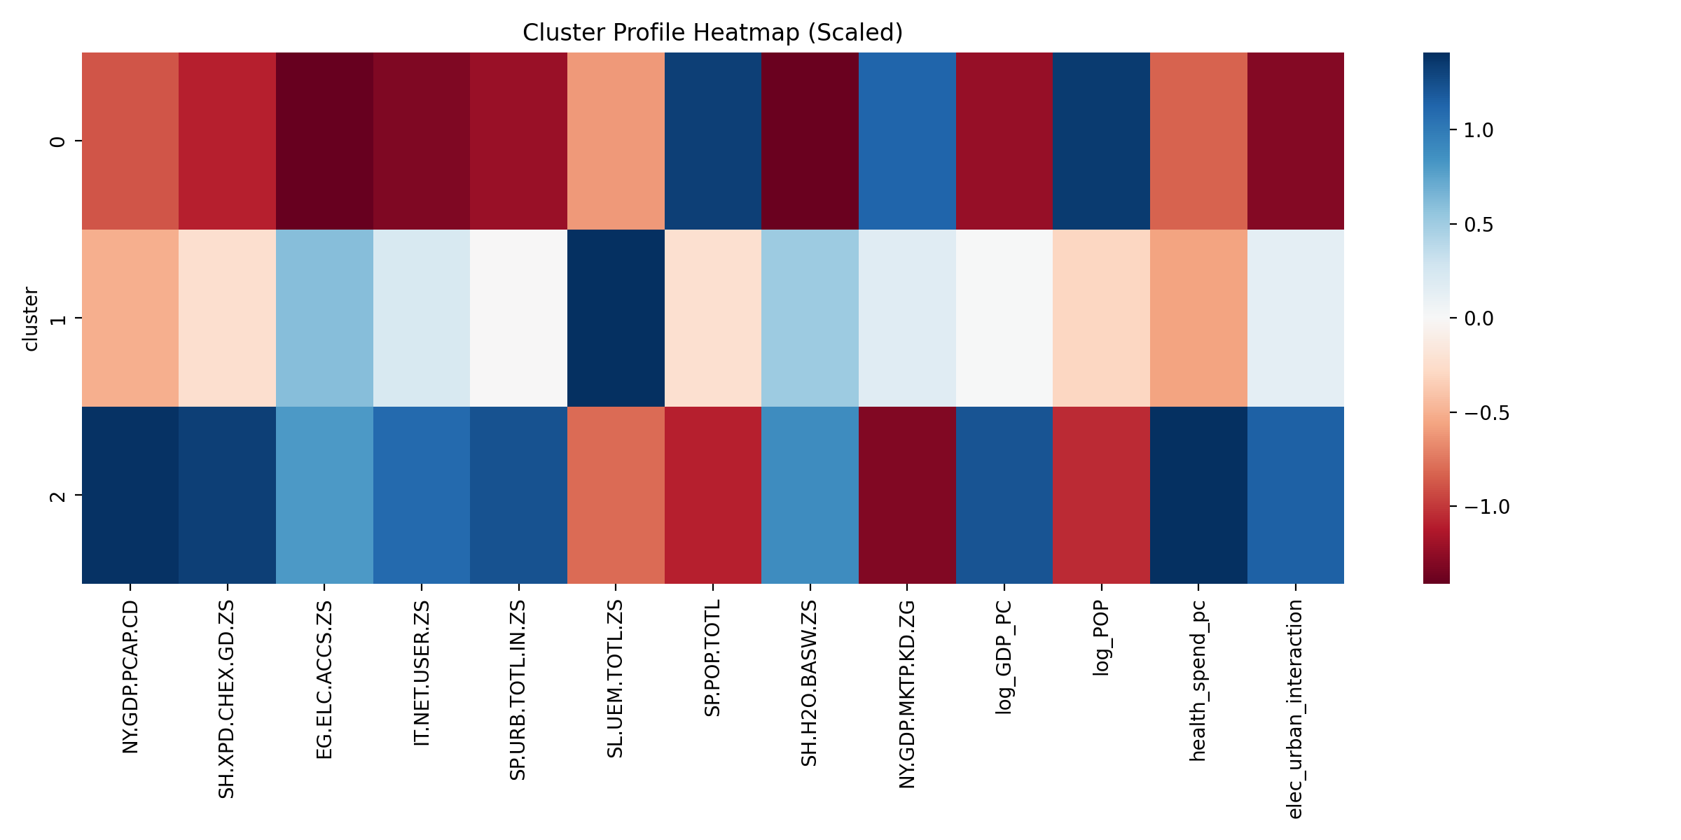
Figure 9: 10_cluster_profiles.png

8.2 Supervised Modeling
I trained Ridge, Random Forest, and Gradient Boosting. Gradient Boosting performed best.
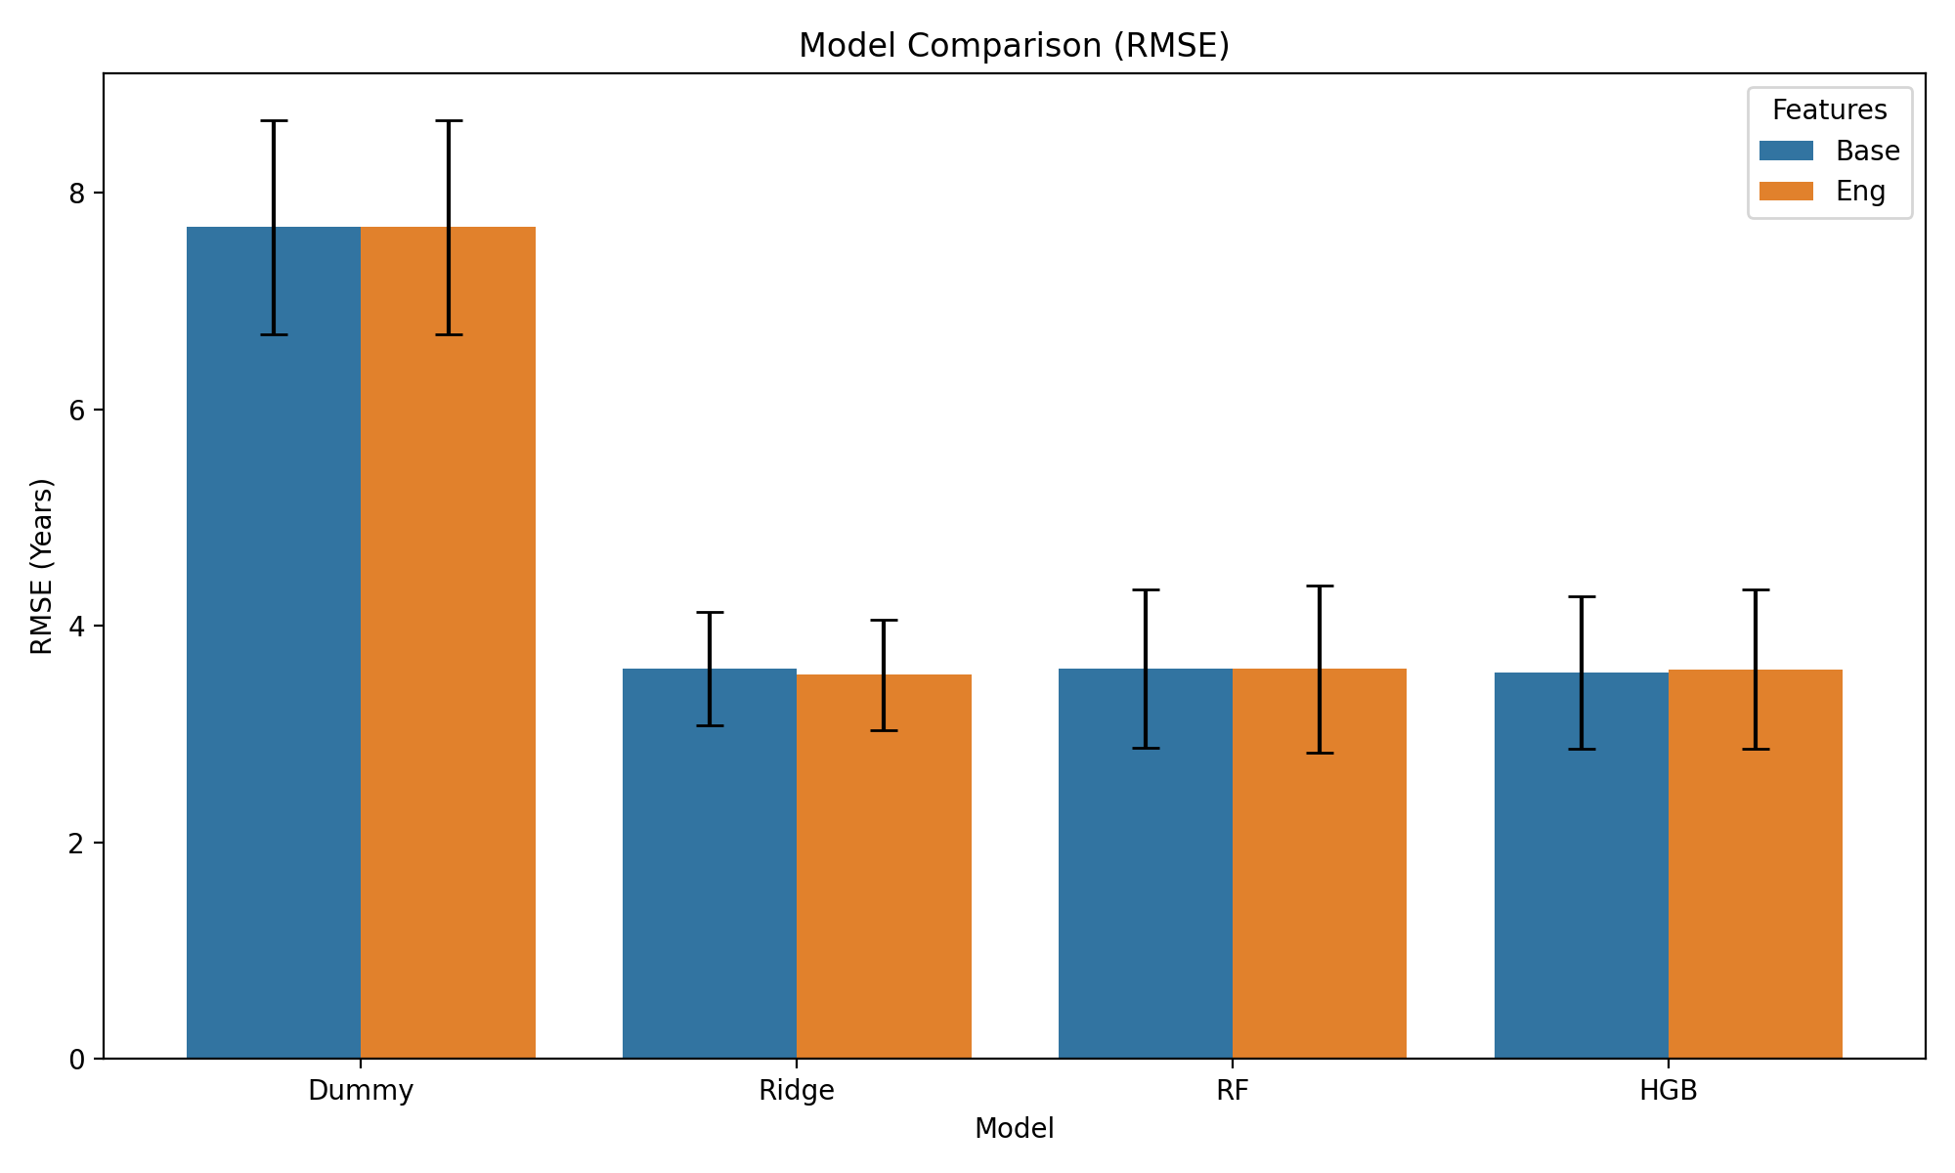
Figure 10: 11_model_comparison.png
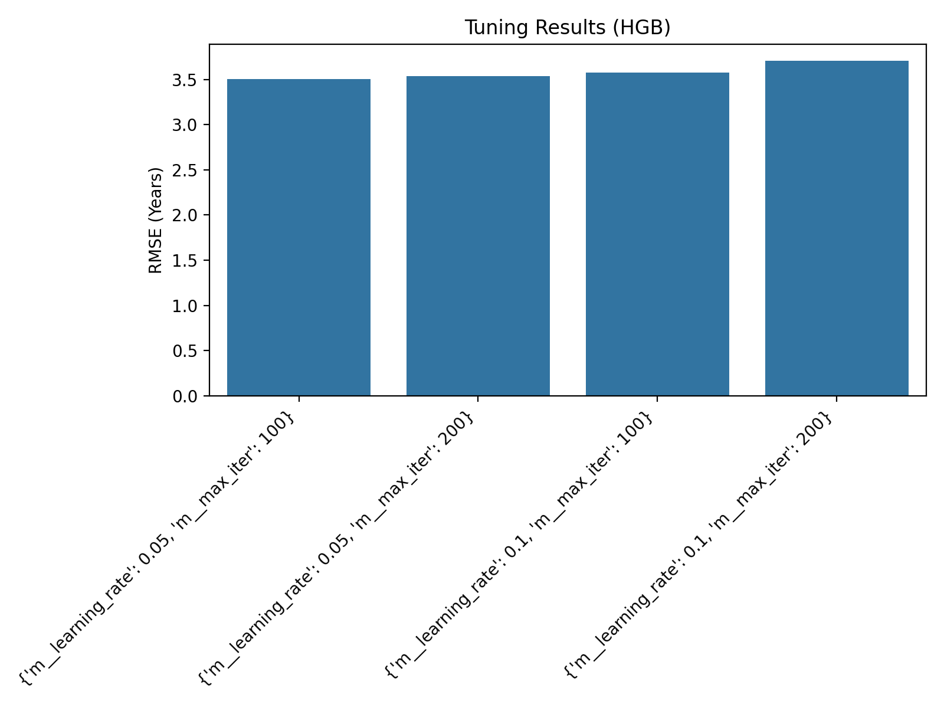
Figure 11: 12_tuning_results.png

9. Evaluation
The test RMSE was 4.28, baseline 8.56.
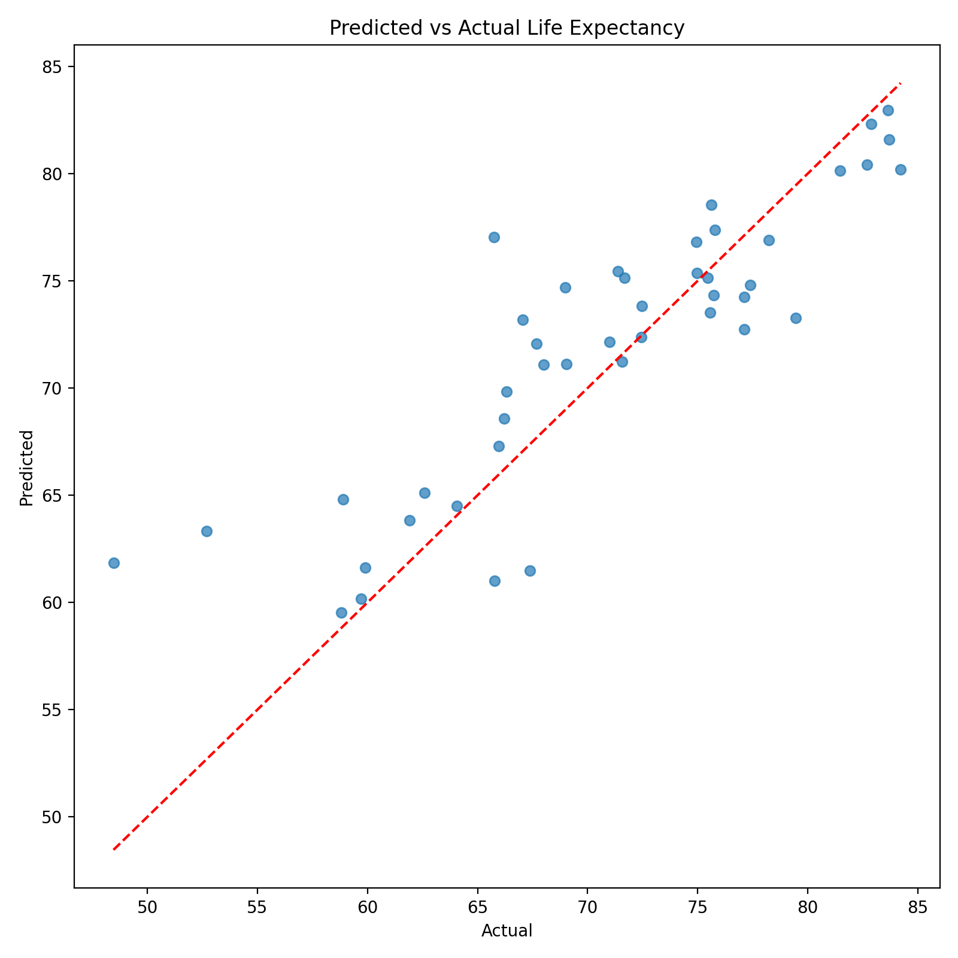
Figure 12: 13_predicted_vs_actual.png
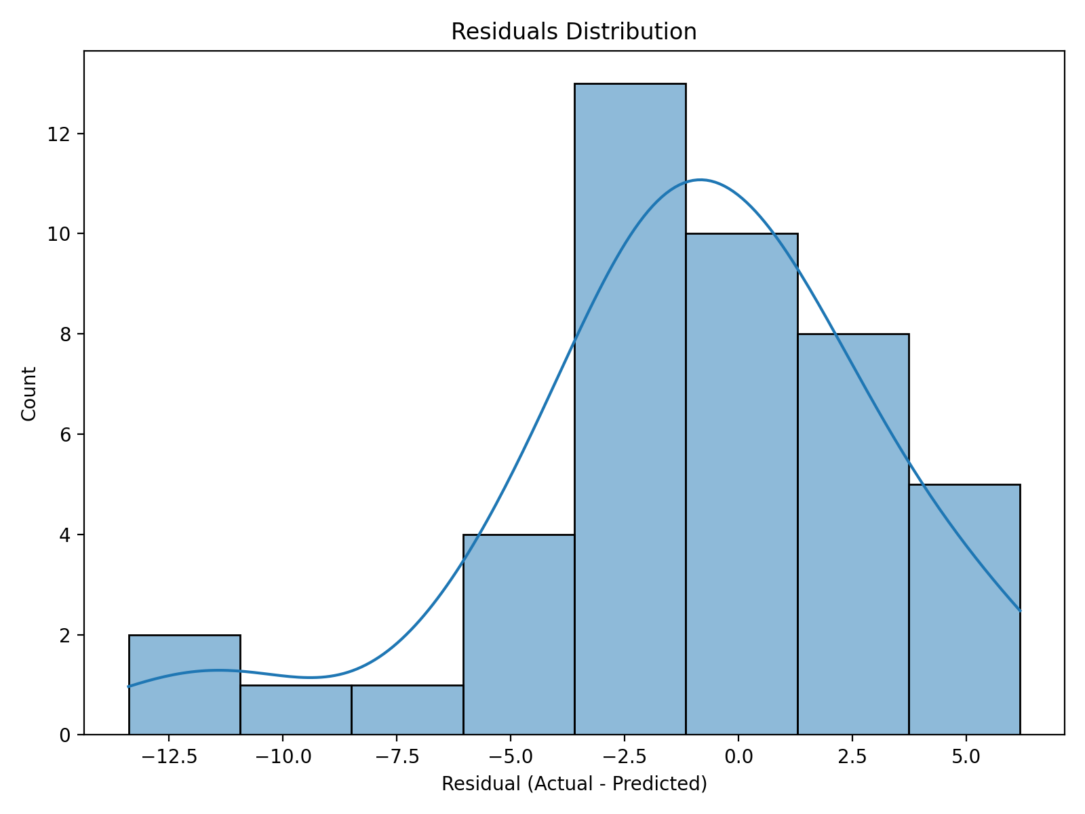
Figure 13: 14_residuals.png
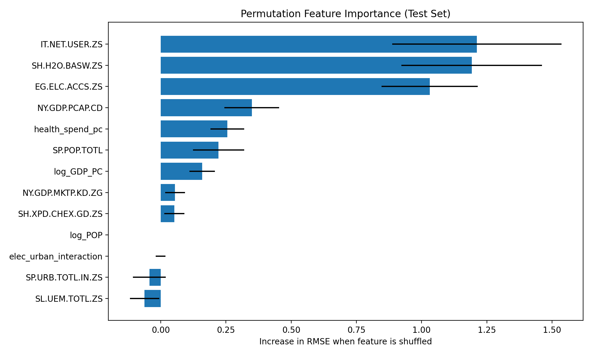
Figure 14: 15_feature_importance.png
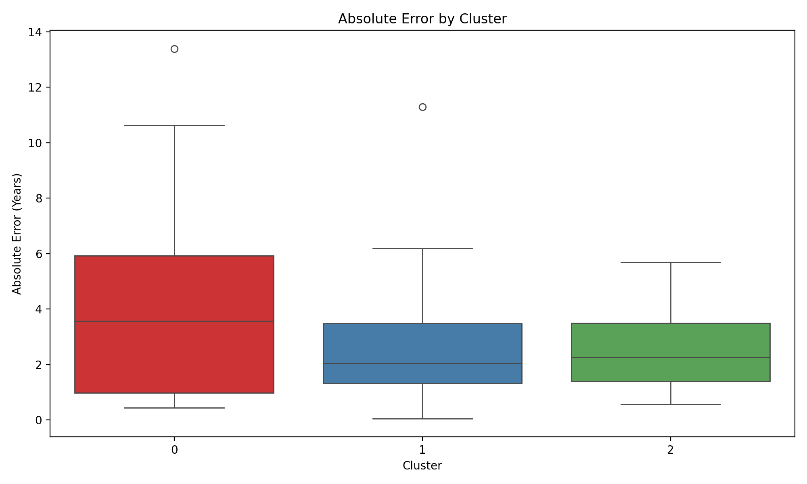
Figure 15: 16_error_by_cluster.png

10. Insights and Recommendations
1. Healthcare spending drives life expectancy. 2. Infrastructure (electricity) is crucial. 3. Some clusters need basic sanitation. 4. High GDP alone does not guarantee long life.
Recommendations: NGOs should focus on basic infrastructure in Cluster 0 countries.

11. Reflection on Challenges and Successes
Data merging was tricky due to missing country codes. Dropping sparse columns helped. The pipeline successfully grouped countries logically.

12. Conclusion and Further Analysis
The model works well but fails on extreme outliers. Future work should use time-series causal modeling.

13. References
World Bank Open Data: https://data.worldbank.org/

Appendix A: Decision log
Decision: Time window, Choice: 2017-2019, Reason: Better coverage
Decision: Remove aggregates, Choice: Remove, Reason: Model needs real countries
Decision: Drop bad indicators, Choice: Drop >50%, Reason: Too much missing
Decision: Drop bad countries, Choice: Drop >50%, Reason: Unreliable rows
Decision: Log transforms, Choice: Log GDP and POP, Reason: Skewed data

Appendix B: Architecture diagram
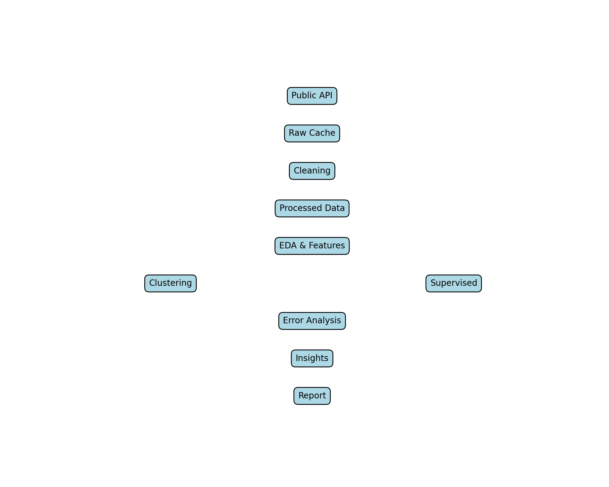

Appendix C: Requirement coverage table
Requirement 1: Section 4-9
Requirement 2: Full report
Requirement 3: This docx

