This is a template based on official TU BCA Project III (8th Semester) prescribed proposal structure. Replace all [PLACEHOLDERS] with your actual project details.

TRIBHUVAN UNIVERSITY
Faculty of Humanities and Social Sciences
[COLLEGE LOGO]
BAZAARSATHI: A PEER-TO-PEER MARKETPLACE WITH ESCROW PAYMENT
PROJECT PROPOSAL
PROJECT III (CAPJ452)
Submitted by
[STUDENT NAME(S)]
TU Registration No.: [TU REGISTRATION NUMBER(S)]
Under the supervision of
[SUPERVISOR NAME]
[COLLEGE NAME]
[COLLEGE ADDRESS]
[MONTH & YEAR]

1. INTRODUCTION
Digital person-to-person trading has expanded through social media groups and classified advertisements, but discovery, communication, payment, and accountability are commonly handled in separate channels. BazaarSathi is proposed as an integrated web marketplace for Nepal in which authenticated users can buy and sell products through structured listings and traceable interactions.
The application will combine listing search, real-time chat, persistent favourites and recently viewed items, payment verification, escrow-oriented seller settlement, verified reviews, reputation information, and an experimental price-assistance facility. Buyers and sellers will use purpose-specific dashboards, while administrators will supervise users, listings, transactions, and marketplace settings.
The project provides a practical context for applying software engineering, database design, web security, real-time event handling, third-party API integration, testing, and machine-learning evaluation within the BCA Project III course.

2. PROBLEM STATEMENT
Informal marketplace transactions expose buyers to inaccurate product information, anonymous sellers, payment loss, and limited recourse. Sellers likewise face false purchase commitments, fragmented conversations, and uncertainty about payment confirmation. Because records are distributed across unrelated services, neither party has a complete and auditable transaction history.
Many general-purpose systems do not prioritize local payment integration, escrow-like control, verified order-linked reviews, or academic transparency of the underlying design. Search results may be inconsistent, seller reputation may be unverified, and price suggestions can be misleading when they are not supported by representative data.
Therefore, a need exists for a modular marketplace prototype that links authenticated identities, owned listings, conversations, orders, verified payment state, seller earnings, reviews, and administrative oversight while clearly communicating the limitations of experimental price prediction.

3. OBJECTIVES
The general objective is to analyse, design, implement, and evaluate BazaarSathi as a secure peer-to-peer marketplace with an escrow-oriented transaction workflow.
The specific objectives define observable capabilities that can later be demonstrated and tested during project evaluation.
- Implement registration, login, password hashing, JWT protection, and role-aware dashboards.
- Allow sellers to create and manage listings while allowing buyers to search, filter, sort, and view them.
- Provide persistent favourites, recently viewed history, listing-linked conversations, and real-time messages.
- Integrate Khalti payment verification and an escrow workflow that retains 10% commission and releases 90% seller earning after approval.
- Support an administrator-controlled autoAccept setting, verified reviews, and seller reputation summaries.
- Evaluate a Random Forest model as a price-assistance experiment using suitable marketplace data and error metrics.
- Verify the integrated system through documented unit and system test cases.

4. METHODOLOGY
An iterative and incremental methodology will be used. Each iteration will select a related set of requirements, refine the design, implement the required model-route-controller or frontend components, and verify the result before integration. Weekly supervisor feedback and version-control evidence will guide corrections.
The methodology separates essential marketplace features from optional enhancements. Authentication, listings, orders, and basic administration will be stabilized first; real-time chat, activity history, reviews, reputation, and price assistance will be integrated in later iterations without weakening core transaction controls.

4.1 Requirement Identification
Requirements will be identified through observation of local online buying and selling practices, informal interviews with potential buyers and sellers, consultation with the project supervisor, and review of payment-provider and technology documentation. Candidate requirements will be recorded with actor, purpose, priority, dependency, and acceptance evidence.
The main actors are visitor, buyer, seller, administrator, and external payment service. User stories and use cases will distinguish public discovery from protected actions and will explicitly identify role, ownership, payment-state, and completed-order constraints.

4.2 Study of Existing System
The study will compare social-media trading groups, classified advertisements, and established marketplace applications. Comparison criteria will include registration, product structure, search, messaging, local payment support, transaction state, reputation, administration, privacy, and evidence available during disputes.
The purpose is not to reproduce a commercial platform at full scale. The study will identify gaps relevant to a semester prototype, including fragmented communication, unverified reviews, weak ownership control, and the absence of a transparent escrow-oriented workflow.

4.3 Literature Review
The literature review will cover software engineering methodology, client-server and MVC architecture, RESTful APIs, document databases, JWT authentication, password hashing, authorization, real-time communication, payment verification, reputation systems, and machine-learning regression.
Primary standards and official technical documentation will support implementation claims. Academic sources will be used to explain trust, ensemble learning, evaluation metrics, and limitations. The final report will compare the proposed solution with related systems and avoid treating synthetic model performance as evidence of real-market accuracy.

4.4 Requirement Analysis
Requirements will be analysed for completeness, consistency, feasibility, security, and traceability. Functional requirements will be mapped to actors, use cases, modules, and tests. Non-functional requirements will specify quality expectations that can be verified within the academic environment.
Priority will be given to rules that protect identity, ownership, transaction amount, payment state, escrow release, review eligibility, and administrative access. Exceptional paths such as invalid tokens, duplicate reviews, repeated approval, unavailable listings, and payment failure will be included.
Functional Requirements
The system shall provide account registration and login, listing management and discovery, chat and message history, favourites and recent history, order creation, Khalti verification, escrow approval, wallet credit, reviews, reputation, price estimation, and administration.
Non-Functional Requirements
The proposed system shall emphasize security, usability, reliability, maintainability, performance under the demonstration load, consistent API responses, backup-ready persistence, accessible interaction, and secret management through environment variables.
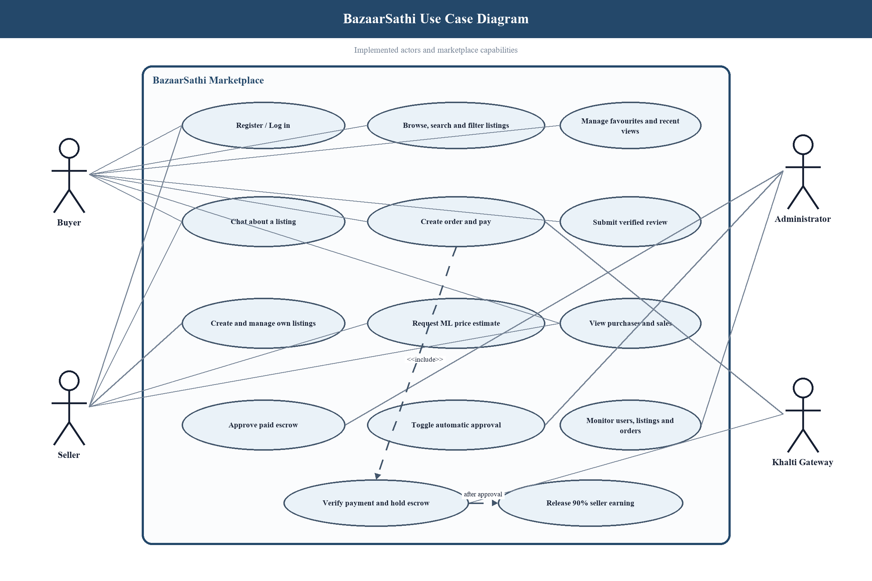
Figure 1: BazaarSathi Use Case Diagram

4.5 Feasibility Study
Feasibility will be assessed before full implementation and reviewed after integration. The study distinguishes what can be demonstrated during the semester from the legal, operational, security, and infrastructure work required for a production marketplace.

4.5.1 Technical Feasibility
React, Node.js, Express, MongoDB, Mongoose, Socket.IO, Python, and scikit-learn can run on commonly available development hardware and have sufficient documentation for the proposed prototype. Khalti sandbox facilities and environment-based configuration support safe integration testing.
Technical risks include payment-provider availability, atomic financial updates, WebSocket authorization, data quality for price prediction, and deployment configuration. These risks will be controlled through validation, repeat-safe service functions, sandbox credentials, automated tests, and documented setup procedures.

4.5.2 Operational Feasibility
The proposed workflows resemble familiar marketplace actions: browsing, saving, messaging, paying, and reviewing. Role-specific dashboards and clear status messages should reduce training needs during the academic demonstration.
A production launch would require seller verification, moderation, user support, dispute procedures, refunds, monitoring, and incident response. These operational dependencies will be recorded as limitations and future recommendations.

4.5.3 Economic Feasibility
Open-source frameworks and student-owned equipment keep development cost low. Limited free or educational tiers may support database, hosting, and image-storage use during development, while payment testing uses a sandbox environment.
Commercial operation would introduce hosting, storage, bandwidth, monitoring, payment, moderation, support, and compliance costs. The proposed 10% commission is an application rule for the prototype and is not presented as a validated business model.

4.6 High Level Design of System
The high-level design uses a React client, an Express REST and Socket.IO server, Mongoose data models, MongoDB persistence, a server-side Khalti integration, and an internal Python model service. JWT middleware protects routes before controller, ownership, or role checks are applied.
Models, routes, controllers, middleware, and services are separated so that financial and authorization rules remain on the server. All API responses use the common structure { success, data, message }, and secrets are loaded from environment configuration.

4.6.1 Methodology of the Proposed System
A visitor may browse listings and create an account. Authenticated sellers publish products, while buyers search, view, save, and discuss items. The backend validates every protected request and stores persistent records through Mongoose.
When a buyer purchases an active listing, the server derives the amount from stored data, creates an order, and initiates payment. After provider verification, the order is held for approval or completed immediately if autoAccept is enabled. Completion credits the seller once and enables a verified buyer review.
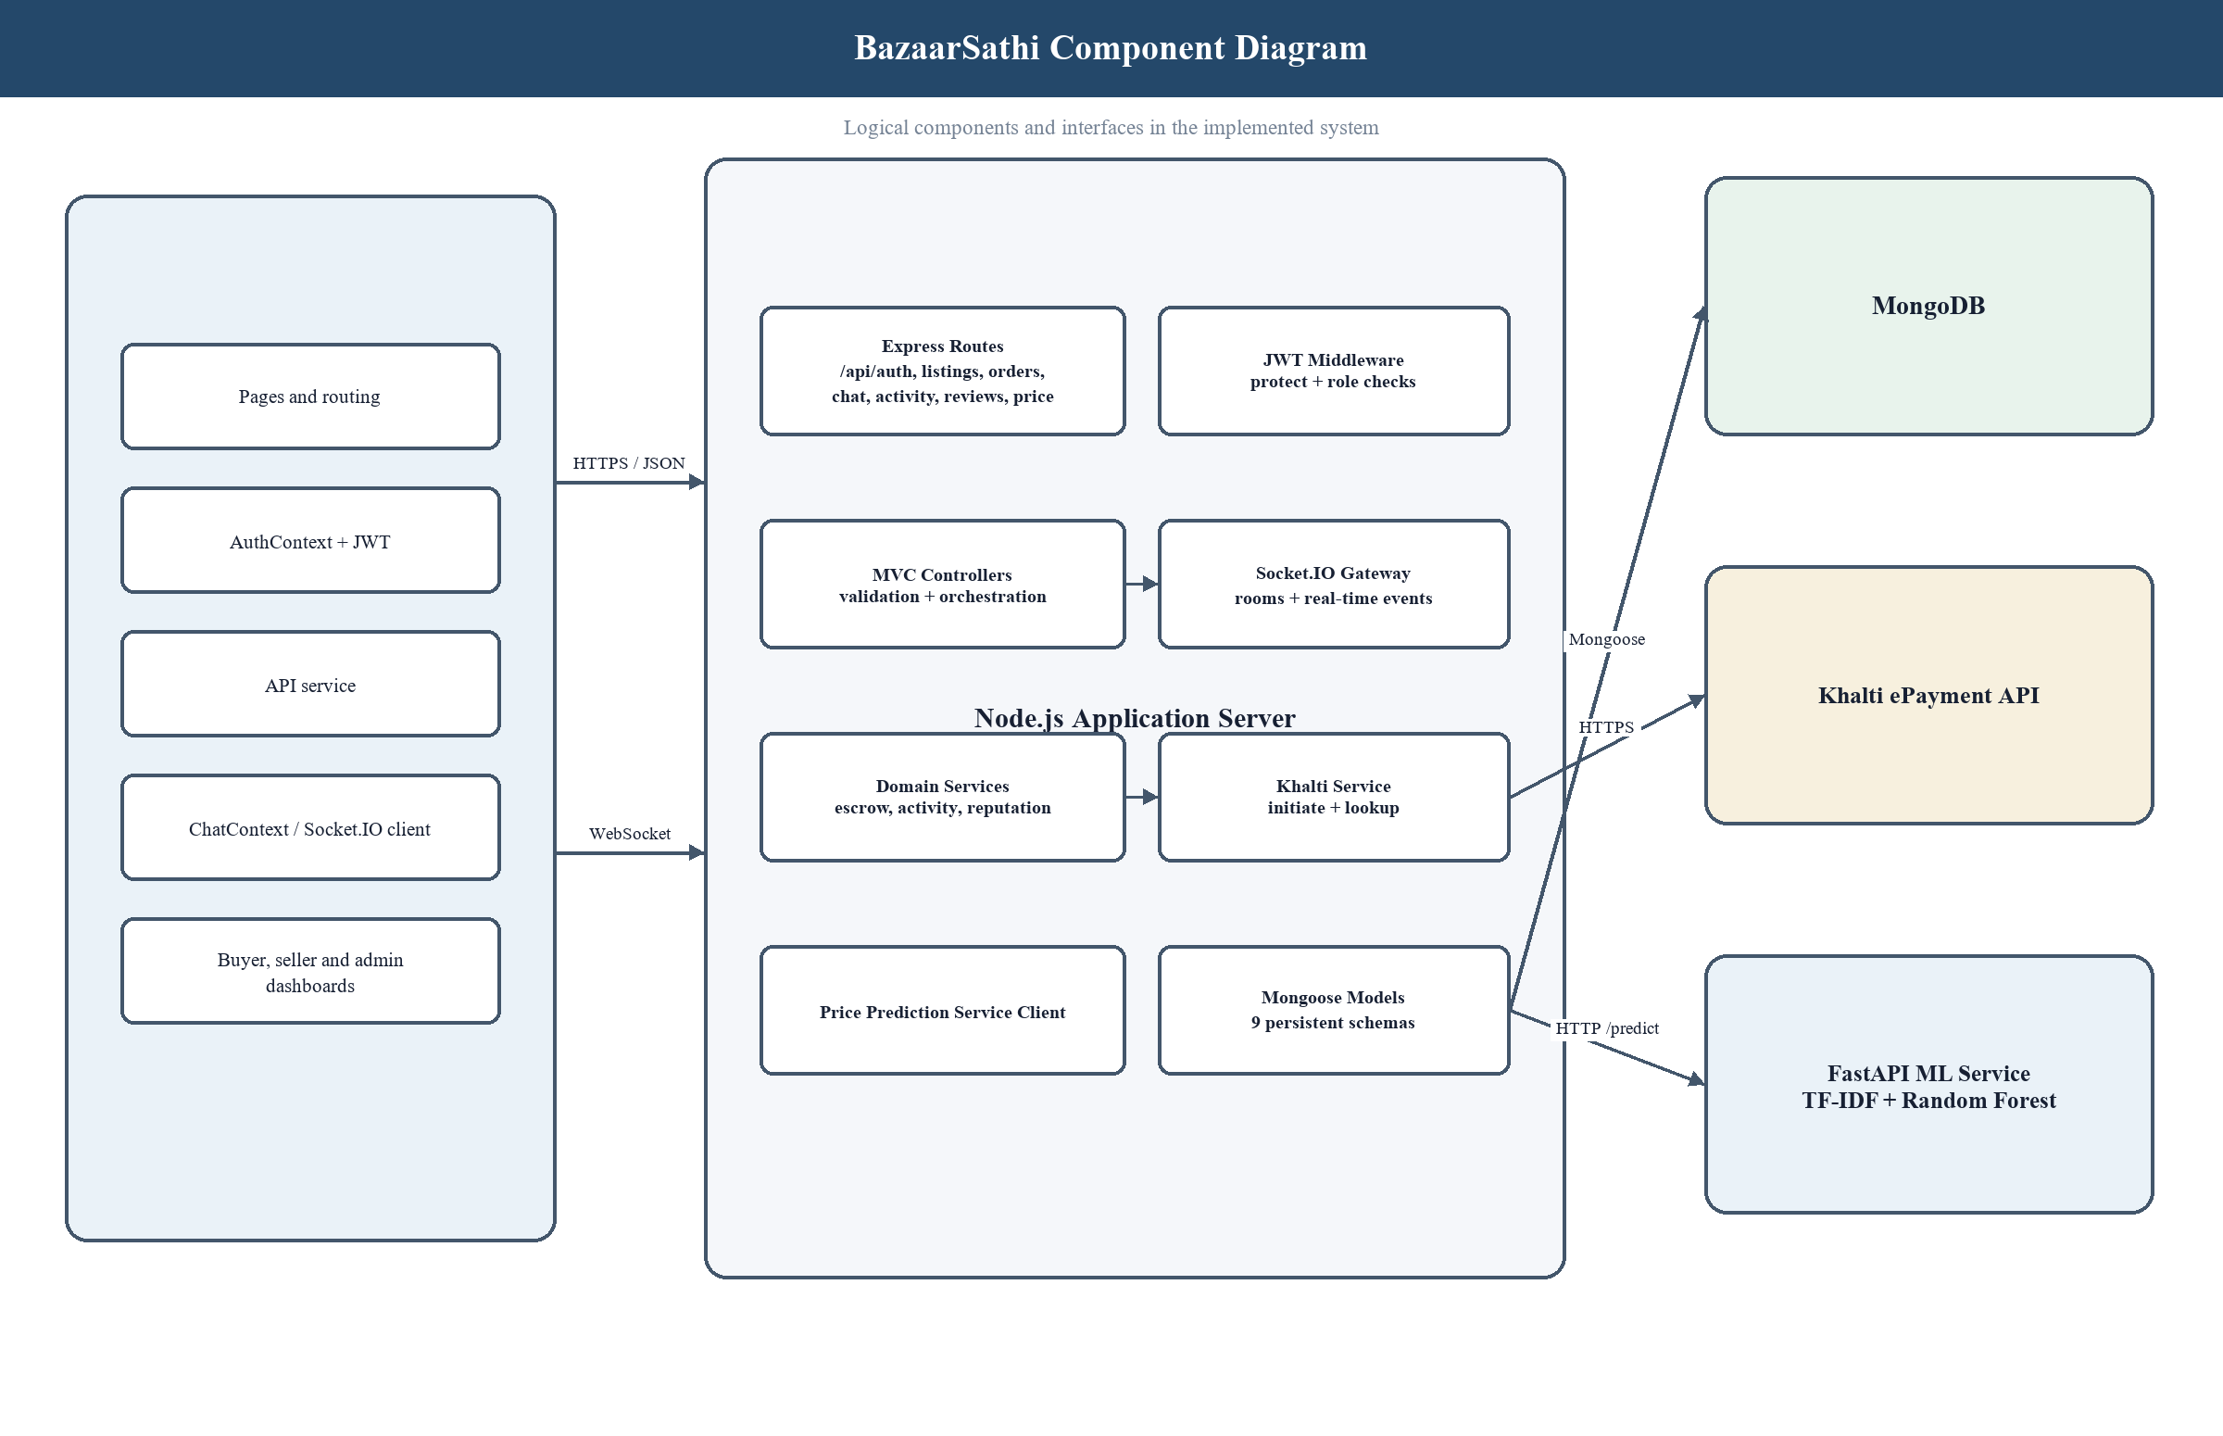
Figure 1: BazaarSathi High-Level Component Diagram

4.6.2 Flow Chart
The primary purchase flow begins with listing discovery and authentication, then proceeds through order creation, payment initiation, provider verification, escrow handling, administrative or automatic approval, seller credit, and completion. Failure branches preserve a non-completed order and provide a clear response.
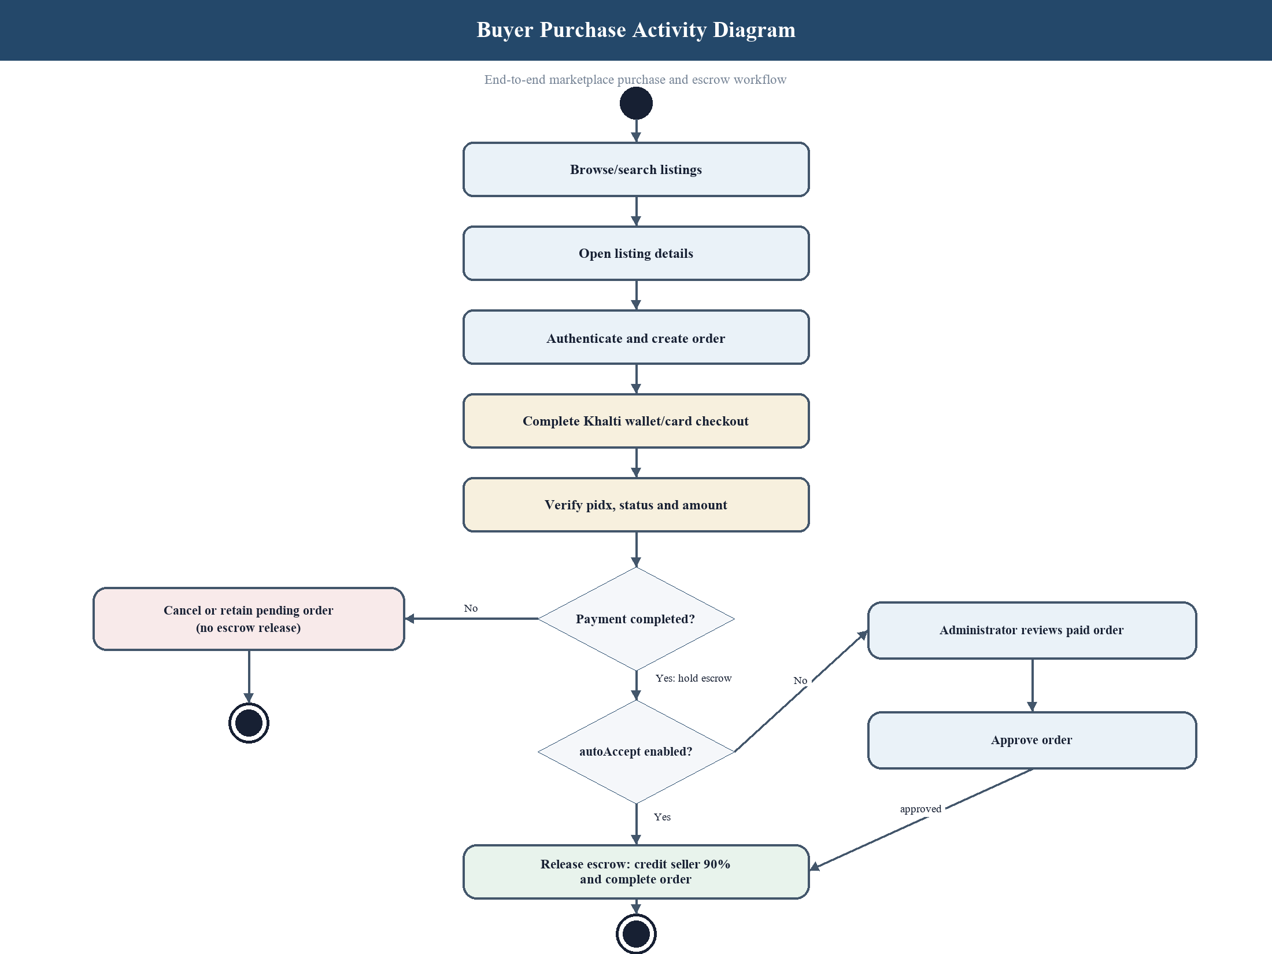
Figure 1: Proposed Purchase and Escrow Flow Chart

4.6.3 Working Mechanism of the Proposed System
Browser requests reach Express routes and pass through validation and, where required, JWT protection. Controllers invoke Mongoose operations or dedicated services; successful and unsuccessful results return the standard response envelope. Socket.IO rooms distribute authorized messages while the database preserves history.
Payment verification is performed server-side against the provider rather than trusting browser confirmation. Order updates and wallet credit follow constrained state transitions. Administrative dashboards expose only role-authorized operations, and the prediction service remains internal to prevent direct browser dependence on the Python runtime.

4.6.4 Description of Algorithms
Escrow calculation: commission = verified amount × 0.10 and seller earning = verified amount × 0.90. Approval checks payment state and prior completion before crediting the wallet, making repeated requests safe.
Seller reputation: aggregate only eligible order-linked reviews, combine rating average and evidence count, and present the count beside the score so users can interpret confidence.
Random Forest price assistance: clean text, encode category and condition, transform text features, fit an ensemble of decision trees to completed-sale labels, average tree predictions, and evaluate on unseen data using mean absolute error and coefficient of determination. Unsupported inputs should receive a warning or no estimate.

5. GANTT CHART
The proposed timeline covers sixteen academic weeks. Core dependencies are sequenced so authentication and listing data are available before payment, chat, reviews, administration, and machine-learning integration. Documentation and supervisor review continue throughout rather than being postponed until the final week.
The schedule is a baseline and should be updated with actual dates, milestones, delays, and corrective actions. Optional features must not displace testing of identity, ownership, payment, and escrow rules.
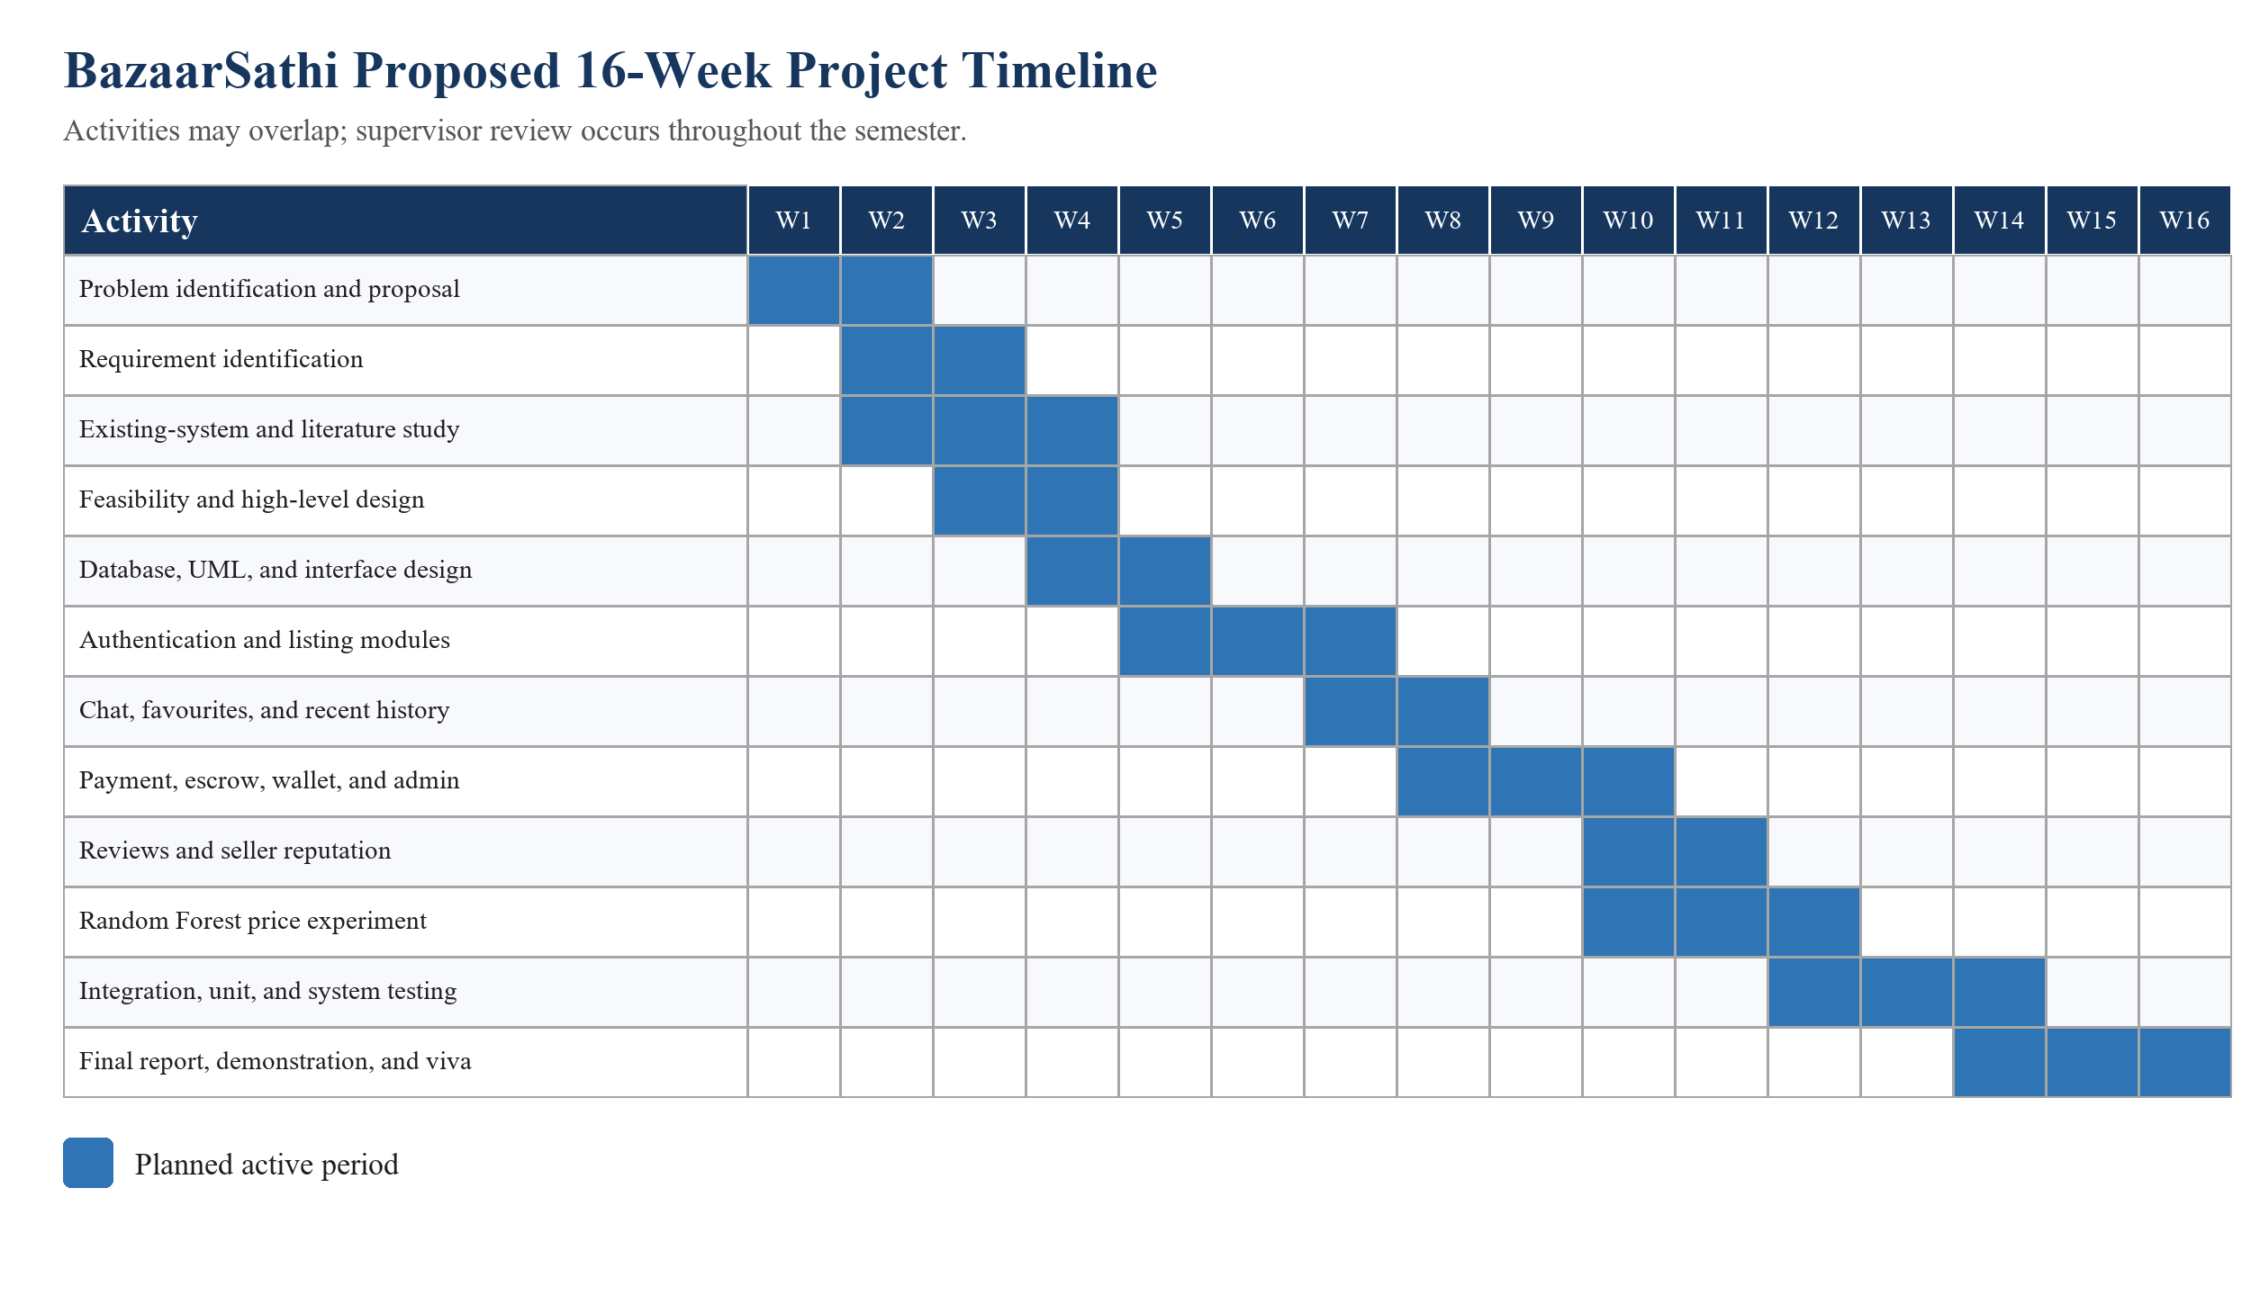
Figure 1: Proposed Sixteen-Week Gantt Chart

6. EXPECTED OUTCOME
The expected outcome is a working web-based marketplace prototype with secure accounts, role-aware dashboards, listing discovery and ownership operations, persistent activity features, listing-linked real-time chat, order and payment records, escrow-oriented settlement, verified reviews, seller reputation, and administrative oversight.
The project is also expected to produce analysed requirements, refined UML diagrams, a maintainable MVC codebase, version-control evidence, documented test cases, screenshots, and a formal TU report. The price feature is expected to demonstrate the machine-learning workflow and its evaluation limits rather than guarantee a market-correct valuation.
During final evaluation, the team should be able to demonstrate representative buyer, seller, and administrator journeys and explain the database relationships, security controls, payment state transitions, algorithms, test evidence, limitations, and individual contributions.

7. REFERENCES
[1] I. Sommerville, Software Engineering, 10th ed. Boston, MA, USA: Pearson, 2015.
[2] R. S. Pressman and B. R. Maxim, Software Engineering: A Practitioner’s Approach, 9th ed. New York, NY, USA: McGraw-Hill, 2020.
[3] M. Jones, J. Bradley, and N. Sakimura, ‘JSON Web Token (JWT),’ RFC 7519, Internet Engineering Task Force, May 2015.
[4] OWASP Foundation, ‘OWASP Application Security Verification Standard 4.0.3,’ Oct. 2021.
[5] MongoDB, Inc., ‘MongoDB Manual,’ [Online]. Available: https://www.mongodb.com/docs/manual/. [Accessed: [DATE]].
[6] React Team, ‘React Documentation,’ [Online]. Available: https://react.dev/. [Accessed: [DATE]].
[7] Socket.IO, ‘Socket.IO Documentation,’ [Online]. Available: https://socket.io/docs/v4/. [Accessed: [DATE]].
[8] F. Pedregosa et al., ‘Scikit-learn: Machine learning in Python,’ Journal of Machine Learning Research, vol. 12, pp. 2825–2830, 2011.
[9] Khalti, ‘Payment Gateway Documentation,’ [Online]. Available: [CONFIRM CURRENT OFFICIAL URL]. [Accessed: [DATE]].
[10] [RELATED NEPALESE MARKETPLACE OR RESEARCH SOURCE], ‘[TITLE],’ [PUBLICATION DETAILS].

