This is a template based on official TU BCA Project III (8th Semester) prescribed structure. Replace all [PLACEHOLDERS] with your actual project details.

TRIBHUVAN UNIVERSITY
Faculty of Humanities and Social Sciences
[COLLEGE LOGO]
[PROJECT TITLE]
PROJECT III (CAPJ452)
Submitted by
[STUDENT NAME(S)]
TU Registration No.: [TU REGISTRATION NUMBER(S)]
[COLLEGE NAME]
[COLLEGE ADDRESS]
[MONTH & YEAR]

TRIBHUVAN UNIVERSITY
Faculty of Humanities and Social Sciences
[PROJECT TITLE]
A Project Report submitted in partial fulfillment of the requirements for the degree of Bachelor of Computer Application (BCA)
Submitted by
[STUDENT NAME(S)] - [TU REGISTRATION NUMBER(S)]
Under the supervision of
[SUPERVISOR NAME]
[COLLEGE NAME]
[COLLEGE ADDRESS]
[MONTH & YEAR]

CERTIFICATE
This is to certify that the project report entitled “[PROJECT TITLE]” was prepared and submitted by [STUDENT NAME(S)], TU Registration Number(s) [TU REGISTRATION NUMBER(S)], in partial fulfillment of the requirements for the degree of Bachelor of Computer Application under the Faculty of Humanities and Social Sciences, Tribhuvan University.
The project work was carried out under the prescribed academic guidelines for Project III (CAPJ452). To the best of our knowledge, the report represents the students’ original work except where due acknowledgement and reference have been provided. The report is therefore recommended for evaluation and acceptance by the concerned authority.
[PROJECT SUPERVISOR]  Supervisor | Date: __________ | [PROJECT COORDINATOR]  Coordinator | Date: __________
[HEAD OF DEPARTMENT]  Department Head | Date: __________ | [CAMPUS CHIEF / PRINCIPAL]  College Authority | Date: __________

SUPERVISOR RECOMMENDATION
I hereby recommend that the project report entitled “[PROJECT TITLE]”, prepared by [STUDENT NAME(S)] under my supervision, be accepted as fulfilling the academic requirements of Project III (CAPJ452) for the Bachelor of Computer Application programme of Tribhuvan University.
The students have participated in scheduled consultations, incorporated the feedback provided during supervision, and demonstrated an adequate understanding of system analysis, design, implementation, testing, and documentation. The work is suitable for presentation before the internal and external examiners, subject to the regulations of the University and the concerned college.
[SUPERVISOR NAME]  Project Supervisor | Signature and Date  ____________________________

INTERNAL AND EXTERNAL EXAMINERS’ APPROVAL LETTER
The project report entitled “[PROJECT TITLE]” submitted by [STUDENT NAME(S)] has been examined and evaluated as a partial fulfillment of the requirements for the degree of Bachelor of Computer Application. The candidates have presented the project, responded to questions, and demonstrated the implemented system before the examination committee.
On the basis of the report, presentation, demonstration, and viva voce examination, the committee records its approval. Any corrections identified during the examination shall be incorporated in the final bound copy before submission to the college and Tribhuvan University.
[INTERNAL EXAMINER]  Signature: __________ | Date: __________ | [EXTERNAL EXAMINER]  Signature: __________ | Date: __________
[PROJECT COORDINATOR]  Signature: __________ | Date: __________ | [HEAD OF DEPARTMENT]  Signature: __________ | Date: __________

ACKNOWLEDGEMENT
The successful completion of this project was possible through the guidance, cooperation, and encouragement of several individuals and institutions. We express our sincere gratitude to [SUPERVISOR NAME] for continuous supervision, constructive criticism, and practical suggestions throughout requirement analysis, design, implementation, testing, and report preparation.
We are thankful to the faculty members and administration of [COLLEGE NAME] for providing the academic environment and technical resources necessary for the project. We also acknowledge the users and respondents who contributed observations during requirement collection and usability evaluation. Their feedback helped refine the workflow and improve the relevance of the proposed solution.
Finally, we are grateful to our families, classmates, and friends for their patience, motivation, and support during the project period. We accept responsibility for any limitations or errors that remain in this report and welcome suggestions for further improvement.

ABSTRACT
[PROJECT TITLE] is a web-based peer-to-peer marketplace developed to improve the reliability, transparency, and convenience of online buying and selling. The system enables users to create secure accounts, publish searchable product listings, communicate through real-time messaging, save favourite items, and review recently viewed products. A role-based administration facility supports listing oversight, transaction monitoring, and marketplace management. To reduce the risk associated with direct person-to-person transactions, the proposed solution incorporates a payment and escrow workflow in which payment is verified before seller earnings are released. Verified buyers may submit order-linked reviews, while seller reputation is calculated from rating history and transaction completion behaviour. The project also evaluates a Random Forest regression model as an academic price-assistance feature using title, description, category, and condition data. The system was developed using an iterative methodology with React for the client interface, Node.js and Express for the application programming interface, MongoDB for persistent data, Socket.IO for messaging, and Python-based machine-learning tools for experimentation. Unit and system testing were applied to authentication, listing management, payment verification, communication, review, and prediction workflows. The resulting prototype demonstrates that an integrated marketplace architecture can centralize discovery, communication, transaction control, and reputation information. However, payment deployment, model accuracy, and operational scalability remain dependent on production credentials, representative completed-sale data, infrastructure capacity, and continued security assessment.
Keywords: peer-to-peer marketplace, escrow, JWT authentication, real-time chat, seller reputation, Random Forest

TABLE OF CONTENTS
Certificate
Supervisor Recommendation
Internal and External Examiners’ Approval Letter
Acknowledgement
Abstract
List of Abbreviations
List of Figures
List of Tables
CHAPTER 1: INTRODUCTION
1.1 Introduction
1.2 Problem Statement
1.3 Objectives
1.4 Scope and Limitation
1.5 Development Methodology
1.6 Report Organization
CHAPTER 2: BACKGROUND STUDY AND LITERATURE REVIEW
2.1 Background Study
2.2 Literature Review
CHAPTER 3: SYSTEM ANALYSIS AND DESIGN
3.1 System Analysis
3.1.1 Requirement Analysis
3.1.2 Feasibility Analysis
3.2 Object Modelling
3.3 Dynamic Modelling
3.4 Process Modelling
3.5 System Design
3.5.1 Iterative Waterfall Development Model
3.5.2 Refinement of Class, Object, State, Sequence and Activity Diagrams
3.5.3 Component Diagrams
3.5.4 Deployment Diagrams
3.6 Algorithm Details (if any)
CHAPTER 4: IMPLEMENTATION AND TESTING
4.1 Implementation
4.1.1 Tools Used
4.1.2 Implementation Details of Modules
4.2 Testing
4.2.1 Test Cases for Unit Testing
4.2.2 Test Cases for System Testing
4.3 Result Analysis
CHAPTER 5: CONCLUSION AND FUTURE RECOMMENDATIONS
5.1 Conclusion
5.2 Future Recommendations
References
Bibliography
Appendices
Appendix A: Screenshots
Appendix B: Source Code (Sample)
Appendix C: Meeting Logs / Supervisor Visit Log
Appendix D: Evaluation Preparation Checklist

LIST OF ABBREVIATIONS
Abbreviation | Meaning
API | Application Programming Interface
BCA | Bachelor of Computer Application
CRUD | Create, Read, Update, and Delete
DBMS | Database Management System
HTTP | Hypertext Transfer Protocol
IEEE | Institute of Electrical and Electronics Engineers
JWT | JSON Web Token
ML | Machine Learning
MVC | Model-View-Controller
P2P | Peer-to-Peer
REST | Representational State Transfer
TU | Tribhuvan University
UI | User Interface
URL | Uniform Resource Locator

LIST OF FIGURES
Figure 1: BazaarSathi Use Case Diagram
Figure 2: BazaarSathi Project Gantt Chart
Figure 3: BazaarSathi Class Diagram
Figure 4: BazaarSathi Object Diagram
Figure 5: Order and Escrow State Diagram
Figure 6: Payment Verification and Escrow Sequence Diagram
Figure 7: Buyer Purchase Activity Diagram
Figure 8: Iterative Waterfall Development Model
Figure 9: BazaarSathi Component Diagram
Figure 10: BazaarSathi Deployment Diagram
Figure 11: Application Screenshot Placeholder

LIST OF TABLES
Table 1: Detailed Use Case Descriptions
Table 2: BazaarSathi Project Timeline
Table 3: Development Tools and Technologies
Table 4: Module Implementation Summary
Table 5: Representative Unit Test Cases
Table 6: Representative System Test Cases
Table 7: Supervisor Visit and Meeting Log

CHAPTER 1: INTRODUCTION
This chapter establishes the context, motivation, goals, boundaries, and development approach of the proposed software project. It introduces the marketplace problem domain and explains how the remaining chapters document the transition from an identified problem to a tested information system.

1.1 Introduction
Digital marketplaces have changed how individuals discover, compare, and exchange goods. In Nepal, social media pages and informal classified channels are commonly used for person-to-person transactions; however, these channels often separate product discovery, communication, payment, and accountability. A dedicated marketplace can combine these activities within a traceable workflow and offer users a more consistent experience.
The proposed project presents a web-based peer-to-peer marketplace in which registered users can publish listings, search and filter available products, communicate in real time, initiate payments, and maintain account activity. The design emphasizes modular development, role-aware access, persistent records, and a structured escrow process so that later enhancements can be incorporated without redesigning the entire system.

1.2 Problem Statement
Informal online trading exposes buyers and sellers to incomplete product information, fraudulent profiles, unrecorded agreements, and payment uncertainty. Buyers may transfer money without assurance that the seller will complete the transaction, while sellers may reserve or deliver products without reliable confirmation of payment. Communication conducted across external applications also makes disputes difficult to reconstruct.
Existing general-purpose platforms may not address local payment methods, student-level deployment constraints, or the need for an academically explainable architecture. Therefore, the project addresses the need for an integrated marketplace prototype that links user identity, listing ownership, conversation history, verified payment status, seller earnings, and post-transaction reputation in one maintainable system.

1.3 Objectives
The general objective of the project is to analyse, design, implement, and evaluate a secure web-based marketplace that supports peer-to-peer buying and selling through a unified workflow. The application should demonstrate the practical use of database-driven web engineering, authentication, real-time communication, payment verification, and software testing.
The specific objectives translate the general purpose into observable system capabilities. Each objective is associated with one or more modules and can be assessed through test cases, interface demonstrations, and database evidence during final evaluation.
- Provide secure registration, login, and role-aware access using hashed passwords and JSON Web Tokens.
- Allow sellers to create, update, manage, and remove structured product listings.
- Enable buyers to search, filter, view, save, discuss, and purchase listed products.
- Implement payment verification and escrow-based seller earning release with administrative oversight.
- Support verified reviews, seller reputation, and an experimental price-assistance model.
- Evaluate the completed prototype using unit and system-level test cases.

1.4 Scope and Limitation
The project scope includes account management, listing management, marketplace search, favourites, recently viewed history, real-time conversations, order creation, Khalti-oriented payment verification, escrow status administration, wallet accounting, verified reviews, seller reputation, and an experimental Random Forest price estimate. The system is designed for a browser-based client connected to a REST API and MongoDB database.
The prototype is limited by the availability of production payment credentials, representative transaction data, deployment infrastructure, and long-term user evaluation. Escrow release represents an application-level accounting workflow and does not independently satisfy banking or regulatory requirements. Price predictions are not reliable until trained on sufficient completed-sale data, while image moderation, logistics, refund arbitration, multilingual support, and large-scale performance testing remain outside the present scope.

1.5 Development Methodology
An iterative and incremental development methodology is adopted because the project contains several interdependent modules that can be analysed, implemented, and tested in short cycles. Each iteration begins with a small set of requirements, continues through design and implementation, and concludes with verification and supervisor review. This supports early discovery of integration problems and allows feedback to influence subsequent work.
The initial iterations establish the project structure, database connection, authentication, and common response conventions. Later iterations add listings, payment and escrow, chat, activity history, reviews, administration, and machine-learning experimentation. Version control records changes throughout development, while repeatable automated tests are used to reduce regression risk when modules are connected.

1.6 Report Organization
Chapter 1 introduces the project, problem, objectives, scope, limitations, and methodology. Chapter 2 presents the background study and literature review relevant to marketplace systems, secure web applications, escrow processes, reputation mechanisms, and price estimation.
Chapter 3 documents requirement, feasibility, modelling, and architectural design decisions. Chapter 4 explains implementation tools, module-level realization, testing activities, and result analysis. Chapter 5 concludes the work and recommends future enhancements, after which references, bibliography guidance, screenshots, source-code samples, and supervision records are provided.

CHAPTER 2: BACKGROUND STUDY AND LITERATURE REVIEW
This chapter places the project within the broader study of online marketplaces and reviews technical and academic concepts that influenced the selected architecture. The discussion should be revised with sources directly related to the final project topic and institutional expectations.

2.1 Background Study
A peer-to-peer marketplace is an information system that coordinates product publication, discovery, negotiation, and exchange among independent users. Unlike a conventional online store operated by one merchant, a marketplace must represent multiple sellers, establish ownership of listings, and provide mechanisms that help users assess transaction risk. Search, messaging, order state, and reputation therefore form a connected domain rather than isolated interface features.
The technical background of the proposed system includes client-server architecture, RESTful communication, document-oriented storage, token-based authentication, real-time event delivery, and third-party payment integration. React supports component-based user interfaces; Express organizes server routes and middleware; MongoDB stores flexible marketplace records; Socket.IO supports bidirectional chat events; and JWT provides signed authentication claims for protected routes.
Escrow introduces an intermediate transaction state between successful payment and seller settlement. In the proposed design, a verified payment marks funds as held, while an administrative approval or configured automatic rule releases the seller share and records the commission. This simplified model demonstrates state management and atomic database updates, although production escrow requires contractual, regulatory, settlement, refund, and dispute procedures beyond the scope of a classroom prototype.

2.2 Literature Review
Software engineering literature emphasizes systematic requirements, modular design, verification, and maintainability as foundations of dependable systems. Marketplace research similarly identifies trust signals, reputation, transparent rules, and secure payment handling as important influences on user participation. These principles informed the separation of controllers, models, routes, middleware, and services within the proposed application.
Security guidance recommends password hashing, protected communication, validation, least-privilege authorization, secure secret management, and resistance to common web application attacks. Accordingly, the prototype hashes passwords, issues time-limited JWTs, checks ownership and administrative roles, keeps secrets in environment configuration, and returns consistent API responses. A complete final report should compare these controls with the selected security standard and document remaining risks.
Machine-learning literature shows that ensemble decision-tree methods can model nonlinear relationships and mixed feature interactions. A Random Forest regressor was selected as an interpretable academic baseline for price assistance; however, model performance depends on representative labelled observations. Consequently, the project distinguishes a reproducible demonstration dataset from production evidence and recommends training on verified completed-sale prices, with brand, model, age, storage, and warranty attributes included as structured features.

CHAPTER 3: SYSTEM ANALYSIS AND DESIGN
This chapter converts the identified problem into requirements, feasibility conclusions, behavioural models, data relationships, and system architecture. Replace the diagram placeholders with final diagrams whose entities, labels, and flows match the implemented system.

3.1 System Analysis
System analysis was conducted by identifying the principal actors, business events, information objects, and constraints of the marketplace. Buyers, sellers, and administrators interact with listings, conversations, orders, payments, reviews, and account records. The analysis separates user goals from implementation decisions so each requirement can later be traced to a module and test case.
The major workflow begins when a user authenticates, explores a listing, communicates with a seller, and creates an order. Payment verification changes the order and listing state, while approval releases the seller earning. Supporting workflows maintain favourites, recently viewed records, message-read status, administrative settings, and reputation summaries.

3.1.1 Requirement Analysis
Requirement analysis defines the observable behaviour and quality expectations of the proposed system. Requirements were organized by actor and workflow, reviewed against project scope, and prioritized according to academic importance, implementation dependency, and user value. Authentication and listing management were treated as foundational because transaction, chat, activity, and review modules depend on valid users and products.
Each functional requirement should be represented in a use case specification containing the initiating actor, preconditions, main flow, alternative flow, exception flow, and postconditions. Non-functional requirements should be expressed in measurable terms wherever possible so testing can determine whether the system meets the stated quality target.
Functional Requirements
Functional requirements describe services that the system must perform. The marketplace shall register and authenticate users, manage role and ownership checks, maintain listings, perform search and filtering, create conversations, exchange messages, create orders, verify payment, release escrow, record account activity, accept eligible reviews, calculate reputation, and expose administrative information.
Use Case diagrams should summarize the relationships between buyers, sellers, administrators, and external payment services. Detailed use cases should clarify which actions require authentication, which actions are restricted by ownership, and how unsuccessful payment, unavailable listings, duplicate reviews, or invalid input are handled.
- Account registration, login, token validation, and role-aware access.
- Listing creation, discovery, detail viewing, update, deletion, and status management.
- Order initiation, payment verification, escrow approval, commission calculation, and wallet credit.
- Conversation creation, room joining, message persistence, typing status, and read tracking.
- Favourite, recently viewed, verified review, seller reputation, and price-estimate workflows.
- Administrative dashboard, order approval, and automatic-approval configuration.
Table 1: Detailed Use Case Descriptions
ID | Use Case and Actor | Precondition | Main Flow, Alternatives, and Postcondition
UC-01 | Register or log in — Visitor | Valid registration data or existing credentials | The visitor submits credentials; the system validates them, hashes a new password where applicable, and returns a JWT with public user data. Duplicate email or invalid credentials produce a safe error. The user becomes authenticated.
UC-02 | Browse and search listings — Visitor/Buyer | Marketplace contains active listings | The actor supplies optional search, category, condition, price, and sort parameters. The system validates parameters and returns matching active listings. Invalid filters are rejected. No persistent state is changed.
UC-03 | Manage listing — Seller | Authenticated seller account | The seller creates, updates, or deletes a listing. The system validates fields and confirms ownership before modification. Non-owners are denied. A valid listing is persisted with its seller reference.
UC-04 | View, favourite, and record recent item — Buyer | Listing exists; authentication is required for persistence | The buyer opens a listing; views increment and recent history is updated. The buyer may add or remove the favourite. Anonymous users may view but do not create account activity records.
UC-05 | Start conversation and exchange messages — Buyer/Seller | Authenticated participant and existing listing | The actor opens or reuses the listing conversation, joins its room, and sends content. The server validates participation, persists the message, and broadcasts it. Unauthorized room access is rejected.
UC-06 | Create order and pay — Buyer | Authenticated buyer; active listing owned by another user | The system derives amount from the listing, creates a pending order, and initiates Khalti payment. Cancellation leaves the order incomplete. Successful provider verification records payment and holds funds in escrow.
UC-07 | Approve escrow release — Administrator/System | Verified payment and non-completed order | An administrator approves the order, or the system applies the enabled autoAccept rule. The order becomes completed and exactly 90% is credited once to the seller wallet; 10% remains commission.
UC-08 | Submit review — Buyer | Buyer owns a completed, unreviewed order | The buyer submits a rating and comment. The system rejects ineligible or duplicate reviews, persists a valid review, and recalculates the seller’s reputation summary.
UC-09 | Request price estimate — Seller | Required title, category, and condition are provided | The API normalizes features and invokes the trained Random Forest service. Supported inputs return an estimate with limitations; invalid or unsupported inputs return a validation or confidence warning.
UC-10 | Administer marketplace — Administrator | Authenticated administrator | The administrator reviews users, listings, orders, and settings; toggles autoAccept; and approves eligible orders. Role checks prevent buyer or seller access to administrative operations.

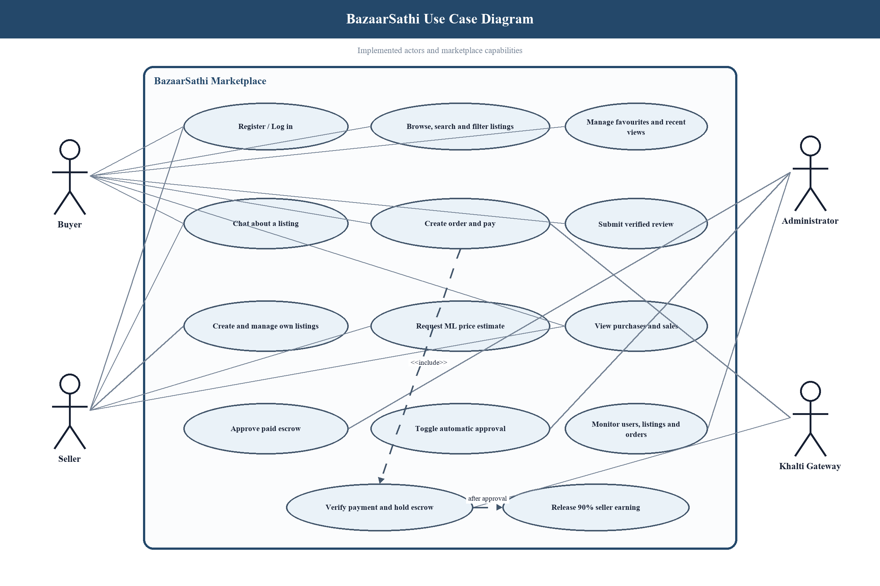
Figure 1: BazaarSathi Use Case Diagram
Non-Functional Requirements
Non-functional requirements define how effectively the system should deliver its services. Security requires protected credentials, authenticated access, authorization checks, input validation, and secret separation. Reliability requires consistent state transitions and idempotent handling where repeated payment or approval requests could otherwise create duplicate financial effects.
Usability requires responsive interfaces, understandable messages, accessible controls, and predictable navigation. Maintainability requires modular MVC organization, reusable services, consistent response formats, and automated tests. Performance targets should be finalized with realistic user and listing volumes, while backup, monitoring, and recovery objectives should be specified before production deployment.
- Security: hashed passwords, signed JWTs, role and ownership checks, validation, and HTTPS in production.
- Performance: responsive common reads and bounded query results under the expected academic demonstration load.
- Reliability: atomic payment and escrow updates with repeat-safe operations.
- Usability: responsive layouts, clear feedback, keyboard-accessible controls, and consistent terminology.
- Maintainability: MVC separation, documented configuration, version control, and automated regression tests.

3.1.2 Feasibility Analysis
Feasibility analysis evaluates whether the proposed system can be completed with the available technology, resources, skills, schedule, and operational environment. The assessment was performed before full implementation and revisited after integration of payment, chat, review, and machine-learning components.
The study indicates that an academic prototype is feasible because the selected technologies are widely documented and can be developed on commonly available computers. Production readiness nevertheless requires additional legal, security, infrastructure, payment-provider, and support arrangements that exceed the resources of the present semester project.
i. Technical Feasibility
The required client, server, database, real-time, and machine-learning capabilities are supported by the selected technology stack. Node.js, Express, React, MongoDB, Socket.IO, and Python libraries are available on standard development platforms, while their modular ecosystems support testing and integration.
The main technical risks concern third-party payment behaviour, database transactions, deployment configuration, model quality, and secure operations. These risks are manageable for a prototype through sandbox credentials, environment variables, controlled test data, service health checks, explicit error handling, and documented setup procedures.
ii. Operational Feasibility
The proposed workflow reflects familiar marketplace activities such as browsing, saving, messaging, purchasing, and reviewing. Clear status indicators and account-based histories reduce the need for users to remember actions performed in separate applications.
Operational adoption will depend on moderation, support, dispute resolution, seller verification, and user education. An administrator dashboard supports basic oversight, but a deployed service would require written policies, escalation procedures, monitoring responsibility, and support availability.
iii. Economic Feasibility
The prototype can be developed with open-source frameworks and student-owned hardware, which keeps direct academic development costs low. Cloud database, image storage, hosting, messaging, and payment sandbox services may provide limited free usage suitable for demonstrations.
Production operation would introduce recurring hosting, storage, bandwidth, monitoring, domain, payment, customer-support, and compliance expenses. A sustainable model should compare these costs with commission income, transaction volume, user acquisition, and expected support burden before commercial deployment.
iv. Schedule Feasibility
The project can be divided into semester-aligned iterations covering analysis, authentication, listings, transactions, communication, administration, enhancements, testing, and reporting. Foundational modules should be completed early so later modules can reuse stable user and listing data.
Schedule risk is controlled through a prioritized backlog, weekly supervisor review, version control, and a feature-complete deadline before final documentation. Optional enhancements should not delay verification of the core marketplace workflow, and unresolved external dependencies should be documented promptly.
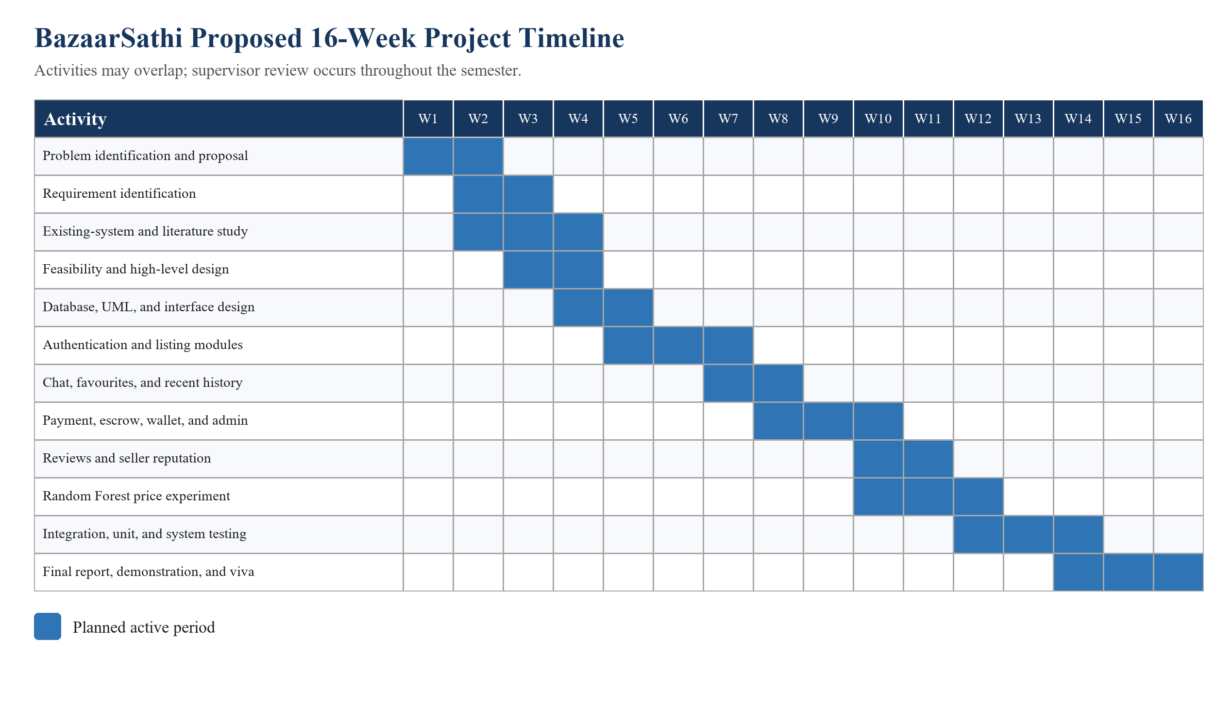
Figure 1: BazaarSathi Project Gantt Chart
Table 1: BazaarSathi Project Timeline
Phase | Weeks | Principal Activities | Milestone / Deliverable
1 | 1-2 | Problem identification, proposal preparation, and supervisor consultation | Approved project topic and proposal draft
2 | 2-4 | Requirement identification, existing-system study, literature review, and feasibility analysis | Reviewed requirements and feasibility findings
3 | 4-5 | Database modelling, UML diagrams, architecture, interface planning, and test planning | System analysis and design baseline
4 | 5-7 | Project setup, authentication, roles, dashboards, listing CRUD, search, filtering, and image workflow | Core account and listing modules
5 | 7-8 | Conversation, message history, Socket.IO events, favourites, and recently viewed listings | Integrated communication and activity modules
6 | 8-10 | Order creation, Khalti verification, escrow states, commission, seller wallet, and admin settings | Transaction and administration modules
7 | 10-12 | Verified reviews, seller reputation, data preparation, Random Forest training, and prediction API | Trust and price-assistance features
8 | 12-14 | Module integration, validation, security review, unit testing, system testing, and defect correction | Feature-complete tested prototype
9 | 14-16 | Final report completion, screenshots, supervisor corrections, presentation, demonstration, and viva preparation | Submission-ready report and demonstration

3.2 Object Modelling (Class and Object Diagrams)
Object modelling identifies persistent entities, their attributes, responsibilities, and relationships. Principal classes include User, Listing, Conversation, Message, Order, Review, Favourite, RecentlyViewed, and AdminSetting. References between entities represent ownership and participation, while schema constraints enforce required fields, valid states, and uniqueness rules.
The class diagram should show multiplicity and important associations, such as one seller owning many listings, one listing participating in multiple conversations, one completed order accepting at most one review, and a conversation containing many messages. Object diagrams may present sample runtime instances to clarify how identifiers connect records during a purchase.
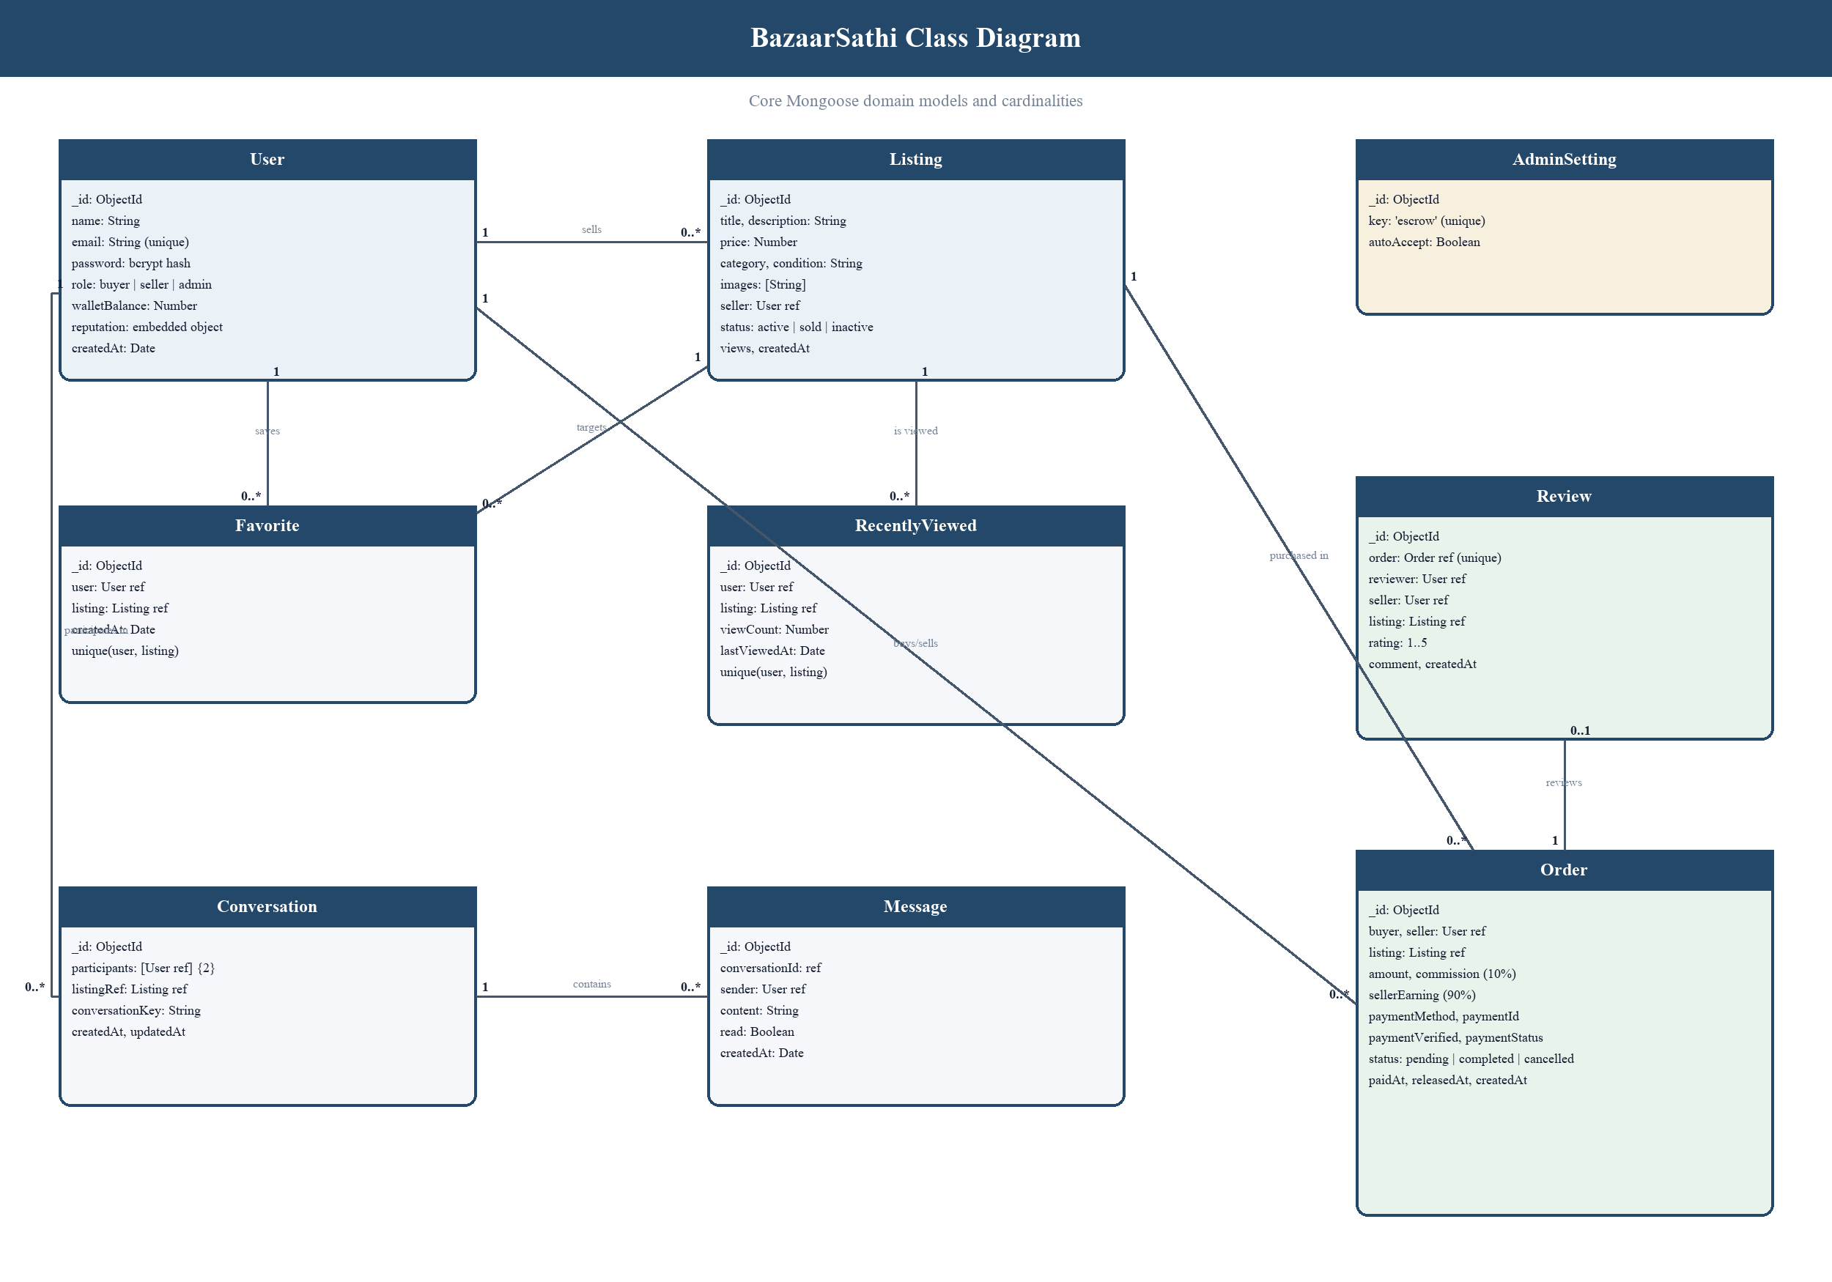
Figure 1: BazaarSathi Class Diagram
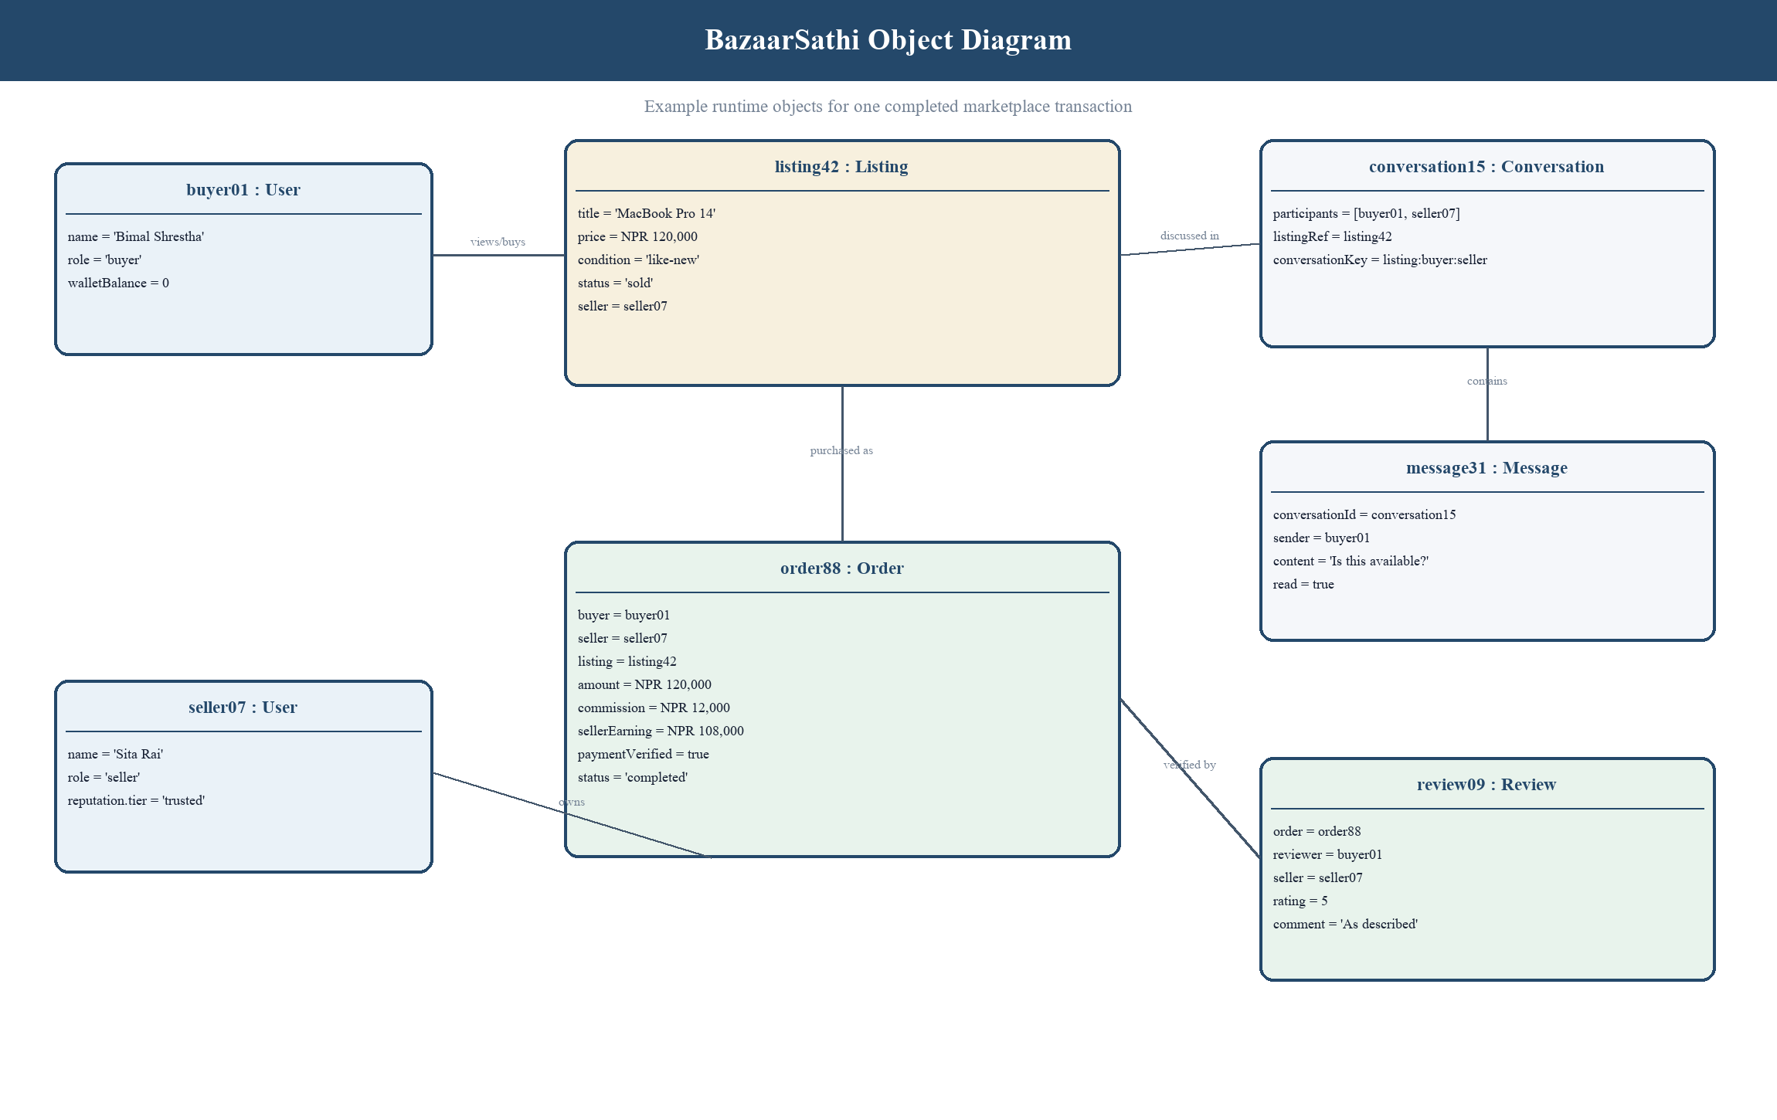
Figure 1: BazaarSathi Object Diagram

3.3 Dynamic Modelling (State and Sequence Diagrams)
Dynamic modelling represents how the system changes over time. The order state begins as pending, receives payment confirmation, and becomes completed when escrow is released or cancelled when a terminal failure is recorded. Listing status changes from active to sold during verified purchase processing, preventing later buyers from purchasing the same item.
Sequence diagrams should illustrate authentication, listing creation, payment verification, escrow approval, chat message delivery, and review submission. Each diagram should identify the browser, API route, middleware, controller, service, database, socket server, and external provider where applicable, including alternative responses for invalid credentials or state conflicts.
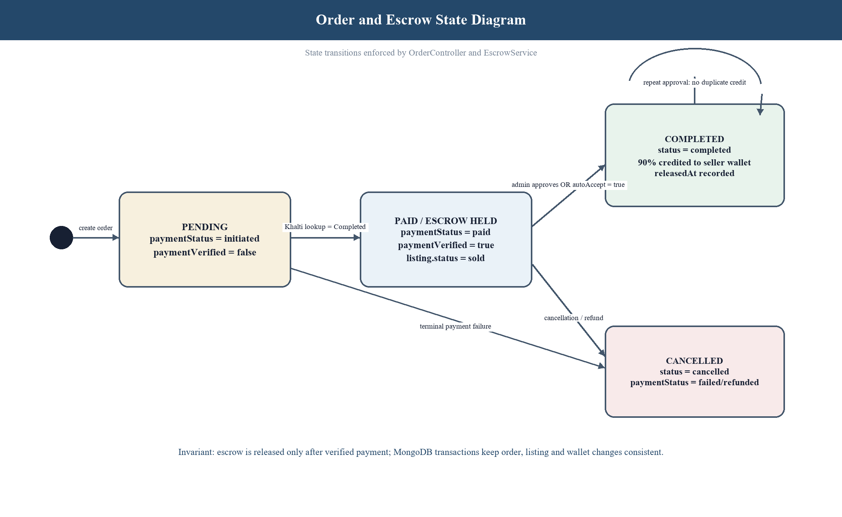
Figure 1: Order and Escrow State Diagram
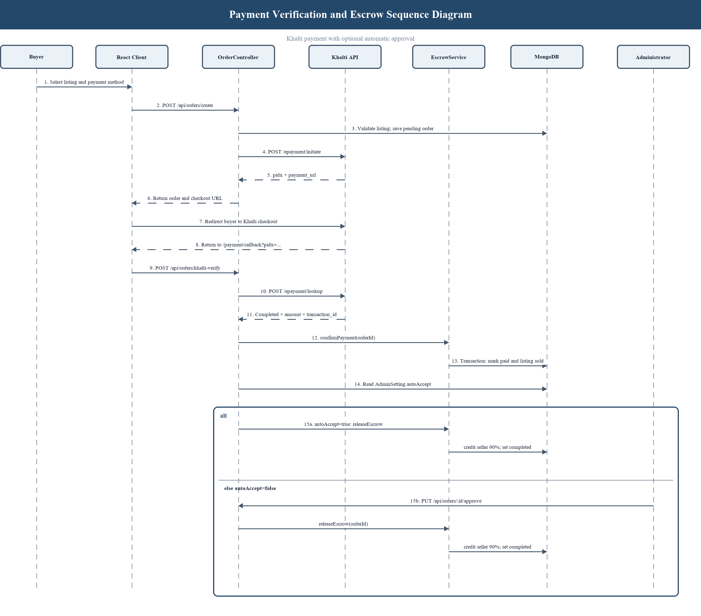
Figure 1: Payment Verification and Escrow Sequence Diagram

3.4 Process Modelling (Activity Diagrams)
Activity diagrams describe decisions, parallel actions, and completion conditions within a business process. The buyer purchase activity includes listing selection, authentication, order creation, payment redirection, provider verification, escrow holding, approval, and completion. Failure branches return clear messages without releasing seller earnings.
Additional activity diagrams may represent seller listing management, conversation initiation, review eligibility, and administrative approval. Swimlanes should be used when responsibility moves among the buyer, seller, administrator, marketplace server, database, and payment provider.
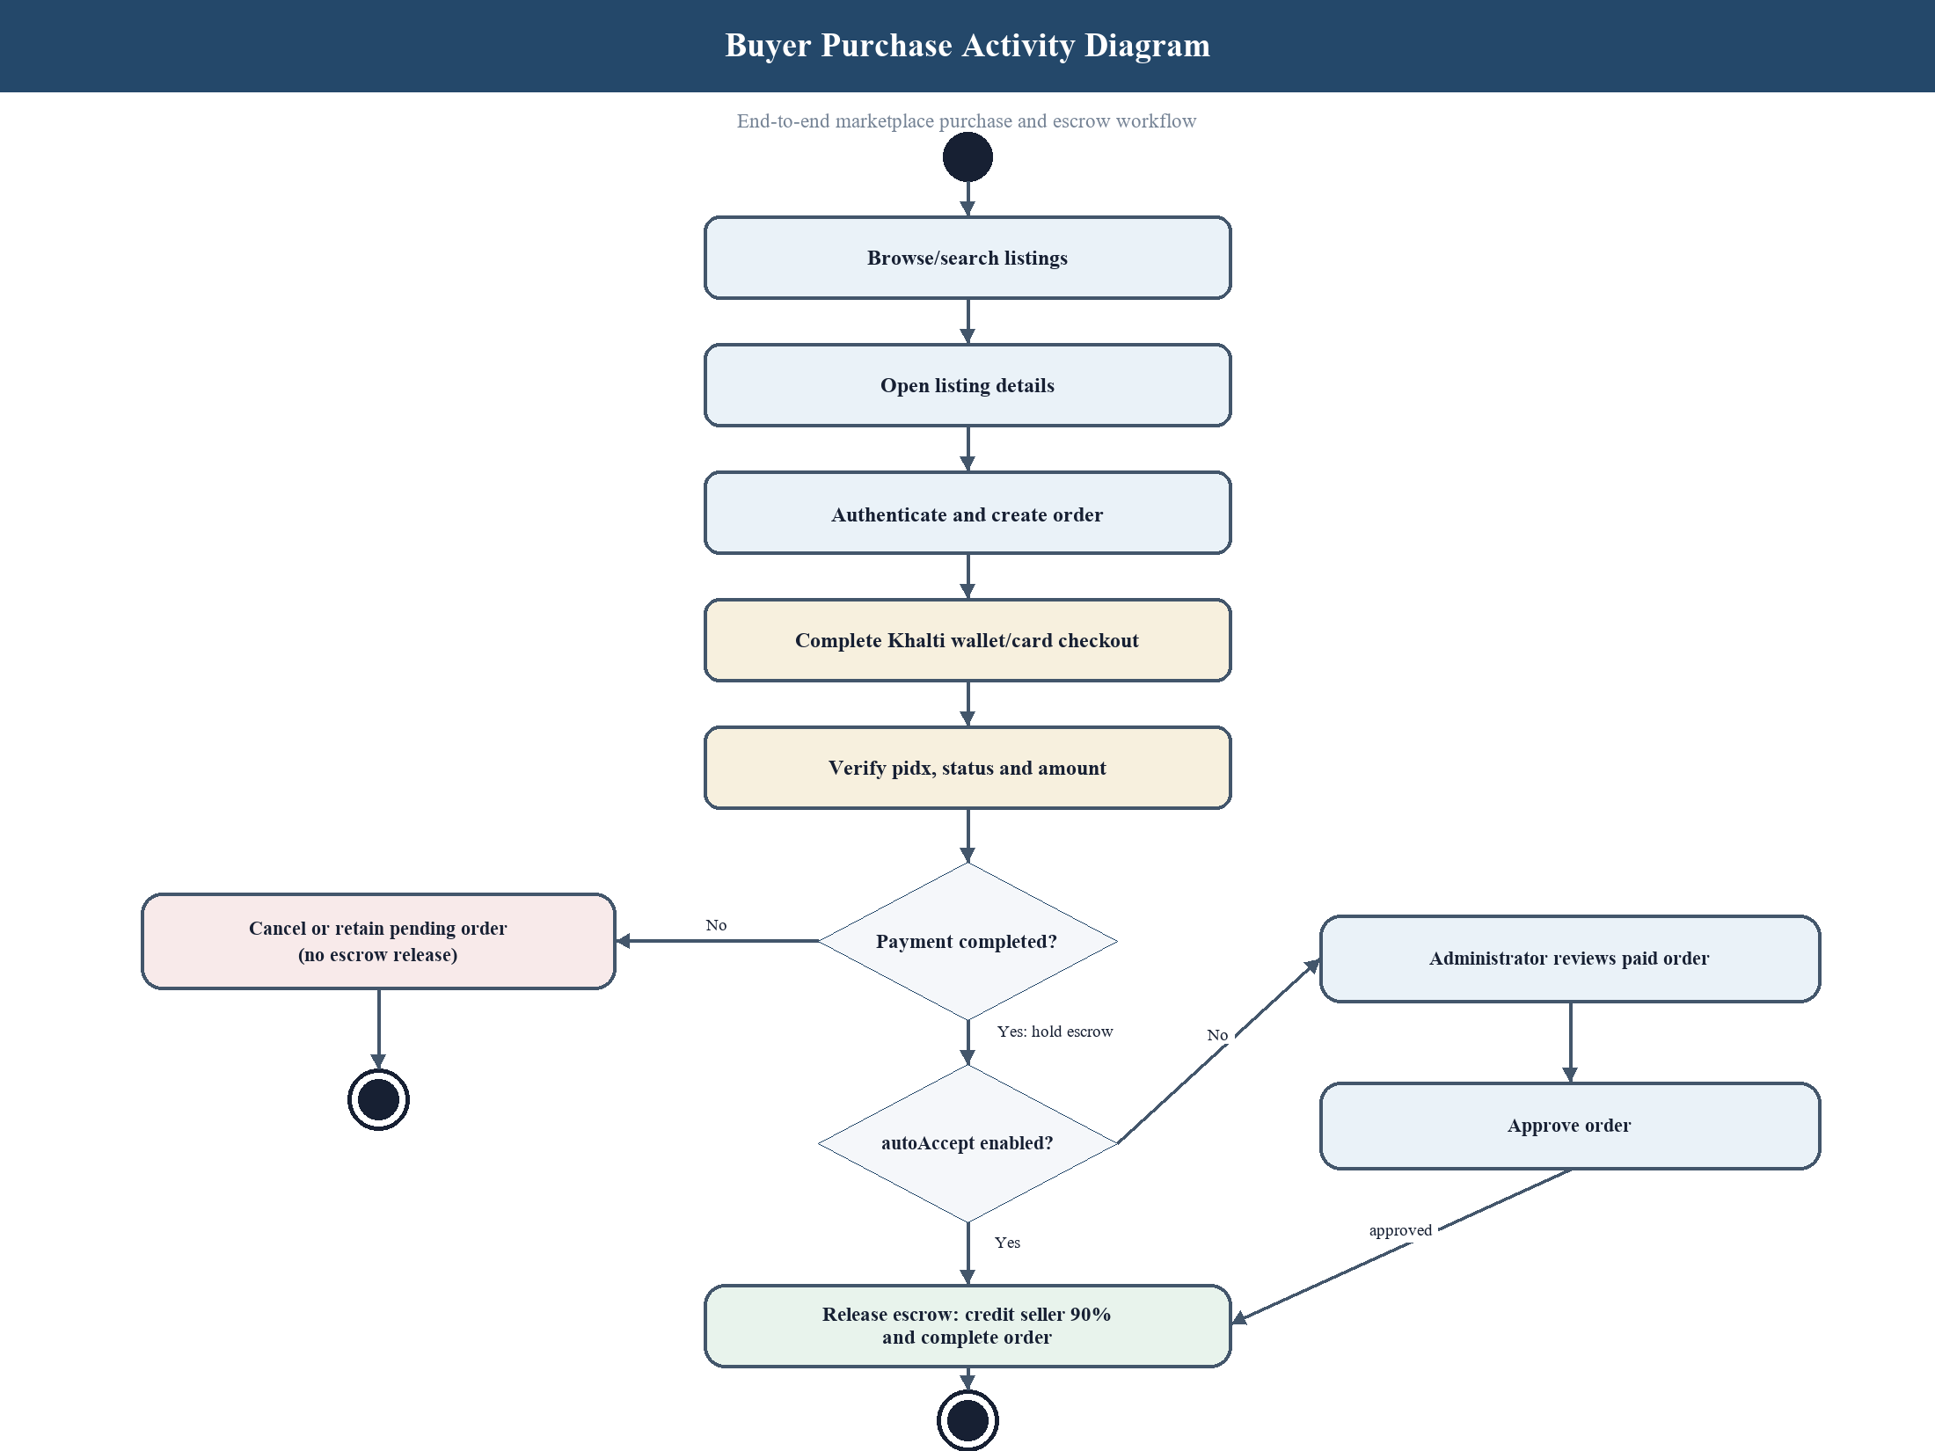
Figure 1: Buyer Purchase Activity Diagram

3.5 System Design
The system follows a layered client-server design. The React client presents pages and reusable components, the Express application exposes REST routes and Socket.IO events, controllers coordinate requests, services encapsulate integration and business rules, and Mongoose models persist data in MongoDB. This separation supports independent testing and reduces duplication.
Protected routes pass through JWT middleware before role or ownership checks are applied. Consistent response envelopes contain success, data, and message fields. Environment variables store connection strings and credentials, while the price-assistance service is isolated behind the Node API so the frontend does not depend directly on the internal Python service.

3.5.1 Iterative Waterfall Development Model
BazaarSathi applies an Iterative Waterfall model. The principal phases remain sequential—requirements, analysis, design, implementation, testing, deployment preparation, and maintenance planning—but each completed phase is reviewed and may return to the immediately preceding phase when defects, requirement gaps, or supervisor feedback are identified.
The model is suitable for the academic project because TU reporting requires defined analysis and design artifacts, while the marketplace modules also need controlled feedback during integration. Each iteration produces a reviewable deliverable: approved requirements, refined diagrams, implemented modules, recorded tests, or corrected documentation. Major scope changes are evaluated before they enter the next baseline.
In practice, authentication and listings form the first implementation baseline; chat and account activity form the second; payment, escrow, wallet, and administration form the third; and reviews, reputation, and price assistance form the fourth. Integration testing can therefore reveal issues early without abandoning the documentation discipline of the Waterfall phases.
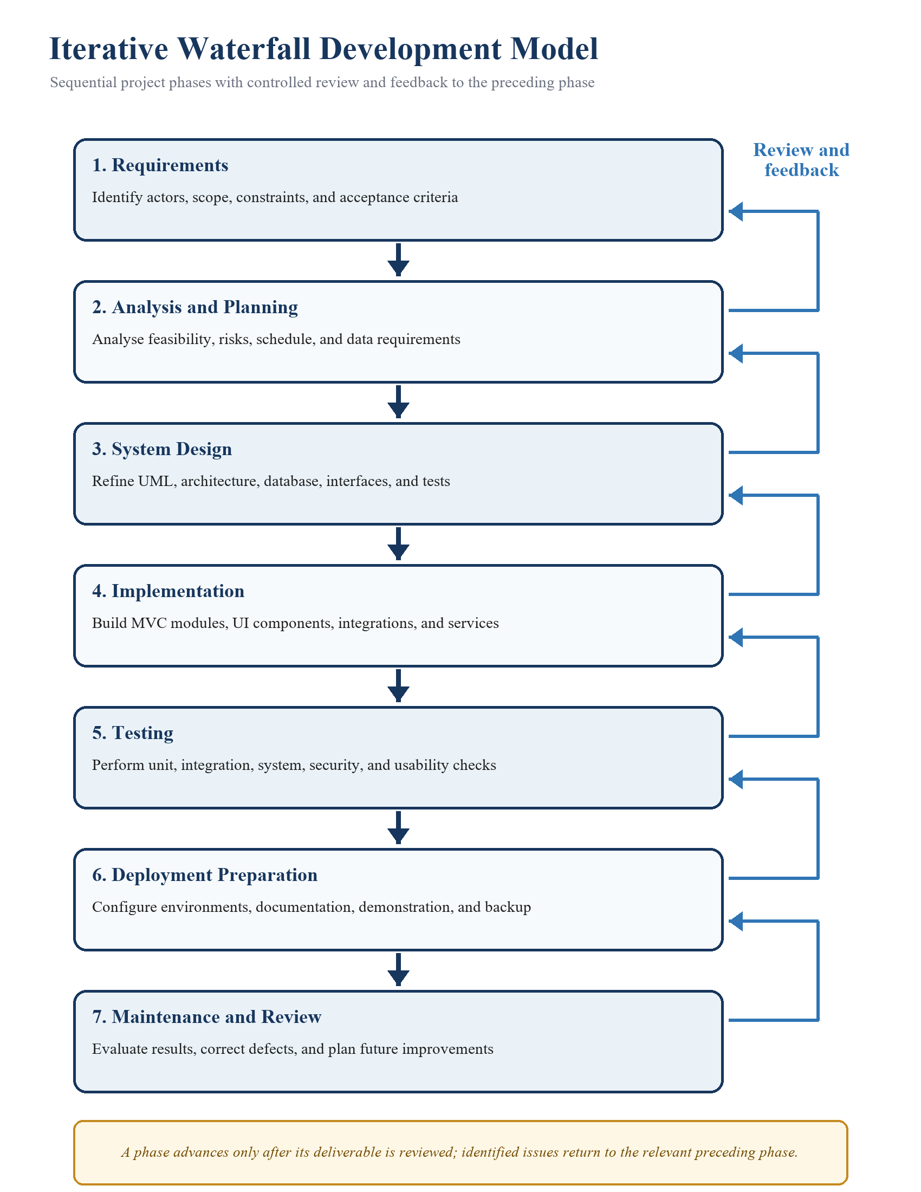
Figure 1: Iterative Waterfall Development Model

3.5.2 Refinement of Class, Object, State, Sequence and Activity Diagrams
Design refinement reconciles the analysis models with the implemented schemas, routes, middleware, services, and external integrations. Class attributes are aligned with Mongoose fields; object identifiers are checked against stored references; state transitions are limited to controller and service rules; and sequence messages correspond to actual REST endpoints or Socket.IO events.
The final diagrams should be reviewed after testing so that alternative paths, authorization failures, payment retries, automatic approval, duplicate prevention, and terminal order states match observed behaviour. Traceability from each refined diagram to functional requirements, implementation modules, and test cases reduces inconsistencies between the report and the submitted system.

3.5.3 Component Diagrams
The component view should show the React frontend, Express REST API, authentication middleware, marketplace controllers, Socket.IO gateway, MongoDB models, payment service, and price-prediction service. Interfaces between components should be labelled with HTTP, WebSocket, database, or provider protocols.
Component boundaries reflect deployable or testable responsibilities rather than individual source files. The diagram should make clear that browser requests reach the Node API, sensitive payment logic remains on the server, and the Python model is an internal supporting service.
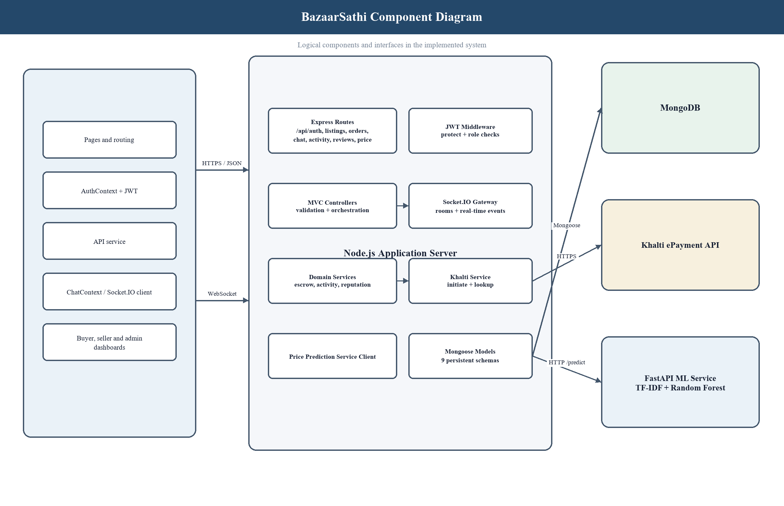
Figure 1: BazaarSathi Component Diagram

3.5.4 Deployment Diagrams
The deployment view maps software components to runtime nodes. A typical deployment contains a user browser, static frontend host, Node application server, Python prediction service, MongoDB database, image storage provider, and Khalti payment endpoint. Secure network connections and environment-specific configuration should be indicated.
For local development, the frontend, backend, and prediction service may execute on one workstation while connecting to a local or managed database. Production deployment should separate responsibilities, apply HTTPS, restrict database access, supervise processes, centralize logs, and use independent secrets for each environment.
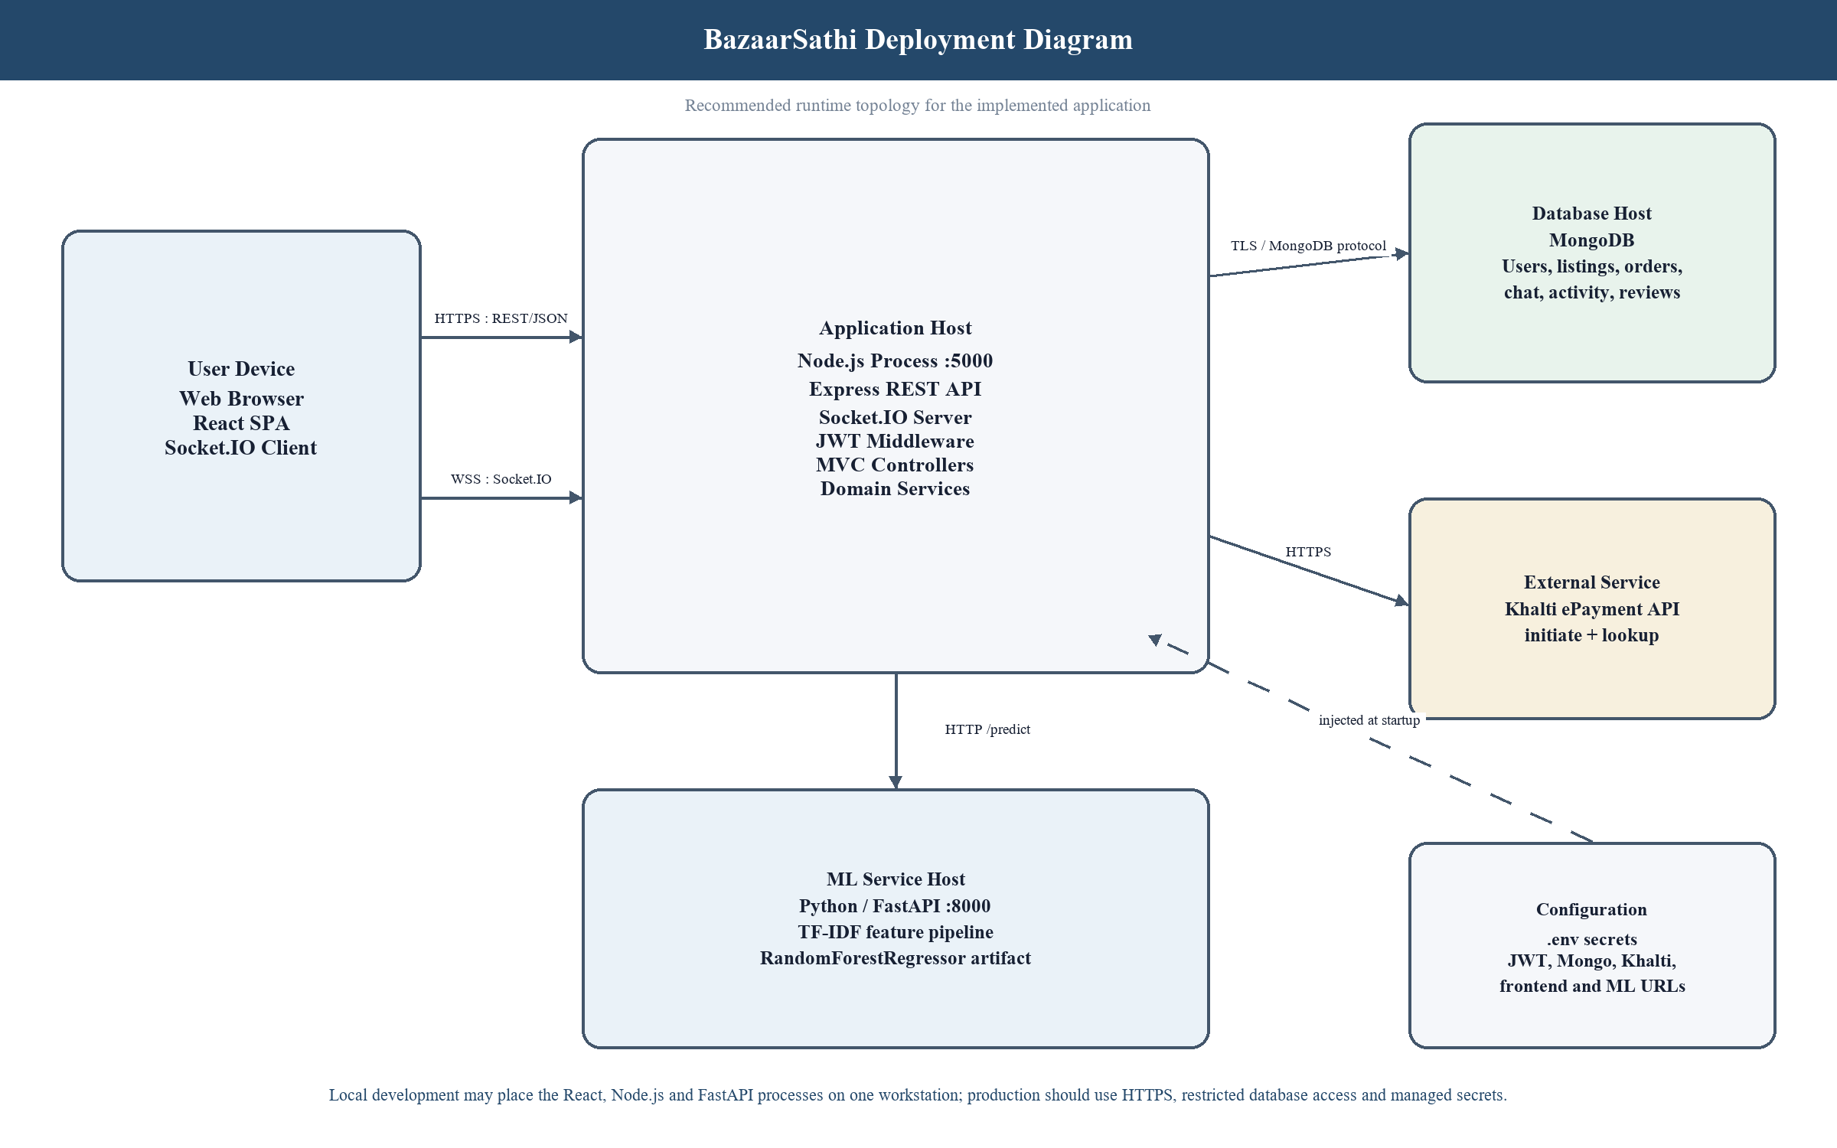
Figure 1: BazaarSathi Deployment Diagram

3.6 Algorithm Details (if any)
Seller reputation is calculated from verified review ratings and completed transaction behaviour. A weighted rating prior prevents a seller with one positive review from immediately outranking established sellers, while rating count and completion rate contribute to reputation tiers. Thresholds should be documented and evaluated for fairness before deployment.
The price-assistance experiment transforms listing title and description into text features, encodes category and condition, and applies a Random Forest regressor. Training and evaluation data must remain separate, metrics should include mean absolute error and coefficient of determination, and the interface should decline prediction when the input is outside the supported data distribution.

CHAPTER 4: IMPLEMENTATION AND TESTING
This chapter explains how the design was implemented and how the completed modules were evaluated. Replace sample results with evidence from the final repository, test output, screenshots, and deployment environment.

4.1 Implementation
Implementation followed the planned MVC organization for the server and component-based organization for the client. Mongoose schemas define persistent data, routes declare endpoints, middleware verifies access, controllers coordinate requests, and services encapsulate payment, escrow, activity, reputation, and prediction logic. The frontend consumes these APIs through a shared request helper.
Development was performed incrementally so each module could be checked before integration. Common conventions for asynchronous operations, error responses, configuration, ownership, and role checks were applied across modules. Git branches and automated checks supported controlled changes and regression detection.

4.1.1 Tools Used
The project uses a JavaScript-centred web stack with an additional Python service for the machine-learning experiment. Tool selection was based on project requirements, student familiarity, documentation availability, community support, and suitability for rapid prototyping.
The final report should record exact versions, hosting platforms, development environments, and external services actually used. Version pinning is particularly important for model persistence and reproducible builds because changes in libraries can alter behaviour or prevent stored artifacts from loading.
Table 1: Development Tools and Technologies
Tool / Technology | Purpose | Final Version
React.js | Client interface and reusable components | [VERSION]
Tailwind CSS | Responsive styling | [VERSION]
Node.js and Express | REST API and server runtime | [VERSION]
MongoDB and Mongoose | Database and object modelling | [VERSION]
Socket.IO | Real-time chat events | [VERSION]
Khalti API | Payment initiation and verification | [API VERSION]
Python and scikit-learn | Random Forest price experiment | [VERSION]
Git and GitHub | Version control and collaboration | [VERSION]

4.1.2 Implementation Details of Modules
The authentication module registers buyers or sellers, hashes passwords before storage, validates login credentials, and issues signed JWTs. Listing endpoints support public discovery and protected ownership operations. Optional authentication on the detail route allows the system to record recently viewed activity for signed-in users without preventing anonymous browsing.
The order module derives the transaction amount from the listing rather than trusting browser input, calculates commission and seller earning, verifies payment identifiers, and releases escrow through controlled state transitions. Chat persists conversations and messages while Socket.IO distributes room, message, and typing events. Review and reputation modules accept feedback only from the completed order’s buyer.
- Authentication and user account module.
- Listing search, filter, detail, ownership, favourites, and recently viewed modules.
- Order, payment verification, escrow approval, commission, and wallet module.
- Real-time conversation and message-history module.
- Verified review and seller reputation module.
- Administrative dashboard and automatic-approval setting module.
- Random Forest price-assistance service and posting-page integration.
Table 1: Module Implementation Summary
Module | Principal Classes / Functions | Implementation Responsibility
Authentication | User model; register; login; protect; authorize | Hashes passwords with bcrypt, issues and verifies JWTs, loads the current user, and enforces roles.
Listings | Listing model; getListings; getListing; createListing; updateListing; deleteListing | Implements searchable public reads, view increments, validation, seller-only creation, and ownership checks.
Orders and escrow | Order and AdminSetting models; createOrder; verifyKhalti; approveOrder; releaseEscrow | Derives price server-side, calculates 10% commission and 90% earning, records payment, and applies repeat-safe release rules.
Chat | Conversation and Message models; join_room; send_message; typing handlers | Validates participants, stores message history, broadcasts room events, and maintains read state.
Account activity | Favourite and RecentlyViewed models; toggle/list/history handlers | Persists saved items and bounded recent history for authenticated users.
Reviews and reputation | Review model; createReview; reputation aggregation | Restricts reviews to completed purchases, blocks duplicates, and summarizes verified seller ratings.
Price assistance | Feature pipeline; RandomForestRegressor; prediction endpoint | Normalizes text and categories, loads the trained model, returns estimates, and exposes model limitations.
Administration | Dashboard queries; order approval; settings update | Provides role-protected oversight and controls the autoAccept payment setting.

4.2 Testing
Testing was planned from requirements and risk. Unit tests isolate models, middleware, controllers, and services to verify validation, authorization, state changes, calculations, and response structures. System tests exercise complete user workflows through the client and API, including both successful and unsuccessful paths.
Regression checks should be executed after changes to shared models, middleware, payment state, or frontend navigation. Final evidence should include test environment, input data, expected output, actual output, pass or fail status, and references to screenshots or logs where useful.

4.2.1 Test Cases for Unit Testing
Unit tests verify one logical unit with dependencies replaced by controlled test doubles where necessary. Representative cases cover password hashing, token protection, listing ownership, price-filter validation, commission calculation, repeat-safe escrow release, review eligibility, favourite persistence, and normalized prediction requests.
Each test should have a stable identifier and explicit expected result. The final report should replace the following examples with tests that correspond exactly to the submitted source code and should attach the complete automated test output in an appendix if required by the college.
Table 1: Representative Unit Test Cases
ID | Unit and Input | Expected Result | Status
UT-01 | Register with valid name, email, and password | Password is hashed; JWT and public user are returned | [PASS/FAIL]
UT-02 | Access protected route without bearer token | Request is rejected with authentication message | [PASS/FAIL]
UT-03 | Create order with browser-supplied altered amount | Stored amount is derived from listing price | [PASS/FAIL]
UT-04 | Approve the same completed escrow twice | Seller wallet is credited only once | [PASS/FAIL]
UT-05 | Review an uncompleted order | Review is rejected and reputation remains unchanged | [PASS/FAIL]
UT-06 | Predict with missing listing condition | Validation response is returned | [PASS/FAIL]

4.2.2 Test Cases for System Testing
System testing validates integrated behaviour from the user’s perspective. The test environment should run the frontend, backend, database, and required internal services with controlled credentials. Payment tests should use provider-approved sandbox data and should never expose a secret key in screenshots or the report.
The cases below illustrate end-to-end workflows. Actual results should record the observed page, API state, database state, and any external redirect. Defects should be linked to corrective action and retested before final submission.
Table 1: Representative System Test Cases
ID | Scenario | Expected Result | Status
ST-01 | Seller signs in and posts a valid listing | Active listing appears in marketplace and seller account | [PASS/FAIL]
ST-02 | Buyer searches, saves, and views a listing | Search result, favourite, and recent history persist | [PASS/FAIL]
ST-03 | Buyer and seller exchange messages | Messages appear in real time and remain in history | [PASS/FAIL]
ST-04 | Buyer completes sandbox payment | Payment is verified and order awaits or receives approval | [PASS/FAIL]
ST-05 | Administrator approves verified order | Order completes and 90% seller earning is credited | [PASS/FAIL]
ST-06 | Completed buyer submits review | Review appears and seller reputation is recalculated | [PASS/FAIL]

4.3 Result Analysis
The implemented prototype should be assessed against the objectives defined in Chapter 1. Successful authentication, listing ownership, marketplace discovery, messaging, order state management, escrow release, account activity, and verified review workflows demonstrate coverage of the principal functional requirements. The analysis should identify any objective that was only partially achieved.
Automated test results provide evidence that individual rules behave as intended, while system tests indicate whether integrated user journeys are understandable and stable. Performance observations should report the test dataset and environment rather than making unsupported scalability claims. Security results should distinguish implemented controls from future hardening activities.
The price-assistance model must be analysed separately from normal application tests. High evaluation scores on synthetic data do not establish real-market accuracy. A valid final analysis should use representative completed-sale data, compare baseline and candidate models, report error by category, identify unsupported inputs, and explain how prediction uncertainty is communicated to users.

CHAPTER 5: CONCLUSION AND FUTURE RECOMMENDATIONS
This chapter summarizes the contribution and identifies responsible next steps. Conclusions should reflect demonstrated evidence and should not claim production readiness where external validation remains incomplete.

5.1 Conclusion
The project demonstrates the analysis, design, implementation, and testing of an integrated peer-to-peer marketplace using contemporary web technologies. The prototype combines authenticated accounts, listing management, discovery, real-time communication, payment-oriented order processing, escrow release, activity history, verified reviews, and administration within a modular architecture.
The work illustrates how MVC separation, Mongoose schemas, JWT middleware, reusable services, Socket.IO events, and component-based interfaces can cooperate in one application. It also demonstrates the importance of deriving financial values on the server, protecting state-changing routes, associating reviews with completed orders, and recording test evidence for critical rules.
The machine-learning experiment provides a foundation for future price assistance but also demonstrates an important limitation: a model can reproduce synthetic training patterns without providing credible real-market estimates. The project therefore treats representative data, uncertainty, monitoring, and refusal of unsupported predictions as necessary conditions for responsible enhancement.

5.2 Future Recommendations
Future development should prioritize production security, reliable operational processes, and evidence-based evaluation before adding cosmetic features. Payment settlement, refund, dispute, identity verification, moderation, auditing, backup, monitoring, and incident response require both technical controls and institutional policies.
The marketplace can later be extended with logistics integration, structured seller verification, notification services, content moderation, multilingual support, accessibility evaluation, analytics, recommendation systems, and mobile clients. Machine-learning work should begin with a governed completed-sale dataset and should include model comparison, confidence assessment, drift monitoring, bias review, and user-facing explanations.
- Integrate production-grade payment settlement, refund, dispute, and reconciliation procedures.
- Add verified identity, moderation queues, abuse reporting, audit logs, and administrator role separation.
- Introduce image upload validation, malware scanning, content review, and storage lifecycle controls.
- Perform load, security, accessibility, recovery, and cross-browser testing in staging.
- Collect consented completed-sale data and retrain price models with brand, model, storage, age, and warranty fields.
- Monitor API health, sockets, payments, database performance, and model drift.

REFERENCES
[1] I. Sommerville, Software Engineering, 10th ed. Boston, MA, USA: Pearson, 2015.
[2] R. S. Pressman and B. R. Maxim, Software Engineering: A Practitioner’s Approach, 9th ed. New York, NY, USA: McGraw-Hill, 2020.
[3] M. Jones, J. Bradley, and N. Sakimura, ‘JSON Web Token (JWT),’ RFC 7519, Internet Engineering Task Force, May 2015.
[4] OWASP Foundation, ‘OWASP Application Security Verification Standard 4.0.3,’ Oct. 2021. [Online]. Available: https://owasp.org/www-project-application-security-verification-standard/
[5] MongoDB, Inc., ‘MongoDB Manual,’ [Online]. Available: https://www.mongodb.com/docs/manual/. [Accessed: [ACCESS DATE]].
[6] OpenJS Foundation, ‘Node.js Documentation,’ [Online]. Available: https://nodejs.org/docs/latest/api/. [Accessed: [ACCESS DATE]].
[7] React Team, ‘React Documentation,’ [Online]. Available: https://react.dev/. [Accessed: [ACCESS DATE]].
[8] Socket.IO, ‘Socket.IO Documentation,’ [Online]. Available: https://socket.io/docs/v4/. [Accessed: [ACCESS DATE]].
[9] F. Pedregosa et al., ‘Scikit-learn: Machine learning in Python,’ Journal of Machine Learning Research, vol. 12, pp. 2825-2830, 2011.
[10] [PAYMENT PROVIDER / LOCAL MARKETPLACE SOURCE], ‘[DOCUMENT OR PAGE TITLE],’ [Online]. Available: [URL]. [Accessed: [ACCESS DATE]].

BIBLIOGRAPHY
This optional section may contain books, reports, standards, manuals, websites, and other materials consulted during the project but not cited directly in the report. Remove this section if it is not required by [COLLEGE NAME], or replace this note with entries formatted consistently with the approved citation style.
Do not duplicate references in both sections. Confirm the final college guideline, verify every author, title, edition, year, URL, and access date, and ensure that all in-text citations correspond to an entry in the References section.

APPENDICES
The appendices contain supporting evidence that is useful for evaluation but would interrupt the main discussion. Replace all placeholders with readable, labelled artifacts and refer to each appendix from the appropriate chapter.

APPENDIX A: SCREENSHOTS
Insert selected screenshots that demonstrate the final implemented workflows. Each screenshot should have a clear caption, readable content, anonymized personal data, and a short explanation of the action or result shown.
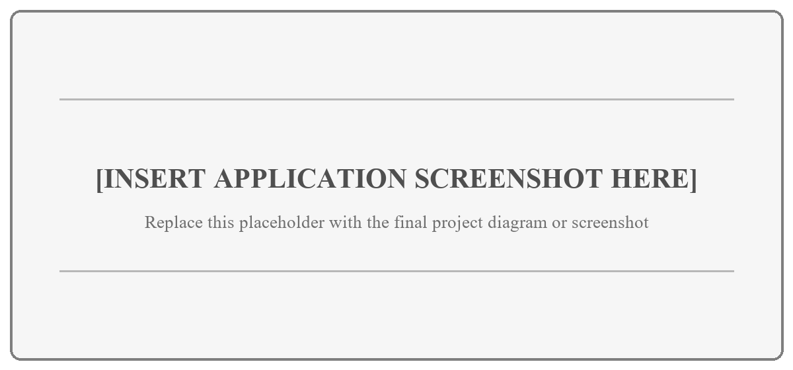
Figure 1: Application Screenshot Placeholder
Suggested evidence includes login, marketplace search, listing details, posting an item, favourites, recently viewed history, chat, checkout, payment verification, reviews, seller reputation, and the administrative dashboard. Include only screens that support a requirement or test result.

APPENDIX B: SOURCE CODE (SAMPLE)
The following extract illustrates the expected formatting for a short, relevant code sample. Replace it with a concise excerpt from the final project and identify the file, module, and purpose. The complete source code should be submitted electronically through the method prescribed by the college.
const protect = async (req, res, next) => {
try {
const authorization = req.headers.authorization;
if (!authorization?.startsWith('Bearer ')) {
return res.status(401).json({ success: false, data: null,
message: 'Authentication token is required' });
}
const token = authorization.slice(7).trim();
const decoded = jwt.verify(token, process.env.JWT_SECRET);
req.user = await User.findById(decoded.id);
return next();
} catch (error) {
return res.status(401).json({ success: false, data: null,
message: 'Authentication token is invalid' });
}
};
Sample B.1 demonstrates a middleware pattern that protects API routes with a bearer token. The final appendix should include only code that supports the discussion in Chapter 4 and should omit passwords, secret keys, connection strings, personal data, and generated dependency files.

APPENDIX C: MEETING LOGS /
SUPERVISOR VISIT LOG
Record each formal supervision meeting or project visit. Summaries should identify decisions, corrections, assigned actions, and evidence reviewed. Obtain signatures according to the practice of [COLLEGE NAME].
Table 1: Supervisor Visit and Meeting Log
S.N. | Date | Discussion and Feedback | Action Due | Supervisor Signature
1 | [DATE] | [DISCUSSION / FEEDBACK / DECISION] | [NEXT ACTION] | [SIGNATURE]
2 | [DATE] | [DISCUSSION / FEEDBACK / DECISION] | [NEXT ACTION] | [SIGNATURE]
3 | [DATE] | [DISCUSSION / FEEDBACK / DECISION] | [NEXT ACTION] | [SIGNATURE]
4 | [DATE] | [DISCUSSION / FEEDBACK / DECISION] | [NEXT ACTION] | [SIGNATURE]
5 | [DATE] | [DISCUSSION / FEEDBACK / DECISION] | [NEXT ACTION] | [SIGNATURE]
6 | [DATE] | [DISCUSSION / FEEDBACK / DECISION] | [NEXT ACTION] | [SIGNATURE]
7 | [DATE] | [DISCUSSION / FEEDBACK / DECISION] | [NEXT ACTION] | [SIGNATURE]
8 | [DATE] | [DISCUSSION / FEEDBACK / DECISION] | [NEXT ACTION] | [SIGNATURE]

Supervisor’s final remarks: [PLACEHOLDER]

APPENDIX D: EVALUATION PREPARATION CHECKLIST
This checklist records the evaluation information supplied for TU BCA Project III. It is included for student preparation and may be removed from the bound report if the college requires appendices to contain only project evidence.
Evaluation Committee
The project is evaluated by the Project Supervisor, HOD/Coordinator, Internal Examiner (Regular Faculty), and External Examiner. Signature and approval spaces for these academic roles are provided in the preliminary pages of this report.
Focus of the Evaluation
Preparation should demonstrate presentation skills, a stable project demonstration, a complete project report, accurate viva or question-and-answer responses, an appropriate level of technical work and understanding, and clear evidence of teamwork and individual contribution.
- Presentation skills: explain the problem, design choices, results, and limitations within the allotted time.
- Project demonstration: prepare representative buyer, seller, and administrator workflows with safe test data.
- Project report: verify that text, diagrams, tables, references, appendices, and source code match the final implementation.
- Viva / question answer: be ready to justify the architecture, security, escrow rules, testing, and Random Forest limitations.
- Level of work and understanding: distinguish implemented behaviour from planned or external production requirements.
- Teamwork and contribution: maintain a contribution record, version-control history, and signed supervisor visit log.

