

TRIBHUVAN UNIVERSITY
FACULTY OF HUMANITITES AND SOCIAL SCIENCE

BaazarSaathi

A PROJECT REPORT

Submitted to:
Department of Computer Science and Application
Mechi Multiple Campus
Bhadrapur, Jhapa

In the partial fulfillment of the requirements for Bachelors in Computer
Application

Submitted By:
Bikal Singh Thakuri (6-2-2-16-2021)
Darpan Giri (6-2-2-22-2021

Under the Supervision of
Bishal Ghimire

TRIBHUVAN UNIVERSITY
FACULTY OF HUMANITIES AND SOCIAL SCIENCE

Mechi Multiple Campus
Bhadrapur, Jhapa

Bachelor in Computer Application (BCA)

SUPERVISOR’S RECOMMENDATION

I hereby recommend that this project prepared under my supervision by Bikal Singh Thakuri and Darpan Giri “BaazarSaathi” in partial fulfilment of the requirements for the degree of Bachelor of Computer Application is recommended for the final evaluation.

…………………………..
Project Supervisor
BCA Department
Mechi Multiple Campus


TRIBHUVAN UNIVERSITY
FACULTY OF HUMANITIES AND SOCIAL SCIENCE
Mechi Multiple Campus
Bhadrapur, Jhapa
Bachelor in Computer Application (BCA)

LETTER OR APPROVAL

This is to certify that the project report entitled “BaazarSaathi” was prepared and submitted by by Darpan Giri and Bikal Singh Thakuri, in partial fulfillment of the requirements for the degree of Bachelor of Computer Application under the Faculty of Humanities and Social Sciences, Tribhuvan University.

Bishal Ghimire Raju Poudel
Supervisor Director
BCA Department Mechi Multiple Campus
Mechi Multiple Campus Bhadrapur, Jhapa

……………………… ………………………...
External Examiner Internal Examiner

ABSTRACT
In this project, we aim to develop BazaarSathi, a web-based peer-to-peer marketplace that enables users to buy and sell products conveniently over the internet. The system improves traditional and social-media-based trading by providing a secure, organized, and user-friendly platform where buyers and sellers can interact within a single application.
Previously, online buying and selling often involved using separate platforms for product discovery, communication, and payment. This process can create problems such as unreliable sellers, incomplete product information, payment fraud, and difficulty tracking transactions. BazaarSathi allows users to browse listings, search and filter products by category, price, and condition, view product details and images, save favourite items, and communicate with sellers through real-time chat.
The system allows users to act as buyers or sellers, manage their profiles, publish listings, view recently visited products, and track their orders. It includes Khalti and card payment options with an escrow mechanism that holds verified payments until approval. After approval, 90% of the amount is released to the seller’s wallet, while 10% is retained as commission. The system also provides verified reviews, seller reputation, administrative controls, and a Random Forest-based price estimation feature. By combining these facilities, BazaarSathi provides a more secure, transparent, and efficient online marketplace experience.

ACKNOWLEDGEMENT
We would like to express our sincere gratitude to our project supervisor, Mr. Bishal Ghimire, for providing us with the valuable opportunity to work on our project titled “BazaarSathi” His continuous guidance, constructive suggestions, and encouragement helped us conduct extensive research and learn various tools, technologies, and software development practices.
We would also like to extend our heartfelt thanks to our Campus Chief, Mr. Devi Prasad Acharya, for granting us permission to undertake this project and for providing the necessary institutional support.
Our sincere appreciation goes to our BCA Program Director, Mr. Raju Poudel, for his valuable guidance, assistance, and encouragement throughout the development and completion of this project.
We are highly indebted to Mechi Multiple Campus for providing the necessary resources, academic environment, supervision, and information required for the successful completion of this project. We would also like to thank the library staff, faculty members, and other members of the campus for their cooperation and encouragement.
Our deepest gratitude goes to our parents, friends, and classmates for their continuous motivation, patience, and support, which helped us complete this project within the available time.
Finally, we would like to thank Tribhuvan University for providing us with this opportunity through the Bachelor of Computer Application Programme. This project has strengthened our understanding of software engineering, project management, professional ethics, teamwork, and the practical application of technologies learned during our academic studies.

Table of Contents
SUPERVISOR’S RECOMMENDATION i
ABSTRACT iii
ACKNOWLEDGEMENT iv
TABLE OF CONTENTS v
LIST OF ABBREVIATIONS viii
LIST OF FIGURES ix
LIST OF TABLES x
CHAPTER 1 1
INTRODUCTION 1
1.1 Introduction 1
1.2 Problem Statement 1
1.3 Objectives 2
1.4 Scope and Limitation 2
1.4.1 Scope 2
1.4.2 Limitations 3
1.5 Report Organization 3
CHAPTER 2 5
BACKGROUND STUDY AND LITERATURE REVIEW 5
2.1 Background Study 5
2.2 Literature Review 5
CHAPTER 3 7
SYSTEM ANALYSIS AND DESIGN 7
3.1 System Analysis 7
3.1.1Requirement Analysis 10
3.1.2Feasibility Analysis 13
3.1.3 Data Modelling (Entity Relationship) 16
3.1.4 Process Modelling (DFD) 18
3.2 System Design 20
3.2.1 Architectural Design 20
3.2.2 High level design of the system 22
3.2.3 Database Schema Design 23
3.2.4 Interface Design 23
3.3 Algorithms Used 24
CHAPTER 4 26
IMPLEMENTATION AND TESTING 26
4.1 Implementation 26
4.2 Testing 27
4.2.1 Test Cases for Unit Testing 27
1.5.1 Test Cases for System Testing 28
CHAPTER 5 30
CONCLUSION AND FUTURE RECOMMENDATIONS 30
CHAPTER 5: CONCLUSION AND FUTURE RECOMMENDATIONS 30
5.1 Lessons Learnt / Outcomes 30
5.2 Conclusion 30
5.3 Future Recommendations 31
REFERENCES 32
APPENDICES 33

LIST OF ABBREVIATIONS
Abbreviation | Meaning
API | Application Programming Interface
BCA | Bachelor of Computer Application
CRUD | Create, Read, Update, and Delete
DBMS | Database Management System
HTTP | Hypertext Transfer Protocol
IEEE | Institute of Electrical and Electronics Engineers
JWT | JSON Web Token
ML | Machine Learning
MVC | Model-View-Controller
P2P | Peer-to-Peer
REST | Representational State Transfer
TU | Tribhuvan University
UI | User Interface
URL | Uniform Resource Locator

LIST OF FIGURES
Figure 1: Incremental Waterfall Model for Vehicle Rental System 7
Figure 2: Use Case Diagram of Vehicle Rental System 12
Figure 3: Gantt Chart for BaazarSaathi 14
Figure 4: ER-Diagram of BaazarSaathi 16
Figure 5: Context Diagram of BaazarSaathi 18
Figure 6: Level 1 DFD of BaazarSaathi 19
Figure 7: Architectural Diagram of BaazarSaathi 20
Figure 8: System Flowchart of BaazarSaathi 22

LIST OF TABLES
Table 1: Development Tools and Technologies 27
Table 2: Representative Unit Test Cases 28
Table 3: Representative System Test Cases 28

CHAPTER 1

INTRODUCTION
This chapter establishes the context, motivation, goals, boundaries, and development approach of the proposed software project. It introduces the marketplace problem domain and explains how the remaining chapters document the transition from an identified problem to a tested information system.

Introduction
Digital marketplaces have changed how individuals discover, compare, and exchange goods. In Nepal, social media pages and informal classified channels are commonly used for person-to-person transactions; however, these channels often separate product discovery, communication, payment, and accountability. A dedicated marketplace can combine these activities within a traceable workflow and offer users a more consistent experience.
The proposed project presents a web-based peer-to-peer marketplace in which registered users can publish listings, search and filter available products, communicate in real time, initiate payments, and maintain account activity. The design emphasizes modular development, role-aware access, persistent records, and a structured escrow process so that later enhancements can be incorporated without redesigning the entire system.

Problem Statement
Informal online trading exposes buyers and sellers to incomplete product information, fraudulent profiles, unrecorded agreements, and payment uncertainty. Buyers may transfer money without assurance that the seller will complete the transaction, while sellers may reserve or deliver products without reliable confirmation of payment. Communication conducted across external applications also makes disputes difficult to reconstruct.
Existing general-purpose platforms may not address local payment methods, student-level deployment constraints, or the need for an academically explainable architecture. Therefore, the project addresses the need for an integrated marketplace prototype that links user identity, listing ownership, conversation history, verified payment status, seller earnings, and post-transaction reputation in one maintainable system.

Objectives
The general objective of the project is to analyses, design, implement, and evaluate a secure web-based marketplace that supports peer-to-peer buying and selling through a unified workflow. The application should demonstrate the practical use of database-driven web engineering, authentication, real-time communication, payment verification, and software testing.
The specific objectives translate the general purpose into observable system capabilities. Each objective is associated with one or more modules and can be assessed through test cases, interface demonstrations, and database evidence during final evaluation.
- To provide secure user authentication and role-based access using hashed passwords and JSON Web Tokens.
- To enable sellers to manage product listings and buyers to search, save, communicate about, and purchase products.
- To implement verified payments, escrow-based seller payouts, and administrative transaction monitoring.
- To support verified reviews, seller reputation, price prediction, and system testing.

Scope and Limitation

1.4.1 Scope
Within the allocated project period, we aim to develop a functional prototype of BazaarSathi. The project covers the following areas:
- User registration, login, profile management, and role-based access.
- Product listing creation, updating, deletion, searching, filtering, and sorting.
- Persistent favorites, recently viewed listings, and real-time buyer–seller chat.
- Order creation, Khalti and card payment processing, and escrow management.
- Administrative management of users, listings, orders, payments, and escrow approval.
- Verified reviews, seller reputation, wallet accounting, and Random Forest-based price estimation.

1.4.2 Limitations
BazaarSathi has certain limitations that could not be fully addressed within the available project development period:
- The system is a web application and does not provide dedicated Android or iOS applications.
- The payment and escrow functions depend on valid payment-provider credentials and external services.
- The escrow process is an application-level simulation and does not provide regulated banking escrow services.
- Price estimates may be inaccurate because the prediction model lacks sufficient real-world completed-sales data.
- Advanced features such as delivery tracking, refund arbitration, multilingual support, automated image moderation, and large-scale performance testing are not included.

Report Organization
The materials presented in this project report are organized into five chapters:
1.5.1 Introduction
This chapter introduces BazaarSathi and explains the problems associated with informal online marketplaces. It presents the project objectives, scope, limitations, development methodology, and reasons for developing a secure peer-to-peer marketplace with integrated listings, communication, payments, escrow, reviews, and price estimation.
1.5.2 Background Study and Literature Review
This chapter explains the fundamental theories, concepts, and technologies related to online marketplaces. It reviews similar systems, research publications, and relevant concepts concerning authentication, real-time communication, digital payments, escrow management, seller reputation, and machine-learning-based price prediction.
1.5.3 System Analysis and Design
This chapter describes the functional and non-functional requirements and evaluates the project’s technical, operational, economic, and schedule feasibility. It presents the system’s Use Case, Class, Object, State, Sequence, Activity, Component, and Deployment diagrams. It also explains the Iterative Waterfall model, system architecture, database structure, interfaces, and major algorithms.
1.5.4 Implementation and Testing
This chapter describes the tools, programming languages, frameworks, database platforms, and external services used to develop BazaarSathi. It explains the implementation of the main modules, classes, functions, procedures, and algorithms. It also presents unit and system test cases together with the resulting analysis.
1.5.5 Conclusion and Future Recommendations
This chapter summarizes the project’s outcomes and determines whether its objectives were achieved. It also discusses the system’s limitations and recommends future improvements, including mobile applications, enhanced security, delivery integration, dispute management, additional payment methods, and improved price-prediction accuracy.

CHAPTER 2

BACKGROUND STUDY AND LITERATURE REVIEW
This chapter places the project within the broader study of online marketplaces and reviews technical and academic concepts that influenced the selected architecture. The discussion should be revised with sources directly related to the final project topic and institutional expectations.

2.1 Background Study
A peer-to-peer marketplace is an information system that coordinates product publication, discovery, negotiation, and exchange among independent users. Unlike a conventional online store operated by one merchant, a marketplace must represent multiple sellers, establish ownership of listings, and provide mechanisms that help users assess transaction risk. Search, messaging, order state, and reputation therefore form a connected domain rather than isolated interface features.
The technical background of the proposed system includes client-server architecture, RESTful communication, document-oriented storage, token-based authentication, real-time event delivery, and third-party payment integration. React supports component-based user interfaces; Express organizes server routes and middleware; MongoDB stores flexible marketplace records; Socket.IO supports bidirectional chat events; and JWT provides signed authentication claims for protected routes.
Escrow introduces an intermediate transaction state between successful payment and seller settlement. In the proposed design, a verified payment marks funds as held, while an administrative approval or configured automatic rule releases the seller share and records the commission. This simplified model demonstrates state management and atomic database updates, although production escrow requires contractual, regulatory, settlement, refund, and dispute procedures beyond the scope of a classroom prototype.

2.2 Literature Review
Software engineering literature emphasizes systematic requirements, modular design, verification, and maintainability as foundations of dependable systems. Marketplace research similarly identifies trust signals, reputation, transparent rules, and secure payment handling as important influences on user participation. These principles informed the separation of controllers, models, routes, middleware, and services within the proposed application.
Security guidance recommends password hashing, protected communication, validation, least-privilege authorization, secure secret management, and resistance to common web application attacks. Accordingly, the prototype hashes passwords, issues time-limited JWTs, checks ownership and administrative roles, keeps secrets in environment configuration, and returns consistent API responses. A complete final report should compare these controls with the selected security standard and document remaining risks.
Machine-learning literature shows that ensemble decision-tree methods can model nonlinear relationships and mixed feature interactions. A Random Forest regressor was selected as an interpretable academic baseline for price assistance; however, model performance depends on representative labelled observations. Consequently, the project distinguishes a reproducible demonstration dataset from production evidence and recommends training on verified completed-sale prices, with brand, model, age, storage, and warranty attributes included as structured features.

CHAPTER 3

SYSTEM ANALYSIS AND DESIGN

3.1 System Analysis
BazaarSathi was developed using the Iterative Waterfall Model. The development process followed a sequence of requirement identification, analysis, system design, implementation, testing, deployment preparation, and maintenance. Unlike the traditional Waterfall Model, the iterative approach allowed the development team to return to a previous phase whenever testing, integration, or supervisor feedback identified a problem.

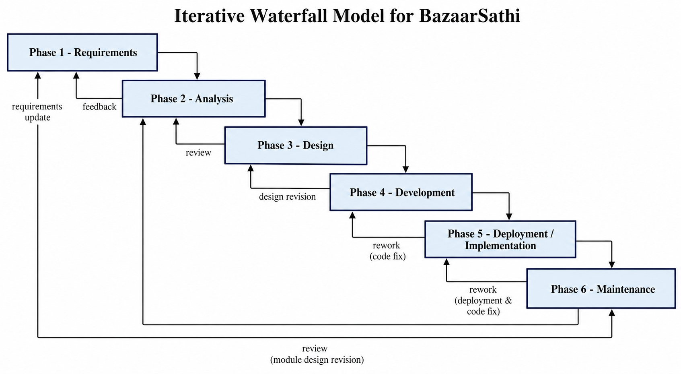
During requirement analysis, the functional and non-functional requirements of buyers, sellers, and administrators were identified. The system architecture, database schemas, interfaces, workflows, and security controls were then designed according to these requirements. After implementation, each module was tested individually and as part of the complete system. Identified defects were corrected before the system proceeded to the next phase.
Figure 1: Incremental Waterfall Model for Vehicle Rental System

The Waterfall Model is one of the earliest Software Development Life Cycle models and is also known as the Linear Sequential Life Cycle Model. It is simple to understand because each development phase produces a defined output before the next phase begins. The Iterative Waterfall Model was selected for BazaarSathi because it maintains this structured process while allowing controlled feedback and revision between phases.
Requirements
The system requirements were identified from the perspectives of buyers, sellers, and administrators. Buyers require product browsing, searching, filtering, favorites, real-time chat, secure payment, order tracking, and review facilities. Sellers required listing management, buyer communication, order information, reputation details, and wallet earnings. Administrators required facilities for managing users, listings, payments, escrow approvals, orders, and system settings.
Analysis
Existing social-media marketplaces and online classified systems were studied to identify their major limitations. The analysis identified problems such as unverified users, incomplete product information, fragmented communication, payment uncertainty, fraudulent transactions, and unreliable reviews.
The project’s technical, operational, economic, and schedule feasibility was also evaluated. The requirements were converted into clear specifications and represented through use cases, data relationships, workflows, system states, and testable acceptance conditions.
Design
The user interfaces and page layouts were designed for buyers, sellers, and administrators. The system’s database structure was designed using MongoDB and Mongoose models for users, listings, conversations, messages, orders, settings, favorites, recently viewed listings, and reviews.
Use Case, Class, Object, State, Sequence, Activity, Component, and Deployment diagrams were prepared to represent the structure and behavior of the system. The application was organized according to the MVC pattern, while JWT authentication, role authorization, ownership verification, API responses, and payment workflows were incorporated into the design.
Development
The frontend was developed using React.js and Tailwind CSS to provide a responsive and user-friendly interface. The backend was implemented using Node.js and Express.js, while MongoDB and Mongoose were used for database operations.
JWT and bcrypt were used for authentication and password protection. Socket.IO provided real-time chat, and Khalti was integrated for payment verification. Additional modules were developed for escrow management, seller wallets, favorites, recently viewed listings, verified reviews, seller reputation, and Random Forest-based price estimation.
Testing
Unit testing was performed on important functions and modules, including authentication, authorization, listing management, payment calculations, escrow approval, review eligibility, and price-prediction input validation. System testing was then conducted on complete workflows involving buyers, sellers, and administrators.
Whenever a test produced an unexpected result, the system returned to the appropriate analysis, design, or implementation phase. The issue was corrected and the affected functions were tested again before integration.
Deployment
The front end, backend, MongoDB database, Socket.IO connection, and machine-learning service were configured and tested together in the local development environment. Environment variables were used to manage database connections, JWT secrets, payment credentials, and other sensitive information.
The system was prepared for demonstration using controlled accounts and test data. Production deployment would require valid payment credentials, HTTPS, secure cloud hosting, database backups, monitoring, moderation procedures, and additional security testing.
Maintenance
Maintenance involves correcting defects, updating dependencies, improving security, and modifying the system according to user or supervisor feedback. Future maintenance may also include mobile applications, delivery tracking, refund and dispute management, improve administrative analytics, and retraining the price-prediction model with reliable completed-sale data.

3.1.1Requirement Analysis
Requirement analysis defines the observable behaviour and quality expectations of the proposed system. Requirements were organized by actor and workflow, reviewed against project scope, and prioritized according to academic importance, implementation dependency, and user value. Authentication and listing management were treated as foundational because transaction, chat, activity, and review modules depend on valid users and products.
Each functional requirement should be represented in a use case specification containing the initiating actor, preconditions, main flow, alternative flow, exception flow, and postconditions. Non-functional requirements should be expressed in measurable terms wherever possible so testing can determine whether the system meets the stated quality target.
I. Functional Requirements
Functional requirements describe services that the system must perform. The marketplace shall register and authenticate users, manage role and ownership checks, maintain listings, perform search and filtering, create conversations, exchange messages, create orders, verify payment, release escrow, record account activity, accept eligible reviews, calculate reputation, and expose administrative information.
Use Case diagrams should summarize the relationships between buyers, sellers, administrators, and external payment services. Detailed use cases should clarify which actions require authentication, which actions are restricted by ownership, and how unsuccessful payment, unavailable listings, duplicate reviews, or invalid input are handled.
- Account registration, login, token validation, and role-aware access.
- Listing creation, discovery, detail viewing, update, deletion, and status management.
- Order initiation, payment verification, escrow approval, commission calculation, and wallet credit.
- Conversation creation, room joining, message persistence, typing status, and read tracking.
- Favourite, recently viewed, verified review, seller reputation, and price-estimate workflows.
- Administrative dashboard, order approval, and automatic-approval configuration.
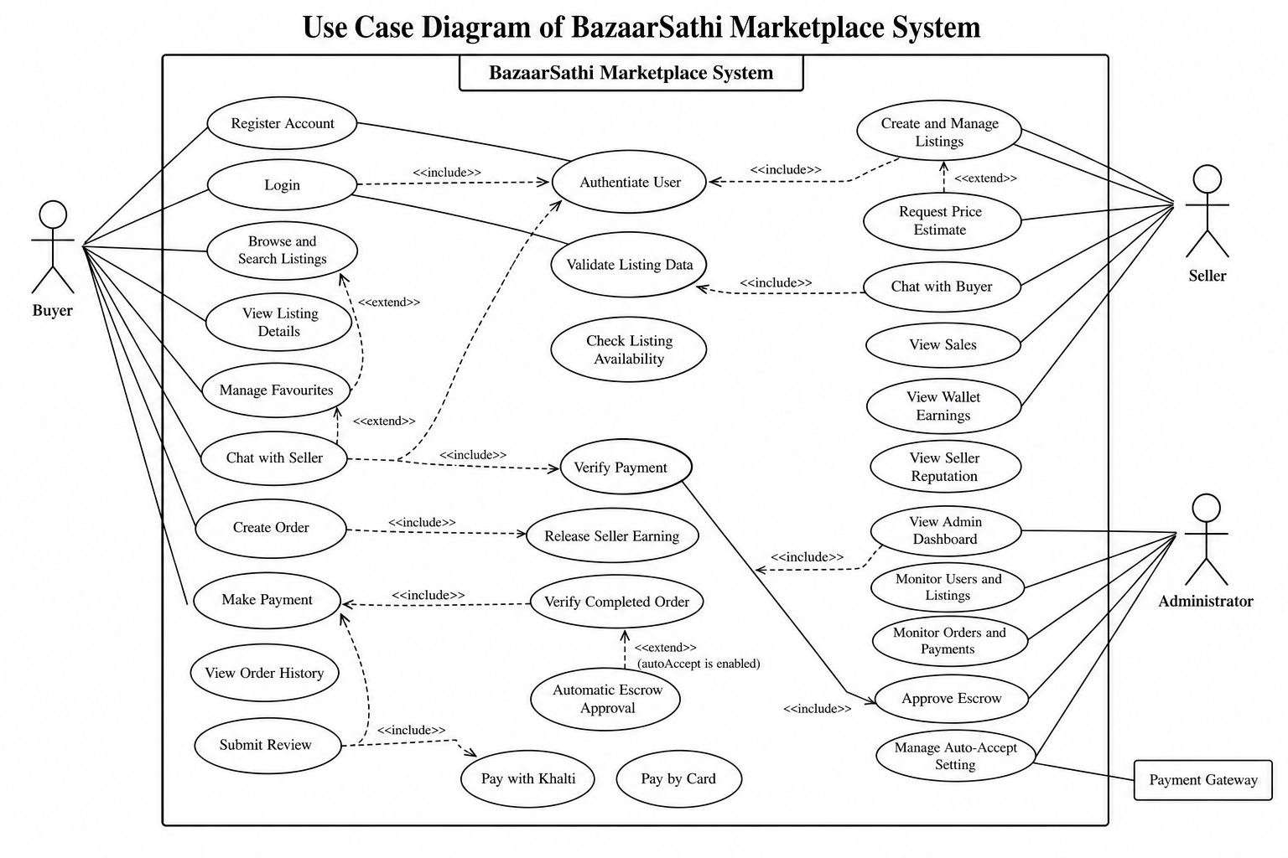
Figure 2: Use Case Diagram of Vehicle Rental System
Non-Functional Requirements
Non-functional requirements define how effectively the system should deliver its services. Security requires protected credentials, authenticated access, authorization checks, input validation, and secret separation. Reliability requires consistent state transitions and idempotent handling where repeated payment or approval requests could otherwise create duplicate financial effects.
Usability requires responsive interfaces, understandable messages, accessible controls, and predictable navigation. Maintainability requires modular MVC organization, reusable services, consistent response formats, and automated tests. Performance targets should be finalized with realistic user and listing volumes, while backup, monitoring, and recovery objectives should be specified before production deployment.
- Security: hashed passwords, signed JWTs, role and ownership checks, validation, and HTTPS in production.
- Performance: responsive common reads and bounded query results under the expected academic demonstration load.
- Reliability: atomic payment and escrow updates with repeat-safe operations.
- Usability: responsive layouts, clear feedback, keyboard-accessible controls, and consistent terminology.
- Maintainability: MVC separation, documented configuration, version control, and automated regression tests.

3.1.2Feasibility Analysis
Feasibility analysis evaluates whether the proposed system can be completed with the available technology, resources, skills, schedule, and operational environment. The assessment was performed before full implementation and revisited after integration of payment, chat, review, and machine-learning components.
The study indicates that an academic prototype is feasible because the selected technologies are widely documented and can be developed on commonly available computers. Production readiness nevertheless requires additional legal, security, infrastructure, payment-provider, and support arrangements that exceed the resources of the present semester project.
- Technical Feasibility
The required client, server, database, real-time, and machine-learning capabilities are supported by the selected technology stack. Node.js, Express, React, MongoDB, Socket.IO, and Python libraries are available on standard development platforms, while their modular ecosystems support testing and integration.
The main technical risks concern third-party payment behaviour, database transactions, deployment configuration, model quality, and secure operations. These risks are manageable for a prototype through sandbox credentials, environment variables, controlled test data, service health checks, explicit error handling, and documented setup procedures.
- Operational Feasibility
The proposed workflow reflects familiar marketplace activities such as browsing, saving, messaging, purchasing, and reviewing. Clear status indicators and account-based histories reduce the need for users to remember actions performed in separate applications.
Operational adoption will depend on moderation, support, dispute resolution, seller verification, and user education. An administrator dashboard supports basic oversight, but a deployed service would require written policies, escalation procedures, monitoring responsibility, and support availability.
- Economic Feasibility
The prototype can be developed with open-source frameworks and student-owned hardware, which keeps direct academic development costs low. Cloud database, image storage, hosting, messaging, and payment sandbox services may provide limited free usage suitable for demonstrations.
Production operation would introduce recurring hosting, storage, bandwidth, monitoring, domain, payment, customer-support, and compliance expenses. A sustainable model should compare these costs with commission income, transaction volume, user acquisition, and expected support burden before commercial deployment.
- Schedule Feasibility
The project can be divided into semester-aligned iterations covering analysis, authentication, listings, transactions, communication, administration, enhancements, testing, and reporting. Foundational modules should be completed early so later modules can reuse stable user and listing data.
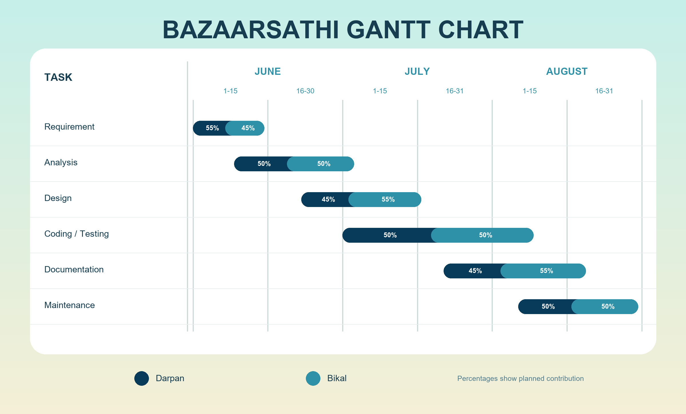
Schedule risk is controlled through a prioritized backlog, weekly supervisor review, version control, and a feature-complete deadline before final documentation. Optional enhancements should not delay verification of the core marketplace workflow, and unresolved external dependencies should be documented promptly.
Figure 3: Gantt Chart for BaazarSaathi
Figure 3 represents the planned timeline for the BazaarSathi project. The duration of each phase is estimated in days or weeks; however, some activities may overlap or require additional time depending on testing results and technical difficulties. The timeline includes project planning, requirement analysis, system design, frontend and backend development, database implementation, module integration, testing, documentation, and maintenance. Since the Iterative Waterfall Methodology is used, feedback obtained during development and testing may return the project to an earlier phase for necessary corrections.
Title | Start | End | Duration
Project Planning | 2026-06-01 | 2026-06-05 | 5 days
Requirement Analysis | 2026-06-06 | 2026-06-15 | 1 week 3 days
System Analysis and Design | 2026-06-16 | 2026-06-30 | 2 weeks 1 day
Frontend Development | 2026-07-01 | 2026-07-25 | 3 weeks 4 days
Backend Development | 2026-07-01 | 2026-07-31 | 4 weeks 3 days
Database Implementation | 2026-07-05 | 2026-07-18 | 2 weeks
Chat, Payment and Escrow Integration | 2026-07-19 | 2026-08-05 | 2 weeks 4 days
Reviews, Reputation and Price Prediction | 2026-07-25 | 2026-08-10 | 2 weeks 3 days
Testing and Debugging | 2026-08-06 | 2026-08-20 | 2 weeks 1 day
Documentation | 2026-08-11 | 2026-08-25 | 2 weeks 1 day
Final Report and Demonstration Preparation | 2026-08-21 | 2026-08-31 | 1 week 4 days
Maintenance and Final Corrections | 2026-08-21 | 2026-08-31 | - week 4 days

3.1.3 Data Modelling (Entity Relationship)
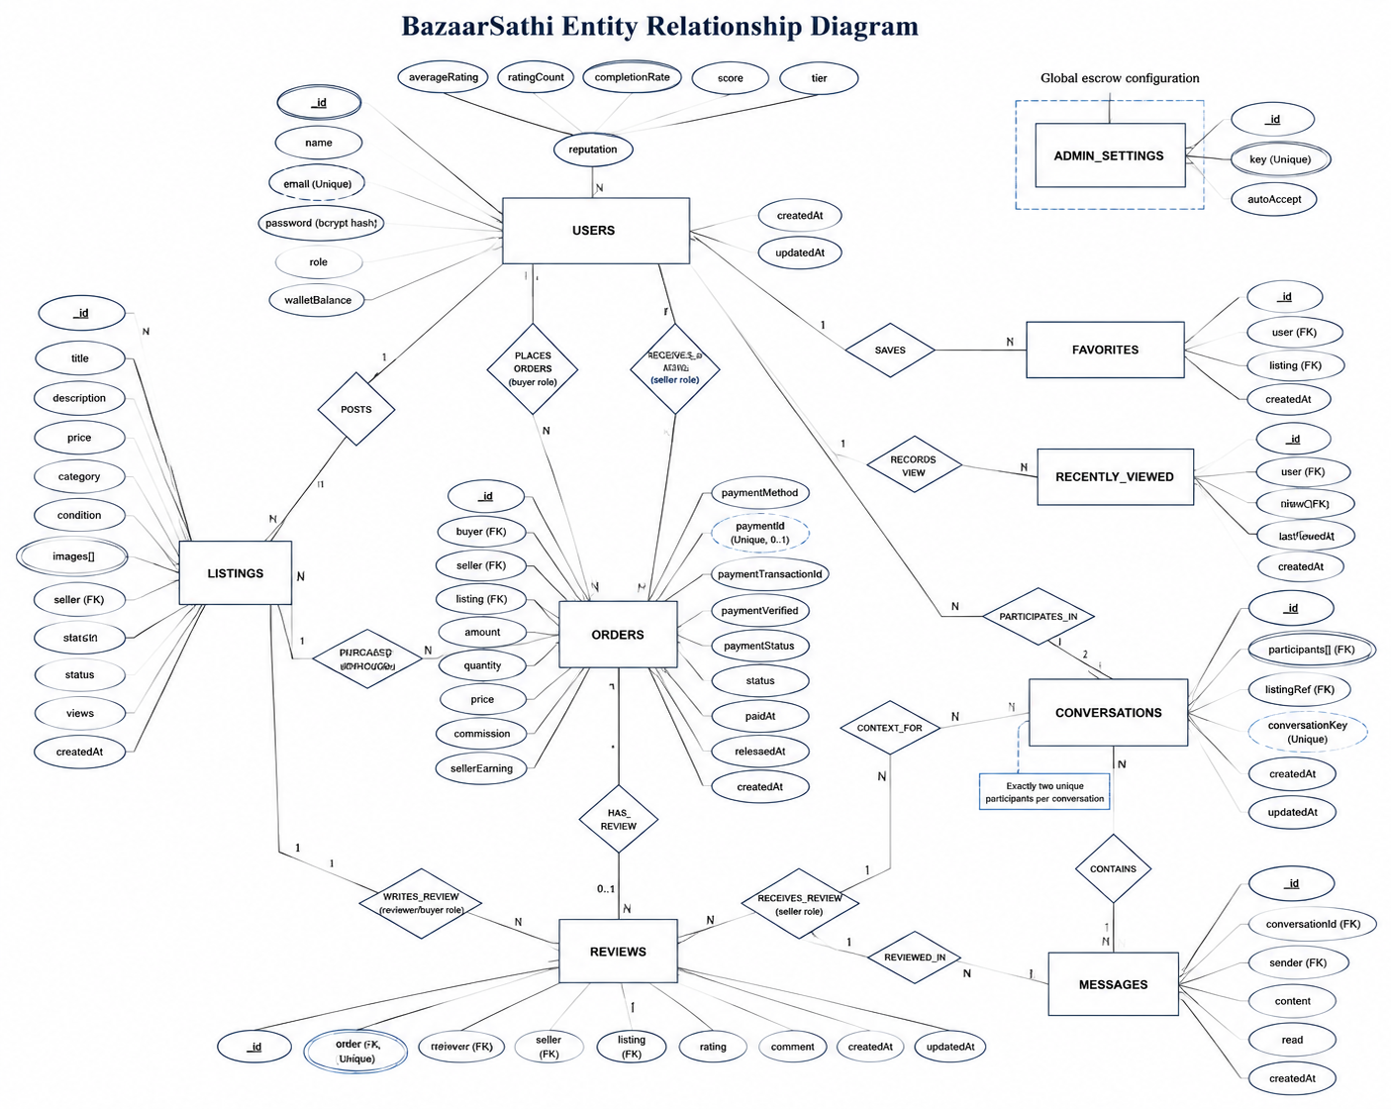
Figure 4: ER-Diagram of BaazarSaathi
The Entity–Relationship (ER) Diagram for the BazaarSathi Marketplace System represents the system’s data model using entities, attributes, relationships, and cardinalities. In the Chen-style diagram, rectangles represent entities such as Users, Listings, Orders, Conversations, Messages, Reviews, Favorites, Recently Viewed, and Admin Settings. Ovals represent attributes such as USER_ID, TITLE, AMOUNT, RATING, and CREATED_AT, while diamonds represent relationships such as Posts, Purchases, Participates In, Sends, Saves, Views, and Reviews. Primary keys are underlined to indicate that they uniquely identify each record.
Cardinalities describe how the entities are connected. One user can post many listings, while each listing belongs to one seller. A buyer can place many orders, but each order is associated with one buyer, one seller, and one listing. A conversation contains exactly two participants and may contain many messages. Each completed order can have a maximum of one verified review. Users can also save multiple listings as favourites and maintain records of recently viewed listings. These relationships provide a structured and extensible foundation for implementing the BazaarSathi MongoDB database.
ER-Diagram Schema
- Users (USER_ID, NAME, EMAIL, PASSWORD, ROLE, WALLET_BALANCE, AVERAGE_RATING, RATING_COUNT, COMPLETION_RATE, REPUTATION_SCORE, REPUTATION_TIER, REPUTATION_UPDATED_AT, CREATED_AT)
- Listings
(LISTING_ID, SELLER_ID (FK), TITLE, DESCRIPTION, PRICE, CATEGORY, CONDITION, IMAGES, STATUS, VIEWS, CREATED_AT)
- Orders
(ORDER_ID, BUYER_ID (FK), SELLER_ID (FK), LISTING_ID (FK), AMOUNT, QUANTITY, PRICE, COMMISSION, SELLER_EARNING, PAYMENT_METHOD, STATUS, PAYMENT_ID, PAYMENT_TRANSACTION_ID, PAYMENT_VERIFIED, PAYMENT_STATUS, PAID_AT, RELEASED_AT, CREATED_AT)
- Conversations
(CONVERSATION_ID, PARTICIPANTS (FK), LISTING_ID (FK), CONVERSATION_KEY, CREATED_AT, UPDATED_AT)
- Messages
(MESSAGE_ID, CONVERSATION_ID (FK), SENDER_ID (FK), CONTENT, READ, CREATED_AT)
- Reviews
(REVIEW_ID, ORDER_ID (FK), REVIEWER_ID (FK), SELLER_ID (FK), LISTING_ID (FK), RATING, COMMENT, CREATED_AT, UPDATED_AT)
- Favorites
(FAVORITE_ID, USER_ID (FK), LISTING_ID (FK), CREATED_AT)
- Recently Viewed
(RECENTLY_VIEWED_ID, USER_ID (FK), LISTING_ID (FK), VIEW_COUNT, LAST_VIEWED_AT, CREATED_AT)
- Admin Settings
(SETTING_ID, KEY, AUTO_ACCEPT)

3.1.4 Process Modelling (DFD)
The Data Flow Diagram of the BazaarSathi Marketplace System consists of two levels: the Context Diagram, also known as the Level 0 DFD, and the Level 1 DFD. These diagrams illustrate how data flows between users, system processes, external services, and data stores.
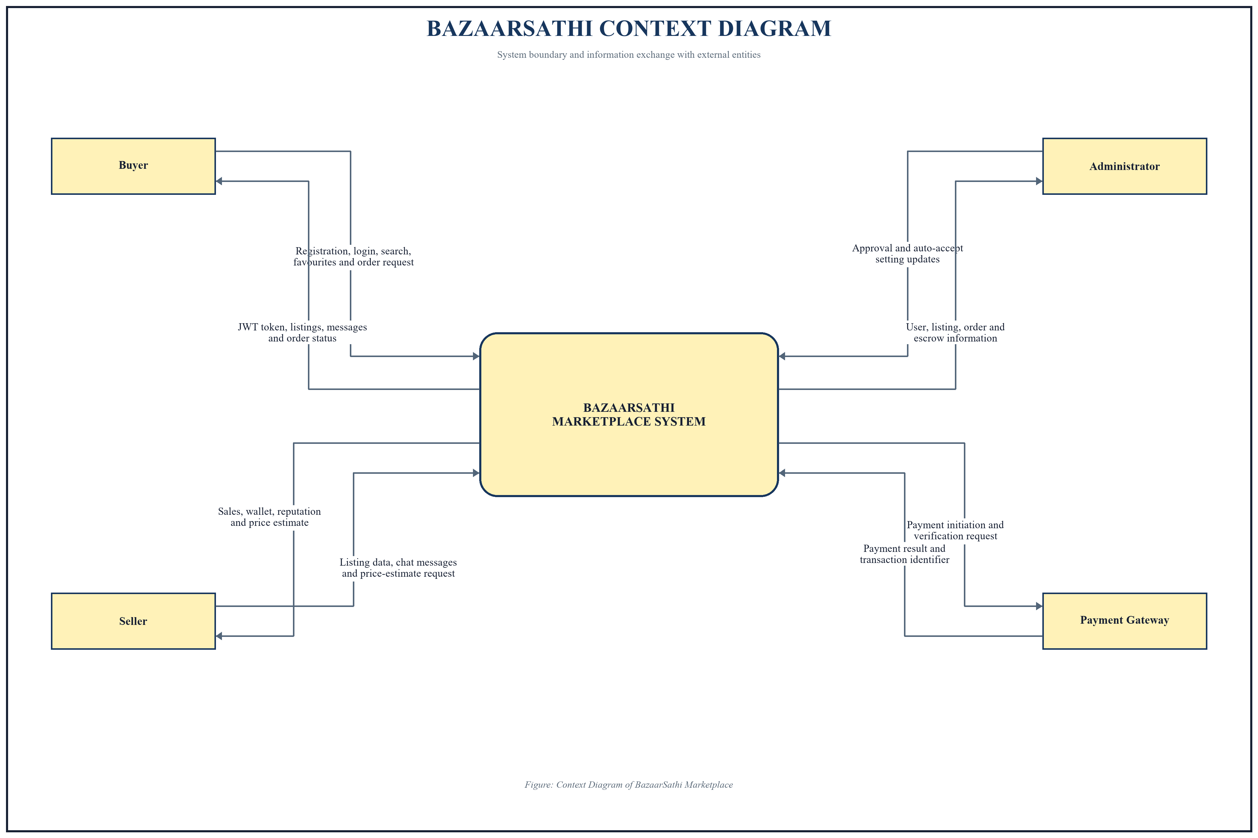
Figure 5: Context Diagram of BaazarSaathi
The Context Diagram represents BazaarSathi as a single process interacting with the Buyer, Seller, Administrator, and Payment Gateway. It shows the information submitted by these external entities, including registration details, listing information, purchase requests, payment details, messages, reviews, and administrative settings. It also represents the system’s responses, such as authentication results, listing details, order status, payment confirmation, wallet updates, and administrative information.
The Level 1 DFD divides BazaarSathi into major processes, including account authentication, listing management, favorites and viewing history, real-time chat, order and escrow management, reviews and seller reputation, administration, and price estimation. It also shows how these processes exchange information with data stores such as Users, Listings, Orders, Conversations, Messages, Reviews, Favorites, and Recently Viewed records.
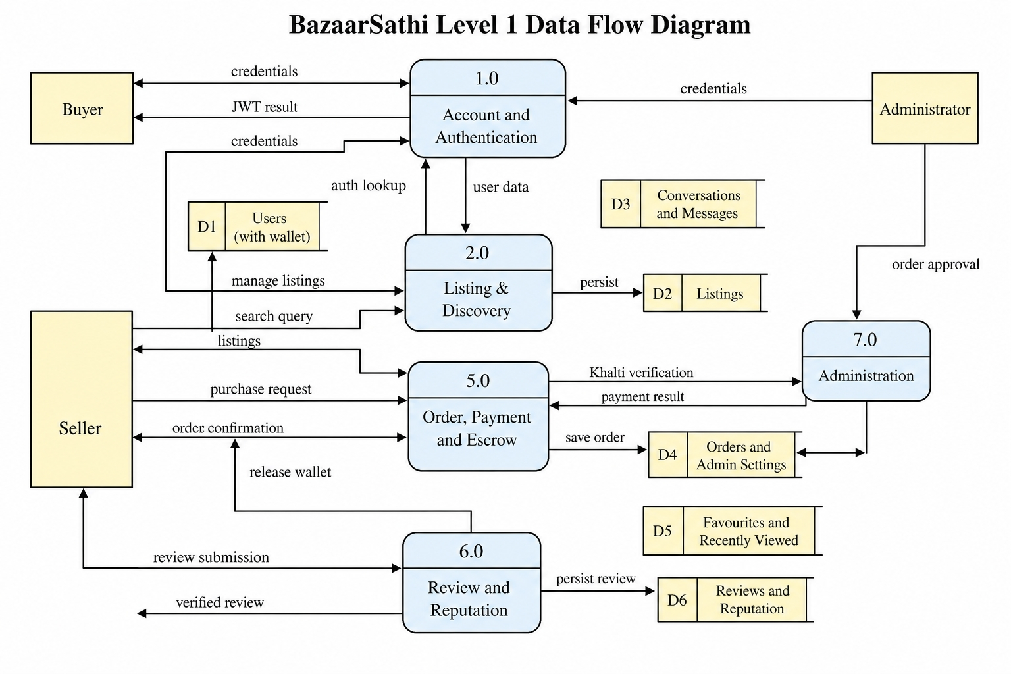
Figure 6: Level 1 DFD of BaazarSaathi
The Level 1 Data Flow Diagram (DFD) for the BazaarSathi Marketplace System provides a detailed overview of the primary processes and data flows within the marketplace. It highlights interactions between buyers, sellers, administrators, the payment gateway, and the system’s main functions. Buyers register and log in, browse listings, submit purchase requests, and receive JWT and payment results. Sellers create listings, manage sales, request price estimates, and receive wallet earnings. The Order, Payment and Escrow process validates listings, verifies payments, records orders, and releases approved earnings. Communication with the payment gateway provides payment verification results before the transaction can continue. The Review and Reputation process stores verified feedback, while Price Estimation analyses listing information. Administrators oversee orders and escrow activities. Data stores for users, listings, orders, wallets, and reviews are accessed and updated as required. This DFD demonstrates how submitted data is processed at different stages, ensuring that marketplace information remains organized, reliable, and traceable throughout the complete system workflow.

3.2 System Design
System design is the process of defining the architecture, modules, components, interfaces, database structure, and data flow of a system. The BazaarSathi Marketplace System is designed using architectural models, database schemas, interface designs, and various CASE tools. The overall structure and interaction between the system components are described through the following design diagrams.

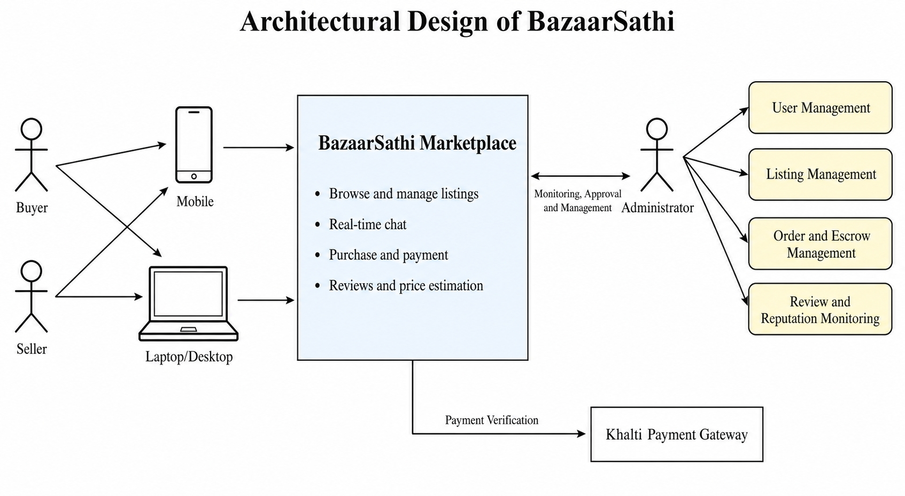
3.2.1 Architectural Design
Figure 7: Architectural Diagram of BaazarSaathi

The architectural design of the BazaarSathi Marketplace System follows a multi-tier architecture to support scalability, maintainability, and security. It consists of presentation, application, and data layers. The presentation layer provides web interfaces through which buyers, sellers, and administrators access listings, chat, payments, and management features. The application layer handles authentication, listing management, real-time communication, orders, escrow payments, reviews, reputation, and price estimation. The data layer uses MongoDB to store users, listings, orders, conversations, messages, and transaction records. Together, these layers provide an efficient and secure architecture that supports BazaarSathi’s functional and non-functional requirements.

3.2.2 High level design of the system
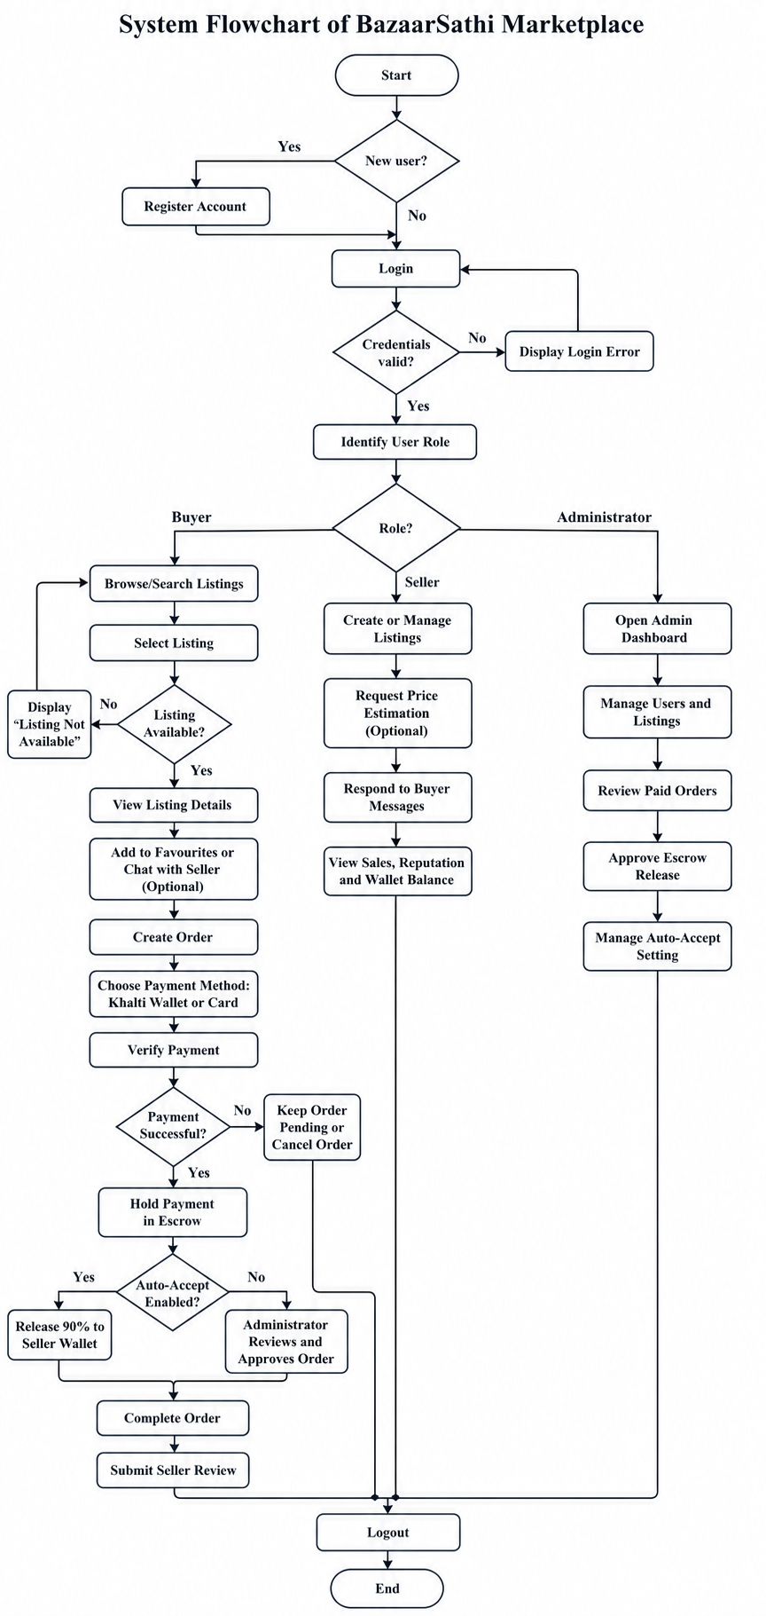
Figure 8: System Flowchart of BaazarSaathi
The above figure represents the flow of the BazaarSathi Marketplace System, where a user must register and verify credentials to access system features such as browsing listings, creating orders, chatting with sellers, making Khalti payments, and submitting reviews, fulfilling certain role-based conditions. The seller can manage listings, respond to messages, and view wallet balance, while the administrator must login with correct credentials to approve orders, manage users and listings, change auto-accept settings, and release escrow payments.

3.2.3 Database Schema Design
Database schema design organizes BazaarSathi’s data into different collections and defines their relationships and constraints. The diagram presents the collections, fields, primary keys, foreign keys, and cardinal relationships used in the system. The main collections are Users, Listings, Orders, Conversations, Messages, Reviews, Favorites, Recently Viewed, and Admin Settings.

3.2.4 Interface Design
The interface design of the BazaarSathi Marketplace System aims to provide a simple and user-friendly experience for buyers and sellers. From the homepage, users can register, log in, browse products, search listings, and filter results by category, condition, and price. Each listing displays images, descriptions, seller information, price, reputation, and product condition. Buyers can save favorites, communicate with sellers, place orders, and complete payments through Khalti or card options.
Sellers receive a dedicated dashboard for creating, updating, and deleting listings, checking sales, viewing wallet earnings, responding to messages, and requesting price estimates. Administrators are directed to a separate dashboard where they can monitor users, listings, orders, and escrow payments. They can approve paid orders and manage the automatic approval setting. Overall, the interface prioritizes clarity, responsiveness, security, and ease of navigation across buyer, seller, and administrator activities.

3.3 Algorithms Used
1. Listing Search, Filter and Sorting Algorithm
A query-based algorithm is used to retrieve relevant marketplace listings. Key functions include:
- Searches listing titles and descriptions using case-insensitive matching.
- Filters listings by category, condition, status, and price range.
- Sorts results in the newest, oldest, lowest price, highest price, or most viewed.
- Uses MongoDB indexes to improve retrieval performance.
This helps buyers find suitable products quickly and efficiently.
2. Escrow and Commission Algorithm
The escrow algorithm securely manages marketplace payments:
- Calculates a 10% platform commission.
- Calculates the seller’s earning as the remaining 90%.
- Verifies payment before marking the listing as sold.
- Releases the seller’s earning automatically or after administrator approval.
- Uses MongoDB transactions to prevent incomplete financial updates.
This ensures secure and consistent payment processing.
3. Seller Reputation Algorithm
The reputation algorithm evaluates sellers using reviews and completed orders:
- Calculates the seller’s average rating and completion rate.
- Applies Bayesian weighting to prevent a single review from producing an unrealistic score.
- Combines rating, completion rate, and completed-order count.
- Assigns sellers to new, developing, trusted, or top-seller tiers.
This provides buyers with a more reliable measure of seller performance.
4. Random Forest Price-Prediction Algorithm
A Random Forest regression model provides experimental listing-price estimates:
- Analyses the listing title, description, category, and condition.
- Convert textual information using TF-IDF.
- Encodes category and condition values using one-hot encoding.
- Combines predictions from 240 decision trees.
- Returns an estimated price and suggested price range in NPR.
This algorithm assists sellers in selecting a reasonable listing price, although its accuracy depends on the quality of the training data.

CHAPTER 4

IMPLEMENTATION AND TESTING

4.1 Implementation
The following tools, technologies, and frameworks were used for the development of the BazaarSathi Marketplace System.
Front-End Tools
HTML5, CSS3, JavaScript, React.js, Tailwind CSS, and Vite were used to develop the front end. HTML5 provides the structure of the web pages, while Tailwind CSS supports responsive and consistent interface styling. React.js was used to create reusable components and interactive pages for buyers, sellers, and administrators. JavaScript handles dynamic operations such as searching, filtering, favourites, payment interaction, and real-time messaging. Vite provided a fast development and built environment.
Back-End and Database Tools
Node.js and Express.js were used to implement the server-side application following the MVC pattern. Express handles API routes, middleware, validation, and business operations. MongoDB was used to store users, listings, orders, conversations, messages, reviews, and activity records, while Mongoose was used for schema definition and database operations. JWT and bcrypt provide protected routes and secure password hashing. Socket.io supports real-time chat, message delivery, and typing notifications.
Payment, Image and Machine-Learning Tools
Khalti was integrated for payment initiation and verification, while the escrow module manages commission and seller earnings. Python, FastAPI, pandas, and scikit-learn were used to develop the Random Forest price-prediction service. The model analyses listing titles, descriptions, categories, and conditions to generate an experimental price estimate.
Software Used
Microsoft Visual Studio Code was used to write and manage the source code. Git and GitHub were used for version control and repository management. Microsoft Word was used to prepare the project documentation and final reports. These tools provided an organized environment for development, testing, collaboration, and documentation.
Table 1: Development Tools and Technologies
Tool / Technology | Purpose
React.js | Client interface and reusable components
Tailwind CSS | Responsive styling
Node.js and Express | REST API and server runtime
MongoDB and Mongoose | Database and object modelling
Socket.IO | Real-time chat events
Khalti API | Payment initiation and verification
Python and scikit-learn | Random Forest price experiment
Git and GitHub | Version control and collaboration

4.2 Testing
Testing was planned from requirements and risk. Unit tests isolate models, middleware, controllers, and services to verify validation, authorization, state changes, calculations, and response structures. System tests exercise complete user workflows through the client and API, including both successful and unsuccessful paths.
Regression checks should be executed after changes to shared models, middleware, payment state, or frontend navigation. Final evidence should include test environment, input data, expected output, actual output, pass or fail status, and references to screenshots or logs where useful.

4.2.1 Test Cases for Unit Testing
Unit tests verify one logical unit with dependencies replaced by controlled test doubles where necessary. Representative cases cover password hashing, token protection, listing ownership, price-filter validation, commission calculation, repeat-safe escrow release, review eligibility, favourite persistence, and normalized prediction requests.
Each test should have a stable identifier and explicit expected result. The final report should replace the following examples with tests that correspond exactly to the submitted source code and should attach the complete automated test output in an appendix if required by the college.
Table 2: Representative Unit Test Cases
ID | Unit and Input | Expected Result | Status
UT-01 | Register with valid name, email, and password | Password is hashed; JWT and public user are returned | PASS
UT-02 | Access protected route without bearer token | Request is rejected with authentication message | PASS
UT-03 | Create order with browser-supplied altered amount | Stored amount is derived from listing price | PASS
UT-04 | Approve the same completed escrow twice | Seller wallet is credited only once | PASS
UT-05 | Review an uncompleted order | Review is rejected and reputation remains unchanged | PASS
UT-06 | Predict with missing listing condition | Validation response is returned | PASS

Test Cases for System Testing
System testing validates integrated behaviour from the user’s perspective. The test environment should run the frontend, backend, database, and required internal services with controlled credentials. Payment tests should use provider-approved sandbox data and should never expose a secret key in screenshots or the report.
The cases below illustrate end-to-end workflows. Actual results should record the observed page, API state, database state, and any external redirect. Defects should be linked to corrective action and retested before final submission.
Table 3: Representative System Test Cases
ID | Scenario | Expected Result | Status
ST-01 | Seller signs in and posts a valid listing | Active listing appears in marketplace and seller account | PASS
ST-02 | Buyer searches, saves, and views a listing | Search result, favourite, and recent history persist | PASS
ST-03 | Buyer and seller exchange messages | Messages appear in real time and remain in history | PASS
ST-04 | Buyer completes sandbox payment | Payment is verified and order awaits or receives approval | PASS
ST-05 | Administrator approves verified order | Order completes and 90% seller earning is credited | PASS
ST-06 | Completed buyer submits review | Review appears and seller reputation is recalculated | PASS

CHAPTER 5

CONCLUSION AND FUTURE RECOMMENDATIONS

CHAPTER 5: CONCLUSION AND FUTURE RECOMMENDATIONS

5.1 Lessons Learnt / Outcomes
The BazaarSathi project taught us the importance of effective communication, teamwork, planning, and task distribution during software development. Along with improving our programming skills, we learned how to analyses system requirements, design database relationships, develop secure APIs, and connect front-end and back-end components. We gained practical knowledge of React.js, Node.js, Express.js, MongoDB, JWT authentication, Socket.io, payment verification, and machine learning. Regular testing and feedback helped us identify errors and improve the usability of the system. We also learned that machine-learning predictions depend heavily on the quality and quantity of training data. Overall, the project strengthened our ability to solve technical problems, cooperate as a team, and develop a complete application according to user requirements.

5.2 Conclusion
It has been a challenging and valuable experience to design and develop the BazaarSathi Marketplace System. The project provides a unified platform where buyers and sellers can register, browse products, manage listings, communicate in real time, complete payments, and provide verified reviews. Administrators can monitor marketplace activities, manage escrow approval, and control automatic payment acceptance.
Throughout the project, we improved our knowledge of system analysis, interface design, database management, API development, authentication, real-time communication, and software testing. The project also helped us understand how secure payment verification, seller reputation, persistent favorites, recently viewed listings, and price estimation can be integrated into a marketplace. The completed prototype demonstrates that BazaarSathi can simplify peer-to-peer buying and selling while providing a structured, secure, and user-friendly experience.

5.3 Future Recommendations
The future development of BazaarSathi should focus on improving security, scalability, payment reliability, and user trust. Production payment credentials and settlement procedures should be integrated to support real financial transactions. Identity verification, dispute resolution, refunds, delivery tracking, content moderation, notification services, and advanced administrative reports can also be introduced. Dedicated Android and iOS applications could make the marketplace more accessible.
The price-prediction model should be retrained using a large collection of genuine completed-sale records containing details such as brand, model, product age, warranty, storage capacity, and condition. Future improvements may also include multilingual support, personalized recommendations, location-based search, image validation, automated fraud detection, accessibility testing, performance monitoring, and cloud deployment. Regular user feedback and system testing should guide these improvements.

REFERENCES
[1] I. Sommerville, Software Engineering, 10th ed. Boston, MA, USA: Pearson, 2015.
[2] R. S. Pressman and B. R. Maxim, Software Engineering: A Practitioner’s Approach, 9th ed. New York, NY, USA: McGraw-Hill, 2020.
[3] M. Jones, J. Bradley, and N. Sakimura, ‘JSON Web Token (JWT),’ RFC 7519, Internet Engineering Task Force, May 2015.
[4] OWASP Foundation, ‘OWASP Application Security Verification Standard 4.0.3,’ Oct. 2021. [Online]. Available: https://owasp.org/www-project-application-security-verification-standard/
[5] MongoDB, Inc., ‘MongoDB Manual,’ [Online]. Available: https://www.mongodb.com/docs/manual/. [Accessed: [ACCESS DATE]].
[6] OpenJS Foundation, ‘Node.js Documentation,’ [Online]. Available: https://nodejs.org/docs/latest/api/. [Accessed: [ACCESS DATE]].
[7] React Team, ‘React Documentation,’ [Online]. Available: https://react.dev/. [Accessed: [ACCESS DATE]].
[8] Socket.IO, ‘Socket.IO Documentation,’ [Online]. Available: https://socket.io/docs/v4/. [Accessed: [ACCESS DATE]].
[9] F. Pedregosa et al., ‘Scikit-learn: Machine learning in Python,’ Journal of Machine Learning Research, vol. 12, pp. 2825-2830, 2011.
[10] [PAYMENT PROVIDER / LOCAL MARKETPLACE SOURCE], ‘[DOCUMENT OR PAGE TITLE],’ [Online]. Available: [URL]. [Accessed: [ACCESS DATE]].

APPENDICES

