### A project report On

### **Kura-Kani**

### Submitted in partial fulfillment of requirement of Project – VI BCA BCA379CO

### Of

### Bachelor of Computer Application

**Submitted To:**



Purbanchal University Biratnagar, Nepal

**Submitted By:**

### Bikalpa Sangat (363418)

### Grishma Shrestha (363420) Kilika Tami Shrestha (363421)

**KANTIPUR CITY COLLEGE**

### Putalisadak, Kathmandu

### A project report On

### **Kura-Kani**

### Submitted in partial fulfillment of the requirement of Project – VI BCA BCA379CO

### Of

### Bachelor of Computer Application

**Submitted To:**



Purbanchal Univeristy Biratnagar, Nepal **Submitted By:**

### Bikalpa Sangat (363418)

Grishma Shrestha (363420) Kilika Tami Shrestha (363421) **Project Supervisor**

**Mr. Ashim Kc**

**KANTIPUR CITY COLLEGE**

### Putalisadak, Kathmandu

**CERTIFICATE OF PROJECT APPROVAL**

This is to notify that the topic chosen by, Bikalpa Sangat, Grishma Shrestha and Kilika Tami Shrestha students of Bachelor of Computer Application, Semester VI, for their semester project has been deemed appropriate and meets the credit requirements set by Purbanchal University (PU), Biratnagar, Nepal

The project committee has granted approval for the following topic for the mentioned students.

Topic Assigned: **Kura-Kani**

……………….. …………………..

Mr. Ashim Kc External Examiner

Lecturer (BCA/BIT) Purbanchal University Project Supervisor

Kantipur City College

**CERTIFICATE FROM SUPEVISOR**

This is to certify that the project titled “**Kura-Kani**” submitted by Bikalpa Sangat, Grishma Shrestha and Kilika Tami Shrestha to the Department of Information and Technology at Kantipur City College, Kathmandu, Nepal, as a part of the requirements for Project-VI (BCA379CO), is an authentic and original piece of work. It was undertaken by them under my close supervision and guidance.

………………… Mr. Ashim Kc Project Supervisor

Department of Information Technology

Place: Kantipur City College, Putalisadak, Kathmandu Date: September 11, 2023

**ACKNOWLEDGEMENT**

We would like to express our deepest appreciation to all those who provided us the possibility to complete this report. We would like to acknowledge with much appreciation the crucial role of the staff of Kantipur City College, who gave us the permission to use all required equipment and the necessary materials to complete the task.

Furthermore, special thanks to our project supervisor, Mr. , whose contribution in stimulating suggestions and encouragement, helped us to coordinate our project especially in writing this report also suggesting us about the task and guiding us during the completion of this project. Finally, many thanks to the lab in- charge for providing the facilities of the lab during our project. We must appreciate the guidance given by other supervisor as well as the panels especially in our project presentation that has improved our presentation skills, thanks to their comment and advice.

**ABSTRACT**

Kura-Kani is a chat application that is developed for users to instantly communicate with each other. This project is a web-based application for users to instantaneously communicate with one another from any place at real time. The most important part of building a good chat application is to focus on the real time data flow on web. This project spends a good amount of research to find the most appropriate technology for delivering the data flow, which is REST API for account management, Web Socket form socket.io library for text chat and react-notify as real time push notification. We have also used variety of cloud computing services for different purpose as well as from hosting images to users in Cloudinary to cloud database as well. The cloud-based database and single threaded backend system written in Nodejs is capable of handling thousands of users simultaneously. With a proper loaded balancing the system can be scaled up for millions of users.

**Table of Contents**

|  |  |
| --- | --- |
| ACKNOWLEDGEMENT | i |
| ABSTRACT | ii |
| LIST OF FIGURES | v |
| LIST OF TABLES | vi |
| ABBREVIATION | vii |
| Chapter 1: INTRODUCTION | 1 |
| 1.1 Project Introduction | 1 |
| 1.2 Statement of Problem | 1 |
| 1.3 Project Objective | 1 |
| 1.4 Project Features | 1 |
| 1.5 Limitations | 2 |
| 1.6 Organization of the Document | 2 |
| Chapter 2: LITERATURE REVIEW | 3 |
| 2.1 Existing System Overview | 3 |
| 2.1.1 Viber | 3 |
| 2.1.1.1 Introduction | 3 |
| 2.1.1.2 Features  2.1.1.3 Cons | 3  3 |
| 2.1.2 WhatsApp | 3 |
| 2.1.2.1 Introduction | 3 |
| 2.1.2.2 Features  2.1.2.2 Cons | 4  4 |
| Chapter 3: SYSTEM ANALYSIS | 5 |
| 3.1 System Development Model | 5 |
| 3.2 Requirement Specification | 5 |
| 3.2.1 Functional Requirement | 5 |
| 3.2.2 Non-Functional Requirement | 5 |
| 3.3 Feasibility Study | 6 |
| 3.3.1 Technical Feasibility | 6 |
| 3.3.2 Economic Feasibility | 6 |
| 3.3.3 Resource and Time Feasibility | 6 |

Chapter 4: SYSTEM DESIGN 8

4.1 Context Level DFD 8

4.2 Level 1 DFD 9

4.3 Use Case Diagram 10

4.4 Data Dictionary 11

Chapter 5: SYSTEM DEVELOPMENT AND IMPLEMENTATION 12

5.1 Programming Platform and Implementation 12

5.2 Testing and Debugging 12

Chapter 6: CONCLUSION AND FUTURE ENHANCEMENT 13

5.3 Conclusion 13

5.4 Limitation 13

5.5 Future Enhancement 13

APPENDIX 14

REFERENCES 17

**LIST OF FIGURES**

|  |  |  |
| --- | --- | --- |
| **S.N** | **Figure Name** | **Reference** |
| 1 | Gantt Chart | 7 |
| 2 | Context Level Diagram | 8 |
| 3 | Level 1DFD Diagram | 9 |
| 4 | Use Case Diagram | 10 |

**LIST OF TABLES**

|  |  |  |
| --- | --- | --- |
| **S.N** | **Table Name** | **Reference** |
| 1.1 | Assignment of Roles | 2 |
| 4.1 | Data Dictionary | 11 |

**Chapter 1: INTRODUCTION**

* 1. **Project Introduction**

Chatting is a method of using technology to bring people and ideas together despite of the geographical barriers. The technology has been available for years but the acceptance was quite recent. Our project is an example of real time chat system.

Kura-Kani is an online chat application build using React on the Frontend and ExpressJs in the backend. It is a real-time chat system that uses web sockets from socket.io package. The main purpose of the software is to provide users with an instant messaging tool that has the ability to handle thousands of users simultaneously when needed and can be easily done.

* 1. **Statement of Problem**

Chat rooms have become a popular way to support a forum for conversation or discussion among a set of people with interest in a common topic. Chat applications range from simple, text-based ones to entire virtual worlds with exotic graphics. In this project we were required to implement a simple text-based chat client/server application.

Email, newspaper and messaging application provide means for communicating among people but these are one-way mechanism and they do not provide an easy way to carry on a real-time conversation or discussion with people involved. Chat room extends the one-way messaging concept to accommodate multi-way communication among a set of people.

* 1. **Project Objective**

The objectives of the project are:

* + - To provide user with instant messaging tool that has ability to handle a lot of users simultaneously in real time.
    - Learn to work with socket.io for real time communication.
    - Define and implement a “chat” protocol for interaction between a chat server and a chat client.
  1. **Project Features**

The features of the project are:

* + - Simple Login and Registration
    - Cloud backup and recovery
    - Data Security
    - Real time messaging
    - Push Notification
    - Group Chat
  1. **Limitations**

The limitations of the project are:

* + - No audio or video calling feature as for now.
    - No android/iOS app.
    - Cannot send files.
  1. **Assignment of Roles**

Table 1.1 Assignment of Roles

|  |  |  |
| --- | --- | --- |
| **S.N** | **Project Members** | **Roles and responsibility** |
| 1 | Bikalpa Sangat | Coding, Presentation and Documentation |
| 2 | Grishma Shrestha | Coding, Presentation and Documentation |
| 3 | Kilika Tami Shrestha | Coding, Presentation and Documentation |

**Chapter 2: LITERATURE REVIEW**

* 1. **Existing System Overview**

#### Viber

##### Introduction

Viber, or Rakuten Viber, is cross-platform voice over IP and instant messaging software application owned by Japanese multinational company Rakuten, provided as freeware for the Google Android, iOS, and Microsoft Windows, Apple MacOS and Linux platforms. It provides unlimited free voice calls and text messages to other Viber users. Group text messages, cheap calling to landline and mobile numbers.

##### Features

* Free VOIP Calls
* Sending audio and video messages.
* Sending images and files.

##### Cons

* Chat can be done from only mobile app or desktop-based app. Users cannot chat from their website

#### WhatsApp

##### Introduction

WhatsApp Messenger, or simply WhatsApp, is an internationally available freeware, cross-platform centralized instant messaging and voice-over-IP service owned by American company Meta Platforms. It allows users to send text and voice messages, make voice and video calls, and share images, documents, users’ locations, and other content. WhatsApp’s client runs on mobile device, and can be accessed from computers. The service requires a cellular mobile telephone number to sign up. In January 2018, WhatsApp released a standalone business app called WhatsApp Business which can communicate with standard WhatsApp client.

##### Features

* Free audio and video call
* Sending audio and video messages.
* Sending images and files.

##### Cons

* Chat history can be backed up only to google drive

**Chapter 3: SYSTEM ANALYSIS**

* 1. **System Development Model**

For this project we have used Spiral model of software development because the spiral model was primarily designed to help adopt the changes in requirements quickly. So, the main aim of the Spiral model is to facilitate quick project competition. To accomplish this task flexibility is required. Flexibility is achieved by fitting the process to the project, removing activities that may not be essential for a specific project. Using spiral methods results in each step of the project contributing to the final outcome by providing a result that can be functionally used at every stage of completion. System project management helps in finding the source of the problem quickly through frequent testing and feedback. That’s why we decided to use spiral method to develop this project. done accordingly.

* 1. **Requirement Specification**

#### Functional Requirement

* The system must be compatible with mobile devices which support different web service.
* This system should allow the user to send and receive real time messages and notification.

#### Non-Functional Requirement

* Smooth transitions and proper layout must be implemented in order to make it simple yet attractive.
* The system should have good security measures for protecting credentials of registered users.
* This system performance should not be heavy on browser.
* The system should offer a cloud backup of chats.
  1. **Feasibility Study**

#### Technical Feasibility

Kura-Kani is a real time web-based chat application. The main technologies associated with this project are HTML5, CSS3, React, NodeJs with ExpressJs, SocketIo and MongoDB. Most of these tools are freely available and technical skills required are manageable. While in development phase website will be hosted locally and tested and later it will be hosted in a free and paid web hosting service gradually.

#### Economic Feasibility

Being a web-based application; Kura-Kani will have some hosting cost. Since the system consists of data transfer, bandwidth required for the operation will be high. This system will follow freeware software standards. Bug fixes and maintaining cost will have some cost too. Hence, it is clear that system is economically feasible.

#### Resource and Time Feasibility

Resources required for Kura-Kani includes: programming devices (laptop), programming tools (freely available), and programming individuals. Thus, it has required resource and time feasibility.

##### Gantt chart

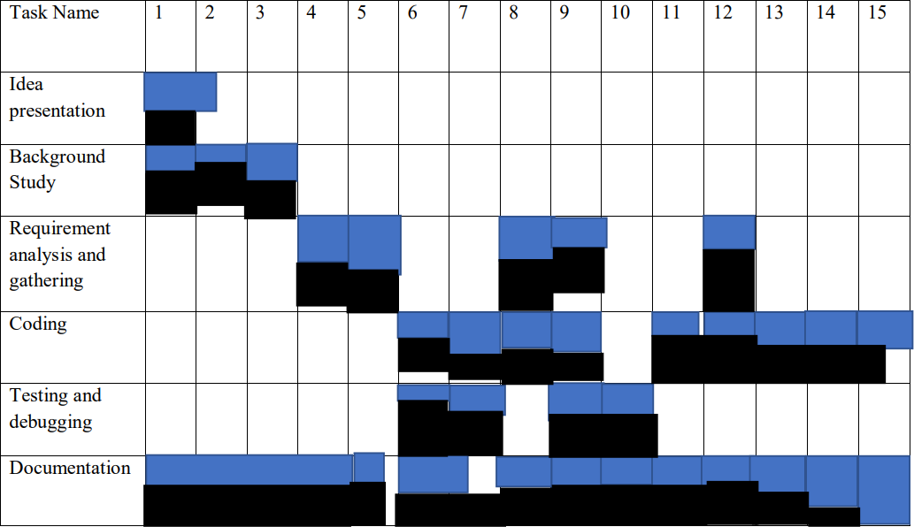

Figure 1. Gantt chart

# Chapter 4: SYSTEM DESIGN

## Context Level DFD

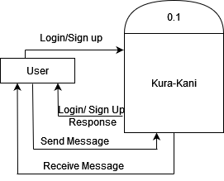

Figure 1. Context Level DFD

## Level 1 DFD

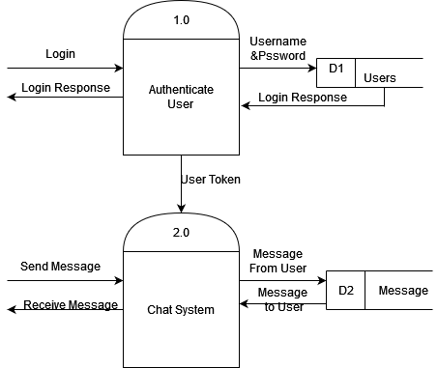

Figure 2. DFD Level 1 Diagram

## Use Case Diagram

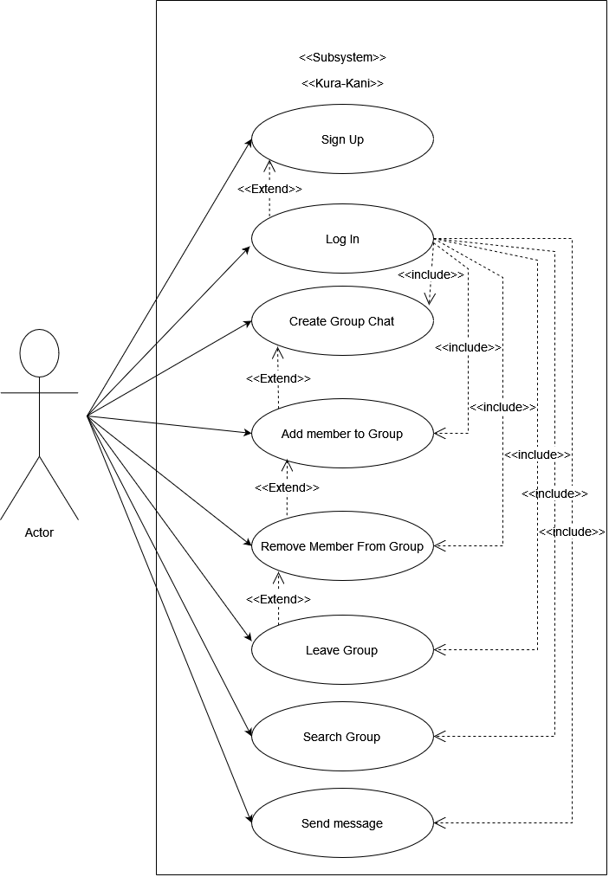

Figure 5. Use Case Diagram

## 4.4 Data Dictionary

Table 4.1 Data Dictionary

**Chat**

|  |  |
| --- | --- |
| **Field Name** | **Type** |
| Chat Name  Is Group Chat  Users  Latest Message  Group Admin  Timestamp | String  Boolean  Array of Objects  String  String  Date |

**Message**

|  |  |
| --- | --- |
| **Field Name** | **Type** |
| Sender  Content  Chat  Timestamp | String  String  String  Date |

**User**

|  |  |
| --- | --- |
| **Field Name** | **Type** |
| Name  Email  Password  Profile  Timestamp | String  String  String  String  Date |

# Chapter 5: SYSTEM DEVELOPMENT AND IMPLEMENTATION

## Programming Platform and Implementation

* + 1. Front-End Web Development
       - Markup Language: HTML
       - Style Sheet: CSS/ Bootstrap Classes
       - Dynamic Programming Language: ReactJs
    2. Back-End Web Development
       - Scripting language: NodeJs, ExpressJs
       - Database: MongoDB
    3. Development Tools: Visual Studio Code
    4. Interface: Web Application

## Testing and Debugging

Testing helps to verify correctness of the system. Debugging also can be done in case of error found in the system. Basically, testing can be done some important module of the system design. Some important modules are: requirement analysis, interface design, algorithm design, implementation, and integration with other modules. Debugging is a technique of solving program related error, testing and code correction. Testing can be done al the level of debugging is different that other stage. Final module testing is focused on correctness of the code to run the system, whereas testing during debugging is performed for locating errors.

# Chapter 6: CONCLUSION AND FUTURE ENHANCEMENT

## Conclusion

There is always an opportunity for improvement in every product, and we attempted to adjust the design accordingly, while still keeping our constraints in mind. During the course of developing this application, we faced few issues and learned how to solve them through study. With the help of this system we think our idea was evident and well presented.

## Limitation

Some of the project limitations are:

* + - No audio or video calling feature as of now.
    - No oath Authentication feature.
    - Cannot tag users in message.

## Future Enhancement

Some of the scopes we can increase for the betterment and effectiveness are listed below:

* + - Build android/iOS app.
    - Add audio /video calling feature using webRtc.
    - Add feature to send files, images and short videos.

# APPENDIX

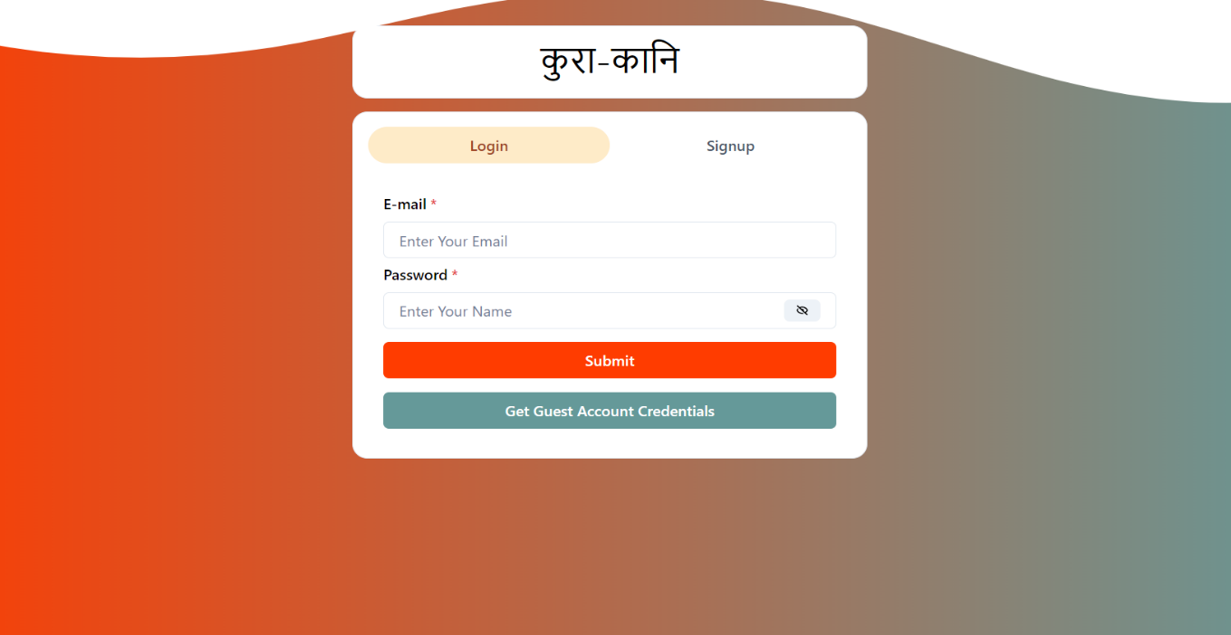

Figure 1. User Interface

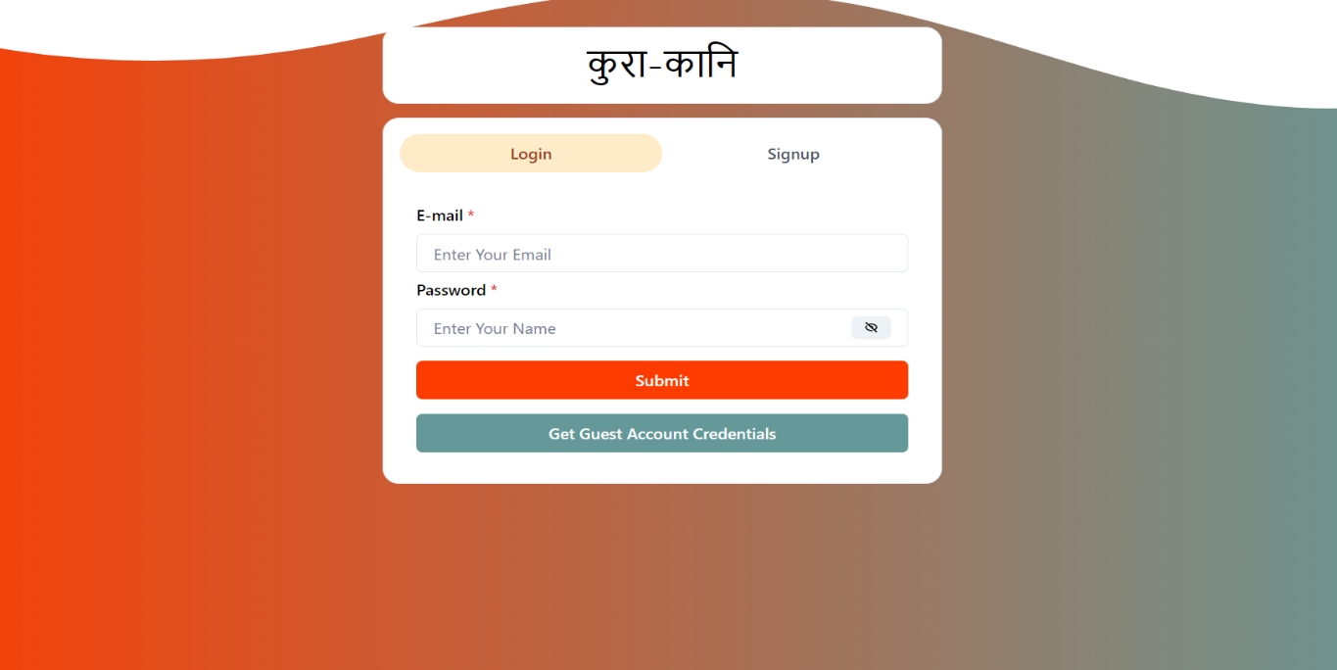

Figure 2. Login

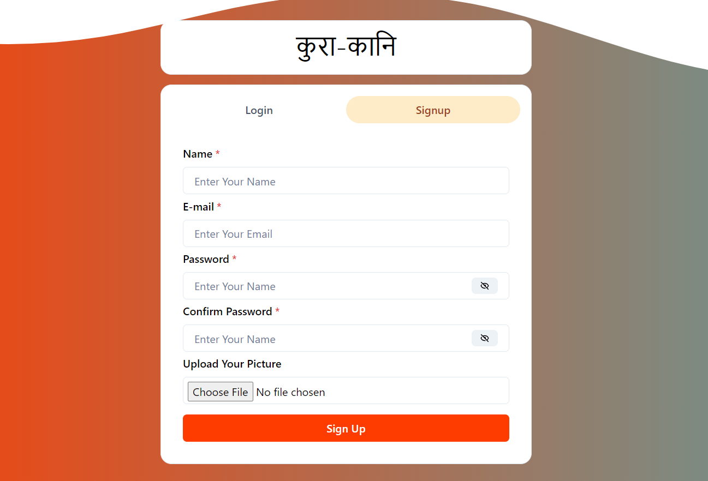

Figure 3. Signup for New Users

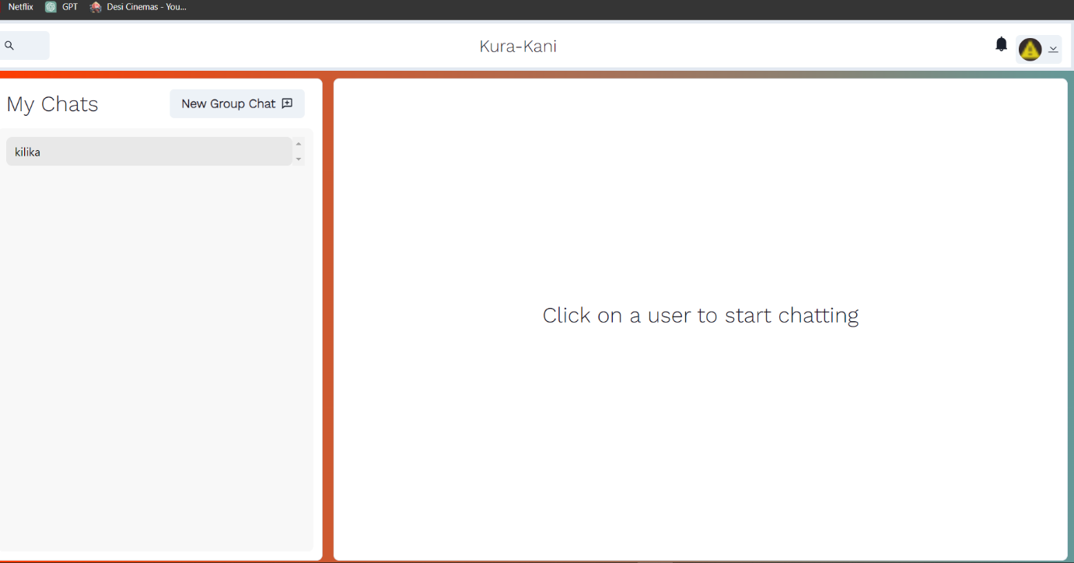

Figure 4. Chat Room

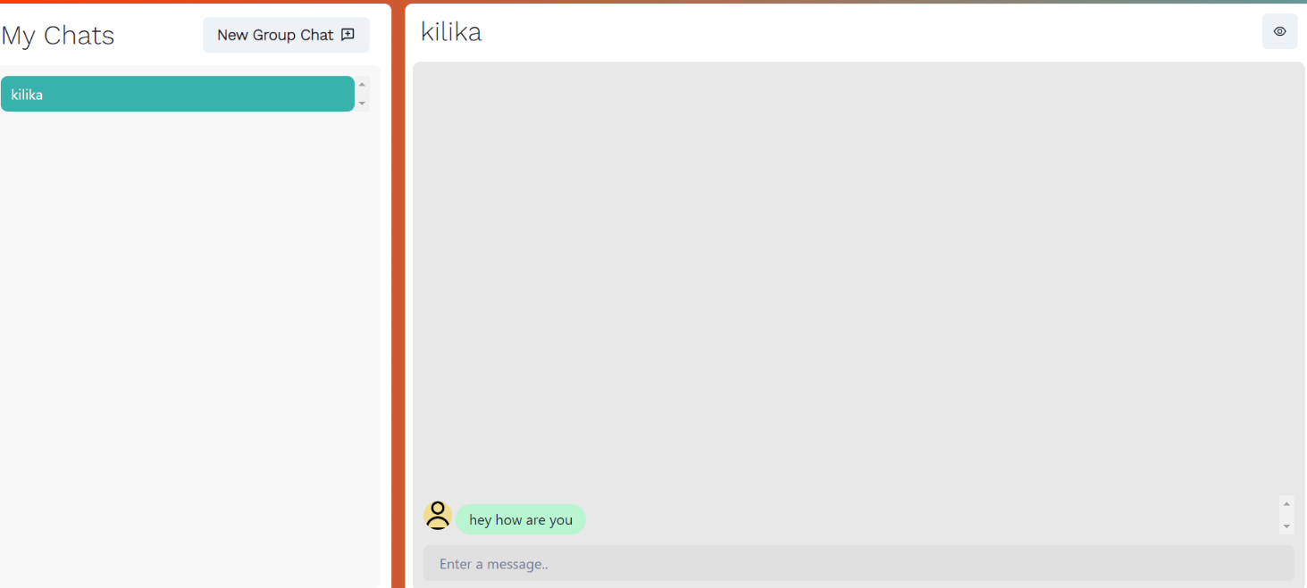

Figure 5. Chat

# REFERENCES

* *Socket.io + ReactJS Tutorial | Learn Socket.io for Beginners*. (n.d.). Www.youtube.com.

Retrieved August 26, 2022, from https://www.youtube.com/watch?v=djMy4QsPWiI

* *Host websites for FREE on HEROKU | 2020*. (n.d.). Www.youtube.com.

Retrieved August 26, 2022, from https://www.youtube.com/watch?v=wIH2qBLwonE

* *React Router V6 Routing*. (2021, November 6).

Stack Overflow. https://stackoverflow.com/questions/69868011/react-router-v6-routing

* *Advanced MongoDB Atlas Search Queries*. (n.d.). Www.youtube.com.

Retrieved August 26, 2022, from https://www.youtube.com/watch?v=1TQ7f__ISgE

* *Create an Elegant Login and Register Form on React*. (2019, May 25).

YouTube. https://www.youtube.com/watch?v=juUaJpMd2LE