**SHREE SHANTI BHAGWATI SECONDARY SCHOOL**

**LETANG-4, MORANG**



Report on field visit to “Manakamana Bee Keeping And Source Center”

Letang-4, Morang

Submitted as a practical course of

Class 10 Science

**SUBMITTED BY : TILA ACHARYA**

**SUBMITTED TO : HARI SAMPANG RAI**

**DEPARTMENT OF COMPUTER ENGI.**

**CLASS : 10 (C.E)**

**ROLL NO : 40**

**TABLE OF CONTENTS:**

1. Introduction ……………………………………………………………3
2. Introduction to bees and its farming..…………………………………..4
3. Life cycle of honey bee…………………………………………………5
4. Products of honey bee…………………………………………………..6
5. Challenges and Equipments in Apiculture ……………………………..7
6. Conclusion………………………………………………………………8

**INTRODUCTION**

As per the requirement of our syllabus, we the class 10 students (C.E) on the Ashad 3, 2080, headed by our incharge mr Santosh Chamlagain , science teacher Mr Hari Sampang Rai and two our class teachers Mr Hemanta Thapa Magar, had gone on educational visit to the "Manakaman Bee Keeping And Source Center" located at letang-9, Jante as seen on the map below.

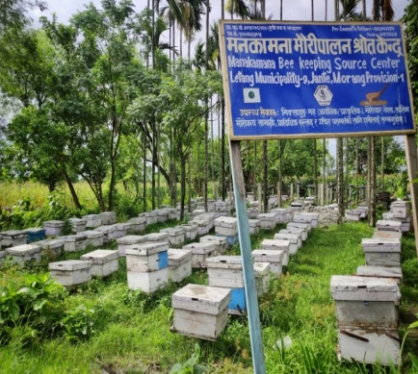

Me including my classmates went to "Manakamana Bee Keeping Center" for observing different kinds of bees and their life cycle. There were two person in that farm they were Imnath Pokhrel and Anish Pokhrel who guide us to learn about bees. First we divide group of 64 students in 2 parts because the theory room was very small. The Manakamana Bee keeping center was established from 8 bee hives and now they have more than 200 hives. We saw only two species of bees in that farm they were Apis merifera and Apis cerena.

# INTRODUCTION TO BEES AND ITS FARMING



**BEE FARMING**

Beekeeping is the maintenance of bee colonies, commonly in man-made beehives. Honey bees in the genus Apis are the most commonly kept species.Bee keepers keep bees to collect honey and other products of the hive: beeswax, propolis, bee pollen, and royal jelly. Pollination of crops, raising queens, and production of package bees for sale are other sources of beekeeping income.

# Types of honey bee

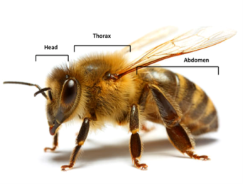Honeybee is a flying insect which falls under class insect of phylum Arthropoda. They have two pairs of eyes below the two pairs of antenna and 3 pairs of legs. It have four wings for flying in the sky. The different types of bees are explained below:

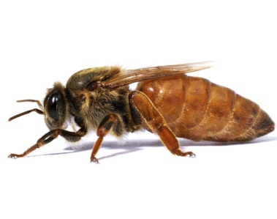1**) Queen Bee**

Queen bees are typically adult, mated females that live in a colony or hive of honey bees. They are the only egg-laying members of a colony of bees and they control the behavior and the population of the colony. Queens are developed from larvae selected by worker bees and specially fed in order to become sexually mature.

2**) Drone Bee**

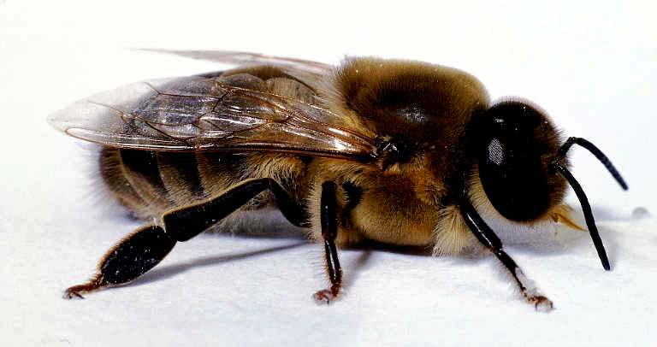Drone bees are male honey bees. Unlike the female worker bee, drones do not have stingers. A drone’s only role is to mate with a maiden queen in nuptial flight. They are usually larger than the worker bees.

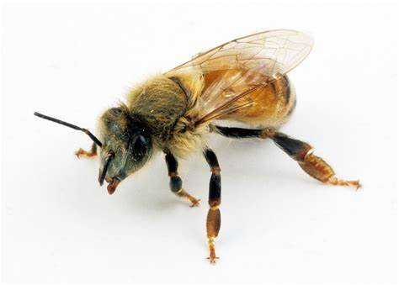**3) Worker Bee**

Worker bees are the smallest of the honey bees. Like all bees, they have a head, thorax, and abdomen. Depending on her age, she has many different roles in the hive. When she is young, she will be a nurse bee. This bees looks after the larva at their early age. It collects pollen and nectar of a flower to feed queen, worker and the larva. It is the most hardworking bee in the hive.

# Life cycle of honey bee

The life cycle of honeybee mainly consists of 4 different stages. They are eggs, larva, pupa, adult. The beginning phase of honey bee is known as eggs and so on.

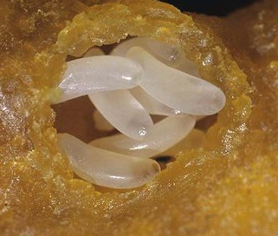**1)Egg**

**-** During the first three days of development, the honey bee egg goes through the embryonic stage. In this phase, the nervous system, digestive system and outer covering begin to form. The eggs are fragile and require the right temperature and humidity to ensure proper development.

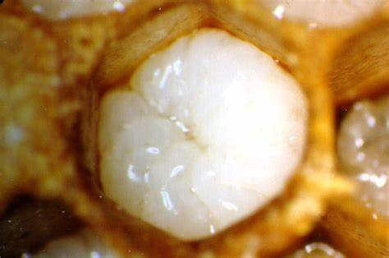**2)Larva**

- After the embryonic stage, the egg hatches into a larva. During the larval stage, the worker bees feed the larva a mixture of pollen, nectar, and royal jelly. The larva will go through several molts as it grows, eventually filling the **cell.**

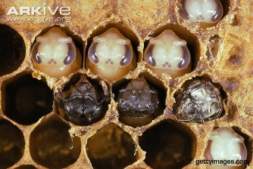**3)Pupa**

- The larva then spins a cocoon around itself and transforms into a pupa. Worker bees will cap the cell with beeswax, providing the developing bee with a secure environment to complete metamorphosis. The pupal stage is when the bee’s eyes, wings , and other adult features develop.

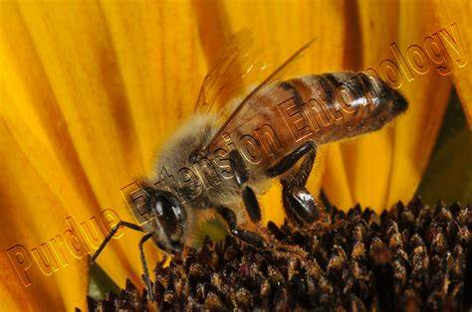**4)Adult**

- Once development is complete, the adult bee will chew through the wax capping and emerge from the cell. The time it takes for the egg to reach adulthood varies depending on the type of bee: worker bees typically emerge after 21 days, drones after 24 days, and new queens after 16 days.

# Products of Honey Bees

Honey bees is the most hardworking insects. Honey Bees have multiple advantages. There are different products of honey which can be use either as medicinal purpose or food products. The main products that we observe in the bee farm are given below:-

1. **Mustard Honey**

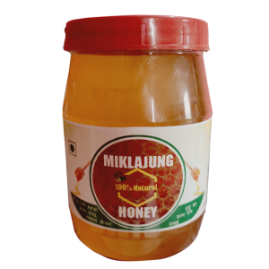Mustard raw honey is a pure, unprocessed honey made from the nectar of mustard flowers. The price of mustard honey is NPR 700/kg.This light amber honey is strained of comb debris almost immediately, as it tends to crystallize very quickly. Mustard honey is high in natural glucose and therefore is normally in semi or fully crystallized state.

1. **Jangali Honey**

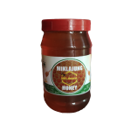Jangali Honey or the wild honey is the types of honey produced by the wild honeybees. It cost RS 850/kg. Wild bees are also known as Apis laboriosa honey are extracted once a year only. It can be found in the holes of the trees, caves and hilly areas. The honey must be made from different species of plant because honey bee collect nectar and pollen in forest.

1. **Royal jelly**

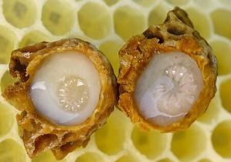Royal jelly is a honey bee secretion that is used in the nutrition of larvae and adult queens. It costs from RS 70,000 to RS 1,00,000. It is secreted from the glands in the hypopharynx of child worker bee, and fed to all the larvae in the colony, regardless of sex or caste.

1. 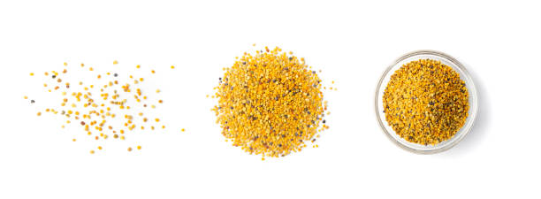**Propolis**

Propolis is a mixture of beeswax and other oils and resins collected by bees and used in construction of the bee hive and in preserving honey and other perishables. It is more expensive.

1. **Bee Venom**

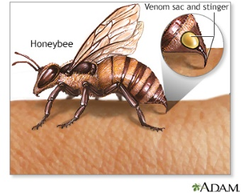Bee venom is a complex mixture of proteins and contains proteins such as phospholipase and melittin, which have an effect on blood clotting and blood clots.It is the poison that is secreted by the bees when they attack others.

# Challenges of Honey bee farming.

The major challenges in bee farming are given below :-

1. It is more challenging to keep bees in small area because it requires large area.
2. The pesticides used in agriculture can kill honey bees.
3. The honey produced by the honeybee might be impure.
4. Well trained person are not easily available to know about the bee farming.
5. Limited access to appropriate beekeeping equipment is among the challenges in bee farming.

# Tools used in Apiculture

The different types of materials that we saw in bee farm are explained below : -

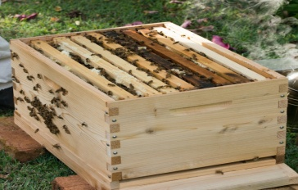

**1) Bee hive**

A bee hive is a rectangular or cylindrical shape that consists of entry holes for bees and different layer of frame to store honey. It is the box where all honeybee survive.

**2)** **Bee Suit**

A beekeeping suit is a protective head-to-ankle garment worn over the clothing by beekeepers when tending to their hives. The fabric, which can be thick, thin, or multilayered, is designed to protect against bee stings. A hat and veils attached to the body helps to prevent stingings in face.

**3)** **Queen Cage**

A queen cage is a small container used to hold a queen bee, usually for shipment. The cage is traditionally made of wood and wire, but plastic queen cages are becoming more common. The purpose of having the queen in a separate container is to protect her from the bees in the colony she is being introduced to, as they do not recognize her as their queen.

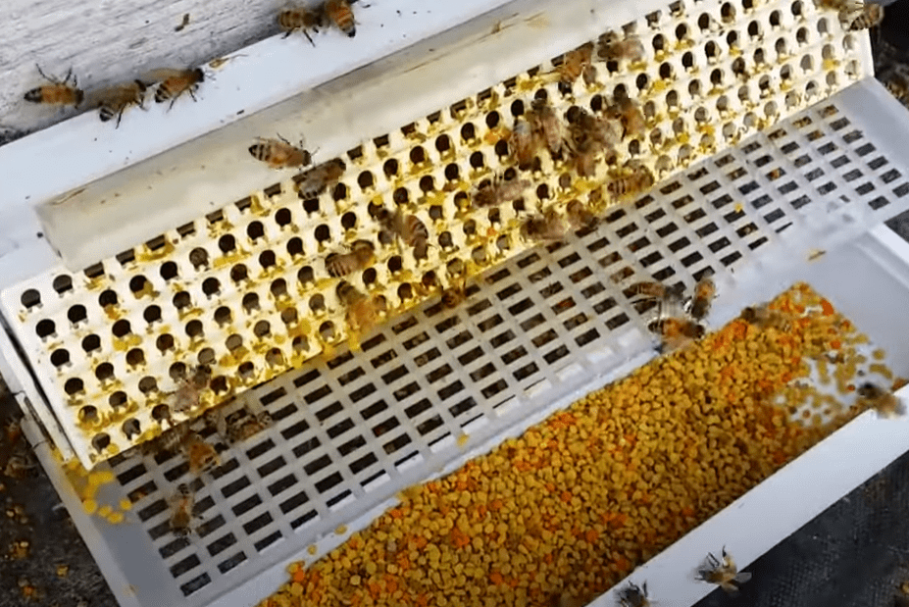

**4)** **Pollean Trap**

A pollen trap is a device that fits over the hive entrance and forces returning foragers to crawl through small openings in order to enter the hive. The openings are so small that some of the pollen pellets are stripped from the bees’ legs and fall into a collection trap.

# CONCLUSION

In Nepal there is presence of large numbers of flowering plants, so Nepal has large probability in bee farming. If it is reared commercially it can make much profit. Bee farming can also be implemented in medical sector, so it has wide range of scope in Nepal.