# Theory Assignment

## Question 1

## A)

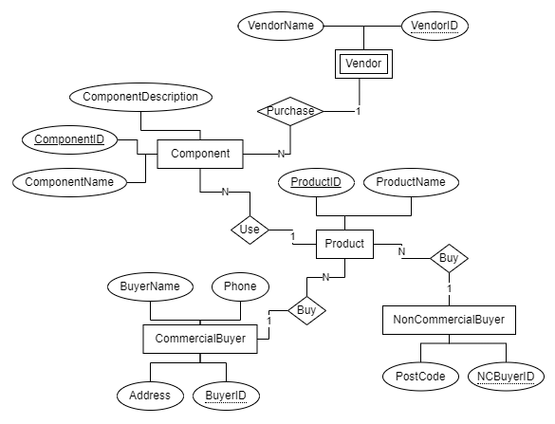

Figure . ERD Diagram of Question 1 A

Assumptions

1. Vendor is a weak entity because it has relation only when there is a component.
2. Many components can be purchased from one vendor.
3. One product can use many components.
4. One non-commercial buyer can buy many products.
5. One commercial buyer can buy many products.

## B)

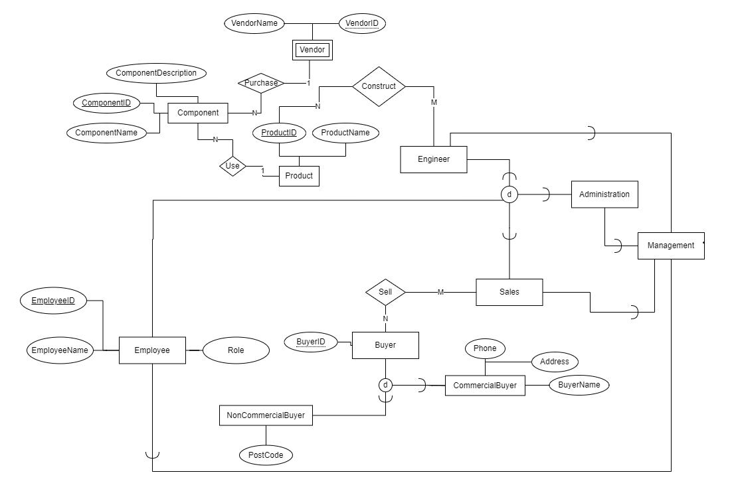

Figure . ERD Diagram of Question 1 B

Assumptions

1. Engineer construct product by using the components. One engineer can construct many products. One product can be constructed by many engineers.
2. Sales sell product to buyer. Buyer can be either commercial or non-commercial.
3. One sales staff can sell product to many buyers and one buyer can purchase from many sales staff.
4. Employee can be either from management, engineer, sales, or administration. Engineer, sales, or administration staff may be a manager as well.

## Question 2

The following is the relational database schema for the data provided, in 3NF:

**Enrollment**

* student_id (foreign key to Student)
* first_name (foreign key to Student)
* last_name (foreign key to Student)
* date_of_birth (foreign key to Student)
* degree (foreign key to Degree)
* school (foreign key to Degree)
* unit_code (foreign key to Unit)
* unit_name (foreign key to Unit)
* degree_length (foreign key to Degree)

**Student**

* student_id (primary key)
* first_name
* last_name
* date_of_birth

**Degree**

* degree_id (primary key)
* degree_name
* degree_length
* school_name (foreign key to School)

**School**

* school_id (primary key)
* school_name

**Unit**

* unit_code (primary key)
* unit_name

**Functional Dependencies**

* student_id -> first_name, last_name, date_of_birth
* degree_id -> degree_name, degree_length
* school_id -> school_name
* unit_code -> unit_name

These relations are in 3NF because:

* The Student table is in 3NF because each non key attribute is fully functionally dependent on the primary key student_id.
* The Degree table is in 3NF because each non key attribute is fully functionally dependent on the primary key degree_id.
* The School table is in 3NF because each non key attribute is fully functionally dependent on the primary key school_id.
* The Unit table is in 3NF because each non key attribute is fully functionally dependent on the primary key unit_id.

The table **Enrollment** is now in 3NF as it is in 1NF and no non-prime attribute is transitively dependent on the primary key. In this schema, all attributes are either primary keys or are fully functionally dependent on a primary key. Therefore, the schema is in 3NF. There are several benefits to using 3NF. First, it helps to prevent data anomalies. Second, it makes the database more efficient to update and maintain. Third, it makes the database more secure.

## Question 3

Applying the algorithm (Testing for Nonadditive Join Property)

|  |  |  |  |  |  |
| --- | --- | --- | --- | --- | --- |
|  | A | B | C | D | E |
| R1 | α1 | α2 | β13 | α4 | α5 |
| **R2** | α**1** | α**2** | α**3** | α**4** | α**5** |
| R3 | α1 | β32 | β33 | α4 | α5 |

From the above table, we can conclude that the decomposition of this schema into {AB}, {BCD}, and {ADE} is lossless.

## Question 4

**A)**

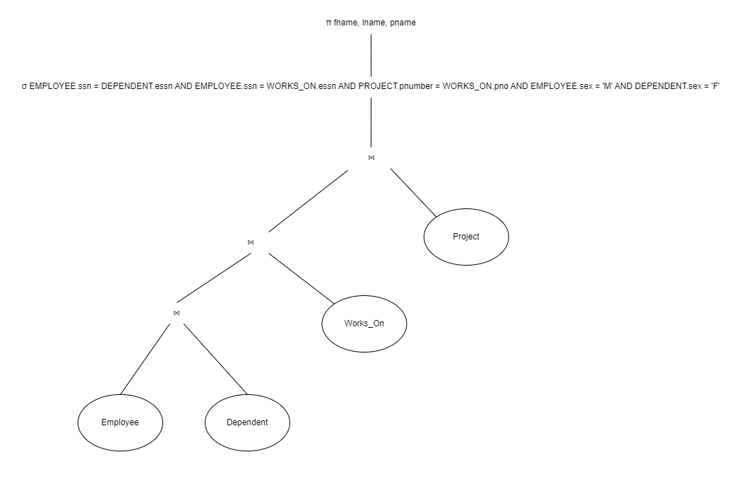

Figure . Canonical Query Tree

**B)**

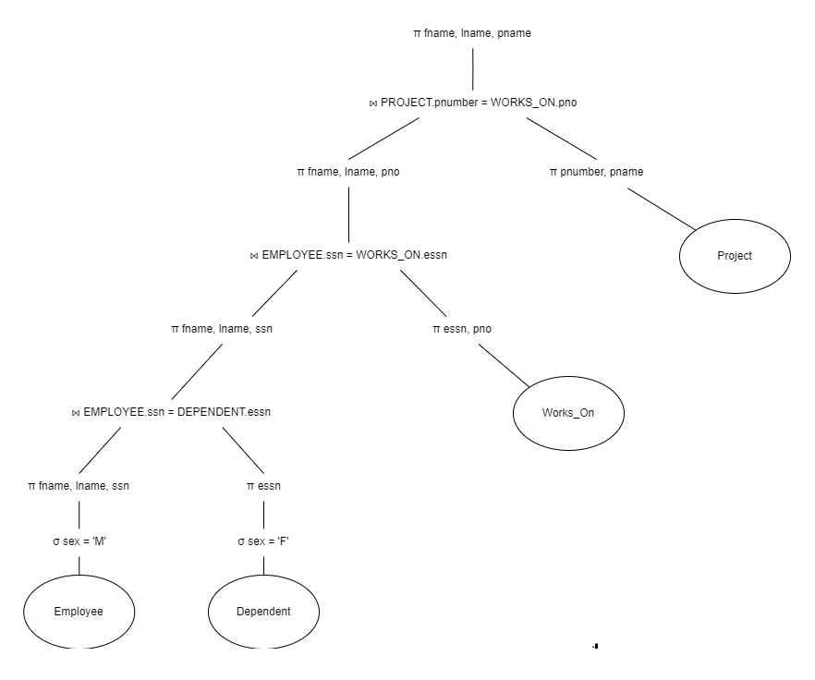

Figure 4. Optimised Query Tree