Answer 27:

Responsive Design

Answer 28 a)

My assignment 1's implementation of responsive design was important since it makes sure that the webpage is accessible and easy to use regardless of the device and screen being used to see it. Responsive design is essential to reach more people and offer a smooth user experience as people access online content from a variety of devices with different screen sizes and resolutions.

Answer 28 b)

Approach 1: Media Queries

Media queries are used to dynamically apply styles to items based on the user's device's specifications, usually using the viewport width. It makes sure that styles are only applied when the prerequisites are satisfied, enabling distinct styling for various screen sizes.

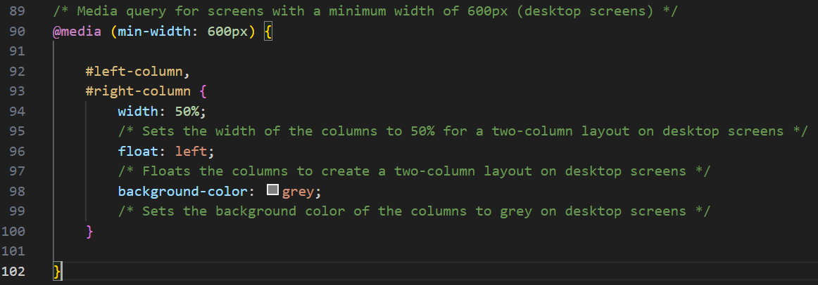

In my assignment 1, the media query adjusts the layout for larger screens by floating the columns to form a two-column layout, each taking up 50% of the width of the container. This media query applies the supplied styles when the viewport width is 600px or higher.

This method of implementing media queries enables adjustments for various screen sizes. By automatically modifying the layout based on the available screen real estate, it makes sure that the webpage layout is user-friendly and visually appealing, not just on computers but also on tablets and mobile devices, offering an ideal viewing experience.

Answer 29 a)

Validation on client-side

Answer 29 b)

In the context of my assignment 2, the principle of client-side validation was important as it ensures that the user has filled out the form correctly before it is submitted, thus enhancing the user's experience, and reducing the load on the server wherever necessary. Client-side validation is the process of verifying user input before it is submitted to the server, often within the user's browser to increase the efficiency of the server and its response.

Answer 29 c)

In my assignment 2, client-side validation was implemented using a combination of Event Listeners, Conditional Statements, and Pattern Matching. Out of these I will describe pattern matching.

My assignment 2 uses regular expressions to validate the format of the user’s input in the email input text field.

In the snippet of my code from assignment 2, a regular expression is used to match the value of the email input against a pattern representing a valid email address format. If the input does not match, a custom validity message is set, and the valid flag is marked as false.

The ability to match user input easily and dynamically against predefined patterns using regular expressions is a valuable technique for performing client-side validation. This ensures data is accurate and complies to expected forms.

Answer 30 a)

Making Asynchronous Requests

Answer 30 b)

The technique of "making asynchronous requests" in my assignment 3, mostly has to do with sending network requests that don't pause the program's main execution thread so that other processes may carry on while the request is being processed. This is significant in web development, because maintaining a responsive user interface is essential. A bad user experience would result if the queries were synchronous, and the user interface became unusable.

In my assignment 3, while making an asynchronous request using jQuery's ajax method,

It makes a POST request to a URL (stored in the variable url).

It sends data serialized from a form with the ID registration.

If the request is successful, it logs the password received from the server to the console and displays a message to the user.

If the request encounters an error, it logs the raw response and attempts to parse and log/display the error message.

In the above code snippets from my assignment 3, as per my knowledge, there may arise a question for security concerns as logging sensitive information like passwords even if it was in temporary form, directly to the console, can expose it to potential security threats. Sensitive information should be handled carefully, and direct logging should be avoided. We were already provided with the starter code and hence, I didn’t want to modify the code more.