Communicating Data Driven Insight

COSC572 Management Information Systems - Assignment 3b

Name: Bikash Neupane

# Part a) Build Your Own Data Visualisation in Tableau (or similar)

URL of Visualisation: https://public.tableau.com/app/profile/bikash.neupane/viz/Earthquakes_16953399144850/Dashboard1_1

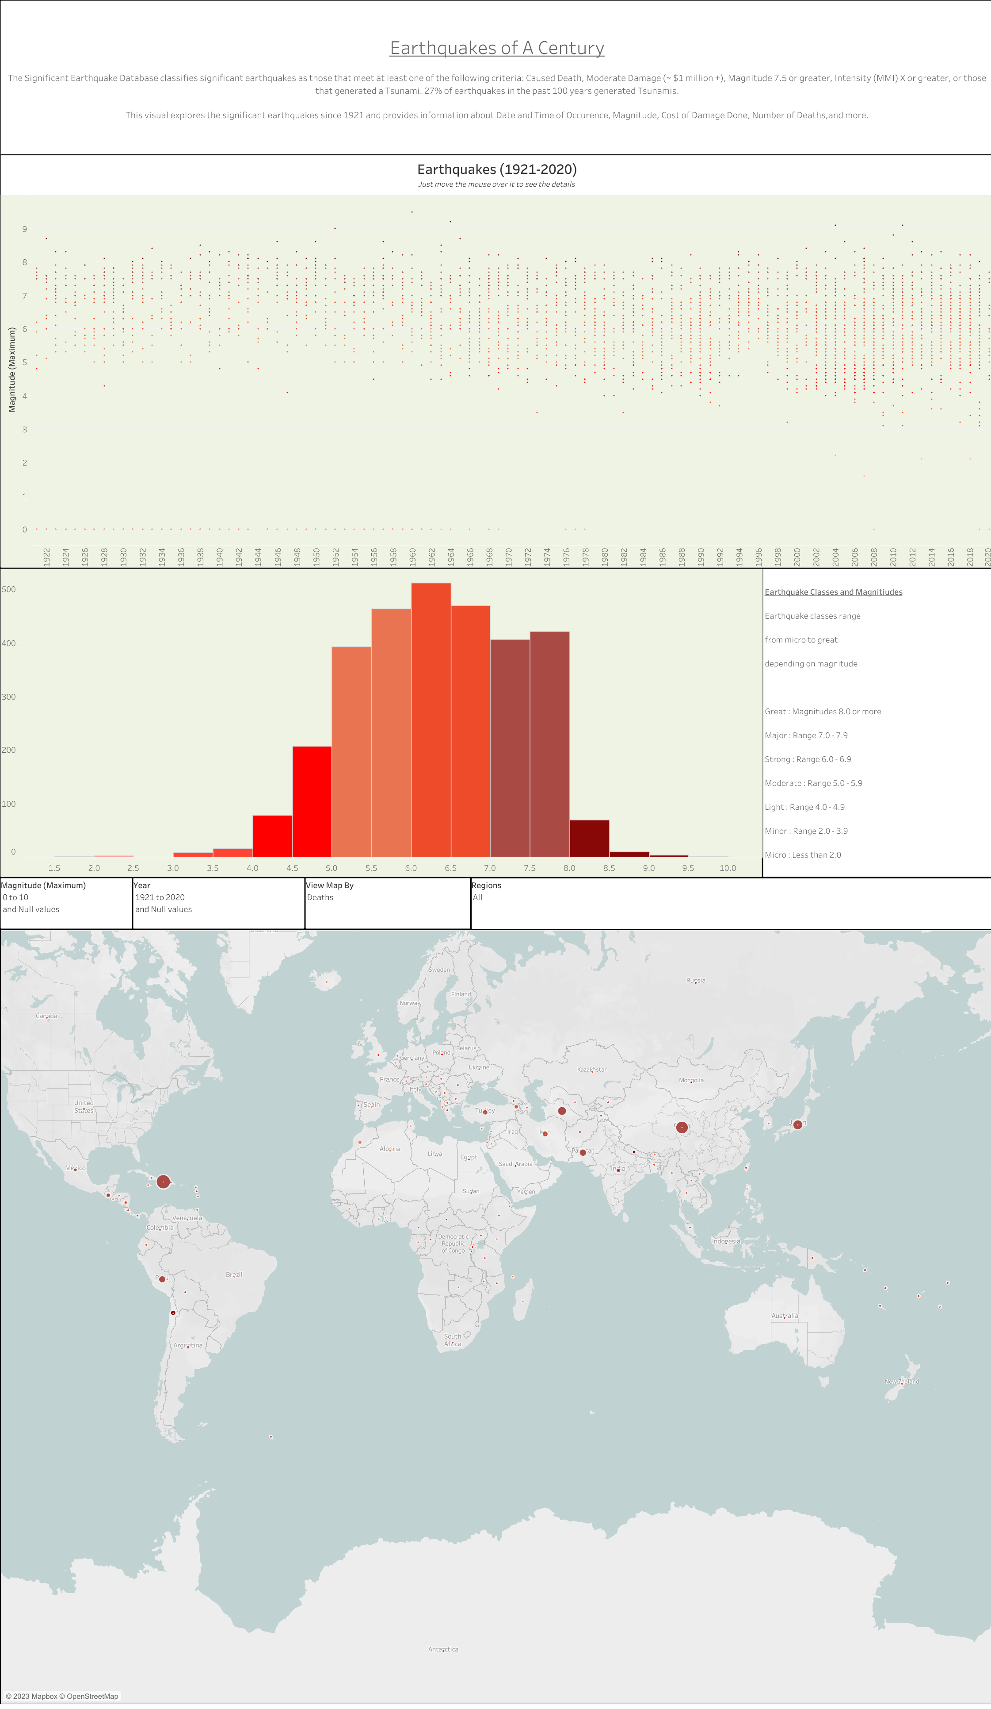

# Part b) Explain Your Application of Unit Theory in Your Data Visualisation

Briefly describe how you used unit theory from Topic 7, Topic 8 or Topic 9 to communicate your insight from your data to your audience.

Guide word limit: less than 500 words total.

My Audience / Target Market

The audience/target market for my visualization includes local governmental bodies, disaster management teams, urban planners, non-profit organizations focusing on disaster relief, as well as digital markets dealing with earthquake preparedness products and services.

My Purpose (in designing this visualisation)

Drawing from the unit, my purpose was to achieve:

* **Operational Excellence:** By presenting earthquake data in a comprehensible format, local governments and organizations can streamline disaster response processes and reduce mitigation costs.
* **Customer Intimacy:** For digital markets dealing in preparedness products and services, understanding earthquake-prone areas allows for tailored product offerings, enhancing customer relations.
* **Digital Markets & Digital Goods Insight:** The visualization can be a valuable digital good, especially for companies in the disaster preparedness industry, informing them where their products might be most needed.

Analysis of my Visualisation

**Knowledge Management:** The visualization captures and displays silent knowledge from seismological experts, converting it into explicit knowledge accessible to anyone. By identifying trends and patterns in earthquake occurrences, I have provided a platform for collaborative understanding and planning.

**Collaborations:** This visual tool can be a foundation for collaborative efforts between disaster relief organizations, local governments, and businesses in the affected regions. It can inform joint strategies and foster partnerships for disaster preparedness and relief.

**Enhancing Decision Making using Information Systems:**

* **Operational Decisions:** On a day-to-day basis, this visualization can help local bodies monitor earthquake-prone zones and prepare accordingly.
* **Managerial Decisions:** The aggregated data can assist regional managers in allocating resources effectively, deciding where more earthquake-resistant infrastructure is needed, or where public awareness campaigns should be concentrated.
* **Strategic Decisions:** On a broader scale, the visualization offers insights for long-term planning. For instance, urban planners and policymakers can use the data to design future city layouts or develop nationwide disaster preparedness strategies.

The central insight my visualization communicates is the pronounced clustering of magnitude 6+ earthquakes around specific global regions, especially the Pacific Ring of Fire. By leveraging the principles from this unit, this visualization not only presents raw data but transforms it into actionable intelligence, bridging the gap between knowledge, collaboration, and decision-making.