Oppgaver GEO2010 Vår 2011
Oppgavesett nr 9
og hjemmeeksamen

Hjemmeeksamen må leveres innen ?. april kl 14.30 enten elektronisk til meg på irenebn(alfakrøll)ulrik.uio.no, eller på papir, utenfor døra på lesesal 219 i ZEB-bygget. Hvis du leverer elektronisk, lever kun én fil (en tekst- eller Word-fil, ikke Excel), og ha med navnet ditt i filnavnet.

Treningsoppgave 9.1

Gjør oppgave 9.2 og 9.3 i Dingman.

Hjemmeeksamen

An example from NVE is also given in classfronter. DO NOT write the report as thorough as they have. It will take to much time. The report is just given as an example of how it can be done.

In your job as a hydrological consultant you are asked to do a hydrological analysis of the possibility of building a powerplant, Bakli powerplant, in the municipality Etne in Hordaland. The result of this analysis, is to be delivered as a SMALL, concise report. Remember; brevity is the soul of wit.

In the map that is given in figure 1. below, the inlet of the powerplant is given.

- Draw the catchment of the powerplant. The different rivers in the catchment are highlighted with blue color. If it is difficult to see, zoom into the picture when you draw. (Download the picture hjemmeeks_kart.jpg from fronter)

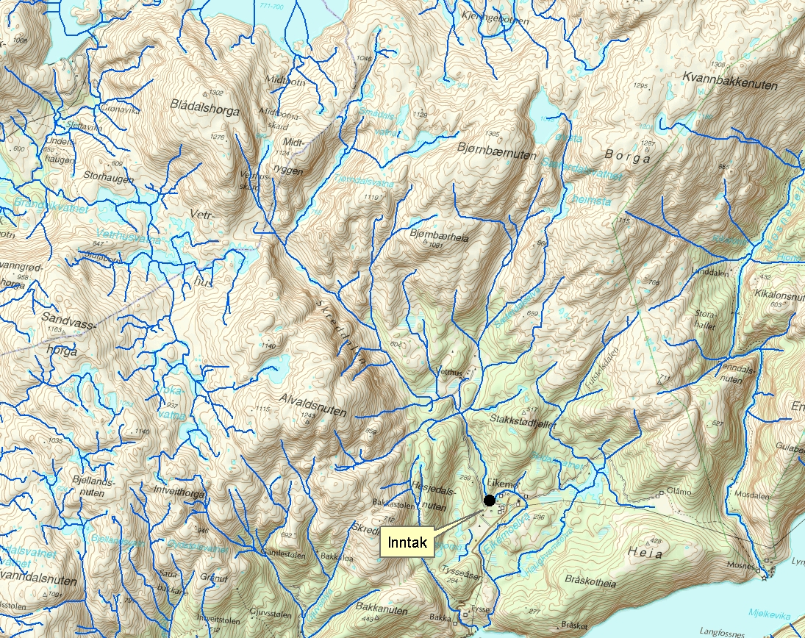
Figure 1. Map of the catchment of Baklia poweplant with the inlet given.

Since we don`t have any hydrologic station at the inlet of the powerplant, we need to find a representative station nearby that we can use. The representative station (catchment) must resemble Baklia`s catchment with respect to physical parameters (size, hypsographic curve, effective lake percentage , discharge from NVE discharge map (Q_{N} (61-90) l/s∙km²) for the normal period 1961-1990). In figure 2. four potential representative catchments are given, and in table 2. their physical characteristics can be found. For Bakli Powerplant, the following physical characteristics can be used (table 1.):

Station | Period | Field-area  (km²) | Lake percentage  (%) | Q_{N} (61-90)¹  (l/s∙km²) | Q_{m} obs²  (l/s∙km²) | Altitude intervall and mean alt.
Bakli powerplant | - | 19,9 | 0,0 | 152 | - | 196-1305 (900)
Table 1. Physical characeristics for Bakli powerplant

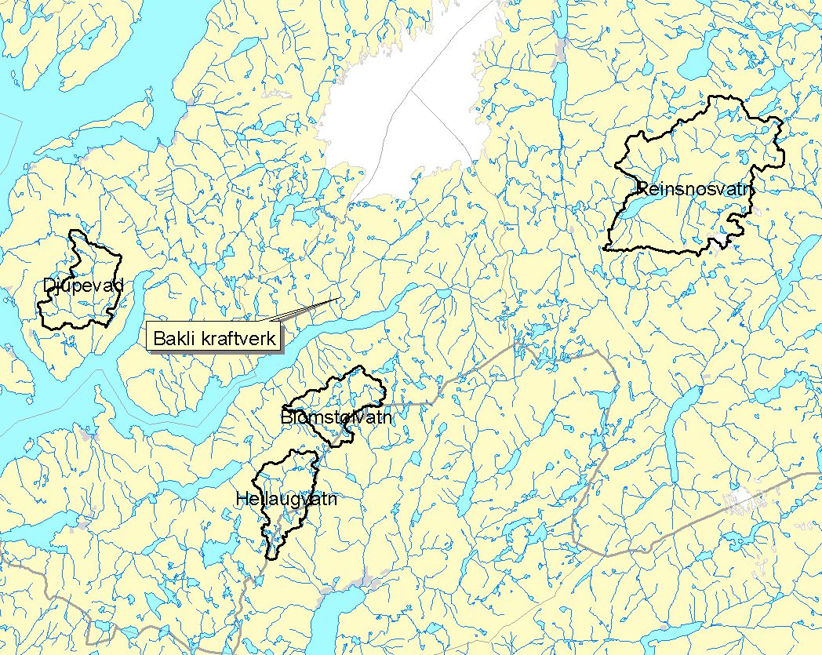
Figure 2. Catchments in the vicinity of Bakli Powerplant.

Station | Period | Field-area  (km²) | Lake percentage  (%) | Q_{N} (61-90)¹  (l/s∙km²) | Q_{m} obs²  (l/s∙km²) | Altitude intervall and mean alt.
41.7 Blomstølvatn | 1981-2003 | 25,7 | 0,6 | 140 | 121,4 | 628-1134
41.8 Hellaugvatn | 1981-d.d. | 27,0 | 1,4 | 126 | 119,1 | 271-1263 (900)
42.2 Djupevad | 1963-d.d. | 31,9 | 0,9 | 108 | 100,3 | 88-1152 (500)
48.5 Reinsnosvatn | 1917-d.d. | 121 | 3,2 | 77 | 75,5³ | 595-1637
¹ Beregnet fra NVEs avrenningskart for normalperioden 1961-1990.
² Beregnet for observasjonsperioden til målestasjonen.
³ Beregnet for perioden 1961-2006 (2005 utelatt pga manglende data)
Table2. Physical characeristics for catchments in the vicinity of Bakli Powerplant

- Which one of the four potential catchments is the most representative for the catchment of Baklia Powerplant, and why? Give a small discussion. The unit l/s∙km² is often used in hydrology instead of mm.

When we have chosen the representative catchment, we can use the data from that catchment in the analysis for Bakli powerplant. But since the representative station has a different size and discharge compared to Baklia, we need to scale the discharge. To do so we use the relation between the size for the representative station and Baklia as a first factor, and the relation between the discharges as the second factor:

Factor 1 = (size Baklia km² / size repr. Catchment km²)
Factor 2 = (discharge Baklia l/s∙km² / discharge repr. catchment l/s∙km² )

Total correction factor = Factor 1 * Factor 2

The total correction factor can then be multiplied with the discharge (each day) for the representative station. This discharge will then be the discharge at Baklia Powerplant.

In the excel file, the mean and minimum discharge for each day is given. The mean discharge for one specific day is the mean discharge of that specific day of all the years there is data.

- Calculate the total correction factor. In an excel file in fronter, discharge data (m/s) for the representative station is given. Use these data independent of which of the four representative stations you have chosen. Multiply the discharge data from the file with the total correction factor (multiply each day with the factor), both the mean data and the minimum data.

- Plot the new corrected mean data and minimum data in one plot. Use date on x-axis and discharge (m/s) on y-axis. Is it likely that the river will dry up in some periods during the year and we cannot produce electrical power?

- What is the mean annual discharge at Bakli Powerplant? If we assume that with a discharge of 1m/s the effect of the power plant is 1kW. In one hour this will be 1kWh, and 1*24*365(kWh)=8760 kWh in one year. How much will Bakli powerplant produce if the yearly mean discharge is used? For comparison, the mean consumption for each household in Norway is about 20 000 kWh each year. Statkrafts biggest powerplant has an effect of 1350 MW (Ulla-Førre). If this powerplant is run throughout a year at full effect, it will produce 11826000 MWh or 11.8 TWh.

- By looking at the plot of the mean values, what sort of hydrological regime would you think this is? You don`t need to give the exact regime, but give the typical regime characteristics you can see from the plot.

