GEO2010 Spring 2017
Exercise 8

Obligatory exercise 8 must be submitted by April 3, 2017.

Training Exercise 8.1
This exercise concerns the contents of chapter 10 in Dingman.
Stream Order
Stream orders describe the bifurcation (Norsk: “Forgrening”) of a river network. The order of a stream can be determined by following these steps (See figure 10.1 on page 456 in Dingman):

a. Give the smallest fingertip tributaries order 1.

b. Where two channels of order i join, a channel of order i+1 results. For example, when two streams of order 1 join together, a stream of order 2 results. When two streams of order 2 join together, a stream of order 3 results.

c. Where a stream of lower order joins a stream of higher order, the stream downstream retains the higher of two orders.

- Define drainage density and various shape factors.
Eq. 10.7 in Dingman:

is the drainage density of an area and is the total length of streams draining that area.

2) Determine stream order for a given basin from a given map of a stream network (Figure 1)

3 Calculate the drainage and stream density from a drainage basin map presented in figure 1.
[ given: Drainage area = 365 sq km; number of streams = 67; total length of all streams = 23 km]

4. How many meteorological station are required in Oslo so as to limit the percentage error with 5% during annual rainfall estimation. [Given: Average annual precipitation = 763 mm, Standard deviation = 75 mm]

5. If the standard deviation of annual mean rainfall of the 5 station was 218 mm in a basin 'A' and mean rainfall over the basin is 1000 mm, how much percent error could be expected during the rainfall estimation?

Obligatory Exercise 8
1. A drainage basin is found to have the following data: Area of the basin = 2500 km2; Length of the main stream = 110 km, the perimeter of the basin = 367 km. Determine the form factor, circularity ratio, elongation ratio and the compactness coefficient for the basin.

2. For an urban watershed, estimate and compare the time of concentration using the Kirpich (1940), Chow(1962) and NERC (1975) methods and comment on your results. (for formula please refer Dingman Table 10.8, page 513) [Given: Length of Main stream (L) = 110 km, Sine of channel slope angle (Sc) = 0.35)

Shape of basin
The shape of the basin is quantitatively measured by various factors such as form factor, circulatory ratio, elongation ratio and compactness codfficient.
The form factor Ff is defined as the ratio of the basin area to the square of the basin length. That is

Ff = A/L2
Where, A is drainage basin area and L is drainage basin length.

Circulatory ratio Cr: It is a ratio of the drainage basin area to the area of the circle whose perimeter is equal to the perimeter of basin

Cr = 4ΠA/p2

Where, P is Perimeter of drainage basin.

Elongation ratio Er: It is a ratio of diameter of a circle whose area is same as the area of drainage basin to the length of the basin.
Er = D/L
Where, D is diameter of circle having area of drainage basin.

Compactness coefficient Cc: it is a ratio between perimeter of a drainage basin and perimeter of circle whose area is equal to the area of the area of drainage basin.

Cc = P/√(4ΠA)

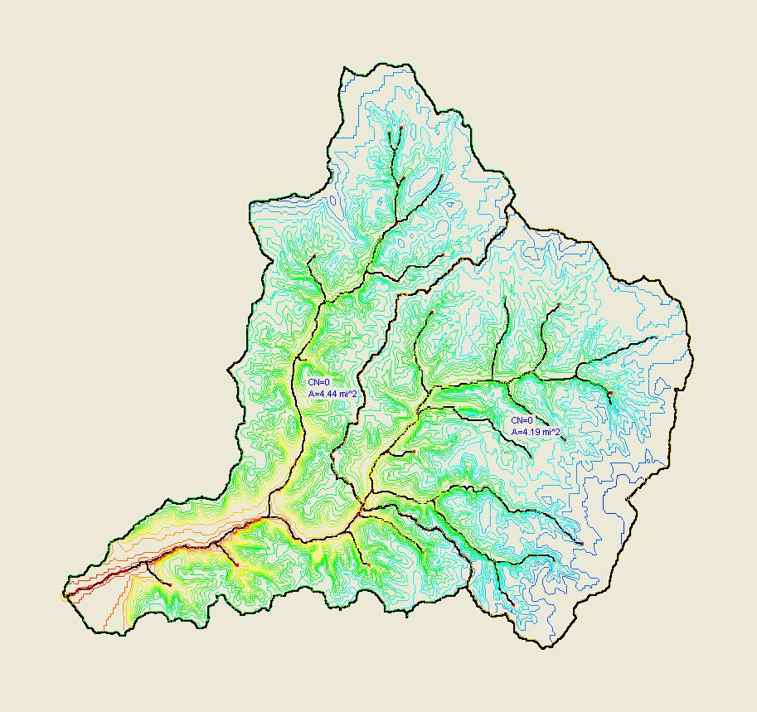
Figure 1: Catchment

