API: Spring Boot, Jpa, H2

Unit testing : Junit

Create contact - http://localhost:8080/rest/contacts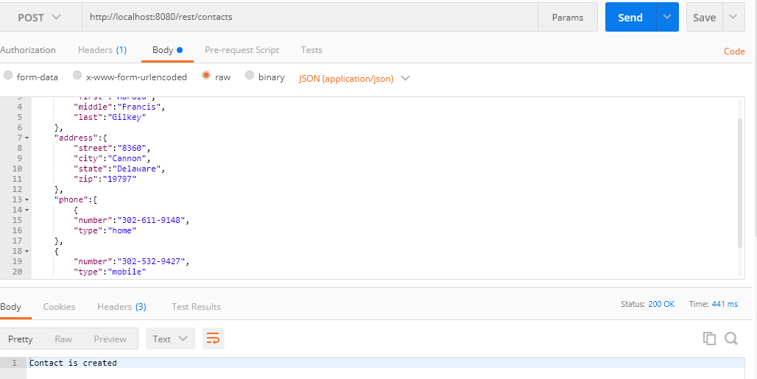

Get Contacts - http://localhost:8080/rest/contacts

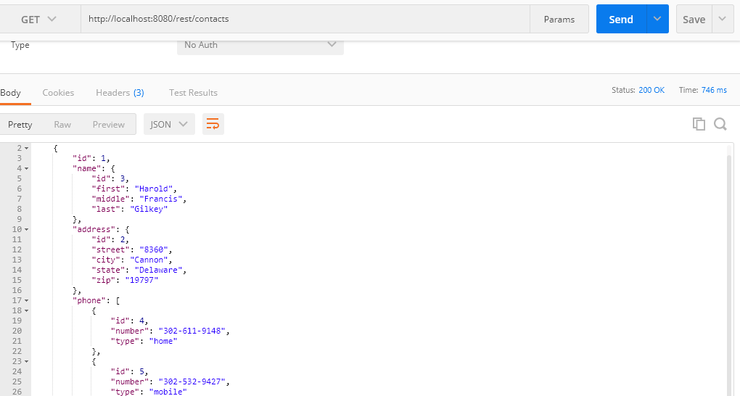

Get the contact based on id - http://localhost:8080/rest/contacts/1

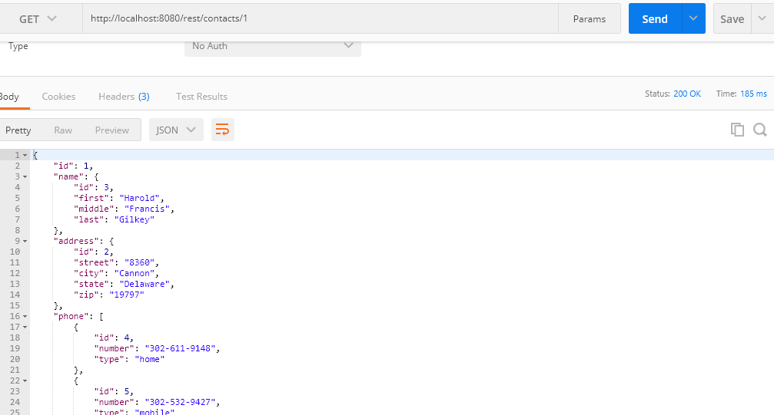

Update the contact - http://localhost:8080/rest/contacts/1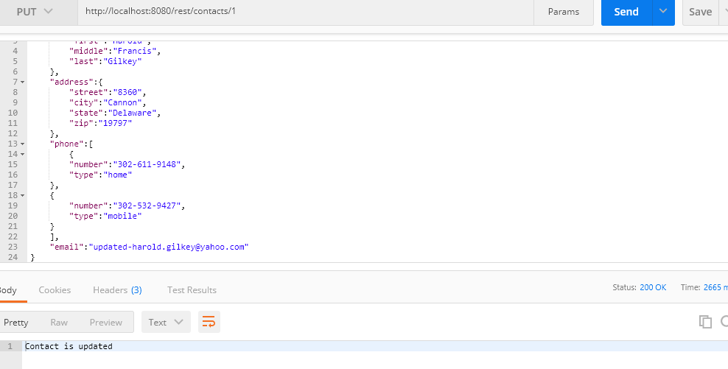

Delete the contact based on id - http://localhost:8080/rest/contacts/1

