About Cuttack

==========================================================

History

The word “Katak” etymologically means army cantonment and also the capital city. The history of Cuttack amply justifies its name.The city of Cuttack started as a military cantonment because of its impregnable situation that further developed into the capital of the state of Odisha. Inscriptions of Anangabhimadeva lll refer the orginal city as Abhinab-Baranasi–Katak. Like the city of Baranasi, situated in between Baruna and Asi, Cuttack is situated between the rivers Mahanadi and Kathajodi and was therefore named as Abhinab Baranasi (a new type of Baranasi). Cuttack developed into a city out of five villages’ viz. Choudwar Katak, Baranasi Katak, Sarangagarh Katak, Viraja Katak and Amaravati Katak. In the remote past, Cuttack was connected both by land routes and waterways with the renowned medieval ports like Chelitalo, Palur and Tarmalipti.

Although politically Cuttack was not that significant before the 8th century A.D, still it was a flourishing mart of Eastern trade. However,Cuttack became a capital city at the end of the 10th century A.D,during the reign of Somavanansi dynasty of Odisha.The importance of Cuttack rapidly increased after the occupation of Odisha by Chodagangadeva early in the 12th century A.D. Chodaganga transferred his capital from Kalinganagar to Katak, which was more centrally located. The famous Barabati Fort was constructed in 1229 A.D.by the famous Ganga ruler Anangabhimadeva lll.After the Ganges, Odisha passed into the hands of the Gajapati under whom Cuttack continued to be the capital of the state. The reference from Ain–i–Akbari clearly denotes that Cuttack was a flourishing capital city during the time of Mukunda Deva. On the eve of Afghan occupation, Cuttack was found to be a well guarded and heavily fortified capital.The Afghans however were not destined to rule Odisha and they were soon ousted by the Imperial Mughals. Cuttack continued to be the capital of Mughal Odisha and Abul Fazl clearly mentions that Mughal Governor was residing in that city.

During the rule of the Marathas, Cuttack greatly prospered as an emporium of trade and commerce and became a central market for exchange between the Marathas of Nagpur and the English merchants of Bengal and Northern Circar.As per the treaty of Deogaon, Cuttack came under British occupation in 1803 and the English set themselves to the task of consolidation and land revenue administration. As an after effect of the devastating famine of 1866, the government gave serious consideration to remove the isolation of Cuttack from the outside world and at the same time to prevent the recurrence of such calamities in future. Along with several water ways, roads were also opened during the later part of the 19th century to provide Cuttack with internal communication. Then towards the last decade of the 19th century, railway line of BNR connected Cuttack directly with Madras and Calcutta.

The first newspaper of Odisha, ‘Utkal Dipika’ was published by the Cuttack Printing Company due to the efforts of Gourisankar Ray in 1866. There was a great change in the educational scenario of Cuttack after the British occupation, with the establishment of the first Government English School in 1841. It slowly progressed as the Higher English School until the famine of 1886. Then the school was converted into a college with intermediate teaching in 1868, which in due course of time took the name of Ravenshaw College. Ravenshaw College was converted to Ravenshaw University on 15th November 2006. Odisha Medical was established in 1875, following the establishment of Cuttack General Hospital in 1874.

The Cuttack Municipality came into existence in 1876. In 1923, two new educational institutions opened in Cuttack. One was Cuttack Training College and the other was Odisha School of Engineering, which developed out of the old Survey School, separated from the Ravenshaw College in 1915 and from the Government workshop located at Jobra.

Barabati Stadium During the freedom struggle, Swaraj Ashram of Sahebazada Bazar was the center of all nationalist activities. The Ashram is a place of pilgrimage for all Gandhites as Gandhiji indoctrinated the youths of Odisha with the mantra of truth and nonviolence.Cuttack has been enjoying all along the unique privilege of being the administrative and commercial nerve center of Odisha. It was the seat of the Commissioner of Odisha Division till 1936, and with the formation of the province of Odisha in that year; it was exalted to be the head quarter of the new province. The historic Lalbagh place which was being occupied by the Commissioner became the Governor House. Now it has been converted to children’s hospital called ‘Sishu Bhawan’. A stadium known as the Barabati Stadium has been built on the famous Killa Maidan near the Barabati Fort.

The High court came into existence in 1948 and its building is another impressive structure of Indo-European style. In 1948, Akasvani (All India Radio) was established in the old Madhupur building of Cuttack.The city is reputed all over the country for its exquisite and delicate filigree works, artistic horn works and as also for its fine and multi-coloured textile products.The state government finally selected Bhubaneswar, situated at a distance of eighteen miles from Cuttack, as its new capital in accordance with the plan of greater Cuttack. Though Bhubaneswer has been made the new capital of Odisha, still Cuttack acts as a bridge linking the past, present and future of state’s history and heritage. It is ranked as one of the old cities of India with her life spread over for more than thousand years; being famous as the ‘Millennium City’.

**History of Cuttack**

Founded in the year 989 A.D. by the Keshari Dynasty, Cuttack is one of the oldest cities of India. Anglicized from a Sanskrit word, ‘KATAK’ which means the military camp or seat or fort of a kingdom, upon which the city has being named as Cuttack. Inscriptions of Anangabhimadeva lll refer the orginal city as Abhinab-Baranasi–Katak. Like the city of Baranasi, situated in between Baruna and Asi, Cuttack is situated between the rivers Mahanadi and Kathajodi and was therefore named as Abhinab Baranasi (a new type of Baranasi). Cuttack developed into a city out of five villages’ viz. Choudwar Katak, Saranasi Katak, Sarangagarh Katak, Viraja Katak and Amaravati Katak. In the remote past, Cuttack was connected both by land routes and waterways with the renowned medieval ports like Chelitalo, Palur and Tarmalipti.

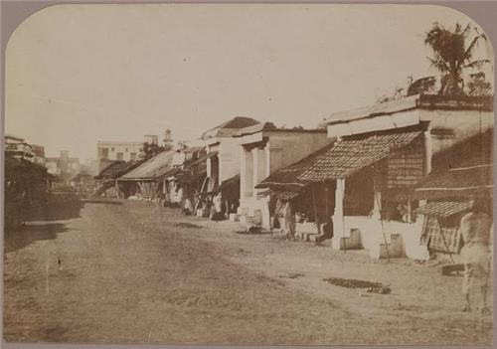

**Cuttack – The Former Capital of Odisha**

Cuttack has been the capital of the state for centuries and has been the home for the armed forces of the kingdoms that ruled the state. After the Keshari dynasty Cuttack was under the rulings of Ganga dynasty under the rulings of Emperor Anangabhima Deva. Later on Gajaptati kings ruled the City of Cuttack which then came under the rulings of Mughals and Muslim Emperors after death of the last Hindu king who ruled, Raja Mukunda Deva. Kalinga was the name of Odisha in past and Katak was its capital which was then shifted to Bhubaneswar after India got the freedom in 1947. Bhubaneswar being a planned city but was the most favored option for the capital of the state but the administrative capital of the state is still Cuttack as the High Court is situated here.

**Legends Related to Cuttack**

There are several evidences of the ancient time culture of the state still present in form of remaining of several historic monuments still there in the City of Cuttack. Barabati fort is among such historical monuments which were built in the ancient times in order to safeguard the province and provide home to the army of the kingdom ruling the state. It is believed that the first Guru of Sikh religion Guru Nanak Dev Ji Maharaj visited Odisha while his journey to West Bengal. In the memory of his visit to the city Gurudwara Dataan Sahab is being built near the banks of River Mahanadi.

**Cuttack – Birthplace of Great Leaders of the Country**

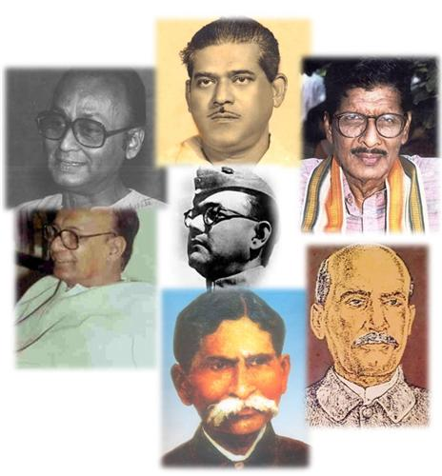The city of Cuttack is known worldwide due to many great personalities who were born here. Netaji Subhash Chandra Bose was among a few leaders of India who fought for the independence of the country from the British rulers. Utkal Gourav Madhusudan Das was born in 1848 at Satyabhamapur village of Cuttack district. He was a renowned poet, freedom fighter. Later on he was a part of Indian politics and his contribution towards the welfare of people got him the title of ‘Utkal Gourav’ which means the pride of Utkal (Odisha). Akshaya Mohanty was a singer, songwriter, writer and musician born at Kendrapada but his home town was Cuttack to which he returned at the age of 22. Also known as Khokha bhai, Akshaya Mohanty has contributed to Oriya Bhajanas, Odissi, folk songs, non-film modern light songs in Orissa on contemporary themes.  
  
  
Today, Cuttack is one of the developed and literate cities of Odisha with most of the people employed. Growth in textile industries and markets of the city, the complete face of Cuttack has changed. Due to the historical connections it has been one of the most favored tourist places of Odisha attracting thousands of tourists every year.

Administration:

|  |  |
| --- | --- |
| **Cuttack**  **Katak** | |
| **Metropolitan City** | |
| [Clockwise from top left: Deity of Cuttack Chandi Temple, Barbati Fort Gate, Welcome arch for Baliyatra, Barabati stadium, Baba Dhabaleshwar Mahadev Temple, A view of the Jobra barrage on Mahanadi River, Orissa High Court](https://en.wikipedia.org/wiki/File:Montage1.png)  Clockwise from top left: Deity of Cuttack Chandi Temple, Barbati Fort Gate, Welcome arch for Baliyatra, Barabati stadium, Baba Dhabaleshwar Mahadev Temple, A view of the Jobra barrage on Mahanadi River, Orissa High Court | |
| [Cuttack is located in Odisha](https://en.wikipedia.org/wiki/File:India_Orissa_location_map.svg)  Cuttack  Cuttack  Location in Odisha, India  [Cuttack is located in India](https://en.wikipedia.org/wiki/File:India_location_map.svg)  Cuttack  Cuttack  Cuttack (India)  Show map of OdishaShow map of IndiaShow all | |
| Coordinates: https://upload.wikimedia.org/wikipedia/commons/thumb/5/55/WMA_button2b.png/17px-WMA_button2b.png[20°31′25″N 85°47′17″E](https://tools.wmflabs.org/geohack/geohack.php?pagename=Cuttack&params=20_31_25_N_85_47_17_E_type:city(606007)_region:IN-OR)[Coordinates](https://en.wikipedia.org/wiki/Geographic_coordinate_system): https://upload.wikimedia.org/wikipedia/commons/thumb/5/55/WMA_button2b.png/17px-WMA_button2b.png[20°31′25″N 85°47′17″E](https://tools.wmflabs.org/geohack/geohack.php?pagename=Cuttack&params=20_31_25_N_85_47_17_E_type:city(606007)_region:IN-OR) | |
| **Country** | https://upload.wikimedia.org/wikipedia/en/thumb/4/41/Flag_of_India.svg/23px-Flag_of_India.svg.png [India](https://en.wikipedia.org/wiki/India) |
| **State** | [Odisha](https://en.wikipedia.org/wiki/Odisha) |
| [**District**](https://en.wikipedia.org/wiki/List_of_districts_of_India) | [Cuttack](https://en.wikipedia.org/wiki/Cuttack_District) |
| **Established** | 989 CE |
| **Founded by** | Markat Keshari of Keshari Dynasty |
| [**Named for**](https://en.wikipedia.org/wiki/Namesake) | Ancient military cantonment of [Utkal](https://en.wikipedia.org/wiki/Utkal" \o "Utkal) |
| **Government** | |
| **• Type** | [Municipal Corporation](https://en.wikipedia.org/wiki/Municipal_Corporations_in_India) |
| **• Body** | [Cuttack Municipal Corporation (CMC)](https://en.wikipedia.org/wiki/Cuttack_Municipal_Corporation) |
| **•**[**Member of Parliament**](https://en.wikipedia.org/wiki/Member_of_Parliament) | **Bhartruhari Mahatab**, ([BJD](https://en.wikipedia.org/wiki/Biju_Janata_Dal)) |
| **• Collector & District Magistrate** | Shri Bhabani Shankar Chayani |
| **•**[**Deputy Commissioner of Police**](https://en.wikipedia.org/wiki/Bhubaneswar-Cuttack_Police_Commissionerate) | Shri Akhileshwar Singh, [IPS](https://en.wikipedia.org/wiki/Indian_Police_Service) |
| **Area** | |
| **• Metropolitan City** | 398 km2 (154 sq mi) |
| **• Metro** | 192.5 km2 (74.3 sq mi) |
| **Elevation** | 36 m (118 ft) |
| **Population**   (2011)[[1]](https://en.wikipedia.org/wiki/Cuttack#cite_note-pop-1) | |
| **• Metropolitan City** | 606,007 |
| **• Rank** | [72nd](https://en.wikipedia.org/wiki/List_of_most_populous_cities_in_India) |
| **• Density** | 3,100/km2(8,000/sq mi) |
| **•**[**Metro**](https://en.wikipedia.org/wiki/Metropolitan_area) | 666,702 |
| [**Demonym(s)**](https://en.wikipedia.org/wiki/Demonym) | Katakia |
| **Languages** | |
| **• Official** | [Odia](https://en.wikipedia.org/wiki/Odia_language) |
| [**Time zone**](https://en.wikipedia.org/wiki/Time_zone) | [UTC+5:30](https://en.wikipedia.org/wiki/UTC%2B5:30) ([IST](https://en.wikipedia.org/wiki/Indian_Standard_Time)) |
| [**ZIP code(s)**](https://en.wikipedia.org/wiki/Postal_Index_Number) | 7530xx/754xxx |
| **Telephone code** | 0671 |
| [**Vehicle registration**](https://en.wikipedia.org/wiki/Vehicle_registration_plate) | OD-05 |
| [**UN/LOCODE**](https://en.wikipedia.org/wiki/UN/LOCODE) | IN CUT |
| **Website** | [cmccuttack.gov.in](http://cmccuttack.gov.in/) |

Link: https://en.wikipedia.org/wiki/Cuttack#cite_note-pop-1

|  |
| --- |
|  |
| |  |  |  |  |  |  |  |  |  |  |  |  |  |  |  |  |  |  |  |  |  |  |  |  |  |  |  |  |  |  |  |  |  |  |  |  |  |  |  |  |  |  |  |  |  |  |  |  |  |  |  |  |  |  |  |  |  |  |  |  |  | | --- | --- | --- | --- | --- | --- | --- | --- | --- | --- | --- | --- | --- | --- | --- | --- | --- | --- | --- | --- | --- | --- | --- | --- | --- | --- | --- | --- | --- | --- | --- | --- | --- | --- | --- | --- | --- | --- | --- | --- | --- | --- | --- | --- | --- | --- | --- | --- | --- | --- | --- | --- | --- | --- | --- | --- | --- | --- | --- | --- | --- | | |  |  | | --- | --- | |  | | | As of 2001 India census, Cuttack had a population of 534,654. Males constituted 52% of the population and females 48%. Cuttack has an average literacy rate of 77% with male literacy at 86% and female literacy at 67%. 29% of the population is under 14 years of age. Around 94% of the city's population is Hindu. Muslims account for around 5% while Christians and Sikhs comprise the rest. | | |  | | | |  |  |  |  | | --- | --- | --- | --- | | **Block Information** | | | | | **Males** | **Females** | **Total** | **Decennial Growth rates (1991-2001) %age** | | **Cuttack  Population** | | | | | 1207569 | 1133117 | 23,40,686 | 14.00 | | **Population age group(0-6)** | | | | | 26,56,046 | 25,24,505 | 2,73,665 | N.A. | | **Literacy Population** | | | | | 9,11,467 | 6,62,179 | 15,73,646 | N.A. | | **Literacy % Total** | | | | | 85.46 | 66.19 | 76.13 | N.A. | | **Sex ratio Female per 1000’male** | | | | | N.A. | N.A. | 938 | N.A. | | | | **Demography** | | | **C**uttack has all the ingredients of progressive  district on the demographic indicators. The decadal growth rate has declined to a healthy level at 14.00%, much below the national and state growth rates. The declining trend has firmly set in as the following graph shows. At this rate, by the end of next two decades, population of Cuttack will stabilize. | C:\Documents and Settings\BHUMIKA\Desktop\Latestcmc\image\POPULATION.jpg | | |

Link: <http://cmccuttack.gov.in/population.html>

Html code:

|  |
| --- |
| <tr> |
|  | <td height="25" colspan="2" align="left" valign="top" bgcolor="#ffffff" class="maincont">As of 2001 India census, Cuttack had a population of 534,654. Males constituted 52% of the population and females 48%. Cuttack has an average literacy rate of 77% with male literacy at 86% and female literacy at 67%. 29% of the population is under 14 years of age. Around 94% of the city's population is Hindu. Muslims account for around 5% while Christians and Sikhs comprise the rest.</td> |
|  | </tr> |
|  | <tr> |
|  | <td height="20" colspan="2" align="left" valign="top" bgcolor="#ffffff" class="maincont"></td> |
|  | </tr> |
|  | <tr> |
|  | <td height="25" colspan="2" align="left" valign="top" bgcolor="#AAAAAA" class="maincont"><table width="100%" border="0" cellspacing="1" cellpadding="0"> |
|  | <tr> |
|  | <td height="30" colspan="4" align="left" valign="middle" bgcolor="#FFFFFF"><span class="subheading"><strong>&nbsp;&nbsp;Block Information</strong></span></td> |
|  | </tr> |
|  | <tr> |
|  | <td width="150" height="30" align="center" valign="middle" bgcolor="#FFFFFF"><span class="subheading">Males</span></td> |
|  | <td width="150" height="30" align="center" valign="middle" bgcolor="#FFFFFF"><span class="subheading">Females</span></td> |
|  | <td width="150" height="30" align="center" valign="middle" bgcolor="#FFFFFF"><span class="subheading">Total</span></td> |
|  | <td width="150" height="30" align="center" valign="middle" bgcolor="#FFFFFF"><span class="subheading">Decennial Growth rates (1991-2001) %age</span></td> |
|  | </tr> |
|  | <tr> |
|  | <td height="30" colspan="4" align="left" valign="middle" bgcolor="#FFFFFF"><span class="subheading"><strong>&nbsp;&nbsp;Cuttack&nbsp; Population</strong></span></td> |
|  | </tr> |
|  | <tr> |
|  | <td height="30" align="center" valign="middle" bgcolor="#FFFFFF" class="maincont">1207569</td> |
|  | <td height="30" align="center" valign="middle" bgcolor="#FFFFFF" class="maincont">1133117</td> |
|  | <td height="30" align="center" valign="middle" bgcolor="#FFFFFF" class="maincont">23,40,686</td> |
|  | <td height="30" align="center" valign="middle" bgcolor="#FFFFFF" class="maincont">14.00</td> |
|  | </tr> |
|  | <tr> |
|  | <td height="30" colspan="4" align="left" valign="middle" bgcolor="#FFFFFF"><span class="subheading">&nbsp;&nbsp;Population age group(0-6)</span></td> |
|  | </tr> |
|  | <tr> |
|  | <td height="30" align="center" valign="middle" bgcolor="#FFFFFF" class="maincont">26,56,046</td> |
|  | <td height="30" align="center" valign="middle" bgcolor="#FFFFFF" class="maincont">25,24,505</td> |
|  | <td height="30" align="center" valign="middle" bgcolor="#FFFFFF" class="maincont">2,73,665</td> |
|  | <td height="30" align="center" valign="middle" bgcolor="#FFFFFF" class="maincont">N.A.</td> |
|  | </tr> |
|  | <tr> |
|  | <td height="30" colspan="4" bgcolor="#FFFFFF"><span class="subheading">&nbsp;&nbsp;Literacy Population</span></td> |
|  | </tr> |
|  | <tr> |
|  | <td height="30" align="center" valign="middle" bgcolor="#FFFFFF" class="maincont">9,11,467</td> |
|  | <td height="30" align="center" valign="middle" bgcolor="#FFFFFF" class="maincont">6,62,179</td> |
|  | <td height="30" align="center" valign="middle" bgcolor="#FFFFFF" class="maincont">15,73,646</td> |
|  | <td height="30" align="center" valign="middle" bgcolor="#FFFFFF" class="maincont">N.A.</td> |
|  | </tr> |
|  | <tr> |
|  | <td height="30" colspan="4" bgcolor="#FFFFFF"><span class="subheading">&nbsp;&nbsp;Literacy % Total</span></td> |
|  | </tr> |
|  | <tr> |
|  | <td height="30" align="center" valign="middle" bgcolor="#FFFFFF" class="maincont">85.46</td> |
|  | <td height="30" align="center" valign="middle" bgcolor="#FFFFFF" class="maincont">66.19</td> |
|  | <td height="30" align="center" valign="middle" bgcolor="#FFFFFF" class="maincont">76.13</td> |
|  | <td height="30" align="center" valign="middle" bgcolor="#FFFFFF" class="maincont">N.A.</td> |
|  | </tr> |
|  | <tr> |
|  | <td height="30" colspan="4" align="left" valign="middle" bgcolor="#FFFFFF"><span class="subheading">&nbsp;&nbsp;Sex ratio Female per 1000&rsquo;male</span></td> |
|  | </tr> |
|  | <tr> |
|  | <td height="30" align="center" valign="middle" bgcolor="#FFFFFF" class="maincont">N.A.</td> |
|  | <td height="30" align="center" valign="middle" bgcolor="#FFFFFF" class="maincont">N.A.</td> |
|  | <td height="30" align="center" valign="middle" bgcolor="#FFFFFF" class="maincont">938</td> |
|  | <td height="30" align="center" valign="middle" bgcolor="#FFFFFF" class="maincont">N.A.</td> |
|  | </tr> |
|  | </table></td> |
|  | </tr> |
|  | <tr> |
|  | <td height="25" colspan="2" align="left" valign="middle" bgcolor="#FFFFFF" class="maincont"><strong class="subheading">Demography</strong></td> |
|  | </tr> |

|  |
| --- |
|  |
| |  |  |  |  |  | | --- | --- | --- | --- | --- | | Block Information  : |  |  |  |  | | Name of The | Name of The | No. Of | No. of | Total Geographical | | Sub-division | Block/Urban | G.P.s | Revenue Villages | area (InAcre) | | Cuttack | Cuttack Sadar | 21 | 115 | 41493.15 | |  | Baranga | 16 | 78 | 30733.79 | |  | Kanatapada | 14 | 89 | 29220.56 | |  | Mahanga | 34 | 193 | 50060.59 | |  | Niali | 23 | 129 | 50439.95 | |  | Nischintakoili | 40 | 221 | 54314.9 | |  | Salepur | 32 | 163 | 60617.56 | |  | Tangi-Choudwar | 20 | 178 | 79763.92 | | Banki | Banki | 18 | 112 | 62208.41 | |  | Banki Dampada | 16 | 47 | 64689.51 | | Athagarh | Athagarh | 29 | 202 | 75142.24 | |  | Tigiria | 10 | 50 | 24990.48 | |  | Baramba | 36 | 138 | 60950.94 | |  | Narsinghpur | 33 | 251 | 102173.08 | | Total | N.A. | 342 | 1966 | 786799.08 | | Urban |  |  |  |  | |  | Cuttack(M.C) | _ | 63 | 28179.46 | |  | Choudwar(M) | _ | 15 | 5606.91 | |  | Athagarh(N.A.C) | _ | 7 | 2588.65 | |  | Banki(N.A.C) | _ | 7 | 1519.43 | |  |  |  |  |  | |

Link: http://cmccuttack.gov.in/blocks_&_tehsils.html

Html:

|  |
| --- |
| <tr> |
|  | <td height="474" align="center" valign="top"><table width="100%" height="474" border="0" cellpadding="4" cellspacing="0"> |
|  | <tr> |
|  | <td width="100%" height="474" align="center" valign="top" class="maincont"><table width="100%" border="0" cellspacing=2" cellpadding="0"> |
|  | <tr> |
|  | <td height="25" align="left" valign="middle" class="maincont"><p align="justify" class="heading"><strong>Block Information&nbsp; :</strong></p></td> |
|  | </tr> |
|  | <tr> |
|  | <td height="25" align="left" valign="top" bgcolor="#AAAAAA" class="maincont"><table width="100%" border="0" cellpadding="0" cellspacing="1"> |
|  | <TR> |
|  | <TD width="17%" height="35" align="middle" vAlign="center" bgColor="#DADADA" class="heading"><p align="center"><strong>Name of The <br> |
|  | Sub-division</strong></p></TD> |
|  | <TD width="21%" height="35" bgColor="#DADADA" class="heading"><p align="center"><strong>Name of The <br> |
|  | Block/Urban</strong></p></TD> |
|  | <TD width="16%" height="35" bgColor="#DADADA" class="heading"><p align="center"><strong>No. Of<br> |
|  | G.P.s</strong></p></TD> |
|  | <TD width="23%" height="35" bgColor="#DADADA" class="heading"><p align="center"><strong>No. of <br> |
|  | Revenue Villages</strong></p></TD> |
|  | <TD width="23%" height="35" bgColor="#DADADA" class="heading"><p align="center"><strong>Total Geographical <br> |
|  | area (InAcre)</strong></p></TD> |
|  | </TR> |
|  | <TR> |
|  | <TD width="17%" height="35" align="center" vAlign="middle" bgColor="#FFFFFF" class="heading"><strong>Cuttack</strong></TD> |
|  | <TD width="21%" height="35" align="center" valign="middle" bgColor="#FFFFFF" class="maincont">Cuttack Sadar</TD> |
|  | <TD width="16%" height="35" align="center" valign="middle" bgColor="#FFFFFF" class="maincont">21</TD> |
|  | <TD width="23%" height="35" align="center" valign="middle" bgColor="#FFFFFF" class="maincont">115</TD> |
|  | <TD width="23%" height="35" align="center" valign="middle" bgColor="#FFFFFF" class="maincont">41493.15</TD> |
|  | </TR> |
|  | <TR> |
|  | <TD width="17%" height="35" rowSpan="7" align="center" vAlign="middle" bgColor="#FFFFFF" class="heading">&nbsp;</TD> |
|  | <TD width="21%" height="35" align="center" valign="middle" bgColor="#FFFFFF" class="maincont">Baranga</TD> |
|  | <TD width="16%" height="35" align="center" valign="middle" bgColor="#FFFFFF" class="maincont">16</TD> |
|  | <TD width="23%" height="35" align="center" valign="middle" bgColor="#FFFFFF" class="maincont">78</TD> |
|  | <TD width="23%" height="35" align="center" valign="middle" bgColor="#FFFFFF" class="maincont">30733.79</TD> |
|  | </TR> |
|  | <TR> |
|  | <TD width="21%" height="35" align="center" valign="middle" bgColor="#FFFFFF" class="maincont">Kanatapada&nbsp;&nbsp;&nbsp;&nbsp;&nbsp;</TD> |
|  | <TD width="16%" height="35" align="center" valign="middle" bgColor="#FFFFFF" class="maincont">14</TD> |
|  | <TD width="23%" height="35" align="center" valign="middle" bgColor="#FFFFFF" class="maincont">89</TD> |
|  | <TD width="23%" height="35" align="center" valign="middle" bgColor="#FFFFFF" class="maincont">29220.56</TD> |
|  | </TR> |
|  | <TR> |
|  | <TD width="21%" height="35" align="center" valign="middle" bgColor="#FFFFFF" class="maincont">Mahanga</TD> |
|  | <TD width="16%" height="35" align="center" valign="middle" bgColor="#FFFFFF" class="maincont">34</TD> |
|  | <TD width="23%" height="35" align="center" valign="middle" bgColor="#FFFFFF" class="maincont">193</TD> |
|  | <TD width="23%" height="35" align="center" valign="middle" bgColor="#FFFFFF" class="maincont">50060.59</TD> |
|  | </TR> |
|  | <TR> |
|  | <TD width="21%" height="35" align="center" valign="middle" bgColor="#FFFFFF" class="maincont">Niali&nbsp;&nbsp;&nbsp;&nbsp;</TD> |
|  | <TD width="16%" height="35" align="center" valign="middle" bgColor="#FFFFFF" class="maincont">23</TD> |
|  | <TD width="23%" height="35" align="center" valign="middle" bgColor="#FFFFFF" class="maincont">129</TD> |
|  | <TD width="23%" height="35" align="center" valign="middle" bgColor="#FFFFFF" class="maincont">50439.95</TD> |
|  | </TR> |
|  | <TR> |
|  | <TD width="21%" height="35" align="center" valign="middle" bgColor="#FFFFFF" class="maincont">Nischintakoili</TD> |
|  | <TD width="16%" height="35" align="center" valign="middle" bgColor="#FFFFFF" class="maincont">40</TD> |
|  | <TD width="23%" height="35" align="center" valign="middle" bgColor="#FFFFFF" class="maincont">221</TD> |
|  | <TD width="23%" height="35" align="center" valign="middle" bgColor="#FFFFFF" class="maincont">54314.90</TD> |
|  | </TR> |
|  | <TR> |
|  | <TD width="21%" height="35" align="center" valign="middle" bgColor="#FFFFFF" class="maincont">Salepur</TD> |
|  | <TD width="16%" height="35" align="center" valign="middle" bgColor="#FFFFFF" class="maincont">32</TD> |
|  | <TD width="23%" height="35" align="center" valign="middle" bgColor="#FFFFFF" class="maincont">163</TD> |
|  | <TD width="23%" height="35" align="center" valign="middle" bgColor="#FFFFFF" class="maincont">60617.56</TD> |
|  | </TR> |
|  | <TR> |
|  | <TD width="21%" height="35" align="center" valign="middle" bgColor="#FFFFFF" class="maincont">Tangi-Choudwar</TD> |
|  | <TD width="16%" height="35" align="center" valign="middle" bgColor="#FFFFFF" class="maincont">20</TD> |
|  | <TD width="23%" height="35" align="center" valign="middle" bgColor="#FFFFFF" class="maincont">178</TD> |
|  | <TD width="23%" height="35" align="center" valign="middle" bgColor="#FFFFFF" class="maincont">79763.92</TD> |
|  | </TR> |
|  | <TR> |
|  | <TD width="17%" height="35" align="center" vAlign="middle" bgColor="#FFFFFF" class="heading"><strong>Banki</strong></TD> |
|  | <TD width="21%" height="35" align="center" valign="middle" bgColor="#FFFFFF" class="maincont">Banki</TD> |
|  | <TD width="16%" height="35" align="center" valign="middle" bgColor="#FFFFFF" class="maincont">18</TD> |
|  | <TD width="23%" height="35" align="center" valign="middle" bgColor="#FFFFFF" class="maincont">112</TD> |
|  | <TD width="23%" height="35" align="center" valign="middle" bgColor="#FFFFFF" class="maincont">62208.41</TD> |
|  | </TR> |
|  | <TR> |
|  | <TD width="17%" height="35" align="center" vAlign="middle" bgColor="#FFFFFF" class="heading">&nbsp;</TD> |
|  | <TD width="21%" height="35" align="center" valign="middle" bgColor="#FFFFFF" class="maincont">Banki Dampada</TD> |
|  | <TD width="16%" height="35" align="center" valign="middle" bgColor="#FFFFFF" class="maincont">16</TD> |
|  | <TD width="23%" height="35" align="center" valign="middle" bgColor="#FFFFFF" class="maincont">47</TD> |
|  | <TD width="23%" height="35" align="center" valign="middle" bgColor="#FFFFFF" class="maincont">64689.51</TD> |
|  | </TR> |
|  | <TR> |
|  | <TD width="17%" height="35" align="center" vAlign="middle" bgColor="#FFFFFF" class="heading"><strong>Athagarh</strong></TD> |
|  | <TD width="21%" height="35" align="center" valign="middle" bgColor="#FFFFFF" class="maincont">Athagarh</TD> |
|  | <TD width="16%" height="35" align="center" valign="middle" bgColor="#FFFFFF" class="maincont">29</TD> |
|  | <TD width="23%" height="35" align="center" valign="middle" bgColor="#FFFFFF" class="maincont">202</TD> |
|  | <TD width="23%" height="35" align="center" valign="middle" bgColor="#FFFFFF" class="maincont">75142.24</TD> |
|  | </TR> |
|  | <TR> |
|  | <TD width="17%" height="35" rowSpan="3" align="center" vAlign="middle" bgColor="#FFFFFF" class="heading">&nbsp;</TD> |
|  | <TD width="21%" height="35" align="center" valign="middle" bgColor="#FFFFFF" class="maincont">Tigiria</TD> |
|  | <TD width="16%" height="35" align="center" valign="middle" bgColor="#FFFFFF" class="maincont">10</TD> |
|  | <TD width="23%" height="35" align="center" valign="middle" bgColor="#FFFFFF" class="maincont">50</TD> |
|  | <TD width="23%" height="35" align="center" valign="middle" bgColor="#FFFFFF" class="maincont">24990.48</TD> |
|  | </TR> |
|  | <TR> |
|  | <TD width="21%" height="35" align="center" valign="middle" bgColor="#FFFFFF" class="maincont">Baramba</TD> |
|  | <TD width="16%" height="35" align="center" valign="middle" bgColor="#FFFFFF" class="maincont">36</TD> |
|  | <TD width="23%" height="35" align="center" valign="middle" bgColor="#FFFFFF" class="maincont">138</TD> |
|  | <TD width="23%" height="35" align="center" valign="middle" bgColor="#FFFFFF" class="maincont">60950.94</TD> |
|  | </TR> |
|  | <TR> |
|  | <TD width="21%" height="35" align="center" valign="middle" bgColor="#FFFFFF" class="maincont">Narsinghpur</TD> |
|  | <TD width="16%" height="35" align="center" valign="middle" bgColor="#FFFFFF" class="maincont">33</TD> |
|  | <TD width="23%" height="35" align="center" valign="middle" bgColor="#FFFFFF" class="maincont">251</TD> |
|  | <TD width="23%" height="35" align="center" valign="middle" bgColor="#FFFFFF" class="maincont">102173.08</TD> |
|  | </TR> |
|  | <TR> |
|  | <TD width="17%" height="35" align="center" vAlign="middle" bgColor="#FFFFFF" class="heading"><strong>Total</strong></TD> |
|  | <TD width="21%" height="35" align="center" valign="middle" bgColor="#FFFFFF" class="maincont">N.A.</TD> |
|  | <TD width="16%" height="35" align="center" valign="middle" bgColor="#FFFFFF" class="maincont">342</TD> |
|  | <TD width="23%" height="35" align="center" valign="middle" bgColor="#FFFFFF" class="maincont">1966</TD> |
|  | <TD width="23%" height="35" align="center" valign="middle" bgColor="#FFFFFF" class="maincont">786799.08</TD> |
|  | </TR> |
|  | <TR> |
|  | <TD vAlign="middle" align="center" bgColor="#FFFFFF" colSpan="5" height="35"><p class="heading"><strong>Urban</strong></p></TD> |
|  | </TR> |
|  | <TR> |
|  | <TD vAlign="center" align="middle" width="17%" bgColor="#FFFFFF" height="35">&nbsp;</TD> |
|  | <TD width="21%" height="35" align="center" valign="middle" bgColor="#FFFFFF" class="maincont">Cuttack(M.C)</TD> |
|  | <TD width="16%" height="35" align="center" valign="middle" bgColor="#FFFFFF" class="maincont">_</TD> |
|  | <TD width="23%" height="35" align="center" valign="middle" bgColor="#FFFFFF" class="maincont">63</TD> |
|  | <TD width="23%" height="35" align="center" valign="middle" bgColor="#FFFFFF" class="maincont">28179.46</TD> |
|  | </TR> |
|  | <TR> |
|  | <TD vAlign="center" align="middle" width="17%" bgColor="#FFFFFF" height="35">&nbsp;</TD> |
|  | <TD width="21%" height="35" align="center" valign="middle" bgColor="#FFFFFF" class="maincont">Choudwar(M)</TD> |
|  | <TD width="16%" height="35" align="center" valign="middle" bgColor="#FFFFFF" class="maincont">_</TD> |
|  | <TD width="23%" height="35" align="center" valign="middle" bgColor="#FFFFFF" class="maincont">15</TD> |
|  | <TD width="23%" height="35" align="center" valign="middle" bgColor="#FFFFFF" class="maincont">5606.91</TD> |
|  | </TR> |
|  | <TR> |
|  | <TD vAlign="center" align="middle" width="17%" bgColor="#FFFFFF" height="35">&nbsp;</TD> |
|  | <TD width="21%" height="35" align="center" valign="middle" bgColor="#FFFFFF" class="maincont">Athagarh(N.A.C)</TD> |
|  | <TD width="16%" height="35" align="center" valign="middle" bgColor="#FFFFFF" class="maincont">_</TD> |
|  | <TD width="23%" height="35" align="center" valign="middle" bgColor="#FFFFFF" class="maincont">7</TD> |
|  | <TD width="23%" height="35" align="center" valign="middle" bgColor="#FFFFFF" class="maincont">2588.65</TD> |
|  | </TR> |
|  | <TR> |
|  | <TD vAlign="center" align="middle" width="17%" bgColor="#FFFFFF" height="35">&nbsp;</TD> |
|  | <TD width="21%" height="35" align="center" valign="middle" bgColor="#FFFFFF" class="maincont">Banki(N.A.C)</TD> |
|  | <TD width="16%" height="35" align="center" valign="middle" bgColor="#FFFFFF" class="maincont">_</TD> |
|  | <TD width="23%" height="35" align="center" valign="middle" bgColor="#FFFFFF" class="maincont">7</TD> |
|  | <TD width="23%" height="35" align="center" valign="middle" bgColor="#FFFFFF" class="maincont">1519.43</TD> |
|  | </TR> |
|  | </table> </td> |
|  | </tr> |
|  | <tr> |
|  | <td height="25" align="left" valign="middle" class="maincont">&nbsp;</td> |
|  | </tr> |
|  | </table></td> |
|  | </tr> |
|  | </table></td> |
|  | </tr> |

Festivals:

Festivals:

* [Durga Puja](https://en.wikipedia.org/wiki/Durga_Puja_in_Odisha): Cuttack is famous throughout the nation for its Durga puja celebrations. Nearly 200 earthen idols of Goddess Durga are prepared by the different Puja Committees of the city to worship Goddess Durga The speciality Cuttack Durga Puja are its **Chandi o Suna Medhas**, in which the idols are adorned with huge amounts of gold and silver, with localities trying to outsmart each other by constructing more attractive idols. Cuttack celebrates Durga Puja with full energy on Maha Saptami, Maha Ashtami, Maha Navami and on [Vijaya Dashami or Dussehra](https://en.wikipedia.org/wiki/Vijayadashami" \o "Vijayadashami) by burning an effigy of the demon [Ravana](https://en.wikipedia.org/wiki/Ravana" \o "Ravana). People from all of [Odisha](https://en.wikipedia.org/wiki/Odisha) and nearby states visit Cuttack during this period observe the famous festival.
* [Boita Bandana](https://en.wikipedia.org/wiki/Boita): This festival is celebrated on the last day of the holy Hindu month of [Kartik](https://en.wikipedia.org/wiki/Kartik_(month)" \o "Kartik (month)). On this auspicious day people flow miniature boitas or model boats in the Mahanadi and Kathajodi rivers to pay homage to the ancient merchants of [Kalinga Kingdom](https://en.wikipedia.org/wiki/Kalinga_(historical_kingdom)). This day also marks the beginning of [Bali Jatra](https://en.wikipedia.org/wiki/Bali_Jatra). This festival is similar to the *[Masakapan Ke Tukad](https://en.wikipedia.org/w/index.php?title=Masakapan_Ke_Tukad&action=edit&redlink=1" \o "Masakapan Ke Tukad (page does not exist))* festival of [Bali](https://en.wikipedia.org/wiki/Bali), and to the *[Loi Krathong](https://en.wikipedia.org/wiki/Loi_Krathong" \o "Loi Krathong)* festival of [Thailand](https://en.wikipedia.org/wiki/Thailand), both of which involve ritualistic floating of model boats around the same time of year
* [Bali Jatra](https://en.wikipedia.org/wiki/Bali_Jatra): The festival which the people of Cuttack await the most is the [Bali Jatra](https://en.wikipedia.org/wiki/Bali_Jatra).[[21]](https://en.wikipedia.org/wiki/Cuttack#cite_note-21) Bali Yatra is supposedly the second largest trade festival in Asia and the largest in [India](https://en.wikipedia.org/wiki/India). The name Bali Jatra literally means **A Voyage to Bali**. In olden times, merchants used to trade with South-East Asian Island Countries of [Bali](https://en.wikipedia.org/wiki/Bali), [Java](https://en.wikipedia.org/wiki/Java), [Sumatra](https://en.wikipedia.org/wiki/Sumatra), [Borneo](https://en.wikipedia.org/wiki/Borneo). Whatever items they brought from those places after trading Oriya goods used to be put up for sale in the capital (which was then Cuttack). People from all over the state and beyond used to come to Cuttack to buy these items. [Bali Jatra](https://en.wikipedia.org/wiki/Bali_Jatra) is the festival of continuing this ancient tradition. It is held every year in November on the banks of the [Mahanadi](https://en.wikipedia.org/wiki/Mahanadi_River). Many stalls are set up selling both local and exotic goods. People from all over Odisha come to the Bali Jatra to buy items, as was the custom back in those days.
* [Kali puja](https://en.wikipedia.org/wiki/Kali_puja): This festival is dedicated to the Hindu Goddess [Kali](https://en.wikipedia.org/wiki/Kali) and is celebrated on the new moon day of the Hindu month of Kartik. It coincides with the pan-Indian festival of [Diwali](https://en.wikipedia.org/wiki/Diwali) amidst the bursting of [firecrackers](https://en.wikipedia.org/wiki/Firecrackers).

[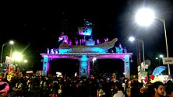](https://en.wikipedia.org/wiki/File:Balijatra_cuttack.JPG)

Bali Jatra Entrance Gate

* [Kartikeshwar Puja](https://en.wikipedia.org/wiki/Kartikeya): The puja in Cuttack is organized by the puja committees of Cuttack. This festival is observed to worship [Kartikeya](https://en.wikipedia.org/wiki/Kartikeya" \o "Kartikeya), the eldest son of [Lord Shiva](https://en.wikipedia.org/wiki/Lord_Shiva). Nowhere else except [Sabarimala](https://en.wikipedia.org/wiki/Sabarimala) is the Kartikeswar puja carried out with so much elan.
* Bada Osha: This is unique to Dhabaleswar Temple. Special Bhoga namely Gaja and Tarana are prepared on this day for the worshippers.
* [Mana Basa](https://en.wikipedia.org/w/index.php?title=Mana_Basa&action=edit&redlink=1) was unique of Cuttack Odisha later celebrated by east Odisha, west Odisha is worship to goddes [Laxmi](https://en.wikipedia.org/wiki/Laxmi" \o "Laxmi) .
* [Kite](https://en.wikipedia.org/wiki/Kite) flying is also celebrated with much enthusiasm and energy in the city. Kite-flying culminates with the Makar Sankranti, with kite-flying competitions being held all over. Cuttack is the first city in the [Eastern India](https://en.wikipedia.org/wiki/East_India) to introduce kite-flying.

All the other regular Indian festivals like [Ratha Yatra](https://en.wikipedia.org/wiki/Ratha-Yatra" \o "Ratha-Yatra), [Raja](https://en.wikipedia.org/wiki/Raja_Parba), [Ganesh Chaturthi](https://en.wikipedia.org/wiki/Ganesh_Chaturthi), [Vasant Panchami](https://en.wikipedia.org/wiki/Vasant_Panchami), [Holi](https://en.wikipedia.org/wiki/Holi), [Diwali](https://en.wikipedia.org/wiki/Diwali), [Chhath](https://en.wikipedia.org/wiki/Chhath" \o "Chhath), [Eid](https://en.wikipedia.org/wiki/Eid_al-Fitr), [Good Friday](https://en.wikipedia.org/wiki/Good_Friday), Christmas, and the numerous festivals are celebrated here.

Link: <https://en.wikipedia.org/wiki/Cuttack#cite_note-pop-1>

|  |  |  |  |
| --- | --- | --- | --- |
| |  |  |  | | --- | --- | --- | | Cuttack is known as the cultural capital of Orissa. It lies near Bhubaneswar, Puri and Konark. This city was founded almost a thousand years ago, in 989 A.D and was the capital of Orissa for almost nine centuries, before Bhubaneswar was made the capital city in 1948. Cuttack along with Bhubaneswar is collectively known as the "twin cities" of Orissa. With its world famous exceptional filigree works in silver, ivory and brass works and textiles of woven silk and cotton, Cuttack city is perhaps the grandest showroom of Orissa. It is widely known as the Silver City because of its fine workmanship in silver. | |  | | --- | | http://cmccuttack.gov.in/(S(0p5dzzasgbuzbuomlsoyihgn))/images/filigree-work.jpg | | |
| Cuttack is a city of brotherhood or Bhai- Chara where people of all religious communities have been residing for centuries in harmony and co-operation.It is here that religious festivals ranging from Dussehra,Holi and Diwali to Id and Christmas are celebrated with equal fervour and devotion by people of all communities.  Apart from temples, the city of Cuttack has some old structures belonging to other faiths. The holy historicalSikh Shrine "`The Gurdwara Daatan Sahib`" is situated here. It is here that the first Sikh Guru, Shree Guru th Nanak Dev halted on his way to Puri, way back in the 15 century. It is believed that a “Sahada “ tree planted by him after using one of its twigs as a tooth Cleaner still flourishes here, hence is the name Daatan Sahib. |
|  |
| |  |  |  | | --- | --- | --- | | During the passage of time numerous Muslim monuments have been built at Cuttack. The Qadam-I-Rasool is a monument of beauty built by Shujaddin Khan.. It contains the footprint of the prophet Mohammed engraved in a circular stone. The dome outside is adorned with a golden pinnacle. The Shahi Mosque is situated inside the Barabati Fort.  Although there are several churches in Cuttack, the oldest among them all is the church of Epiphany on the Cantonment Road built in the year 1865. | |  | | --- | | http://cmccuttack.gov.in/(S(0p5dzzasgbuzbuomlsoyihgn))/images/qadam-I-rasool.jpg | | |
| Cuttack town has the distinction of having four Jain shrines of modern origin. The Digambar Jain temple at Choudhury Bazar, constructed during the second half of the 20 century,is remarkable for its artistic design. |
|  |
| |  |  |  | | --- | --- | --- | | Oriya is the official state language of cuttack in eastern India, on the Bay of Bengal, with 22 million speakers in orissa according to the 1981 census of India. It is a close relative of its northern neighbour Bengali, but it is written in a completely different script. Outside Oriya  language is also spoken in Andhra Pradesh, Madhya Pradesh, and Bihar. Oriya literature can be traced back to at least the 13th century.The written Oriya language retains a conservative spelling system that owes much to Sanskrit. The sound system is simplified from Sanskrit, so there are some redundant letters in writing. Oriya also has numerous dialect differences. | |  | | --- | | http://cmccuttack.gov.in/(S(0p5dzzasgbuzbuomlsoyihgn))/images/culture_img.gif | | |
| Its morphology and syntax are broadly similar to Bengali, and the two languages are alike in having largely lost most of the old Indo-Aryan grammatical gender system, replacing it with natural gender. The Oriya verb system is distinguished by a great use of impersonal constructions. |

Link: http://cmccuttack.gov.in/(S(0p5dzzasgbuzbuomlsoyihgn))/culture.html

Key people:

| **Profile Picture** | **Name** | **Designation** | **Email** | **Address** | **Phone** | **Fax** | **Room No** |
| --- | --- | --- | --- | --- | --- | --- | --- |
| Bhabani Shankar Chayani DM Cuttack | Shri Bhabani Shankar Chayani, OAS(SAG) | Collector & District Magistrate, Cuttack | dm-cuttack[at]nic[dot]in | Office of the Collector and District Magistrate, Collectorate ,Cuttack, PIN -753002 | 0671-2508100 | 0671-2301103 | 20 |
| SP Rural | Shri Radha Binod Panigrahi, OPS(I) | SP (Rural) | spctc[dot]orpol[at]nic[dot]in | Office of the Superintendent of Police, Cuttack ,753002 Mobile No. - 9438916200 | 0671-2368116 | 0671-2368301 |  |
| Shri Bijay Kumar Khandayatray. | Shri Bijay Kumar Khandayatray, OAS(S) | Additional District Magistrate (General),Cuttack | admcuttack[at]gmail[dot]com | Office of the Collector and District Magistrate, Collectorate ,Cuttack, PIN -753002 | 0671-2508265 |  |  |
|  | Shri Purna Chandra Mishra, OAS(S) | Additional District Magistrate (Revenue),Cuttack | admrev-ctc[dot]od[at]nic[dot]in | Office of the Collector and District Magistrate, Collectorate ,Cuttack, PIN -753002 | 06712509265 |  |  |
| Abdaal Akhtar PD | Md. Abdaal Akhtar, IAS | Project Director, D.R.D.A, Cuttack | ori-dcuttack[at]nic[dot]in | Office of the Project Director, DRDA, Cuttack, Near Collectorate, Cuttack PIN -753002 | 0671-2368139 |  |  |
| **District Level** | | | | | | | |
| **Profile Picture** | **Name** | **Designation** | **Email** | **Address** | **Phone** | **Fax** | **Room No** |
|  | Shri Amiya Kumar Sahoo, OAS(SB) | Sub-Collector and Sub-Divisional Magistrate, Athagarh | subcoll-athgarh[at]nic[dot]in | Office of the Sub-Collector, Athagarh | 06723-220311 |  |  |
|  | . | Sub-Collector and Sub-Divisional Magistrate,Banki | subcoll[dot]banki[at]nic[dot]in | Office of the Sub Collector,Banki,Cuttack | 06723-240201 |  |  |
| shubhransu mishra sub-collector | Shri Shubhranshu Mishra, OAS-A(SB) | SDM-cum-Sub-Collector , Sadar, Cuttack | subcollectorctc[at]nic[dot]in | Office of the Sub-Collector, Sadar , Cuttack, PIN-753002 | 0671-2507626 |  |  |
| **Sub-Division Level** | | | | | | | |

News:

**WHAT'S NEW**

* [Tender Call Notice of sub-Collector’s Office Cuttack.](https://cuttack.nic.in/notice/tender-call-notice-of-sub-collectors-office-cuttack/)
* [ARMY RECRUITMENT RALLY AT PARADIP WITH EFFECT FROM 05 APRIL 2020 TO 16 APRIL 2020](https://cuttack.nic.in/?post_type=document&p=30345)
* [Supply of different items to Anganwadi Center Articles under the ICDS Project Badamba.](https://cuttack.nic.in/notice/supply-of-different-items-to-anganwadi-center-articles-under-the-icds-project-badamba/)
* [Tender Call Notice and Tender document of Level-I Transport contractor of O.S.C.S.C. Ltd, Cuttack for the year-2019-2021.](https://cuttack.nic.in/notice/tender-call-notice-and-tender-document-of-level-i-transport-contractor-of-o-s-c-s-c-ltd-cuttack-for-the-year-2019-2021/)
* [Cause list in the Court of Revenue Divisional Commissioner,Central Division, Cuttack-Cause on date 11.02.2020.](https://cuttack.nic.in/?post_type=document&p=30336)
* [Recruitment and Selection of dedicated Centre of Excellence (COE) staffs at Abhimanpur Maa Kalapat GPLF,under Badamba Block Cuttack.](https://cuttack.nic.in/?post_type=document&p=30333)

Link: https://cuttack.nic.in/

**INDIAN HELPLINE NUMBERS**

|  |  |
| --- | --- |
| **NATIONAL EMERGENCY NUMBER** | **112** |
| **POLICE** | **100** |
| **FIRE** | **101** |
| **AMBULANCE** | **102** |
| **Disaster Management Services** | **108** |
| **Women Helpline** | **1091** |
| **Women Helpline - ( Domestic Abuse )** | **181** |
| **Air Ambulance** | **9540161344** |
| **Aids Helpline** | **1097** |
| **Anti Poison ( New Delhi )** | **1066  or**  **011-1066** |
| **Disaster Management ( N.D.M.A )  : 011-26701728** | **1078** |
| ***EARTHQUAKE / FLOOD / DISASTER  (*N.D.R.F Headquaters )**    **NDRF HELPLINE NO :** | **011-24363260**    **9711077372** |
| **Deputy Commissioner Of Police – Missing Child And Women** | **1094** |
| **Railway Enquiry** | **139** |
| **Senior Citizen Helpline** | **1091 , 1291** |
| **Medical Helpline in Andhra Pradesh, Gujarat, Uttarakhand, Goa, Tamil Nadu, Rajasthan, Karnataka, Assam, Meghalaya, M.P And U.P** | **108** |
| **Railway Accident Emergency Service** | **1072** |
| **Road Accident Emergency Service** | **1073** |
| **Road Accident Emergency Service On National Highway For Private Operators** | **1033** |
| **ORBO Centre, AIIMS (For Donation Of Organ) Delhi** | **1060** |
| **Kisan Call Centre** | **1551** |
| **Relief Commissioner For Natural Calamities** | **1070** |
| **Children In Difficult Situation** | **1098** |
| **All India Institute of Medical Sciences (AIIMS) Poision Control ( 24*7 )** | **011-26593677, 26589391, 26583282** |
| **Tourist Helpline** | **1363 or 1800111363** |
| **LPG Leak Helpline** | **1906** |

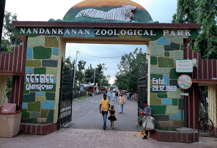

Nandankanan Zoological Park

4.4



(44,259)

Popular zoo with a white tiger safari

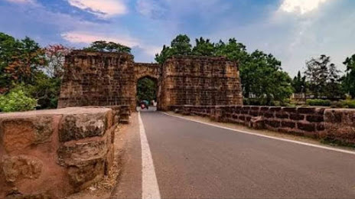

Barabati fort

4.4



(7,153)

Ruins of a 14th-century fortress

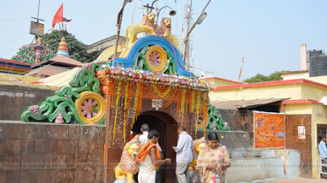

Cuttack Chandi Temple

4.7



(2,102)

Ancient Hindu temple with festivals

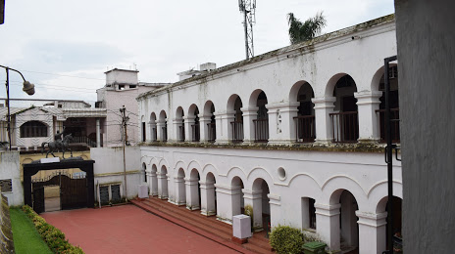

Netaji Birth Place Museum - Cuttack

4.5



(866)

Exhibits on the famous freedom fighter

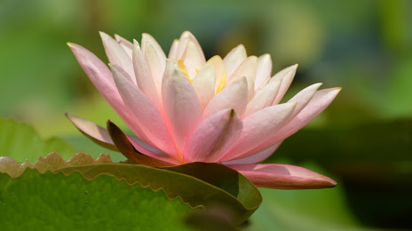

State Botanical Garden

4.4



(615)

Diverse plant displays & picnic spots

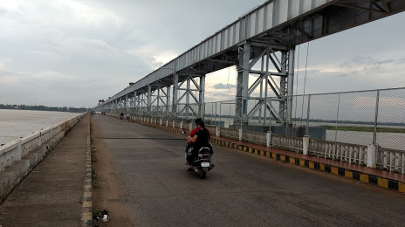

Mahanadi Barrage

Dam

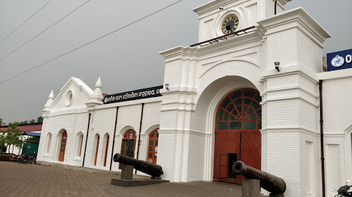

Odisha State Maritime Museum, Cuttack

4.4



(3,687)

Maritime museum with model boats & maps

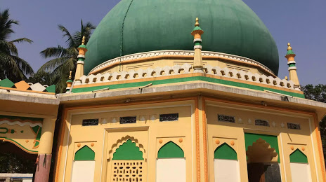

Qadam-E-Rasool

4.4



(39)

Shrine

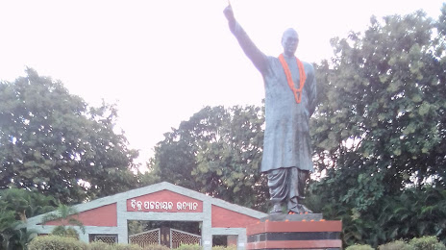

Biju Pattanaik Park

4.1



(1,663)

Park

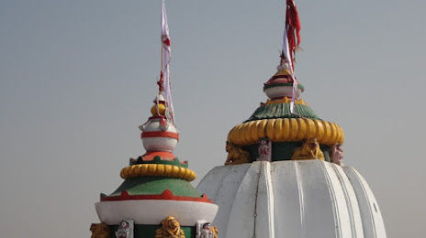

LORD DHABALESWAR - SHIVA TEMPLE

4.4



(59)

Hindu temple

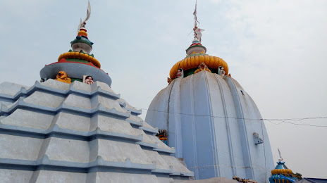

Ranihat Dhabaleswar Temple

4.4



(691)

Hindu temple

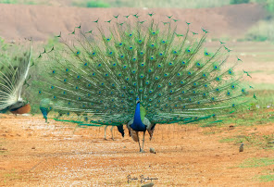

Peacock Valley

4.5



(377)

Tourist attraction

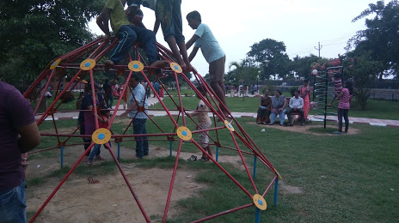

Khannagar Park

4.1



(2,996)

Park

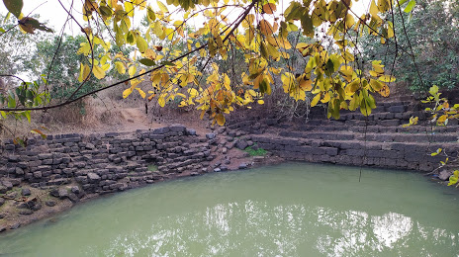

Chudanga Gada

4.5



(2)

History

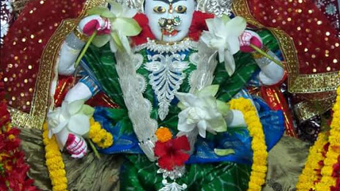

Maa Gada Chandi Mandir, ମା ଗଡ଼ଚଣ୍ଡୀ ମନ୍ଦିର

4.7



(149)

Hindu temple

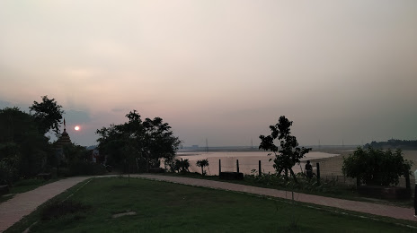

Park in Cuttack

4.0



(70)

Park

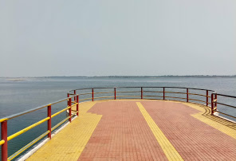

Mahanadi River View(Sunset Point)

4.4



(817)

Tourist attraction

Send feedback