Freight Rate Prediction: Validation Approach
Bikash Kushwaha · Machine Learning Engineer assessment

1. Data overview
train_test.csv has 48,000 labelled loads from 1 Jan to 31 Oct 2025 across 64 cities and three equipment types (Dry Van 57%, Reefer 25%, Flatbed 18%). validation.csv has 12,000 unlabelled loads from 1 Nov to 31 Dec 2025, so every prediction is for dates after the training data. It also includes 8 cities that never appear in training, touching 12% of validation loads.
Rate scales almost linearly with distance, so I modelled rate per mile. Rate per mile falls with distance (short hauls carry a fixed cost), is highest for Reefer, then Flatbed, then Dry Van, and moves with the market index, which peaks in May to June and is lower in the validation months.

2. Data-quality issues and fixes
- Negative weights (292 rows): treated as sign errors and replaced with the absolute value. Missing weights (300 rows) are left missing; LightGBM learns a split direction for them.
- Impossible distances (111 rows): road distance should be about 1.05 to 1.6 times the straight-line distance between the coordinates. Rows outside that band (for example 70 miles on a roughly 600 mile lane) are rebuilt as straight-line distance times the median road factor learned from training rows (about 1.18).
- Missing market_index (374 rows): market_index is a daily market level plus small load-level noise, so missing values are filled with the average for that date.
- Corrupted labels (707 rows, about 1.5%): some posted rates are 2 to 5 times above or below the normal rate per mile for the same lane and equipment. They behave like entry errors, not market moves, so they are removed from training. The model also uses L1 loss so any that remain have limited influence.
- Unseen cities: city names are not used as features. The model uses coordinates and distance, so it generalises to new cities.
The road factor and daily index used for cleaning are fitted on the training portion of each split only. On test windows, the outlier check is used only to decide which rows count as clean labels for scoring; it never feeds the model.

3. Train/test split and validation approach
Because the real task is to forecast later months, a random split would leak future market conditions into training and overstate accuracy. I used an expanding-window time-based backtest instead: each fold trains only on months before a cut-off and tests on the following two months. The last fold (train January to August, test September to October) mirrors the final setup (train January to October, predict November to December).
Metrics are reported on test rows with clean labels, because scoring a model against corrupted labels mostly measures the corruption. MAE on all rows is shown for completeness.
Test months | Train rows | Test rows | MAE ($) | MAPE | Baseline MAPE
May-Jun 2025 | 19,110 | 9,696 | 50 | 1.9% | 9.0%
Jul-Aug 2025 | 28,806 | 9,671 | 79 | 4.2% | 8.0%
Sep-Oct 2025 | 38,477 | 9,523 | 74 | 3.0% | 8.1%
Baseline: median rate per mile for the equipment type, times distance. The model cuts MAPE by 79%, 48% and 63% against it in the three folds. Jul-Aug is the hardest fold: the market index fell sharply from 1.28 in June to 0.98 in August, after five months of rises.

4. Model
I compared a rate-per-mile baseline, a ridge regression on log rate, and LightGBM with L2 and L1 losses, predicting either log rate or log rate per mile. LightGBM with L1 loss on log rate per mile was best on the September to October holdout (MAPE 3.0% versus 4.4% for ridge). Adding day of week and city target encodings gave little or no gain, so I left them out to keep the model simpler and robust to new cities. The final model is trained on all January to October data.
Most important features (share of total gain): quote_signal 22%, straight_line_mi 17%, log_distance 15%, equipment 14%, daily_market_index 8%, weight 7%.

5. December prediction chart
The December file gives lane, distance, equipment, weight and date, but not coordinates, market_index or quote_signal. Coordinates come from the city lookup in the training data. market_index uses the average index of December loads in validation.csv for each day, and quote_signal uses the December median. The day-to-day movement in the chart therefore reflects the daily market index; the level (about $770 to $800) is consistent with historical Dry Van loads on this lane ($760 to $900).
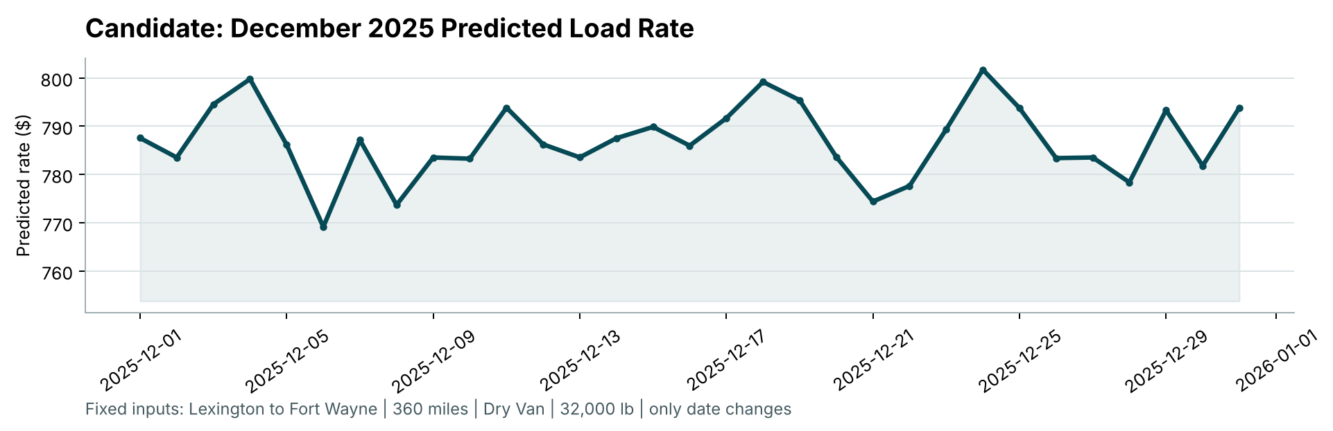

6. Limitations and next steps
- November and December are lower-market months than most of the training period; the model has seen similar index levels in January and September to October, but holiday effects are not in the data.
- The December chart depends on how market_index and quote_signal are filled; with real daily market feeds the chart would use those directly.
- Next steps: prediction intervals with quantile models, monitoring for drift in market_index, and a lane-level hierarchical prior if more history per lane becomes available.

