**Introduction**

StopWatch is GUI system that displays 4 circular shaped Stop watch. This is a concept of using Multithreading. The time of stopwatch increase on their own also the stopwatch time increase and decrease using specified keys from the keyboard. The time of stopwatch is displayed in both text format and graphically.

The system has used the concept of multithreading. The four objects are processed using the thread. Each object works independently. The thread is used to for each multi processing.

The Stopwatch also increases and decreases the speed on by using **UP** and **DOWN** Key from the keyboard.

**Explanation:**

File Used:

1.Main.java

2.ClockPane.java

3.application.css

4.1.jpg(Image)

**System Design**

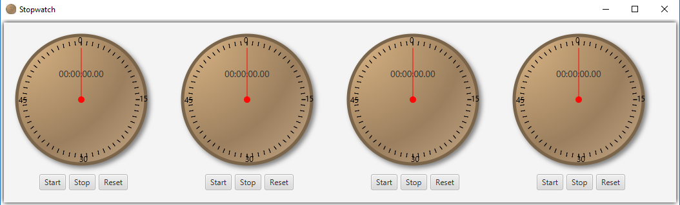

Initially Stopwatch starts from 0. The Start, Stop and Reset button is used to Start the timer, Stop is used to stop the timer and Reset reset the timer to 0.

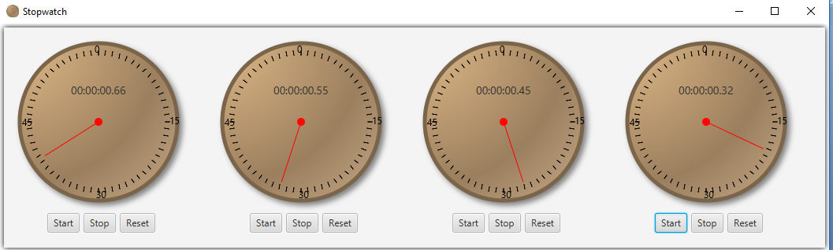

This figure shows that all the stopwatch has started.

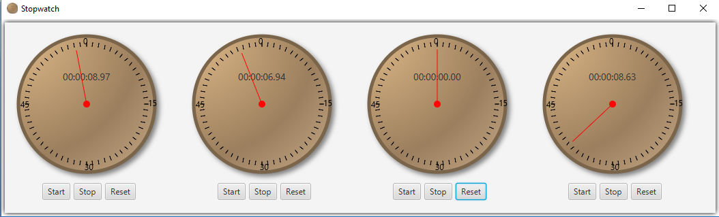

The above figure shows that second clock has stopped and the third is reset. Similarly, all the stop watch works independently.

For the implementation of **UP** and **DOWN** keyboard which increase and decrease the speed of the clock respectively, I have provided the **Stopwatch Demonstration** video for demonstration purpose. Please have a look into it.

**Code:**

1. **Main.java**

**import** javafx**.**application**.**Application**;**

**import** javafx**.**geometry**.**Insets**;**

**import** javafx**.**scene**.**Scene**;**

**import** javafx**.**scene**.**control**.*;**

**import** javafx**.**scene**.**image**.**Image**;**

**import** javafx**.**scene**.**layout**.*;**

**import** javafx**.**stage**.**Stage**;**

public class Main **extends** Application **{**

private Button btnStart1 **=** **new** Button**(**"Start"**);**

private Button btnStop1 **=** **new** Button**(**"Stop"**);**

private Button btnReset1 **=** **new** Button**(**"Reset"**);**

private Button btnStart2 **=** **new** Button**(**"Start"**);**

private Button btnStop2 **=** **new** Button**(**"Stop"**);**

private Button btnReset2 **=** **new** Button**(**"Reset"**);**

private Button btnStart3 **=** **new** Button**(**"Start"**);**

private Button btnStop3 **=** **new** Button**(**"Stop"**);**

private Button btnReset3 **=** **new** Button**(**"Reset"**);**

private Button btnStart4 **=** **new** Button**(**"Start"**);**

private Button btnStop4 **=** **new** Button**(**"Stop"**);**

private Button btnReset4 **=** **new** Button**(**"Reset"**);**

public void start**(**Stage primaryStage**)** **throws** Exception **{**

**try** **{**

// Object for each stopwatch

ClockPane clockPane **=** **new** ClockPane**(**250**);**

ClockPane clockPane1 **=** **new** ClockPane**(**250**);**

ClockPane clockPane2 **=** **new** ClockPane**(**250**);**

ClockPane clockPane3 **=** **new** ClockPane**(**250**);**

HBox hBox **=** **new** HBox**();**

VBox vBox1 **=** **new** VBox**();**

VBox vBox2 **=** **new** VBox**();**

VBox vBox3 **=** **new** VBox**();**

VBox vBox4 **=** **new** VBox**();**

HBox hBox1 **=** **new** HBox**();**

hBox1**.**getChildren**().**addAll**(**btnStart1**,** btnStop1**,** btnReset1**);**

hBox1**.**setPadding**(new** Insets**(**0**,** 60**,** 0**,** 60**));**

hBox1**.**setSpacing**(**5**);**

HBox hBox2 **=** **new** HBox**();**

hBox2**.**getChildren**().**addAll**(**btnStart2**,** btnStop2**,** btnReset2**);**

hBox2**.**setPadding**(new** Insets**(**0**,** 60**,** 0**,** 60**));**

hBox2**.**setSpacing**(**5**);**

HBox hBox3 **=** **new** HBox**();**

hBox3**.**getChildren**().**addAll**(**btnStart3**,** btnStop3**,** btnReset3**);**

hBox3**.**setPadding**(new** Insets**(**0**,** 60**,** 0**,** 60**));**

hBox3**.**setSpacing**(**5**);**

HBox hBox4 **=** **new** HBox**();**

hBox4**.**getChildren**().**addAll**(**btnStart4**,** btnStop4**,** btnReset4**);**

hBox4**.**setPadding**(new** Insets**(**0**,** 60**,** 0**,** 60**));**

hBox4**.**setSpacing**(**5**);**

vBox1**.**getChildren**().**addAll**(**clockPane**,** hBox1**);**

vBox2**.**getChildren**().**addAll**(**clockPane1**,** hBox2**);**

vBox3**.**getChildren**().**addAll**(**clockPane2**,** hBox3**);**

vBox4**.**getChildren**().**addAll**(**clockPane3**,** hBox4**);**

hBox**.**getChildren**().**addAll**(**vBox1**,** vBox2**,** vBox3**,** vBox4**);**

AnchorPane root **=** **new** AnchorPane**();**

root**.**getChildren**().**add**(**hBox**);**

Scene scene **=** **new** Scene**(**root**);**

scene**.**getStylesheets**().**add**(**getClass**().**getResource**(**"application.css"**).**toExternalForm**());**

primaryStage**.**getIcons**().**add**(new** Image**(**getClass**().**getResourceAsStream**(**"1.png"**)));**

primaryStage**.**setTitle**(**"Stopwatch"**);**

primaryStage**.**setScene**(**scene**);**

primaryStage**.**show**();**

// Button to start the thread

btnStart1**.**setOnAction**(**e1 **->** clockPane**.**start**());**

btnStart2**.**setOnAction**(**e1 **->** clockPane1**.**start**());**

btnStart3**.**setOnAction**(**e1 **->** clockPane2**.**start**());**

btnStart4**.**setOnAction**(**e1 **->** clockPane3**.**start**());**

// Button to stop the thread

btnStop1**.**setOnAction**(**e2 **->** clockPane**.**suspend**());**

btnStop2**.**setOnAction**(**e2 **->** clockPane1**.**suspend**());**

btnStop3**.**setOnAction**(**e2 **->** clockPane2**.**suspend**());**

btnStop4**.**setOnAction**(**e2 **->** clockPane3**.**suspend**());**

// Button to reset the thread

btnReset1**.**setOnAction**(**e3 **->** clockPane**.**reset**());**

btnReset2**.**setOnAction**(**e3 **->** clockPane1**.**reset**());**

btnReset3**.**setOnAction**(**e3 **->** clockPane2**.**reset**());**

btnReset4**.**setOnAction**(**e3 **->** clockPane3**.**reset**());**

**}** **catch** **(**Exception e**)** **{**

e**.**printStackTrace**();**

**}**

**}**

public static void main**(**String**[]** args**)** **{**

launch**(**args**);**

**}**

**}**

1. **ClockPane.java**

**import** javafx**.**application**.**Platform**;**

**import** javafx**.**scene**.*;**

**import** javafx**.**scene**.**control**.*;**

**import** javafx**.**scene**.**input**.*;**

**import** javafx**.**scene**.**layout**.*;**

**import** javafx**.**scene**.**paint**.**Color**;**

**import** javafx**.**scene**.**shape**.*;**

**import** javafx**.**scene**.**text**.*;**

public class ClockPane **extends** Pane **{**

// Clock pane's width and height

private int size**;**

double time**;**

private int miliseconds **=** 0**;**

private int seconds **=** 0**;**

private int minutes **=** 0**;**

private int hours **=** 0**;**

private int sleepTime **=** 100**;**

int center**;**

int radius**;**

double clockRadius**;**

private Label lbl1 **=** **new** Label**(**"00:00:00"**);**

private Circle circle**;**

private Circle spindle**;**

private Text t1**;**

private Text t2**;**

private Text t3**;**

private Text t4**;**

Group groupLayout **=** **new** Group**();**

Group group**;**

// Constructor

public ClockPane**(**int size**)** **{**

**this.**size **=** size**;**

center **=** size **/** 2**;**

radius **=** **(**size **-** 80**);**

clockRadius **=** Math**.**min**(**size**,** size**)** **\*** 0.8 **\*** 0.5**;**

init**();**

**this.**setFocusTraversable**(true);**

thread**.**start**();**

// start clock from 0

**if** **(**thread**.**isAlive**())** **{**

thread**.**suspend**();**

reset**();**

**}**

//Increase and Decrease the clock

**this.**setOnKeyPressed**(**e **->** **{**

**if** **(**e**.**getCode**()** **==** KeyCode**.**UP**)** **{**

**this.**faster**();**

**}**

**else** **if** **(**e**.**getCode**()** **==** KeyCode**.**DOWN**)** **{**

**this.**slower**();**

**}**

e**.**consume**();**

**});**

**}**

// Initialize design

private void init**()** **{**

// Draw Circle

circle **=** **new** Circle**(**center**,** center**,** clockRadius**);**

circle**.**setId**(**"circle"**);**

circle**.**setFill**(**Color**.**WHITE**);**

circle**.**setStroke**(**Color**.**BLACK**);**

circle**.**setStrokeWidth**(**2**);**

// text

t1 **=** **new** Text**(**center **-** 5**,** center **-** clockRadius **+** 12**,** "0"**);**

t2 **=** **new** Text**(**center **-** clockRadius **+** 3**,** center **+** 5**,** "45"**);**

t3 **=** **new** Text**(**center **+** clockRadius **-** 10**,** center **+** 3**,** "15"**);**

t4 **=** **new** Text**(**center **-** 3**,** center **+** clockRadius **-** 3**,** "30"**);**

// Center

spindle **=** **new** Circle**(**center**,** center**,** 5**);**

spindle**.**setId**(**"spindle"**);**

spindle**.**setFill**(**Color**.**RED**);**

// Label

lbl1**.**setId**(**"lbl1"**);**

lbl1**.**layoutXProperty**().**bind**(**circle**.**centerXProperty**().**subtract**(**lbl1**.**widthProperty**().**divide**(**2**)));**

lbl1**.**layoutYProperty**().**bind**(**circle**.**centerYProperty**().**add**(**circle**.**radiusProperty**()).**divide**(**3**));**

groupLayout**.**getChildren**().**addAll**(**circle**,** spindle**,** lbl1**,** t1**,** t2**,** t3**,** t4**);**

setTimer**();**

**}**

// Digital stop watch

private void setTimer**()** **{**

miliseconds**++;**

**if** **(**miliseconds **>** 99**)** **{**

miliseconds **=** 0**;**

seconds**++;**

**if** **(**seconds **>** 60**)** **{**

seconds **=** 0**;**

minutes**++;**

**if** **(**minutes **>** 60**)** **{**

hours**++;**

**}**

**}**

**}**

lbl1**.**setText**(**String**.**format**(**"%02d"**,** hours**)** **+** ":" **+** String**.**format**(**"%02d"**,** minutes**)** **+** ":"

**+** String**.**format**(**"%02d"**,** seconds**)** **+** "." **+** String**.**format**(**"%02d"**,** miliseconds**));**

paintClock**();**

**}**

private void paintClock**()** **{**

// Initialize clock parameters

group **=** **new** Group**();**

int anim**;**

int anim2**;**

int anim3**;**

int anim4**;**

double sLength **=** clockRadius **\*** 0.8**;**

double secondX **=** center **+** sLength **\*** Math**.**sin**((**miliseconds**)** **\*** **(**2 **\*** Math**.**PI **/** 100**));**

double secondY **=** center **-** sLength **\*** Math**.**cos**((**miliseconds**)** **\*** **(**2 **\*** Math**.**PI **/** 100**));**

Line sLine **=** **new** Line**(**center**,** center**,** secondX**,** secondY**);**

sLine**.**setStroke**(**Color**.**RED**);**

Group ticks **=** **new** Group**();**

double t**;**

// Draws a tick line inside the circle

**for** **(**int i **=** 0**;** i **<** 60**;** i**++)** **{**

radius **=** size **-** 80**;**

t **=** **(**i **+** 1**)** **%** 60.0 **/** 60 **\*** Math**.**PI **\*** 2**;**

anim **=** **(**int**)** **((**center**)** **+** **(**Math**.**sin**(**t**)** **\*** radius **/** 2**));**

anim2 **=** **(**int**)** **((**center**)** **-** **(**Math**.**cos**(**t**)** **\*** radius **/** 2**));**

radius **=** size **-** 70**;**

anim3 **=** **(**int**)** **((**center**)** **+** **(**Math**.**sin**(**t**)** **\*** radius **/** 2**));**

anim4 **=** **(**int**)** **((**center**)** **-** **(**Math**.**cos**(**t**)** **\*** radius **/** 2**));**

Line tick **=** **new** Line**(**anim**,** anim2**,** anim3**,** anim4**);**

tick**.**getStyleClass**().**add**(**"tick"**);**

ticks**.**getChildren**().**add**(**tick**);**

**}**

group**.**getChildren**().**addAll**(**sLine**,** ticks**);**

**this.**getChildren**().**clear**();**

**this.**getChildren**().**addAll**(**groupLayout**,** group**);**

**}**

//Thread used

public Thread thread **=** **new** Thread**(()** **->** **{**

**try** **{**

**while** **(true)** **{**

Platform**.**runLater**(()** **->** setTimer**());**

Thread**.**sleep**(**sleepTime**);**

**}**

**}** **catch** **(**InterruptedException ex**)** **{**

**}**

**});**

// Reset the digital clock

public void reset**()** **{**

miliseconds **=** 0**;**

seconds **=** 0**;**

minutes **=** 0**;**

hours **=** 0**;**

lbl1**.**setText**(**String**.**format**(**"%02d"**,** hours**)** **+** ":" **+** String**.**format**(**"%02d"**,** minutes**)** **+** ":"

**+** String**.**format**(**"%02d"**,** seconds**)** **+** "." **+** String**.**format**(**"%02d"**,** miliseconds**));**

paintClock**();**

**}**

// Make the stopwatch timer faster

public void faster**()** **{**

**if** **(**sleepTime **>** 1**)**

sleepTime**--;**

**}**

// Make the stopwatch timer slower

public void slower**()** **{**

sleepTime **++;**

**}**

//Start the thread

public void start**()** **{**

thread**.**resume**();**

**}**

//Stop the thread

public void suspend**()** **{**

thread**.**suspend**();**

**}**

**}**